Insights into the microbiome assembly during different growth stages and storage of strawberry plants
Expedito Olimi, Peter Kusstatscher*, Wisnu Adi Wicaksono, Ahmed Abdelfattah, Tomislav Cernava & Gabriele Berg
Institute of Environmental Biotechnology, Graz University of Technology, 8010 Graz, Austria
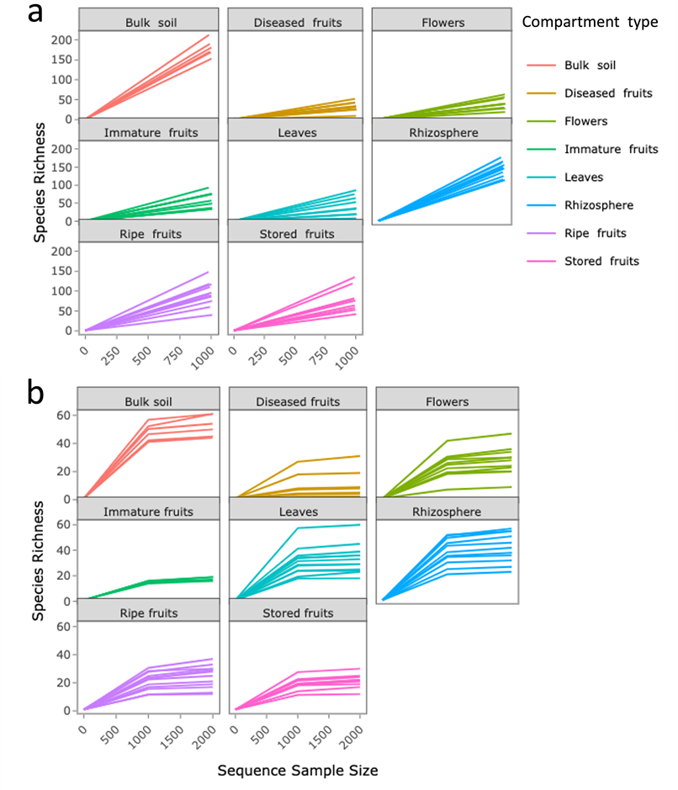
Figure S1. Compartment-specific alpha rarefaction curves for Bacterial (a) and fungal communities (b). The sampling depths for were 1000 and 2500 reads per sample for bacterial and fungal communities respectively. Colors represent different compartments.

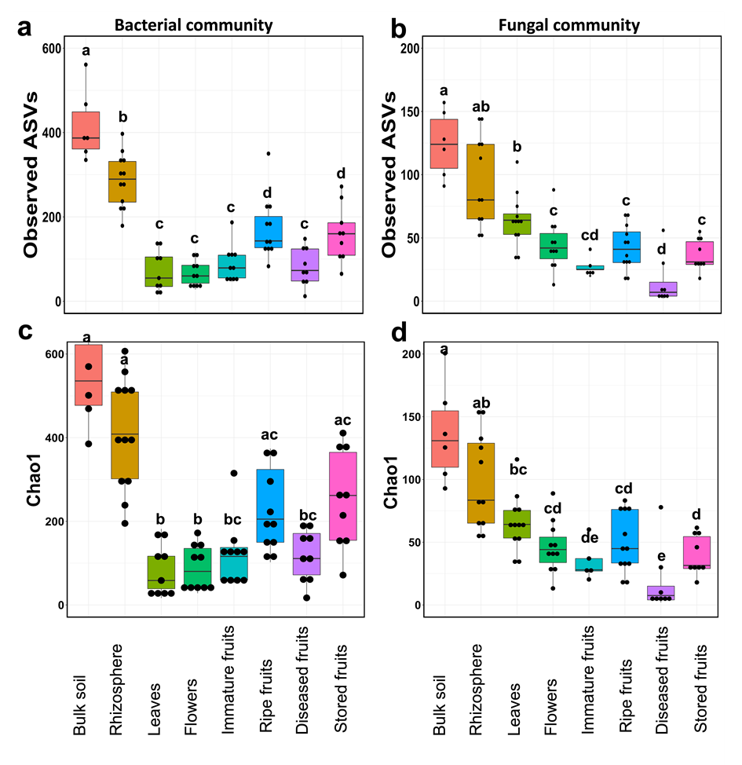
Figure S2. Bacterial and fungal community richness as estimated by observed ASVs (a and b) and Chao1 (c and d). Boxplots indicate bacterial (a, c) and fungal (b, d) richness in soil, rhizosphere and strawberry phyllosphere compartments. Significant differences (P<0.05) were respectively tested using pairwise Wilcoxon Rank Sum Test, followed by FDR correction. Statistical differences are indicated by different letters above the boxplots.

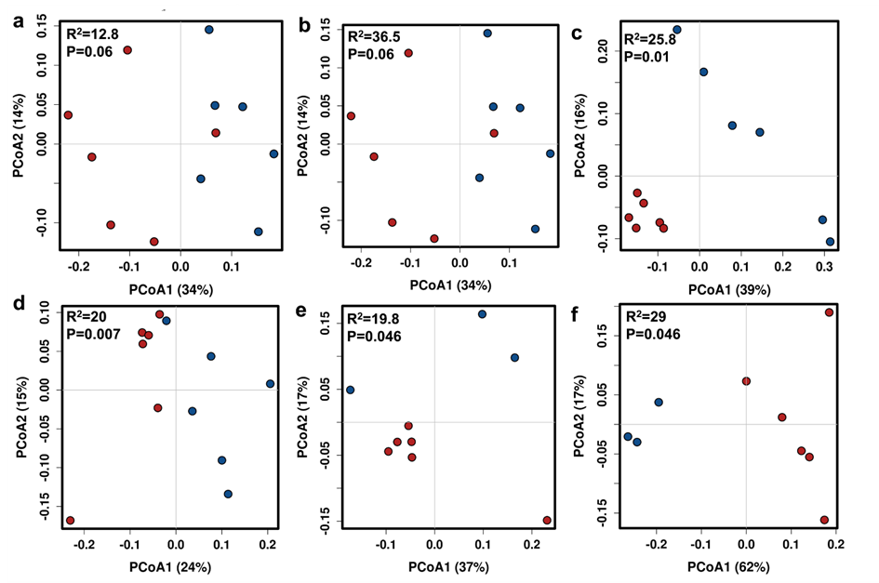
Figure S3. PCoAs based on Bray-Curtis distances showing bacterial community separation in individual compartments. The Bacterial community clustering in different compartments is represented as: rhizosphere (a), leaves (b), flowers (c), ripe fruits (d), stored fruits (e), and diseased fruits (f). No significant difference in microbial beta diversity was observed in immature fruits (PERMANOVA: R²=16.8 and P=0.05). Color codes on the PCoAs indicate host cultivars: cultivar 1 (red) and cultivar2 (blue).
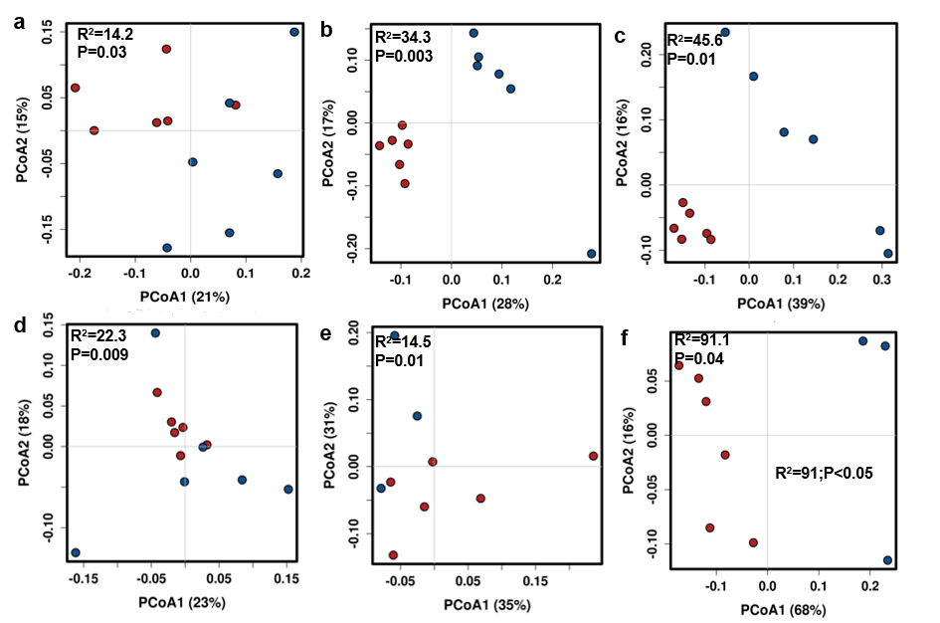
Figure S4. PCoAs based on Bray-Curtis distances showing fungal community separation in individual compartments. The fungal community clustering in different compartments is represented as: rhizosphere (a), leaves (b), flowers (c), ripe fruits (d), stored fruits (e), and diseased fruits (f). No significant difference in microbial beta diversity was observed in immature fruits (PERMANOVA: R²=32.8 and P=0.4). Color codes on the PCoAs indicate host cultivars: cultivar 1 (red) and cultivar2(blue).
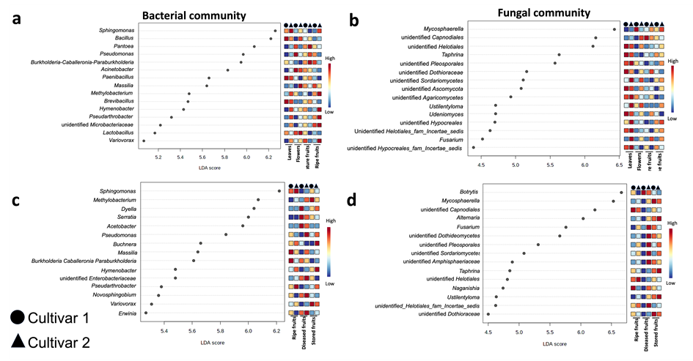
Figure S5. Linear discriminant analysis Effect Size (LEfSe) plots showing genera explaining differences between strawberry cultivars in the different compartments and fruit conditions. Plots (a and b) represent bacterial and fungal community differences between cultivars in the phyllosphere compartments, while (c and d) show cultivar differences between the fruit conditions. Feature table (ASV table) of subset datasets of fruit condition (c and d) and phyllosphere compartments (a and b), taxonomy, and mapping file were used as input. The shapes represent cultivars.
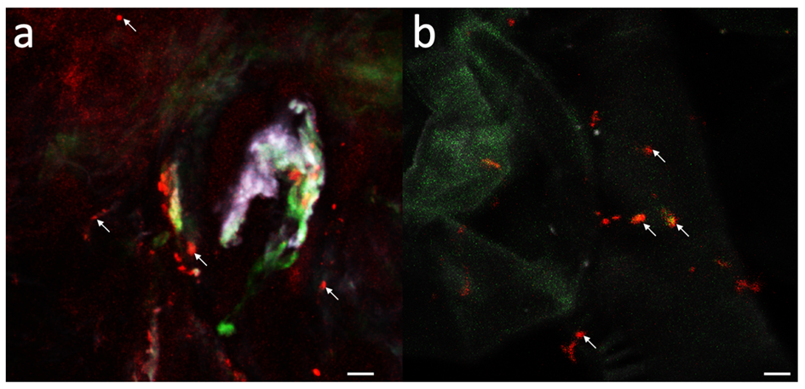
Figure S6. Micrographs of bacterial colonization of fresh ripe strawberry tissues. Bacteria visualization in the fruit pulp (a) and fruit surface (b). The white arrows in the micrographs indicate individual cells of the visualized bacteria colonizing fruit tissues. The scale bars on the micrographs indicate 10 μm.

Table S1. Chemical characteristics of the soil on which the experiment was established.

pH in H₂O | Nog. | Cog. | P | K | Mg | Ca | Stot
pH in H₂O | % |  | mg kg⁻¹
7.55 | 0.29 | 3.72 | 2113 | 1848 | 6395 | 12860 | 522
P | K | B | Cu | Fe | Mn | Zn | Na
mg 100 g⁻¹ |  | mg kg⁻¹
46.8 | 7.22 | 25.0 | 48.8 | 25420 | 718 | 109 | 206

Table S2. Statistical tests on microbial abundance between strawberry compartments
Bacterial community
Compartment type: Kruskal-Wallis chi-squared = 56.561, df = 7, p-value = 0.00***
Cultivar: Kruskal-Wallis chi-squared = 0.46265, df = 1, p-value = 0.496
Position (Belowground and phyllosphere): Kruskal-Wallis chi-squared = 43.882, df = 2, p-value = 0.00***
 | Bulk soil | Rhizosphere | Leaves | Flowers | Immature fruits | Ripe fruits | Diseased fruits
Rhizosphere | 0.883
Leaves | 0.000*** | 0.000***
Flowers | 0.001** | 0.000*** | 0.356
Immature fruits | 0.000 | 0.000*** | 0.000*** | 0.008*
Ripe fruits | 0.000*** | 0.000*** | 0.977 | 0.478 | 0.001**
Diseased fruits | 0.000** | 0.000*** | 0.104 | 0.037* | 0.000*** | 0.116
Stored fruits | 0.000** | 0.000*** | 0.008* | 0.001** | 0.000*** | 0.017* | 0.966
Fungal community
Compartment type: Kruskal-Wallis chi-squared = 18.618, df = 7, p-value = 0.01
Cultivar: Kruskal-Wallis chi-squared = 9.5631, df = 1, p-value = 0.002
Position (Belowground and phyllosphere): Kruskal-Wallis chi-squared = 11.554, df = 1, p-value = 0.0007
 | Bulk soil | Rhizosphere | Leaves | Flowers | Immature fruits | Ripe fruits | Diseased fruits
Rhizosphere | 0.766
Leaves | 0.017* | 0.017*
Flowers | 0.475 | 0.701 | 0.201
Immature fruits | 0.017* | 0.017* | 0.766 | 0.160
Ripe fruits | 0.017* | 0.088 | 0.701 | 0.475 | 0.533
Diseased fruits | 0.766 | 0.766 | 0.543 | 1.000 | 0.701 | 0.701
Stored fruits | 0.475 | 0.250 | 0.393 | 0.701 | 0.410 | 0.766 | 0.938

Table S3: Alpha and Beta diversity indices for the bacterial community.
Shannon diversity (Bacterial community)
 | SS | df |  | F | P
All Compartments including bulk soil | 73.360 | 7 |  | 29.070 | 0.000 | ***
Position: Belowground & Phyllosphere | 56.380 | 1 |  | 100.600 | 0.000 | ***
Exclude soil from the analysis (Two-way Anova)
Compartment type | 45.580 | 6 |  | 28.094 | 0.000 | ***
Host-cultivar | 2.300 | 1 |  | 8.496 | 0.005 | **
Compartment type: Cultivar | 6.810 | 6 |  | 4.198 | 0.001 | **
Compartment-specific Shannon diversity differences between cultivars | SS | df |  | F | P
Diseased fruits | 3.765 | 1 |  | 5.013 | 0.060
Flowers | 0.010 | 1 |  | 0.072 | 0.795
Leaves | 4.374 | 1 |  | 33.86 | 0.001 | ***
Ripe fruits | 0.022 | 1 |  | 0.073 | 0.794
Immature fruits | 0.505 | 1 |  | 1.304 | 0.287
Stored fruits | 0.194 | 1 |  | 0.944 | 0.364
Rhizosphere | 0.240 | 1 |  | 3.765 | 0.081
Post-hoc analysis (Shannon diversity)
Compartment-specific comparison in bacterial diversity (Shannon) | diff | lwr | upr | p adj
Rhizosphere & Bulk soil | -0.778 | -1.717 | 0.161 | 0.177
Leaves & Bulk soil | -2.985 | -3.975 | -1.996 | 0
Flowers & Bulk soil | -2.917 | -3.886 | -1.947 | 0
Immature fruits & Bulk soil | -2.735 | -3.705 | -1.766 | 0
Ripe fruits & Bulk soil | -1.837 | -2.790 | -0.884 | 0
Diseased fruits & Bulk soil | -2.991 | -3.980 | -2.001 | 0
Stored fruits & Bulk soil | -1.900 | -2.889 | -0.909 | 0
Leaves & Rhizosphere | -2.2067 | -3.035 | -1.379 | 0
Flowers & Rhizosphere | -2.139 | -2.943 | -1.335 | 0
Immature fruits & Rhizosphere | -1.957 | -2.761 | -1.153 | 0
Ripe fruits & Rhizosphere | -1.058 | -1.842 | -0.275 | 0.002
Diseased fruits & Rhizosphere | -2.213 | -3.040 | -1.385 | 0
Stored fruits & Rhizosphere | -1.121 | -1.949 | -0.293 | 0.002
Flowers & Leaves | 0.068 | -0.794 | 0.931 | 0.999
Immature fruits & Leaves | 0.250 | -0.613 | 1.112 | 0.985
Ripe fruits & Leaves | 1.149 | 0.305 | 1.992 | 0.001
Diseased fruits & Leaves | -0.006 | -0.891 | 0.880 | 1
Stored fruits & Leaves | 1.086 | 0.201 | 1.971 | 0.006
Immature fruits & Flowers | 0.181 | -0.658 | 1.021 | 0.998
Ripe fruits & Flowers | 1.080 | 0.260 | 1.901 | 0.003
Diseased fruits & Flowers | -0.074 | -0.937 | 0.789 | 0.999
Stored fruits & Flowers | 1.018 | 0.155 | 1.881 | 0.010
Ripe fruits & Immature fruits | 0.899 | 0.078 | 1.719 | 0.022
Diseased fruits & Immature fruits | -0.255 | -1.118 | 0.607 | 0.982
Stored fruits & Immature fruits | 0.836 | -0.026 | 1.667 | 0.064
Diseased fruits & Ripe fruits | -1.154 | -1.998 | -0.310 | 0.001
Stored fruits & Ripe fruits | -0.062 | -0.906 | 0.782 | 0.999
Stored fruits & Diseased fruits | 1.092 | 0.207 | 1.977 | 0.006

Observed ASVs (Bacterial community)
 | SS | df |  | F | P
All Compartments including bulk soil | 6.362 | 7 |  | 18.790 | 0.000 | ***
Position: Belowground & Phyllosphere | 4.273 | 1 |  | 58.790 | 0.000 | ***
Exclude soil from the analysis (Two-way Anova)
Compartment type | 4.492 | 6 |  | 18.665 | 0.000 | ***
Host-cultivar | 0.298 | 1 |  | 7.438 | 0.009 | **
Compartment type: Cultivar | 0.710 | 6 |  | 2.949 | 0.01 | *
Compartment-specific richness (Observed ASVs) differences between cultivars | SS | df |  | F | P
Diseased fruits | 0.231 | 1 |  | 2.446 | 0.162
Flowers | 0.001 | 1 |  | 0.024 | 0.88
Leaves | 0.603 | 1 |  | 13.73 | 0.008 | **
Ripe fruits | 0.039 | 1 |  | 1.369 | 0.272
Immature fruits | 0.066 | 1 |  | 1.891 | 0.206
Stored fruits | 0.065 | 1 |  | 1.912 | 0.209
Rhizosphere | 0.003 | 1 |  | 0.316 | 0.586
Post-hoc analysis (Observed ASVs)
Compartment-specific comparison in bacterial richness | diff | lwr | upr | pvalue
Rhizosphere & Bulk soil | -0.165 | <0.00 | 0.179 | 0.804
Leaves & Bulk soil | -0.858 | <0.00 | -0.495 | 0.00
Flowers & Bulk soil | -0.840 | <0.00 | -0.485 | 0.00
Immature fruits & Bulk soil | -0.706 | <0.00 | -0.351 | 0.00
Ripe fruits & Bulk soil | -0.405 | <0.00 | -0.056 | 0.012
Diseased fruits & Bulk soil | -0.790 | <0.00 | <0.00 | 0.00
Stored fruits & Bulk soil | -0.443 | <0.00 | <0.00 | 0.007
Leaves & Rhizosphere | -0.693 | <0.00 | <0.00 | 0.00
Flowers & Rhizosphere | -0.675 | <0.00 | <0.00 | 0.00
Immature fruits & Rhizosphere | -0.542 | <0.00 | <0.00 | 0.00
Ripe fruits & Rhizosphere | -0.240 | <0.00 | 0.047 | 0.167
Diseased fruits & Rhizosphere | -0.624 | <0.00 | -0.321 | 0.00
Stored fruits & Rhizosphere | -0.278 | <0.00 | 0.025 | 0.096
Flowers & Leaves | 0.0175 | <0.00 | 0.334 | 1
Immature fruits & Leaves | 0.152 | <0.00 | 0.468 | 0.804
Ripe fruits & Leaves | 0.452 | 0 | 0.761 | 0.000
Diseased fruits & Leaves | 0.068 | <0.00 | 0.393 | 0.998
Stored fruits & Leaves | 0.415 | <0.00 | 0.739 | 0.004
Immature fruits & Flowers | 0.134 | <0.00 | 0.442 | 0.870
Ripe fruits & Flowers | 0.435 | 0.00 | 0.735 | 0.001
Diseased fruits & Flowers | 0.051 | <0.00 | 0.367 | 1
Stored fruits & Flowers | 0.397 | 0.00 | 0.713 | 0.005
Ripe fruits & Immature fruits | 0.300 | <0.00 | 0.601 | 0.050
Diseased fruits & Immature fruits | -0.083 | <0.00 | 0.233 | 0.991
Stored fruits & Immature fruits | 0.263 | <0.00 | 0.579 | 0.173
Diseased fruits & Ripe fruits | -0.384 | <0.00 | -0.075 | 0.006
Stored fruits & Ripe fruits | -0.038 | <0.00 | 0.272 | 1
Stored fruits & Diseased fruits | 0.346 | 0.00 | 0.670 | 0.028

Chao1 (Bacterial community)
 | SS | df |  | F | P
All Compartments including bulk soil | 7.437 | 7 |  | 15.140 | 0.000 | ***
Position: Belowground & Phyllosphere | 4.59 | 1 |  | 44.570 | 0.000 | ***
Exclude soil from the analysis
Compartment type | 5.479 | 6 |  | 14.326 | 0.000 | ***
Host-cultivar | 0.400 | 1 |  | 6.279 | 0.020 | *
Compartment type: Cultivar | 3.570 | 6 |  | 1.863 | 0.1
Compartment-specific Chao1 diversity index differences between cultivars | SS | df |  | F | P
Diseased fruits | 0.175 | 1 |  | 1.607 | 0.245
Flowers | 0.001 | 1 |  | 0.013 | 0.911
Leaves | 0.664 | 1 |  | 11.62 | 0.010 | *
Ripe fruits | 0.088 | 1 |  | 1.653 | 0.231
Immature fruits | 0.022 | 1 |  | 0.314 | 0.591
Stored fruits | 0.162 | 1 |  | 3.527 | 0.102
Rhizosphere | 0.001 | 1 |  | 0.034 | 0.857
Post-hoc analysis (Chao1)
Compartment-specific comparison in bacterial richness (Chao1) | diff | lwr | upr | p
Rhizosphere & Bulk soil | -0.1601 | -0.575 | 0.254 | 0.926
Leaves & Bulk soil | -0.952 | -1.390 | -0.516 | 0.00
Flowers & Bulk soil | -0.884 | -1.312 | -0.456 | 0.00
Immature fruits & Bulk soil | -0.739 | -1.167 | -0.311 | 0.00
Ripe fruits & Bulk soil | -0.404 | -0.824 | 0.017 | 0.069
Diseased fruits & Bulk soil | -0.768 | -1.205 | -0.331 | 0.00
Stored fruits & Bulk soil | -0.398 | -0.834 | 0.039 | 0.100
Leaves & Rhizosphere | -0.793 | -1.157 | -0.427 | 0.00
Flowers & Rhizosphere | -0.723 | -1.078 | -0.369 | 0.00
Immature fruits & Rhizosphere | -0.579 | -0.933 | -0.223 | 0.00
Ripe fruits & Rhizosphere | -0.243 | -0.589 | 0.103 | 0.365
Diseased fruits & Rhizosphere | -0.608 | -0.973 | -0.242 | 0.00
Stored fruits & Rhizosphere | -0.237 | -0.602 | 0.128 | 0.471
Flowers & Leaves | 0.069 | -0.312 | 0.449 | 0.999
Immature fruits & Leaves | 0.213 | -0.167 | 0.594 | 0.653
Ripe fruits & Leaves | 0.547 | 0.1763 | 0.921 | 0.000
Diseased fruits & Leaves | 0.184 | -0.206 | 0.575 | 0.817
Stored fruits & Leaves | 0.555 | 0.164 | 0.945 | 0.001
Immature fruits & Flowers | 0.145 | -0.226 | 0.515 | 0.923
Ripe fruits & Flowers | 0.480 | 0.118 | 0.842 | 0.002
Diseased fruits & Flowers | 0.116 | -0.265 | 0.496 | 0.979
Stored fruits & Flowers | 0.486 | 0.106 | 0.867 | 0.004
Ripe fruits & Immature fruits | 0.335 | -0.027 | 0.697 | 0.089
Diseased fruits & Immature fruits | -0.029 | -0.410 | 0.352 | 1
Stored fruits & Immature fruits | 0.342 | -0.039 | 0.722 | 0.111
Diseased fruits & Ripe fruits | -0.364 | -0.737 | 0.008 | 0.059
Stored fruits & Ripe fruits | 0.006 | -0.366 | 0.379 | 1
Stored fruits & Diseased fruits | 0.371 | -0.019 | 0.761 | 0.075

Bacterial community β-diversity Analysis (PERMANOVA)
 | df | Sums of Sqs |  | F.Model | % variation | P value
All Compartments including bulk soil | 7 | 12.196 |  | 7.961 | 45.040 | 0.001***
Position: Belowground & Phyllosphere | 1 | 5.376 |  | 18.332 | 19.900 | 0.001***
Exclude soil from the analysis to investigate cultivar effect
Compartment type | 6 | 9.895 |  | 8.589 | 41.400 | 0.001***
Host-Cultivar | 1 | 0.399 |  | 2.078 | 1.669 | 0.017*
Plant organ: Cultivar | 6 | 2.854 |  | 2.478 | 11.943 | 0.001***
Compartment-specific Beta diversity comparison (PERMANOVA Adonis) | F.Model |  | % variation | p.value | p.adjusted
Diseased fruits & Flowers | 5.161 | 23.3 |  | 0.001 | 0.021 | *
Diseased fruits & Leaves | 6.819 | 29.9 |  | 0.001 | 0.021 | *
Diseased fruits & Stored fruits | 5.683 | 26.2 |  | 0.001 | 0.021 | *
Diseased fruits & Ripe fruits | 8.008 | 30.8 |  | 0.001 | 0.021 | *
Diseased fruits & Rhizosphere | 12.662 | 40.0 |  | 0.001 | 0.021 | *
Diseased fruits & Immature fruits | 5.514 | 24.5 |  | 0.001 | 0.021 | *
Flowers & Leaves | 2.799 | 14.1 |  | 0.001 | 0.021 | *
Flowers & Stored fruits | 3.539 | 17.2 |  | 0.001 | 0.021 | *
Flowers & Ripe fruits | 3.246 | 14.6 |  | 0.001 | 0.021 | *
Flowers & Rhizosphere | 14.028 | 41.2 |  | 0.001 | 0.021 | *
Flowers & Immature fruits | 1.851 | 9.3 |  | 0.02 | 0.42
Leaves & Stored fruits | 5.056 | 24.0 |  | 0.001 | 0.021 | *
Leaves & Ripe fruits | 2.995 | 14.3 |  | 0.001 | 0.021 | *
Leaves & Rhizosphere | 17.033 | 47.3 |  | 0.001 | 0.021 | *
Leaves & Immature fruits | 2.542 | 13.0 |  | 0.004 | 0.084
Stored fruits & Ripe fruits | 4.429 | 19.7 |  | 0.001 | 0.021 | *
Stored fruits & Rhizosphere | 18.420 | 49.2 |  | 0.001 | 0.021 | *
Stored fruits & Immature fruits | 3.574 | 17.4 |  | 0.001 | 0.021 | *
Ripe fruits & Rhizosphere | 20.288 | 49.1 |  | 0.001 | 0.021 | *
Ripe fruits & Immature fruits | 1.663 | 8.0 |  | 0.035 | 0.735
Rhizosphere & Immature fruits | 15.053 | 42.9 |  | 0.001 | 0.021 | *
Beta diversity due to cultivar influence in the different strawberry compartments (PERMANOVA)
 | df | Sums of Sqs |  | F. Model | % variation | P value
Diseased fruits | 1 | 0.712 |  | 2.87 | 29.0 | 0.046
Flowers | 1 | 0.664 |  | 2.793 | 25.8 | 0.01*
Leaves | 1 | 0.627 |  | 4.019 | 36.5 | 0.062
Ripe fruits | 1 | 0.340 |  | 2.257 | 20.0 | 0.007**
Immature fruits | 1 | 0.036 |  | 1.466 | 16.8 | 0.051
Stored fruits | 1 | 0.286 |  | 1.735 | 19.8 | 0.046
Rhizosphere | 1 | 0.235 |  | 1.478 | 12.8 | 0.062
Significant differences are marked by asterisks as follows: 0.00***; 0.001 **; 0.01 *; 0.05 . ; and 0.1 ' ' 1

Table S4: A statistical summary of alpha and beta diversity indices for the fungal community.
Fungal richness (Observed ASVs)
Position (Belowground & Phyllosphere): Kruskal-Wallis chi-squared = 29.628, df = 1, p-value = 0.00***
Compartment type: Kruskal-Wallis chi-squared = 47.708, df = 7, p-value 0.00***
Cultivar influence (richness): Kruskal-Wallis chi-squared = 10.688, df = 1, p-value = 0.001*
Compartment | Bulk soil | Rhizosphere | Leaves | Flowers | Immature fruits | Ripe fruits | Diseased fruits
Rhizosphere | 0.123
Leaves | 0.005* | 0.058*
Flowers | 0.004** | 0.004** | 0.038*
Immature fruits | 0.014* | 0.006* | 0.008* | 0.072*
Ripe fruits | 0.003** | 0.004** | 0.032* | 0.975 | 0.124
Diseased fruits | 0.006* | 0.004** | 0.0023* | 0.012* | 0.138 | 0.012*
Stored fruits | 0.004** | 0.004** | 0.006* | 0.450 | 0.127 | 0.450 | 0.039*
Shannon diversity index (Fungal community)
Position (Belowground & Phyllosphere): Kruskal-Wallis chi-squared = 33.066, df = 1, p-value = 8.908e-09
Compartment type: Kruskal-Wallis chi-squared = 56.531, df = 7, p-value = 7.407e-10
Cultivar influence (Shannon): Kruskal-Wallis chi-squared = 8.9144, df = 1, p-value = 0.002829
Compartment | Bulk soil | Rhizosphere | Leaves | Flowers | Immature fruits | Ripe fruits | Diseased fruits
Rhizosphere | 0.057
Leaves | 0.000** | 0.044**
Flowers | 0.000** | 0.000** | 0.000*
Immature fruits | 0.007* | 0.001** | 0.001** | 0.210
Ripe fruits | 0.000** | 0.000** | 0.000** | 0.466 | 0.466
Diseased fruits | 0.001* | 0.000** | 0.000** | 0.060 | 0.208 | 0.097
Stored fruits | 0.000** | 0.000** | 0.000** | 0.121 | 0.898 | 0.311 | 0.099
Chao1 (Fungal community)
Position (Belowground & Phyllosphere): Kruskal-Wallis chi-squared = 27.488, df = 1, p-value = 0.00***
Compartment type: Kruskal-Wallis chi-squared = 41.573, df = 7, p-value = 0.00***
Cultivar influence (Chao1): Kruskal-Wallis chi-squared = 11.047, df = 1, p-value = 0.001**
Compartment | Bulk soil | Rhizosphere | Leaves | Flowers | Immature fruits | Ripe fruits | Diseased fruits
Rhizosphere | 0.1095
Leaves | 0.0024** | 0.0647
Flowers | 0.002** | 0.004** | 0.065
Immature fruits | 0.009* | 0.006* | 0.018* | 0.285
Ripe fruits | 0.002** | 0.008* | 0.234 | 0.833 | 0.312
Diseased fruits | 0.007* | 0.004** | 0.009* | 0.018* | 0.123 | 0.016*
Stored fruits | 0.002** | 0.002** | 0.009* | 0.680 | 0.471 | 0.312 | 0.039*
Compartment-specific differences in fungal alpha diversity between cultivars (Kruskal-Wallis chi-square test and Wilcoxon Rank Sum Tests)
Compartment-specific differences in fungal alpha diversity between cultivars | pvalues (White ananas Vs Mara de Bois)
 | Observed ASVs | Shannon | Chao1
Rhizosphere | 0.227 | 0.187 | 0.266
Leaves | 0.911 | 1 | 0.992
Flowers | 0.563 | 0.014* | 0.843
Immature fruits | 0.841 | 0.867 | 1
Ripe fruits | 0.038* | 0.581 | 0.038
Diseased fruits | 0.132 | 0.114 | 0.185
Stored fruits | 0.495 | 0.639 | 0.744

β-diversity in the Fungal community (PERMANOVA)
 | df | Sums of Sqs | F. Model | % variation | P value
All Compartments including bulk soil | 7 | 12.577 | 14.748 | 61.0 | 0.001***
Position: Belowground & Phyllosphere | 1 | 6.258 | 31.026 | 30.4 | 0.001***
Exclude soil from the analysis to investigate cultivar effect
Compartment type | 6 | 10.118 | 21.226 | 59.54 | 0.001***
Cultivar | 1 | 0.384 | 4.827 | 2.26 | 0.001**
Compartment type: Cultivar | 6 | 2.201 | 4.617 | 13.0 | 0.001***
Pairwise comparison between compartment-specific microbial Beta Diversity (PERMANOVA adonis)
Compartment | F. Model | R2 | p.value | p. adjusted
Diseased fruits & Flowers | 19.7822 | 53.8 | 0.001 | 0.021*
Diseased fruits & Leaves | 19.9761 | 52.6 | 0.001 | 0.021*
Diseased fruits & Stored fruits | 24.1614 | 61.7 | 0.001 | 0.021*
Diseased fruits & Ripe fruits | 30.7998 | 63.1 | 0.001 | 0.021*
Diseased fruits & Rhizosphere | 9.6582 | 36.2 | 0.001 | 0.021*
Diseased fruits & Immature fruits | 13.7552 | 55.5 | 0.007 | 0.147
Flowers & Leaves | 6.9975 | 25 | 0.001 | 0.021*
Flowers & Stored fruits | 3.5484 | 16.5 | 0.032 | 0.672
Flowers & Ripe fruits | 1.7715 | 7.8 | 0.133 | 1
Flowers & Rhizosphere | 17.2584 | 46.3 | 0.001 | 0.021*
Flowers & Immature fruits | 0.6976 | 4.7 | 0.503 | 1
Leaves & Stored fruits | 17.0198 | 47.3 | 0.001 | 0.021*
Leaves & Ripe fruits | 11.9251 | 35.2 | 0.001 | 0.021*
Leaves & Rhizosphere | 16.1594 | 43.5 | 0.001 | 0.021*
Leaves & Immature fruits | 4.6572 | 23.7 | 0.003 | 0.063
Stored fruits & Ripe fruits | 10.8819 | 36.4 | 0.001 | 0.021*
Stored fruits & Rhizosphere | 18.5351 | 50.7 | 0.001 | 0.021*
Stored fruits & Immature fruits | 9.8174 | 45 | 0.002 | 0.042*
Ripe fruits & Rhizosphere | 23.9633 | 53.3 | 0.001 | 0.021*
Ripe fruits & Immature fruits | 1.6314 | 9.8 | 0.145 | 1
Rhizosphere & Immature fruits | 10.3062 | 42.4 | 0.001 | 0.021*
Phyllosphere & Below ground | 25.9265 | 28.2 | 0.001 | 0.001**
Beta diversity due to cultivar influence in different the strawberry compartments (PERMANOVA)
Compartment | df | Sums of Sqs | F. Model | % variation | P value
Diseased fruits | 1 | 1.208 | 61.11 | 91.1 | 0.036*
Flowers | 1 | 0.374 | 7.557 | 45.6 | 0.012*
Leaves | 1 | 0.406 | 5.229 | 34.3 | 0.003**
Ripe fruits | 1 | 0.058 | 2.878 | 22.3 | 0.009**
Immature fruits | 1 | 0.036 | 1.466 | 32.8 | 0.4
Stored fruits | 1 | 0.075 | 5.606 | 44.5 | 0.018 *
Rhizosphere | 1 | 0.428 | 1.493 | 14.2 | 0.031*
Significant differences are marked by asterisks as follows: 0.00***; 0.001 **; 0.01 *; 0.05 . ; and 0.1 ' ' 1

Table S5. Proportion of taxa transferred from soil (source) to aboveground parts (sink).
Cultivar | Source-Sink | Bacteria [%] | Fungi [%]
Cultivar 1 | Bulk soil-Immature fruits | 1 | 0
Cultivar 2 | Bulk soil-Immature fruits | 0 | 0
Cultivar 1 | Bulk soil-Ripe fruits | 1 | 0
Cultivar 2 | Bulk soil-Ripe fruits | 7 | 0
Cultivar 1 | Bulk soil-Flowers | 0 | 0
Cultivar 2 | Bulk soil-Flowers | 0 | 0
Cultivar 1 | Bulk soil-Leaves | 0 | 0
Cultivar 2 | Bulk soil-Leaves | 1 | 1

Table S6: A statistical summary of alpha and beta diversity indices for the fungal community

β-diversity due to cultivar and fruit condition
Bacterial community |  |  |  |  |  | Fungal community
 | Df | Sums of Sqs | F. Model | R2 | Pr(>F) | Df | Sums of Sqs | F. Model | R2 | Pr(>F)
Fruit condition | 2 | 2.694 | 7.438 | 33.0 | 0.001*** | 2 | 3.466 | 96.387 | 66.4 | 0.001***
Cultivar | 1 | 0.437 | 2.410 | 5.3 | 0.006** | 1 | 0.389 | 21.653 | 7.6 | 0.001***
Fruit condition: Cultivar | 2 | 0.879 | 2.428 | 11 | 0.001*** | 2 | 0.952 | 26.466 | 18.2 | 0.001***
Significant differences are marked by asterisks as follows: 0.00***; 0.001 **; 0.01 *; 0.05 . ; and 0.1 ' ' 1

