Supplementary Figure S2-S3
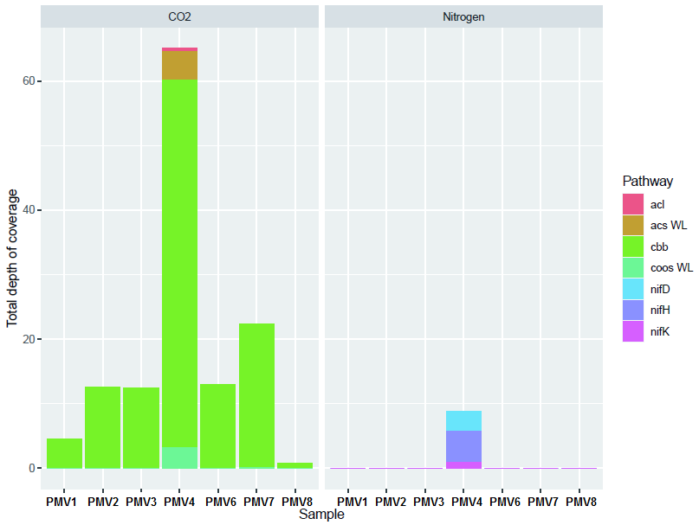
Supplementary Figure S2. The number of reads (expressed as total depth of coverage**) from the 7 metagenomes mapped back to the reference sequences of the marker genes. The genes reference sequences can be viewed in the Additional file 5: Table S10.
** On the y axes, the total depth of coverage is defined as the number of bases mapped to the sequences divided by the sequence's size.
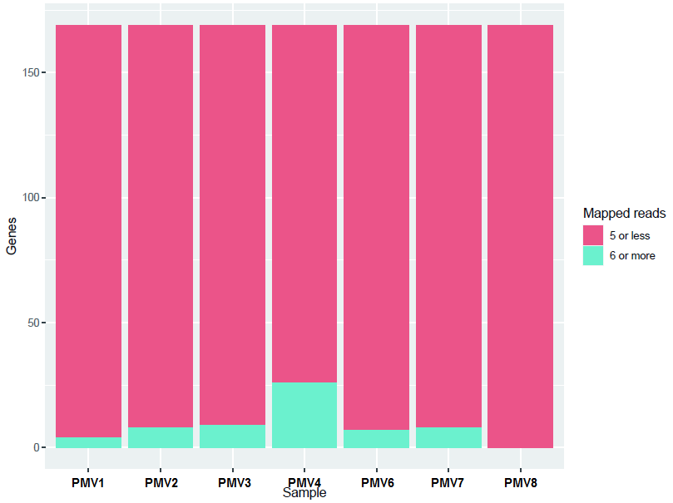
Supplementary Figure S3. The overall number of reads per metagenome/sample mapped to the reference sequences of all considered marker genes (nitrogen fixation (nifH/D/K), carbon fixation (cbbL/S, aclA/B, acsA(cooS)/B)).

Supplementary Tables S10

Table S10. Reference sequences for the marker genes used in predicting nitrogen and carbon fixation potential in sediments of Movile Cave based on the metagenomic read mapping analysis.
Pathway | Gene | KEGG Orthology | KEGG Organism/CDS entry
Nitrogen metabolism  Nitrogen fixation | nifH | K02588 | kpv:KPNIH29_17525
Nitrogen metabolism  Nitrogen fixation | nifH | K02588 | ppol:X809_05005
Nitrogen metabolism  Nitrogen fixation | nifH | K02588 | ppoy:RE92_06765
Nitrogen metabolism  Nitrogen fixation | nifH | K02588 | mmad:MMJJ_01420
Nitrogen metabolism  Nitrogen fixation | nifH | K02588 | mmad:MMJJ_09380
Nitrogen metabolism  Nitrogen fixation | nifH | K02588 | dsd:GD606_12195
Nitrogen metabolism  Nitrogen fixation | nifH | K02588 | dsd:GD606_19425
Nitrogen metabolism  Nitrogen fixation | nifH | K02588 | cbut:ATN24_18575
Nitrogen metabolism  Nitrogen fixation | nifH | K02588 | avn:Avin_49000
Nitrogen metabolism  Nitrogen fixation | nifH | K02588 | avn:Avin_01380
Nitrogen metabolism  Nitrogen fixation | nifD | K02586 | kpv:KPNIH29_17530
Nitrogen metabolism  Nitrogen fixation | nifD | K02586 | ppol:X809_05010
Nitrogen metabolism  Nitrogen fixation | nifD | K02586 | ppoy:RE92_06760
Nitrogen metabolism  Nitrogen fixation | nifD | K02586 | mmad:MMJJ_01390
Nitrogen metabolism  Nitrogen fixation | nifD | K02586 | dsd:GD606_12210
Nitrogen metabolism  Nitrogen fixation | nifD | K02586 | dsd:GD606_19410
Nitrogen metabolism  Nitrogen fixation | nifD | K02586 | cbut:ATN24_18590
Nitrogen metabolism  Nitrogen fixation | nifD | K02586 | avn:Avin_48990
Nitrogen metabolism  Nitrogen fixation | nifD | K02586 | avn:Avin_01390
Nitrogen metabolism  Nitrogen fixation | nifK | K02591 | kpv:KPNIH29_17535
Nitrogen metabolism  Nitrogen fixation | nifK | K02591 | ppol:X809_05015
Nitrogen metabolism  Nitrogen fixation | nifK | K02591 | mmad:MMJJ_01380
Nitrogen metabolism  Nitrogen fixation | nifK | K02591 | dsd:GD606_12220
Nitrogen metabolism  Nitrogen fixation | nifK | K02591 | dsd:GD606_19405
Nitrogen metabolism  Nitrogen fixation | nifK | K02591 | cbut:ATN24_18595
Nitrogen metabolism  Nitrogen fixation | nifK | K02591 | avn:Avin_01400
Pathway | Gene | KEGG Orthology | KEGG Organism/CDS entry
Carbone metabolism | cbbL/rbcL | K01601 | mox:DAMO_2165
Carbon fixation | cbbL/rbcL | K01601 | mca:MCA2743
 | cbbL/rbcL | K01601 | metu:GNH96_04105
Calvin–Benson–Bassham cycle (CBB) | cbbL/rbcL | K01601 | mmai:sS8_2433
Calvin–Benson–Bassham cycle (CBB) | cbbL/rbcL | K01601 | msl:Msil_1195
Calvin–Benson–Bassham cycle (CBB) | cbbL/rbcL | K01601 | mtun:MTUNDRAET4_0602
Calvin–Benson–Bassham cycle (CBB) | cbbL/rbcL | K01601 | reh:H16_B1395
Calvin–Benson–Bassham cycle (CBB) | cbbL/rbcL | K01601 | afr:AFE_1691
Calvin–Benson–Bassham cycle (CBB) | cbbL/rbcL | K01601 | afr:AFE_2155
Calvin–Benson–Bassham cycle (CBB) | cbbL/rbcL | K01601 | afr:AFE_3051
Calvin–Benson–Bassham cycle (CBB) | cbbL/rbcL | K01601 | paut:Pdca_16240
Calvin–Benson–Bassham cycle (CBB) | cbbS/rbcS | K01602 | mox:DAMO_2166
Calvin–Benson–Bassham cycle (CBB) | cbbS/rbcS | K01602 | mca:MCA2744
Calvin–Benson–Bassham cycle (CBB) | cbbS/rbcS | K01602 | metu:GNH96_04100
Calvin–Benson–Bassham cycle (CBB) | cbbS/rbcS | K01602 | mmai:sS8_2432 K01602
Calvin–Benson–Bassham cycle (CBB) | cbbS/rbcS | K01602 | msl:Msil_1196 K01602
Calvin–Benson–Bassham cycle (CBB) | cbbS/rbcS | K01602 | mtun:MTUNDRAET4_0601
Calvin–Benson–Bassham cycle (CBB) | cbbS/rbcS | K01602 | reh:H16_B1394
Calvin–Benson–Bassham cycle (CBB) | cbbS/rbcS | K01602 | afr:AFE_1690
Calvin–Benson–Bassham cycle (CBB) | cbbS/rbcS | K01602 | afr:AFE_3052
Calvin–Benson–Bassham cycle (CBB) | cbbS/rbcS | K01602 | paut:Pdca_16250
Reverse tricarboxylic acid cycle (rTCA) | aclA | K15230 | spal:FM071_07485
Reverse tricarboxylic acid cycle (rTCA) | aclA | K15230 | ssei:FJR45_08955
Reverse tricarboxylic acid cycle (rTCA) | aclA | K15230 | sku:Sulku_0667
Reverse tricarboxylic acid cycle (rTCA) | aclA | K15230 | smul:SMUL_0067
Reverse tricarboxylic acid cycle (rTCA) | aclA | K15230 | sinu:IMZ28_08250
Reverse tricarboxylic acid cycle (rTCA) | aclA | K15230 | cmed:FE773_04940
Reverse tricarboxylic acid cycle (rTCA) | aclA | K15230 | cte:CT1088
Reverse tricarboxylic acid cycle (rTCA) | aclA | K15230 | cpc:Cpar_1009
Reverse tricarboxylic acid cycle (rTCA) | aclA | K15230 | cph:Cpha266_1306
Reverse tricarboxylic acid cycle (rTCA) | aclA | K15230 | cli:Clim_1231
Reverse tricarboxylic acid cycle (rTCA) | aclA | K15230 | sul:SYO3AOP1_1055
Reverse tricarboxylic acid cycle (rTCA) | aclA | K15230 | tam:Theam_1021
Reverse tricarboxylic acid cycle (rTCA) | aclA | K15230 | dte:Dester_1134
Reverse tricarboxylic acid cycle (rTCA) | aclB | K15231 | spal:FM071_07490
Reverse tricarboxylic acid cycle (rTCA) |  |  | ssei:FJR45_08960
 |  |  | sku:Sulku_0666
 |  |  | smul:SMUL_0066
 |  |  | sinu:IMZ28_08255
 |  |  | cmed:FE773_04935
 |  |  | cte:CT1089
 |  |  | cpc:Cpar_1008
 |  |  | cph:Cpha266_1307
 |  |  | cli:Clim_1232
 |  |  | sul:SYO3AOP1_1056
 |  |  | tam:Theam_1022
 |  |  | dte:Dester_1135
Wood-Ljungdahl (WL) pathway | acsA(cooS) | K00198 | dbk:DGMP_17830
Wood-Ljungdahl (WL) pathway | acsA(cooS) | K00198 | dbk:DGMP_17900
Wood-Ljungdahl (WL) pathway | acsA(cooS) | K00198 | dal:Dalk_2379
Wood-Ljungdahl (WL) pathway | acsA(cooS) | K00198 | dal:Dalk_0680
Wood-Ljungdahl (WL) pathway | acsA(cooS) | K00198 | dalk:DSCA_26710
Wood-Ljungdahl (WL) pathway | acsA(cooS) | K00198 | dalk:DSCA_27610
Wood-Ljungdahl (WL) pathway | acsA(cooS) | K00198 | dalk:DSCA_28100
Wood-Ljungdahl (WL) pathway | acsA(cooS) | K00198 | dek:DSLASN_16750
Wood-Ljungdahl (WL) pathway | acsA(cooS) | K00198 | dek:DSLASN_29000
Wood-Ljungdahl (WL) pathway | acsA(cooS) | K00198 | dek:DSLASN_47710
Wood-Ljungdahl (WL) pathway | acsA(cooS) | K00198 | dti:Desti_0232
Wood-Ljungdahl (WL) pathway | acsA(cooS) | K00198 | clj:CLJU_c09110
Wood-Ljungdahl (WL) pathway | acsA(cooS) | K00198 | clj:CLJU_c17910
Wood-Ljungdahl (WL) pathway | acsA(cooS) | K00198 | clj:CLJU_c37670
Wood-Ljungdahl (WL) pathway | acsA(cooS) | K00198 | cck:Ccar_07140
Wood-Ljungdahl (WL) pathway | acsA(cooS) | K00198 | cck:Ccar_08590
Wood-Ljungdahl (WL) pathway | acsA(cooS) | K00198 | cck:Ccar_18845
Wood-Ljungdahl (WL) pathway | acsA(cooS) | K00198 | cck:Ccar_23090
Wood-Ljungdahl (WL) pathway | acsA(cooS) | K00198 | pbif:KXZ80_13960
Wood-Ljungdahl (WL) pathway | acsA(cooS) | K00198 | pbif:KXZ80_14960
Wood-Ljungdahl (WL) pathway | acsA(cooS) | K00198 | cdf:CD630_01740
Wood-Ljungdahl (WL) pathway | acsA(cooS) | K00198 | cdf:CD630_07160
Wood-Ljungdahl (WL) pathway | acsA(cooS) | K00198 | roc:HF520_11320
Wood-Ljungdahl (WL) pathway | acsA(cooS) | K00198 | tem:JW646_03340
Wood-Ljungdahl (WL) pathway | acsA(cooS) | K00198 | tem:JW646_10835
Wood-Ljungdahl (WL) pathway | acsA(cooS) | K00198 | tem:JW646_19155
 | acsA(cooS) | K00198 | dsy:DSY4442
 |  |  | dsy:DSY4173
 |  |  | dsy:DSY2630
 |  |  | dsy:DSY1653
 |  |  | dhd:Dhaf_3792
 |  |  | dhd:Dhaf_1166
 |  |  | dhd:Dhaf_0882
 |  |  | dhd:Dhaf_2798
 |  |  | dai:Desaci_0709
 |  |  | dai:Desaci_0260
 |  |  | dai:Desaci_2975
 |  |  | drs:DEHRE_00735
 |  |  | aacx:DEACI_2511
 |  |  | aacx:DEACI_0147
 |  |  | aacx:DEACI_1162
 |  |  | awo:Awo_c10740
 |  |  | cthm:CFE_0653
 |  |  | cthm:CFE_1617
 |  |  | cthm:CFE_1666
 |  |  | cthm:CFE_0163
 |  |  | cthm:CFE_0173
 |  |  | cthm:CFE_1919
 |  |  | chy:CHY_0736
 |  |  | chy:CHY_0034
 |  |  | chy:CHY_0085
 |  |  | chy:CHY_1824
 |  |  | mta:Moth_1972
 |  |  | mta:Moth_1203
 |  |  | adg:Adeg_0335
 |  |  | aar:Acear_0983
 |  |  | aar:Acear_1305
 |  |  | toc:Toce_0761
 |  |  | toc:Toce_0335
 |  |  | toc:Toce_0800 sted:SPTER_06840
 |  |  | sted:SPTER_13670
 |  |  | sted:SPTER_01630
 |  |  | bpit:BPIT_02260
 |  |  | jet:L3J17_07160
 |  |  | tpi:TREPR_3069
 |  |  | dtp:JZK55_05490
 | acsB | K14138 | dbk:DGMP_17890
 | acsB | K14138 | dal:Dalk_0681
 | acsB | K14138 | dalk:DSCA_26720
 | acsB | K14138 | dek:DSLASN_16760
 | acsB | K14138 | dti:Desti_0231
 | acsB | K14138 | clj:CLJU_c37550
 | acsB | K14138 | cck:Ccar_18785
 | acsB | K14138 | pbif:KXZ80_13900
 | acsB | K14138 | cdf:CD630_07280
 | acsB | K14138 | roc:HF520_11260
 | acsB | K14138 | tem:JW646_10895
 | acsB | K14138 | dsy:DSY1652
 | acsB | K14138 | dhd:Dhaf_2797
 | acsB | K14138 | dai:Desaci_2974
 | acsB | K14138 | drs:DEHRE_00705
 | acsB | K14138 | aacx:DEACI_2512
 | acsB | K14138 | awo:Awo_c33680
 | acsB | K14138 | cthm:CFE_1665
 | acsB | K14138 | chy:CHY_1222
 | acsB | K14138 | mta:Moth_1202
 | acsB | K14138 | adg:Adeg_0336
 | acsB | K14138 | aar:Acear_1304
 | acsB | K14138 | toc:Toce_0813
 | acsB | K14138 | sted:SPTER_05160
 | acsB | K14138 | bpit:BPIT_02250
 | acsB | K14138 | jet:L3J17_07150
 | acsB | K14138 | tpi:TREPR_3067
 | acsB | K14138 | dtp:JZK55_05480

