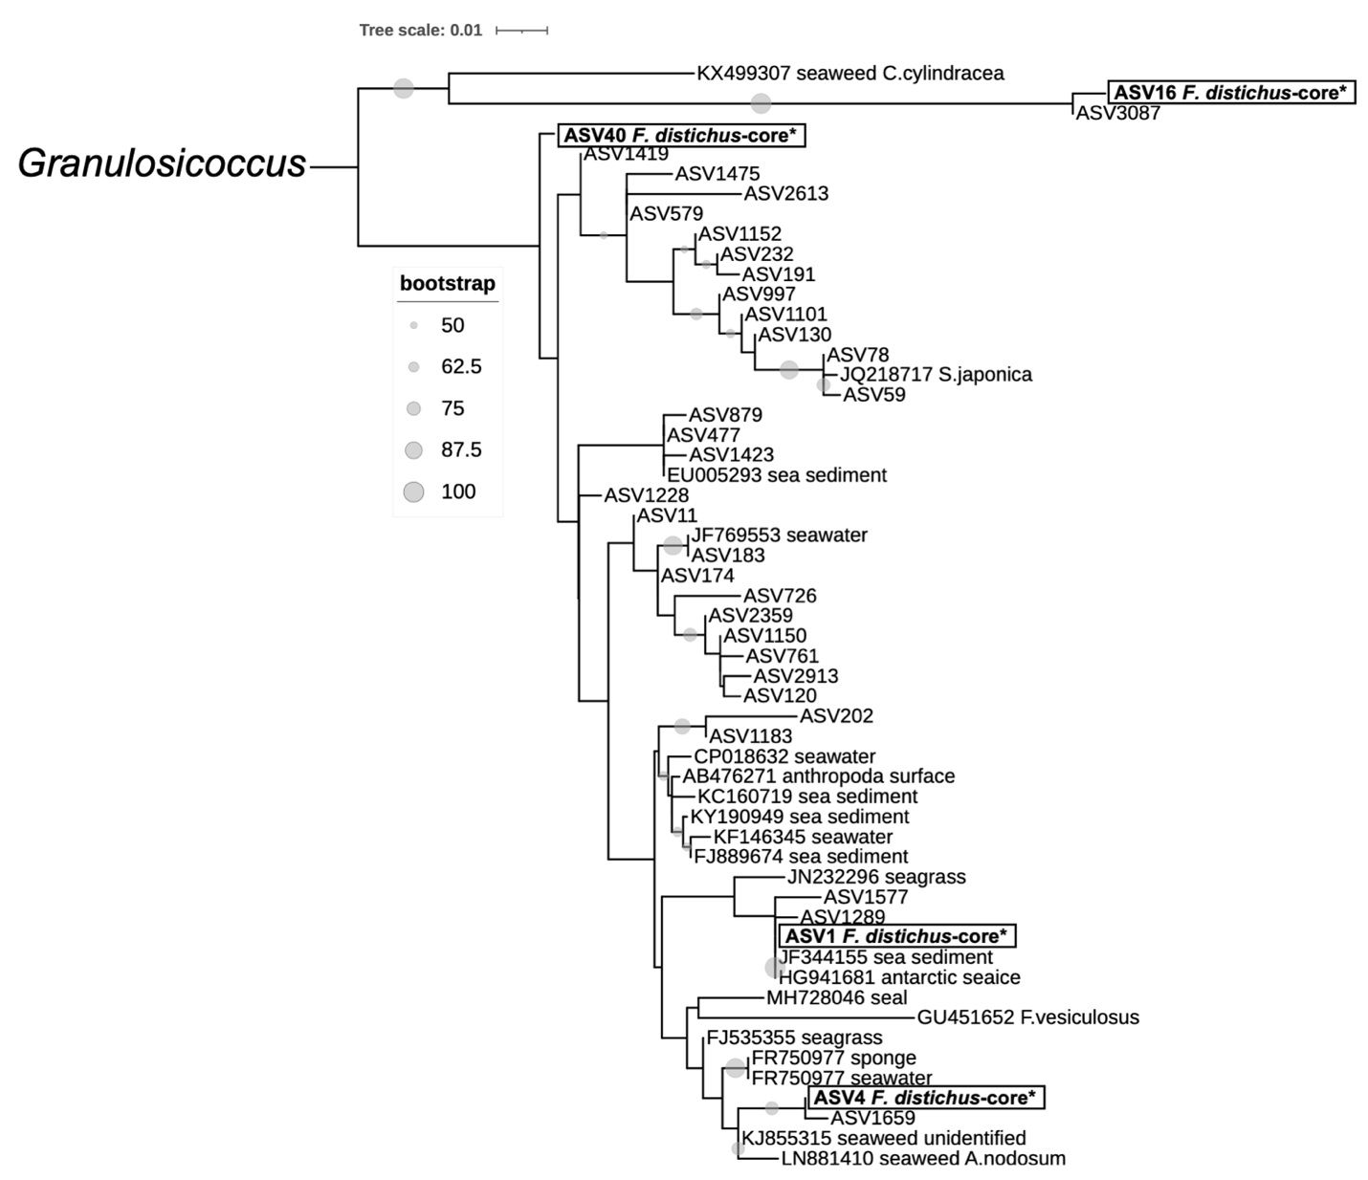
Supplementary Figure.1 | Maximum likelihood phylogenetic tree of F. distichus-core taxa within Granulosicoccus clade constructed in RAxML with rapid bootstrapping. Sequences from this study are labeled by ASV number and core ASVs are denoted with an * and placed within a box. Database sequences are labeled with GenBank accession number followed by reported isolation habitat or host. Bootstrap values are denoted by dot size on branches.

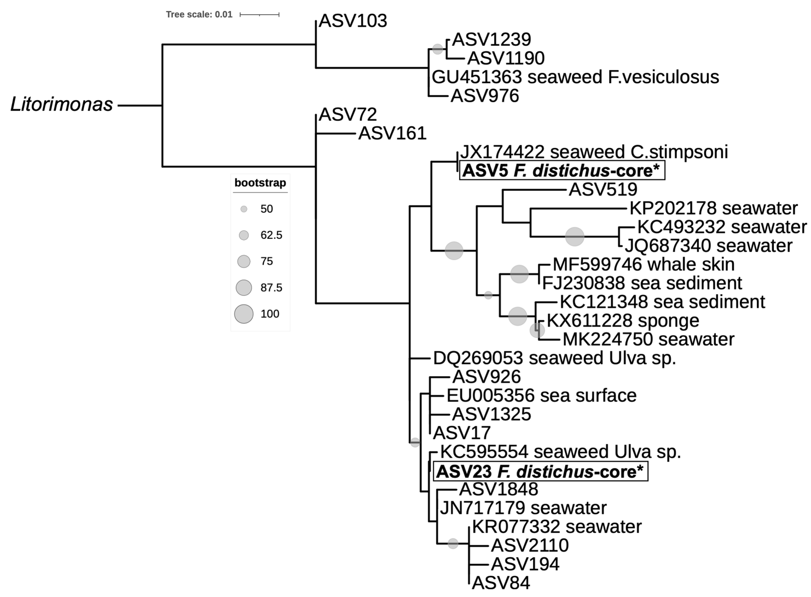
Supplementary Figure.2 | Maximum likelihood phylogenetic tree of F. distichus-core taxa within Litorimonas clade constructed in RAxML with rapid bootstrapping. Other notes as in Figure S1.

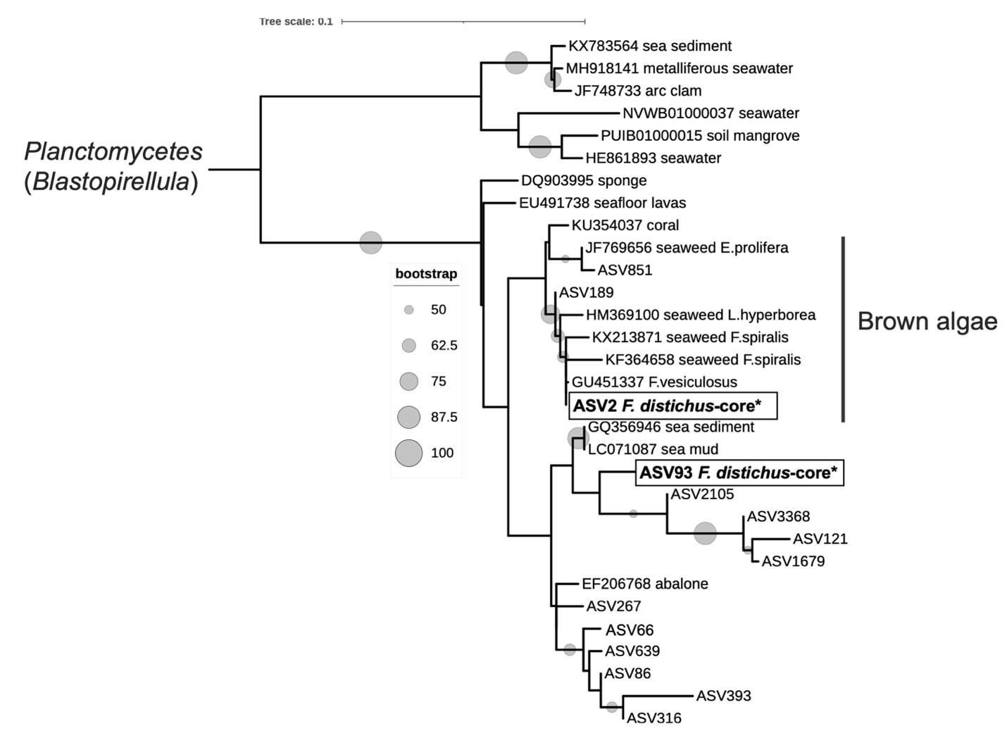
Supplementary Figure.3 | Maximum likelihood phylogenetic tree of F. distichus-core taxa within Blastopirellula clade constructed in RAxML with rapid bootstrapping. Other notes as in Figure S1.

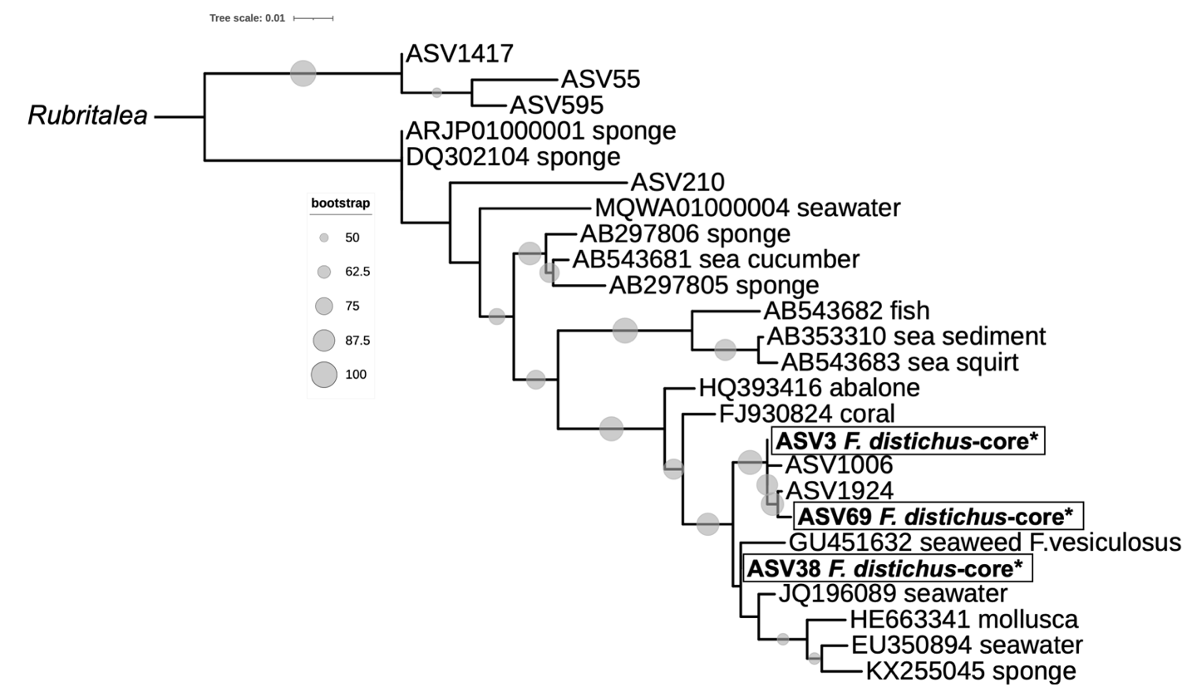
Supplementary Figure.4 | Maximum likelihood phylogenetic tree of F. distichus-core taxa within Rubritalea clade constructed in RAxML with rapid bootstrapping. Other notes as in Figure S1.

