Supplementary Material
The microbiome of Riccia liverworts is an important reservoir for microbial diversity in temporary agricultural crusts
Wisnu Adi Wicaksono¹, Bettina Semler¹, Martina Pöltl², Christian Berg², Gabriele Berg^{1,3,4}, Tomislav Cernava^{1#},
¹ Institute of Environmental Biotechnology, Graz University of Technology, 8010 Graz, Austria
² University of Graz, Institute of Biology, 8010 Graz, Austria
³ Leibniz Institute for Agricultural Engineering and Bioeconomy (ATB), Potsdam, Germany
⁴ Institute for Biochemistry and Biology, University of Potsdam, Potsdam, Germany

#Corresponding author:
Tomislav Cernava, Graz University of Technology, Graz
Emails: tomislav.cernava@tugraz.at

Authors’ email addresses
wisnu.wicaksono@tugraz.at, bettina.semler@gmail.com, martina.poeltl@museum-joanneum.at, christian.berg@uni-graz.at, gabriele.berg@tugraz.at

Short title: Liverworts microbiome
Submitted to: Environmental Microbiome

Supplementary Table S1. Details of sampling locations
Sample ID | Species | Location | Field type
A 1-6 | Riccia bifurca | Steiermark, Hausmannstätten, 1,0 km NW Enzelsdorf | pumpkin field
B 1-6 | Riccia bifurca | Steiermark, Hartberg, 2 km NNE Wörth an der Lafnitz | pumpkin field
C 1-6 | Riccia bifurca | Steiermark, Preding, 690 m SE Mettersdorf | pumpkin field
D 1-6 | Riccia glauca | Steiermark, Hausmannstätten, 1,1 km NNE Fernitz | corn field
E 1-6 | Riccia bifurca | Burgenland, Güssing, 1.5 km SW Wörtherberg | pumpkin field
F 1-6 | Riccia bifurca | Steiermark; Eggersdorf bei Graz, 1.1 km W Brodersdorf | corn field

Supplementary Table S2. List of bacterial ASVs that were significantly enriched in thallus samples in comparison to the surrounding soil according to linear discriminant analysis effect size (LEfSe) analysis

ASV ID | LDA score | Taxonomical information |  | Relative abundance (%)
ASV ID | LDA score | Class | Genus
0f74a957d2a112908a68b9ad19d1da6d | 3.8 | Nitrososphaeria | Unc. Nitrososphaeraceae |  | 0.024
85fca7d0ba5e9b3a3198961bd9557f18 | 3.9 | Nitrososphaeria | Unc. Nitrososphaeraceae |  | 0.028
c4907d9038f53a0d8a39b0c156c5b9bc | 3.8 | Blastocatellia_(Subgroup_4) | Unc. 11_24 |  | 0.023
f7f3f2e319eb0bbe833cec1454ce0787 | 3.9 | Blastocatellia_(Subgroup_4) | Aridibacter |  | 0.053
a652f496fb4f9105e6797d717c3926ef | 3.7 | Blastocatellia_(Subgroup_4) | Unc. Blastocatellaceae |  | 0.100
135c54fd0b2c2cd074f7be044efce948 | 3.6 | Subgroup_6 | Unc. Subgroup_6 |  | 0.023
67588f6f0b9b141bc5f37204a50da5bf | 4.0 | Subgroup_6 | Unc. Subgroup_6 |  | 0.049
69304d479a6cbf8e4d348d51bbdffe7a | 3.3 | Subgroup_6 | Unc. Subgroup_6 |  | 0.030
956f15a69b1fac98cc58d6143a5d75d8 | 3.8 | Subgroup_6 | Unc. Subgroup_6 |  | 0.022
b1a795217b9a3f4814ee5cae27450501 | 3.5 | Thermoanaerobaculia | Subgroup_10 |  | 0.103
09de3dde6c465b74bcb8e6f8a478e4e0 | 3.2 | Actinobacteria | Rhodococcus |  | 0.040
e8ccf9dcc883d1d3cef7bb69235bfdda | 3.4 | Actinobacteria | Actinoplanes |  | 0.038
b3b99c7e3a0d655fd4aeadf93820978c | 3.1 | Actinobacteria | Nocardioides |  | 0.029
e7f82f35bba1e81dafa173bf71a879cf | 3.1 | Armatimonadia | Unc. Armatimonadales |  | 0.056
4258f737dc7eddabe5676f2de2276614 | 3.4 | Fimbriimonadia | Unc. Fimbriimonadaceae |  | 0.124
4d7dd0cbb43d17d729f234f2f0bf62cd | 3.9 | Bacteroidia | Flavihumibacter |  | 0.033
af4f82920f7e7ab5aaea052daf84e26b | 4.1 | Bacteroidia | Lacibacter |  | 0.042
a0b9c413db1dc97e273db823b71d0a07 | 3.5 | Bacteroidia | Sediminibacterium |  | 0.040
8f71a7b9dc989c5b4688583a2111651f | 3.9 | Bacteroidia | Terrimonas |  | 0.052
2eaaa4a12d530b11bcd95a69a80646e2 | 3.2 | Bacteroidia | Unc. Chitinophagaceae |  | 0.039
33b680eee4f8b01a15a33f7fe5e0596c | 3.0 | Bacteroidia | Unc. Chitinophagaceae |  | 0.045
5dd9b4c4fb4de32a93a6e834dde0faa2 | 3.2 | Bacteroidia | Unc. Chitinophagaceae |  | 0.026
64bd319e4d15d6e8c2d76f097883303c | 3.8 | Bacteroidia | Unc. Chitinophagaceae |  | 0.037
8678dea077ece20287b950cd5bc66db8 | 3.8 | Bacteroidia | Unc. Chitinophagaceae |  | 0.047
8e66bb13463efd8fe5ef1bfadc38d0a6 | 3.5 | Bacteroidia | Unc. Chitinophagaceae |  | 0.030
edb114398ced5bf958f4f404493a6642 | 3.9 | Bacteroidia | Haliscomenobacter |  | 0.103
d1fab8bc86502174bd144adb087a852e | 3.2 | Bacteroidia | Unc. Saprospiraceae |  | 0.039
44245871134a7a84ac8e3049b9769980 | 3.7 | Bacteroidia | Rhodocytophaga |  | 0.048
3e39c317a82e348f46ebe8943a3df168 | 3.2 | Bacteroidia | Hymenobacter |  | 0.023
5f7326bcb7c2a6349f99a07e09085430 | 3.9 | Bacteroidia | Flexibacter |  | 0.056
a8a8751d72c8d3e4fe1bf8f149027d79 | 4.2 | Bacteroidia | Flexibacter |  | 0.121
4cc867835a4167f163fa7da41d843281 | 3.5 | Bacteroidia | Unc. Microscillaceae |  | 0.028
60c5e21779c0b5b385d77df36cdcf45b | 3.4 | Bacteroidia | Unc. Microscillaceae |  | 0.146
b6aa0321169856fa2d98ea9a21520b5a | 3.6 | Bacteroidia | Unc. Microscillaceae |  | 0.065
ba9ecb28932826e70d43988826679fbc | 3.4 | Bacteroidia | Unc. Microscillaceae |  | 0.020
8ba8d462bcfca4f3dffd540c2595af0e | 4.3 | Bacteroidia | Arcicella |  | 0.164
1ebf3c81b9f872f5a309a1a08ab97d1a | 3.4 | Bacteroidia | Dyadobacter |  | 0.107
b69cb20337bec667ab64a7cf2c5cea83 | 4.1 | Bacteroidia | Dyadobacter |  | 0.039
eebca187d104e314ca21d1c61cd5ad31 | 4.1 | Bacteroidia | Dyadobacter |  | 0.055
cb7242fb2a2ccdda6e2ead2c5f13e097 | 3.5 | Bacteroidia | Lacihabitans |  | 0.085
025f8d52bf0fe507d3355b96f306b99b | 3.9 | Bacteroidia | Runella |  | 0.096
090540da987889f054f49b2eea04ffd8 | 2.8 | Bacteroidia | Spirosoma |  | 0.049
5294c0e2c5ab571842b07c413291a71e | 3.3 | Bacteroidia | Spirosoma |  | 0.057
4db5730d0bbca58a8ecb6d9d5352f5bb | 3.5 | Bacteroidia | Flavobacterium |  | 0.049
69dc82f398c9aa68a819235b4bf0ffd4 | 4.0 | Bacteroidia | Flavobacterium |  | 0.041
85a3d7550bf533f1cdbb64dfb47d699a | 4.0 | Bacteroidia | Flavobacterium |  | 0.031
a26da340960942d894b28559f2430838 | 3.9 | Bacteroidia | Flavobacterium |  | 0.053
fca1ed7792b0c80cd00c60203ba400e8 | 3.7 | Bacteroidia | Flavobacterium |  | 0.041
12dd6509c32da6a9937d21f5b52f07dc | 3.7 | Bacteroidia | Unc. env.OPS_17 |  | 0.087
4313306b43246178431cfd48a6a6850a | 3.1 | Bacteroidia | Mucilaginibacter |  | 0.203
a531dc57776d2c54e4dd31f15d2e3517 | 3.7 | Bacteroidia | Mucilaginibacter |  | 0.026
ec2fa165297294eadaa031c1ded90990 | 4.5 | Bacteroidia | Mucilaginibacter |  | 0.277
efd7180718b7d32861503979452ea9ee | 3.6 | Bacteroidia | Mucilaginibacter |  | 0.055
0d34e514b2d0d3a14fbfa27a9717f5ae | 3.3 | Bacteroidia | Pedobacter |  | 0.028
21727479c0ea68be39ae81351790bc55 | 3.6 | Bacteroidia | Pedobacter |  | 0.038
861c357388b498ed9ef7ef6440b4dffa | 3.0 | Bacteroidia | Pedobacter |  | 0.030
eed4445c6828c17a10169e46afa6fa5c | 3.6 | Bacteroidia | Pedobacter |  | 0.113
3ba1982f89303f12066c5e9355ea6a16 | 4.2 | Anaerolineae | Unc. A4b |  | 0.050
e4d0937b69713698efbb066f6eb82bce | 3.3 | Anaerolineae | Unc. A4b |  | 0.022
fd9f7f75931346a713bfd1fab9bbe103 | 3.4 | Anaerolineae | Unc. A4b |  | 0.023
68c1b0dd626da94d2775582a1c56c3ae | 3.8 | Chloroflexia | Unc. Chloroflexaceae |  | 0.114
7ba80206a0bd1b67828dcf580d7f7cae | 4.3 | Chloroflexia | Unc. Chloroflexaceae |  | 0.066
00152f4ee92b88f80848c1a406e0c75f | 3.8 | Chloroflexia | Unc. JG30-KF-CM45 |  | 0.022
b5a75ee30645cb947ad835d87d6cfa11 | 3.2 | Chloroflexia | Unc. JG30-KF-CM45 |  | 0.027
e05c79009fd7877b24e3127bd49986a0 | 3.3 | Chloroflexia | Unc. JG30-KF-CM45 |  | 0.040
4240cbdefb886ef8e0b16e50862861b4 | 3.6 | TK10 | Unc. TK10 |  | 0.057
60c56a4328049f5adcfe005b820f4e0e | 3.7 | Oxyphotobacteria | Unc. Leptolyngbyaceae |  | 0.123
8e1a6a5890d8fa172a8e163e59354352 | 3.9 | Oxyphotobacteria | Unc. Leptolyngbyaceae |  | 0.029
b895b57881451be1a15a9ad8ae19c77d | 4.5 | Oxyphotobacteria | Unc. Leptolyngbyaceae |  | 0.099
ac224dcace889a6d0aba2c7370cea1e2 | 3.9 | Oxyphotobacteria | Unc. Coleofasciculaceae |  | 0.030
eb8d2f053f7543470dbc92ccdec4a732 | 3.7 | Oxyphotobacteria | Unc. Coleofasciculaceae |  | 1.266
f7f8b063ce4a5a492dd81a6691416982 | 3.9 | Oxyphotobacteria | Unc. Coleofasciculaceae |  | 0.027
3e4fa9b6325c9bde8be2fae806c05a06 | 3.7 | Oxyphotobacteria | Desmonostoc_PCC-7422 |  | 0.036
63f3ef8d5630be1b78efd960c93b16de | 4.3 | Oxyphotobacteria | Desmonostoc_PCC-7422 |  | 0.072
e449efdbe35238e3bdef2b82db526189 | 4.7 | Oxyphotobacteria | Desmonostoc_PCC-7422 |  | 0.192
8d52cb718d903c851f933ea50736b98f | 3.9 | Oxyphotobacteria | Nostoc_PCC-73102 |  | 0.027
af46164da838e8da9591dba9ab73c47b | 3.9 | Oxyphotobacteria | Nostoc_PCC-73102 |  | 0.028
0ae5c24423a66064004078d992f01e5a | 3.8 | Oxyphotobacteria | Nostoc_PCC-7524 |  | 0.137
ab96d1a4f844d82cf7a50d318ea1d9fe | 4.3 | Oxyphotobacteria | Nostoc_PCC-7524 |  | 0.070
5a8847b3ca60344b74b9fddc331aafea | 3.9 | Oxyphotobacteria | Tolypothrix_PCC-7601 |  | 0.037
ac0758d667de4ffa5463a00b7366644e | 3.9 | Oxyphotobacteria | Tolypothrix_PCC-7601 |  | 0.024
0a45522cefed356ff2c749a67addcc60 | 4.4 | Oxyphotobacteria | Unc. Nostocaceae |  | 0.083
0ff572ebb03238089a34066ed9df61a2 | 4.1 | Oxyphotobacteria | Unc. Nostocaceae |  | 1.759
79d0a0b0935bb622692f55cadfce2d71 | 4.3 | Oxyphotobacteria | Unc. Nostocaceae |  | 0.086
b87b2cdba1ced5742d13294be4ab09de | 4.3 | Oxyphotobacteria | Unc. Nostocaceae |  | 0.248
cadccdfb86d52c6082d051fe82b40d9e | 4.0 | Oxyphotobacteria | Unc. Nostocaceae |  | 0.063
f0f7f6402506e94b4d324194449decdf | 3.6 | Oxyphotobacteria | Unc. Nostocaceae |  | 0.024
ed6703658fa0dd8e2a34c26cfc4c6fcc | 4.5 | Oxyphotobacteria | Unc. Nostocales |  | 0.123
0163abc62d56baf585a505dedd9efccf | 2.7 | Oxyphotobacteria | Unc. Oxyphotobacteria_Incertae_Sedis |  | 0.230
48cbcfc08d9024dafffb2c485575c59e | 4.6 | Oxyphotobacteria | Unc. Oxyphotobacteria_Incertae_Sedis |  | 0.289
7530a5618050119850926d8ede651558 | 4.5 | Oxyphotobacteria | Unc. Oxyphotobacteria_Incertae_Sedis |  | 0.220
8fef6295cdbe8469d364b1ffd9785e90 | 4.3 | Oxyphotobacteria | Unc. Oxyphotobacteria_Incertae_Sedis |  | 0.073
9309d02d468b5da179eee6df0e389eda | 4.2 | Oxyphotobacteria | Unc. Oxyphotobacteria_Incertae_Sedis |  | 0.048
d9bb002371fd4d69be8f846905705dfb | 3.8 | Oxyphotobacteria | Unc. Oxyphotobacteria_Incertae_Sedis |  | 0.023
dd25b975148e5aa51ca36fb002f7da5e | 4.1 | Oxyphotobacteria | Unc. Oxyphotobacteria_Incertae_Sedis |  | 0.385
e608fb0f86eeed97d9bf010c8d63bc13 | 5.0 | Oxyphotobacteria | Unc. Oxyphotobacteria_Incertae_Sedis |  | 0.368
e9ddf3ee95ee015b41923a3ada331c96 | 4.4 | Oxyphotobacteria | Unc. Oxyphotobacteria_Incertae_Sedis |  | 0.227
ea4944f4a6672022b58b763552fdb34f | 4.1 | Oxyphotobacteria | Unc. Oxyphotobacteria_Incertae_Sedis |  | 0.041
eb39bb09b42890d610424c2e2b5e48eb | 4.6 | Oxyphotobacteria | Unc. Oxyphotobacteria_Incertae_Sedis |  | 0.146
1f59c7c7d6315b9eef6f6da2d7bc1d54 | 3.8 | Oxyphotobacteria | Nodosilinea_PCC-7104 |  | 0.054
72997509405337509c1a935bdc038979 | 4.0 | Oxyphotobacteria | Nodosilinea_PCC-7104 |  | 0.040
cdb0711b3674e74cf792830728c088b4 | 4.2 | Oxyphotobacteria | Nodosilinea_PCC-7104 |  | 0.056
cf1d1f1c81bd074c0147e2b18a7509f5 | 4.1 | Oxyphotobacteria | Pseudanabaena_PCC-7429 |  | 0.137
25fe23e989514e818f4bc1f680ad6da1 | 3.5 | Bacilli | Exiguobacterium |  | 0.023
529f11e5ccc0f6a50128fefb3d4bb216 | 4.1 | Gemmatimonadetes | Gemmatimonas |  | 0.041
a03a07448de89a434e18e5c995194cf4 | 3.6 | Gemmatimonadetes | Unc. Gemmatimonadaceae |  | 0.030
3b9a640a2fb04ef04b82b218fc1fb455 | 3.5 | Planctomycetacia | Fimbriiglobus |  | 0.020
7930a1a2ee1c943cc57b41c8266c843c | 4.2 | Planctomycetacia | Fimbriiglobus |  | 0.054
cd69ca36ef48989ae692ab250a60f179 | 3.8 | Planctomycetacia | Gemmata |  | 0.026
3c3861c581adf9b8a8cf01f20fdbaf2c | 3.7 | Planctomycetacia | Pir4_lineage |  | 0.089
c630b2c3c028752c233b408d0dd72656 | 3.4 | Planctomycetacia | Pirellula |  | 0.026
1eebc9a9a74a9e6d87faf669f27fd6a4 | 3.6 | Planctomycetacia | Unc. Pirellulaceae |  | 0.058
6c06afff9b6b2f236e0662547acd6671 | 3.8 | Planctomycetacia | Unc. Pirellulaceae |  | 0.022
929e8450daa3418e6311c0a70f6aae0c | 3.6 | Planctomycetacia | SH-PL14 |  | 0.040
1274879de84c6e9f91c004eb4037d06f | 3.9 | Alphaproteobacteria | Roseomonas |  | 0.029
de3901260547a323762fba9b9dec22ca | 3.1 | Alphaproteobacteria | Roseomonas |  | 0.053
0fa9b44d52836d2f173f4ac532f8a013 | 3.6 | Alphaproteobacteria | Skermanella |  | 0.048
22b545cd4650317c5335dc492e3bf8cf | 3.6 | Alphaproteobacteria | Brevundimonas |  | 0.082
41e6c0b55654af1d5cd503359fb77d18 | 4.0 | Alphaproteobacteria | Brevundimonas |  | 0.093
a537d8bab85c83b0e74c73c55790324b | 3.3 | Alphaproteobacteria | Brevundimonas |  | 0.049
573091d7ddd85f9c5f14a7e53d2ba0bf | 3.1 | Alphaproteobacteria | Caulobacter |  | 0.044
df14192046a031174a4ff560c358db28 | 3.2 | Alphaproteobacteria | Caulobacter |  | 0.021
6ed92ab63df4b70c0ecb57cff4e0f6c8 | 3.1 | Alphaproteobacteria | Unc. Caulobacteraceae |  | 0.031
5b9a650710e7f198e4be4a316a0ddfed | 4.0 | Alphaproteobacteria | Hyphomonas |  | 0.036
f073df90e41bdd0c9674d8de667f5f32 | 3.8 | Alphaproteobacteria | SWB02 |  | 0.025
f5fab172b06ecb22a6fa3a3e46aebf8b | 3.4 | Alphaproteobacteria | Unc. Micavibrionaceae |  | 0.032
48cc8977d2f62f22558655e3a53d2300 | 3.6 | Alphaproteobacteria | Unc. Micavibrionales |  | 0.026
6830008201e282eff938198a4d4acca8 | 3.3 | Alphaproteobacteria | Unc. Micavibrionales |  | 0.077
0ae5531a9802e71139c959faebdde10c | 2.9 | Alphaproteobacteria | Reyranella |  | 0.027
709a1dba0b0023a853d5cf6767864035 | 3.7 | Alphaproteobacteria | Unc. A0839 |  | 0.043
4473ac847f597164696bc96da74ca753 | 3.8 | Alphaproteobacteria | Bosea |  | 0.062
04ecfad5772d2e09a84a0f5ef460536c | 3.4 | Alphaproteobacteria | Methylobacterium |  | 0.168
853db0ade7009a2872dc479f2465aba1 | 3.4 | Alphaproteobacteria | Methylobacterium |  | 0.038
a91108c92f693afd91f04b849e036d52 | 3.8 | Alphaproteobacteria | Methylobacterium |  | 0.309
ab6b7b90747341ce39f82d0a22a1d37d | 3.9 | Alphaproteobacteria | Methylobacterium |  | 0.148
e0f50c5adf537a0a3a63e61720b38ed5 | 3.1 | Alphaproteobacteria | Methylobacterium |  | 0.020
398b683b106b191a01b80619fcae58ee | 3.9 | Alphaproteobacteria | Devosia |  | 0.024
b7f5af401f678ffbe9f7299cfa59e3bf | 3.4 | Alphaproteobacteria | Devosia |  | 0.039
41b024826cbf8203352777d695f524d5 | 3.8 | Alphaproteobacteria | Hyphomicrobium |  | 0.033
2653f9a6e90d957c951070035e6edeea | 3.6 | Alphaproteobacteria | Allorhizobium-Neorhizobium-Pararhizobium-Rhizobium |  | 0.021
31dce60a2ad0740fbba0a68b81c80b75 | 4.0 | Alphaproteobacteria | Allorhizobium-Neorhizobium-Pararhizobium-Rhizobium |  | 0.214
46ef48b6096947c86bd1a70949ca8c97 | 4.2 | Alphaproteobacteria | Allorhizobium-Neorhizobium-Pararhizobium-Rhizobium |  | 0.285
4ba6bad752253e930876e8c688e4d9fb | 3.4 | Alphaproteobacteria | Allorhizobium-Neorhizobium-Pararhizobium-Rhizobium |  | 0.024
5073eb042f1600783fe65118c8151bc3 | 4.0 | Alphaproteobacteria | Allorhizobium-Neorhizobium-Pararhizobium-Rhizobium |  | 0.035
8b9ab15395d95e4eb8b0592b2a46be6d | 3.5 | Alphaproteobacteria | Allorhizobium-Neorhizobium-Pararhizobium-Rhizobium |  | 0.043
cd9bccba7f7c9aecd8eeac841bcb72cc | 3.6 | Alphaproteobacteria | Allorhizobium-Neorhizobium-Pararhizobium-Rhizobium |  | 0.038
e1c7d97fe13e9127d225d76a1feb8c78 | 4.6 | Alphaproteobacteria | Allorhizobium-Neorhizobium-Pararhizobium-Rhizobium |  | 0.458
fc6622c636a5210293fb2873fc4761d9 | 3.8 | Alphaproteobacteria | Allorhizobium-Neorhizobium-Pararhizobium-Rhizobium |  | 0.110
c3fe6ae58bb1e240a989dac6b2708532 | 3.5 | Alphaproteobacteria | Aureimonas |  | 0.056
dfad8c8bd0537264e789e7f08664f69b | 3.5 | Alphaproteobacteria | Unc. Rhizobiaceae |  | 0.053
860b11244363460108e1a96df96599a1 | 3.8 | Alphaproteobacteria | Nordella |  | 0.024
4d5b8c2c09a9e464f466f3ddc5ab1de5 | 3.8 | Alphaproteobacteria | Unc. Rhizobiales_Incertae_Sedis |  | 0.024
00f22fe0aa7d9b976a6a884f493a1b75 | 3.9 | Alphaproteobacteria | Unc. Xanthobacteraceae |  | 0.062
ca8f1c260ac18a133685554fc1089155 | 3.9 | Alphaproteobacteria | Rhodobacter |  | 0.076
d2ac92ef7b0297714611e7160d79672a | 4.0 | Alphaproteobacteria | Rhodobacter |  | 0.034
6c3fb343f46983254cdb83e99fa07a49 | 4.6 | Alphaproteobacteria | Unc. Rhodobacteraceae |  | 0.428
6e0f9d60b3729c86b31a72bc587db1e7 | 4.1 | Alphaproteobacteria | Unc. Rhodobacteraceae |  | 0.086
26f173c04574871aba8876838e2d9e61 | 3.4 | Alphaproteobacteria | Novosphingobium |  | 0.041
3b50e9874fa67e04b49f5a59ecf0059a | 4.4 | Alphaproteobacteria | Porphyrobacter |  | 0.310
0aa2e510fc63e5d46add3e8000cf0a7f | 4.7 | Alphaproteobacteria | Sphingobium |  | 0.182
2bbb28b70c3a3757e48663f4d0003ecc | 4.0 | Alphaproteobacteria | Sphingobium |  | 0.034
8359cc1215c0ae7475efe27dbd6cdc26 | 4.0 | Alphaproteobacteria | Sphingobium |  | 0.109
0a165844daf38d8ce2008c94a5b4565e | 3.2 | Alphaproteobacteria | Sphingomonas |  | 0.119
2727f819185a7e8993f13df355a399fa | 4.2 | Alphaproteobacteria | Sphingomonas |  | 0.434
5d0c6af420698f1cdff612c8f7960627 | 3.4 | Alphaproteobacteria | Sphingomonas |  | 0.060
8bd7e79466b5a176fbb500254a2f9c9a | 4.4 | Alphaproteobacteria | Sphingomonas |  | 0.126
9ac3bb1d7dedb08a012692a6f536b5af | 4.1 | Alphaproteobacteria | Sphingomonas |  | 0.474
bcba47620c299fd34809f143e3d26dff | 3.7 | Alphaproteobacteria | Sphingomonas |  | 0.233
db66071d30f1e311d4458035a349d027 | 3.9 | Alphaproteobacteria | Sphingomonas |  | 0.059
e526b7bcb6bcc4067b9f0430c5399489 | 3.5 | Alphaproteobacteria | Sphingomonas |  | 0.023
fbdac2cf390ac4655eb3ff7f2de744d9 | 4.4 | Alphaproteobacteria | Sphingomonas |  | 0.075
ad16b779f2ec6d8afc200de7c5d2f39a | 4.0 | Alphaproteobacteria | Sphingopyxis |  | 0.117
9c038c39cdaf030d74210a7b5a5f0734 | 3.6 | Alphaproteobacteria | Sphingorhabdus |  | 0.024
1b3ab31378bec1762458af796e6f4b08 | 3.4 | Alphaproteobacteria | Unc. Sphingomonadaceae |  | 0.027
45111cb138eeeecaf4eeffdf929707d8 | 3.8 | Alphaproteobacteria | Unc. Sphingomonadaceae |  | 0.022
ba7b5d03d6feb3245377d14103b5ce6e | 3.5 | Alphaproteobacteria | Unc. Sphingomonadaceae |  | 0.068
f23d11f758362cd09bfad7083fd86bbb | 4.4 | Alphaproteobacteria | Unc. Sphingomonadaceae |  | 0.086
2672fd13538d2c0e313477a0424a749c | 3.7 | Alphaproteobacteria | Unc. Alphaproteobacteria |  | 0.570
1d2c6bccd2a309860c56c2f5eee9e337 | 3.8 | Deltaproteobacteria | Unc. Blfdi19 |  | 0.022
67355e95ba31971f190f204bb8274b04 | 3.4 | Deltaproteobacteria | Phaselicystis |  | 0.043
7259b295d119e34a72b818f94bffe025 | 3.5 | Deltaproteobacteria | Pajaroellobacter |  | 0.024
a049257d7bbf044aecea70f98876eed5 | 3.5 | Deltaproteobacteria | Pajaroellobacter |  | 0.024
f37fc1dccfeba0004cbeb4f1ad6083c6 | 4.3 | Gammaproteobacteria | Duganella |  | 0.402
4e6488dfc93f2eefe477c4511d0e8a49 | 4.1 | Gammaproteobacteria | Hydrogenophaga |  | 0.169
a21fc26b0d5f89da6136be69e1380e65 | 4.5 | Gammaproteobacteria | Hydrogenophaga |  | 0.133
0a5a25f4502f341173aba7e91dd1a35a | 3.8 | Gammaproteobacteria | Ideonella |  | 0.020
d922e28fdfb36aa671e51df99219225a | 3.8 | Gammaproteobacteria | Leptothrix |  | 0.164
3c9b3c34a5d4ff8b22d5e7cae520b7d0 | 3.5 | Gammaproteobacteria | Methylibium |  | 0.618
fa3ee069c33307053fe12d59a0d26f41 | 4.3 | Gammaproteobacteria | Methylibium |  | 0.075
c3357091b1eb1426ead2803433360b07 | 4.8 | Gammaproteobacteria | Noviherbaspirillum |  | 0.261
d4ecfe33623f297a74de51d7f28b39aa | 4.3 | Gammaproteobacteria | Pseudorhodoferax |  | 0.190
fc7b257064027e1bc2b6fbfb4584677d | 3.8 | Gammaproteobacteria | Rhizobacter |  | 0.572
0054f49e4bd159d2b5d64c4a5e26135d | 4.1 | Gammaproteobacteria | Unc. Burkholderiaceae |  | 0.046
01ef1f83c86823200c8c0e7597cd6a3a | 3.1 | Gammaproteobacteria | Unc. Burkholderiaceae |  | 0.109
2b9972ea6484895a1a40f6b660ef1a8f | 3.7 | Gammaproteobacteria | Unc. Burkholderiaceae |  | 0.045
3e6ed11dba3266973529e728a20bf957 | 4.4 | Gammaproteobacteria | Unc. Burkholderiaceae |  | 0.436
47a9d10e32ffbceb163e240b65825d7e | 4.9 | Gammaproteobacteria | Unc. Burkholderiaceae |  | 1.283
56aedcf6ae4ccd4e92f4a6e6429fe7be | 3.9 | Gammaproteobacteria | Unc. Burkholderiaceae |  | 0.087
6abc517aa40e9e7b9c652902fe04bb1a | 4.4 | Gammaproteobacteria | Unc. Burkholderiaceae |  | 0.259
6fd05e11fe57bb5ba9fd3b0fdd8b80f1 | 4.7 | Gammaproteobacteria | Unc. Burkholderiaceae |  | 0.455
9f796d7ce01bf3256cb922eedbc7e0d1 | 4.2 | Gammaproteobacteria | Unc. Burkholderiaceae |  | 0.054
ba1561bbc611b63065c0eeb0f1197e14 | 4.1 | Gammaproteobacteria | Unc. Burkholderiaceae |  | 0.047
ba7c460bf2d0ff592fc2a6f198046b7b | 3.6 | Gammaproteobacteria | Unc. Burkholderiaceae |  | 0.025
d3530350480a2196e24a004fa0027558 | 4.6 | Gammaproteobacteria | Unc. Burkholderiaceae |  | 0.323
d590c23ecc6ae2ebb1cd5619aef7b97b | 3.9 | Gammaproteobacteria | Unc. Burkholderiaceae |  | 0.027
dc6a4cb8b307c33c3b87d1506423d4ed | 4.0 | Gammaproteobacteria | Unc. Burkholderiaceae |  | 0.035
f672aa3aea2d03f0b297739022e9b716 | 3.8 | Gammaproteobacteria | Unc. Burkholderiaceae |  | 0.059
f78576e24f12dd1e98e9df281c1ebbe7 | 4.4 | Gammaproteobacteria | Unc. Burkholderiaceae |  | 0.299
1e104b993416995498346089f57fd3bf | 3.6 | Gammaproteobacteria | Methylophilus |  | 0.074
31c51c7cfd98f27206b360d393dd2948 | 3.7 | Gammaproteobacteria | Methylotenera |  | 0.030
731d9d7f7bce53a7dd5d190aabdedb5d | 4.2 | Gammaproteobacteria | Methylotenera |  | 0.174
dcaa56491d749ca0e1cbc91a2a3d3755 | 3.6 | Gammaproteobacteria | Unc. Methylophilaceae |  | 0.043
b7af60278d43e64c877784e4d885c00a | 3.3 | Gammaproteobacteria | Ellin6067 |  | 0.035
d6bbdaced0e23728c47239b6f83cafbd | 3.5 | Gammaproteobacteria | Ellin6067 |  | 0.021
6112d362565c5797eb555106a550d353 | 3.7 | Gammaproteobacteria | Cellvibrio |  | 0.025
fd2899fba49792389b004ff5b4edc105 | 3.6 | Gammaproteobacteria | Cellvibrio |  | 0.023
78fd02b88fb6af8c7d8f3f615935447f | 4.0 | Gammaproteobacteria | Aquicella |  | 0.033
c2435778f6ec07c2f8f824428e3fff56 | 3.7 | Gammaproteobacteria | Aquicella |  | 0.025
945184b6386c192c0066e0a98a154780 | 3.9 | Gammaproteobacteria | Enterobacter |  | 0.158
0f18144d308ada95632ab5193d92073f | 4.0 | Gammaproteobacteria | Pseudomonas |  | 0.128
3abea7a304e461351b7de2cfc4b65846 | 3.5 | Gammaproteobacteria | Pseudomonas |  | 0.024
b4289ab0a9a00034c1fbce477b2c4ded | 4.0 | Gammaproteobacteria | Pseudomonas (Pseudomonas viridiflava) |  | 0.104
c8b9afe5f6282d1f00f655026543d8ec | 3.4 | Gammaproteobacteria | Unc. Steroidobacteraceae |  | 0.020
f36950a3d35495f3ee5aac81e18685f8 | 3.2 | Gammaproteobacteria | Dyella |  | 0.181
8dddfea89ebf354cce15ed349857a3f5 | 3.7 | Gammaproteobacteria | Unc. Rhodanobacteraceae |  | 0.041
ae190110cb738b311ffd882ca15c4252 | 3.5 | Gammaproteobacteria | Unc. Rhodanobacteraceae |  | 0.022
10c9c807090e88a746c9b282152fde70 | 3.5 | Gammaproteobacteria | Unc. Xanthomonadales |  | 0.028
c6ecf0fe8c87aa11b74dc6516b34b904 | 3.6 | Gammaproteobacteria | Arenimonas |  | 0.040
fc53f4c6401c6a2fb8190bdb3bb60648 | 3.7 | Gammaproteobacteria | Arenimonas |  | 0.060
e10a3c79a39afb01f516a753e612dd4c | 4.2 | Gammaproteobacteria | Luteimonas |  | 0.056
7c286c1be50c5942270c41334d417c95 | 4.0 | Gammaproteobacteria | Pseudoxanthomonas |  | 0.047
b25042e177d93328dacdc1dbb769dab1 | 4.2 | Gammaproteobacteria | Pseudoxanthomonas |  | 0.106
f47beff0fc3748fcf424bf33bc490cf2 | 3.9 | Gammaproteobacteria | Pseudoxanthomonas |  | 0.084
496ecde24f9ab698992413d3d4f04b5f | 3.9 | Gammaproteobacteria | Stenotrophomonas |  | 0.056
c2d5b1fe7e78d3d6f19b77c071c5c0f8 | 4.0 | Gammaproteobacteria | Xanthomonas (Xanthomonas campestris) |  | 0.043
9bf08b3e87436850e71d2fb2bae207f1 | 3.3 | Verrucomicrobiae | Chthoniobacter |  | 0.034
ca3a23e08569cf875944dac81527e3c4 | 3.8 | Verrucomicrobiae | Chthoniobacter |  | 0.024
3f81ddbf1e37df55c0b274186577654d | 3.8 | Verrucomicrobiae | Candidatus_Xiphinematobacter |  | 0.023
6348e946199e8fa60d37ac2e765464c8 | 3.9 | Verrucomicrobiae | Lacunisphaera |  | 0.028
57608fce970f7f3c1d7cacb6cd93cb1c | 3.6 | Verrucomicrobiae | Opitutus |  | 0.034
042e74b5c8d47ba694ce24c2bed730b0 | 3.7 | Verrucomicrobiae | Luteolibacter |  | 0.044
367fd0532f406448a26bcca3b54e8e2b | 3.9 | Verrucomicrobiae | Luteolibacter |  | 0.070
3e1a26e59596ea4b27910d21a7f2685f | 3.7 | Verrucomicrobiae | Luteolibacter |  | 0.103
0ad5811c815352c78b3a50978aad2edd | 3.7 | Verrucomicrobiae | Roseimicrobium |  | 0.023
6bd8bdc08257c42a63097ae67d5590ff | 4.0 | Verrucomicrobiae | Unc. Verrucomicrobiaceae |  | 0.172
69ea7bf023c94c0e9e322cf8722862e4 | 3.2 | Verrucomicrobiae | Verrucomicrobium |  | 0.023
146195f72933e590d98b89c38d6eda33 | 3.4 | Actinobacteria | Geodermatophilus |  | 0.031
e918731f0def8c5e34473a87f277e62f | 3.5 | Armatimonadia | Unc. Armatimonadales |  | 0.025
cbcc718b54a5d4f76baf4aa2c7ffb097 | 3.7 | Bacteroidia | Ferruginibacter |  | 0.077
d9ea61005643a4051b118703705322ae | 3.7 | Bacteroidia | Ferruginibacter |  | 0.041
8618e0050b4448db9314348748e44047 | 3.9 | Bacteroidia | Terrimonas |  | 0.125
6348e24d925434a5aa8218148b5c279d | 4.1 | Bacteroidia | Unc. Chitinophagaceae |  | 0.130
33dc047eea2341f7105bc0f78a193ca0 | 3.2 | Bacteroidia | Unc. Saprospiraceae |  | 0.057
494db538559fffe9f1233e228cf3b4e0 | 3.5 | Bacteroidia | Cytophaga |  | 0.031
0c4f8c95fedb27fdbdf839992673c20d | 3.8 | Bacteroidia | OLB12 |  | 0.039
2a55261fb22634e1eeb49246ca99e55b | 4.2 | Bacteroidia | Unc. Microscillaceae |  | 0.097
8c527e768c4215dde051230d503fc8f6 | 3.9 | Bacteroidia | Unc. Microscillaceae |  | 0.063
c7cf18b36e0a4630662c83970a30dfd4 | 3.9 | Bacteroidia | Unc. Microscillaceae |  | 0.048
e352928848235ea73d5ba4a4fbe4d748 | 3.8 | Bacteroidia | Unc. Microscillaceae |  | 0.047
2b8313923596f09c18a4b6802c632b36 | 3.5 | Bacteroidia | Dyadobacter |  | 0.032
d93b123098236d27ea93bd41fa983e3b | 3.2 | Bacteroidia | Larkinella |  | 0.029
061c698374f3607abb59bf33a925ef1d | 3.7 | Bacteroidia | Spirosoma |  | 0.074
d7c3c7544156a9d47929a449b0f58591 | 3.9 | Bacteroidia | Spirosoma |  | 0.088
0dee873eac9bfa04eb672ce295ebbcee | 4.0 | Bacteroidia | Flavobacterium |  | 0.064
e61a7bc42a30f0ca4f170b5e3f6cad0c | 3.4 | Bacteroidia | Chryseobacterium |  | 0.099
23620e81538019f85c727ec1791df244 | 3.7 | Bacteroidia | Mucilaginibacter |  | 0.055
57806064e7b57eed3984469dc58f6140 | 3.5 | Bacteroidia | Mucilaginibacter |  | 0.046
5a26205869ba51d709fd0f81a5fb12db | 4.5 | Bacteroidia | Mucilaginibacter |  | 0.146
ad0935af41c7af13338ce2d751488a3a | 4.4 | Bacteroidia | Mucilaginibacter |  | 0.215
b36b1ae2161ca5039ec88db9edb3c872 | 4.1 | Bacteroidia | Mucilaginibacter |  | 0.062
eded838989509e4970383c837ca72f01 | 3.9 | Bacteroidia | Mucilaginibacter |  | 0.269
47e207d6c2becbf11ff6927edef8d9c4 | 3.8 | Chloroflexia | FFCH7168 |  | 0.027
f7f6db4376ca85aaa842a962597ff926 | 3.9 | Chloroflexia | FFCH7168 |  | 0.100
b47d251f99f4d7f5f043e781f720a4a7 | 3.8 | Chloroflexia | Unc. Chloroflexaceae |  | 0.048
ccadeb04c55b571c0885a7a915417e7f | 3.8 | Oxyphotobacteria | Phormidesmis_ANT.L52.6 |  | 0.143
70411cc79cfd7029d493a37ef7c9b9ec | 4.3 | Oxyphotobacteria | Wilmottia_Ant-Ph58 |  | 0.256
4aee044bee666c8984a0718a6ca2f3ec | 4.8 | Oxyphotobacteria | Tychonema_CCAP_1459-11B |  | 1.152
123ebc98f5bb5ad6c4c76be377835bab | 5.2 | Oxyphotobacteria | Unc. Oxyphotobacteria_Incertae_Sedis |  | 1.328
31b6e81120bc75aa74589615f84bc423 | 3.7 | Oxyphotobacteria | Unc. Oxyphotobacteria_Incertae_Sedis |  | 0.047
4c2d3790830716f3b6ff0a198a19f46c | 3.6 | Oxyphotobacteria | Unc. Oxyphotobacteria_Incertae_Sedis |  | 0.065
e4d2ff134ed388b5711bae642db18036 | 3.6 | Gemmatimonadetes | Gemmatimonas |  | 0.043
5271b01a0a9c7bd4575092999db6580d | 3.4 | Phycisphaerae | Unc. WD2101_soil_group |  | 0.022
6638c7b6e8863db06d741eabc54ecd80 | 3.4 | Phycisphaerae | Unc. WD2101_soil_group |  | 0.024
525cb4813e9d9ceb3771c27300f3be3c | 3.5 | Planctomycetacia | Gemmata |  | 0.030
4a68df22f17735a23cb8eb6b7f113c68 | 3.9 | vadinHA49 | Unc. vadinHA49 |  | 0.030
990af54737a612396bfcb924cfbbe72b | 3.3 | Alphaproteobacteria | Roseomonas |  | 0.025
c08751aa5c0ce81720da7543b8f64786 | 3.5 | Alphaproteobacteria | Unc. Acetobacteraceae |  | 0.035
a60f0b4bc20e5a162b45b3d2ed7a0d6c | 3.6 | Alphaproteobacteria | Caulobacter |  | 0.060
2173ff99b55e25f3178d3943d534facc | 3.6 | Alphaproteobacteria | Phenylobacterium |  | 0.027
f120d43d6fcd4e8c2ff09268fcc41e4e | 3.7 | Alphaproteobacteria | Dongia |  | 0.055
e07417e82c2d3493a38ebd6765540920 | 3.3 | Alphaproteobacteria | Unc. Micavibrionales |  | 0.029
ca04af74472ae45465b2bf15ccf076ce | 3.7 | Alphaproteobacteria | alphaI_cluster |  | 0.050
374b724806294b861c4ed5cfb74e2f31 | 4.0 | Alphaproteobacteria | Methylobacterium |  | 0.159
397b2f8e42f9fa4f7e37216716ebfcfe | 3.4 | Alphaproteobacteria | Methylobacterium |  | 0.021
7b9ce8e5c02aca74dd6c923413e99764 | 3.8 | Alphaproteobacteria | Methylobacterium |  | 0.059
7e8d4aa8fe2e2253d3aba3e515ca2c51 | 4.2 | Alphaproteobacteria | Allorhizobium-Neorhizobium-Pararhizobium-Rhizobium |  | 0.095
8a83da895f30577482440adf41ccfcf0 | 3.9 | Alphaproteobacteria | Allorhizobium-Neorhizobium-Pararhizobium-Rhizobium |  | 0.129
a9164d01308501b576afa06256a15b0f | 4.5 | Alphaproteobacteria | Allorhizobium-Neorhizobium-Pararhizobium-Rhizobium |  | 0.244
41da1f67db882e54aa2020701805031e | 4.0 | Alphaproteobacteria | Rhodopseudomonas |  | 0.155
83bfcfd2290b7c4261e0cbdcc96c0b97 | 4.0 | Alphaproteobacteria | Unc. Rhodobacteraceae |  | 0.128
b56c9d82534f9b8b62c40c2e6f267bb7 | 3.7 | Alphaproteobacteria | Novosphingobium |  | 0.061
98a97c8c238eded7aa70ac0af471c46f | 3.9 | Alphaproteobacteria | Rhizorhapis |  | 0.128
44349931377434a54bb432488ce41d8f | 4.0 | Alphaproteobacteria | Sphingomonas |  | 0.085
02d37f45629c4adfae251010a6b7c1ab | 3.5 | Alphaproteobacteria | Unc. Alphaproteobacteria |  | 0.051
975dad73b6b5c8a4f3170049d1c88b43 | 4.0 | Gammaproteobacteria | Acidovorax |  | 0.144
cc3cdd2ff9769ffe23e1c9cb097e0af8 | 4.1 | Gammaproteobacteria | Herbaspirillum |  | 0.056
f721d83108dd078d9769b367dfa3c1d9 | 4.5 | Gammaproteobacteria | Massilia |  | 0.273
25cb02fb17426d878afd69a79572b858 | 4.0 | Gammaproteobacteria | Polaromonas |  | 0.199
e8724520788bb38a7f9d22c91318f016 | 4.2 | Gammaproteobacteria | Rhizobacter |  | 0.573
aed191bac0b1c3264208a084af848bed | 3.9 | Gammaproteobacteria | Rhodoferax |  | 0.518
f34cdcd73e535507d29c29b19d01f658 | 3.7 | Gammaproteobacteria | Rhodoferax |  | 0.109
e416d0916760d2fc17b616e2ac3ad855 | 3.8 | Gammaproteobacteria | Methylotenera |  | 0.041
cc761daf51f27c423da57f3f1f0ff5cc | 3.9 | Gammaproteobacteria | Pantoea |  | 0.039
0ddcd311e02f742e2e0e61ce02cf9c29 | 4.3 | Gammaproteobacteria | Pseudomonas |  | 0.137
9f775e92b88a1437af90dc4a544e7a5f | 3.6 | Gammaproteobacteria | Luteibacter |  | 0.020
14d05bcb6de5774c6a83affe499761f1 | 3.9 | Gammaproteobacteria | Thermomonas |  | 0.087
1709eee19967e40cdfc7154f64dce114 | 3.7 | Verrucomicrobiae | Chthoniobacter |  | 0.061
a6e1599ff40db75eaf7214a826be285c | 3.9 | Verrucomicrobiae | Chthoniobacter |  | 0.048
19bf0c1b9f4d2805e5df22736695b103 | 4.0 | Verrucomicrobiae | Prosthecobacter |  | 0.074
1a76b31651a5561f9002b1096c1a426b | 3.5 | Verrucomicrobiae | Roseimicrobium |  | 0.024
62f7ecf7d05f92813a3f21b862040dda | 4.0 | Verrucomicrobiae | Verrucomicrobium |  | 0.085
5011a0ea9d7402163345550ceb728e0d | 3.5 | Unc. WPS-2 | Unc. WPS-2 |  | 0.022
8562afaf3955423d4eda6d71b8b277d8 | 3.9 | Blastocatellia_(Subgroup_4) | RB41 |  | 0.061
a831520d4ccdc381bf81d5733699ddfd | 3.5 | Armatimonadia | Unc. Armatimonadales |  | 0.036
a5aa30da0b2685c7b0c47be160249bee | 3.4 | Bacteroidia | Flavitalea |  | 0.020
a8df653da66acd4d326cda1667bc2941 | 3.5 | Bacteroidia | Lacibacter |  | 0.060
ed45fc478ac528cb6c53d5188897ddf7 | 3.8 | Bacteroidia | Unc. Saprospiraceae |  | 0.036
10653b7a7516a0d43c68e9b8bb771a8f | 3.4 | Bacteroidia | Chryseolinea |  | 0.024
fb0b99a33771ab37c61cccd46891f54a | 3.3 | Bacteroidia | Unc. Microscillaceae |  | 0.045
d15bd1dcb9de71d7452648673a59f5b8 | 3.8 | Bacteroidia | Pedobacter |  | 0.271
b6a7369fb4bf1be14116033b76a0af4f | 3.8 | Chloroflexia | FFCH7168 |  | 0.038
aa18e1c2f6149435a333e1cf128b27c5 | 4.2 | Chloroflexia | Unc. Chloroflexaceae |  | 0.244
111e022a19c811e209e03999c398f113 | 3.5 | Oxyphotobacteria | Unc. Leptolyngbyaceae |  | 0.029
f3e8b73fc6a41d5dbf5ff87857f191b3 | 5.5 | Oxyphotobacteria | Unc. Coleofasciculaceae |  | 5.290
6ad66b90bca7ea98c7dd6eb6dfc74657 | 4.7 | Oxyphotobacteria | Nostoc_PCC-73102 |  | 0.421
6033d3285cd5401519784fc3709ffa9d | 4.0 | Oxyphotobacteria | Unc. Oxyphotobacteria_Incertae_Sedis |  | 0.192
eaad01515fc39f898a5afa7883d6a246 | 3.8 | Oxyphotobacteria | Unc. Oxyphotobacteria_Incertae_Sedis |  | 0.228
117dea1a2ad5db7890155aa5e018e9c3 | 4.1 | Oxyphotobacteria | Nodosilinea_PCC-7104 |  | 0.171
2dc7087fc87a98349d880c5cc9b29f49 | 3.4 | Alphaproteobacteria | Phenylobacterium |  | 0.042
455cee7813d5211906cd43c371990c3d | 4.1 | Alphaproteobacteria | Unc. Caulobacteraceae |  | 0.037
3209a1e49860e30a9135e714f413fd15 | 3.7 | Alphaproteobacteria | Unc. Rhizobiales_Incertae_Sedis |  | 0.077
f4089dbf9f29b31de4628aca91af0ebe | 3.7 | Alphaproteobacteria | Unc. Rhizobiales_Incertae_Sedis |  | 0.036
8495a7602793efbeca7e9822804d198a | 3.9 | Alphaproteobacteria | Unc. Rhodobacteraceae |  | 0.026
312562ce33611e742b6e57c7d754fbe0 | 4.3 | Alphaproteobacteria | Novosphingobium |  | 0.107
1e2f6526aade1b144f211784b2698e81 | 3.5 | Alphaproteobacteria | Sphingoaurantiacus |  | 0.028
cd0ff809ace0c955b41b32a8e16883e3 | 3.5 | Alphaproteobacteria | Sphingomonas |  | 0.040
655273c1c38e976754fa517fa9a40f4a | 4.1 | Gammaproteobacteria | Unc. Burkholderiaceae |  | 0.229
7d2c0bf77d1048b740a0eb47b3f80c23 | 4.0 | Gammaproteobacteria | Unc. Burkholderiaceae |  | 0.204
3d67411a8df43090196f48b82ee031d1 | 3.3 | Gammaproteobacteria | Unc. Gammaproteobacteria_Incertae_Sedis |  | 0.021
6376ea6dab7d0fde3cd66f53b57e1484 | 4.3 | Gammaproteobacteria | Pseudomonas |  | 0.487
c06ccd1f7d57566ef669942328b1a946 | 3.9 | Gammaproteobacteria | Pseudomonas |  | 0.167
8385345dad8cab2b5f25cdd7455e67a6 | 3.9 | Verrucomicrobiae | Candidatus_Xiphinematobacter |  | 0.024
cc52d51ef41eda377f6f26631bdaa7b7 | 3.8 | Verrucomicrobiae | Opitutus |  | 0.097
e24b8fd23804052c8a536f242997d7dd | 3.4 | Verrucomicrobiae | Unc. Verrucomicrobiaceae |  | 0.030
1d6b9da3bd2d4ac1a99d1a57a422c3f1 | 3.7 | Nitrososphaeria | Unc. Nitrososphaeraceae |  | 0.052
a3fe6144bb655c43f48abfa8bc92709d | 3.7 | Nitrososphaeria | Unc. Nitrososphaeraceae |  | 0.051
b590eb8bb692cc36076c9cadb6a10e79 | 3.6 | Nitrososphaeria | Unc. Nitrososphaeraceae |  | 0.028
f0ccfc9bb93021c9fc6b4acffb404afc | 3.8 | Nitrososphaeria | Unc. Nitrososphaeraceae |  | 0.046
ceb36da1a26eecc6429aa5cefb368a09 | 3.2 | Acidobacteriia | Unc. Acidobacteriales |  | 0.049
d7d5ad3fd42fd1ff7918613de090cf05 | 3.8 | Acidobacteriia | Bryobacter |  | 0.041
edb9c10a487ad4ace7c08ebe26d7145a | 3.7 | Acidobacteriia | Bryobacter |  | 0.032
f4e02ec0242b8d3731f2eb480154c315 | 3.6 | Acidobacteriia | Bryobacter |  | 0.065
1547e1c203c67b773f73c1fef1072566 | 3.5 | Blastocatellia_(Subgroup_4) | JGI_0001001-H03 |  | 0.074
ef98cc2984cd3ce0ca6a46589a6df194 | 4.2 | Blastocatellia_(Subgroup_4) | JGI_0001001-H03 |  | 0.188
e6ae687fa14ab2cd9955578eb02bdcab | 3.8 | Blastocatellia_(Subgroup_4) | RB41 |  | 0.060
8af9b72c1b3847562719d980e6cab6ef | 3.6 | Subgroup_6 | Unc. Subgroup_6 |  | 0.029
ad145b5c8b7c9b7ffb1c647fa0da640d | 4.0 | Subgroup_6 | Unc. Subgroup_6 |  | 0.176
1975f0f2b6531e29f1c84e99f1b51ef8 | 3.3 | Actinobacteria | Acidothermus |  | 0.054
fe0b139ead8552cf0813868bc8fc75c7 | 3.8 | Actinobacteria | Phycicoccus |  | 0.067
b17a2f19f4c913ea1af58c2cf5b3abbe | 3.5 | Actinobacteria | Terrabacter |  | 0.060
fc4d567d1d0828e1fdc36916f0d53d15 | 3.3 | Actinobacteria | Actinoplanes |  | 0.025
68c56896f754db932a51a88ebad5bc6a | 3.5 | Actinobacteria | Nocardioides |  | 0.036
a5e48b027fcf233fa5c9a33e67ddd2c4 | 3.4 | Thermoleophilia | Gaiella |  | 0.023
86e14dd85367bf944f87fb172a7697ea | 3.6 | Thermoleophilia | Unc. Gaiellales |  | 0.051
d66ae513dcd054596701af5cfd106aed | 3.4 | Armatimonadia | Unc. Armatimonadales |  | 0.020
2dcef2e3399d94ba6ac2a0f2f9f31c4c | 4.4 | Bacteroidia | Ferruginibacter |  | 0.146
6ca072aeb676074a4f3eeda5740f38be | 4.2 | Bacteroidia | Ferruginibacter |  | 0.088
cc92e59ca899dbd31fe97f6344e82ba9 | 4.0 | Bacteroidia | Ferruginibacter |  | 0.056
d798484e097b6518f50a27ccf383ca37 | 4.1 | Bacteroidia | Ferruginibacter |  | 0.045
dfaf9cbc71eda99adf1bb93cc4be9a07 | 3.6 | Bacteroidia | Ferruginibacter |  | 0.032
e1ed6b8bc192db07db757992cf49470f | 3.7 | Bacteroidia | Ferruginibacter |  | 0.034
67aa187e7915900cc6979df994fc867c | 3.5 | Bacteroidia | Flavihumibacter |  | 0.026
69b3be6879a865e22dcfae668de16708 | 3.4 | Bacteroidia | Flavisolibacter |  | 0.046
3a243c419f242f78d33de701e1c590d0 | 3.6 | Bacteroidia | Parasegetibacter |  | 0.061
13fd47213c2ac0a5bc2776572e8cbd88 | 3.4 | Bacteroidia | Terrimonas |  | 0.048
85719161db021464513f7c3d5a3d02eb | 3.8 | Bacteroidia | Unc. Chitinophagaceae |  | 0.040
af7da67e9f7eda1e214f26eaa9ac9d55 | 3.6 | Bacteroidia | Unc. Chitinophagaceae |  | 0.071
07fa00f734b717f43bd95dbca5224947 | 3.4 | Bacteroidia | Candidatus_Amoebophilus |  | 0.037
e60021903181c4747e9a6ec7eb85565f | 3.4 | Bacteroidia | Unc. Microscillaceae |  | 0.021
f617f0ce888fe9b6b91cb9069b7a11f5 | 4.1 | Bacteroidia | Dyadobacter |  | 0.064
2ca2d98e0489dc0314d8c79541be9115 | 4.7 | Bacteroidia | Emticicia |  | 0.221
cc0f02e357468fe01879f0c91c5edffa | 4.4 | Bacteroidia | Flavobacterium |  | 0.122
dddb6d460c953d92bf9a3eee51155857 | 3.8 | Bacteroidia | Flavobacterium |  | 0.022
19c8643ae0215cd6647a6482dafc05c2 | 4.0 | Bacteroidia | Mucilaginibacter |  | 0.147
78fd66d99d6b013e4426236a89124d6a | 4.0 | Bacteroidia | Mucilaginibacter |  | 0.327
a753f742930e6d35d887a334bebfc461 | 4.5 | Bacteroidia | Mucilaginibacter |  | 0.116
4ec3e45b26626e6f79c68bb9861d9aa1 | 3.9 | Anaerolineae | Unc. A4b |  | 0.027
b090a09cec21542703d779fa6a2479b9 | 3.8 | Anaerolineae | Unc. A4b |  | 0.034
b3c40552fec4d0b1f6cc4c7bbf6496fa | 3.9 | Anaerolineae | Unc. A4b |  | 0.041
6631126838cb98ec2800beebac288be4 | 3.4 | Chloroflexia | FFCH7168 |  | 0.031
9fc2c06c798d6f4ec0b2913916160007 | 4.3 | Chloroflexia | FFCH7168 |  | 0.189
e04dc9f11a0b336f93b31a7b43211b94 | 3.9 | Chloroflexia | FFCH7168 |  | 0.093
c3709f6d60f200e02e4a239cf622b38c | 3.6 | Chloroflexia | Unc. Chloroflexaceae |  | 0.042
111e8e48a5111d4360329eef12acd3b7 | 3.5 | Chloroflexia | Unc. Roseiflexaceae |  | 0.024
d899e645f1d8a9d189a96277f0a5a81a | 3.8 | Chloroflexia | Unc. Roseiflexaceae |  | 0.056
ebb0349f3f4010c2cf9c3bffc4f5061e | 3.2 | Chloroflexia | Unc. JG30-KF-CM45 |  | 0.025
f4be2f08546d37a21f58a82ff64fa989 | 3.3 | Chloroflexia | Unc. JG30-KF-CM45 |  | 0.032
c710e81ef0729edbd6e9f9899b2b4677 | 3.4 | Ktedonobacteria | Unc. C0119 |  | 0.024
46cc5948892ea0997452f8280123454c | 2.9 | Oxyphotobacteria | Unc. Leptolyngbyaceae |  | 0.180
8bdc7d4f7384a16862f4d1063270d14d | 4.3 | Oxyphotobacteria | Unc. Leptolyngbyaceae |  | 0.233
1ad9e23d708017c0783a416a3a35a6bf | 3.2 | Oxyphotobacteria | Unc. Coleofasciculaceae |  | 0.259
71cae704631791daeb8c616421d59652 | 2.9 | Oxyphotobacteria | Unc. Coleofasciculaceae |  | 0.099
b5b8e22b2e406e3a6d3484caa445f4a4 | 4.4 | Oxyphotobacteria | Unc. Coleofasciculaceae |  | 0.856
ac44246b11ca5893bb2d215c0cf09206 | 4.3 | Oxyphotobacteria | Nostoc_PCC-73102 |  | 0.095
eb96d3a3bbcdd829a48a49f77de2f98f | 4.5 | Oxyphotobacteria | Nostoc_PCC-73102 |  | 0.588
1f628831b1709d15c1799e5a5e0cc084 | 3.6 | Oxyphotobacteria | Unc. Nostocaceae |  | 0.034
5fd1c26b10700dc41be4d29fd14842ca | 3.8 | Oxyphotobacteria | Unc. Nostocaceae |  | 0.021
98ebd885852f9c108b13365084c2f067 | 4.2 | Oxyphotobacteria | Unc. Nostocaceae |  | 0.229
9fcad870defe3d376932305565ce2a16 | 3.2 | Oxyphotobacteria | Unc. Nostocaceae |  | 0.336
db56f5915628e529335c0f15b845d5ee | 4.1 | Oxyphotobacteria | Unc. Nostocaceae |  | 0.058
e58415f192423183f67e39502b46bd45 | 5.1 | Oxyphotobacteria | Unc. Nostocaceae |  | 1.371
817614455305017b9e38c74918681cbe | 4.3 | Oxyphotobacteria | Unc. Oxyphotobacteria_Incertae_Sedis |  | 0.173
be71f34324cb0beaf6a7b275e8cb349f | 2.9 | Oxyphotobacteria | Unc. Oxyphotobacteria_Incertae_Sedis |  | 0.328
68ca776355d44c624ea54eae0bb04ca6 | 2.7 | Oxyphotobacteria | Unc. Pseudanabaenaceae |  | 0.136
6c5f4f9666d82b1bedf94e99acfe6741 | 4.2 | Bacilli | Bacillus |  | 0.267
83e948f389f9d97b0c975afc880989e8 | 3.7 | Bacilli | Bacillus |  | 0.089
2d9a9d6012e671d8135cb2df734d9edd | 2.8 | Gemmatimonadetes | Gemmatimonas |  | 0.073
3501d03f4da902cab194448b80dbcb86 | 3.4 | Gemmatimonadetes | Gemmatimonas |  | 0.039
214a9805d0ba28f1966432d4ac7e884d | 3.5 | Planctomycetacia | Unc. Pirellulaceae |  | 0.031
d3d472c89611f2b47bbe1b12747001e8 | 3.4 | Alphaproteobacteria | Unc. Azospirillales |  | 0.024
e529f921adcae0ca6ba1d9148d23802a | 3.4 | Alphaproteobacteria | Phenylobacterium |  | 0.022
fcacc1a798bb0322e8cd110c6d8d1011 | 3.8 | Alphaproteobacteria | Unc. Micropepsaceae |  | 0.082
4fa9023e0e34aa50c180c60440bfb741 | 3.1 | Alphaproteobacteria | Unc. A0839 |  | 0.093
1fd1f3fbc0437b678ede5a76465a1326 | 4.0 | Alphaproteobacteria | alphaI_cluster |  | 0.163
1c2b8892a0d7f828d72808cd01cfd199 | 4.0 | Alphaproteobacteria | Devosia |  | 0.365
c130baecd35f08a8f79bdfbdc0abb6c0 | 4.0 | Alphaproteobacteria | Allorhizobium-Neorhizobium-Pararhizobium-Rhizobium |  | 0.209
2988fa1676e6fdd0af3bf6ba655a3569 | 3.5 | Alphaproteobacteria | Unc. Rhizobiales_Incertae_Sedis |  | 0.030
3a7bcfd3dd1c23c2efae4b6b3fcd36a3 | 3.6 | Alphaproteobacteria | Bradyrhizobium |  | 0.044
6472eb8b1e09f892aca2f23182962903 | 3.8 | Alphaproteobacteria | Bradyrhizobium |  | 0.084
d829bee4984f82ffc2453212157caf96 | 4.1 | Alphaproteobacteria | Bradyrhizobium |  | 0.646
c63a29416a7eabd7ff67a49489118771 | 3.3 | Alphaproteobacteria | Unc. Xanthobacteraceae |  | 0.031
481de4037ed3f3bcf51b47e548dcbd9e | 3.6 | Alphaproteobacteria | Novosphingobium |  | 0.021
d6efd2da2728fd74ded268122ee05036 | 3.9 | Alphaproteobacteria | Sphingomonas |  | 0.065
e71c86754bc9e5d7e0aa0f297bd99dda | 3.8 | Alphaproteobacteria | Sphingomonas |  | 0.034
0032ab5da12fadd744023dc9bbba5169 | 3.5 | Gammaproteobacteria | Unc. A21b |  | 0.024
b760d597e018a73c8f6ff59001f23f0b | 4.1 | Gammaproteobacteria | AAP99 |  | 0.129
12f0627b0f930aff1182481eb84cbc7d | 4.2 | Gammaproteobacteria | Aquabacterium |  | 0.088
4608fae4bbc9964cdd17af8782f2155e | 4.7 | Gammaproteobacteria | Massilia |  | 0.426
ca6c2b3b469c08212142e8821c65882a | 3.9 | Gammaproteobacteria | Massilia |  | 0.054
f4801b7a68515d9005fa572ee6afdf41 | 3.3 | Gammaproteobacteria | Ralstonia (Ralstonia syzygii subsp. syzygii) |  | 0.039
9dcc5f01b6693e2f5cd147e0427e7beb | 3.9 | Gammaproteobacteria | Rhodoferax |  | 0.062
584dbd9cf4b609aecf37caf15ee9ebab | 4.2 | Gammaproteobacteria | Unc. Burkholderiaceae |  | 0.080
585acbab6a2210c0f4feb3a5180a89a3 | 3.6 | Gammaproteobacteria | Unc. Burkholderiaceae |  | 0.515
9c5a08f7a567648f9428c111774c2260 | 4.7 | Gammaproteobacteria | Unc. Burkholderiaceae |  | 0.302
ce0932e3265dfbbdb1378bb64b6cc5b2 | 3.8 | Gammaproteobacteria | Unc. Burkholderiaceae |  | 0.036
a843fc211658b32d18ca8567f97f1a1e | 3.9 | Gammaproteobacteria | Variovorax |  | 0.045
bf1969c0e412e57637a9ae7a3b638492 | 3.9 | Gammaproteobacteria | Variovorax |  | 0.043
facf0a18c6b8cfb59f661168c07f1e03 | 4.1 | Gammaproteobacteria | Methylotenera |  | 0.107
d381b0c4baf4c092e37d645b910d42d7 | 3.9 | Gammaproteobacteria | Ellin6067 |  | 0.055
ed4eb0c93690ed93b1306bbc507ef2ba | 3.8 | Gammaproteobacteria | mle1-7 |  | 0.063
332864e3168e91e2d124d018a0f71974 | 3.7 | Gammaproteobacteria | Unc. SC-I-84 |  | 0.029
4027a1857865117ca02f6277aa2b37ac | 3.6 | Gammaproteobacteria | Unc. SC-I-84 |  | 0.083
6e6f306a337ba255a7f4a7f8469ff691 | 4.3 | Gammaproteobacteria | Cellvibrio |  | 0.122
86d6db0b6e15510fa5d27ceae8fd5e0d | 3.7 | Gammaproteobacteria | Pseudomonas |  | 0.042
46edd9a681a1c394007859666f76d477 | 3.6 | Gammaproteobacteria | Luteibacter |  | 0.136
0af2aee8c0040db1b011087cf18f51cc | 3.6 | Gammaproteobacteria | Arenimonas |  | 0.051
b60765bf2e10d524fe9872a961bc4c53 | 3.9 | Gammaproteobacteria | Arenimonas |  | 0.072
d5597224e77808aa34962e88365b21da | 4.1 | Gammaproteobacteria | Arenimonas |  | 0.045
69023e9c72ccf5e979a500bf1c235026 | 3.5 | Verrucomicrobiae | Candidatus_Udaeobacter |  | 0.041
8abdf967e5b46a4af2dc34923219a392 | 4.0 | Verrucomicrobiae | Candidatus_Udaeobacter |  | 0.202
9e04003825b786bb57df86bd48e6b9f8 | 3.7 | Verrucomicrobiae | Candidatus_Udaeobacter |  | 0.059
b0546a8c6a38415c52d2dc916319d3fd | 3.8 | Verrucomicrobiae | Candidatus_Udaeobacter |  | 0.234
06201419387b9de1d0cfd85df261347b | 3.7 | Verrucomicrobiae | Chthoniobacter |  | 0.034
21d0385c2e94cbc178fc8986b1688f79 | 3.8 | Verrucomicrobiae | Chthoniobacter |  | 0.030
9169bf917c18782d253cd25c935164ca | 3.4 | Verrucomicrobiae | Chthoniobacter |  | 0.025
f6ef60c91b599d120920ede216b6af8e | 3.4 | Verrucomicrobiae | Chthoniobacter |  | 0.046
7827d172fdf2185978863eb87542dd41 | 3.7 | Verrucomicrobiae | Roseimicrobium |  | 0.036
e921e545e3e42c795f12a215f520b1e2 | 4.2 | Blastocatellia_(Subgroup_4) | Aridibacter |  | 0.104
48a2fef2d869ef51bd9c82f5017c72dd | 3.9 | Thermoanaerobaculia | Subgroup_10 |  | 0.041
a3d7ab745b47e86ab463b688dcec88b3 | 3.7 | Armatimonadia | Unc. Armatimonadales |  | 0.027
0e9ae3d0137092a4fbf8d113097c38af | 4.0 | Bacteroidia | Flavisolibacter |  | 0.042
683d7ebfecfa72db7fc109d35c397914 | 4.2 | Bacteroidia | Unc. Chitinophagaceae |  | 0.081
d5a5c8f530423b6fc84d830e90ac433b | 3.6 | Bacteroidia | Unc. Chitinophagaceae |  | 0.062
286d57e898ad1cb1f5388dd351e521b5 | 3.8 | Bacteroidia | Flavobacterium |  | 0.058
896e7d78ea2659016cfa15853fbbdd4a | 4.4 | Bacteroidia | Mucilaginibacter |  | 0.210
177681e107264958ff375252377883f9 | 3.9 | Chloroflexia | FFCH7168 |  | 0.042
56930f9f8316ad0bba7049826d057111 | 3.6 | Chloroflexia | FFCH7168 |  | 0.023
bf5ba2a740a713183ca18c097ac736e8 | 4.3 | Chloroflexia | FFCH7168 |  | 0.172
a933340217d5525b38d864498e7a53c7 | 4.1 | Oxyphotobacteria | Phormidesmis_ANT.L52.6 |  | 0.077
4ccce8bf47f920ce2b2c2e08e38b2db9 | 4.6 | Oxyphotobacteria | Unc. Coleofasciculaceae |  | 0.130
a8fc8720c6451a36643c950bc5dbb832 | 4.2 | Oxyphotobacteria | Nostoc_PCC-73102 |  | 0.074
e49982af31b379ea48df231c15f8fc73 | 3.6 | Oxyphotobacteria | Tolypothrix_PCC-7601 |  | 0.054
9a4c38a6ba457dc97a9aa32b37f9db88 | 4.4 | Oxyphotobacteria | Unc. Nostocales |  | 0.080
1eeaaeccfd472abab3c3c038e87563f0 | 3.8 | Oxyphotobacteria | Unc. Oxyphotobacteria_Incertae_Sedis |  | 0.036
7b505be6f098dc9ab5b100177f9006d1 | 3.1 | Oxyphotobacteria | Unc. Oxyphotobacteria_Incertae_Sedis |  | 0.029
88703d1758d8974e903c91e576219fa0 | 4.1 | Oxyphotobacteria | Unc. Oxyphotobacteria_Incertae_Sedis |  | 0.047
a137d2ed9aaef41cebb43ecf91f7794e | 4.1 | Oxyphotobacteria | Unc. Oxyphotobacteria_Incertae_Sedis |  | 0.055
fdaadf57687444e1787bf2b72b5749f8 | 4.3 | Oxyphotobacteria | Unc. Oxyphotobacteria_Incertae_Sedis |  | 0.095
402f7b5a9279452dd51c413b3de5b85d | 2.9 | Oxyphotobacteria | Unc. Oxyphotobacteria |  | 0.126
5b707538be256f1ac3e23b60bbe2b22d | 3.9 | Clostridia | Unc. Clostridia |  | 0.076
35e48064d71b163be36ce2ac9ba1b2ae | 4.1 | Phycisphaerae | Unc. WD2101_soil_group |  | 0.058
ee6b2a4b31df092b72c64a13d54575d5 | 3.6 | Phycisphaerae | Unc. WD2101_soil_group |  | 0.024
92f1720367db58c68a96eceb9feb416a | 3.5 | Alphaproteobacteria | Methylobacterium |  | 0.022
928b67e64faa0e5503b45c9c643bdcdc | 3.7 | Alphaproteobacteria | Rubellimicrobium |  | 0.029
3d6da4853055ccfc80db03cefee88f5a | 4.1 | Alphaproteobacteria | Sphingomonas |  | 0.105
50b61496d772ef01f3cbdacc5c6ca371 | 4.0 | Alphaproteobacteria | Sphingomonas |  | 0.049
67b44c397cdc30646117216f1f794b6a | 3.7 | Alphaproteobacteria | Sphingomonas |  | 0.040
832285aae93ea2d7c8bb1010f6809539 | 3.8 | Alphaproteobacteria | Sphingomonas |  | 0.047
c70d023fe6256e1a2d03c1dc62713ca1 | 4.2 | Alphaproteobacteria | Sphingomonas |  | 0.076
0697aa6efec5a3702949fd86c35b6c9b | 3.7 | Alphaproteobacteria | Unc. Sphingomonadaceae |  | 0.034
fed24691259ad53bae4ae128168a1870 | 3.6 | Alphaproteobacteria | Unc. Sphingomonadaceae |  | 0.035
ef842304c4abd41a0d12022583c3e8be | 3.9 | Gammaproteobacteria | Hydrogenophaga |  | 0.094
c6e9c9fe9159441c4ffe44947875236a | 3.8 | Gammaproteobacteria | Rhizobacter |  | 0.078
8012da7c810e58147175f741af2a78d2 | 4.4 | Gammaproteobacteria | Unc. Burkholderiaceae |  | 0.198
f36c50279a8fa1c121cb9dda1ab1cb42 | 4.2 | Gammaproteobacteria | Unc. Burkholderiaceae |  | 0.249
df71de0e92459aa808364311135bb8fc | 3.6 | Gammaproteobacteria | Variovorax |  | 0.104

Supplementary Table S3. List of fungal ASVs that were significantly enriched in thallus samples in comparison to the surrounding soil according to linear discriminant analysis effect size (LEfSe) analysis and their ecological guild according to FUNGuild

ASV ID | Taxonomical information |  | Relative abundance (%) | Ecological guild
ASV ID | Class | Genus |  | Ecological guild
31710f04c1d3def7bfea4ec1a43757f0 | Dothideomycetes | Cladosporium | 0.276 | na
06fe039e6c439c062fea71deda5adb84 | Dothideomycetes | Unc._Didymellaceae | 0.08 | Animal Pathogen-Plant Pathogen-Undefined Saprotroph
3579bd9a7985dc76cb4d728f2bc3b291 | Dothideomycetes | Unc._Didymellaceae | 0.734 | Animal Pathogen-Plant Pathogen-Undefined Saprotroph
bf5b3d89020b717ed5a86a0ad6f1c568 | Dothideomycetes | Unc._Didymellaceae | 5.846 | Animal Pathogen-Plant Pathogen-Undefined Saprotroph
ccfab76388bc41a39c02f86215622a0a | Dothideomycetes | Unc._Didymellaceae | 0.035 | Animal Pathogen-Plant Pathogen-Undefined Saprotroph
500fd43697a5b0eade33dafbdc97b439 | Dothideomycetes | Unc._Phaeosphaeriaceae | 0.193 | Fungal Parasite-Plant Pathogen-Plant Saprotroph
6ce7604e712f963bbd0ae0f6b7a3cf5e | Dothideomycetes | Alternaria | 1.154 | Animal Pathogen-Endophyte-Plant Pathogen-Wood Saprotroph
20cb2381c7329d2363cd71598db48a88 | Dothideomycetes | Unc._Pleosporales | 0.273 | na
abd6c202e5d0874b9c43ba9ff0a3fff2 | Eurotiomycetes | Rhinocladiella | 0.031 | Undefined Saprotroph-Wood Saprotroph
3fe9dcd9a20fe6e5fef54533f925c59d | Leotiomycetes | Hymenoscyphus | 0.025 | Bryophyte Parasite-Ectomycorrhizal-Ericoid Mycorrhizal-Undefined Saprotroph
f3fd364007b89f16f8b252f73daa3d9c | Leotiomycetes | Unc._Helotiales | 0.034 | na
baf7b8771974e996dbe2ad60d1cc7216 | Sordariomycetes | Unc. Sordariomycetes | 0.051 | na
7fbb93d82e4abea98be2b43aa3e311fd | Unc. Ascomycota | Unc. Ascomycota | 3.38 | na
4674f4ee98aa79fee390da5c7d1ccb6b | Agaricomycetes | Psathyrella | 0.039 | Wood Saprotroph
52a21c107edd8df09a971fa76af060bb | Agaricomycetes | Hypholoma | 0.032 | Undefined Saprotroph
cc5bbe01d7b49f4c364863dfaa733ac4 | Agaricomycetes | Baeospora | 0.02 | Undefined Saprotroph
3a2b33bb6a2bf99228e3514fccc73fb6 | Exobasidiomycetes | Tilletiopsis | 0.087 | Endophyte-Litter Saprotroph-Undefined Saprotroph
91a2b4697ae445f4f1c590367115d341 | Microbotryomycetes | Sporobolomyces | 0.024 | Fungal Parasite-Litter Saprotroph
36fd32226e14333d400809aaaa6575c3 | Tremellomycetes | Itersonilia | 0.208 | Litter Saprotroph-Plant Pathogen
d2a4e880edf16321f209e6411a0560a8 | Tremellomycetes | Udeniomyces | 0.25 | na
5271e5d43b7a1db5b3297324373abd4b | Tremellomycetes | Hannaella | 0.029 | na
82d7e342b069362f347b318c569a5e33 | Tremellomycetes | Hannaella | 1.556 | na
4bf299390537696958f70c44a1af11ae | Tremellomycetes | Cryptococcus | 0.208 | Animal Pathogen-Endophyte-Epiphyte-Undefined Saprotroph
da4ad7f71108b11abccd74e36cb2f452 | Dothideomycetes | Paraphaeosphaeria | 0.157 | Undefined Saprotroph
0d32a5d37e541c527ab7fdf98100fbc2 | Dothideomycetes | Unc. Dothideomycetes | 0.107 | na
e40f69f6fcc2a5c9fcb28c4ff08d319c | Dothideomycetes | Unc. Dothideomycetes | 0.044 | na
83996f2a0929abc17e868b2aba781be0 | Leotiomycetes | Unc_Helotiaceae | 0.038 | Ectomycorrhizal-Fungal Parasite-Plant Pathogen-Wood Saprotroph
b06d7ec87b48ae65b2fdbea4aa0ef51a | Leotiomycetes | Neobulgaria | 0.105 | Undefined Saprotroph
44b99e8a064c2af80b7d63fd0444bddc | Leotiomycetes | Unc._Helotiales | 1.63 | na
8b1075e33ae08cdfc4be1bd10ea35ca3 | Leotiomycetes | Unc._Helotiales | 0.283 | na
a00b66a5981f00f9986e8de72368d72a | Leotiomycetes | Unc._Helotiales | 0.079 | na
b9cb830fa2a0517a66cc72da495eebcf | Leotiomycetes | Unc._Helotiales | 0.714 | na
bf2b91af110361aa098a82153407d41c | Leotiomycetes | Unc._Helotiales | 2.394 | na
c1b786834d4704aaba8de52530748052 | Leotiomycetes | Unc._Helotiales | 0.119 | na
e232ae55fc0a9649344f6ec96020bd55 | Pezizomycetes | Peziza | 0.461 | Dung Saprotroph-Ectomycorrhizal-Litter Saprotroph-Undefined Saprotroph
3bd77764cabef86c551d465ca8c63bbc | Sordariomycetes | Plectosphaerella | 1.959 | Endophyte-Plant Pathogen
6e69a6f3ec79d95c17b18266e54d53be | Sordariomycetes | Plectosphaerella | 2.917 | Endophyte-Plant Pathogen
05999798420eb90277e254f067f7ea98 | Sordariomycetes | Sarocladium | 0.211 | Undefined Saprotroph
4809fda2e0604ac3834f12bf7e3f695c | Sordariomycetes | Fusarium | 0.125 | Animal Pathogen-Endophyte-Lichen Parasite-Plant Pathogen-Soil Saprotroph-Wood Saprotroph
806a1f68df44f259e259612aca7ce4ad | Sordariomycetes | Unc._Nectriaceae | 0.032 | Animal Pathogen-Endophyte-Fungal Parasite-Lichen Parasite-Plant Pathogen-Wood Saprotroph
9d8ec7fef0f8d07518c933df849ae298 | Sordariomycetes | Unc._Nectriaceae | 0.026 | Animal Pathogen-Endophyte-Fungal Parasite-Lichen Parasite-Plant Pathogen-Wood Saprotroph
bde718847f41be286a85301fdf2cd739 | Sordariomycetes | Unc._Nectriaceae | 0.246 | Animal Pathogen-Endophyte-Fungal Parasite-Lichen Parasite-Plant Pathogen-Wood Saprotroph
d1f7226b59e99a9a0b86962eebe128b8 | Sordariomycetes | Unc._Nectriaceae | 0.081 | Animal Pathogen-Endophyte-Fungal Parasite-Lichen Parasite-Plant Pathogen-Wood Saprotroph
1cabb90bfec770a69522ed5501c9204c | Sordariomycetes | Unc._Hypocreales | 0.143 | na
05086b9b0f3caddfaac60d8b249e35ac | Sordariomycetes | Unc. Sordariomycetes | 0.841 | na
3395ebc76e3d50073f92f265d06d7ea0 | Unc. Ascomycota | Unc. Ascomycota | 0.027 | na
d257f7577f2dea34b48f6bccacd423dd | Unc. Ascomycota | Unc. Ascomycota | 0.039 | na
8e56264af45e50a57a484d928ab95807 | Agaricomycetes | Psathyrella | 0.061 | Wood Saprotroph
75e64604d0ab18afe068e141e5cb595e | Agaricomycetes | Unc. Auriculariales | 0.313 | na
13751030de438f5e1a86ff24c9834ddc | Agaricomycetes | Unc. Ceratobasidiaceae | 0.083 | Endomycorrhizal-Plant Pathogen-Undefined Saprotroph
317400b92d0452a2deb7a3c95b518739 | Agaricomycetes | Unc. Ceratobasidiaceae | 0.203 | Endomycorrhizal-Plant Pathogen-Undefined Saprotroph
676a05fe9c3bc335998e0dcd7d3798a2 | Agaricomycetes | Unc. Agaricomycetes | 0.048 | na
a9b9e65d2db2060061c0acdef5b5ea80 | Agaricostilbomycetes | Kondoa | 0.036 | na
04be918d39b535f6f9b8be516a4557ca | Microbotryomycetes | Leucosporidium | 0.389 | Soil Saprotroph-Undefined Saprotroph
9ad2b19f844b967b49cc51153794b37e | Tremellomycetes | Filobasidium | 0.026 | Undefined Saprotroph
dd75ea6d4d79830de79a29b7b4808657 | Tremellomycetes | Solicoccozyma | 0.435 | na
8cc6f570cb70aa02a79a07553a13e935 | Tremellomycetes | Unc. Piskurozymaceae | 0.232 | na
5a1d1c0df7c26548b9bed575ab484bda | Tremellomycetes | Dioszegia | 0.056 | na
73f2936bdd1d96497864bc002c21e6b4 | Tremellomycetes | Dioszegia | 0.039 | na
7538297481157995cb5e32435e0161a2 | Tremellomycetes | Hannaella | 0.94 | na
a4149cc0c29db1d1586442c5ef8884e8 | Tremellomycetes | Hannaella | 0.192 | na
2c1c506eed56cfbca61cdd8c174e12ab | Tremellomycetes | Unc. Tremellales | 0.074 | na
4cc334715d4b68bad2f5176d50814406 | Mortierellomycetes | Mortierella | 0.193 | Endophyte-Litter Saprotroph-Soil Saprotroph-Undefined Saprotroph
71eec45193eed470a8a10a148ff03be3 | Mortierellomycetes | Mortierella | 0.169 | Endophyte-Litter Saprotroph-Soil Saprotroph-Undefined Saprotroph
97d864cef61ddec6a59995b4e8170166 | Mortierellomycetes | Mortierella | 0.067 | Endophyte-Litter Saprotroph-Soil Saprotroph-Undefined Saprotroph
c89be317eefd2160381cd14252444435 | Mortierellomycetes | Mortierella | 0.437 | Endophyte-Litter Saprotroph-Soil Saprotroph-Undefined Saprotroph
cd3cd060909cbaa4504945a56f633999 | Mortierellomycetes | Mortierella | 0.276 | Endophyte-Litter Saprotroph-Soil Saprotroph-Undefined Saprotroph
db54f9122156c575c065d56f0c838f38 | Mortierellomycetes | Mortierella | 0.052 | Endophyte-Litter Saprotroph-Soil Saprotroph-Undefined Saprotroph
e62a1f870faaa4c71e36d23e08ec7b4d | Mortierellomycetes | Mortierella | 0.047 | Endophyte-Litter Saprotroph-Soil Saprotroph-Undefined Saprotroph
b568c1c9d490fbda16eca5f4c50bfc7c | Rozellomycotina_cls_Incertae_sedis | Unc. GS02 | 0.17 | na
1647f941fc2797891326bbd7b0bdfc42 | Leotiomycetes | Unc. Thelebolales | 0.164 | na
a4e748c619aa7525d6f16157eacfc4b2 | Agaricomycetes | Minimedusa | 0.086 | na
2c23d7d90e2d9922c0d484c5864335b1 | Microbotryomycetes | Leucosporidium | 2.789 | Soil Saprotroph-Undefined Saprotroph
5610469e3cf08551cb5298e7cfa87c12 | Dothideomycetes | Stagonosporopsis | 5.267 | Plant Pathogen
c55bd67c613e3d1a00d8cc70bae61d47 | Dothideomycetes | Unc. Didymosphaeriaceae | 0.071 | Endophyte-Lichen Parasite-Plant Pathogen-Undefined Saprotroph
803e9a7639e21715c3d9d2128758b3c9 | Eurotiomycetes | Cyphellophora | 1.227 | Animal Pathogen-Undefined Saprotroph
fe6e0d84335c1c1de1b254c8c3bcd054 | Sordariomycetes | Plectosphaerella | 9.63 | Endophyte-Plant Pathogen
eee66ab32802b2911297e77f9bd8e2a6 | Unc. Ascomycota | Unc. Ascomycota | 2.436 | na
cbbb38bd7df5194437c9f2d0475c7c4d | Agaricomycetes | Unc. Ceratobasidiaceae | 0.067 | Endomycorrhizal-Plant Pathogen-Undefined Saprotroph

Supplementary Table S4. Bacterial identification based on partial 16S rRNA genes of bacteria isolated from Riccia
Isolate ID | Closest match | Similarity (%) | Putative role | Reference
RIC_8 | Pseudomonas alkylphenolica | 98.31% | alkylphenol degradation | Song, M. M., Veeranagouda, Y., Ganzorig, M., & Lee, K. (2018). Circular pellicles formed by Pseudomonas alkylphenolica KL28 are a sophisticated architecture principally designed by matrix substance. Journal of Microbiology, 56(11), 790-797.
RIC_11 | Pseudomonas alkylphenolica | 99.44% | alkylphenol degradation
RIC_12 | Pseudomonas alkylphenolica | 99.71% | alkylphenol degradation
RIC_14 | Pseudomonas asplenii | 99.62% | a causal agent of bacterial soft rot disease in cyclamen plant and a bacterial pathogen in Birds nest fern (Asplenium nidus) | 1) Rodríguez-Parra, J. A., Moreno-López, J. P., & González-Almario, A. (2022). Dickeya solani, Pectobacterium atrosepticum and Pseudomonas asplenii: causal agents of bacterial soft rot in cyclamen plants (Cyclamen persicum Mill.) in Colombia. Canadian Journal of Plant Pathology, 1-19. 2) Ude, S., Arnold, D. L., Moon, C. D., Timms‐Wilson, T., & Spiers, A. J. (2006). Biofilm formation and cellulose expression among diverse environmental Pseudomonas isolates. Environmental microbiology, 8(11), 1997-2011.
RIC_16 | Pseudomonas furukawaii | 99.53% | polychlorinated biphenyl-degradation | Kimura, N., Watanabe, T., Suenaga, H., Fujihara, H., Futagami, T., Goto, M., ... & Hirose, J. (2018). Pseudomonas furukawaii sp. nov., a polychlorinated biphenyl-degrading bacterium isolated from biphenyl-contaminated soil in Japan. International journal of systematic and evolutionary microbiology, 68(5), 1429-1435.
RIC_23 | Pseudomonas laurentiana | 99.35% | antagonism against fungal pathogens | Rafikova, G. F., Kuzina, E. V., Korshunova, T. Y., & Loginov, O. N. (2020). New bacterial strains of Рseudomonas laurentiana: promising agents for agrobiotechnology. Moscow University Biological Sciences Bulletin, 75(4), 206-211.
RIC_33 | Pseudomonas laurentiana | 99.81% | antagonism against fungal pathogens
RIC_9 | Pseudomonas putida | 97.67% | plant growth-promotion i.e., salt stress tolerance, antagonism against fungal pathogens and phytohormone production | 1) Costa-Gutierrez, S. B., Lami, M. J., Santo, M. C. C. D., Zenoff, A. M., Vincent, P. A., Molina-Henares, M. A., ... & de Cristóbal, R. E. (2020). Plant growth promotion by Pseudomonas putida KT2440 under saline stress: role of eptA. Applied microbiology and biotechnology, 104(10), 4577-4592. 2) Berg, G., Krechel, A., Ditz, M., Sikora, R. A., Ulrich, A., & Hallmann, J. (2005). Endophytic and ectophytic potato-associated bacterial communities differ in structure and antagonistic function against plant pathogenic fungi. FEMS Microbiology Ecology, 51(2), 215-229.
RIC_18 | Pseudomonas putida | 99.91%
RIC_19 | Pseudomonas putida | 99.52%
RIC_22 | Pseudomonas putida | 98.40%
RIC_25 | Pseudomonas putida | 99.90%
RIC_27 | Pseudomonas putida | 99.56%
RIC_32 | Pseudomonas putida | 99.64%
RIC_13 | Pseudomonas resinovorans | 99.62% | phenol-degradation | 1) Yang, C. F., & Lee, C. M. (2007). Enrichment, isolation, and characterization of phenol-degrading Pseudomonas resinovorans strain P-1 and Brevibacillus sp. strain P-6. International Biodeterioration & Biodegradation, 59(3), 206-210.
RIC_20 | Pseudomonas resinovorans | 99.62% | phenol-degradation
RIC_21 | Pseudomonas psychrotolerans | 99.54% | plant growth-promotion i.e., heavy metal tolerance, fixing nitrogen and salt stress tolerance | 1) Kang, S. M., Asaf, S., Khan, A. L., Khan, A., Mun, B. G., Khan, M. A., ... & Lee, I. J. (2020). Complete genome sequence of Pseudomonas psychrotolerans CS51, a plant growth-promoting bacterium, under heavy metal stress conditions. Microorganisms, 8(3), 382. 2) Kubi, H. A. A., Khan, M. A., Adhikari, A., Imran, M., Kang, S. M., Hamayun, M., & Lee, I. J. (2021). Silicon and plant growth-promoting Rhizobacteria Pseudomonas psychrotolerans CS51 mitigates salt stress in Zea mays L. Agriculture, 11(3), 272. 3) Liu, R., Zhang, Y., Chen, P., Lin, H., Ye, G., Wang, Z., ... & Ren, D. (2017). Genomic and phenotypic analyses of Pseudomonas psychrotolerans PRS08-11306 reveal a turnerbactin biosynthesis gene cluster that contributes to nitrogen fixation. Journal of biotechnology, 253, 10-13.
RIC_3 | Xanthomonas translucens | 99.79% | a causal agent of bacterial leaf streak in of wheat and cereal crop | 1. Sapkota, S., Mergoum, M., & Liu, Z. (2020). The translucens group of Xanthomonas translucens: Complicated and important pathogens causing bacterial leaf streak on cereals. Molecular plant pathology, 21(3), 291-302.
RIC_24 | Xanthomonas translucens | 99.71%
RIC_35 | Xanthomonas translucens | 98.89%
RIC_36 | Xanthomonas translucens | 99.49%
RIC_39 | Xanthomonas translucens | 96.54%
RIC_38 | Xanthomonas translucens | 100.00%
RIC_10 | Xanthomonas translucens | 98.92%
RIC_15 | Xanthomonas translucens | 99.81%
RIC_24 | Xanthomonas translucens | 99.72%
RIC_28 | Xanthomonas translucens | 99.90%
RIC_30 | Xanthomonas translucens | 99.81%
RIC_37 | Xanthomonas translucens | 99.11%
RIC_1 | Xanthomonas translucens pv. undulosa | 99.09%

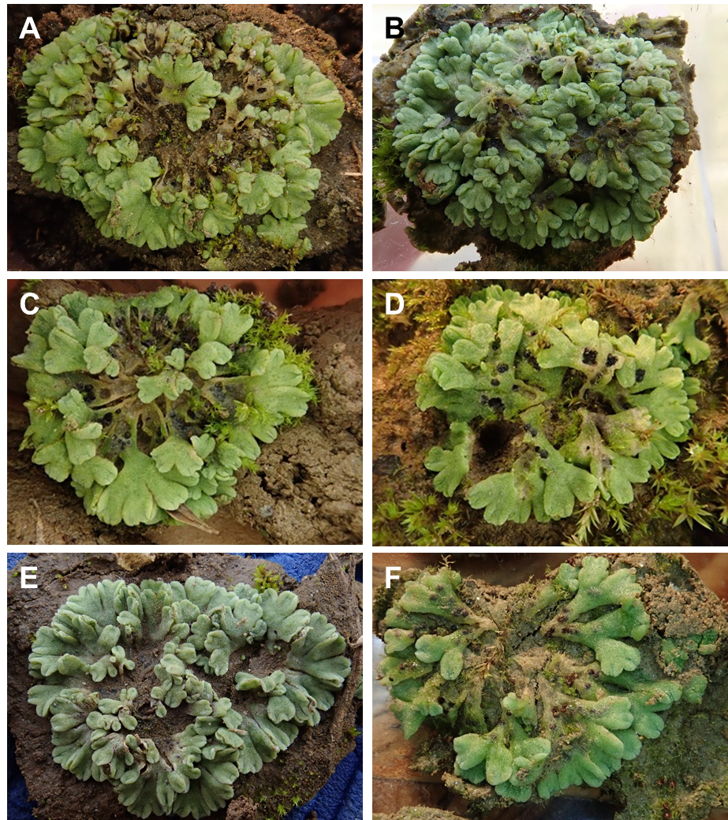
Supplementary Figure S1. Photographs of selected Riccia samples that were analyzed as part of this study. A-C and E-F – Riccia bifurca; D – Riccia glauca.

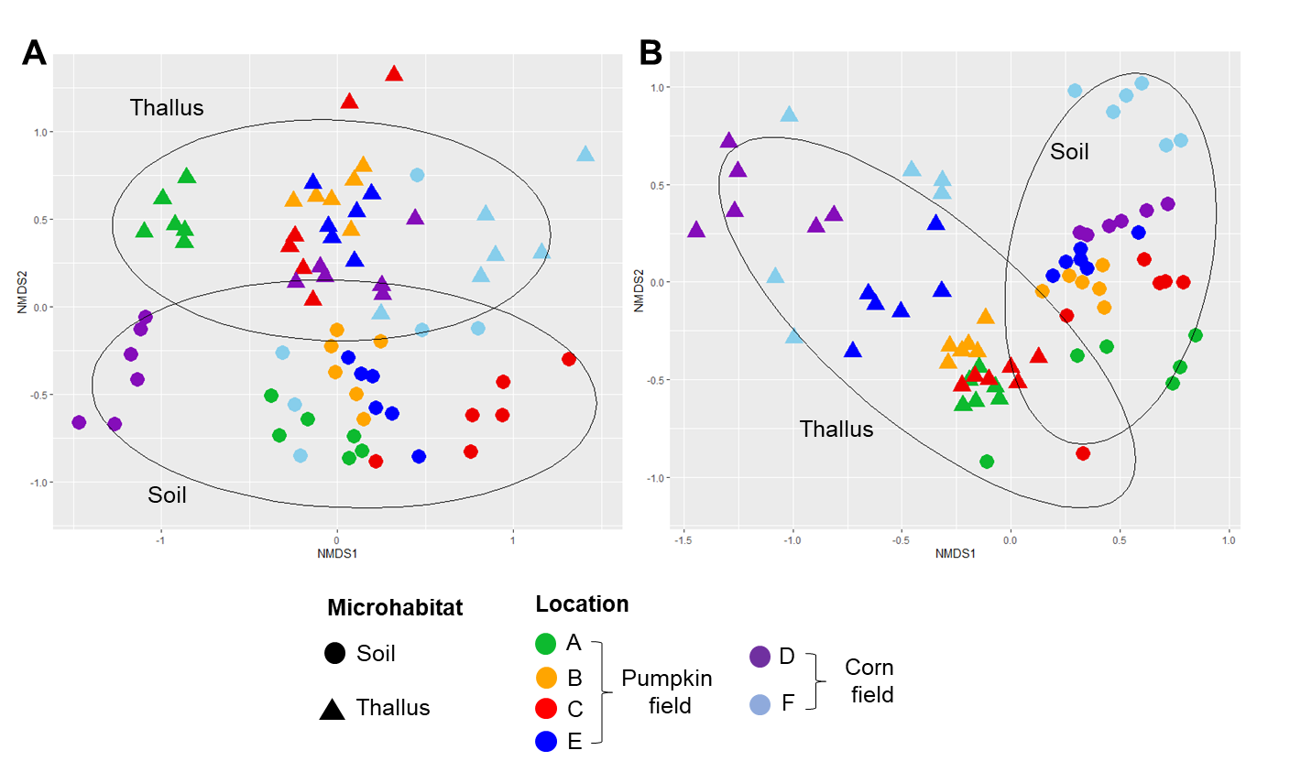
Supplementary Figure S2. NMDS plots showing clustering of bacterial (A) and fungal (B) community structures in thallus and soil samples.

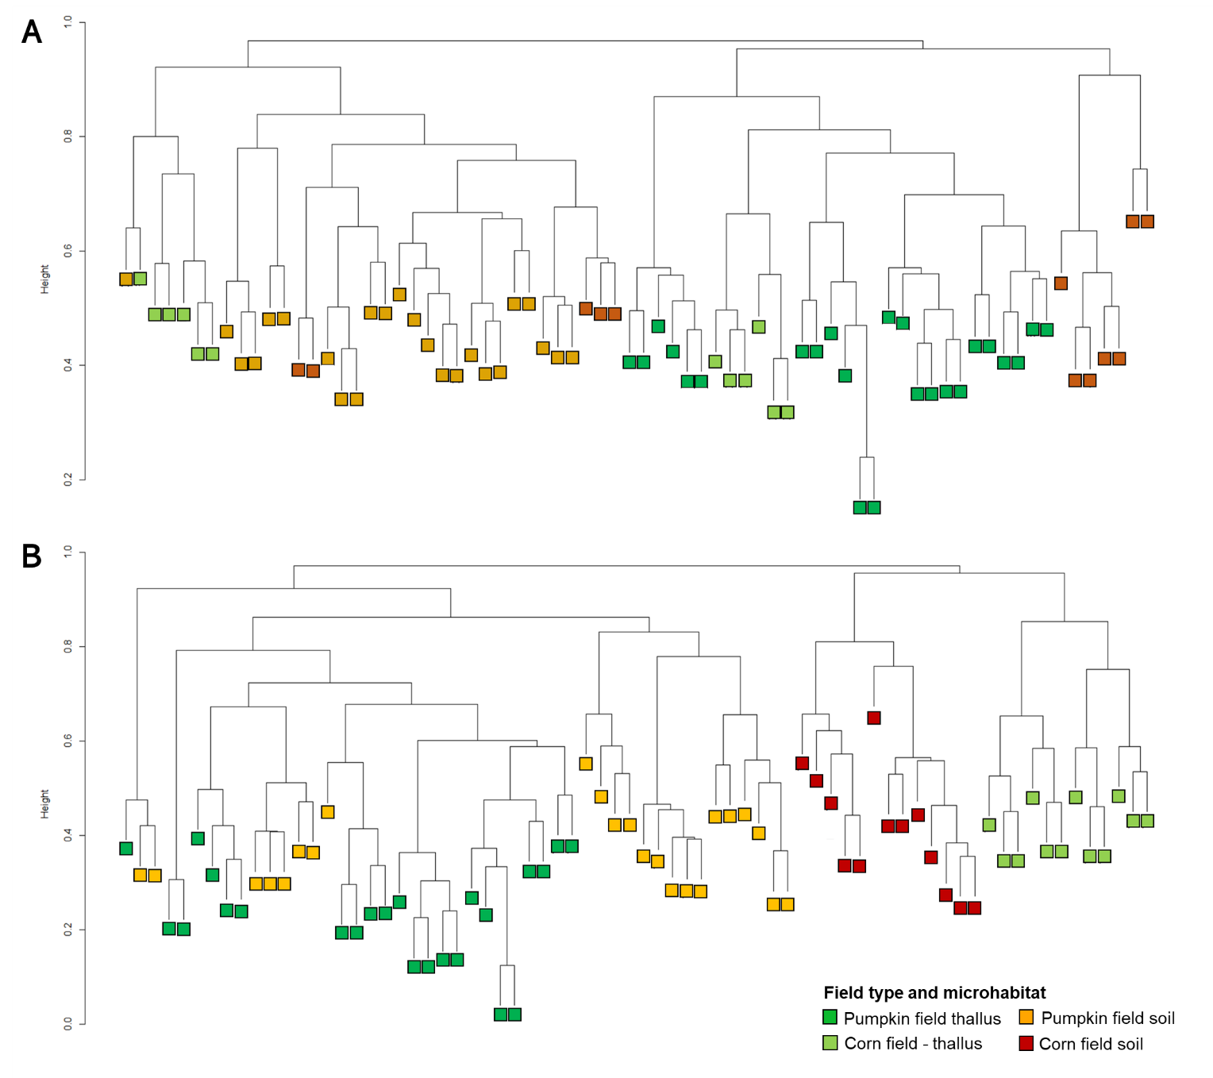Supplementary Figure S3. Hierarchical clustering of bacterial (A) and fungal (B) community structures of thallus and soil samples that were obtained from different field types.

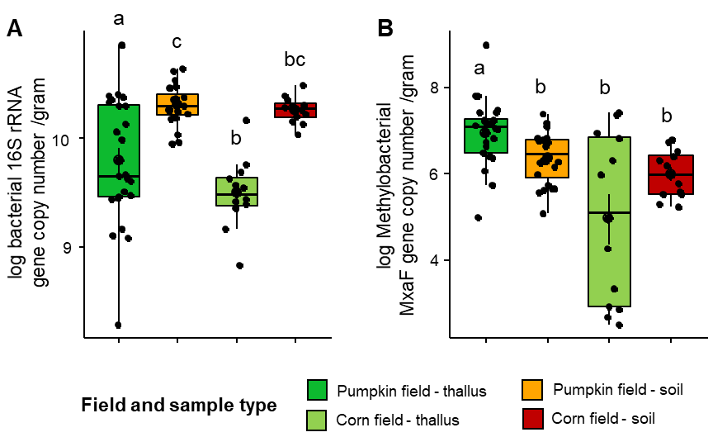
Supplementary Figure S4. Comparisons of microbial abundances between soil and liverwort thalli that were collected from different field types. Bacterial (A) and methylobacterial (B), abundances were quantified using a qPCR-based approach and transformed into log values. Data are presented as the mean for each group. The different letters above each bar indicate statistical significance at P_{adj} < 0.05 based on post-hoc Dunn’s test for multiple pairwise comparisons.

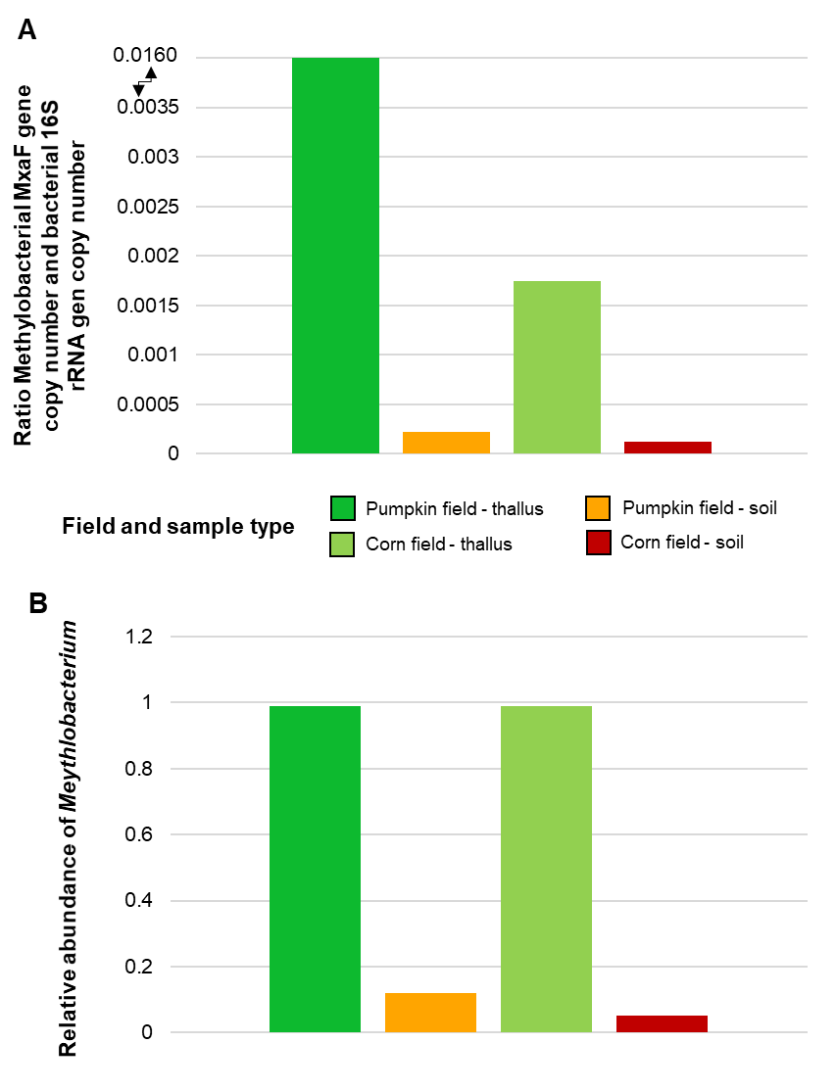
Supplementary Figure S5. Ratio between the methylobacterial MxaF gene copy number and bacterial 16S rRNA gene copy number based on qPCR analysis (A) and relative abundance of the genus Methylobacterium in thallus and soil samples from different fields based on amplicon sequencing (B).

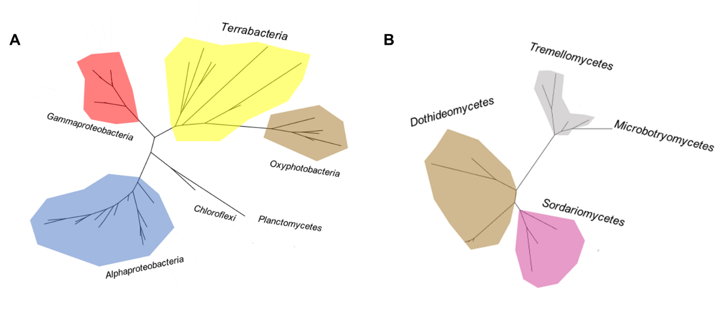
Supplementary Figure S6. Core microbiome assessment. The core microbiome of prokaryotic (A) and fungal (B) communities contains only ASVs that were present in at least 90% of the total samples. A phylogenetic tree was constructed with partial 16S rRNA gene and ITS region sequences of the core microbiome (A: prokaryotes and B: fungi).

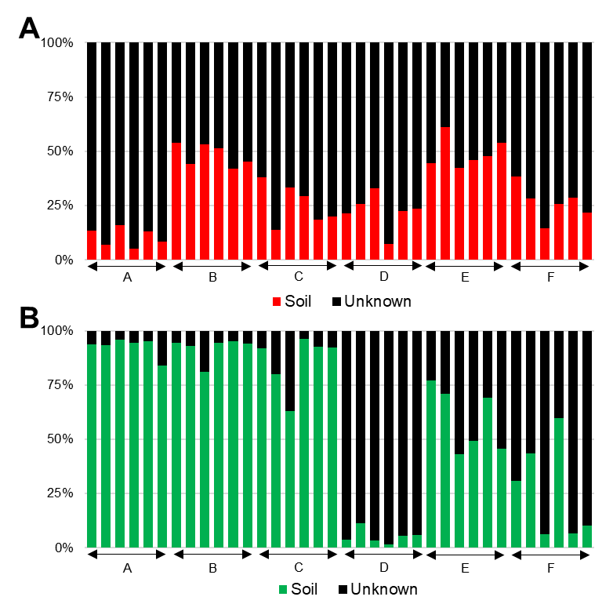
Supplementary Figure S7. Tracking of bacterial (A) and fungal (B) microbiome constituents in thallus samples from surrounding soil samples. The percentages are based on SourceTracker2 analysis in R.

