Fig. S1 Pearson’s correlation values between the examined environmental variables presented by heatmap.
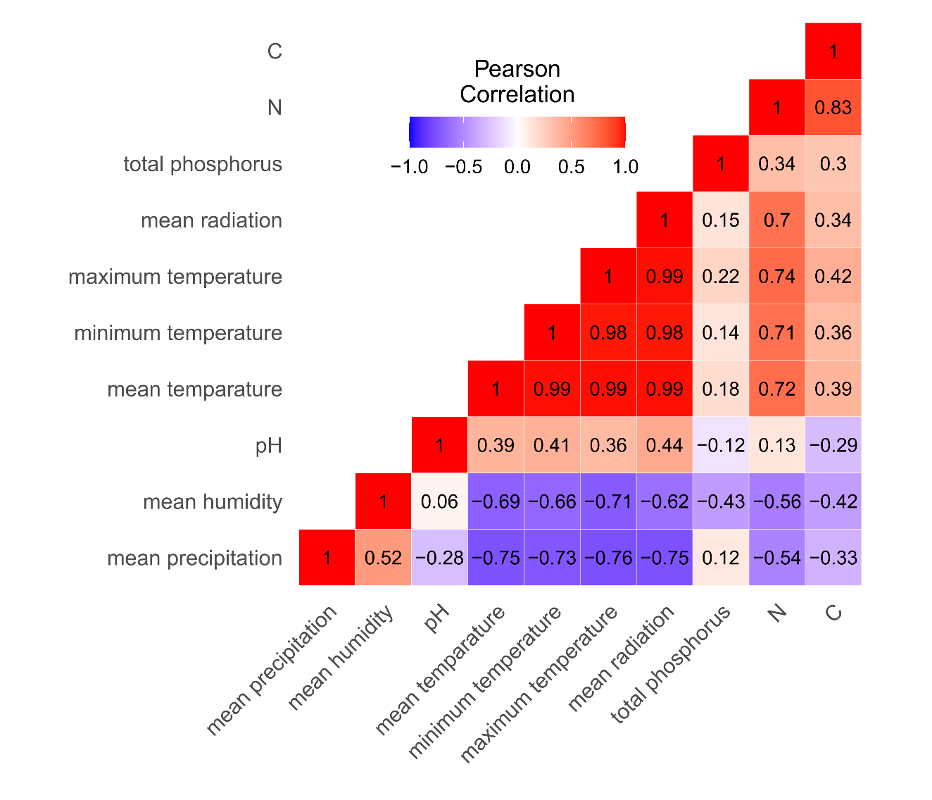

Fig. S2 Fungal community profiles in the two regions demonstrated by stacked bar plots at the family (A) and class (B) levels. Only the most dominant taxa are shown.
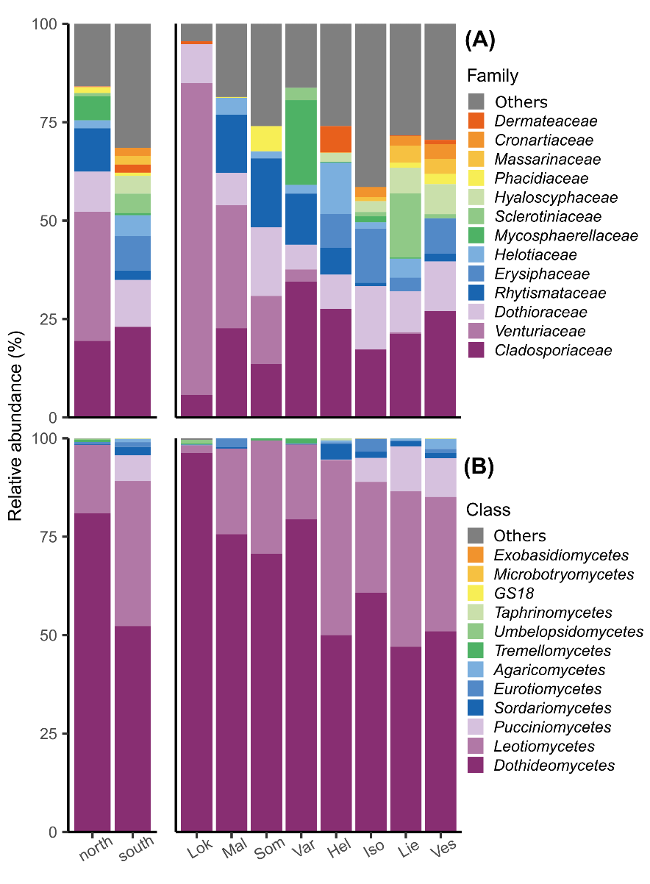

Table S1 metadata (in a separate excel file)

Table S2 Explanatory variables and their description
 | VARIABLE | DESCRIPTION
WEATHER | Mean temperature
 | Maximum temperature
 | Minimum temperature
 | Mean precipitation
 | Mean humidity
 | Mean radiation
TOPOGRAPHY | Altitude
PC1 | PC1 | PC1 axis of PCA for weather variables
SOIL | C | Carbon content
 | N | Nitrogen content
 | TP | Total phosphorus
 | pH
 | CN | C:N ratio
FACTOR | Region
FACTOR | Location
FACTOR | Clone (random)
COVARIATE | Sequencing depth
 | Vegetation type

Table S3 Summary of model validations and AICc values of all models. The final models are indicated in blue characters.
Model | AICc | Model validation
Response variable: fungal richness | explanatory variable: region
m1 <- glmmTMB (richness ~ region + offset (log sequencing depth) + vegetation type + (1|region:clone), data = metadata, family = poisson(), REML = T) | 560.0474 | pass
m1.1 <- glmmTMB (richness ~ region + offset (log sequencing depth) + (1|region:clone), data = metadata, family = poisson(), REML = T) | 554.6011 | fail
Response variable: fungal richness | explanatory variable: environmental variables
m2 <- glmmTMB (richness ~ PC1 + CN + TP + pH + offset (log sequencing depth) + vegetation type + (1|region:clone), data = metadata, family = poisson(), REML = T) | 572.9129 | pass
m2.1 <- glmmTMB (richness ~ PC1 + CN + TP + pH + offset (log sequencing depth) + (1|region:clone), data = metadata, family = poisson(), REML = T) | 567.1198 | fail
m2.2 <- glmmTMB (richness ~ PC1 + TP + pH + offset (log sequencing depth) + (1|region:clone), data = metadata, family = poisson(), REML = T) | 563.1118 | fail
m2.3 <- glmmTMB (richness ~ PC1 + TP + offset (log sequencing depth) + (1|region:clone), data = metadata, family = poisson(), REML = T) | 559.2997 | pass
m2.4 <- glmmTMB (richness ~ PC1 + offset (log sequencing depth) + (1|region:clone), data = metadata, family = poisson(), REML = T) | 556.2189 | fail
Response variable: fungal richness | explanatory variable: environmental variables | for each region
m.north <- glmmTMB (richness ~ PC1 + CN + TP + pH + offset (log sequencing depth) + vegetation type + (1|region:clone), data = metadata north, family = poisson(), REML = T) | 267.5424 | pass
m.south <- glmmTMB (richness ~ PC1 + CN + TP + pH + offset (log sequencing depth) + vegetation type + (1|region:clone), data = metadata south, family = poisson(), REML = T) | 321.3638 | pass
Response variable: distance-to-centroid | explanatory variable: environmental variables
m3 <- glmmTMB (sqrt (distance to centroid) ~ PC1 + CN + TP + pH + offset (log sequencing depth) + vegetation type + (1|region:clone), data = metadata, family = gaussian(), REML = T) | 230.7039 | pass
Response variable: distance-to-centroid | explanatory variable: fungal richness
m7 <- glmmTMB (sqrt (distance to centroid) ~ sqrt (richness) + vegetation type + offset (log sequencing depth) + (1|region:clone), data = metadata, family = gaussian(), REML = T) | 147.3237 | pass
m7.1 <- glmmTMB (sqrt (distance to centroid) ~ sqrt (richness) + offset (log sequencing depth) + (1|region:clone), data = metadata, family = gaussian(), REML = T) | 137.8882 | pass
Response variable: Podosphaera abundance | explanatory variable: environmental variables
m4 <- glmmTMB (abundance ~ PC1 + CN + TP + pH + offset (log sequencing depth) + vegetation type + (1|region:clone), data = metadata, family = nbinom2(), REML = F) | NA | pass
m4.1 <- glmmTMB (abundance ~ PC1 + CN + TP + pH + offset (log sequencing depth) + (1|region:clone), data = metadata, family = nbinom2(), REML = F) | 292.1874 | pass
m4.2 <- glmmTMB (abundance ~ PC1 + TP + pH + offset (log sequencing depth) + (1|region:clone), data = metadata, family = nbinom2(), REML = F) | 290.3283 | pass
m4.3 <- glmmTMB (abundance ~ PC1 + pH + offset (log sequencing depth) + (1|region:clone), data = metadata, family = nbinom2(), REML = F) | 288.4245 | pass
m4.4 <- glmmTMB (abundance ~ PC1 + offset (log sequencing depth) + (1|region:clone), data = metadata, family = nbinom2(), REML = F) | 287.2086 | fail
Response variable: Venturia abundance | explanatory variable: environmental variables
m5 <- glmmTMB (abundance ~ PC1 + CN + TP + pH + offset (log sequencing depth) + vegetation type + (1|region:clone), data = metadata, family = poisson(), REML = F) | 2663.501 | pass
m5.1 <- glmmTMB (abundance ~ PC1 + CN + TP + pH + offset (log sequencing depth) + (1|region:clone), data = metadata, family = poisson(), REML = F) | 2659.192 | fail
m5.2 <- glmmTMB (abundance ~ PC1 + TP + CN + offset (log sequencing depth) + (1|region:clone), data = metadata, family = poisson(), REML = F) | 2657.372 | pass
m5.3 <- glmmTMB (abundance ~ PC1 + TP + offset (log sequencing depth) + (1|region:clone), data = metadata, family = poisson(), REML = F) | 2655.299 | pass
m5.4 <- glmmTMB (abundance ~ PC1 + offset (log sequencing depth) + (1|region:clone), data = metadata, family = nbinom2(), REML = F) | 2653.525 | fail
Response variable: Cladosporium abundance | explanatory variable: environmental variables
m6 <- glmmTMB (abundance ~ PC1 + CN + TP + pH + offset (log sequencing depth) + vegetation type + (1|region:clone), data = metadata, family = nbinom1(), REML = F) | 950.3769 | pass
m6.1 <- glmmTMB (abundance ~ PC1 + CN + TP + pH + offset (log sequencing depth) + (1|region:clone), data = metadata, family = nbinom1(), REML = F) | 946.9042 | pass
m6.2 <- glmmTMB (abundance ~ PC1 + CN + TP + offset (log sequencing depth) + (1|region:clone), data = metadata, family = nbinom1(), REML = F) | 944.6919 | pass
m6.3 <- glmmTMB (abundance ~ PC1 + TP + offset (log sequencing depth) + (1|region:clone), data = metadata, family = nbinom1(), REML = F) | 942.5431 | pass
m6.4 <- glmmTMB (abundance ~ PC1 + offset (log sequencing depth) + (1|region:clone), data = metadata, family = nbinom1(), REML = F) | 941.4011 | pass

Table S4 Summary of the best GLMM model of the fungal richness as a function of regions. Predictor variables included in the model are denoted in the Fixed effects column. ns: non-significant (P > 0.1).
Fixed effects | Estimate | Std. Error | z value | P
(Intercept) | -10.167 | 0.127 | -79.970 | < 0.001
south | 0.373 | 0.189 | 1.970 | < 0.05
Vegetation type: mixed forest on mineral soil | 0.075 | 0.306 | 0.240 | ns
Vegetation type: mixed forest on peatland | 0.391 | 0.468 | 0.840 | ns
Vegetation type: peatbogs | -0.161 | 0.545 | -0.300 | ns

Table S5 Summary of the best GLMM model of the fungal richness as a function of environmental variables. Predictor variables included in the model are denoted in the Fixed effects column. ns: non-significant (P > 0.1).
Fixed effects | Estimate | Std. Error | z value | P
(Intercept) | -10.0 | 0.1 | -122.5 | <0.001
PC1 | -0.2 | 0.1 | -2.3 | <0.05
TP | 0.1 | 0.1 | 1.5 | ns

Table S6 Summary of the best GLMM model of the square root of distance-to-centroid values as a function of square root of richness. Predictor variables included in the model are denoted in the Fixed effects column. ns: non-significant (P > 0.1).
Fixed effects | Estimate | Std. Error | z value | P
(Intercept) | -11.4 | 0.1 | -78.6 | <0.001
sqrt(richness) | 0.6 | 0.1 | 10.3 | <0.001

Table S7 Marginal permutation tests (9999 permutations) of the full dbRDA models with all tested environmental variables as the explanators for the community structure of the whole dataset and the north region. The dbRDA models were built for two scales: the whole dataset and the north region. Df: degrees of freedom. ns: non-significant (P > 0.1). Significant terms are in bold.
 | Whole dataset |  |  |  |  | North region
 | Df | Variance | F | P |  | Df | Variance | F | P
PC1 | 1 | 0.26 | 2.87 | < 0.01 |  | 1 | 0.41 | 3.26 | < 0.05
Total phosphorus | 1 | 0.09 | 1.05 | ns |  | 1 | 0.17 | 1.35 | ns
C:N ratio | 1 | 0.08 | 0.89 | ns |  | 1 | 0.11 | 0.88 | ns
pH | 1 | 0.14 | 1.59 | ns |  | 1 | 0.15 | 1.17 | ns
Residual | 100 | 9.01 |  |  |  | 49 | 6.16

Table S8 Summary of the differential abundance analysis performed by the ALDEx2 package
Taxon | adjusted P | median effect size | overlap
Podosphaera | <0.05 | 0.32 | 0.35
Venturia | <0.001 | -1.17 | 0.11
Cladosporium | <0.05 | 0.37 | 0.34

Table S9 Summary of the best GLMM models of the genus abundance as a function of the environmental variables. Predictor variables included in the model are denoted in the Fixed effects column. ns: non-significant (P > 0.1).
Venturia
Fixed effects | Estimate | Std. Error | z value | P
(Intercept) | -13.1 | 0.9 | -14.9 | <0.001
PC1 | 4.1 | 0.8 | 5.0 | <0.001
TP | -0.4 | 0.7 | -0.6 | ns

Podosphaera
Fixed effects | Estimate | Std. Error | z value | P
(Intercept) | -14.0 | 2.6 | -5.4 | <0.001
PC1 | -6.1 | 2.7 | -2.3 | <0.05
pH | -0.6 | 0.5 | -1.0 | ns

Cladosporium
Fixed effects | Estimate | Std. Error | z value | P
(Intercept) | -5.2 | 0.3 | -16.1 | <0.001
PC1 | -0.5 | 0.1 | -3.4 | <0.001

