Supplementary material

Methane-cycling microbial communities from Amazon floodplains and upland forests respond differently to simulated climate change scenarios

Júlia B. Gontijo^{1,2*}; Fabiana S. Paula¹; Wanderlei Bieluczyk¹; Aline G. França¹; Deisi Navroski¹; Jéssica A. Mandro¹; Andressa M. Venturini³; Fernanda O. Asselta¹; Lucas W. Mendes¹; José M. S. Moura⁴; Marcelo Z. Moreira¹; Klaus Nüsslein⁵; Brendan J.M. Bohannan⁶; Paul L.E. Bodelier⁷; Jorge L. Mazza Rodrigues^{2,8}; Siu M. Tsai¹

¹Centro de Energia Nuclear na Agricultura, Universidade de São Paulo, Piracicaba, SP, Brazil
²Department of Land, Air and Water Resources, University of California, Davis, CA, USA
³Department of Biology, Stanford University, Stanford, CA, USA
⁴Instituto de Formação Interdisciplinar e Intercultural, Universidade Federal do Oeste do Pará, Santarém, PA, Brazil
⁵Department of Microbiology, University of Massachusetts, Amherst, MA, USA
⁶Institute of Ecology and Evolution, Department of Biology, University of Oregon, Eugene, OR, USA
⁷Netherlands Institute of Ecology, NIOO-KNAW, Wageningen, GE, The Netherlands
⁸Environmental Genomics and Systems Biology Division, Lawrence Berkeley National Laboratory, Berkeley, CA, USA
*Corresponding author: jbgontijo@ucdavis.edu

Supplementary Tables
Table S1. Chemical properties of the floodplain and upland forest soils during wet and dry seasons.
Parameter | Unit | FP1 |  |  | FP2 |  |  | PFO
pH (H₂O) | - | 5,3 | ± | 0,5ª | 5 | ± | 0,1ª | 4 | ± | 0,1^{b}
OM | g/dm³ | 10,8 | ± | 3,9^{c} | 503,2 | ± | 27,8ª | 47,8 | ± | 11,0^{b}
N | mg/Kg | 882 | ± | 106,2^{b} | 11914 | ± | 2526,5ª | 2828 | ± | 1165,7^{ab}
SO₄²⁻ | mg/dm³ | 8,8 | ± | 2,3^{b} | 18,2 | ± | 3,0ª | 11,8 | ± | 1,6^{ab}
P | mg/dm³ | 7,4 | ± | 2,1^{b} | 13 | ± | 1,6ª | 8,8 | ± | 1,3^{b}
K | mmolc/dm³ | 1,7 | ± | 0,4ª | 1,8 | ± | 0,5ª | 1,2 | ± | 0,1ª
Ca | mmolc/dm³ | 42,2 | ± | 20,1ª | 2,4 | ± | 0,5^{b} | 4,6 | ± | 1,9^{b}
Mg | mmolc/dm³ | 33,8 | ± | 13,5ª | 2,4 | ± | 0,9^{b} | 3,4 | ± | 0,9^{b}
Al | mmolc/dm³ | 16,4 | ± | 8,8^{b} | 71,6 | ± | 5,6ª | 67,8 | ± | 11,1ª
Cu | mg/dm³ | 2,1 | ± | 0,4ª | 0,3 | ± | 0,1^{b} | 0,3 | ± | 0,1^{b}
Fe | mg/dm³ | 232 | ± | 83,5ª | 7,4 | ± | 1,9^{b} | 190,2 | ± | 70,6ª
Zn | mg/dm³ | 3,3 | ± | 0,7ª | 1,2 | ± | 0,3^{b} | 1,7 | ± | 1,3^{ab}
Mn | mg/dm³ | 31,2 | ± | 11,9ª | 6,3 | ± | 0,5^{b} | 8,5 | ± | 1,7^{ab}
B | mg/dm³ | 0,2 | ± | 0,1ª | 0,4 | ± | 0,1ª | 0,3 | ± | 0,1ª
Clay | g/kg | 308 | ± | 54,5^{b} | 362 | ± | 28,5^{b} | 775 | ± | 59,2ª
Silt | g/kg | 466 | ± | 60,6ª | 284 | ± | 45,6^{ab} | 179 | ± | 62,3^{b}
Sand | g/kg | 226 | ± | 111,7ª | 354 | ± | 50,8^{ab} | 46 | ± | 15,2^{b}
pH: hydrogen potential; OM: organic matter; N: nitrogen P: phosphorus, SO₄²⁻: sulfate; K: potassium; Ca: calcium; Mg: magnesium; Al: aluminium; B: boron; Cu: copper; Fe: iron; Mn manganese; Zn: zinc. Values are presented as means ± standard deviation. Lower-case letters indicate the comparison between sites (Kruskal-Wallis and Dunn Test; p < 0.05). FP1: Floodplain 1; FP2: Floodplain 2; PFO: Upland Forest.

Table S2. Results of the envfit analysis - correlation of the soil chemical and physical properties in the floodplain and upland forest soils.
Parameter | R² | p-value
Soil chemical and physical properties
pH | 0.513 | 0.012
OM | 0.860 | 0.002
N | 0.802 | 0.002
SO₄²⁻ | 0.724 | 0.002
P | 0.588 | 0.004
K | 0.495 | 0.013
Ca | 0.779 | 0.001
Mg | 0.829 | 0.001
Al | 0.919 | 0.001
Cu | 0.958 | 0.001
Fe | 0.588 | 0.009
Zn | 0.562 | 0.006
Mn | 0.778 | 0.001
B | 0.324 | 0.082
Clay | 0.874 | 0.001
Silt | 0.740 | 0.001
Sand | 0.892 | 0.001
Factor
Site | 0.949 | 0.001
pH: hydrogen potential; OM: organic matter; N: nitrogen P: phosphorus, SO₄²⁻: sulfate; K: potassium; Ca: calcium; Mg: magnesium; Al: aluminium; B: boron; Cu: copper; Fe: iron; Mn manganese; Zn: zinc. Bold values indicate statistical significance at p-value < 0.05.
Table S3. Three-way ANOVA of the aligned rank transformed relative abundance of methanogens and methanotrophs from the floodplain and upland forest soils.
Data | Sampling Day |  |  | Temperature |  |  | Flooding
Data | gl | F | p | gl | F | p | gl | F | p
Floodplain 1 - FP1
Bathyarchaeia | 1 | 0.058 | 0.811 | 1 | 0.019 | 0.892 | 1 | 0.042 | 0.838
Methanobacterium | 1 | 1.322 | 0.262 | 1 | 2.648 | 0.117 | 1 | 0.617 | 0.440
Methanocella | 1 | 0.018 | 0.895 | 1 | 1.623 | 0.215 | 1 | 0.010 | 0.921
Methanosaeta | 1 | 25.183 | <0.001 | 1 | 0.168 | 0.686 | 1 | 0.117 | 0.736
Methanosarcina | 1 | 1.923 | 0.178 | 1 | 0.190 | 0.667 | 1 | 0.040 | 0.842
Methanomassiliicoccus | 1 | 2.133 | 0.157 | 1 | 0.054 | 0.818 | 1 | 0.219 | 0.644
Thermoplasmatales | 1 | 1.549 | 0.225 | 1 | 0.005 | 0.945 | 1 | 0.229 | 0.637
Candidatus Methanoperedens | 1 | 0.000 | 1.000 | 1 | 0.256 | 0.618 | 1 | 0.660 | 0.425
Methylomirabilia | 1 | 0.630 | 0.437 | 1 | 0.019 | 0.892 | 1 | 0.630 | 0.435
Methylocystis | 1 | 0.500 | 0.486 | 1 | 0.018 | 0.895 | 1 | 0.653 | 0.427
Methylovirgula | 1 | 1.619 | 0.215 | 1 | 6.000 | 0.029 | 1 | 6.530 | 0.0174
Candidatus Methylospira | 1 | 0.090 | 0.767 | 1 | 0.449 | 0.509 | 1 | 2.345 | 0.139
Methylomonas | 1 | 0.404 | 0.501 | 1 | 1.039 | 0.318 | 1 | 0.404 | 0.531
RCP2-54 | 1 | 0.257 | 0.616 | 1 | 0.169 | 0.685 | 1 | 1.012 | 0.324
Floodplain 2 - FP2
Bathyarchaeia | 1 | 1.276 | 0.230 | 1 | 0.004 | 0.947 | 1 | 0.018 | 0.895
Candidatus Methanomethylicus | 1 | 1.714 | 0.203 | 1 | 0.004 | 0.843 | 1 | 0.896 | 0.353
Methanobacterium | 1 | 5.650 | 0.026 | 1 | 0.054 | 0.818 | 1 | 5.383 | 0.029
Methanocella | 1 | 6.932 | 0.015 | 1 | 1.661 | 0.210 | 1 | 17.388 | <0.001
Methanosarcina | 1 | 0.708 | 0.408 | 1 | 0.054 | 0.818 | 1 | 0.135 | 0.717
Methanomassiliicoccus | 1 | 0.071 | 0.792 | 1 | 0.452 | 0.508 | 1 | 2.276 | 0.144
Thermoplasmatales | 1 | 0.658 | 0.425 | 1 | 0.714 | 0.406 | 1 | 11.409 | 0.002
Methylomirabilia | 1 | 0.717 | 0.406 | 1 | 0.219 | 0.644 | 1 | 0.071 | 0.792
Methylocystis | 1 | 0.160 | 0.693 | 1 | 0.501 | 0.486 | 1 | 7.023 | 0.014
Methylosinus | 1 | 0.251 | 0.621 | 1 | 0.499 | 0.487 | 1 | 0.964 | 0.336
Methylovirgula | 1 | 0.365 | 0.551 | 1 | 0.018 | 0.895 | 1 | 2.281 | 0.144
RCP2-54 | 1 | 0.7152 | 0.406 | 1 | 0.055 | 0.817 | 1 | 1.720 | 0.202
Upland forest - PFO
Bathyarchaeia | 1 | 0.126 | 0.725 | 1 | 0.039 | 0.845 | 1 | 0.136 | 0.716
Thermoplasmatales | 1 | 9.751 | 0.005 | 1 | 3.648 | 0.068 | 1 | 2.408 | 0.134
Methylovirgula | 1 | 3.855 | 0.061 | 1 | 0.213 | 0.648 | 1 | 3.301 | 0.082
RCP2-54 | 1 | 5.698 | 0.025 | 1 | 2.788 | 0.107 | 1 | 0.005 | 0.944
df: degrees of freedom, F: F-values. Bold values indicate statistical significance at p-value < 0.05.

Table S3 (continuation). Three-way ANOVA of the aligned rank transformed relative abundance of methanogens and methanotrophs from the floodplain and upland forest soils.
Data | Sampling Day x Temperature |  |  | Sampling Day x Flooding |  |  | Temperature x Flooding |  |  | Sampling Day x Temperature x Flooding
Data | gl | F | p | gl | F | p | gl | F | p | gl | F | p
Floodplain 1 - FP1
Bathyarchaeia | 1 | 0.019 | 0.892 | 1 | 0.303 | 0.587 | 1 | 0.424 | 0.521 | 1 | 0.573 | 0.457
Methanobacterium | 1 | 0.338 | 0.566 | 1 | 0.683 | 0.417 | 1 | 0.005 | 0.947 | 1 | 0.005 | 0.764
Methanocella | 1 | 0.028 | 0.870 | 1 | 0.405 | 0.531 | 1 | 0.405 | 0.531 | 1 | 1.118 | 0.301
Methanosaeta | 1 | 0.679 | 0.418 | 1 | 0.170 | 0.684 | 1 | 0.010 | 0.919 | 1 | 2.261 | 0.146
Methanosarcina | 1 | 0.136 | 0.716 | 1 | 3.417 | 0.077 | 1 | 1.271 | 0.271 | 1 | 0.500 | 0.486
Methanomassiliicoccus | 1 | 0.027 | 0.869 | 1 | 0.111 | 0.742 | 1 | 0.188 | 0.668 | 1 | 0.001 | 0.973
Thermoplasmatales | 1 | 0.165 | 0.688 | 1 | 0.398 | 0.534 | 1 | 0.686 | 0.416 | 1 | 0.001 | 0.973
Candidatus Methanoperedens | 1 | 0.460 | 0.504 | 1 | 1.286 | 0.268 | 1 | 0.165 | 0.688 | 1 | 1.054 | 0.315
Methylomirabilia | 1 | 0.004 | 0.947 | 1 | 1.070 | 0.311 | 1 | 0.951 | 0.339 | 1 | 0.231 | 0.635
Methylocystis | 1 | 1.056 | 0.314 | 1 | 0.712 | 0.407 | 1 | 0.071 | 0.792 | 1 | 0.457 | 0.506
Methylovirgula | 1 | 0.840 | 0.369 | 1 | 1.721 | 0.202 | 1 | 0.018 | 0.895 | 1 | 0.452 | 0.508
Candidatus Methylospira | 1 | 0.286 | 0.598 | 1 | 0.832 | 0.371 | 1 | 1.800 | 0.192 | 1 | 0.218 | 0.645
Methylomonas | 1 | 0.713 | 0.407 | 1 | 0.071 | 0.793 | 1 | 1.180 | 0.283 | 1 | 2.234 | 0.148
RCP2-54 | 1 | 0.624 | 0.437 | 1 | 0.074 | 0.788 | 1 | 0.166 | 0.687 | 1 | 0.377 | 0.545
Floodplain 2 - FP2
Bathyarchaeia | 1 | 0.219 | 0.644 | 1 | 0.367 | 0.550 | 1 | 0.135 | 0.716 | 1 | 0.251 | 0.621
Candidatus Methanomethylicus | 1 | 0.287 | 0.597 | 1 | 1.350 | 2.567 | 1 | 0.010 | 0.921 | 1 | 0.498 | 0.487
Methanobacterium | 1 | 0.598 | 0.447 | 1 | 9.714 | 0.005 | 1 | 0.599 | 0.447 | 1 | 0.834 | 0.370
Methanocella | 1 | 0.001 | 0.973 | 1 | 18.153 | <0.001 | 1 | 8.089 | 0.009 | 1 | 1.939 | 0.177
Methanosarcina | 1 | 0.160 | 0.692 | 1 | 4.957 | 0.036 | 1 | 0.160 | 0.692 | 1 | 0.286 | 0.598
Methanomassiliicoccus | 1 | 0.496 | 0.488 | 1 | 0.219 | 0.644 | 1 | 1.525 | 0.229 | 1 | 0.288 | 0.597
Thermoplasmatales | 1 | 1.916 | 0.179 | 1 | 7.625 | 0.011 | 1 | 0.606 | 0.444 | 1 | 0.090 | 0.767
Methylomirabilia | 1 | 0.452 | 0.508 | 1 | 0.071 | 0.792 | 1 | 0.090 | 0.767 | 1 | 0.136 | 0.716
Methylocystis | 1 | 0.497 | 0.488 | 1 | 4.756 | 0.039 | 1 | 0.111 | 0.742 | 1 | 0.188 | 0.668
Methylosinus | 1 | 0.004 | 0.948 | 1 | 0.071 | 0.793 | 1 | 0.071 | 0.793 | 1 | 0.001 | 0.974
Methylovirgula | 1 | 0.251 | 0.621 | 1 | 0.367 | 0.550 | 1 | 0.973 | 0.334 | 1 | 0.253 | 0.619
RCP2-54 | 1 | 0.367 | 0.550 | 1 | 0.716 | 0.406 | 1 | 0.040 | 0.842 | 1 | 0.919 | 0.347
Upland forest - PFO
Bathyarchaeia | 1 | 2.008 | 0.169 | 1 | 0.897 | 0.353 | 1 | 0.030 | 0.863 | 1 | 0.406 | 0.530
Thermoplasmatales | 1 | 1.187 | 0.287 | 1 | 0.688 | 0.415 | 1 | 0.164 | 0.689 | 1 | 4.902 | 0.037
Methylovirgula | 1 | 0.978 | 0.333 | 1 | 0.191 | 0.666 | 1 | 0.378 | 0.544 | 1 | 0.290 | 0.595
RCP2-54 | 1 | 0.049 | 0.827 | 1 | 0.008 | 0.930 | 1 | 0.085 | 0.773 | 1 | 0.373 | 0.547
df: degrees of freedom, F: F-values. Bold values indicate statistical significance at p-value < 0.05.

Supplementary Figures

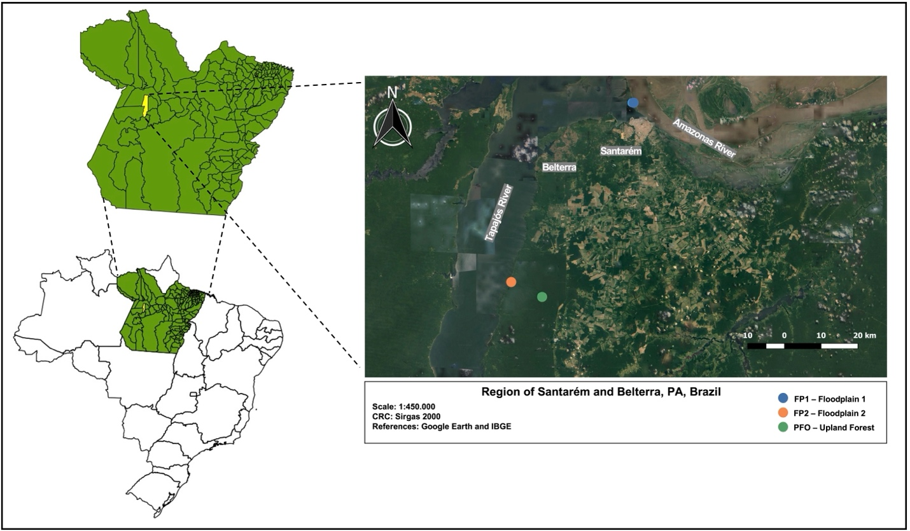

Figure S1. Location of the studied sites.

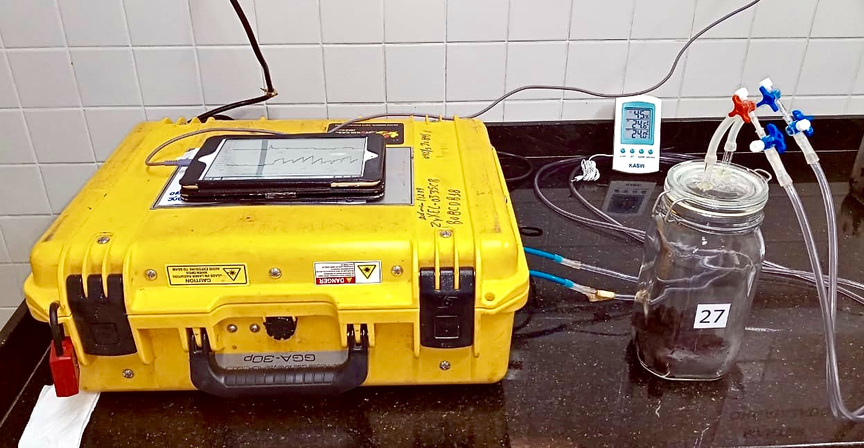
Figure S2. Gas measurement using the Ultra-Portable Greenhouse Gas Analyzer (Los Gatos Research, USA).

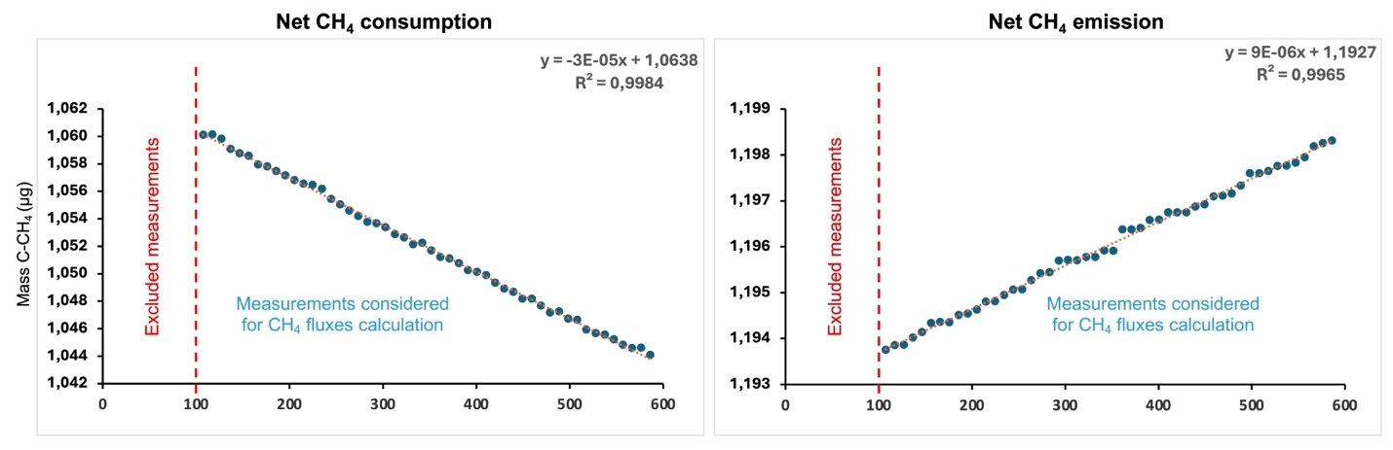
Figure S3. Example of the linear regression analysis of CH₄ concentration measurements during incubation period. The graphs display the CH₄ concentrations over time, excluding the first 100 seconds to reduce fluctuations. Two examples are provided: one demonstrating CH₄ consumption and the other showing positive CH₄ emissions. The high R² values (greater than 0.9) indicate a strong linear relationship, demonstrating the accuracy and reliability of the flux calculations based on these measurements.
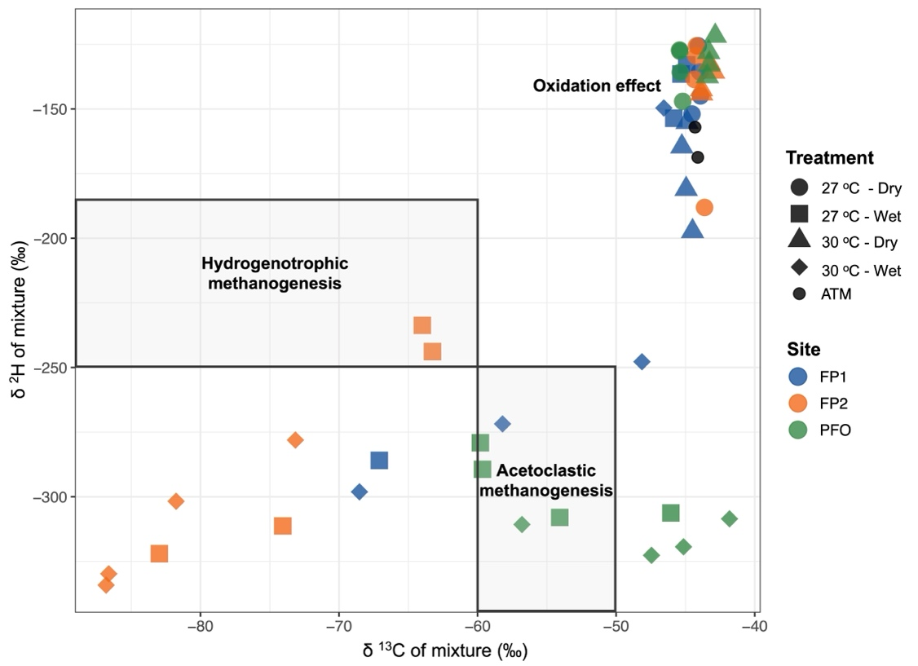
Figure S4. Isotopic signatures (δ¹³C and δ²H) for CH₄ production pathways according to Chanton et al. (2005) and Whiticar (1999), from floodplain (FP1 and FP2) and upland forest (PFO) soils samples under different conditions of flooding (wet and dry) and temperature (27 ºC and 30 ºC), at the day 30 of the experiment. The CH₄ produced by the hydrogenotrophic pathway has lower δ¹³C and higher δ²H (δ¹³C = -110‰ to -60‰ and δ²H = -250‰ to -170‰) when compared to the CH₄ produced by the acetoclastic pathway (δ¹³C = -60‰ to -50‰ and δ²H = -400‰ to -250‰). Also, methanotrophic activity results in enriched values of δ¹³C and δ²H (the heavier isotopes), based on the microbial preference to oxidize lighter molecules.

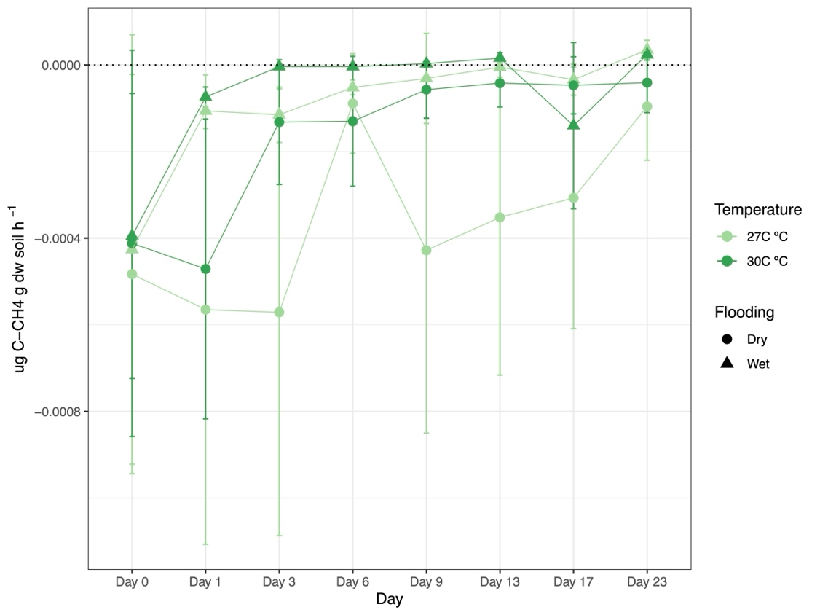
Figure S5. Detailed CH₄ emission dynamics for PFO soils from Days 0 to 23. The soil samples were submitted to changes in flooding (wet and dry) and temperature (27 ºC and 30 ºC) conditions.
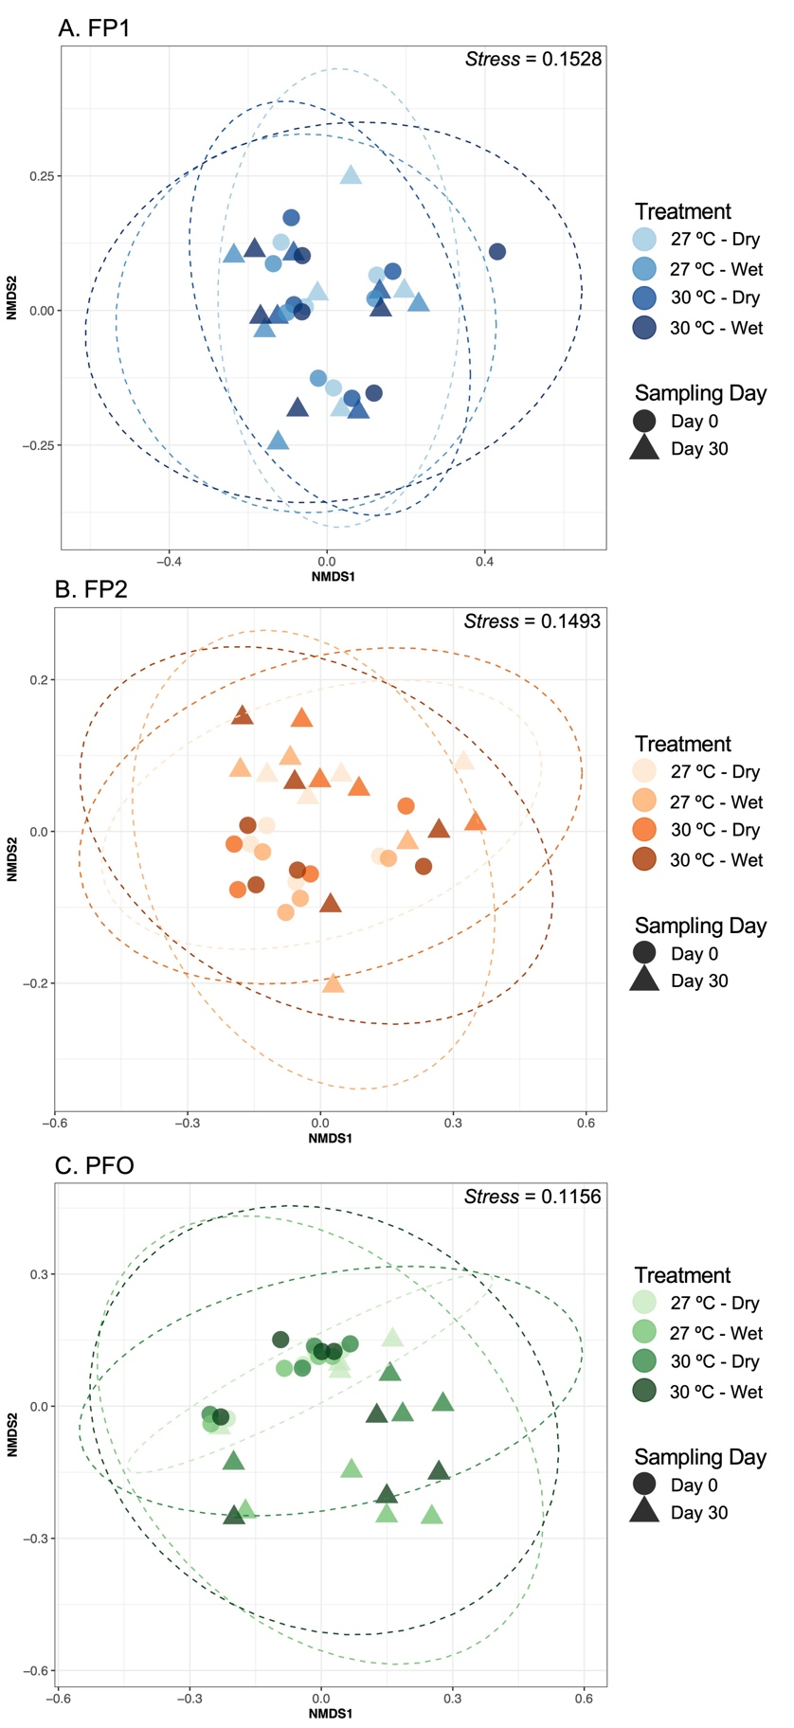
Figure S6. Clustering of the taxonomic structure of the floodplain 1 (A), floodplain 2 (B) and upland forest (C) soils under different conditions of flooding (wet and dry) and temperature (27 ºC and 30 ºC). Plot is based on the non-metric multidimensional scaling (NMDS) using the Bray-Curtis distance index.
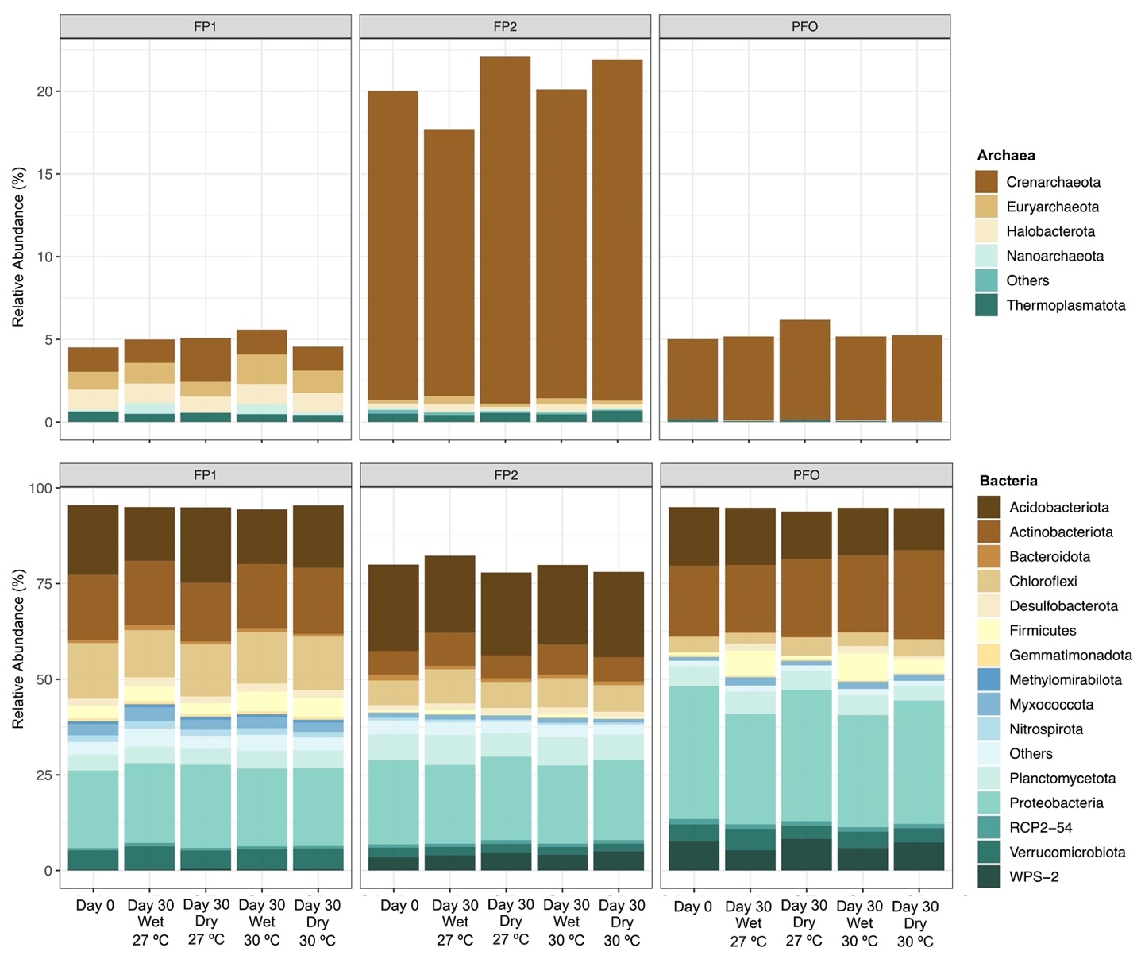
Figure S7. Relative abundance (means per treatment) of the Archaeal and Bacterial microbial communities in the floodplain (FP1 and FP2) and upland forest soils (PFO) under different conditions of flooding (wet and dry) and temperature (27 ºC and 30 ºC). Days 0 and 30 represents the first and last days of the experiment that the microbial communities where accessed.

