Supplementary figures
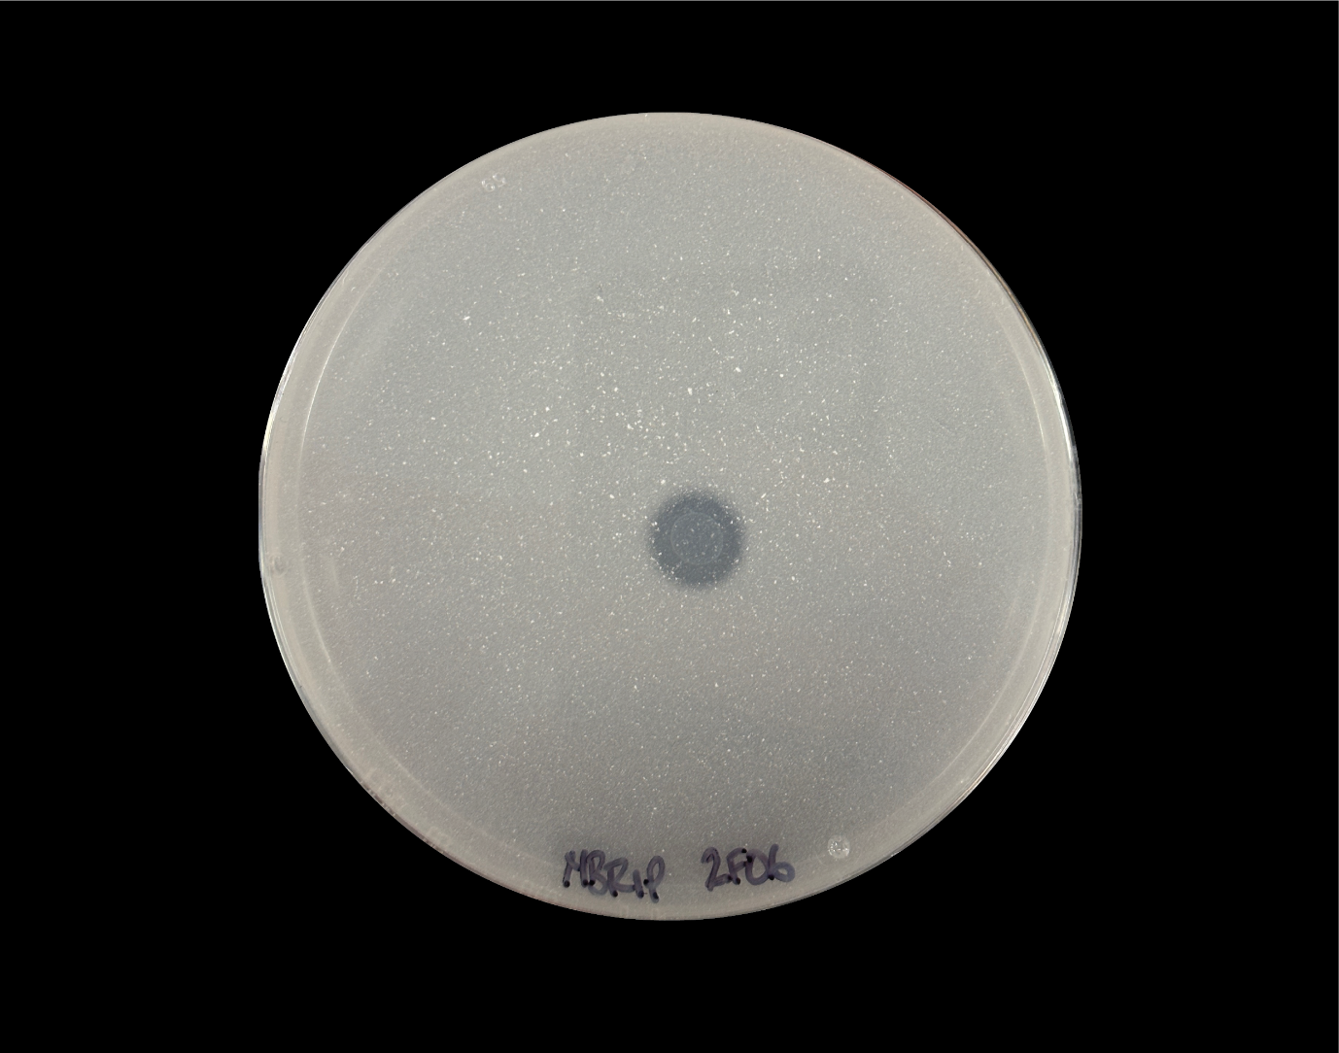
Figure S1: Example of a phosphate solubilising isolate recovered from Acacia ulicifolia seeds.

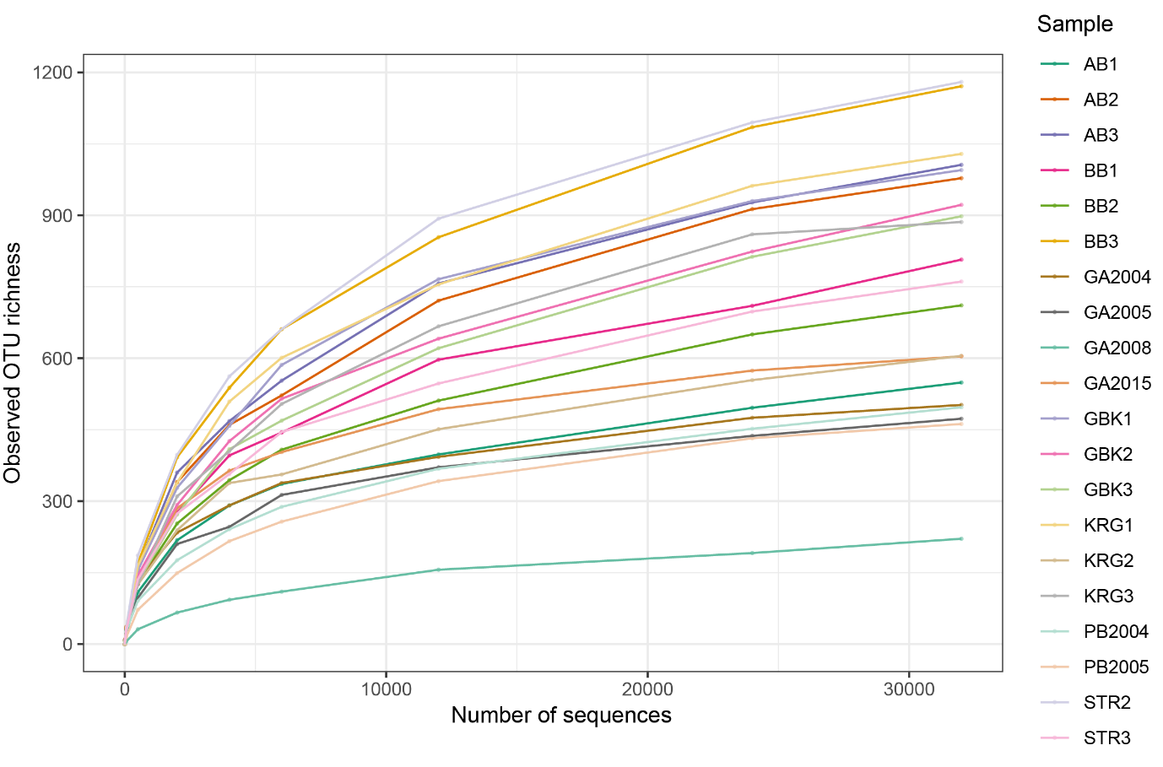
Figure S2: Rarefaction curves showing observed OTU richness per sample at different sequencing depths.

Figure S3: Venn diagram indicating the number of unique and shared OTUs between Acacia ulicifolia seed epiphytes from each sampling location for (A) stored seeds and (B) fresh seeds. Abbreviations refer to specific sampling locations. STR: Strickland, KRG: Ku-ring-gai, AB: Agnes Banks, GBK: Glenbrook, BB: Burnum Burnum, HXT: Hoxton Park, NBC: Nabiac, CDH: Crowdy Head.

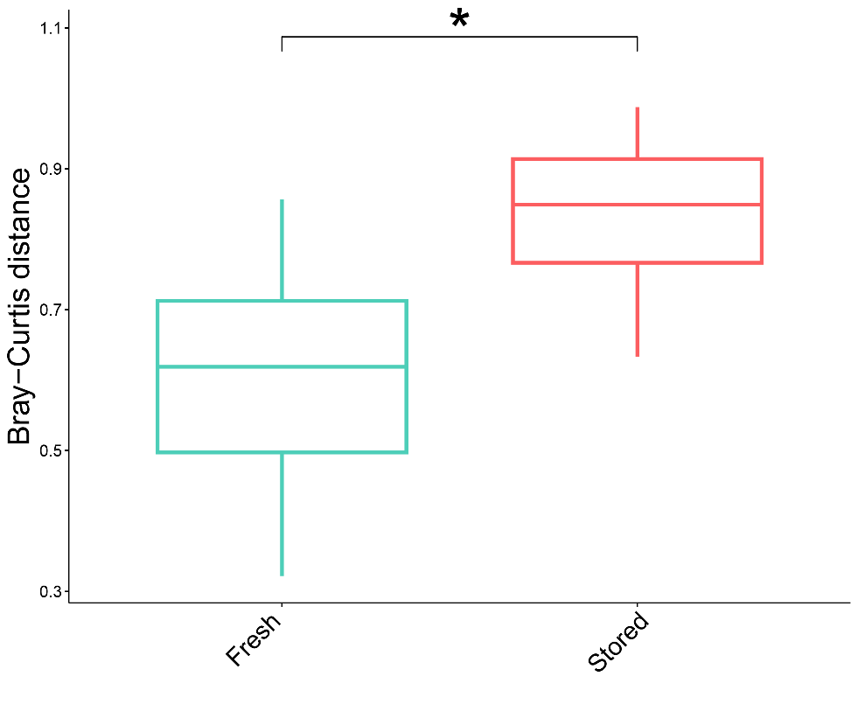
Figure S4: Difference in Bray-Curtis distances of Acacia ulicifolia seed epiphyte composition, grouped between sample sources assessed by Wilcoxon rank sum test. Significance label indicates p < 0.001 following FDR adjustment.
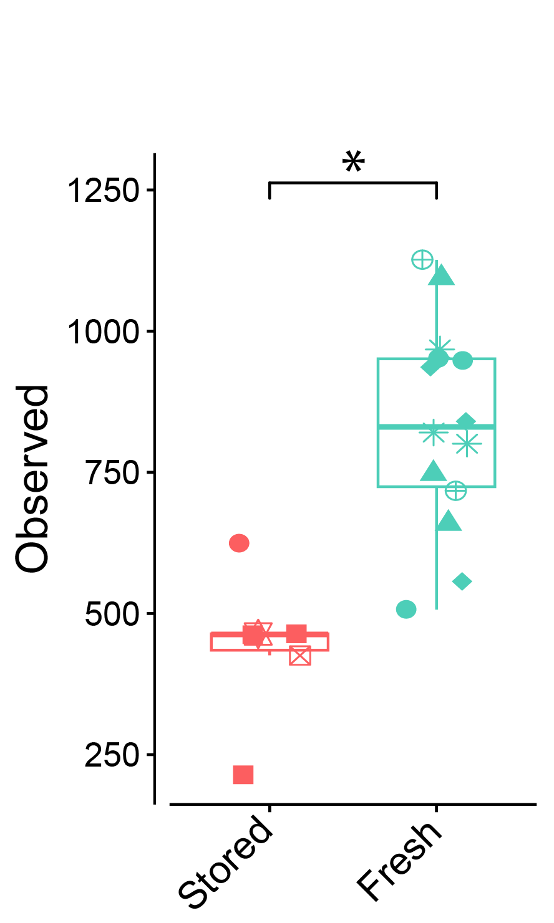
Figure S5: Acacia ulicifolia seed-associated epiphytic community observed species richness. Significance label indicates p < 0.05 following FDR adjustment.

