Additional File 5: Raw assembly and MinION polished assembly metrics for biofilm and sediment samples

Raw assembly data: Biofilm samples
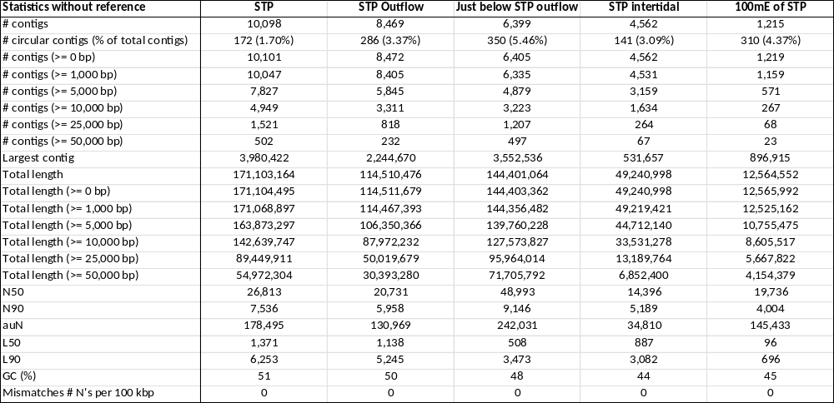

Raw assembly data: Sediment samples

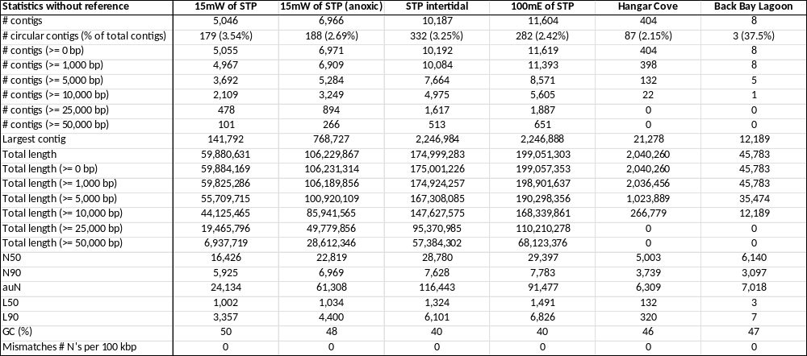

MinION polished assembly data: Biofilm samples

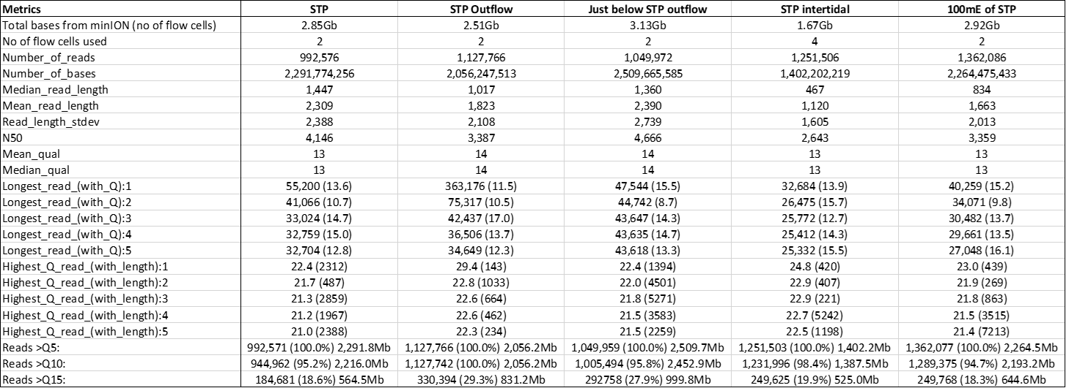

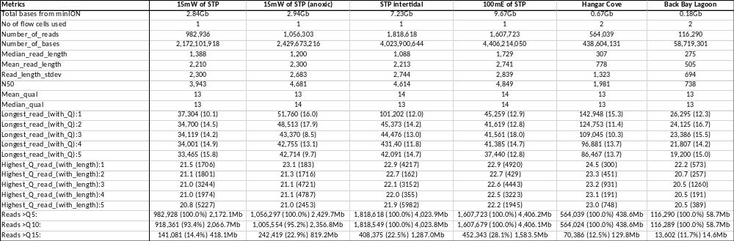
MinION polished assembly data: Sediment samples

