Supplementary Information
Differential response patterns of root and leaf-associated microbiota to continuous monocultures
Hao-Ran Li¹, Xiang-Yu Zhang¹, Kai-Ling He², Xin Xu¹, Xin-Wen Chen², Yaseen Ullah¹, Ting-Ting Zhang²*, Yan Chen³, Chuan-Chao Dai¹, Wei Zhang¹*
- Jiangsu Key Laboratory for Pathogens and Ecosystems, Jiangsu Engineering and Technology Research Center for Industrialization of Microbial Resources, College of Life Sciences, Nanjing Normal University, Jiangsu Province, China
- Jiangsu Key Laboratory for Molecular and Medical Biotechnology, College of Life Sciences, Nanjing Normal University, Jiangsu Province, China
- State Key Laboratory of Soil and Sustainable Agriculture, Institute of Soil Science, Chinese Academy of Science, Nanjing, China
Corresponding to: zhangtt@njnu.edu.cn; zhwnjnu@163.com

Supplementary figures
Supplementary Figure 1 The peanut root rot and leaf spot disease severity of MP and RP plots in the field experiment at flowering stage in 2022. Data are presented as the mean ± SEM (n = 4). The asterisk indicates a significant difference between monoculture and rotated plots according to Student’s t-test (***P < 0.001). MP, monocropping; RP, rotation.

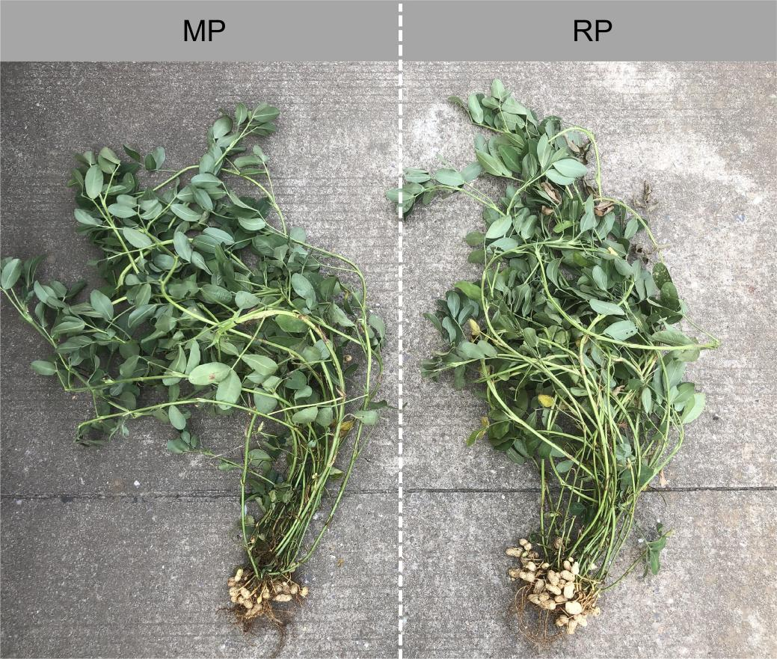
Supplementary Figure 2 Representative images showing monocropping reduces the pod number of peanut plants in pot experiment. MP, monocropping; RP, rotation.

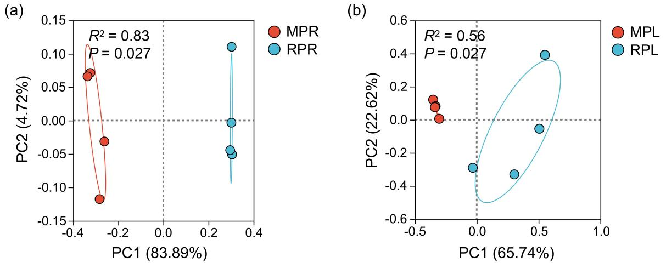
Supplementary Figure 3 PCoA (based on the relative abundance of OTUs) analysis of Bray-Curtis distances of rhizosphere and leaf epiphytic samples under MP and RP conditions. (a) PCoA (based on the relative abundance of OTUs) analysis of Bray-Curtis distances of rhizosphere samples under MP and RP conditions. (b) PCoA (based on the relative abundance of OTUs) analysis of Bray-Curtis distances of leaf epiphytic samples under MP and RP conditions. PERMANOVA was performed using the adonis function from the R package. MPR, monocropped rhizosphere; RPR, rotated rhizosphere; MPL, monocropped leaf epiphyte; RPL, rotated leaf epiphyte.

Supplementary Figure 4 Heatmap of the top 30 most abundant in metabolic and ecological functions of bacteria based on FAPROTAX prediction. FAPROTAX, functional annotation of prokaryotic taxa.

