Fig.S1 Schematic diagram of field experiment and sampling of fava beans and soils. The Big group consists of individuals with higher biomass and height, and the Little group consists of individuals with lower biomass and height.

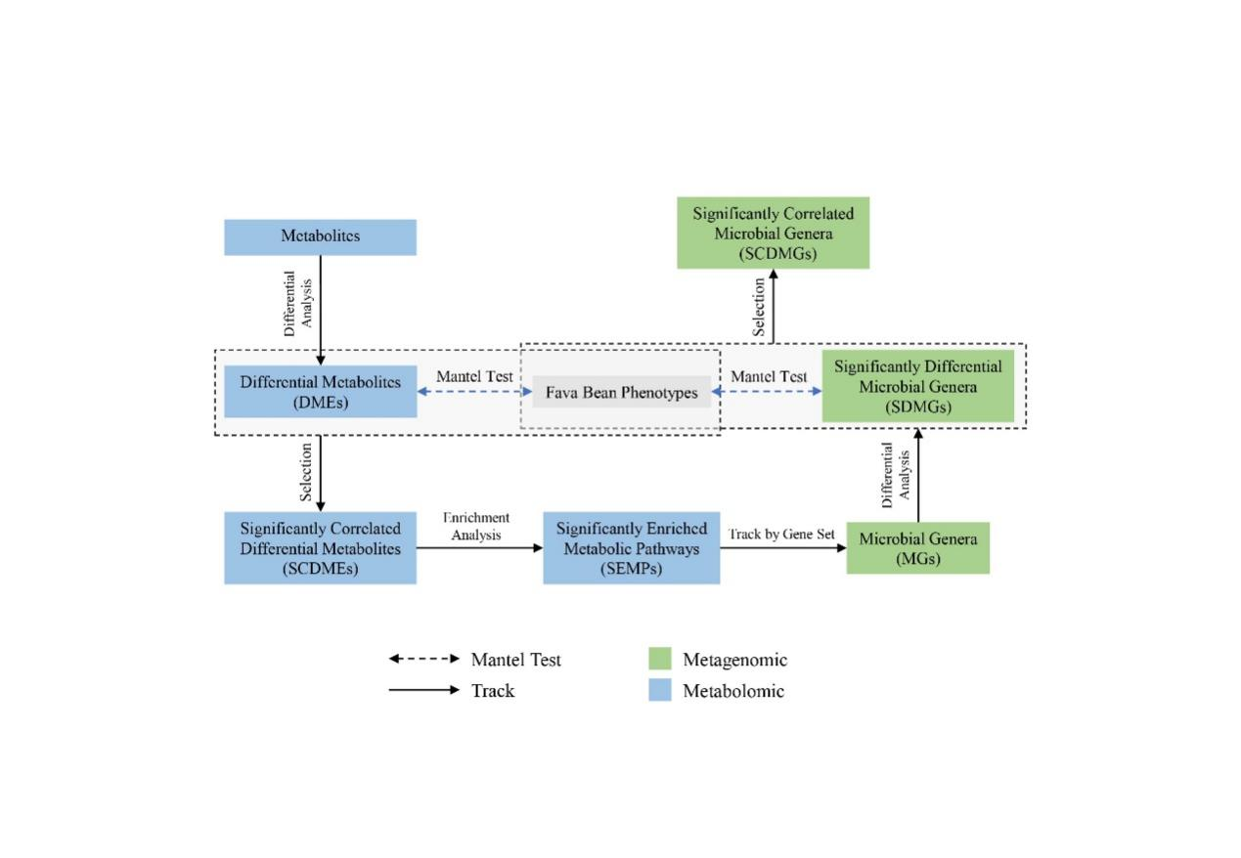Fig. S2. Flowchart of the multi-omics analyses for targeting the metabolites, microbial taxa and metabolic pathways that in relation to fava bean phenotypes.

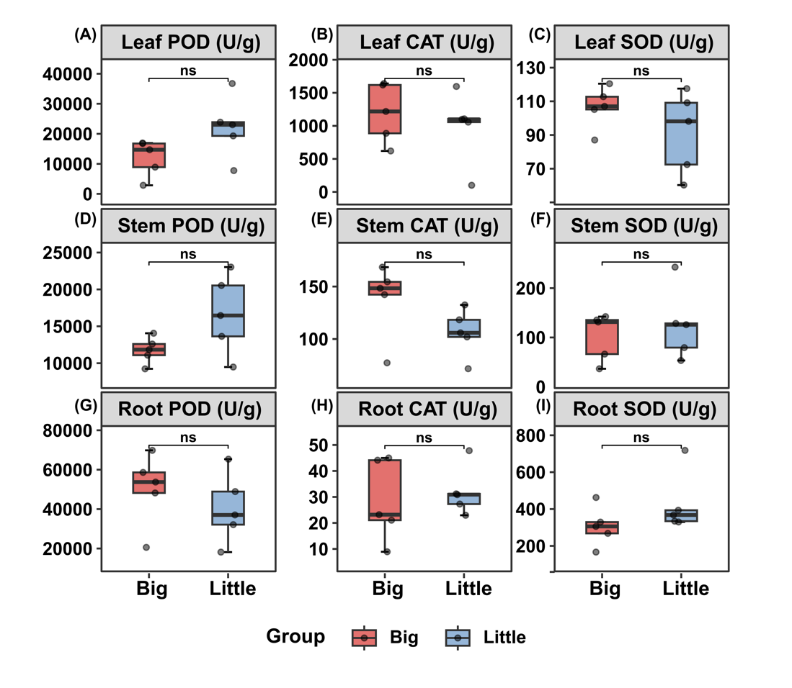
Fig.S3 Antioxidant enzyme activities of fava bean tissues. Peroxidase (POD) (A), catalase (CAT) (B) and peroxidase (POD) (C) of leaf, the peroxidase (POD) (D), catalase (CAT) (E) and peroxidase (POD) (F) of stem, and the peroxidase (POD) (G), catalase (CAT) (H) and peroxidase (POD) (I) of root. Significant difference of each variable between the two groups (Big vs Little) was measured by Wilcoxon rank-sum test analysis. Asterisks indicate significance: P < 0.05 (*); P < 0.01 (**); P < 0.001 (***). The Big group consists of individuals with higher biomass and height, and the Little group consists of individuals with lower biomass and height.

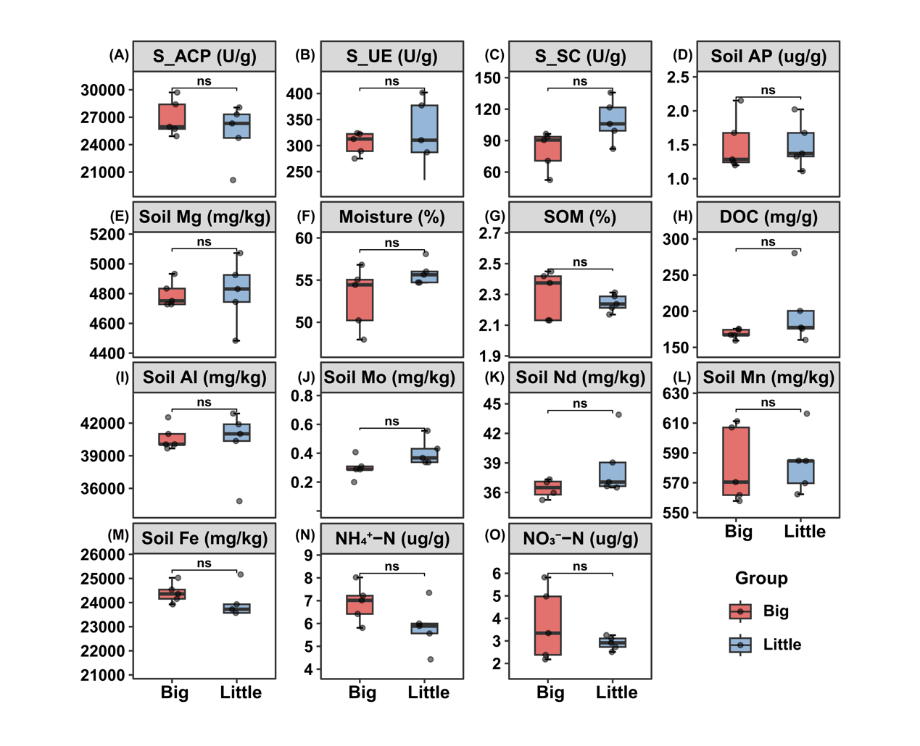
Fig.S4 Rhizosphere soil enzymatic activities between the two groups (Big vs Little) of fava beans phenotypes. (A): Soil acid phosphatase enzyme activity (S_ACP), (B): soil urease enzyme activity (S-UE), (C): soil sucrase enzyme activity (S-SC). The concentration of soil available P (D) and Mg (E). Rhizosphere soil moisture (F). Soil organic matter (G) and dissolved organic carbon (H). The concentration of soil Al (I), Mo (J), Nd (K), Mn (L), Fe (M), NH₄⁺−N (N) and NO₃ ⁻-N (O). Significant difference of each variable between the two groups (Big vs Little) was measured by Wilcoxon rank-sum test analysis. Asterisks indicate significance: P < 0.05 (*); P < 0.01 (**); P < 0.001 (***). The Big group consists of individuals with higher biomass and height, and the Little group consists of individuals with lower biomass and height.

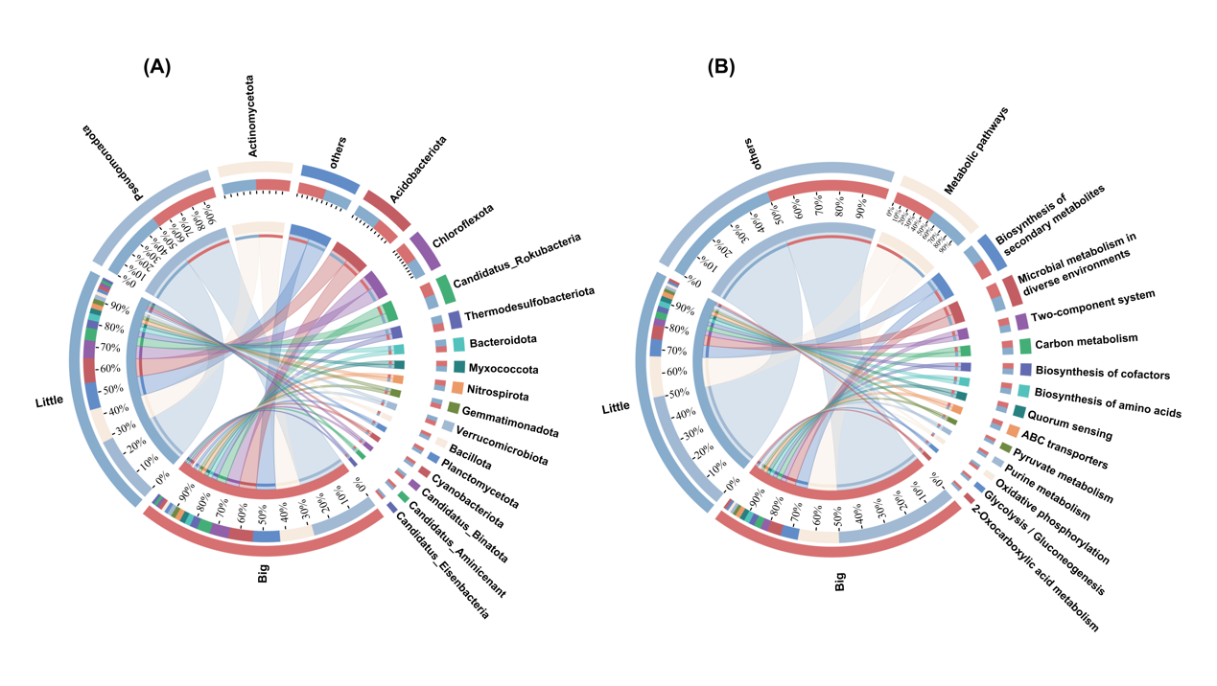
Fig.S5 The composition of rhizosphere microbial communities at phylum level (A) and metabolic pathways at KEGG level 3 (B). The Big group consists of individuals with higher biomass and height, and the Little group consists of individuals with lower biomass and height.
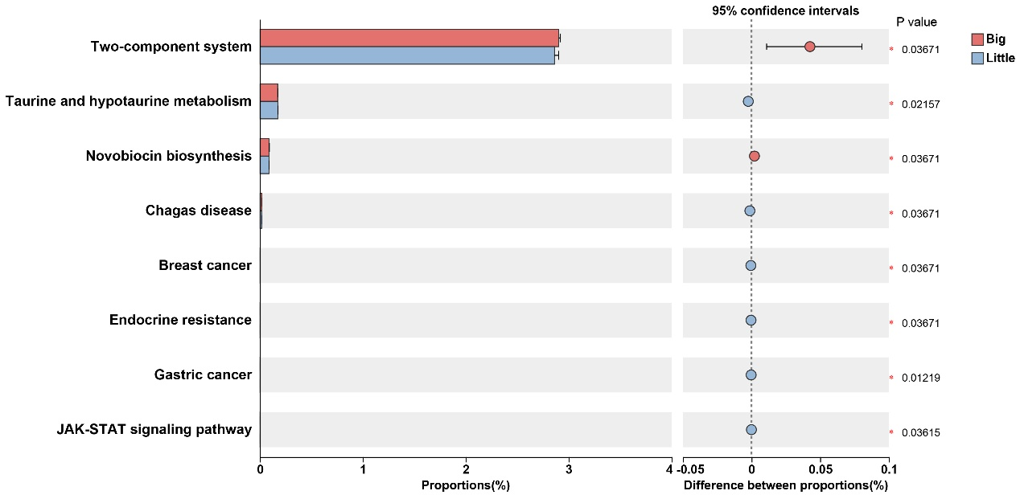
Fig.S6 Differential metabolic pathways in rhizosphere soils between the two groups. The Big group consists of individuals with higher biomass and height, and the Little group consists of individuals with lower biomass and height.

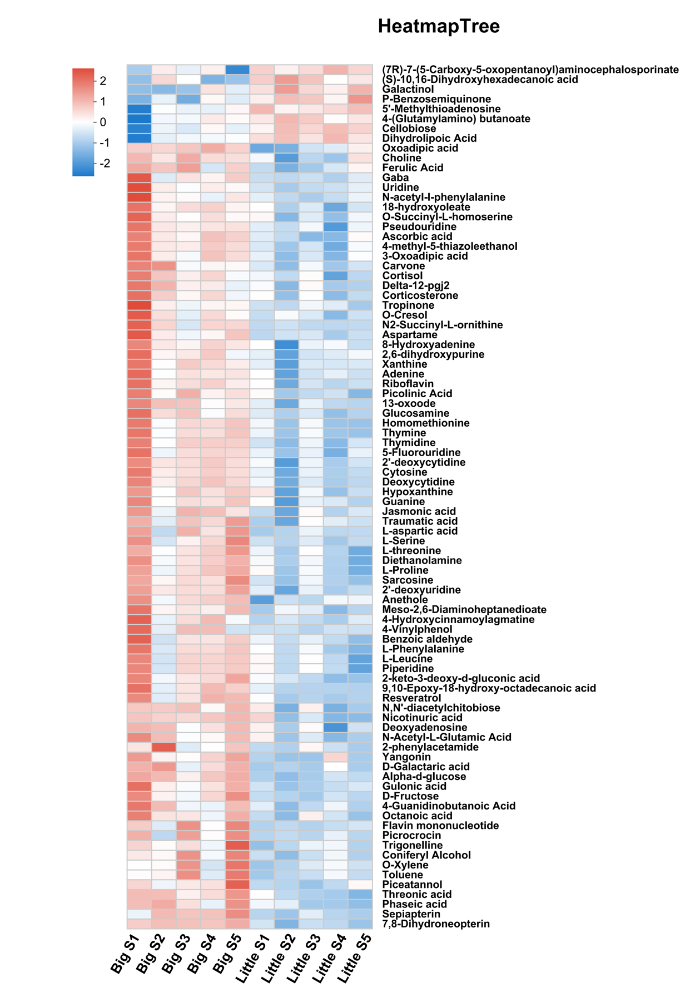
Fig.S7 The relative abundance of the metabolites that could be identified by KEGG function annotation. The Big group consists of individuals with higher biomass and height, and the Little group consists of individuals with lower biomass and height.

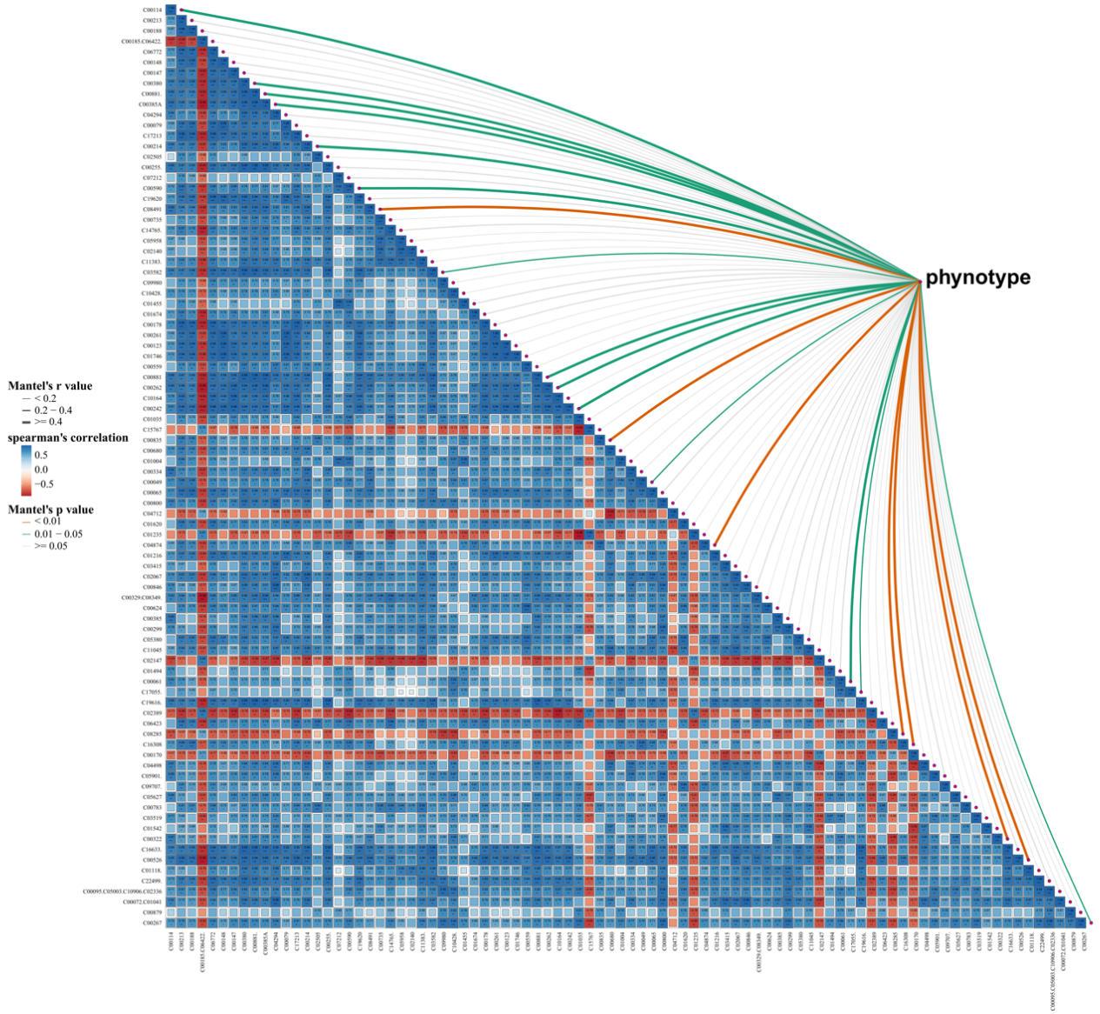
Fig.S8 Mantel-test analysis of associations between differential metabolites and phenotypes of fava beans. The Mantel's r value is proportional to the width of the line, and significant associations between metabolites and phenotypes were considered at Mantel's P < 0.05. Spearman's correlation analysis was used to identified the correlation between metabolites, and statistically significant correlation was considered at P < 0.05. Asterisks indicate significance: P < 0.05 (*); P < 0.01 (**); P < 0.001 (***). The Big group consists of individuals with higher biomass and height, and the Little group consists of individuals with lower biomass and height.

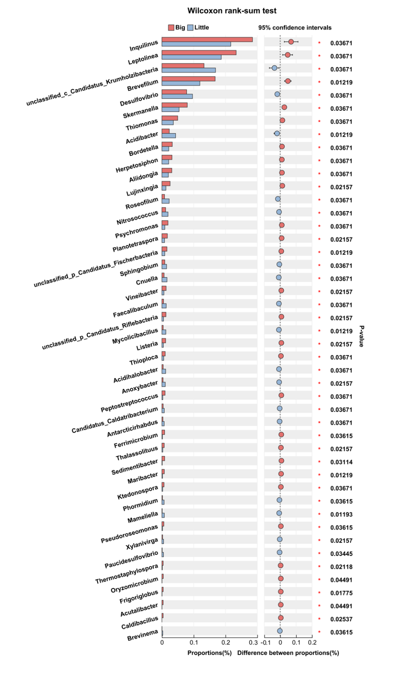
Fig.S9 Differential rhizosphere microbial genera that involving in the 15 metabolic pathways enriched by the differential metabolites that associating with phenotype of fava beans. Significant difference of each variable between the two groups (Big vs Little) was measured by Wilcoxon rank-sum test analysis. Asterisks indicate significance: P < 0.05 (*); P < 0.01 (**); P < 0.001 (***). The Big group consists of individuals with higher biomass and height, and the Little group consists of individuals with lower biomass and height.
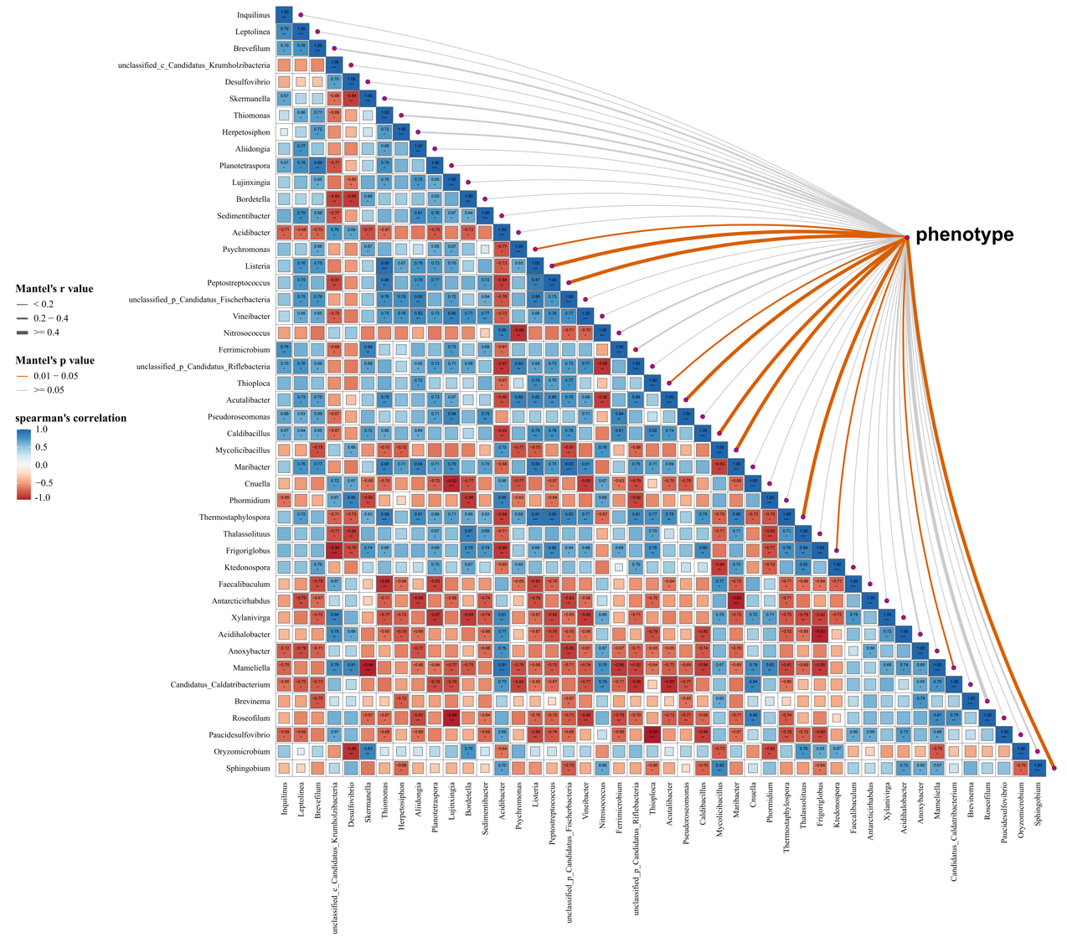
Fig.S10 Mantel-test analysis of associations between rhizosphere microbial genera and phenotypes of fava beans. The Mantel's r value is proportional to the width of the line, and significant associations between microbial genera and phenotypes were considered at Mantel's P < 0.05. Spearman's correlation analysis was used to identified the correlation between microbial genera, and statistically significant correlation was considered at P < 0.05. Asterisks indicate significance: P < 0.05 (*); P < 0.01 (**); P < 0.001 (***). The Big group consists of individuals with higher biomass and height, and the Little group consists of individuals with lower biomass and height.

