Distinct microbial communities drive methane cycling in below- and above-ground compartments of tropical cloud forests growing on peat

Authors’ information
Fahad Ali Kazmi¹, Ülo Mander¹, Ramita Khanongnuch¹, Maarja Öpik², Reti Ranniku^{1,3}, Kaido Soosaar¹, Mohit Masta¹, Salla A. M. Tenhovirta^{1,4,5}, Kuno Kasak^{1,6}, Claudine Ah-Peng^{7,8}, Mikk Espenberg¹

Corresponding author:
Fahad Ali Kazmi¹ fahad.ali.kazmi@ut.ee
ORCID: https://orcid.org/0000-0001-8088-961X

Affiliations
¹ Department of Geography, University of Tartu, Tartu, 51003 Estonia
² Department of Botany, University of Tartu, Tartu, 50409 Estonia
³ Department of Biological and Agricultural Engineering, University of Arkansas, Fayetteville, AR 72701, USA
⁴ Department of Agricultural Sciences, Environmental Soil Science, University of Helsinki, Finland
⁵ Institute for Atmospheric and Earth System Research, University of Helsinki, Finland
⁶ Department of Environmental Science, Policy and Management, University of California, Berkeley, USA
⁷ UMR PVBMT, Université de La Réunion, 97410 Saint-Pierre, La Réunion, France
⁸ OSU-Réunion, Université de La Réunion, 97400 Saint-Denis, La Réunion, France

Supplementary material
This supplementary material includes:
1. Extended methods, including references
2. Supplementary tables (Tables S1-S6)
3. Additional qPCR melting curves and intensities

Extended methods
Metagenomic data processing
Raw metagenomic reads were quality filtered and adapters were trimmed using fastp v0.23.2 (Chen et al. 2018) using the following options: -q -y -g -Y 10 -l 100 -b 150 -B 150. The clean reads from each sample were de novo assembled individually using MEGAHIT v1.2.9 (Li et al. 2015) with the following options: --min-contig-len 200 --k-list 21,41,61,81,101,121. Assembled contigs were used to predict protein-coding sequences (CDSs) with Prodigal v2.6.3 (Hyatt et al. 2010) in metagenomic mode. To reduce sequence redundancy, redundant genes were clustered using CD-HIT v4.8.1(Li and Godzik 2006; Fu et al. 2012) with parameters: -c 0.95 -aS 0.9. CDSs were annotated using DIAMOND v2.1.10.164 in blastp mode (-max-target-seqs 1 --evalue 1e-5 -d uniprot_db) against the UniProtKB/SwissProt reference database (release 2024_05). Assembled contigs of each sample were indexed using bowtie2-build and clean reads were aligned to the assemblies using bowtie2 (bowtie2 v2.5.4, (Langmead and Salzberg 2012). The obtained SAM files were converted to BAM format and sorted using SAMtools v1.21 (Danecek et al. 2021). Gene abundance was quantified with featureCounts v2.0.8 (Liao et al. 2014) to obtain raw read counts. The annotations were then mapped to the corresponding gene IDs based on the matching of gene identifiers from the GFF file used during the featureCounts step. Genes associated with aerobic CH₄ oxidation, methanol oxidation, and methanogenesis were identified using Python (v3.12.3) libraries such as pandas (v2.2.3), glob, and os. Specifically, gene annotations were filtered by searching for gene name identifiers (GN) corresponding to functional genes involved in these pathways. The targeted keywords included: 'GN=pmo', 'GN=mmo', 'GN=xox', 'GN=mdh', 'GN=mox', 'GN=mcr', 'GN=mtr', 'GN=mtb', 'GN=mtm', 'GN=mtt'. To normalize for sequencing depth and compositional biases, we used the R package DESeq2 (V1.44.0) (Love et al. 2014) with the 'poscounts' size factor estimation method. Normalized counts were extracted using the DESeq2 function “counts (dds, normalized = TRUE)”, ensuring comparability across samples.
Microbial community composition, including all prokaryotes (bacteria and archaea), was analyzed based on small subunit (SSU) rRNA sequences. These sequences were extracted from clean reads of metagenome sequencing data using SortMeRNA v4.3.6 (Kopylova et al. 2012) then the data was used to estimate the relative abundances of microbial taxa. Nucleotide sequence alignment was performed using Nucleotide-Nucleotide BLAST 2.5.0+ (Altschul et al. 1990) against the SILVA SSU r138.2 database with the following parameters: -evalue 1e-50 -max_target_seqs 1.

Table S1. Primers’ detail and qPCR program settings.
Target gene | Primers | Primer reference | Amplicon size (bp) | Primer concentration (µM) | qPCR program
Bacterial 16S rRNA | Bact517F | (Liu et al. 2007) | 530 | 0,6 | 95°C 10 min; 35 cycles: 95°C 30 s; 60°C 45 s; 72°C 45 s
Bacterial 16S rRNA | Bact1028R | (Dethlefsen et al. 2008) | 530 | 0,6 | 95°C 10 min; 35 cycles: 95°C 30 s; 60°C 45 s; 72°C 45 s
Archaeal 16S rRNA | Arc519F | (Espenberg et al. 2016) | 393 | 0,6 | 95°C 10 min; 45 cycles: 95°C 15 s; 56°C 30 s; 72°C 30 s
Archaeal 16S rRNA | Arch910R
n-DAMO 16S rRNA | pq2F | (Ettwig et al. 2009) | 292 | 0,8 | 95 °C 10 min, 40 cycles: 95 °C 15 s, 60°C 30 s, 72 °C 30 s, 80 °C 30 sª
n-DAMO 16S rRNA | pq2R
mcrA | METH-F | (Espenberg et al. 2016) | 135 | 0,8 | 95 °C 10 min, 55 cycles: 95 °C 15 s, 51 °C 30 s, 72 °C 30 s
mcrA | mcrAqR
pmoA | A189F | (Costello and Lidstrom 1999) | 510 | 0,6 | 95 °C 10 min, 35 cycles: 95 °C 15 s, 57 °C 30 s, 72 °C 30 s
pmoA | Mb661R

Ecosystem | Erica forest | Mixed forest
Dominant Species | Erica reunionensis | Alsophila glaucifolia | Erica reunionensis
Archaeal 16S rRNA | 3.42×10¹⁰ ± 4.27×10⁹ | 5.25×10⁹ ± 1.64×10⁹ | 6.81×10¹⁰ ± 1.37×10¹⁰
Bacterial 16S rRNA | 3.62×10¹¹ ± 2.56×10¹⁰ | 1.19×10¹¹ ± 2.58×10¹⁰ | 1.51×10¹¹ ± 2.35×10¹⁰
mcrA | 3.97×10⁶ ± 3.97×10⁶ | 2.14×10⁷ ± 6.91×10⁶ | 3.56×10⁷ ± 4.94×10⁶
pmoA | n.d. | 1.09×10⁸ ± 9.40×10⁷ | 1.06×10⁸ ± 5.41×10⁷
n-DAMO 16S rRNA | 1.25×10⁸ ± 1.93×10⁷ | 4.89×10⁷ ± 1.31×10⁷ | 6.25×10⁷ ± 1.15×10⁷
Table S2. Abundance of studied genes in qPCR (gene copies g⁻¹ dw ± Standard error of means) in soil from different studied ecosystems.
Ecosystem | Sample type | Species | mcrA | pmoA | n-DAMO
Erica forest | Canopy soil | Erica reunionensis | NA | NA | NA
Erica forest | Leaves | Erica reunionensis | 1.66×10⁵ ± 1.66×10⁵ | n.d. | 2.97×10⁴ ± 2.24×10⁴
Erica forest | Stem cores | Erica reunionensis | n.d. | n.d. | n.d.
Mixed forest | Canopy soil | Alsophila glaucifolia | 1.59×10⁶ ± 6.44×10⁵ | 3.50×10⁴ ± 1.47×10⁴ | 2.93×10⁵ ± 5.82×10⁴
Mixed forest |  | Erica reunionensis | 9.78×10⁵ ± 5.49×10⁵ | 1.26×10⁴ ± 8.44×10³ | 1.75×10⁵ ± 3.95×10⁴
Mixed forest | Leaves | Alsophila glaucifolia | 8.42×10⁵ ± 6.18×10⁵ | n.d. | 3.64×10³ ± 3.64×10³
Mixed forest |  | Erica reunionensis | n.d. | n.d. | n.d.
Mixed forest | Stem cores | Alsophila glaucifolia | n.d. | n.d. | n.d.
Mixed forest |  | Erica reunionensis | n.d. | n.d. | n.d.
Table S3. Abundances of mcrA, pmoA, and n-DAMO 16S rRNA genes (copies g⁻¹ dw) in various samples collected from the above-ground compartments of cloud forests, presented as mean ± standard error of the mean. Canopy soil data is not available (NA) for the Erica forest. Gene instances that were not detected are indicated as not detected (n.d.).

Table S4. Quality control results of 36 DNA samples used in metagenomic sequencing for this study. DNA samples were extracted from different sample types, e.g. soil, canopy soil, and leaves, collected in Reunion Island. The quality control results were provided by Biomarker Technologies (BMKGENE), Münster, Germany. Since DNA samples were sent for multiple projects in the same time, the data have been cropped out to include only the samples relevant to this study.
No. | Library (Sample) Name | Samples type | Sites | Dominant Species | QC Results
 |  |  |  |  | Nuclei acid Quality | Lib prep Method | Species | Qubit Conc (ng/ul) | Region[300- 800] Size [BP] | nmol/l | Note
1 | RF1_B 1_S1 | Soil | Erica forest | Erica reunionensis | A | WGS | Environmental Samples | 10.6 | 529 | 30.36
2 | RF2_B 1_S3 | Soil | Erica forest | Erica reunionensis | A | WGS | Environmental Samples | 7.94 | 511 | 23.54
3 | RF3_B 1_S6 | Soil | Erica forest | Erica reunionensis | A | WGS | Environmental Samples | 11.4 | 529 | 32.65
4 | RF4_B 1_L1 | Leaves | Erica forest | Erica reunionensis | D | WGS | Environmental Samples | 3.3 | 448 | 11.16 | Insert size too small
5 | RF5_B 1_L2 | Leaves | Erica forest | Erica reunionensis | A | WGS | Environmental Samples | 8.08 | 516 | 23.72
6 | RF6_B 1_L3 | Leaves | Erica forest | Erica reunionensis | A | WGS | Environmental Samples | 9.26 | 501 | 28
7 | RF7_B 2_S1 | Soil | Erica forest | Erica reunionensis | A | WGS | Environmental Samples | 9.22 | 521 | 26.81
8 | RF8_B 2_S2 | Soil | Erica forest | Erica reunionensis | A | WGS | Environmental Samples | 20.4 | 507 | 60.96
9 | RF9_B 2_S4 | Soil | Erica forest | Erica reunionensis | A | WGS | Environmental Samples | 7.8 | 506 | 23.35
10 | RF10_ B2_L1 | Leaves | Erica forest | Erica reunionensis | A | WGS | Environmental Samples | 6.42 | 511 | 19.03
11 | RF11_ B2_L2 | Leaves | Erica forest | Erica reunionensis | A | WGS | Environmental Samples | 10.6 | 510 | 31.49
12 | RF12_ B2_L3 | Leaves | Erica forest | Erica reunionensis | A | WGS | Environmental Samples | 8.62 | 510 | 25.61
13 | RM1_S 1 | Soil | Mixed forest | Alsophila glaucifolia | A | WGS | Environmental Samples | 22.8 | 529 | 65.3
14 | RM2_S 3 | Soil | Mixed forest | Alsophila glaucifolia | A | WGS | Environmental Samples | 6.74 | 510 | 20.02
15 | RM3_S 4 | Soil | Mixed forest | Alsophila glaucifolia | A | WGS | Environmental Samples | 6.92 | 513 | 20.44
16 | RM4_C S1 | Canopy soil | Mixed forest | Erica reunionensis | A | WGS | Environmental Samples | 7.76 | 520 | 22.61
17 | RM5_C S3 | Canopy soil | Mixed forest | Erica reunionensis | A | WGS | Environmental Samples | 7.2 | 524 | 20.82
18 | RM6_C S4 | Canopy soil | Mixed forest | Erica reunionensis | A | WGS | Environmental Samples | 6.62 | 522 | 19.21
19 | RM7_F 1 | Canopy soil | Mixed forest | Alsophila glaucifolia | A | WGS | Environmental Samples | 8.88 | 512 | 26.28
20 | RM8_F 2 | Canopy soil | Mixed forest | Alsophila glaucifolia | A | WGS | Environmental Samples | 7.66 | 519 | 22.36
21 | RM9_F 3 | Canopy soil | Mixed forest | Alsophila glaucifolia | A | WGS | Environmental Samples | 10.7 | 518 | 31.29
22 | RM10_ L1 | Leaves | Mixed forest | Erica reunionensis | A | WGS | Environmental Samples | 10.4 | 514 | 30.65
23 | RM15_ S1 | Soil | Mixed forest | Erica reunionensis | A | WGS | Environmental Samples | 15.3 | 514 | 45.1
24 | RM16_ S2 | Soil | Mixed forest | Erica reunionensis | A | WGS | Environmental Samples | 11 | 517 | 32.23
25 | RM17_ S3 | Soil | Mixed forest | Erica reunionensis | A | WGS | Environmental Samples | 14.5 | 523 | 42
26 | RM18_ C1 | Canopy soil | Mixed forest | Erica reunionensis | A | WGS | Environmental Samples | 8.38 | 516 | 24.6
27 | RM19_ C2 | Canopy soil | Mixed forest | Erica reunionensis | A | WGS | Environmental Samples | 8.86 | 520 | 25.81
28 | RM20_ C3 | Canopy soil | Mixed forest | Erica reunionensis | A | WGS | Environmental Samples | 11.5 | 520 | 33.5
29 | RM21_ C4 | Canopy soil | Mixed forest | Erica reunionensis | A | WGS | Environmental Samples | 7.36 | 514 | 21.69
30 | RM22_ C5 | Canopy soil | Mixed forest | Erica reunionensis | A | WGS | Environmental Samples | 8.62 | 512 | 25.51
31 | RM23_ F1 | Canopy soil | Mixed forest | Alsophila glaucifolia | A | WGS | Environmental Samples | 5.86 | 504 | 17.61
32 | RM24_ F4 | Canopy soil | Mixed forest | Alsophila glaucifolia | A | WGS | Environmental Samples | 8.92 | 508 | 26.6
33 | RM25_ F6 | Canopy soil | Mixed forest | Alsophila glaucifolia | A | WGS | Environmental Samples | 10.4 | 488 | 32.29
34 | RM26_ L1 | Leaves | Mixed forest | Alsophila glaucifolia | D | WGS | Environmental Samples | 5.32 | 486 | 16.58
35 | RM27_ L2 | Leaves | Mixed forest | Alsophila glaucifolia | D | WGS | Environmental Samples | 13.2 | 450 | 44.44 | Insert size too small
36 | RM28_ L3 | Leaves | Mixed forest | Alsophila glaucifolia | A | WGS | Environmental Samples | 6.74 | 506 | 20.18

Table S5. Electropherogram demonstrating DNA fragment size distribution of 36 DNA samples extracted from different sample types, e.g. soil, canopy soil, and leaves, collected in Reunion Island. The analysis showed the DNA fragment distribution for metagenomic sequencing libraries.
No | Sample | Samples type | Sites | Dominant Species
1 | RF1_B1_S1 | Soil | Erica forest | Erica reunionensis | 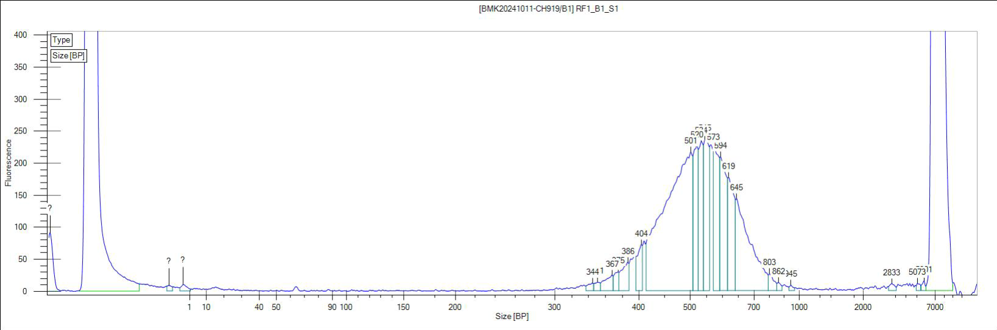
2 | RF2_B1_S3 | Soil | Erica forest | Erica reunionensis | 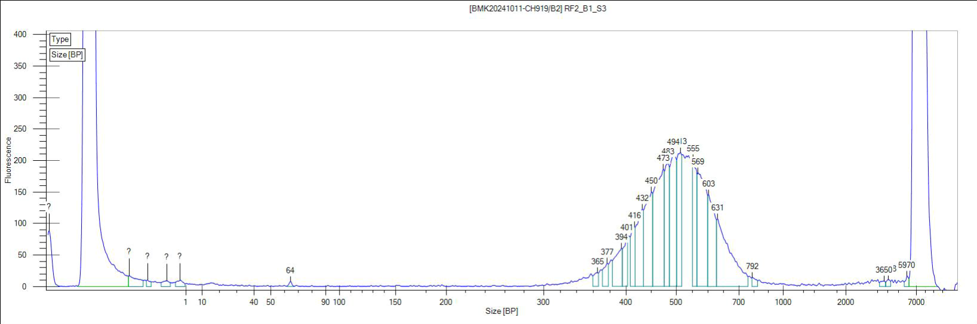
3 | RF3_B1_S6 | Soil | Erica forest | Erica reunionensis | 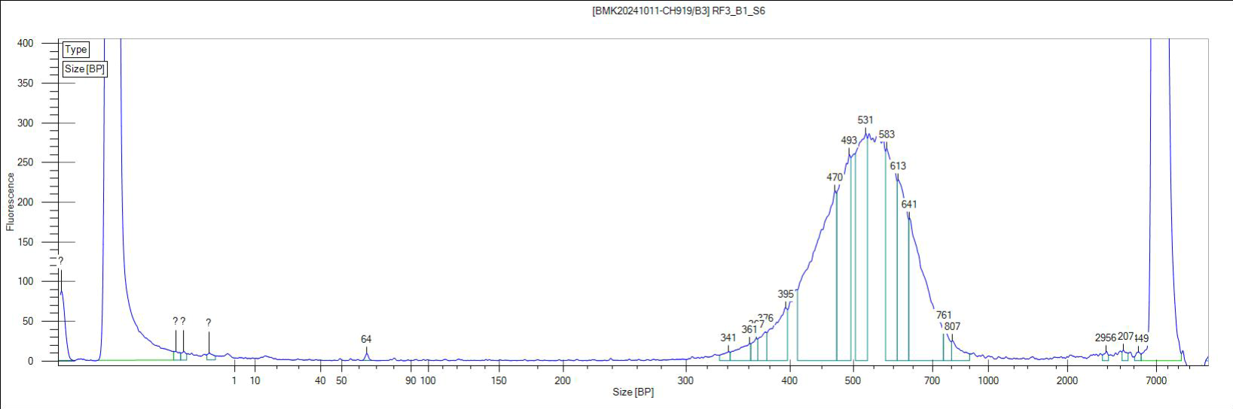
4 | RF4_B1_L1 | Leaves | Erica forest | Erica reunionensis | 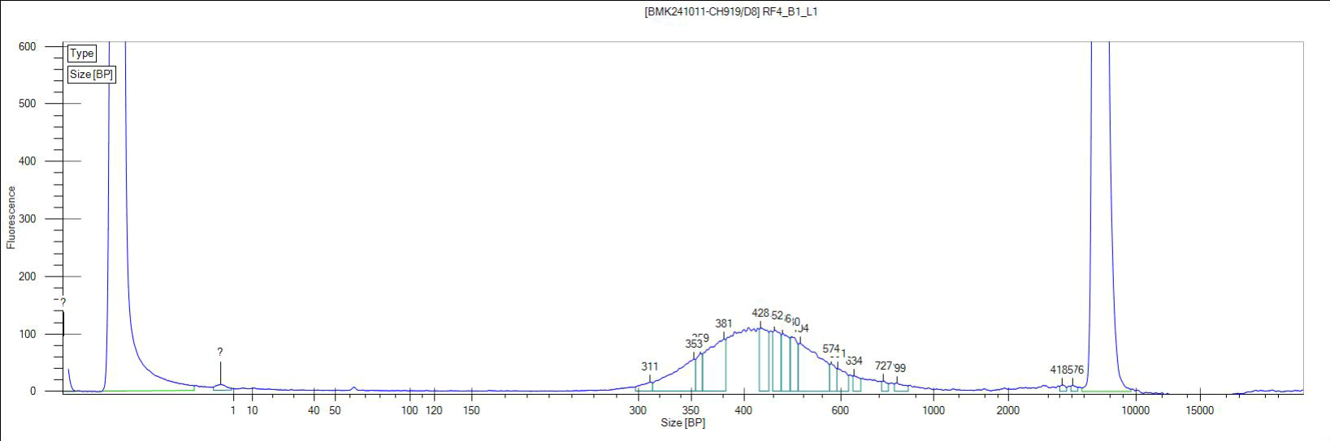
5 | RF5_B1_L2 | Leaves | Erica forest | Erica reunionensis | 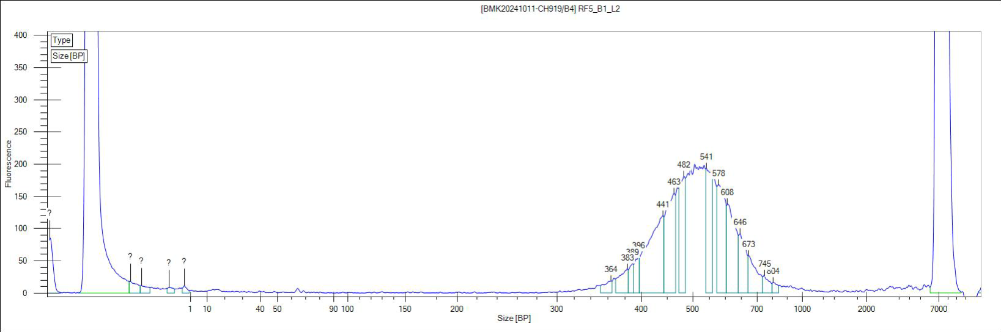
6 | RF6_B1_L3 | Leaves | Erica forest | Erica reunionensis | 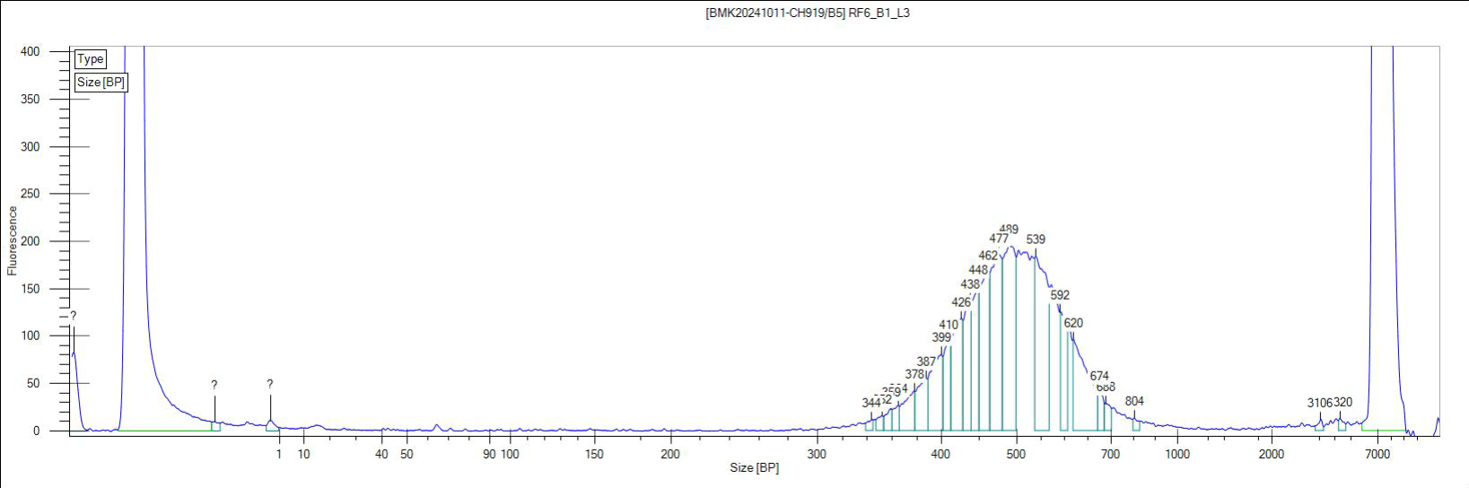
7 | RF7_B2_S1 | Soil | Erica forest | Erica reunionensis | 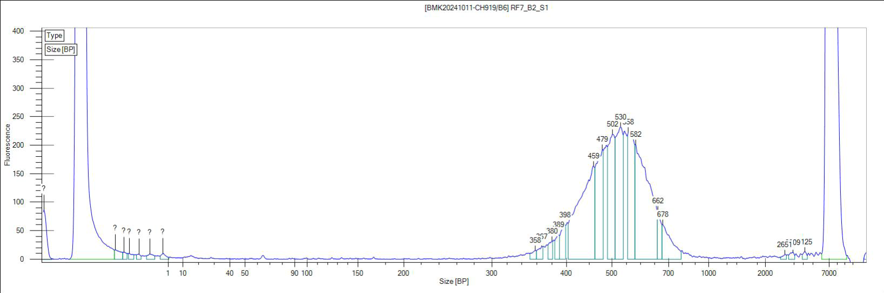
8 | RF8_B2_S2 | Soil | Erica forest | Erica reunionensis | 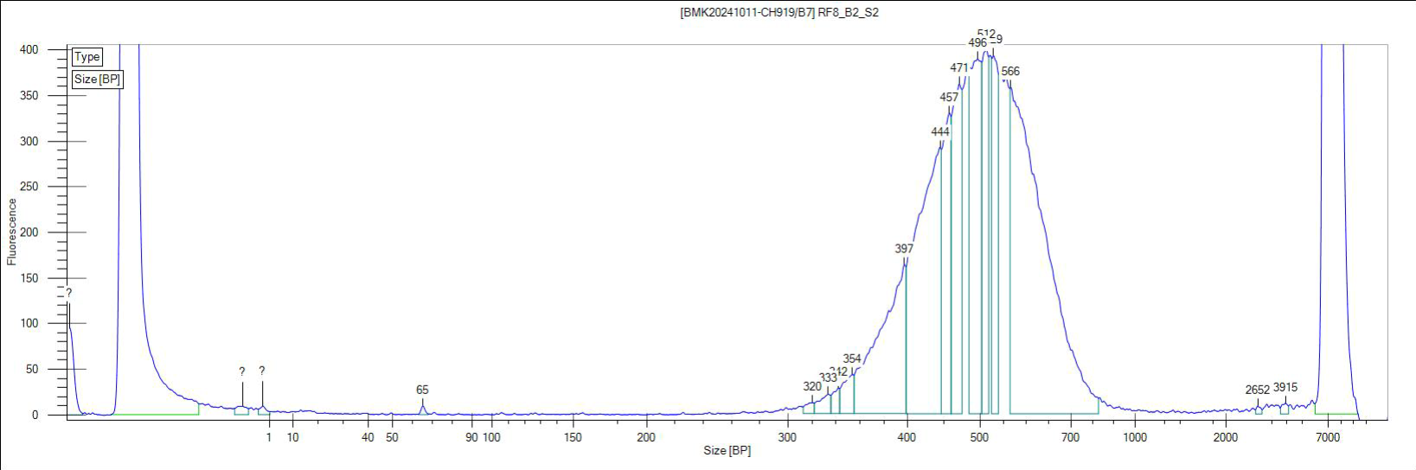
9 | RF9_B2_S4 | Soil | Erica forest | Erica reunionensis | 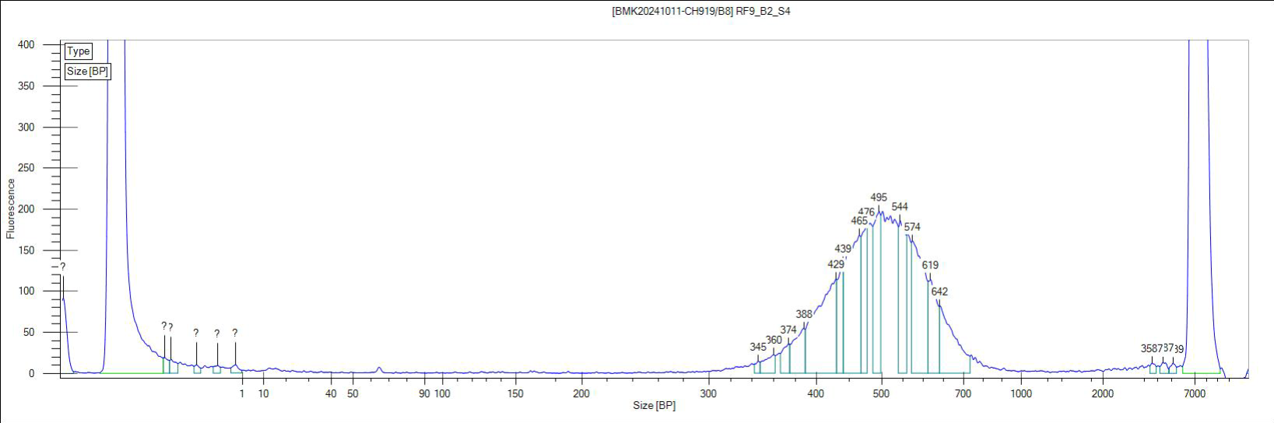
10 | RF10_B2_L1 | Leaves | Erica forest | Erica reunionensis | 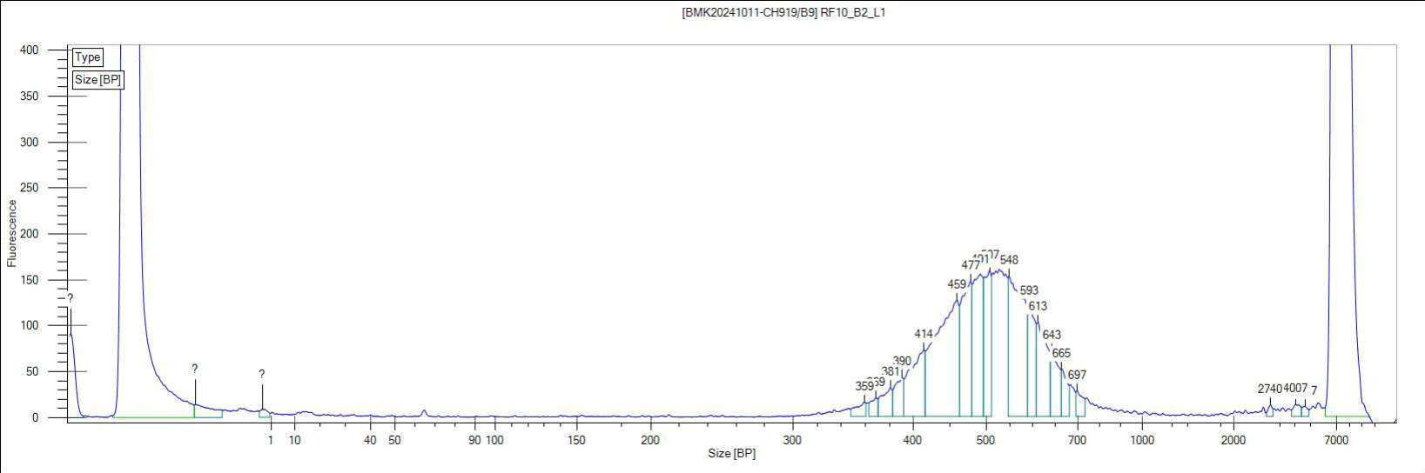
11 | RF11_B2_L2 | Leaves | Erica forest | Erica reunionensis | 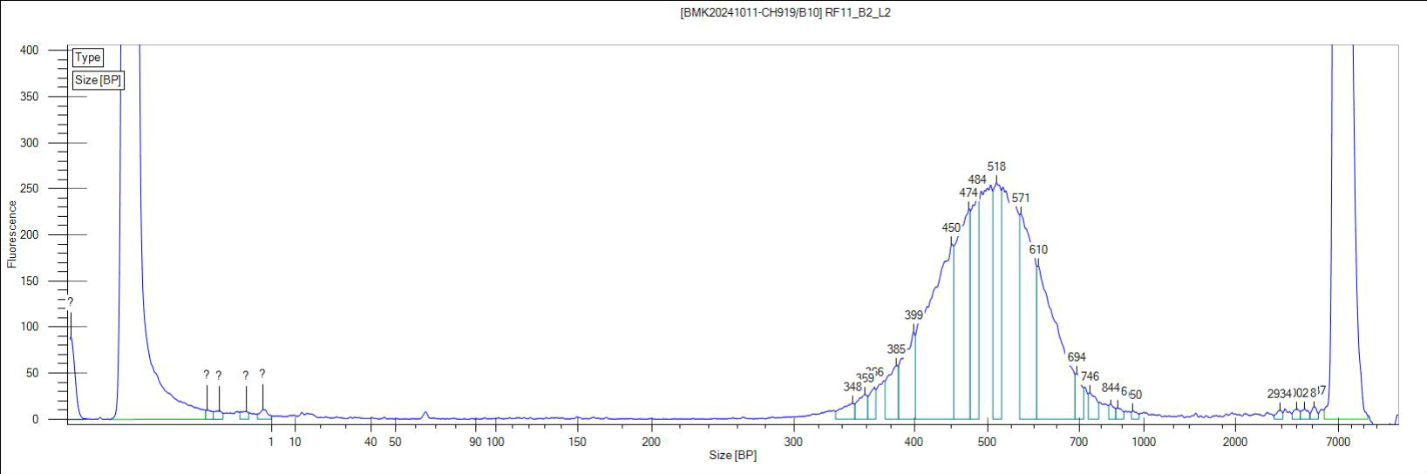
12 | RF12_B2_L3 | Leaves | Erica forest | Erica reunionensis | 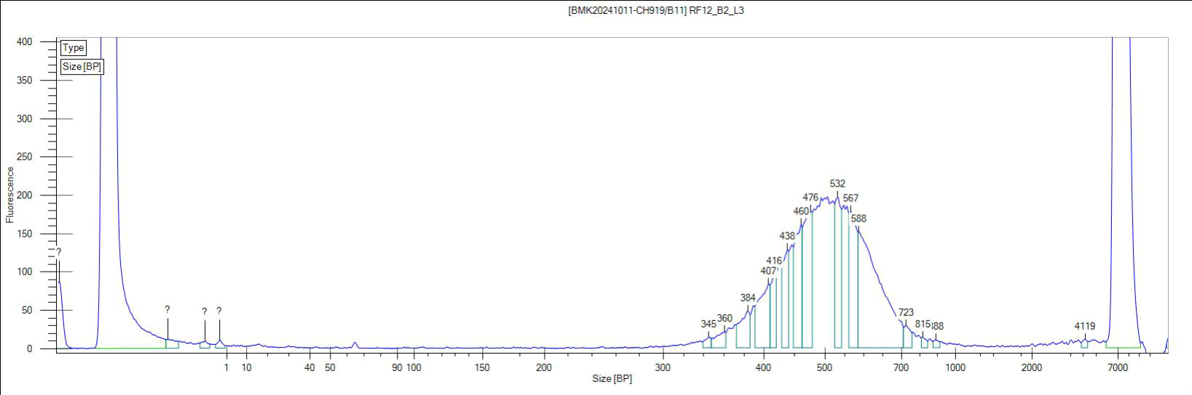
13 | RM1_S1 | Soil | Mixed forest | Alsophila glaucifolia | 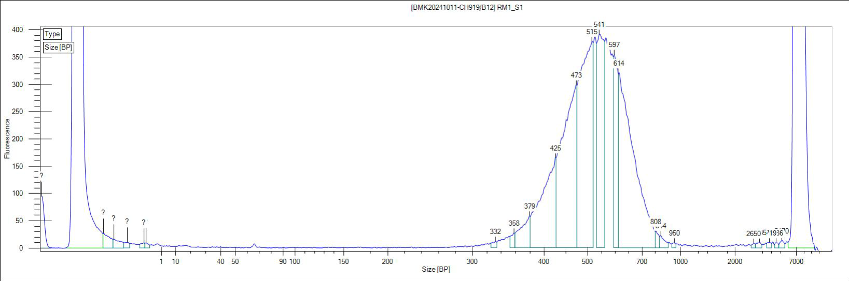
14 | RM2_S3 | Soil | Mixed forest | Alsophila glaucifolia | 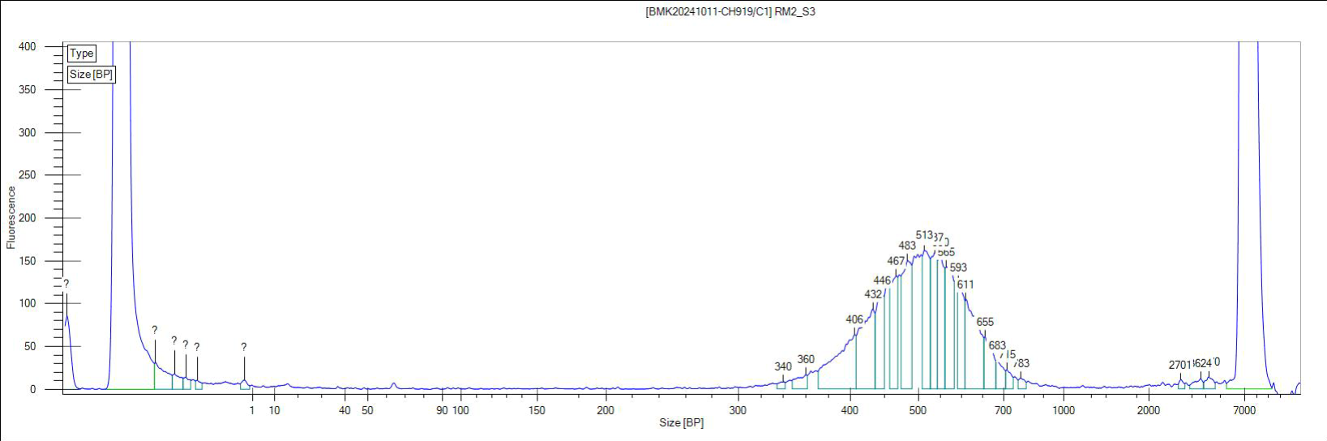
15 | RM3_S4 | Soil | Mixed forest | Alsophila glaucifolia | 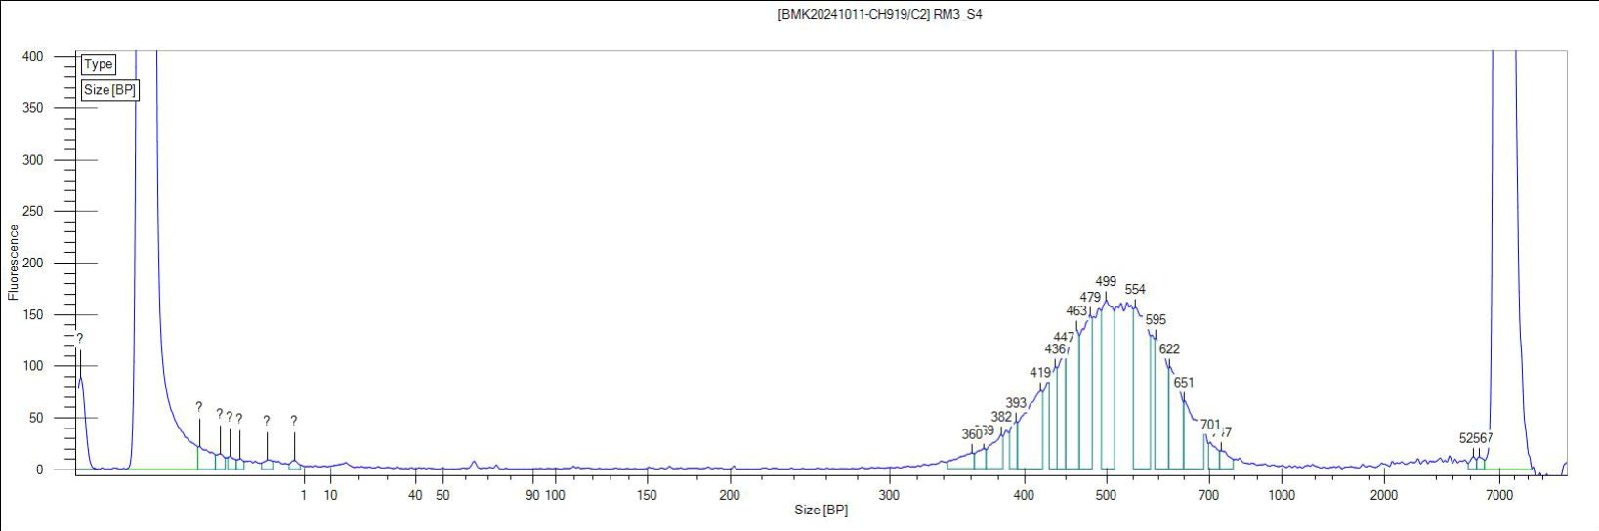
16 | RM4_CS1 | Canopy soil | Mixed forest | Erica reunionensis | 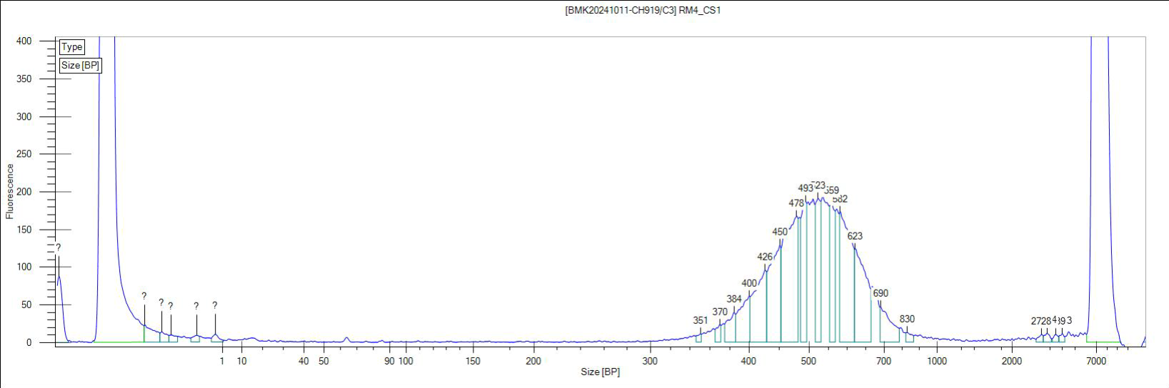
17 | RM5_CS3 | Canopy soil | Mixed forest | Erica reunionensis | 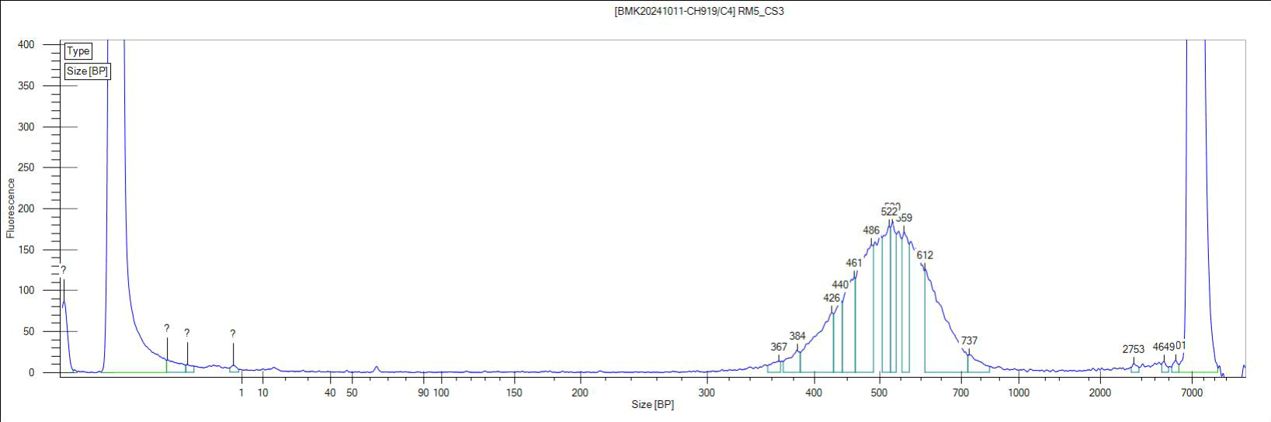
18 | RM6_CS4 | Canopy soil | Mixed forest | Erica reunionensis | 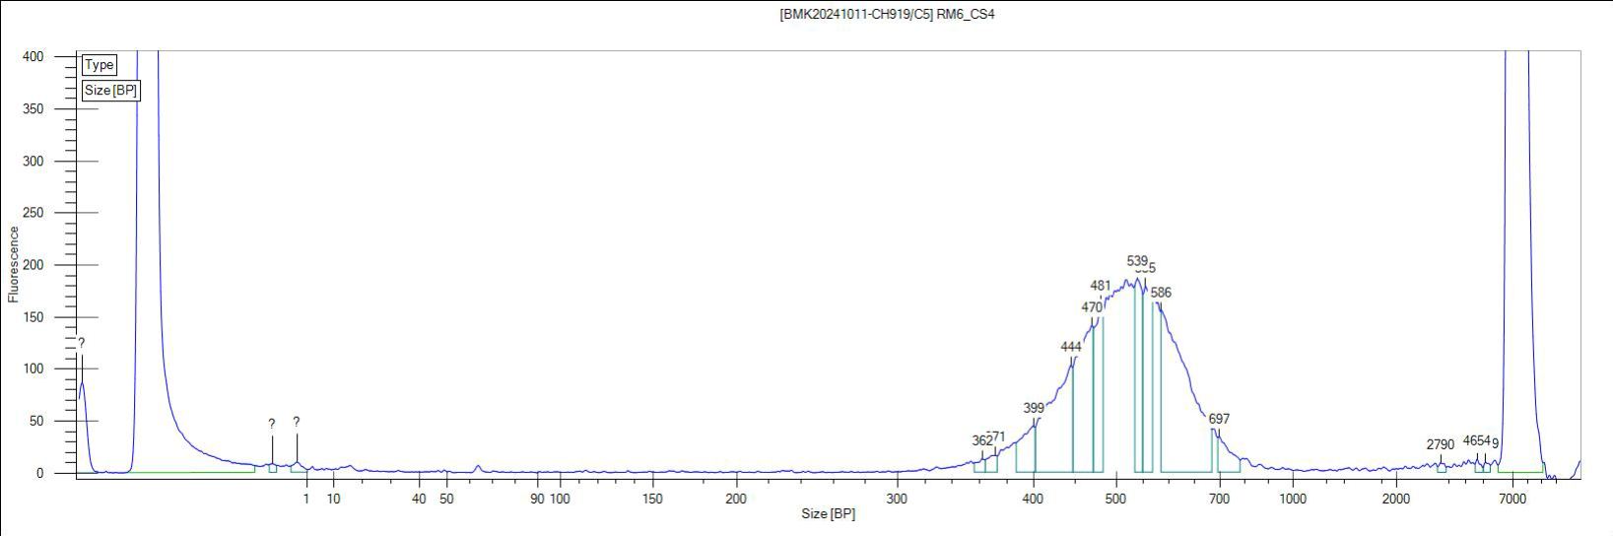
19 | RM7_F1 | Canopy soil | Mixed forest | Alsophila glaucifolia | 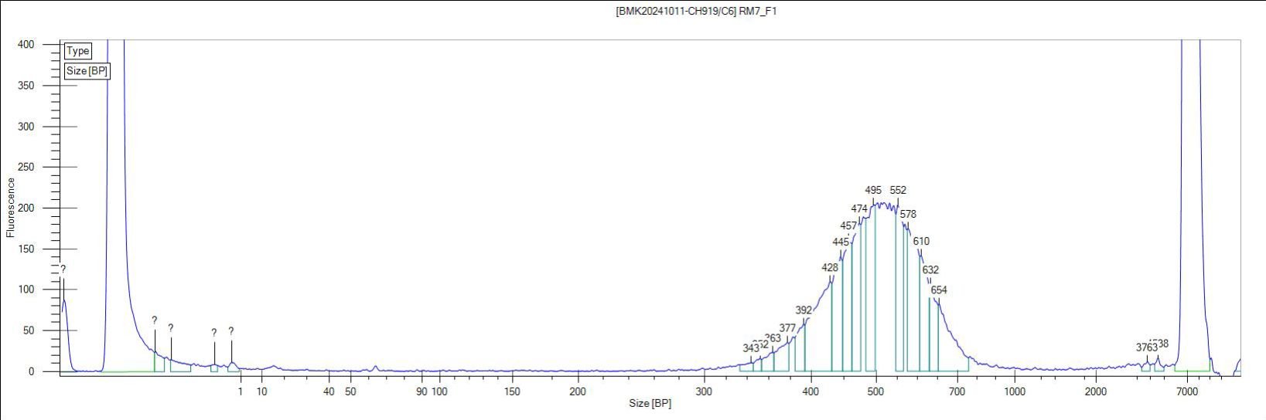
20 | RM8_F2 | Canopy soil | Mixed forest | Alsophila glaucifolia | 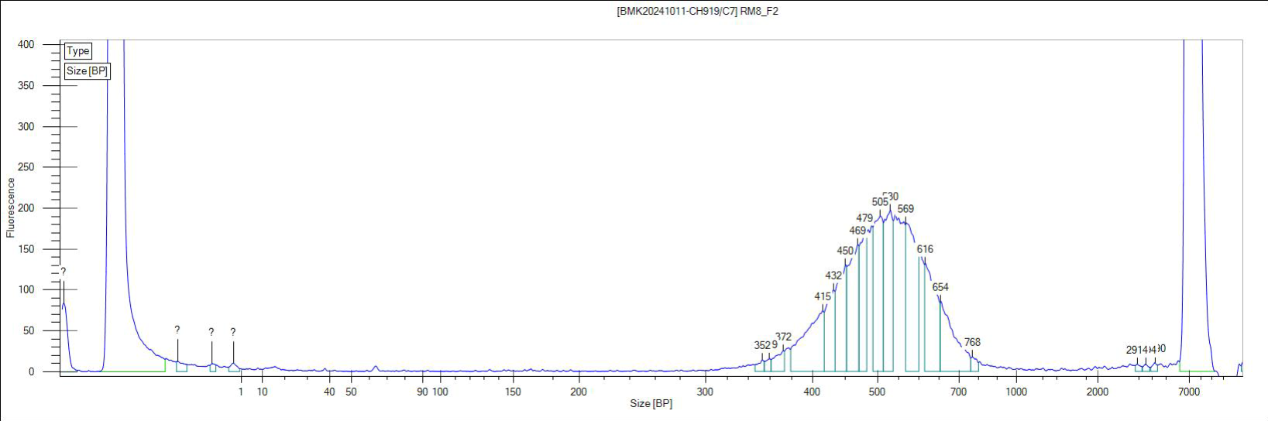
21 | RM9_F3 | Canopy soil | Mixed forest | Alsophila glaucifolia | 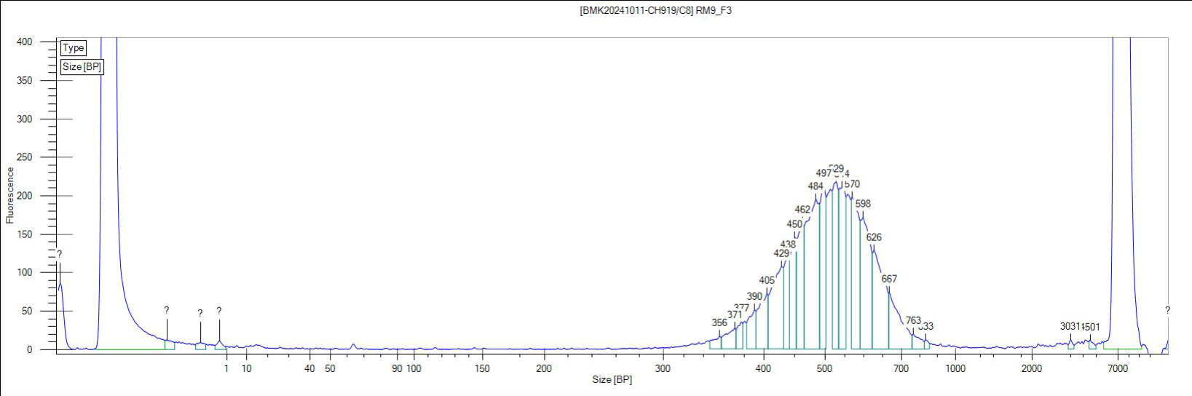
22 | RM10_L1 | Leaves | Mixed forest | Erica reunionensis | 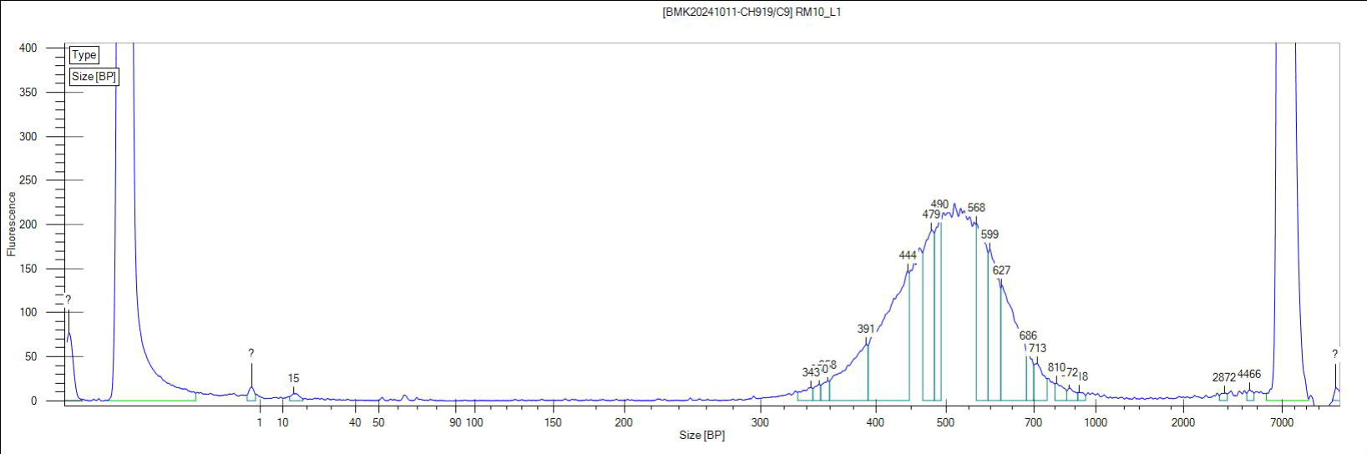
23 | RM15_S1 | Soil | Mixed forest | Erica reunionensis | 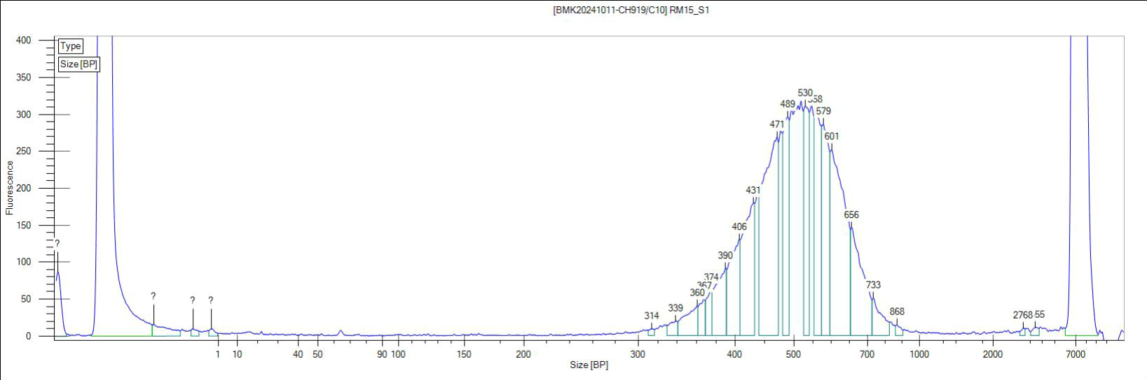
24 | RM16_S2 | Soil | Mixed forest | Erica reunionensis | 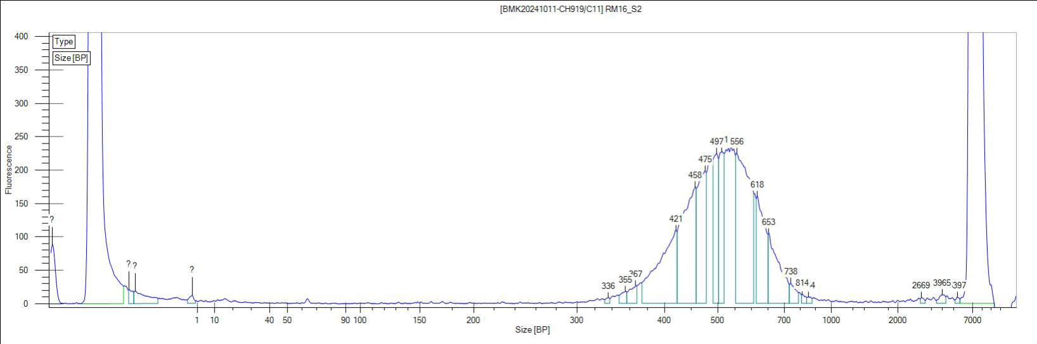
25 | RM17_S3 | Soil | Mixed forest | Erica reunionensis | 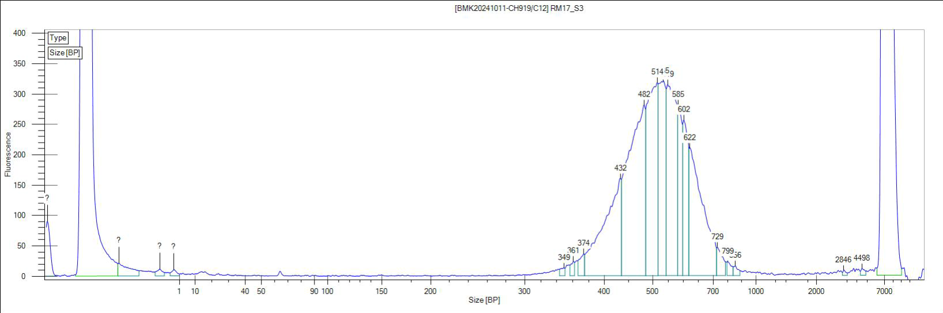
26 | RM18_C1 | Canopy soil | Mixed forest | Erica reunionensis | 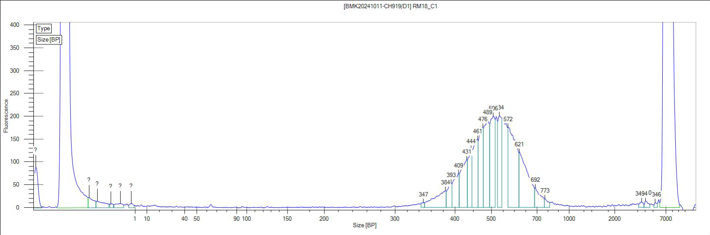
27 | RM19_C2 | Canopy soil | Mixed forest | Erica reunionensis | 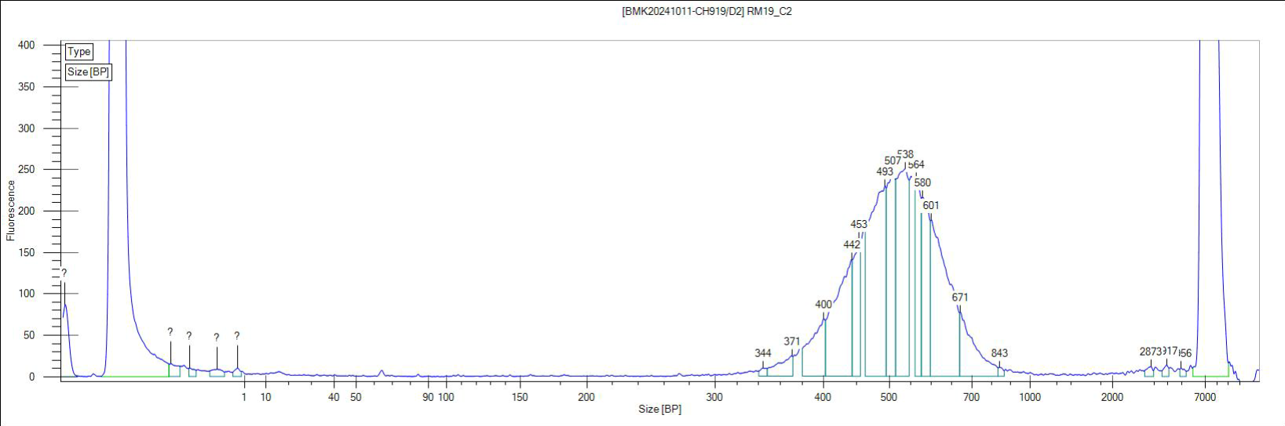
28 | RM20_C3 | Canopy soil | Mixed forest | Erica reunionensis | 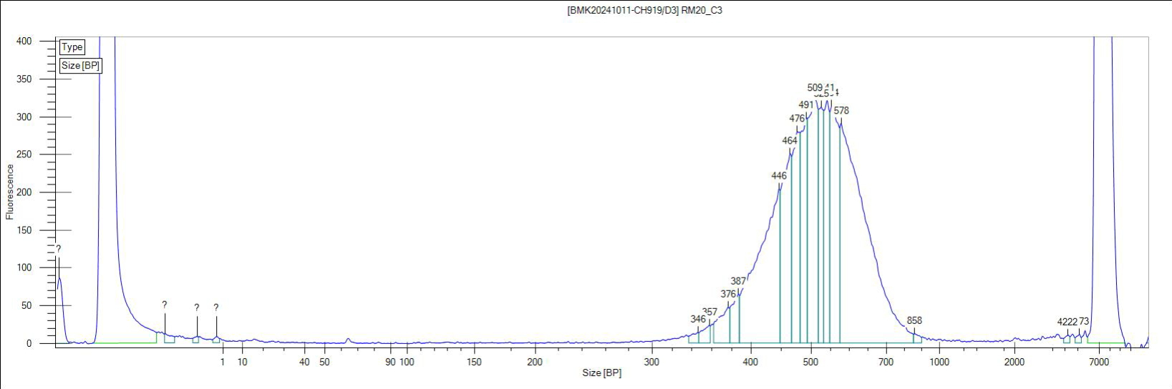
29 | RM21_C4 | Canopy soil | Mixed forest | Erica reunionensis | 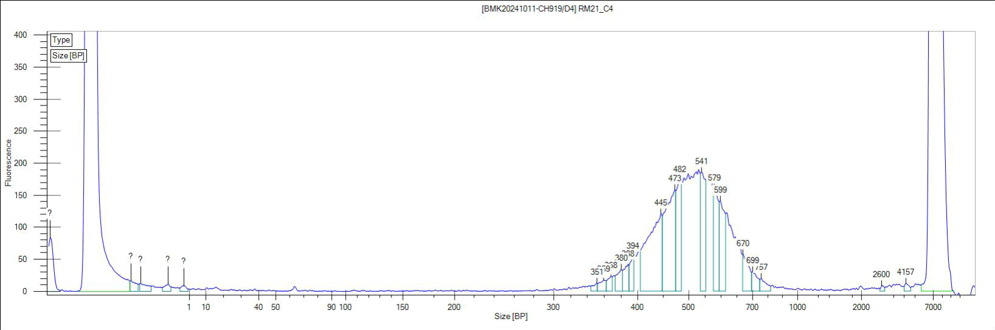
30 | RM22_C5 | Canopy soil | Mixed forest | Erica reunionensis | 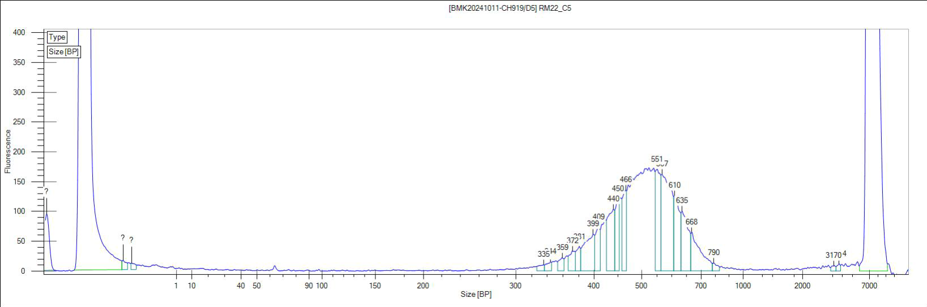
31 | RM23_F1 | Canopy soil | Mixed forest | Alsophila glaucifolia | 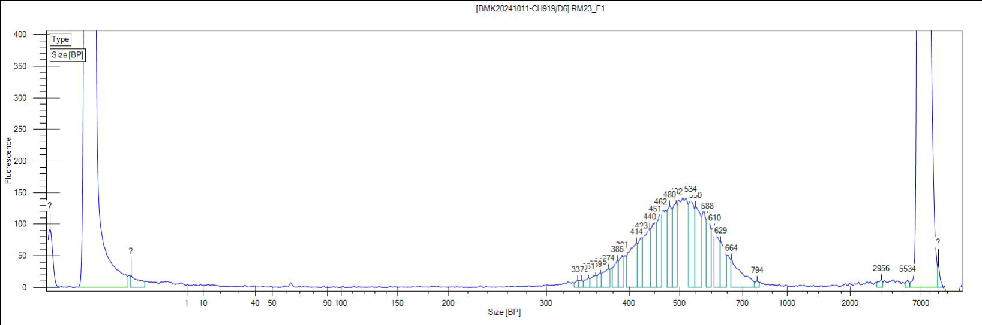
32 | RM24_F4 | Canopy soil | Mixed forest | Alsophila glaucifolia | 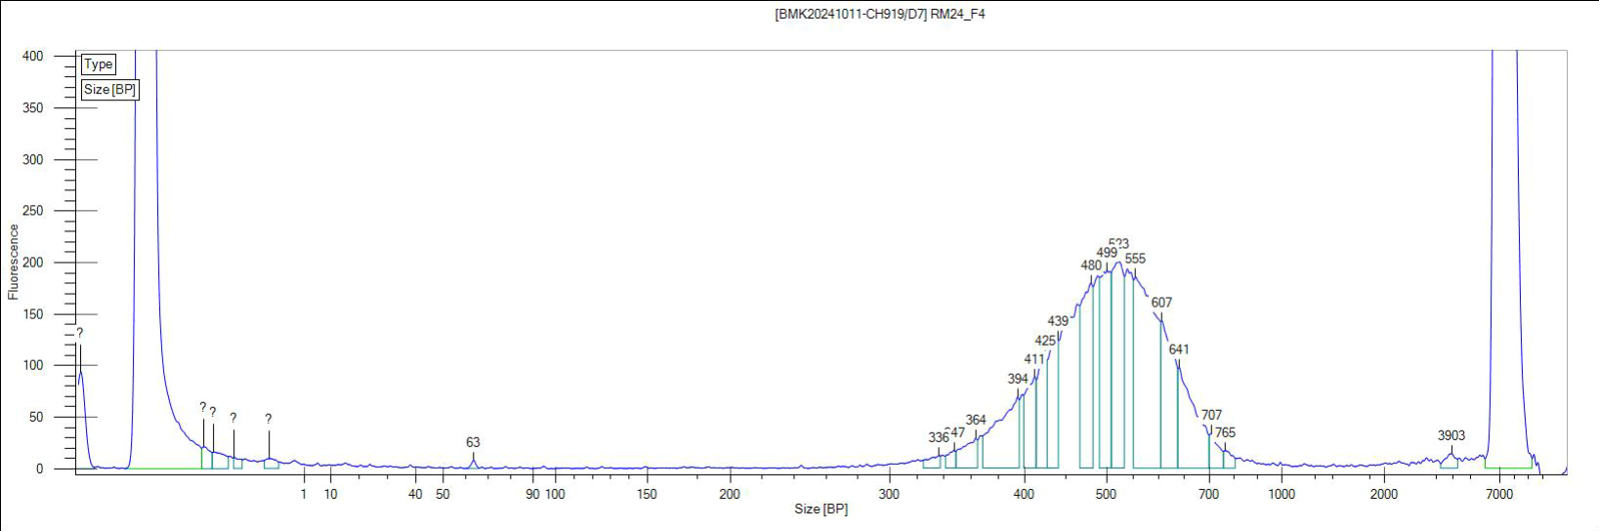
33 | RM25_F6 | Canopy soil | Mixed forest | Alsophila glaucifolia | 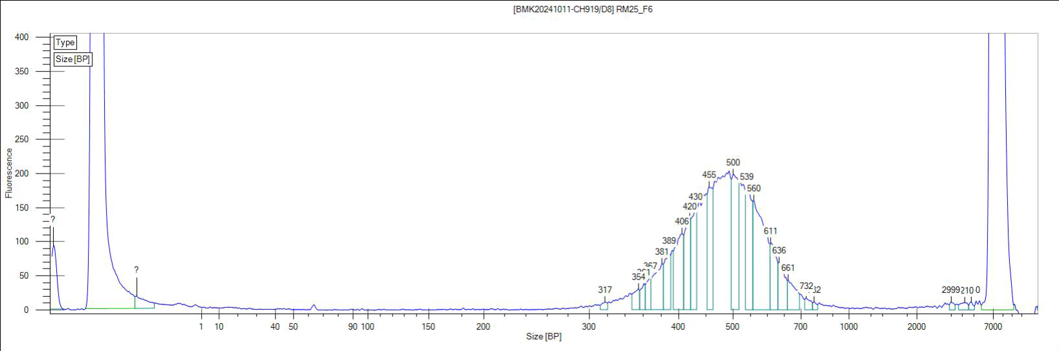
34 | RM26_L1 | Leaves | Mixed forest | Alsophila glaucifolia | 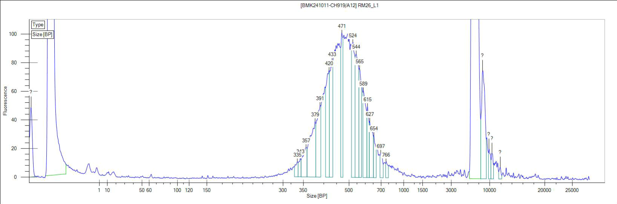
35 | RM27_L2 | Leaves | Mixed forest | Alsophila glaucifolia | 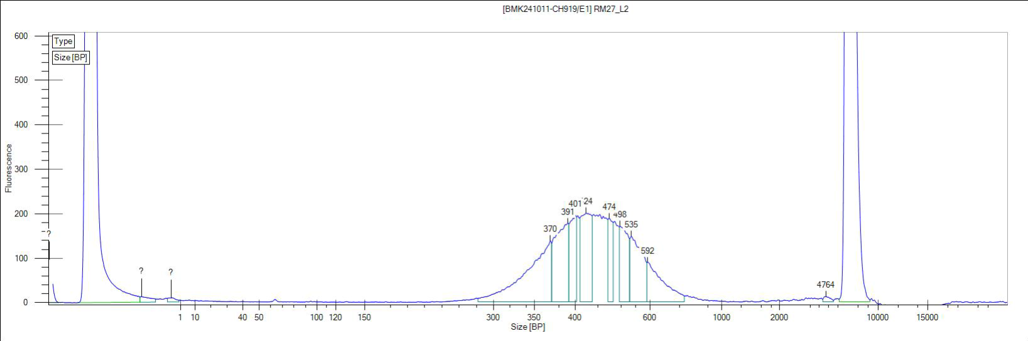
36 | RM28_L3 | Leaves | Mixed forest | Alsophila glaucifolia | 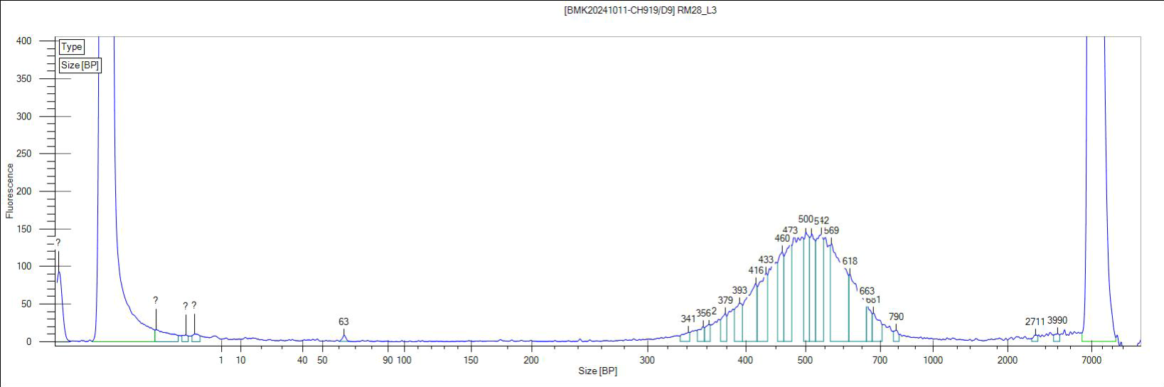

Table S6. Statistics on sequencing data of 36 DNA samples extracted from different sample types, e.g. soil, canopy soil, and leaves, collected in Reunion Island. The quality control results were provided by Biomarker Technologies (BMKGENE), Münster, Germany.
No | Sample | Samples type | Sites | Dominant Species | Reads | Data(bp) | Q20% | Q30% | GC%
1 | RF1_B1_S1 | Soil | Erica forest | Erica reunionensis | 48357982 | 7245562113 | 0.944 | 0.881 | 0.6142
2 | RF2_B1_S3 | Soil | Erica forest | Erica reunionensis | 53099766 | 7957086212 | 0.9517 | 0.8926 | 0.6161
3 | RF3_B1_S6 | Soil | Erica forest | Erica reunionensis | 56265814 | 8431390933 | 0.9524 | 0.894 | 0.6184
4 | RF4_B1_L1 | Leaves | Erica forest | Erica reunionensis | 42329824 | 6326982832 | 0.9559 | 0.8936 | 0.3486
5 | RF5_B1_L2 | Leaves | Erica forest | Erica reunionensis | 47323080 | 7079852406 | 0.9407 | 0.8645 | 0.3467
6 | RF6_B1_L3 | Leaves | Erica forest | Erica reunionensis | 43899396 | 6567849029 | 0.9582 | 0.8977 | 0.3521
7 | RF7_B2_S1 | Soil | Erica forest | Erica reunionensis | 49083236 | 7355214746 | 0.9478 | 0.8868 | 0.6177
8 | RF8_B2_S2 | Soil | Erica forest | Erica reunionensis | 56119490 | 8408568340 | 0.9514 | 0.8922 | 0.6158
9 | RF9_B2_S4 | Soil | Erica forest | Erica reunionensis | 55441604 | 8307764672 | 0.9501 | 0.8903 | 0.6205
10 | RF10_B2_L1 | Leaves | Erica forest | Erica reunionensis | 48110648 | 7196939643 | 0.9606 | 0.9021 | 0.3471
11 | RF11_B2_L2 | Leaves | Erica forest | Erica reunionensis | 44211362 | 6612504266 | 0.9585 | 0.8983 | 0.3438
12 | RF12_B2_L3 | Leaves | Erica forest | Erica reunionensis | 40732032 | 6091687158 | 0.956 | 0.8933 | 0.3422
13 | RM1_S1 | Soil | Mixed forest | Alsophila glaucifolia | 49236368 | 7378315464 | 0.953 | 0.8943 | 0.6162
14 | RM2_S3 | Soil | Mixed forest | Alsophila glaucifolia | 42433760 | 6357716425 | 0.9537 | 0.8961 | 0.5976
15 | RM3_S4 | Soil | Mixed forest | Alsophila glaucifolia | 52162938 | 7816910320 | 0.953 | 0.8949 | 0.6217
16 | RM4_CS1 | Canopy soil | Mixed forest | Erica reunionensis | 53462018 | 8009674491 | 0.9526 | 0.8924 | 0.5541
17 | RM5_CS3 | Canopy soil | Mixed forest | Erica reunionensis | 53896514 | 8075706666 | 0.952 | 0.8916 | 0.5975
18 | RM6_CS4 | Canopy soil | Mixed forest | Erica reunionensis | 40857598 | 6122296334 | 0.9509 | 0.8904 | 0.6263
19 | RM7_F1 | Canopy soil | Mixed forest | Alsophila glaucifolia | 48772688 | 7307206743 | 0.9477 | 0.8865 | 0.5971
20 | RM8_F2 | Canopy soil | Mixed forest | Alsophila glaucifolia | 55682794 | 8343117592 | 0.9535 | 0.8953 | 0.5948
21 | RM9_F3 | Canopy soil | Mixed forest | Alsophila glaucifolia | 45841434 | 6867950648 | 0.951 | 0.8911 | 0.6008
22 | RM10_L1 | Leaves | Mixed forest | Erica reunionensis | 43866772 | 6566918915 | 0.9593 | 0.8998 | 0.3607
23 | RM15_S1 | Soil | Mixed forest | Erica reunionensis | 59315768 | 8886475815 | 0.9544 | 0.8972 | 0.6031
24 | RM16_S2 | Soil | Mixed forest | Erica reunionensis | 50704156 | 7598211506 | 0.9512 | 0.8925 | 0.6136
25 | RM17_S3 | Soil | Mixed forest | Erica reunionensis | 47079068 | 7055560912 | 0.956 | 0.8995 | 0.6073
26 | RM18_C1 | Canopy soil | Mixed forest | Erica reunionensis | 51462690 | 7710584885 | 0.9535 | 0.8956 | 0.5968
27 | RM19_C2 | Canopy soil | Mixed forest | Erica reunionensis | 51460276 | 7711596818 | 0.9519 | 0.8923 | 0.6291
28 | RM20_C3 | Canopy soil | Mixed forest | Erica reunionensis | 50915038 | 7629340562 | 0.9511 | 0.8919 | 0.6321
29 | RM21_C4 | Canopy soil | Mixed forest | Erica reunionensis | 49682910 | 7443927843 | 0.9528 | 0.8952 | 0.609
30 | RM22_C5 | Canopy soil | Mixed forest | Erica reunionensis | 57609976 | 8630329778 | 0.9511 | 0.8909 | 0.6279
31 | RM23_F1 | Canopy soil | Mixed forest | Alsophila glaucifolia | 48271470 | 7230843952 | 0.9508 | 0.8916 | 0.6136
32 | RM24_F4 | Canopy soil | Mixed forest | Alsophila glaucifolia | 55005874 | 8239886793 | 0.953 | 0.8958 | 0.6116
33 | RM25_F6 | Canopy soil | Mixed forest | Alsophila glaucifolia | 55429436 | 8301259241 | 0.9562 | 0.8999 | 0.5829
34 | RM26_L1 | Leaves | Mixed forest | Alsophila glaucifolia | 45258906 | 6776303517 | 0.9542 | 0.894 | 0.4789
35 | RM27_L2 | Leaves | Mixed forest | Alsophila glaucifolia | 79037216 | 11827118188 | 0.9536 | 0.8966 | 0.6017
36 | RM28_L3 | Leaves | Mixed forest | Alsophila glaucifolia | 44943516 | 6729476742 | 0.9531 | 0.8916 | 0.4809

qPCR results
The qPCR efficiencies were as follows: Archaeal 16S rRNA gene (1.85 ± 0.20, average ± standard deviation), Bacterial 16S rRNA gene (1.82 ± 0.08), mcrA gene (1.45 ± 0.13), pmoA gene (1.75 ± 0.30), and n-DAMO 16S rRNA gene (1.76 ± 0.13).
The following are the images of qPCR run analyses showing the amplification and melting curves of the Bacterial 16S rRNA gene (Fig. 1,2,3), the Archaeal 16S rRNA gene (Fig. 4,5,6), mcrA gene (7,8,9), pmoA gene (10,11,12), and the n-DAMO 16S rRNA gene (Fig. 13,14,15).

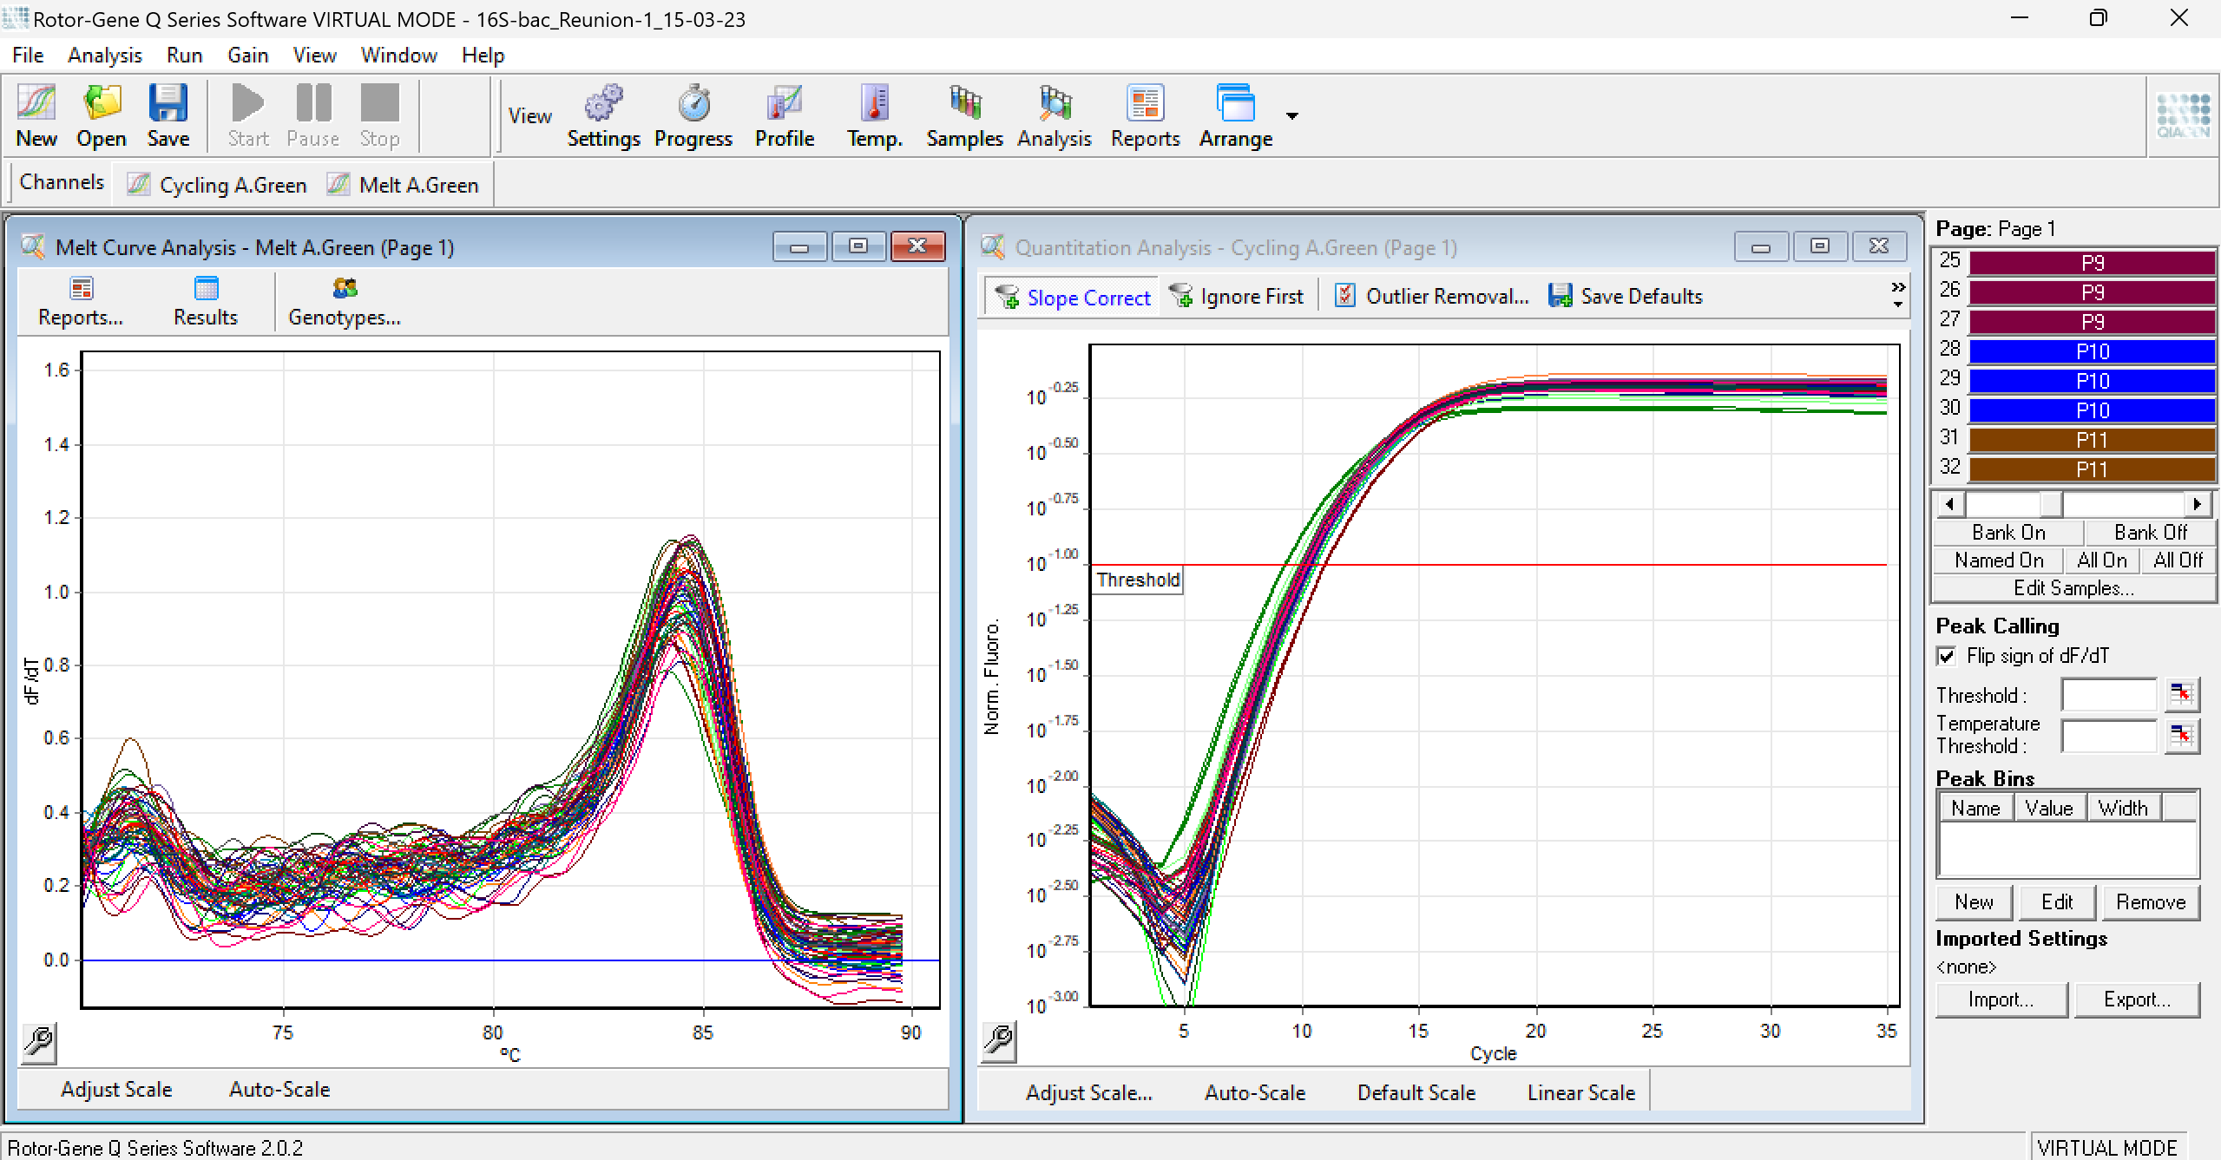
Fig. S1. Amplification and melt curves of the bacterial 16S rRNA gene in soil samples.

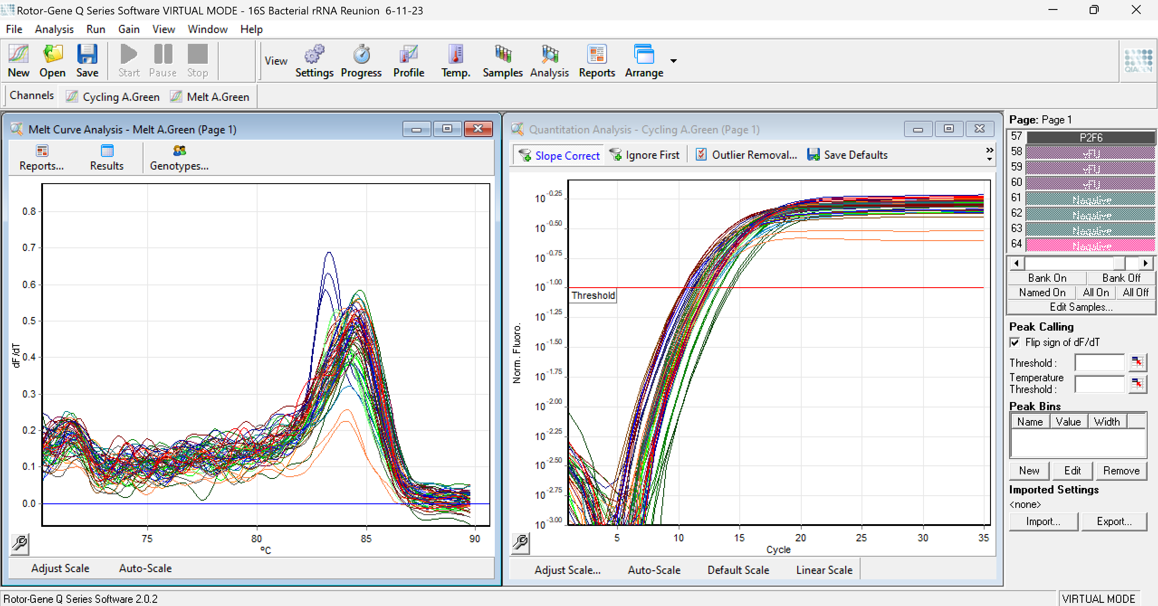
Fig. S2. Amplification and melt curves of the bacterial 16S rRNA gene in canopy soil samples.

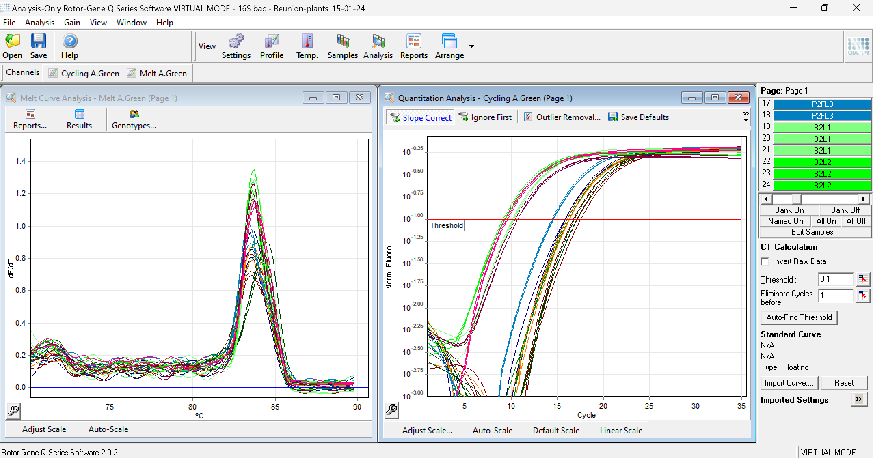
Fig. S3. Amplification and melt curves of the bacterial 16S rRNA gene in plant samples.

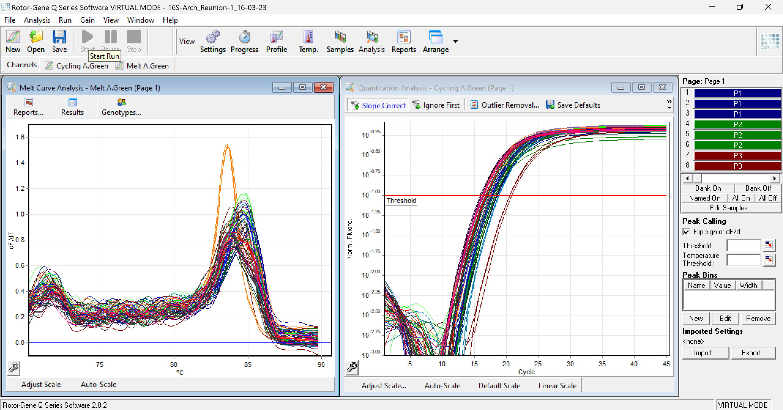
Fig. S4. Amplification and melt curves of the archaeal 16S rRNA gene in soil samples.

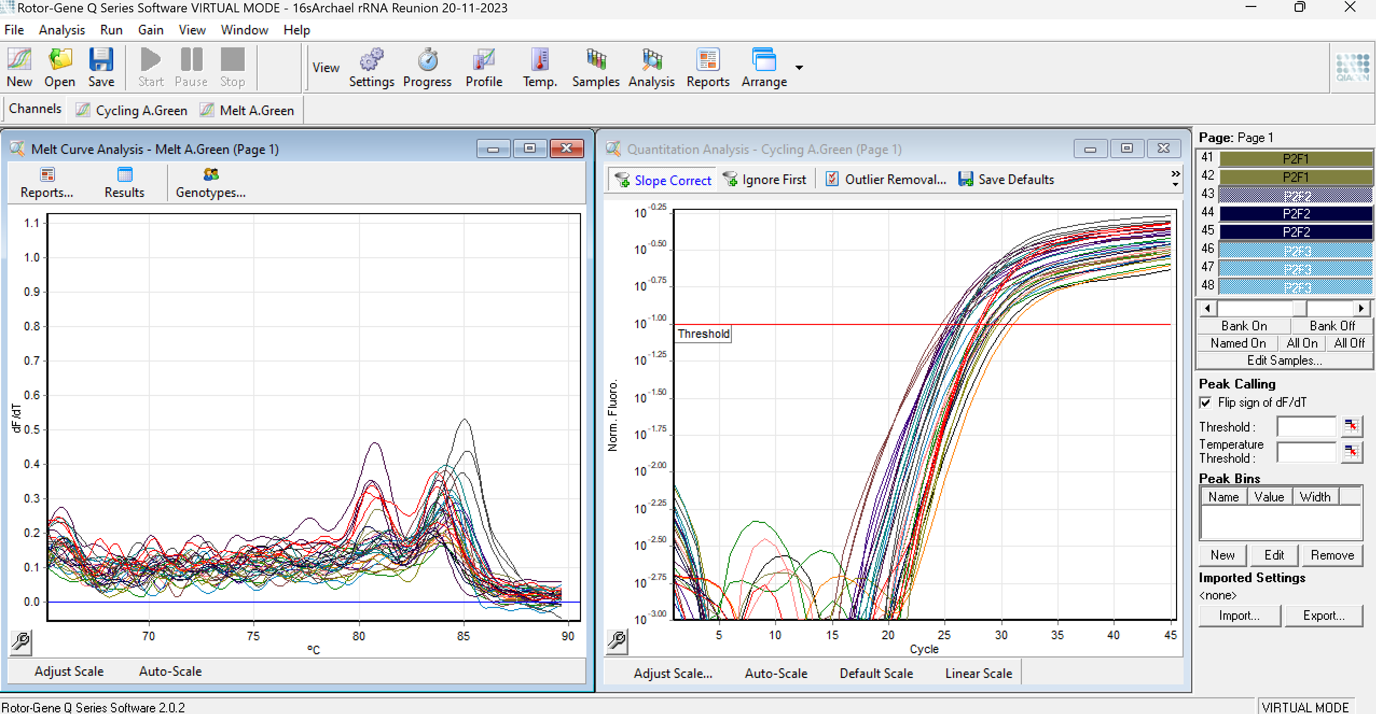
Fig. S5. The amplification and melt curves of the archaeal 16S rRNA gene in canopy soil samples.

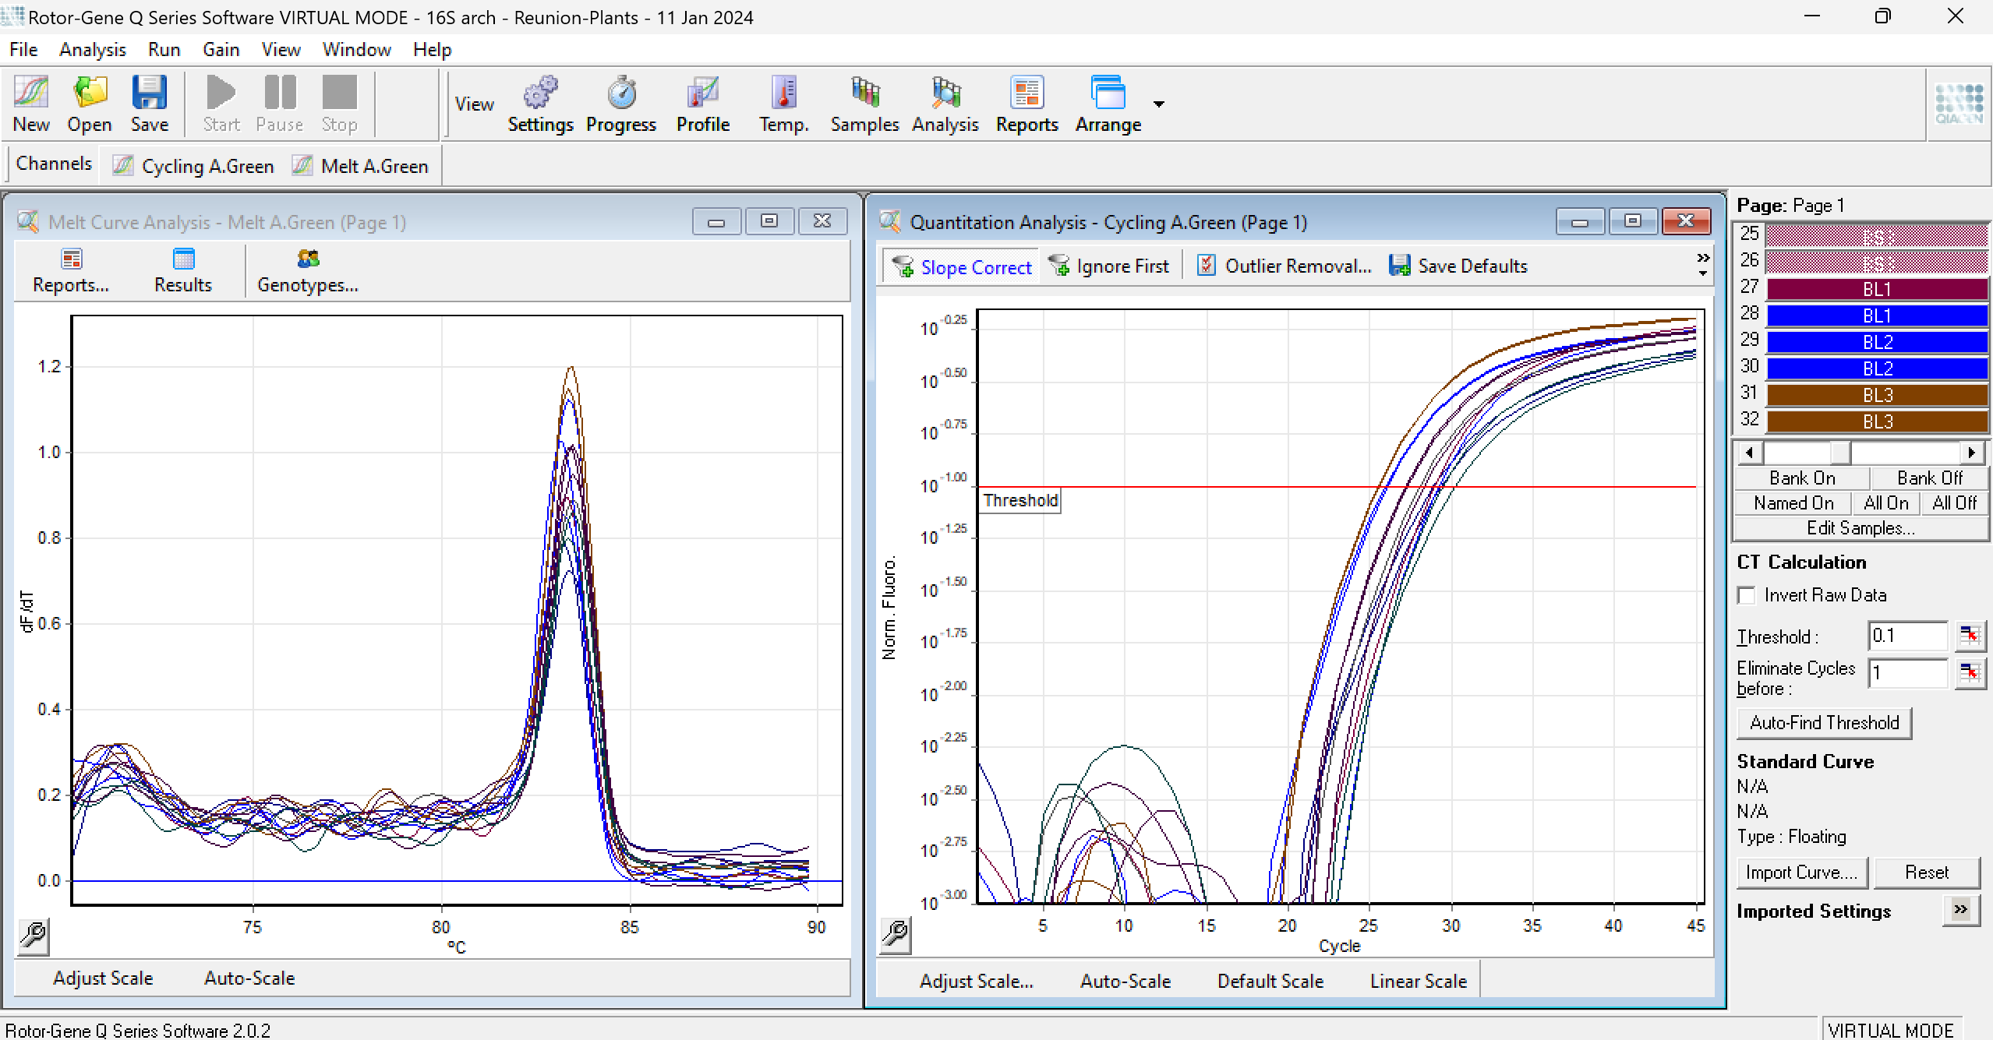
Fig. S6. Amplification and melt curves of the archaeal 16S rRNA gene in plant samples.

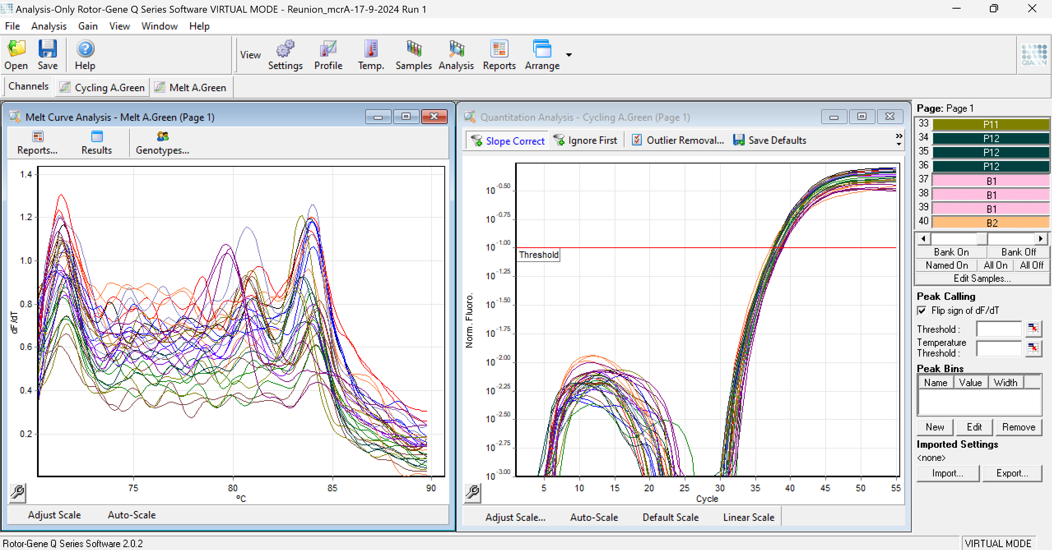
Fig. S7. The amplification and melt curves of the mcrA gene in the soil samples

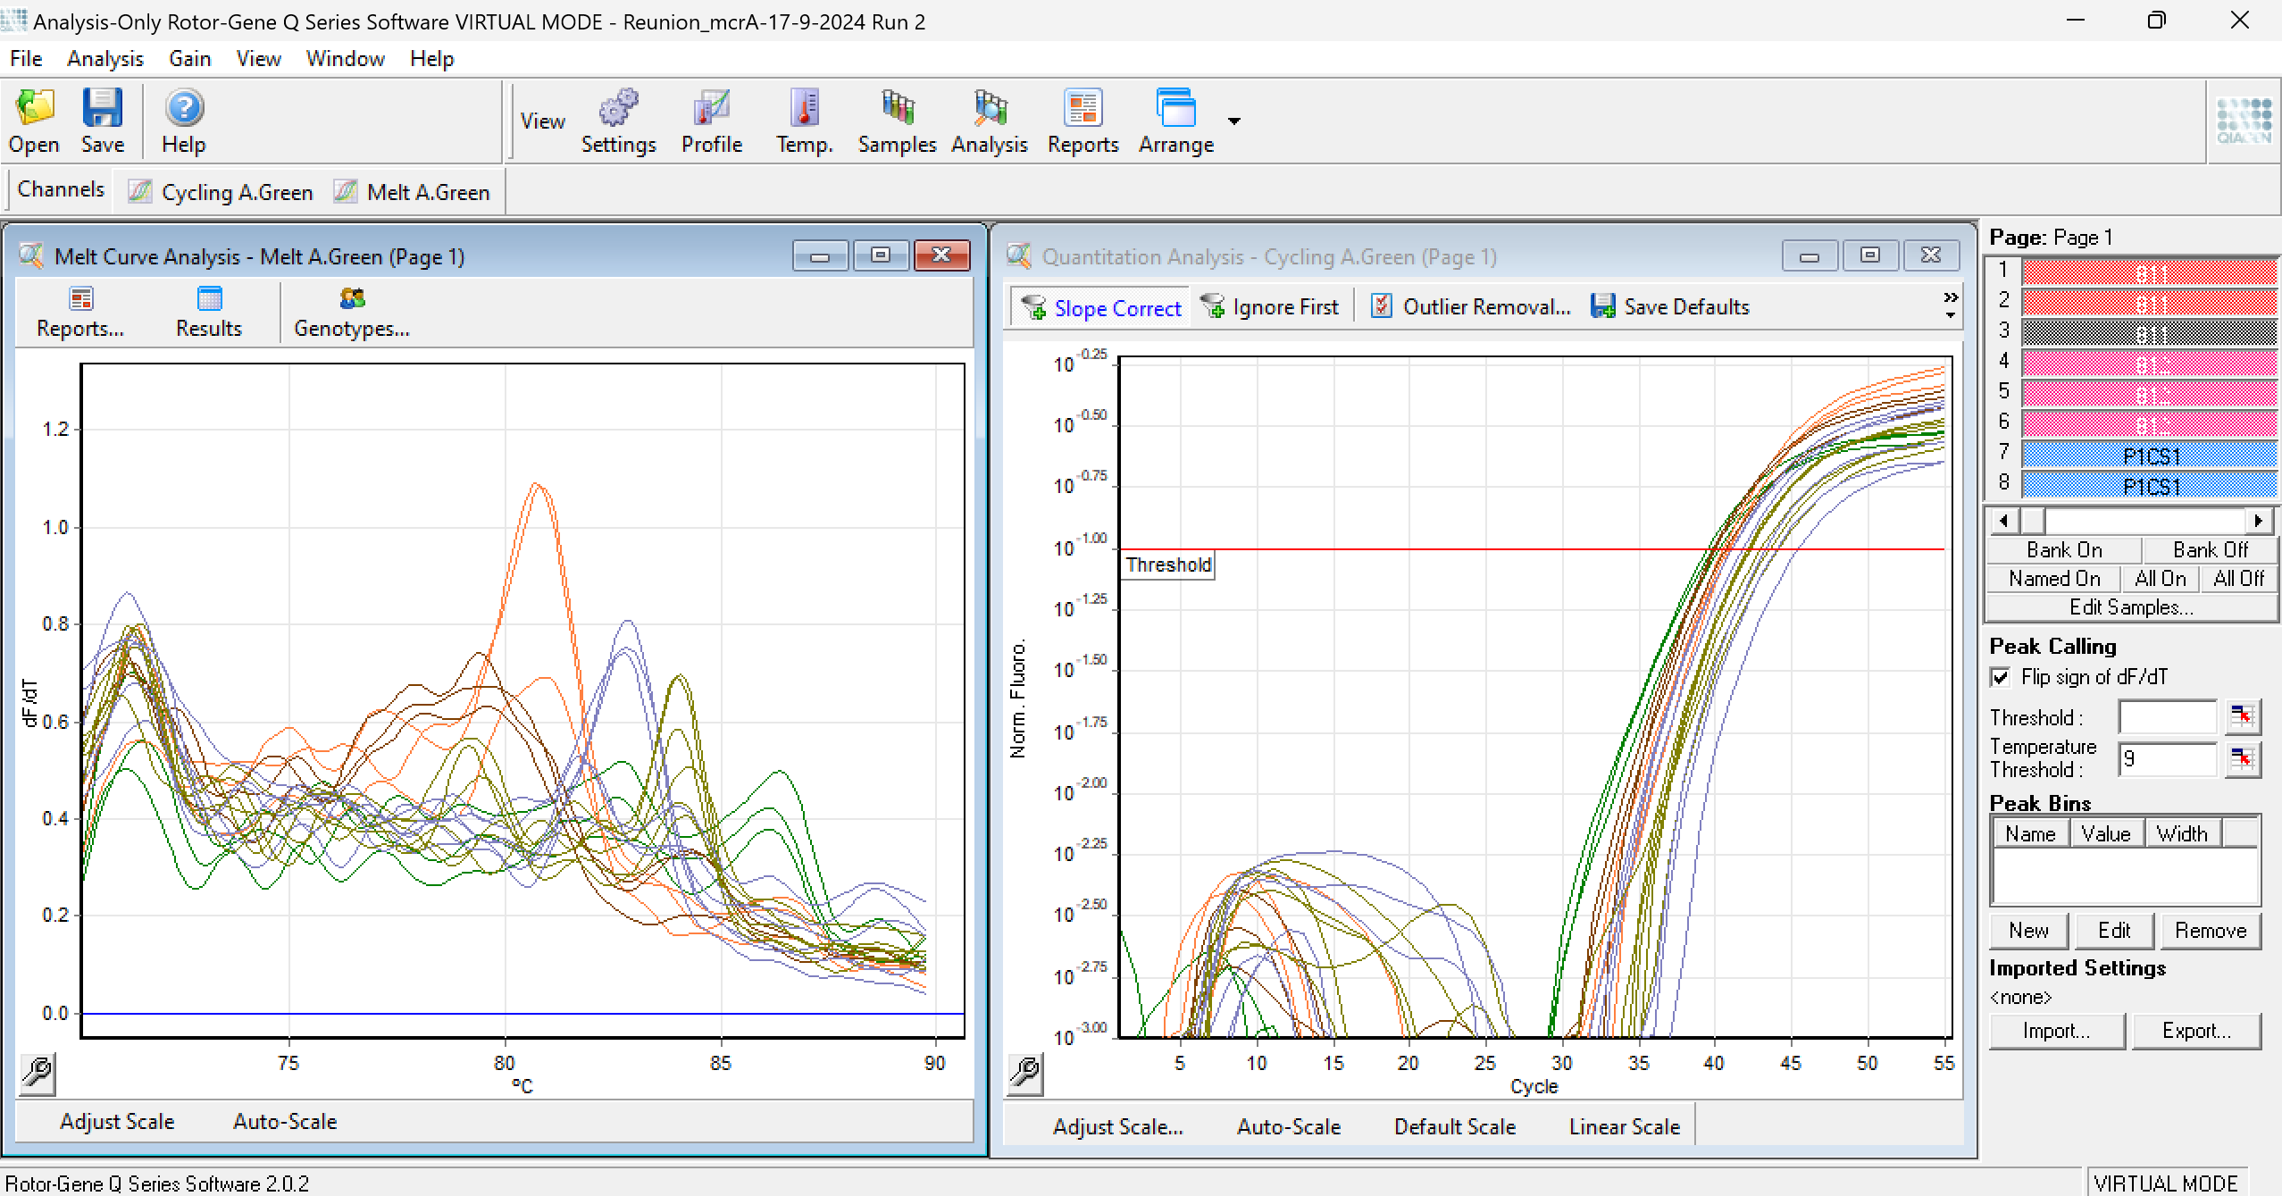
Fig. S8. The amplification and melt curves of the mcrA gene in canopy soil samples

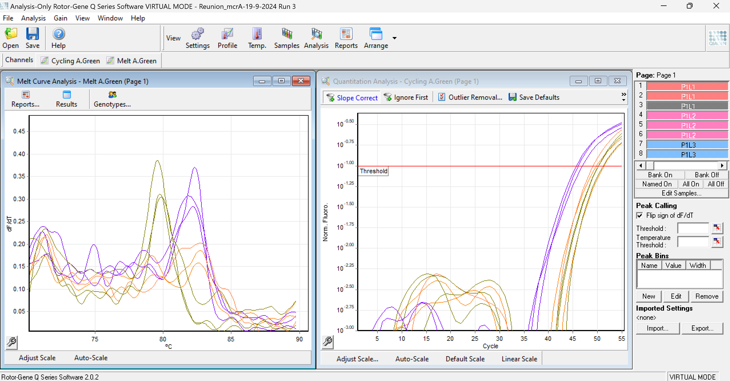
Fig. S9. The amplification and melt curves of the mcrA gene in plant samples.

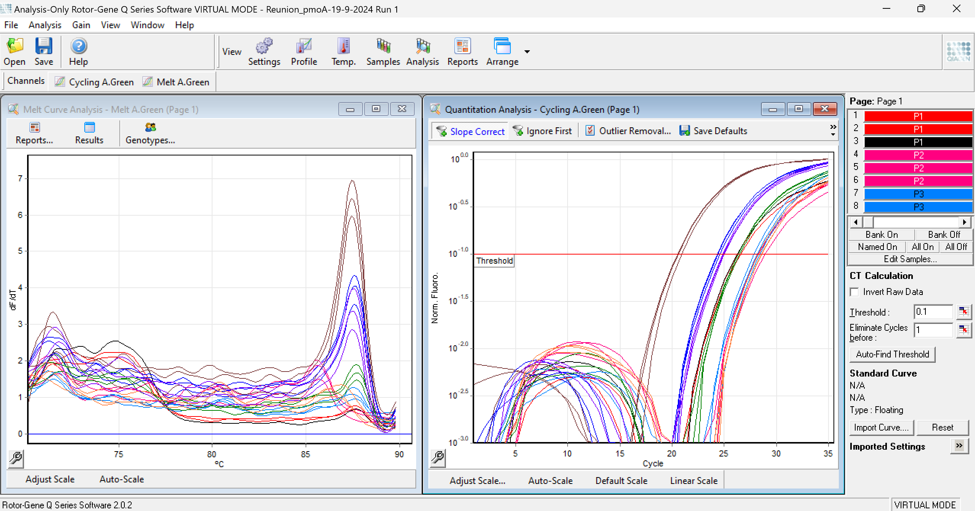
Fig. S10. The amplification and melt curves of the pmoA gene in soil samples.

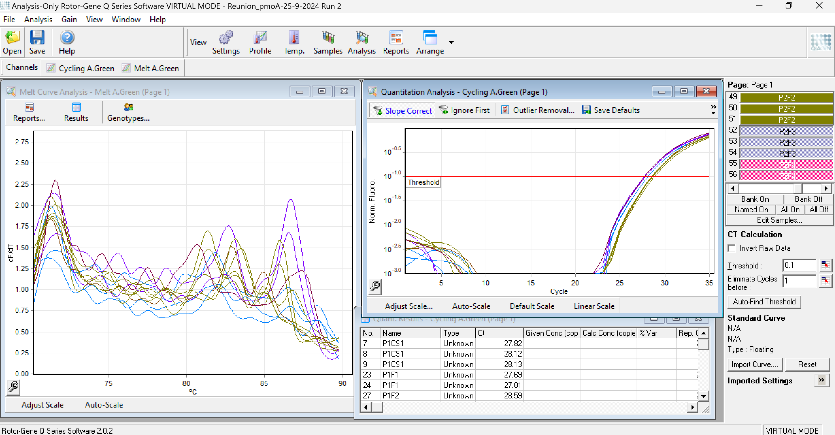
Fig. S11. The amplification and melt curves of the pmoA gene in canopy soil samples.

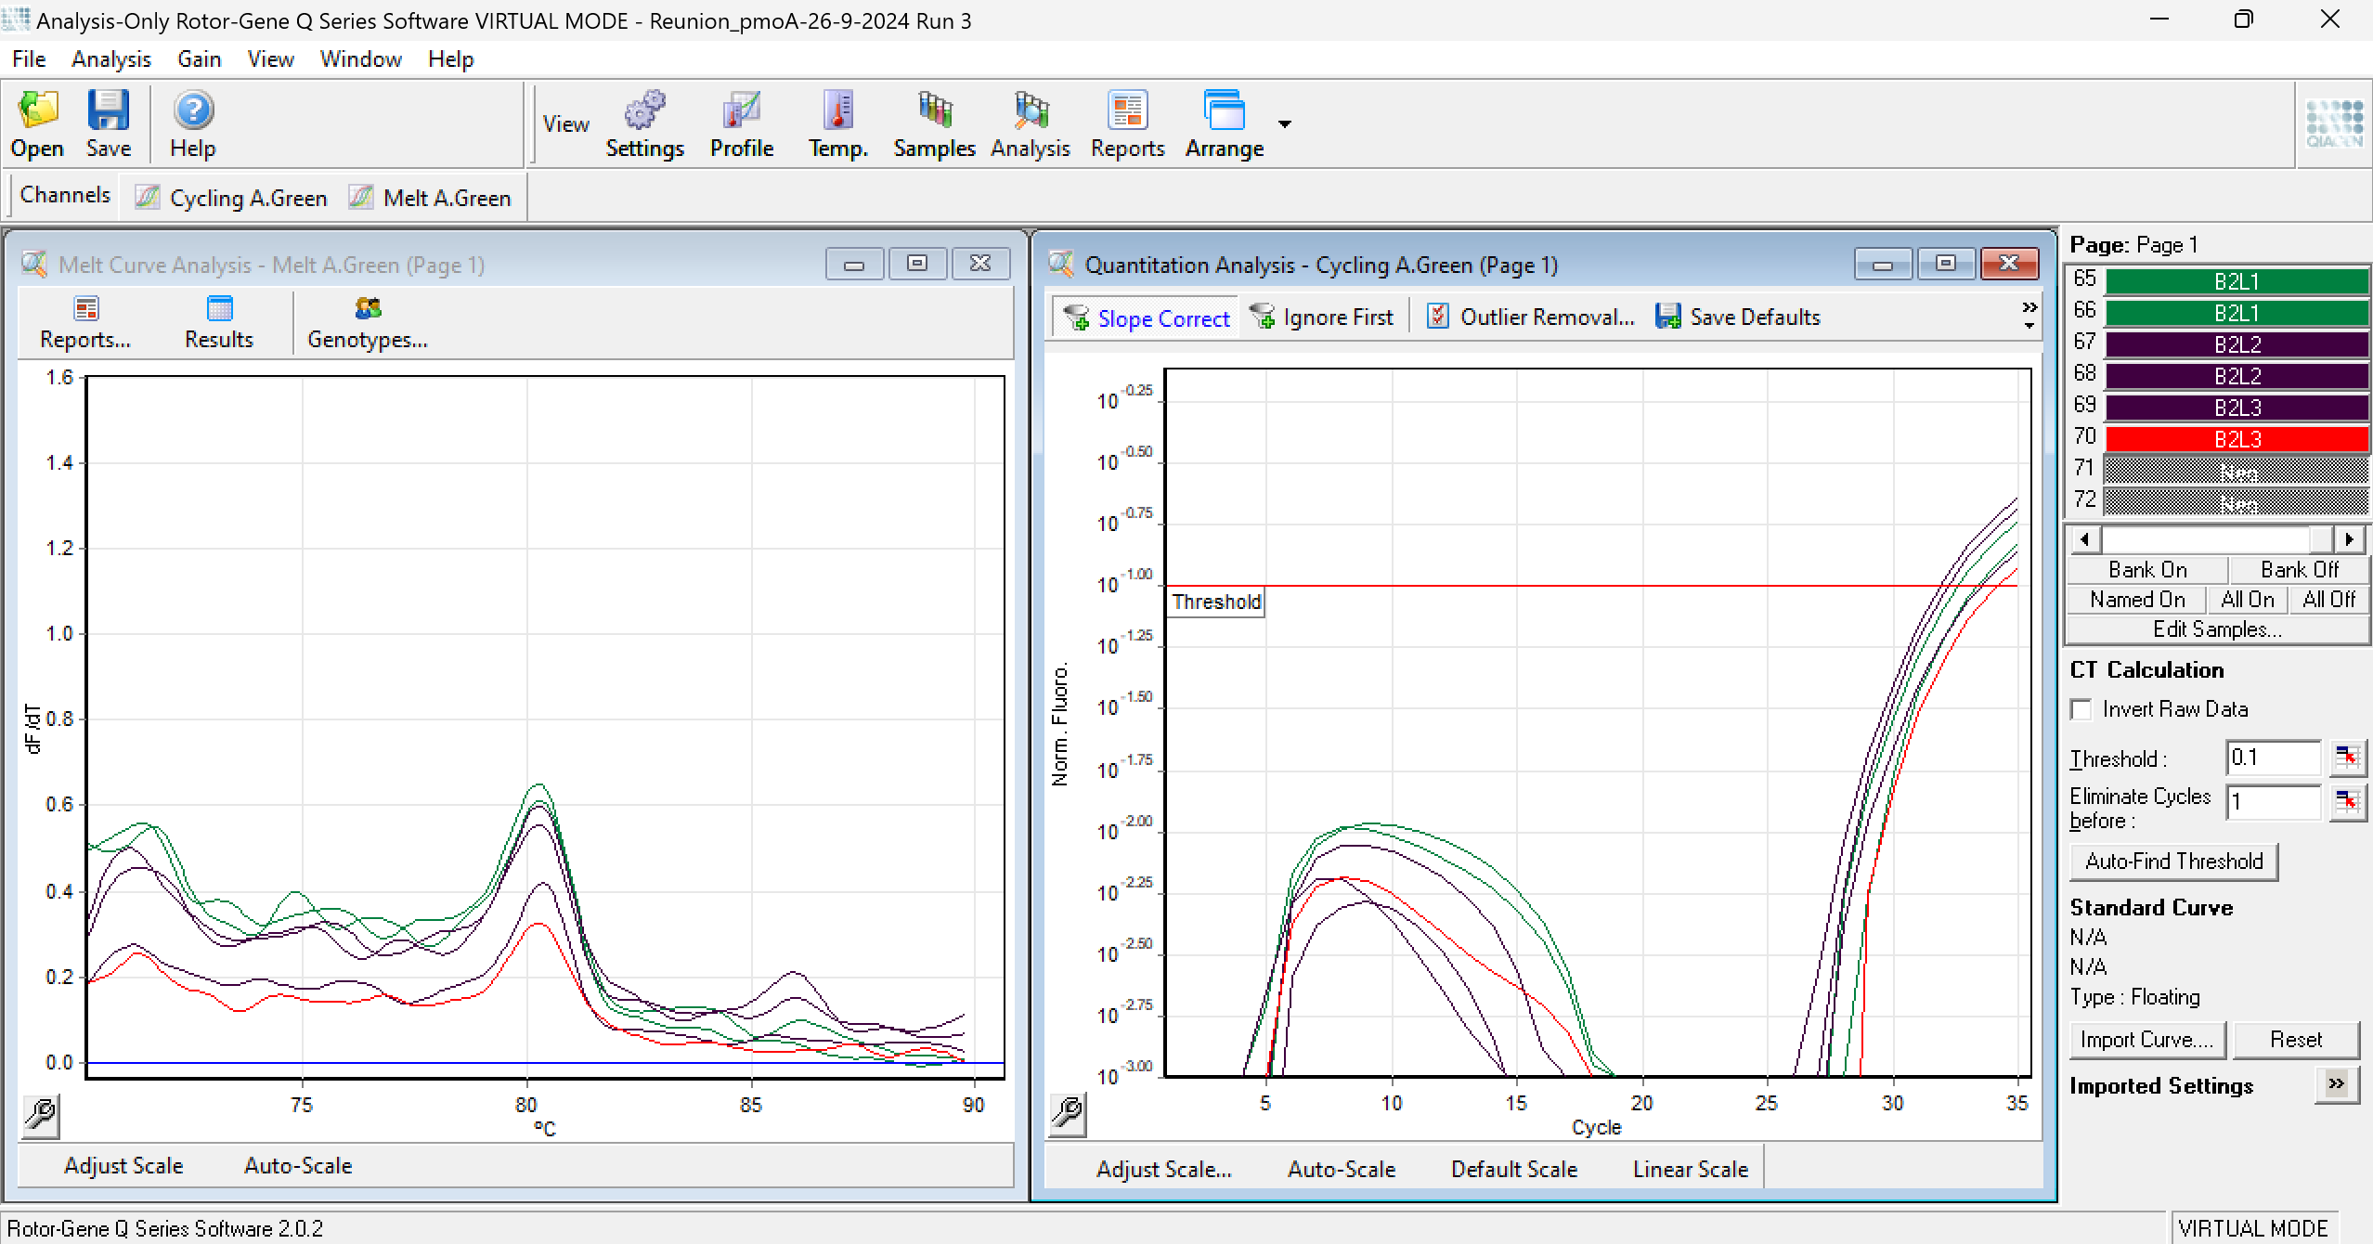
Fig. S12. The amplification and melt curves of the pmoA gene in the plant samples.

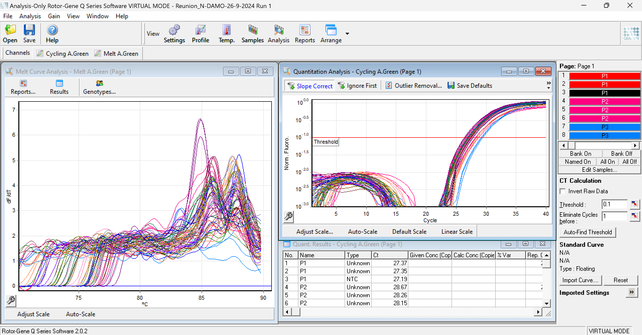
Fig. S13. The amplification and melt curves of the n-DAMO 16S rRNA gene in soil samples.

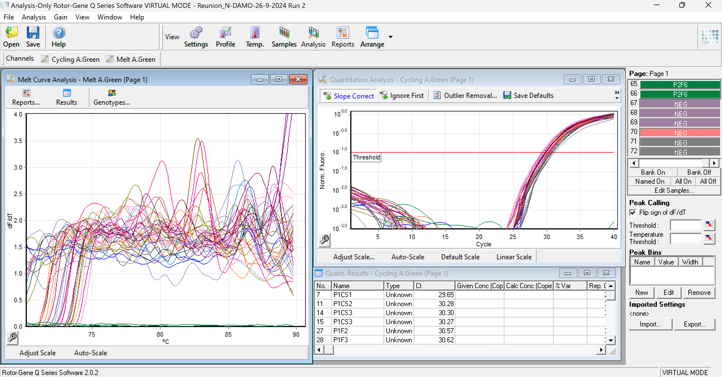
Fig. S14. The amplification and melt curves of the n-DAMO 16S rRNA gene in the canopy soil samples.

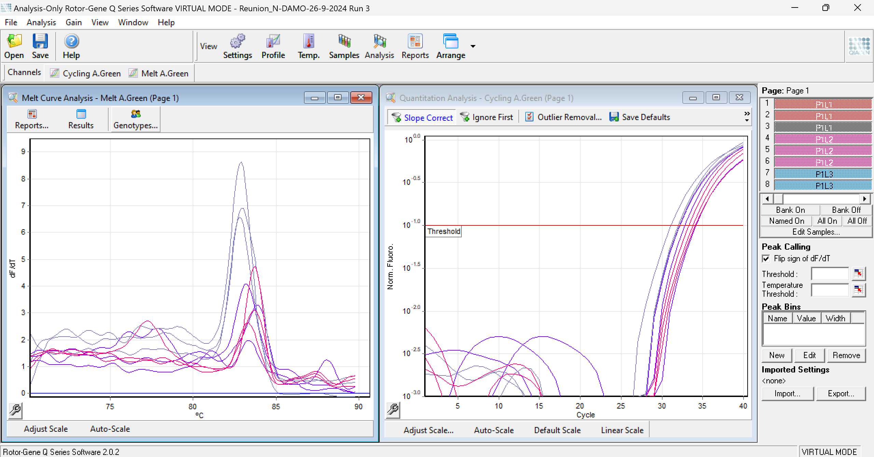
Fig. S15. The amplification and melting curves of the n-DAMO 16S rRNA gene in the plant samples.

References
Altschul SF, Gish W, Miller W, et al (1990) Basic local alignment search tool. Journal of Molecular Biology 215:403–410. https://doi.org/10.1016/S0022-2836(05)80360-2
Chen S, Zhou Y, Chen Y, Gu J (2018) fastp: an ultra-fast all-in-one FASTQ preprocessor. Bioinformatics 34:i884–i890. https://doi.org/10.1093/bioinformatics/bty560
Costello AM, Lidstrom ME (1999) Molecular Characterization of Functional and Phylogenetic Genes from Natural Populations of Methanotrophs in Lake Sediments. Applied and Environmental Microbiology 65:5066–5074. https://doi.org/10.1128/AEM.65.11.5066-5074.1999
Danecek P, Bonfield JK, Liddle J, et al (2021) Twelve years of SAMtools and BCFtools. GigaScience 10:giab008. https://doi.org/10.1093/gigascience/giab008
Dethlefsen L, Huse S, Sogin ML, Relman DA (2008) The Pervasive Effects of an Antibiotic on the Human Gut Microbiota, as Revealed by Deep 16S rRNA Sequencing. PLOS Biology 6:e280. https://doi.org/10.1371/journal.pbio.0060280
Espenberg M, Truu M, Truu J, et al (2016) Impact of Reed Canary Grass Cultivation and Mineral Fertilisation on the Microbial Abundance and Genetic Potential for Methane Production in Residual Peat of an Abandoned Peat Extraction Area. PLOS ONE 11:e0163864. https://doi.org/10.1371/journal.pone.0163864
Ettwig KF, van Alen T, van de Pas-Schoonen KT, et al (2009) Enrichment and Molecular Detection of Denitrifying Methanotrophic Bacteria of the NC10 Phylum. Applied and Environmental Microbiology 75:3656–3662. https://doi.org/10.1128/AEM.00067-09
Fu L, Niu B, Zhu Z, et al (2012) CD-HIT: accelerated for clustering the next-generation sequencing data. Bioinformatics 28:3150–3152. https://doi.org/10.1093/bioinformatics/bts565
Hyatt D, Chen G-L, LoCascio PF, et al (2010) Prodigal: prokaryotic gene recognition and translation initiation site identification. BMC Bioinformatics 11:119. https://doi.org/10.1186/1471-2105-11-119
Kopylova E, Noé L, Touzet H (2012) SortMeRNA: fast and accurate filtering of ribosomal RNAs in metatranscriptomic data. Bioinformatics 28:3211–3217. https://doi.org/10.1093/bioinformatics/bts611
Langmead B, Salzberg SL (2012) Fast gapped-read alignment with Bowtie 2. Nat Methods 9:357–359. https://doi.org/10.1038/nmeth.1923
Li D, Liu C-M, Luo R, et al (2015) MEGAHIT: an ultra-fast single-node solution for large and complex metagenomics assembly via succinct de Bruijn graph. Bioinformatics 31:1674–1676. https://doi.org/10.1093/bioinformatics/btv033
Li W, Godzik A (2006) Cd-hit: a fast program for clustering and comparing large sets of protein or nucleotide sequences. Bioinformatics 22:1658–1659. https://doi.org/10.1093/bioinformatics/btl158
Liao Y, Smyth GK, Shi W (2014) featureCounts: an efficient general purpose program for assigning sequence reads to genomic features. Bioinformatics 30:923–930. https://doi.org/10.1093/bioinformatics/btt656
Liu Z, Lozupone C, Hamady M, et al (2007) Short pyrosequencing reads suffice for accurate microbial community analysis. Nucleic Acids Research 35:e120. https://doi.org/10.1093/nar/gkm541
Love MI, Huber W, Anders S (2014) Moderated estimation of fold change and dispersion for RNA-seq data with DESeq2. Genome Biol 15:550. https://doi.org/10.1186/s13059-014-0550-8

