Severe drought impact traits and associated soil microbial communities of clonal oaks
Camilo Quiroga-González^{1§}, Luis Daniel Prada-Salcedo¹, François Buscot^{1,2}, Mika Tarkka^{1,2}, Sylvie Herrmann¹, Marie-Lara Bouffaud^{1*} and Kezia Goldmann^{1*}
Supplemental material
Table S1. Sample overview: The columns provide information of the drought period (before and after the drought in 2018), and the plot where the samples were collected; P1 = Plot1 and P2 = Plot2. The rows have the information of the study site and the year of the trees after outplanting.
 | Before drought |  |  | After drought |  |  | Total number of samples
 | P1 | P2 | Total | P1 | P2 | Total
Bad Lauchstädt | 46 | 12 | 58 | 6 | 48 | 54 | 112
1 year | 4 | 6 | 10 |  | 6 | 6 | 16
2 year | 6 | 6 | 12 |  | 12 | 12 | 24
3 year | 12 |  | 12 |  | 12 | 12 | 24
4 year | 12 |  | 12 |  | 12 | 12 | 24
5 year | 12 |  | 12 | 6 | 6 | 12 | 24
Kreinitz | 49 | 12 | 61 | 6 | 47 | 53 | 114
1 year | 6 | 6 | 12 |  | 6 | 6 | 18
2 year | 6 | 6 | 12 |  | 12 | 12 | 24
3 year | 12 |  | 12 |  | 12 | 12 | 24
4 year | 12 |  | 12 |  | 11 | 11 | 23
5 year | 13 |  | 13 | 6 | 6 | 12 | 25
Both sites combined | 95 | 24 | 119 | 12 | 95 | 107 | 226

Table S2. Comparison of soil chemical variables between sampling sites. Bold results show significantly higher value (linear mix model, P<0.05) in that specific site.
 | Bad Lauchstädt |  | Kreinitz
Variable | Mean | Std. Error | Mean | Std. Error
pH | 6.598 | 0.484 | 5.130 | 0.276
Soil Moisture (MOI) | 11.817 | 3.563 | 5.395 | 3.059
Soil Dry Matter (DMC) | 97.783 | 0.461 | 99.376 | 0.147
Ammonium Nitrogen Content (NH₄⁺-N) | 1.157 | 0.783 | 1.506 | 1.332
Nitrate Nitrogen Content (NO₃⁻−N) | 3.263 | 3.889 | 2.774 | 4.051
Inorganic Nitrogen Content (N_{min}) | 4.420 | 3.848 | 4.280 | 4.853
Hot Water Extractable Organic Carbon (HWC) | 427.062 | 76.028 | 449.671 | 108.235
Hot Water Extractable Nitrogen (HWN) | 41.746 | 13.788 | 39.342 | 11.089
HWC/HWN | 10.912 | 2.4606 | 11.659 | 2.047
Cold Water Extractable Organic Carbon (CWC) | 54.429 | 18.280 | 53.503 | 17.026
Cold Water Extractable Nitrogen (CWN) | 6.570 | 3.180 | 7.315 | 3.859
CWC/CWN | 9.634 | 4.0406 | 8.476 | 3.152
Total Soil Organic Carbon (TOC) | 1.866 | 0.191 | 0.847 | 0.159
Total Soil Nitrogen (TN) | 0.135 | 0.0186 | 0.0719 | 0.019
TOC/TN | 13.968 | 1.645 | 12.338 | 2.852

Table S3. Comparison of each soil chemical variable between the two drought periods “Before” and “After”. Bold results show a significantly higher value (linear mix model, P<0.05).
 | Before drought |  | After drought
Variables | Mean | Std. Error | Mean | Std. Error
pH | 6.062 | 0.900 | 5.592 | 0.690
Soil Moisture (MOI) | 9.793 | 4.643 | 7.135 | 4.194
Soil Dry Matter (DMC) | 98.613 | 0.871 | 98.658 | 0.854
Ammonium Nitrogen Content (NH₄⁺-N) | 1.829 | 1.099 | 0.921 | 0.964
Nitrate Nitrogen Content (NO₃⁻−N) | 3.386 | 4.492 | 2.664 | 3.447
Inorganic Nitrogen Content (N_{min}) | 5.215 | 4.987 | 3.585 | 3.684
Hot Water Extractable Organic Carbon (HWC) | 420.144 | 97.705 | 455.803 | 89.987
Hot Water Extractable Nitrogen (HWN) | 43.796 | 13.995 | 37.543 | 10.104
HWC/HWN | 9.926 | 1.498 | 12.524 | 2.147
Cold Water Extractable Organic Carbon (CWC) | 48.079 | 16.597 | 60.168 | 16.506
Cold Water Extractable Nitrogen (CWN) | 6.753 | 3.895 | 7.198 | 3.193
CWC/CWN | 8.453 | 3.310 | 9.612 | 3.869
Total Soil Organic Carbon (TOC) | 1.289 | 0.557 | 1.347 | 0.521
Total Soil Nitrogen (TN) | 0.090 | 0.039 | 0.111 | 0.0314
TOC/TN | 14.499 | 2.336 | 11.867 | 1.939

Table S4. Comparison between plant traits and sampling location. Bold results show a significantly higher value (linear mix model, P<0.05).
 | Bad Lauchstädt |  | Kreinitz
Variable | Mean | Std. Error | Mean | Std. Error
Leaf Area | 18.053 | 7.662 | 18.130 | 6.264
Number of Leaves/SF | 4.9802 | 0.173 | 4.893 | 0.540
Leaf Dry Weight | 1.105 | 0.348 | 1.029 | 0.422
Number of Shoot Flushes | 2.162 | 0.842 | 1.982 | 0.771
Branch Elongation | 32.962 | 22.545 | 32.910 | 21.789
Apical Growth | 71.069 | 49.471 | 63.330 | 46.199
Shoot Flush Length | 28.162 | 14.411 | 28.340 | 13.568

Table S5. Comparison between plant traits and drought period. Bold results show a significantly higher value (linear mix model, P<0.05).
 | Before drought |  | After drought
Variable | Mean | Std. Error | Mean | Std. Error
Leaf Area | 17.506 | 6.953 | 18.755 | 6.830
Number of Leaves | 4.976 | 0.155 | 4.883 | 0.585
Leaves Dry Weight | 1.112 | 0.357 | 1.009 | 0.421
Number of Shoot Flush | 2.365 | 0.765 | 1.728 | 0.718
Branch Elongation | 40.268 | 21.343 | 27.616 | 20.980
Apical Growth | 81.677 | 46.280 | 59.919 | 47.225
Length Shoot Flush | 31.894 | 13.202 | 19.301 | 11.336

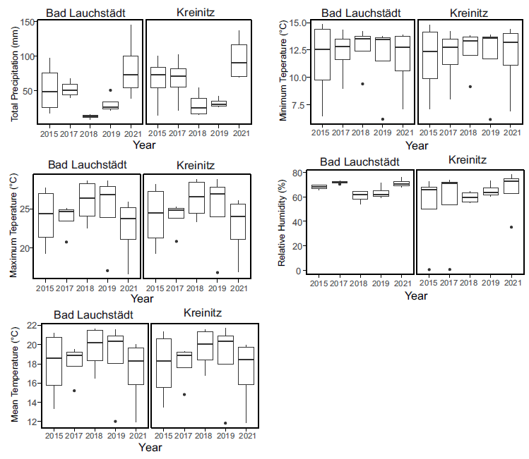
Figure S2. Differences in environmental variables in between years for each sampling site. The values in °C and % represent the mean while the other variables mm represent the cumulative value. Yearly values are filtered from the month of May to August
Figure S1. Differences in environmental variables in between years for each sampling site. Values for temperature and humidity represent means, while the precipitation is represented as cumulative values. Annual values are filtered from the months May to August.

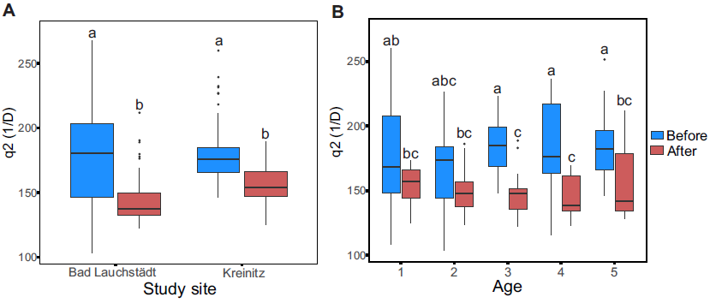
Figure S2. Boxplot showing the distribution of inverse Simpson index of bacteria A) study site and B) age. The boxes represent the quartiles (25%, 50% and 75%), and the whiskers indicate the range of the data, excluding outliers. Blue color represents the values before the drought and the red color after. Letters above boxplots represent significant differences according to ANOVA analysis.
Figure S3. Boxplot showing the distribution of q0 in A) Bacteria and B) Fungi for each location site. The boxes represent the quartiles (25%, 50% and 75%), and the whiskers indicate the range of the data, excluding outliers. Blue color represents the values before the drought and the red color after.
Figure S4. Inverse of Simpson Index for Bacteria A) diversity of OTU in relation to study site and B) diversity of OTU in relation to oak age. The colors represent the period of the collected sample.

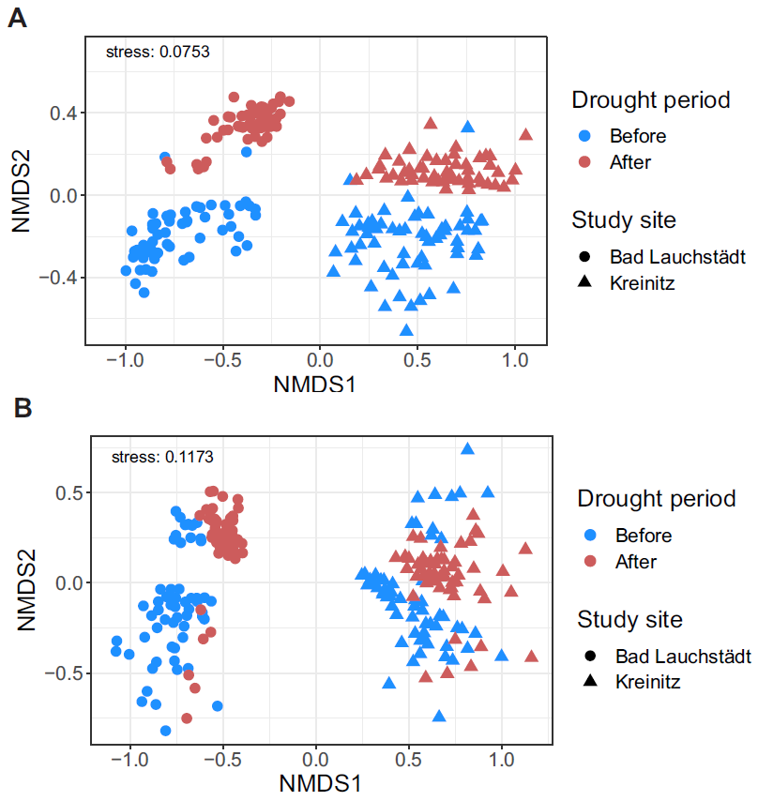
Figure S3. NMDS of the microbial communities based on OTU from A) bacteria and B) fungi. The symbols represent the study site and the colors the drought period.
Figure S5. NMDS of the microbial communities based on OTU from A) Bacteria and B) Fungi. The forms represent the study site and the colors the drought period.

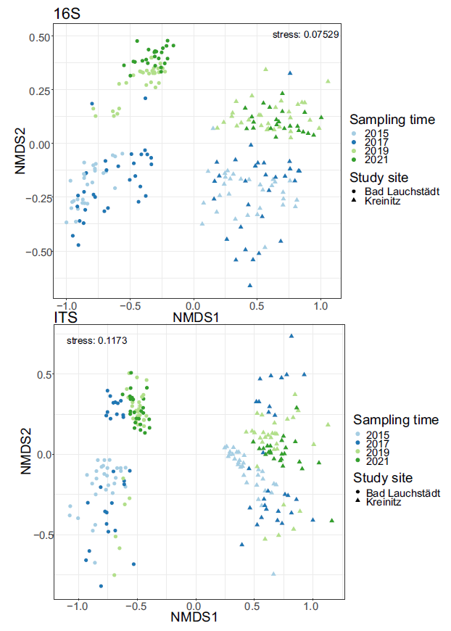
Figure S4. NMDS of the microbial communities based on OTU abundance from A) bacteria and B) fungi. The symbols represent the study site and the colors the year of sampling.
A
B

Figure S6. NMDS of the microbial communities based on OUT from A) Bacteria and B) Fungi. The forms represent the study site and the colors the year of sampling.

