SUPPLEMENTARY INFORMATION

Uncovering functional deterioration in the rhizosphere microbiome associated with post-green revolution wheat

Monique E. Smith[1,2], Vanessa N. Kavamura[1], David Hughes[3], Rodrigo Mendes[4], George Lund[1], Ian Clark[1] & Tim H. Mauchline[1]*

[1] Sustainable Soils and Crops, Rothamsted Research, Harpenden, Hertfordshire, United Kingdom
[2] Department of Ecology, Swedish University of Agricultural Sciences, Uppsala, Sweden
[3] Intelligent Data Ecosystems, Rothamsted Research, Harpenden, Hertfordshire, United Kingdom
[4] Laboratory of Environmental Microbiology, Embrapa Environment, Jaguariúna-SP, Brazil

* To whom correspondence should be addressed:
tim.mauchline@rothamsted.ac.uk

CONTENTS
SI 1. SUPPLEMENTARY FIGURES
Fig. S1. Rarefaction curves for all samples based on the a) taxonomy and function b) of the prokaryote communities.
Fig. S2. Relative abundance of Prokaryote taxa in each metagenomic sample (S1-S23).
Fig. S3. The proportion (%) of enriched taxa belonging to each phylum according to differential abundance analysis contrasts between each pair of sample types.
SI 2. SUPPLEMENTARY TABLES
Table S1. The 20 most abundant functional genes out of 1,712 that are differentially abundant between bulk soils and heritage wheat rhizospheres.
Table S2. Mean relative abundance (%) of reads assigned to the most common phyla for the differentially abundant functional genes between heritage and modern rhizospheres.

SI 1. SUPPLEMENTARY FIGURES
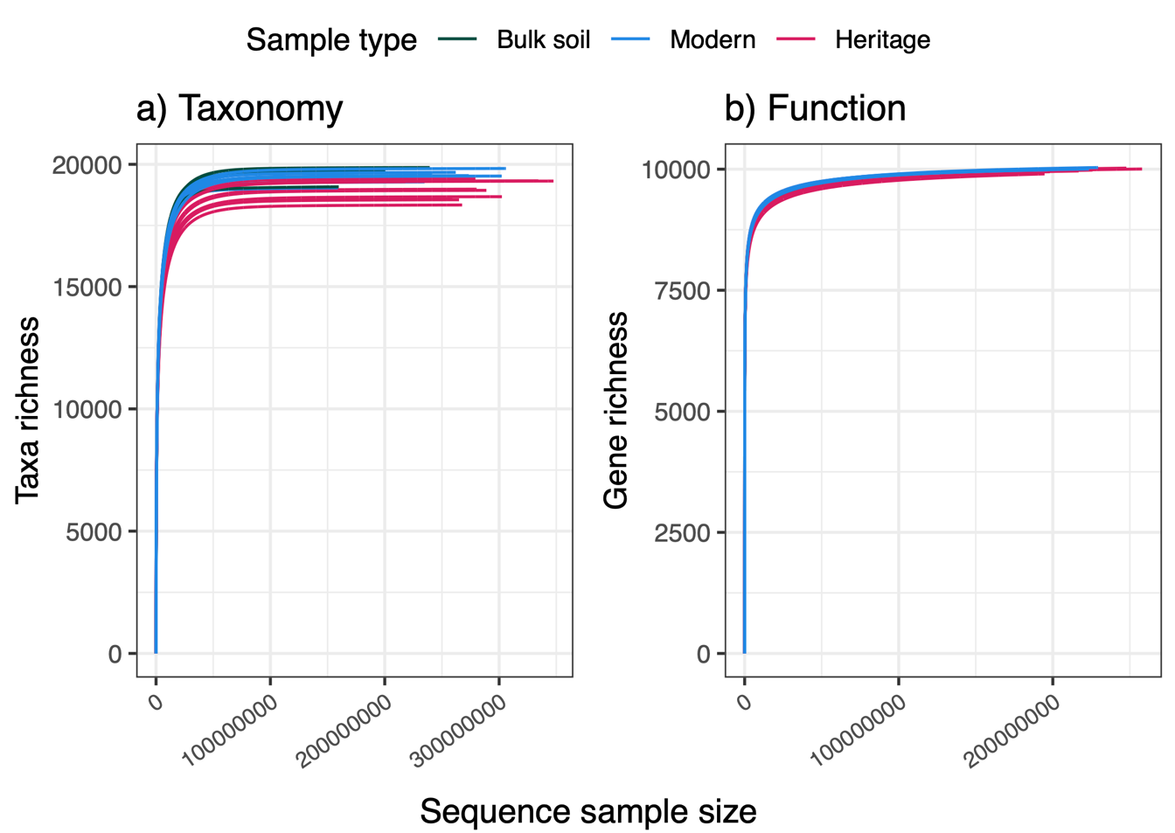
Fig. S1. Rarefaction curves for all samples based on the a) taxonomy and b) function of the prokaryote communities. Sample types, i.e., bulk soil controls or rhizosphere soil from modern or heritage wheat cultivars, are depicted by the colours of the curves.

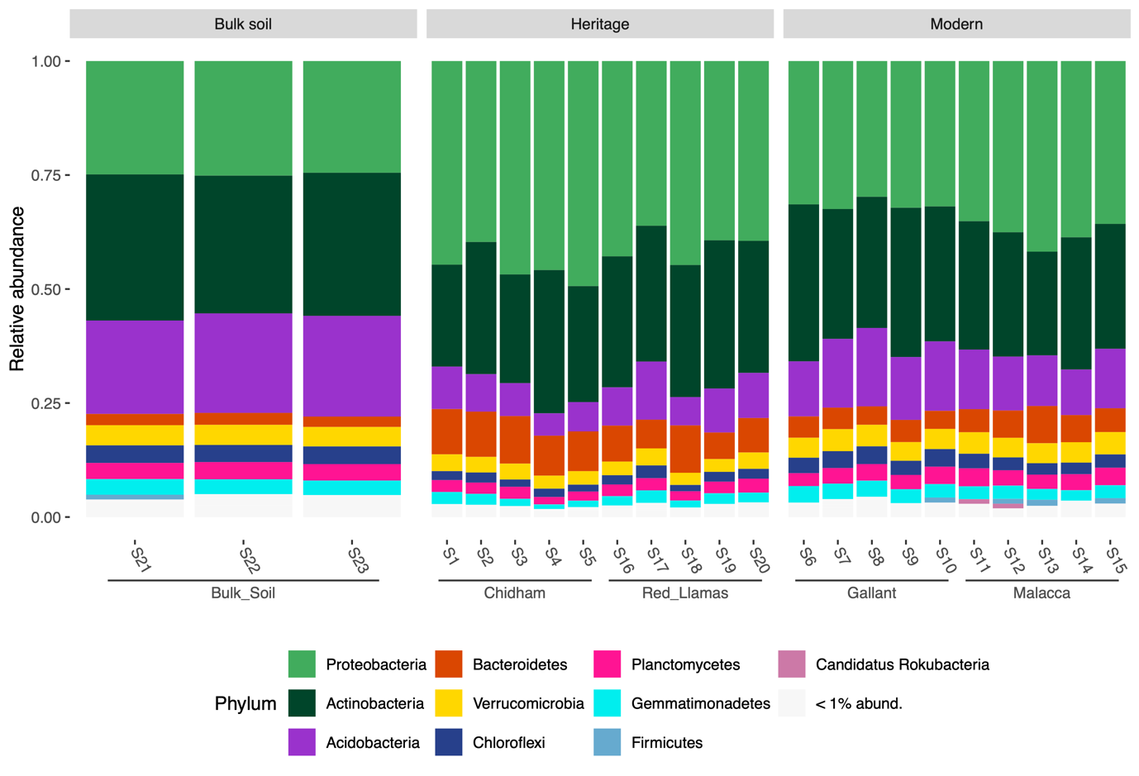
Fig. S2. Relative abundance of Prokaryote taxa in each metagenomic sample (S1-S23). Colours represent the phyla level of the most abundant (> 1 % relative abundance) and taxa not classified at this level were excluded from analysis. Samples are grouped first by sample type, (grey header boxes) and then by wheat cultivar (x-axis labels).

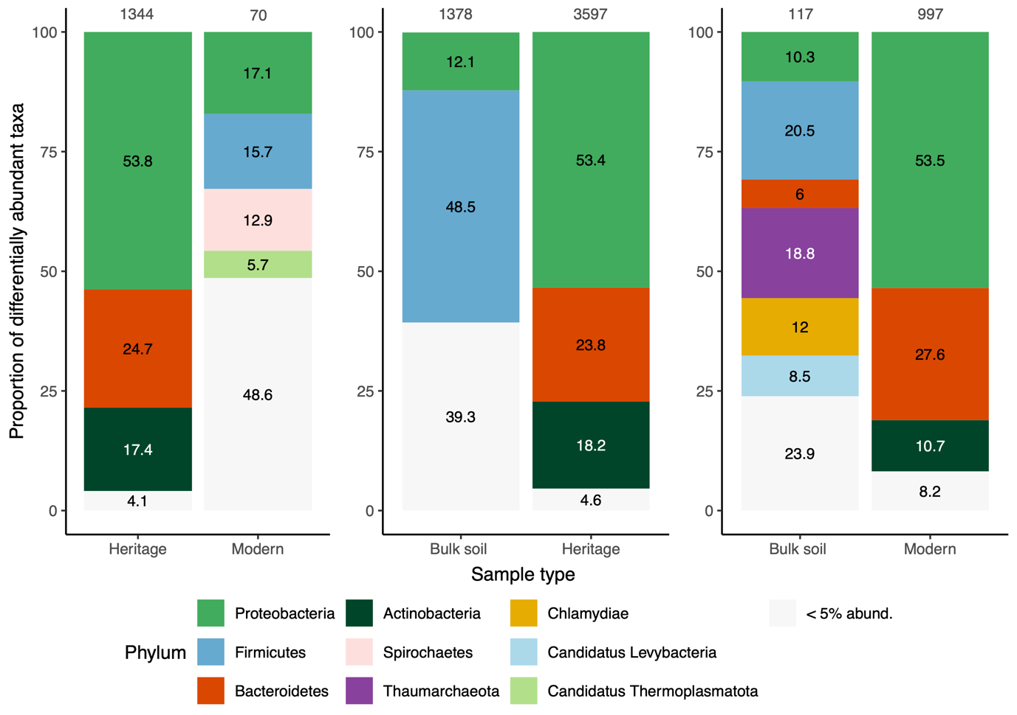

Fig. S3. The proportion (%) of enriched taxa belonging to each phylum according to differential abundance analysis contrasts between each pair of sample types. The proportions were based on the total number of taxa enriched in each sample type per comparison (numbers on top of bars) and each plot represents a different comparison with the sample types on the x-axis. Only phyla that contained more than 5% of taxa are indicated by colour, all others were considered rare and grouped together (< 5% abund.).

SI2. SUPPLEMENTARY TABLES
Table S1. The 20 most abundant functional genes out of 1,712 that are differentially abundant between bulk soils and heritage wheat rhizospheres. The functional genes are identified by the Kyoto Encyclopaedia of Genes and Genomes identifier (KEGG ID) and put into broad functional groups, and secondary functions are included where applicable. The total read count refers to the total number of reads for each functional gene found in rhizosphere samples normalised by DESeq2 size factors for each sample (McMurdie and Holmes, 2013). The means for each sample type (bulk soil and rhizosphere soil from semi-dwarf or tall wheat) were compared and significant differences are depicted by different letters (ANOVA, p < 0.05).

KEGG ID | Functional group | Secondary function | Gene | Total read count (normalised) | Bulk soil mean (n=3) | Modern mean (n=10) | Heritage mean (n=10)
K02014 | Membrane transport | Iron transport | iron complex outermembrane recepter protein | 24,116,914 | 410,340a | 774,734b | 1,408,208c
K07305 | Primary metabolism |  | peptide-methionine (R)-S-oxide reductase [EC:1.8.4.12] | 10,282,206 | 48,158a | 500,964b | 498,096b
K21573 | Membrane transport |  | TonB-dependent starch-binding outer membrane protein SusC | 7,793,265 | 99,172a | 245,353a | 472,111b
K02529 | Transcription factors |  | LacI family transcriptional regulator | 7,145,118 | 158,668a | 253,414b | 388,382c
K03406 | Two-component system |  | methyl-accepting chemotaxis protein | 6,392,258 | 115,927a | 212,267a | 367,048b
K01190 | Primary metabolism | Carbohydrate metabolism | beta-galactosidase [EC:3.2.1.23] | 5,975,470 | 127,700a | 196,772a | 341,105b
K21572 | Membrane transport |  | starch-binding outer membrane protein, SusD/RagB family | 5,364,121 | 79,015a | 170,800a | 320,784b
K03566 | Biofilm formation |  | LysR family transcriptional regulator, glycine cleavage system transcriptional activator | 2,563,859 | 44,755a | 88,709b | 144,466c
K12308 | Primary metabolism | Carbohydrate metabolism | beta-galactosidase [EC:3.2.1.23] | 2,560,477 | 53,670a | 84,359a | 146,379b
K14266 | Secondary metabolism | Staurosporine biosynthesis | tryptophan 7-halogenase [EC:1.14.19.9] | 2,558,916 | 19,996a | 65,155b | 170,581c
K01811 | Primary metabolism | Carbohydrate metabolism | alpha-D-xyloside xylohydrolase [EC:3.2.1.177] | 2,386,478 | 57,423a | 81,787a | 131,742b
K01198 | Primary metabolism | Carbohydrate metabolism | xylan 1,4-beta-xylosidase [EC:3.2.1.37] | 2,361,118 | 45,804a | 79,884b | 133,775c
K00362 | Primary metabolism | Nitrogen metabolism | nitrite reductase (NADH) large subunit [EC:1.7.1.15] | 2,327,961 | 55,160a | 88,952b | 120,169c
K18900 | Transcription factors |  | LysR family transcriptional regulator, regulator for bpeEF and oprC | 2,191,402 | 32,775a | 72,464b | 128,082c
K15923 | Primary metabolism | Carbohydrate metabolism | alpha-L-fucosidase 2 [EC:3.2.1.51] | 1,917,215 | 36,859a | 64,578b | 108,985c
K07552 | Membrane transport |  | MFS transporter, DHA1 family, multidrug resistance protein | 1,860,700 | 44,058a | 70,312b | 96,325c
K12373 | Primary metabolism | Carbohydrate metabolism | hexosaminidase [EC:3.2.1.52] | 1,739,338 | 43,712a | 56,293a | 98,598b
K15270 | Membrane transport |  | S-adenosylmethionine uptake transporter | 1,493,249 | 32,067a | 53,982b | 80,286c
K05970 | Primary metabolism |  | sialate O-acetylesterase [EC:3.1.1.53] | 1,414,362 | 33,542a | 52,449b | 74,192c
K16135 | Transcription factors |  | LysR family transcriptional regulator, transcriptional activator for dmlA | 1,377,784 | 19,342a | 44,193b | 81,970c

Table S2. Mean relative abundance (%) of reads assigned to the most common phyla for the differentially abundant functional genes between heritage and modern rhizospheres. The relative abundances of Proteobacteria are shown at the class level whereby the three most dominant classes, alphaproteobacteria (α), betaproteobacteria (β) and gammaproteobacterial (γ) are shown and other classes are grouped together. Means were calculated for tall and semi-dwarf rhizosphere samples (n = 10). Dominant taxa group in each wheat ancestry are underlined for each functional gene. Genes enriched in the heritage and modern rhizospheres are separated by the horizontal line. Results from PERMANOVAs based on Bray-Curtis dissimilarity of the relative abundances of all phyla and with wheat ancestry as the main effect are presented. Significant differences between heritage and modern gene-associated communities are in bold and p values have been adjusted for multiple comparisons using a false-discovery rate correction. NA are present when there was not enough variation, i.e., the functional gene is only present in one phylum or if there were not enough samples in a particular height phenotype to run the model. See Table 3 for more details on each gene.

 |  | Modern |  |  |  |  |  |  |  |  |  | Heritage |  |  |  |  |  |  |  |  | Permanova
 |  | Pseudomonadota |  |  |  |  | Actino-mycetota | Bacter-iodota | Bacillota | Verruco-microbiota | Other | Pseudomonadota |  |  |  | Actino-mycetota | Bacter-iodota | Bacillota | Verruco-microbiota | Other | (p-values)
KEGG ID | Function | α | β | γ | other |  |  |  |  |  |  | α | β | γ | other
K14266 | Secondary metabolism | 58 | 14 | 6 | 14 |  |  |  |  | 4 | 4 | 58 | 24 | 5 | 10 |  |  |  | 2 | 1 | <0.001
K16397 | Secondary metabolism |  |  |  | 2 | 80 |  |  |  |  | 18 |  |  |  | <1 | 94 |  |  |  | 6 | <0.001
K16403 | Secondary metabolism |  |  |  | <1 | 83 |  |  |  |  | 16 |  |  |  |  | 96 |  |  |  | 4 | <0.001
K14627 | Secondary metabolism |  |  |  |  | 100 |  |  |  |  |  |  |  |  |  | 100 |  |  |  |  | NA
K14368 | Secondary metabolism |  |  |  |  | 100 |  |  |  |  | <1 |  |  |  |  | 100 |  |  |  | <1 | 0.017
K11009 | Secondary metabolism |  |  |  | 36 | 47 |  |  |  |  | 17 |  | 4 |  | 12 | 83 |  |  |  | 2 | <0.001
K19885 | Secondary metabolism |  | 6 |  | <1 | 58 |  |  |  |  | 36 |  | 24 |  | <1 | 76 |  |  |  | <1 | 0.050
K21212 | Secondary metabolism |  |  |  |  | 99 |  |  |  |  | <1 |  |  |  |  | 99 |  |  |  | <1 | 0.593
K16448 | Secondary metabolism |  |  |  |  | 51 |  |  |  |  | 49 |  |  |  |  | 94 |  |  |  | 6 | <0.001
K15968 | Secondary metabolism |  |  |  |  | 90 |  |  |  |  | 10 |  |  |  |  | 100 |  |  |  |  | 0.288
K20086 | Secondary metabolism |  |  |  |  |  |  |  |  |  | 100 |  | 99 |  | <1 |  |  |  |  | <1 | 1.000
K20090 | Secondary metabolism |  |  |  |  |  |  |  |  |  | 100 |  | 80 |  |  |  |  |  |  | 20 | 0.010
K20088 | Secondary metabolism |  |  |  |  |  |  |  |  |  | 100 |  | 69 |  | 1 |  |  |  |  | 30 | 0.005
K18578 | Cell wall degradation | 13 | 37 | 2 | 7 | 16 |  | 11 | 1 | 3 | 10 | 12 | 56 | 2 | 4 | 10 | 12 | <1 | <1 | 4 | <0.001
K18651 | Cell wall degradation | 12 | 41 | 2 | 6 | 19 |  | 7 | 1 | <1 | 12 | 10 | 60 | 2 | 4 | 16 | 4 | <1 | <1 | 4 | <0.001
K18786 | Cell wall degradation | 3 | 49 | 11 | 16 |  |  |  | 6 | <1 | 13 | 2 | 75 | 9 | 8 |  |  | 1 |  | 5 | <0.001
K18576 | Cell wall degradation |  | 14 |  | 2 | 67 |  | 8 | <1 |  | 8 | <1 | 24 |  | 1 | 61 | 7 | <1 |  | 7 | <0.001
K01202 | Primary metabolism | 3 | 16 |  | 2 | 47 |  | 12 | <1 | 5 | 15 | 7 | 26 |  | <1 | 47 | 10 | <1 | 2 | 8 | <0.001
K20455 | Primary metabolism |  | 41 | 24 | 34 |  |  |  |  |  |  | <1 | 48 | 21 | 31 |  |  |  |  |  | <0.001
K02847 | Primary metabolism | 42 | 31 | 5 | <1 |  |  | 19 |  |  | 2 | 36 | 39 | 9 | <1 |  | 15 |  |  | 1 | 0.001
K08961 | Primary metabolism |  |  |  |  | 3 |  | 30 | 1 | 54 | 12 |  |  |  |  | <1 | 67 | <1 | 30 | 3 | <0.001
K08325 | Primary metabolism | 3 | 28 | 11 | 16 | 3 |  | 17 | <1 |  | 22 | 2 | 37 | 8 | 14 | 9 | 21 |  | <1 | 9 | <0.001
K00211 | Primary metabolism |  |  |  |  |  |  | 99 |  |  | 1 |  |  |  |  |  | 100 |  |  | <1 | 0.201
K03181 | Primary metabolism |  | 89 | 11 | <1 |  |  |  |  |  | <1 |  | 93 | 6 | <1 |  |  |  |  | <1 | 0.773
K01085 | Primary metabolism | 55 | <1 | 9 | 11 |  |  |  |  |  | 24 | 84 |  | 7 | 4 |  |  |  |  | 5 | <0.001
K01355 | Primary metabolism | 100 |  |  | <1 |  |  |  |  |  |  | 99 |  | <1 | <1 |  |  |  |  | <1 | 0.151
K01819 | Primary metabolism | 47 | 18 |  | 6 | 22 |  |  |  |  | 7 | 59 | 24 | <1 | 8 | 7 |  |  |  | 2 | <0.001
K16215 | Primary metabolism |  | 2 | 25 | 10 | 56 |  |  |  |  | 7 |  | 3 | 11 | 3 | 81 |  |  |  | 2 | 0.006
K00998 | Primary metabolism |  | 6 | 86 | 8 |  |  |  |  |  |  |  | <1 | 97 | 3 |  |  |  |  | <1 | NA
K21280 | Primary metabolism | 80 |  |  | <1 |  |  |  |  |  | 19 | 99 |  |  |  |  |  |  |  | <1 | 0.001
K12455 | Primary metabolism |  | 53 |  | 14 |  |  | 4 |  |  | 30 |  | 87 |  | 4 |  | 2 |  |  | 7 | <0.001
K21239 | Primary metabolism | 100 |  |  |  |  |  |  |  |  |  | 100 |  |  |  |  |  |  |  |  | 0.151
K00608 | Primary metabolism |  |  |  |  |  |  |  |  |  | 100 |  |  |  |  |  |  |  |  | 100 | 0.004
K01352 | Primary metabolism | 11 |  |  | 3 | 29 |  |  |  |  | 58 | 8 |  |  | 20 | 65 |  |  |  | 7 | 0.004
K02383 | Sensor regulator |  |  |  |  |  |  |  |  |  | 100 |  |  |  |  |  |  |  |  | 100 | 0.964
K02399 | Sensor regulator |  | 65 | 15 | 18 |  |  |  |  |  | 2 |  | 81 | 14 | 5 |  |  |  |  | <1 | 0.009
K02532 | Sensor regulator | 27 | 45 |  | 12 | 3 |  |  | 12 |  | 1 | 23 | 67 | <1 | 6 | <1 |  | 3 |  | 1 | <0.001
K03202 | Sensor regulator | 96 |  |  | 4 |  |  |  |  |  | <1 | 99 |  |  | <1 |  |  |  |  | <1 | 0.150
K03397 | Sensor regulator |  | 14 |  |  |  |  |  |  |  | 86 |  | 77 |  | 3 |  |  |  |  | 20 | 0.010
K03477 | Sensor regulator | 58 | 10 | 4 | 3 | 5 |  |  |  | 2 | 19 | 58 | 29 | 1 | <1 | 4 | <1 |  | <1 | 8 | <0.001
K04338 | Membrane transport | 43 | 39 | 3 | 10 |  |  | 2 |  |  | 3 | 46 | 25 | 3 | 4 | 8 | 14 |  |  | <1 | 0.018
K04643 | Membrane transport | 33 |  |  | 21 | 6 |  | 18 |  |  | 22 | 14 |  |  | 1 | 6 | 77 |  |  | 2 | 0.001
K05372 | Membrane transport | 4 |  | 10 | 12 |  |  | 57 | 1 |  | 16 | 17 |  | 2 | 4 |  | 68 | <1 |  | 8 | <0.001
K05660 | Membrane transport |  |  |  |  |  |  |  |  |  | 100 |  |  |  |  |  |  |  |  | 100 | 0.379
K05874 | Membrane transport | 10 | 68 | 4 | 7 | <1 |  | <1 | <1 | <1 | 11 | 14 | 74 | 5 | 4 | <1 | <1 | <1 |  | 3 | <0.001
K05876 | Membrane transport |  | 93 | <1 | 6 |  |  |  |  |  | 1 |  | 96 | 1 | 3 |  |  |  |  |  | 0.004
K06080 | Membrane transport |  |  |  |  |  |  |  |  |  | 100 |  |  |  |  |  | 89 |  |  | 11 | <0.001
K07345 | Membrane transport |  | 61 | 30 | 9 |  |  |  |  |  |  |  | 48 | 47 | 4 |  |  |  |  | <1 | 1.000
K07786 | Membrane transport |  |  |  |  | 73 |  | 13 |  |  | 14 |  |  |  |  | 37 | 60 |  |  | 3 | <0.001
K07991 | Membrane transport |  |  |  |  |  |  |  |  |  | 100 |  |  |  |  |  |  |  |  | 100 | 0.001
K08156 | Membrane transport |  | 38 | 2 | <1 |  |  | 57 |  |  | 2 |  | 61 | 1 | <1 | <1 | 36 |  |  | 2 | 0.003
K08566 | Membrane transport | 77 |  |  | 3 |  |  |  |  |  | 20 | 98 |  |  | 2 |  |  |  |  |  | 0.009
K10094 | Membrane transport | 6 | 76 | 2 | 15 |  |  |  |  |  | 1 | 4 | 88 | 3 | 5 |  |  |  |  | <1 | 0.006
K10235 | Membrane transport | 67 | 20 |  | 8 | 1 |  |  |  |  | 4 | 72 | 22 | <1 | 4 | <1 |  |  |  | 2 | <0.001
K10857 | Membrane transport | 85 | 1 | <1 | 2 | 5 |  |  |  |  | 6 | 93 | <1 | <1 | 1 | 4 |  |  |  | 2 | <0.001
K10926 | Biofilm formation |  | 84 | 8 | 3 |  |  |  |  |  | 5 |  | 94 | 4 | <1 |  |  |  |  | 1 | <0.001
K10927 | Biofilm formation |  | 87 | 7 | 2 |  |  |  |  |  | 4 |  | 95 | 4 | <1 |  |  |  |  | 1 | <0.001
K10975 | Biofilm formation |  |  |  |  | 56 |  |  | 14 |  | 30 |  |  |  |  | 100 |  |  |  | <1 | 0.005
K11017 | Biofilm formation | 18 | 61 | 14 | 8 |  |  |  |  |  |  | 28 | 60 | 10 | 2 |  |  |  |  | <1 | 0.536
K11734 | Biofilm formation |  | 39 | 11 | 4 | 1 |  | 1 | 12 |  | 32 | <1 | 64 | 10 | 2 | <1 | 7 | 5 |  | 13 | <0.001
K11743 | Biofilm formation |  |  | 21 | 13 |  |  |  |  |  | 66 | 22 |  | 59 | 6 | <1 |  |  |  | 12 | 0.001
K11889 | Biofilm formation | 88 |  |  | <1 |  |  |  |  |  | 12 | 100 |  |  | <1 |  |  |  |  | <1 | 0.002
K11909 | Biofilm formation | 66 |  | 7 | 24 |  |  |  |  |  | 3 | 88 |  | 3 | 7 |  |  |  |  | 3 | 0.005
K11934 | Quorum sensing |  |  |  | 4 |  |  | 95 |  |  | 1 |  |  |  | <1 |  | 99 |  |  | <1 | <0.001
K11964 | Quorum sensing | 70 |  |  |  |  |  |  |  |  | 30 | 100 |  |  |  |  |  |  |  |  | 0.054
K12059 | Quorum sensing | 54 | 40 | 3 | 3 |  |  |  |  |  | <1 | 66 | 32 | <1 | <1 |  |  |  |  | 1 | <0.001
K12069 | Quorum sensing | 69 | 21 |  | 5 |  |  |  |  |  | 5 | 75 | 22 |  | 2 |  |  |  |  | 1 | <0.001
K12083 | Quorum sensing |  | 26 |  | 51 |  |  |  |  |  | 23 |  | 84 |  | 10 |  |  |  |  | 6 | 0.014
K12228 | Quorum sensing |  | 17 |  | 33 |  |  |  |  |  | 50 |  | 86 |  | 14 |  |  |  |  |  | 0.006
K12280 | Transcriptional regulation |  | 87 | 12 | <1 |  |  |  |  |  | <1 |  | 95 | 5 | <1 |  |  |  |  | <1 | 0.965
K12281 | Transcriptional regulation |  | 93 | 2 | 5 |  |  |  |  |  |  |  | 95 | 5 | <1 |  |  |  |  | <1 | NA
K12284 | Transcriptional regulation |  | 94 | 5 | <1 |  |  |  |  |  |  |  | 93 | 7 | <1 |  |  |  |  | <1 | NA
K12285 | Transcriptional regulation |  | 90 | 7 | 2 |  |  |  |  |  |  |  | 96 | 4 | <1 |  |  |  |  | <1 | NA
K12286 | Transcriptional regulation |  | 93 | 5 | 2 |  |  |  |  |  |  |  | 95 | 5 |  |  |  |  |  |  | NA
K12688 | Secretion systems | 3 | 13 | 79 | 5 |  |  |  |  |  | <1 | 2 | 4 | 93 | <1 |  |  |  |  | 1 | 0.145
K12820 | Secretion systems |  |  |  |  |  |  |  |  |  | 100 |  |  |  |  |  |  |  |  | 100 | <0.001
K13448 | Secretion systems |  |  |  |  | 69 |  |  |  |  | 31 |  |  |  |  | 99 |  |  |  | <1 | 0.033
K13454 | Secretion systems |  |  |  |  |  |  |  |  |  |  |  | 44 |  |  |  |  |  |  | 56 | NA
K13585 | Secretion systems | 90 |  |  |  |  |  |  |  |  | 10 | 92 |  |  |  |  |  |  |  | 8 | 0.050
K13586 | Secretion systems | 94 | <1 |  | 4 |  |  |  |  |  | <1 | 97 | <1 |  | 2 |  |  |  |  | <1 | 0.134
K13831 | Secretion systems |  |  |  |  |  |  |  |  |  | 100 |  |  |  |  |  |  |  |  | 100 | <0.001
K13964 | Secretion systems |  |  |  |  | 98 |  |  |  |  | 2 |  |  |  |  | 99 |  |  |  | 1 | 0.466
K14781 | Secretion systems |  |  |  |  |  |  |  |  |  | 100 |  |  |  |  |  |  |  |  | 100 | <0.001
K16088 | Secretion systems | 42 | 27 | 23 | 6 |  |  |  |  | <1 | 1 | 42 | 30 | 25 | 2 |  |  |  | <1 | 1 | 0.057
K16210 | Secretion systems | 55 | 8 | 3 | 13 |  |  |  | 7 |  | 14 | 62 | 23 | 2 | 8 |  |  | 2 |  | 3 | <0.001
K16347 | Secretion systems | 41 | 17 |  | 31 |  |  |  |  |  | 11 | 56 | 42 |  | 3 |  |  |  |  |  | 0.003
K16348 | Secretion systems | 85 | 6 |  | 9 |  |  |  |  |  |  | 88 | 11 |  | <1 |  |  |  |  | <1 | 0.151
K16552 | Secretion systems | 100 |  |  | <1 |  |  |  |  |  | <1 | 100 |  |  |  |  |  |  |  | <1 | 0.964
K16553 | Antibiotic resistance | 59 |  |  | <1 | 4 |  |  |  |  | 36 | 89 |  |  | <1 | 3 |  |  |  | 8 | <0.001
K16696 | Antibiotic resistance |  |  | 11 | 11 |  |  |  |  |  | 78 |  |  | 91 | 9 |  |  |  |  | <1 | <0.001
K17060 | Antibiotic resistance | 16 | 74 | 2 | 4 |  |  |  |  |  | 3 | 14 | 81 | 2 | 2 |  |  |  |  | 1 | <0.001
K18373 | Antibiotic resistance |  | 99 |  | <1 |  |  |  |  |  | <1 |  | 99 |  | <1 |  |  |  |  | <1 | 0.754
K18380 | Antibiotic resistance |  | 99 |  | <1 |  |  |  |  |  | <1 |  | 100 |  | <1 |  |  |  |  | <1 | 0.965
K18642 | Motility | 100 |  |  |  |  |  |  |  |  |  | 100 |  |  |  |  |  |  |  |  | NA
K18793 | Motility |  |  |  |  |  |  | 92 |  |  | 8 |  | <1 |  | <1 |  | 99 |  |  | <1 | <0.001
K19033 | Secondary messaging |  |  | 23 |  |  |  | 74 |  |  | 3 |  |  | 40 | <1 |  | 59 |  |  | <1 | 0.002
K19060 | Secondary messaging | 65 |  |  | <1 | 18 |  |  |  |  | 16 | 76 |  |  | 2 | 17 |  |  |  | 5 | <0.001
K19101 | Defence | 8 | 32 | 1 | 45 |  |  |  |  |  | 14 | 9 | 59 | 1 | 25 |  |  |  |  | 5 | <0.001
K19213 | Defence | 45 |  |  | 54 |  |  |  |  |  | 1 | 74 | 17 |  | 9 |  |  |  |  | <1 | 0.151
K19216 | Defence |  |  |  |  |  |  | 94 |  |  | 6 |  |  |  |  |  | 99 |  |  | 1 | <0.001
K19611 | Defence |  |  | 63 | 3 |  |  |  |  |  | 34 |  |  | 98 | 2 |  |  |  |  | <1 | 0.002
K19731 | Calcium sensors | 67 | 24 | 3 | 2 |  |  |  |  |  | 4 | 66 | 32 | <1 | 1 |  |  |  |  | 1 | 0.003
K20267 | Cell cycle | 99 |  |  | 1 |  |  |  |  |  |  | 100 |  |  |  |  |  |  |  |  | <0.001
K20268 | Cell cycle | 17 | 4 | 13 | 7 | 25 |  | 5 |  |  | 29 | 13 | 12 | 12 | 4 | 17 | 16 |  |  | 26 | 0.050
K20272 | Cell cycle | 90 |  |  |  |  |  |  |  |  | 10 | 100 |  |  |  |  |  |  |  |  | 0.117
K20275 | Cell cycle |  |  | 10 | 11 |  |  | 51 |  |  | 28 | 3 |  | 8 | 6 |  | 70 |  |  | 14 | <0.001
K20326 | Cell cycle | 42 |  |  | 2 |  |  | 55 |  |  | <1 | 51 |  |  | <1 |  | 48 |  |  | 1 | 0.010
K20555 | Primary metabolism | 60 |  |  |  |  |  |  |  |  | 40 | 90 |  |  |  |  |  |  |  | 10 | 0.076
K20961 | Primary metabolism |  | 72 | 5 | 14 | <1 |  |  |  |  | 9 |  | 86 | 3 | 7 |  |  |  |  | 3 | <0.001
K20966 | Primary metabolism | 56 |  |  | 31 |  |  |  |  |  | 13 | 78 |  | 2 | 14 |  |  |  |  | 6 | <0.001
K21346 | Membrane transport |  |  |  |  |  |  |  |  |  | 100 |  |  |  |  |  |  |  |  | 100 | <0.001
K21825 | Motility | 35 | 48 | 5 | 2 | 2 |  |  |  | 7 | <1 | 30 | 60 | 5 | <1 | 3 |  | <1 | 2 | 1 | <0.001
K22335 | Motility | 49 | 12 |  | 37 |  |  |  |  |  | 1 | 61 | 19 |  | 19 |  |  |  |  | 1 | 0.773

References
McMurdie, P.J., Holmes, S., 2014. Waste Not, Want Not: Why Rarefying Microbiome Data Is Inadmissible. PLOS Computational Biology 10, e1003531. https://doi.org/10.1371/journal.pcbi.1003531

