Supplementary Material
Methods
Bioinformatics Analysis Workflow
- Quality Filtering with Trimmomatic: We used Trimmomatic [1] (version 0.33) to perform quality filtering on the raw sequencing data. Trimmomatic is a widely-used tool for quality control of Illumina high-throughput sequencing reads. It supports both single-end and paired-end FASTQ format data with Phred quality scores of 64.
Parameters:
Window size: 50 bp
Average quality threshold within the window: 20
Trimming action: If the average quality within the window falls below 20, the sequence is trimmed from that point onward.
This step ensures that only high-quality reads are retained for downstream analysis.
2. Primer Sequence Identification and Removal with Cutadapt: We employed Cutadapt [2] (version 1.9.1) to identify and remove primer sequences from the filtered reads.
Parameters:
Maximum mismatch rate: 20%
Minimum primer match coverage: 80%
This step ensures that primer sequences do not interfere with subsequent analyses.
3. Paired-End Reads Assembly with USEARCH: We used USEARCH [3] (version 10) to merge the paired-end reads.
Parameters:
Minimum overlap length: 10 bp
Minimum similarity in the overlap region: 90%
Maximum mismatches in the overlap region: 5 bp (default)
This step combines the forward and reverse reads into contiguous sequences, enhancing the quality and length of the sequences for further analysis.
- Chimera Detection and Removal with UCHIME: We applied UCHIME [4] (version 8.1) to detect and remove chimeric sequences.
Principle:
Step 1: Split the query sequence into non-overlapping chunks and align them against a reference database.
Step 2: Identify the best matches for each chunk and select the two best parent sequences.
Step 3: Compare the query sequence with the two parent sequences. If both parents have segments with a similarity of over 80% to the query sequence, the query is flagged as a chimera.
This step ensures that only genuine biological sequences are retained for downstream analysis.
- Denoising with DADA2 in QIIME2: After quality filtering and primer removal, we performed denoising using the DADA2 [5] method implemented in QIIME2 [6] (version 2020.6). DADA2 is a state-of-the-art method for resolving exact sequence variants from amplicon sequencing data, providing a more accurate representation of microbial diversity compared to traditional OTU clustering methods.
Parameters:
Default threshold: 0.005% of the total number of sequences for filtering ASVs.
This step ensures that only true biological sequences are retained, minimizing the impact of sequencing errors..
The trim lengths for the 16S and ITS sequencing prior to merging and taxonomic assignment are now detailed in Supplementary Figure 1 and Supplementary Figure 2, respectively.
References:
- Bolger A M, Lohse M, Usadel B. Trimmomatic: a flexible trimmer for Illumina sequence data. Bioinformatics, 2014, 30(15): 2114-2120. https://doi.org/10.1093/bioinformatics/btu170
- Martin M. Cutadapt removes adapter sequences from high-throughput sequencing reads. EMBnet. journal, 2011, 17(1): 10-12. https://doi.org/10.14806/ej.17.1.200
- Edgar R C. UPARSE: highly accurate OTU sequences from microbial amplicon reads. Nature methods, 2013, 10(10): 996-998. https://doi.org/10.1038/nmeth.2604
- Edgar R C, Haas B J, Clemente J C, et al. UCHIME improves sensitivity and speed of chimera detection. Bioinformatics, 2011, 27(16): 2194-2200. https://doi.org/10.1093/bioinformatics/btr381
- Callahan B J, McMurdie P J, Rosen M J, et al. DADA2: High-resolution sample inference from Illumina amplicon data. Nature methods, 2016, 13(7): 581-583. https://doi.org/10.1038/nmeth.3869
- Bolyen E, Rideout J R, Dillon M R, et al. Reproducible, interactive, scalable and extensible microbiome data science using QIIME 2. Nature biotechnology, 2019, 37(8): 852-857. https://doi.org/10.1038/s41587-019-0209-9

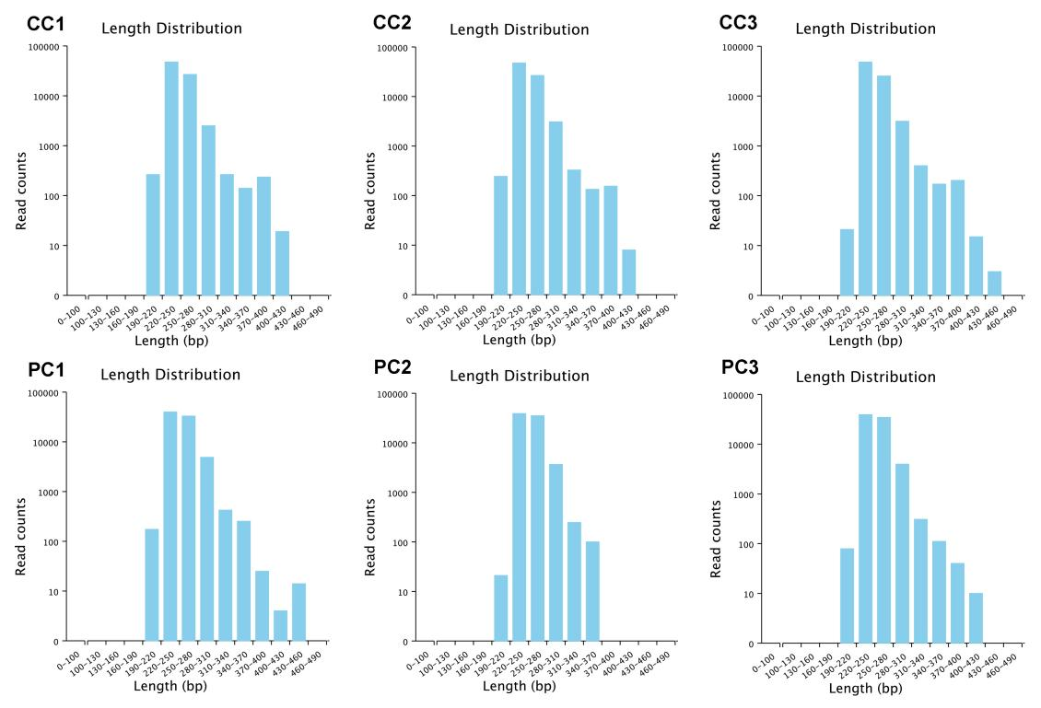
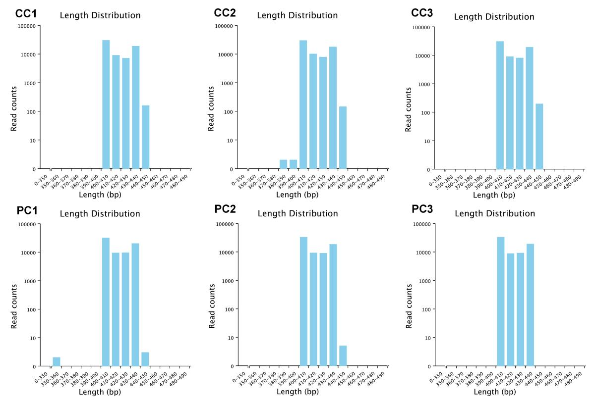
Supplementary Fig. 1 The trim length of the 16S sequencing
Supplementary Fig. 2 The trim length of the ITS sequencing

Methods
Soil DNA extraction and real-time quantitative PCR amplifcation
The total DNA of 0.1 g rhizosphere soil was extracted by using Fast DNA Spin Kit for Soil (MP biomedicals, USA), and the quality of DNA were detected by nanodrop 2000. The total Fusarium species abundances were estimated in the rhizosphere soil using real-time qPCR with the forward primer FusEF (5'-CTGGGTTCTTGACAAGCTCA-3'), and the reverse primer FusER (5'-CGGTGACATAGTAGCGAGGA-3') [1]. The specific primers of Fusarium oxysporum, FoQF (5'-CTCAAACAGTGGTACATGCGAGG-3') and FoQR (5'-CATCTAGGTCTTCCATCCACTTGA-3') was designed to amplify PCR products of 209 bp [2]. Standard curve obtained by plotting the log of a known DNA concentration of Fusarium oxysporum f.sp. foetens strain ZJ-3-1 (34.9 pg-34.9 ng) against the Ct values obtained from real-time qPCR assays. Real-time fluorescent qPCR reactions were carried out in a 20 μL volume according to realUniversal kit instructions mention (Tiangen Biochemical Technology (Beijing) Co., Ltd).
- Sohlberg E, Virkajärvi V, Parikka P, Rämö S, Laitila A, Sarlin T (2022) Taqman qPCR Quantification and Fusarium Community Analysis to Evaluate Toxigenic Fungi in Cereals. Toxins 14 (1):45. doi:http://www.doi.org/10.3390/toxins14010045
- Li X, Cui XM, Liu DQ, Sun T, Guo AL, Chen J (2019) Real-time PCR detection method of Panax notoginseng root rot pathogen Fusarium oxysporum. Hua Bei Nong Xue Bao 34 (S01):7

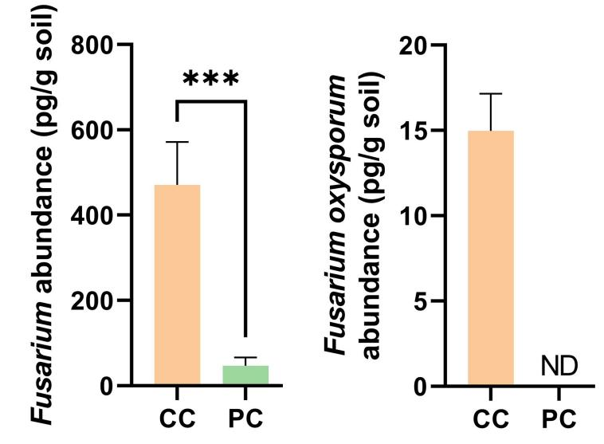
Supplementary Fig. 3 Absolute abundance of Fusarium species and F. oxysporum in rhizosphere soil of C. morifolium by real-time quantitative PCR.
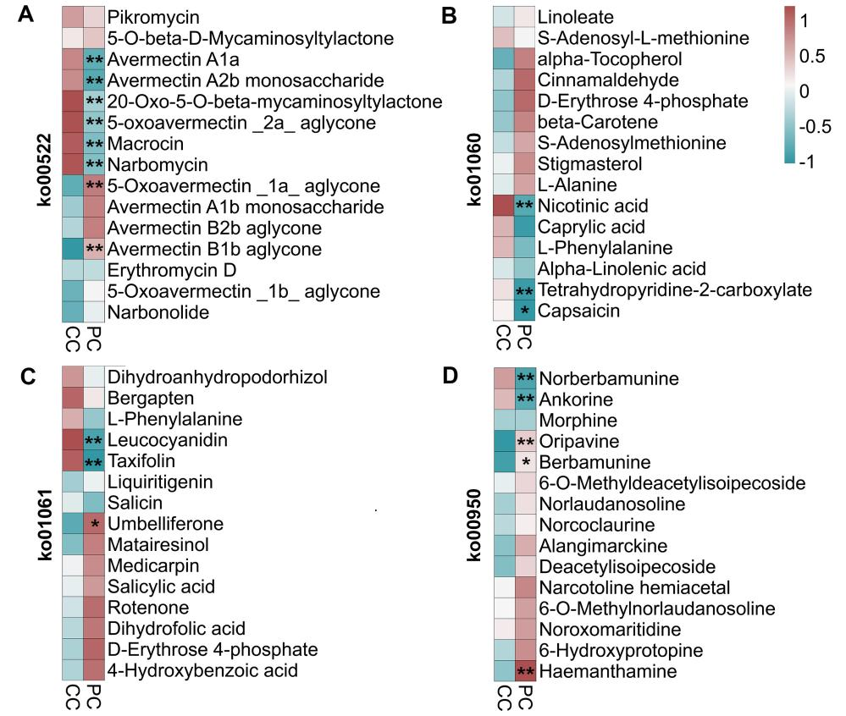
Supplementary Fig. 4 Top 15 metabolites in key KEGG pathways of C. morifolium rhizosphere soil in two treatments.
Note: A: Biosynthesis of 12-, 14- and 16-membered macrolides (ko00522), B: Biosynthesis of plant secondary metabolites (ko01060), C: Biosynthesis of phenylpropanoids (ko01061), D: Biosynthesis of isoquinoline alkaloid (ko00950); C. morifolium monoculture system (CC), P. vulgaris - C. morifolium rotation system (PC); “*” and “**” represent p<0.05 and p<0.01, respectively.

Methods
Network Construction
The network depicted in the figure was constructed using the BioinCloud platform (https://www.bioincloud.tech/), employing a series of parameters to define the relationships between fungal and bacterial genera, soil physicochemical properties, and soil enzymatic activities. The construction process involved the following steps and parameters:
1. Correlation Coefficient Type: Spearman correlation coefficient was selected to assess the monotonic relationships between variables without assuming a linear relationship.
2. Correlation Coefficient Threshold: A threshold of 0.6 was applied to include only strong correlations in the network. Absolute values of the Spearman correlation coefficient greater than or equal to 0.6 were considered significant.
3. P-Value Threshold: A significance level of 0.05 was used to determine statistically significant correlations, ensuring that the relationships depicted in the network were not due to random chance.
4. Number of Fungal Genera: The network included 10 fungal genera, represented in the innermost circle of the network diagram.
5. Number of Bacterial Genera: The network incorporated 20 bacterial genera, positioned in the outermost circle of the diagram.
6. Number of Soil Physicochemical Properties and Soil Enzymatic Activities: Fifteen soil physicochemical properties and five soil enzymatic activities were included as intermediate variables.
Network Visualization
The network visualization was designed with the following characteristics:
Node Size: The size of each node was determined by its degree, which reflects the number of connections a node has with other nodes. Larger nodes indicate a higher degree, suggesting a more central role in the network.
Edge Color: The color of the edges represents the direction of the correlation between nodes. Red edges indicate negative correlations, while green edges signify positive correlations.
Node Arrangement: Nodes were arranged in concentric circles, with fungal genera in the innermost circle, followed by soil physicochemical properties and enzymatic activities in the middle circle, and bacterial genera in the outermost circle.
This network analysis provides a visual representation of the complex interactions between soil microbiota and environmental factors, highlighting the significant relationships that may influence ecosystem functions and microbial community dynamics.
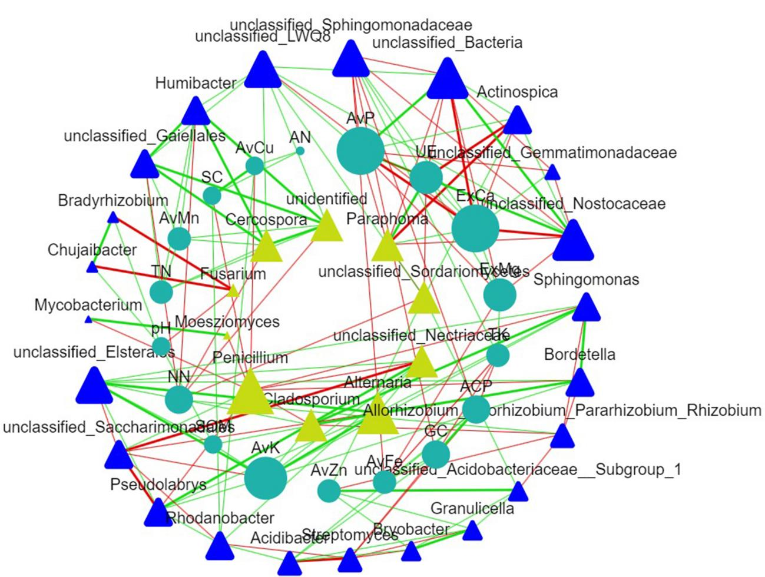
Supplementary Fig. 5 The interaction network between environmental factors and bacterial and fungal community at the genus level.
Note: The edge data of interaction network can be viewed in the Supplementary table.

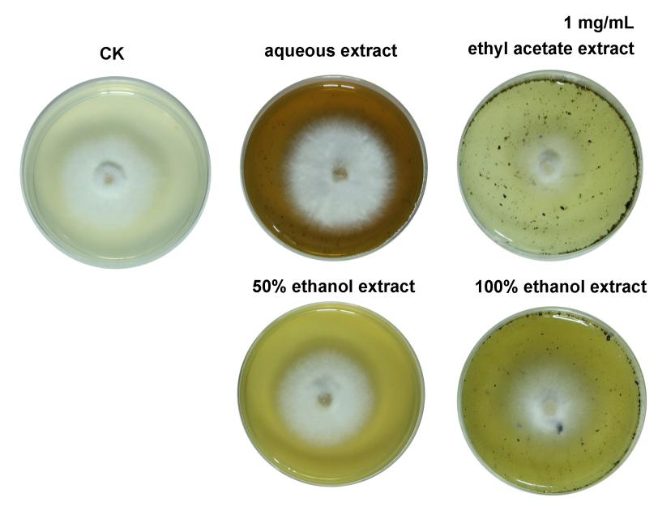
Supplementary Fig. 6 Antibacterial effects of different parts extracts of Prunella vulgaris (1 mg/mL) on Fusarium oxysporum.

Domain | Phyla | Relative abundance (%)
Domain | Phyla | CC | PC
Bacteria | Proteobacteria | 50.47±1.04 | 45.69±0.70*
Bacteria | Actinobacteriota | 21.09±0.98 | 24.43±0.29*
Bacteria | Acidobacteriota | 7.66±0.37 | 8.32±0.32
Bacteria | Cyanobacteria | 6.16±0.35 | 9.22±0.46**
Bacteria | Patescibacteria | 4.81±0.05 | 4.45±0.22
Bacteria | Gemmatimonadota | 2.64±0.16 | 1.42±0.07**
Bacteria | unclassified_Bacteria | 2.04±0.09 | 2.46±0.11*
Bacteria | Bacteroidota | 2.61±0.10 | 2.02±0.09*
Bacteria | Chloroflexi | 0.60±0.02 | 0.64±0.00
Bacteria | Myxococcota | 0.74±0.05 | 0.50±0.05*
Bacteria | Firmicutes | 0.42±0.02 | 0.47±0.07
Bacteria | Nitrospirota | 0.22±0.02 | 0.10±0.01**
Fungi | Ascomycota | 92.22±0.09 | 89.03±1.15*
Fungi | Basidiomycota | 5.53±0.24 | 9.96±1.04*
Fungi | unclassified_Fungi | 1.05±0.04 | 0.38±0.14**
Fungi | Chytridiomycota | 0.39±0.10 | 0.22±0.04
Fungi | Glomeromycota | 0.25±0.01 | 0.04±0.02**
Fungi | Kickxellomycota | 0.05±0.01 | 0.04±0.06
Fungi | Mortierellomycota | 0.43±0.14 | 0.23±0.04
Fungi | Rozellomycota | 0.07±0.05 | 0.09±0.01
Fungi | Mucoromycota | 0.00±0.00 | 0.01±0.01
Fungi | Olpidiomycota | 0.02±0.03 | 0.00±0.00
Supplementary Table 1. Comparison of the relative abundance of dominant phylum of C. morifolium rhizosphere soil bacterial and fungal communities in two treatments. Data are shown as means ± standard deviations (n = 3). “*” and “**” represent p < 0.05 and p < 0.01, respectively.

Supplementary Table 2. Comparison of the relative abundance of dominant genus of C. morifolium rhizosphere soil bacterial and fungal communities in two treatments. Data are shown as means ± standard deviations (n = 3). “*” and “**” represent p < 0.05 and p < 0.01, respectively.
Genus | Relative abundance (%) |  | Genus | Relative abundance (%)
Genus | CC | PC | Genus | CC | PC
unclassified_Nostocaceae | 6.09±0.59 | 9.15±0.8** | Pseudolabrys | 0.91±0.11 | 1.37±0.03**
Sphingomonas | 5.17±0.46 | 6.14±0.21* | Granulicella | 0.57±0.05 | 1.49±0.03**
Mycobacterium | 1.79±0.15 | 3.87±0.23** | unclassified_Elsterales | 0.84±0.09 | 1.17±0.06**
Rhodanobacter | 2.08±0.05 | 3.61±0.13** | Acidibacter | 0.84±0.11 | 1.26±0.1**
unclassified_Bacteria | 2.04±0.16 | 2.46±0.18* | Humibacter | 0.96±0.17 | 1.73±0.09*8
Allorhizobium_Neorhizobium_Pararhizobium_Rhizobium | 5.38±0.84 | 0.84±0.11** | Bradyrhizobium | 0.92±0.07 | 1.36±0.01**
unclassified_Gaiellales | 1.33±0.11 | 2.22±0.05** | Ralstonia | 1.49±0.11 | 1.14±0.07*
Streptomyces | 3.03±0.42 | 1.58±0.12** | Cladosporium | 13.95±0.33 | 16.81±0.7**
unclassified_Acidobacteriaceae__Subgroup_1 | 1.18±0.06 | 1.88±0.16** | unidentified fungi | 5.97±0.51 | 19.39±0.73**
unclassified_Gemmatimonadaceae | 1.6±0.16 | 0.94±0.05** | Penicillium | 18.89±0.82 | 10.02±0.99**
Actinospica | 0.75±0.06 | 2.03±0.09** | unclassified_Sordariomycetes | 5.99±0.17 | 11.74±0.89**
Bryobacter | 1.11±0.05 | 1.64±0.1** | Fusarium | 19.35±0.6 | 2.5±0.77**
unclassified_Frankiales | 0.93±0.06 | 1.5±0.1** | Alternaria | 4.24±0.43 | 6.59±0.21**
Bordetella | 1.27±0.06 | 1.64±0.05** | unclassified_Nectriaceae | 0.86±0.16 | 6.64±0.42**
Chujaibacter | 0.99±0.12 | 1.83±0.04** | Paraphoma | 2.2±0.19 | 0.74±0.16**

Supplementary Table 3. Top 15 up-regulated and down-regulated acidic metabolites of C. morifolium rhizosphere soil in two treatments. Data are shown as means ± standard deviations (n = 3). “*” and “**” represent p < 0.05 and p < 0.01, respectively.
Name | Category | CC | PC | regulated
CMP-pseudaminic acid | Carbohydrates | 11186±730.67 | 17257.68±2149.04** | up
3-O-p-Coumaroyloleanolic acid | Terpenoids | 10432.09±1832.56 | 16915.92±2892.04* | up
N-Acetylneuraminic acid | Carbohydrates | 3334.22±221.21 | 4671.76±241.67** | up
Quinic acid | Organic acids | 2911.09±161.15 | 4261.65±225.05** | up
3-Carboxy-2,3,4,9-tetrahydro-1H-pyrido[3,4-b]indole-1-propanoic acid | Organic acids | 1186.02±197.43 | 3049.04±155.87** | up
Decanoic acid | Fatty acids | 441.35±9.49 | 866.28±107.44** | up
2-Methylbenzoic acid | Organic acids | 508.29±92.24 | 759.02±61.34* | up
Myristoleic acid | Fatty acids | 482.71±21.15 | 714.21±40.43** | up
2-Hydroxy-4-(1-oxo-1,3-dihydro-2H-inden-2-ylidene)-but-2-enoic acid | Organic acids | 463.94±24.99 | 604.71±48.93* | up
5-oxo-7E-decenoic acid | Organic acids | 444.77±24.11 | 604.77±69.34* | up
Cis-10-Pentadecenoic Acid | Fatty acids | 406.09±13.94 | 527.66±52.6* | up
alpha-hydroxy myristic acid | Fatty acids | 321.78±12.71 | 545.44±60.1** | up
9-hydroxy-5Z-nonenoic acid | Organic acids | 378.16±12.59 | 452.5±32.24* | up
Novobiocic acid | Organic acids | 267.06±19.82 | 400.3±27.14** | up
Pseudolaric Acid B | Terpenoids | 276.42±24.37 | 354.37±36.25* | up
12-amino-octadecanoic acid | Fatty acids | 5246.96±445.98 | 3466.11±742.58* | down
(13Z,16Z)-Docosadienoic acid | Fatty acids | 4433.09±324.5 | 2629.92±560.06** | down
Euscaphic acid | Terpenoids | 2685.22±261.11 | 1148.92±222.95** | down
12-Methyltetradecanoic acid | Fatty acids | 2607.84±96.54 | 1656.47±346.1* | down
lignoceric acid | Fatty acids | 1415.9±169.34 | 572.7±175.45** | down
3-Hexaprenyl-4-hydroxybenzoic acid | Organic acids | 1051.77±33.43 | 338.1±98.21** | down
Docosanoic acid | Fatty acids | 972.09±69.97 | 580.62±121.54** | down
(4Z,7Z,10Z,13Z,16Z,19Z)-Docosahexaenoic acid | Fatty acids | 1094.83±91.48 | 483.37±62.05** | down
DL-Pipecolic acid | Fatty acids | 713.52±43.78 | 549.78±78.19* | down
Azelaic acid | Organic acids | 814.08±81.17 | 307±31.47** | down
myristic acid | Fatty acids | 714.18±35.41 | 491.28±65.65** | down
3,4-dimethylenedioxy mandelic acid | Organic acids | 562.87±12.6 | 260.16±4.23** | down
(9Z)-Hexadecenoic acid | Fatty acids | 513.98±39.84 | 339.81±70.66* | down
Nicotinic acid | Organic acids | 468.53±34.34 | 228.78±71.54** | down
Docosatrienoic Acid | Fatty acids | 384.53±71.5 | 112.06±8.68** | down

Supplementary Table 4. Table of total variance of principal component analysis (PCA) of C. morifolium soil physicochemical properties and enzyme activities.
Principal companents | Initial eigenvalues |  |  | Extraction sums of squared loadings
Principal companents | Total | Variance percentage (%) | Cumulative percentage (%) | Total | Variance percentage (%) | Cumulative percentage (%)
1 | 16.036 | 80.179 | 80.179 | 16.036 | 80.179 | 80.179
2 | 1.996 | 9.98 | 90.159 | 1.996 | 9.98 | 90.159
3 | 1.095 | 5.474 | 95.633 | 1.095 | 5.474 | 95.633
4 | 0.704 | 3.518 | 99.151 | - | - | -
5 | 0.17 | 0.849 | 100 | - | - | -
6 | 0 | 0 | 100 | - | - | -
7 | 0 | 0 | 100 | - | - | -
8 | 0 | 0 | 100 | - | - | -
9 | 0 | 0 | 100 | - | - | -
10 | 0 | 0 | 100 | - | - | -
11 | 0 | 0 | 100 | - | - | -
12 | 0 | 0 | 100 | - | - | -
13 | 0 | 0 | 100 | - | - | -
14 | 0 | 0 | 100 | - | - | -
15 | 0 | 0 | 100 | - | - | -
16 | 0 | 0 | 100 | - | - | -
17 | 0 | 0 | 100 | - | - | -
18 | 0 | 0 | 100 | - | - | -
19 | 0 | 0 | 100 | - | - | -
20 | 0 | 0 | 100 | - | - | -

Supplementary Table 5. Table of matrix components of principal component analysis (PCA) of C. morifolium soil physicochemical properties and enzyme activities. pH, soil organic matter (SOM), total nitrogen (TN), total phosphorus (TP), total potassium (TK), ammonium nitrogen (AN), nitrate nitrogen (NN), available phosphorus (AvP), available potassium (AvK), exchangeable calcium (ExCa), exchangeable magnesium (ExMg), available ferrum (AvFe), available manganese (AvMn), available cuprum (AvCu), available zinc (AvZn), available boron (AvB), soil urease (UE), soil sucrase (SC), soil acid phosphatase (ACP), soil catalase (CAT).
Soil parameters | Component matrix |  |  | Principal components |  |  | Comprehensive score coefficient | weight coefficient
Soil parameters | U1 | U2 | U3 | 1 | 2 | 3 | Comprehensive score coefficient | weight coefficient
ACP | 0.223 | -0.2 | -0.22 | 0.895 | -0.282 | -0.23 | 0.2208 | 5.38%
GC | 0.218 | -0.189 | -0.283 | 0.872 | -0.267 | -0.296 | 0.2185 | 5.33%
SC | 0.248 | 0.035 | -0.011 | 0.995 | 0.05 | -0.011 | 0.2126 | 5.18%
UE | -0.223 | 0.315 | -0.006 | -0.893 | 0.444 | -0.006 | 0.2202 | 5.37%
CAT | -0.042 | -0.432 | 0.738 | -0.17 | -0.611 | 0.772 | 0.123 | 3.00%
pH | 0.243 | 0.125 | -0.018 | 0.971 | 0.176 | -0.019 | 0.2175 | 5.30%
TN | 0.247 | 0.07 | 0.075 | 0.991 | 0.099 | 0.078 | 0.219 | 5.34%
TP | -0.01 | 0.588 | 0.215 | -0.039 | 0.83 | 0.225 | 0.0819 | 2.00%
TK | -0.249 | -0.036 | -0.001 | -0.998 | -0.051 | -0.002 | 0.2129 | 5.19%
NN | -0.231 | -0.086 | -0.115 | -0.924 | -0.121 | -0.12 | 0.209 | 5.10%
AN | 0.235 | -0.091 | -0.171 | 0.943 | -0.129 | -0.179 | 0.2167 | 5.28%
AvP | 0.249 | -0.036 | 0.024 | 0.996 | -0.051 | 0.025 | 0.2137 | 5.21%
AvK | 0.233 | 0.235 | 0.056 | 0.933 | 0.332 | 0.059 | 0.2231 | 5.44%
ExCa | -0.244 | 0.083 | -0.117 | -0.975 | 0.117 | -0.122 | 0.2195 | 5.35%
ExMg | -0.219 | 0.218 | -0.22 | -0.875 | 0.309 | -0.23 | 0.2187 | 5.33%
AvFe | 0.244 | 0.004 | -0.031 | 0.976 | 0.005 | -0.032 | 0.2064 | 5.03%
AvMn | 0.199 | 0.282 | 0.401 | 0.796 | 0.398 | 0.42 | 0.219 | 5.34%
AvZn | 0.247 | -0.07 | -0.052 | 0.987 | -0.098 | -0.055 | 0.217 | 5.29%
AvCu | 0.246 | 0.021 | -0.034 | 0.987 | 0.03 | -0.035 | 0.2108 | 5.14%
SOM | 0.234 | 0.242 | -0.006 | 0.935 | 0.342 | -0.006 | 0.2215 | 5.40%

Supplementary Table 6. The agronomic traits and yield of Prunella vulgaris

Plant weight (g)  n=10 | Plant height (cm)  n=10 | Number of fruit spikes per plant  n=10 | Fresh weight of fruit spikes per plant (g)  n=10 | Dry weight of fruit spikes per plant (g)  n=10
531.4±126.51 | 87.2±8.05 | 236.2±32.34 | 136.67±29.72 | 55.6±7.81

