Supplementary Information
Occupants and Surface Types Drive Microbial Dynamics in Controlled Indoor Environments
Jianjian Hou¹, Makiko Nakajima^{2, 3}, Yukiko Nishiuchi¹, Daisuke Ogura^{2, 4}, Atsushi Teramoto^{1, 5, 6}, China Kuratomi⁵, Yoko Iwamoto⁷, Yoshiko Okamura⁸, Kazuki Moriguchi⁹, Mateja Dovjak^{1, 10}, Kento Takayama¹¹, Yusaku Tsugami¹², So Fujiyoshi^{1, 2} *, Fumito Maruyama^{1, 2} *
¹ Center for the Planetary Health and Innovation Science (PHIS), The IDEC Institute, Hiroshima University, Higashi-Hiroshima, 739-8530, Japan
² Center for Holobiome and Built Environment (CHOBE), Hiroshima University, Higashi-Hiroshima, 739-8530, Japan
³ Department of Architectural Engineering, Faculty of Engineering, Hiroshima Institute of Technology, Hiroshima, 731-5193, Japan
⁴ Department of Architecture and Architectural Engineering, Graduate School of Engineering, Kyoto University, Kyoto, 615-8540, Japan
⁵ Department of Architecture, Graduate School of Advanced Science and Engineering, Hiroshima University, Higashi-Hiroshima, 739-8527, Japan
⁶ Graduate School of Engineering, Kyoto University, Kyoto, 615-8540, Japan
⁷ Program of Life and Environmental Sciences, Graduate School of Integrated Sciences for Life, Hiroshima University, Higashi-Hiroshima, 739-8521, Japan
⁸ Program of Biotechnology, Graduate School of Integrated Sciences for Life, Hiroshima University, Higashi-Hiroshima, 739-8530, Japan
⁹ Program of Basic Biology, Graduate School of Integrated Sciences for Life, Hiroshima University, Higashi-Hiroshima, 739-8526, Japan
¹⁰ Chair of Buildings and Constructional Complexes, Faculty of Civil and Geodetic Engineering, University of Ljubljana, Jamova cesta 2, Ljubljana, 1000, Slovenia
¹¹ School of Pharmacy, Showa Medical University, Tokyo, 142-8555, Japan
¹² National Institute of Animal Health, National Agriculture and Food Research Organization, Sapporo, 062-0045, Japan
*Email: fujiyoshi.so.62w@kyoto-u.jp and fumito@hiroshima-u.ac.jp

Contents
1. Supplementary Methods 3
1.1 Experimental Setup 3
1.2 Sample Collection and Processing 3
1.3 DNA Extraction, MiSeq Preparation, and Sequencing 4
1.4 Statistical Analysis 5
2. Supplementary Results 6
2.1 Sequencing Data 6
2.2 Predominant Bacterial and Eukaryotic Phyla 6
3. Supplementary Tables 8
4. Supplementary Figures 28

1. Supplementary Methods

1.1 Experimental Setup
To assess the impact of occupant presence on the indoor environment and its microbiome, samples were collected after one month of occupation—a period sufficient for microbial communities to stabilize and accumulate human-associated signatures. Each participation period included one month of occupancy followed by a sample collection session (Figure S2). To mitigate unit-specific biases, the two occupants exchanged units after the first month of each participation period. Each unit was occupied by one volunteer, with two occupants participating per period. Over the six periods, 11 volunteers participated, with one volunteering twice.
Guidelines for occupant behavior were as follows: Occupants were free to leave for work or other activities during the day but were required to return to their respective units for bathing and sleeping at night. In the control unit (#401), to minimize biases due to the absence of water flow from bathroom activities, toilet flushing, showering, and faucet use were conducted for 15 minutes each day by an occupant from Unit #402 or #403. To prevent cross-contamination, anyone entering the test units for flushing or sample collection wore a disposable laboratory coat and gloves, and disinfected their hands and shoes with 70% ethanol before entering.
Each of the air-conditioner filters and showerheads was cleaned and dried before the start of each participation period to ensure consistency in sample quality. The setup of these environmental controls is illustrated in Figure S1 and Figure S2.

1.2 Sample Collection and Processing
Aerosol samples were collected using a filter-based high-volume air sampler (HV-500R, Sibata Scientific Technology, Tokyo, Japan) with a flow rate of 700 L/min for a duration of one hour, using a quartz fiber filter (QR-100; Toyo Roshi Kaisha, Tokyo, Japan). Air sampler was placed on a chair 0.5 m above the floor. The filters were sterilized by dry-heat sterilization at 180℃ for 45 minutes before sampling. A sterilized filter was briefly attached to the air sampler at the sampling location and collected without running the sampler for negative control as blank. Upon the completion of each sampling event, the filters were transferred to a sterilized 50 mL Falcon tube and transported back to the laboratory storage at −80 °C for later use.
Samples from settled dust on floor source were collected using a floor vacuum cleaning robot (Roomba i3+, iRobot corporation, Bedford, MA, USA) with replacement paper packs, which was set to clean every morning during occupation. Before sampling, the brash and parts in contact with floor were disinfected with 70% ethanol, and new replacement filter and paper packs were changed. The dust-laden filter and paper packs were removed and carefully transferred into a sealed bag, which then stored at −80°C for later use.
Samples from surface of the AC filter (30 cm × 34 cm) source were collected using a swab (FLOQswab 5U005Sdual, Copan, Brescia, Italy) wetted with sterile phosphate-buffered saline. Samples from inside of showerhead and waste drain sources were collected using a swab (FLOQswab 5U005Sdual, Copan, Brescia, Italy) without wetting. The swab samples were then stored at −80°C for later use.

1.3 DNA Extraction, MiSeq Preparation, and Sequencing
DNA was extracted using the repeated bead-beating and column method with the DNeasy PowerBiofilm Kit (QIAGEN, Germantown, MD, USA) according to the manufacturer’s protocol with specific modifications, as follows.
Samples, including aerosol filters from air samplers, swabs from AC filters, waste drains, and showerheads, along with approximately 5 mg of floor dust, were placed directly into bead tubes within a laminar flow cabinet. For homogenization, the typical glass beads in the PowerBiofilm bead tubes were replaced with 400 μL of sterilized φ0.5 mm zirconia beads and two φ5 mm zirconia beads (TORAY, Tokyo, Japan). Mechanical disruption was performed using a Multi-bead shocker® (Yasui Kikai Corporation, Osaka, Japan) for five cycles; each cycle consisted of 60 seconds of operation at 2700 rpm followed by a 60-second rest period. The DNA was finally eluted in 100 μL of elution buffer. The total DNA concentration was measured using the Quant-iTTM PicoGreenTM dsDNA assay (Thermo Fisher Scientific, MA, USA) with a DS-11 FX+ spectrophotometer/fluorometer (DeNovix Inc., MA, USA).
The first round PCR was performed with the extracted genomic DNA as a template using the KAPA3G Plant PCR Kit (Kapa Biosystems, Boston, USA) according to the manufacturer’s protocol. The 16S rRNA gene were amplified with 30 cycles and the 18S rRNA gene were amplified with 35 cycles. The cycling condition was 95℃ for 3 min, amplification cycles with 95℃ for 20 s, 55℃ (annealing temperature for 16S rRNA gene) / 51℃ (annealing temperature for 18S rRNA gene) for 15 s, 72°C for 30 s, and a final extension at 72℃ for 1 min. PCR-grade water was used as a negative control for each first-round PCR run, and after confirming the absence of contamination by gel electrophoresis, the PCR products were purified with ProNex® Size-Selective Purification System (Promega, WI, USA) and subjected to a second round of PCR (Indexing PCR). This step uses 10 cycles PCR to add the Illumina sequencing adapters and add dual-index barcodes to the amplicon target using the KAPA HiFi HotStart ReadyMix PCR Kit (Kapa Biosystems, Boston, USA) according to the manufacturer’s protocol. The PCR products were purified as described above. Finished amplicon libraries were quantitated using the Quant-iTTM PicoGreenTM dsDNA assay and the average library size was determined on an Agilent 4150 TapeStation System (Agilent, Santa Clara, CA, USA) with the Agilent D1000 ScreenTape assay for normalization. The normalized libraries (4 nM) were then pooled at equimolar concentrations and sequenced on the Illumina MiSeq platform with 30% PhiX spike-in and at a read-length of 300 bp paired-end (MiSeq reagent kits V3).

1.4 Statistical Analysis
To explore clustering of indoor environmental quality parameter profiles across different unit types and participation periods, we conducted a Principal Component Analysis (PCA).

2. Supplementary Results

2.1 Sequencing Data
A total of 180 samples were initially collected across five distinct sources within three units. However, six samples were not collected from the waste drain and one from the floor due to logistical issues. Of these, PCR amplicon sequencing was unsuccessful in 14 samples for 16S rRNA gene and 48 samples for 18S rRNA gene, resulting in their exclusion from further analysis. Notably, the yield of eukaryotic 18S rRNA gene PCR products from the showerhead samples was insufficient for sequencing, which precluded analysis of the eukaryotic composition from these samples. Consequently, 159 samples and one negative control for aerosols were analyzed for bacterial communities via 16S rRNA amplicon sequencing, and 125 samples were evaluated for eukaryotic communities via 18S rRNA amplicon sequencing.
In the 16S rRNA gene amplicon sequencing, a total of 5,284,867 high-quality filtered sequences were obtained, classifying 15,384 Amplicon Sequence Variants (ASVs) across 159 samples from five different sources: aerosols, AC filter dust, floor dust, waste drain, and showerhead. The 18S rRNA gene amplicon sequencing yielded 3,168,265 high-quality filtered sequences, resulting in the classification of 10,306 ASVs from 125 samples collected from four sources: aerosols, AC filter dust, floor dust, and waste drain. Notably, minimal to no eukaryotic DNA was detected in samples from the showerhead, as the PCR amplicons for the Eukaryote 18S rRNA gene did not meet the required quantity for sequencing. To ensure a fair comparative analysis of microbial compositions across samples and groups, all samples were randomly rarefied to the minimum sequencing depth observed. For 16S rRNA gene, this was 5,967 reads per sample, achieving an average Good’s coverage of 99.50% ± 0.58%; for 18S rRNA gene, the depth was 5,842 reads per sample with an average Good’s coverage of 99.47% ± 0.60% (Table S4 and Table S5).

2.2 Predominant Bacterial and Eukaryotic Phyla
The bacterial community structure of all 159 samples, drawn from five distinct sources, was predominantly comprised of six phyla: Proteobacteria (55.1%), Firmicutes (20.9%), Actinobacteria (14.1%), Bacteroidota (4.2%), Planctomycetota (1.2%), Cyanobacteria (1.0%), and Bdellovibrionota (0.6%). Together, these groups constituted 97.1% of the total sequences analyzed. In contrast, the negative control for aerosols consisted primarily of three phyla: Proteobacteria (73.86%), Actinobacteria (21.60%), and Bacteroidota (4.54%).
The eukaryotic profiles of all 125 samples across four sample sources were predominantly composed of ten phyla, constituting 97.3% of the total sequences analyzed. Basidiomycota was the most abundant at 42.9%, followed by Ascomycota at 26.5%, and Arthropoda at 9.8%. Other significant contributions included Phragmoplastophyta (6.2%), Amoebozoa (3.5%), Ciliophora (3.4%), Vertebrata (3.1%), Holozoa (0.8%), Apicomplexa (0.7%), and Rotifera (0.5%).

3. Supplementary Tables

Table S1. Sampling overview for indoor microbiome analysis at Yamanaka Hall, Hiroshima University
Sampling Event | Participation Period | Start Date | Sampling Date | Unit Configuration | Unit Number | Occupancy Status
Sampling-1 | 21_Jun-Jul | 2021-05-25 | 2021-06-24 | Control | 401 | Unoccupied
Sampling-2 | 21_Jun-Jul | 2021-06-25 | 2021-07-22 | Control | 401 | Unoccupied
Sampling-3 | 21_Oct-Nov | 2021-09-10 | 2021-10-10 | Control | 401 | Unoccupied
Sampling-4 | 21_Oct-Nov | 2021-10-11 | 2021-11-07 | Control | 401 | Unoccupied
Sampling-5 | 22_Apr-May | 2022-04-04 | 2022-05-02 | Control | 401 | Unoccupied
Sampling-6 | 22_Apr-May | 2022-05-03 | 2022-06-01 | Control | 401 | Unoccupied
Sampling-7 | 22_Jun-Jul | 2022-06-02 | 2022-07-03 | Control | 401 | Unoccupied
Sampling-8 | 22_Jun-Jul | 2022-07-04 | 2022-07-28 | Control | 401 | Unoccupied
Sampling-9 | 22_Sep-Oct | 2022-08-18 | 2022-09-15 | Control | 401 | Unoccupied
Sampling-10 | 22_Sep-Oct | 2022-09-16 | 2022-10-17 | Control | 401 | Unoccupied
Sampling-11 | 22_Nov-Dec | 2022-10-18 | 2022-11-20 | Control | 401 | Unoccupied
Sampling-12 | 22_Nov-Dec | 2022-11-21 | 2022-12-18 | Control | 401 | Unoccupied
Sampling-1 | 21_Jun-Jul | 2021-05-25 | 2021-06-24 | Occupied, No Biotope | 402 | Occupant A, Male
Sampling-2 | 21_Jun-Jul | 2021-06-25 | 2021-07-22 | Occupied, No Biotope | 402 | Occupant B, Female
Sampling-3 | 21_Oct-Nov | 2021-09-10 | 2021-10-10 | Occupied, With Biotope | 402 | Occupant C, Female
Sampling-4 | 21_Oct-Nov | 2021-10-11 | 2021-11-07 | Occupied, With Biotope | 402 | Occupant D, Female
Sampling-5 | 22_Apr-May | 2022-04-04 | 2022-05-02 | Occupied, With Biotope | 402 | Occupant E, Female
Sampling-6 | 22_Apr-May | 2022-05-03 | 2022-06-01 | Occupied, With Biotope | 402 | Occupant F, Male
Sampling-7 | 22_Jun-Jul | 2022-06-02 | 2022-07-03 | Occupied, With Biotope | 402 | Occupant G, Female
Sampling-8 | 22_Jun-Jul | 2022-07-04 | 2022-07-28 | Occupied, With Biotope | 402 | Occupant H, Male
Sampling-9 | 22_Sep-Oct | 2022-08-18 | 2022-09-15 | Occupied, With Biotope | 402 | Occupant I, Male
Sampling-10 | 22_Sep-Oct | 2022-09-16 | 2022-10-17 | Occupied, With Biotope | 402 | Occupant C, Female
Sampling-11 | 22_Nov-Dec | 2022-10-18 | 2022-11-20 | Occupied, No Biotope | 402 | Occupant K, Male
Sampling-12 | 22_Nov-Dec | 2022-11-21 | 2022-12-18 | Occupied, No Biotope | 402 | Occupant L, Female
Sampling-1 | 21_Jun-Jul | 2021-05-25 | 2021-06-24 | Occupied, With Biotope | 403 | Occupant B, Female
Sampling-2 | 21_Jun-Jul | 2021-06-25 | 2021-07-22 | Occupied, With Biotope | 403 | Occupant A, Male
Sampling-3 | 21_Oct-Nov | 2021-09-10 | 2021-10-10 | Occupied, No Biotope | 403 | Occupant D, Female
Sampling-4 | 21_Oct-Nov | 2021-10-11 | 2021-11-07 | Occupied, No Biotope | 403 | Occupant C, Female
Sampling-5 | 22_Apr-May | 2022-04-04 | 2022-05-02 | Occupied, No Biotope | 403 | Occupant F, Male
Sampling-6 | 22_Apr-May | 2022-05-03 | 2022-06-01 | Occupied, No Biotope | 403 | Occupant E, Female
Sampling-7 | 22_Jun-Jul | 2022-06-02 | 2022-07-03 | Occupied, No Biotope | 403 | Occupant H, Male
Sampling-8 | 22_Jun-Jul | 2022-07-04 | 2022-07-28 | Occupied, No Biotope | 403 | Occupant G, Female
Sampling-9 | 22_Sep-Oct | 2022-08-18 | 2022-09-15 | Occupied, No Biotope | 403 | Occupant C, Female
Sampling-10 | 22_Sep-Oct | 2022-09-16 | 2022-10-17 | Occupied, No Biotope | 403 | Occupant I, Male
Sampling-11 | 22_Nov-Dec | 2022-10-18 | 2022-11-20 | Occupied, With Biotope | 403 | Occupant L, Female
Sampling-12 | 22_Nov-Dec | 2022-11-21 | 2022-12-18 | Occupied, With Biotope | 403 | Occupant K, Male

Table S2. Summary of the sample sizes per sample type, per participation period, and unit type in each sample type for microbial community analysis
 | Sample size (n) | Participation Period | Sample size (n) | Unit type | Sample size (n)
Aerosol | 29 | 21_Jun-Jul | 5 | Cont | 9
 |  | 21_Oct-Nov | 5 | NoBio | 10
 |  | 22_Apr-May | 6 | Bio | 10
 |  | 22_Jun-Jul | 4
 |  | 22_Sep-Oct | 5
 |  | 22_Nov-Dec | 4
AC filter dust | 34 | 21_Jun-Jul | 5 | Cont | 10
 |  | 21_Oct-Nov | 5 | NoBio | 12
 |  | 22_Apr-May | 6 | Bio | 12
 |  | 22_Jun-Jul | 6
 |  | 22_Sep-Oct | 6
 |  | 22_Nov-Dec | 6
Floor dust | 33 | 21_Jun-Jul | 5 | Cont | 9
 |  | 21_Oct-Nov | 5 | NoBio | 12
 |  | 22_Apr-May | 6 | Bio | 12
 |  | 22_Jun-Jul | 6
 |  | 22_Sep-Oct | 6
 |  | 22_Nov-Dec | 5
Showerhead | 34 | 21_Jun-Jul | 5 | Cont | 10
 |  | 21_Oct-Nov | 5 | NoBio | 12
 |  | 22_Apr-May | 6 | Bio | 12
 |  | 22_Jun-Jul | 6
 |  | 22_Sep-Oct | 6
 |  | 22_Nov-Dec | 6
Waste drain | 29 | 21_Jun-Jul | 0 | Cont | 9
 |  | 21_Oct-Nov | 5 | NoBio | 10
 |  | 22_Apr-May | 6 | Bio | 10
 |  | 22_Jun-Jul | 5
 |  | 22_Sep-Oct | 6
 |  | 22_Nov-Dec | 6
Note: Unit type was categorized as Cont (control), NoBio (occupied without a biotope), and Bio (occupied with a biotope)

Table S3. Sampling schedule, occupancy metrics, kitchen use, and indoor environmental conditions across 12 sampling events
 |  |  |  |  |  |  |  |  |  |  | Temperature (℃) |  |  |  | Relative humidity (%) |  |  |  | CO₂ (ppm)
Sampling Event | Participation Period | Period | Period group¹ | Sampling date  DD/MM/YYYY | Month | Unit Number | Unit type | Occupancy rate² (%) | Stay rate³ (%) | Kitchen use frequency⁴ (%) | Mean | Minimum | Median | Maximum | Mean | Minimum | Median | Maximum | Mean | Minimum | Median | Maximum
Sampling-1 | 21_Jun-Jul | Period.1 | Jun-Jul | 24/06/2021 | 21_Jun | R401 | Cont | 0.0 | 4.8 | 0 | 25.6 | 21.4 | 26.2 | 27.6 | 58.9 | 47 | 59 | 77 | 451.5 | 374 | 443 | 899
Sampling-1 | 21_Jun-Jul | Period.1 | Jun-Jul | 24/06/2021 | 21_Jun | R402 | NoBio | 75.9 | 54.8 | 0 | 24.9 | 19.4 | 25 | 27.5 | 61.3 | 48 | 60 | 84 | 728.9 | 379 | 611 | 1726
Sampling-1 | 21_Jun-Jul | Period.1 | Jun-Jul | 24/06/2021 | 21_Jun | R403 | Bio | 75.9 | 52.6 | 0 | 25.6 | 21.5 | 26.2 | 28.5 | 59.7 | 48 | 60 | 78 | 653.6 | 374 | 560.5 | 1645
Sampling-2 | 21_Jun-Jul | Period.2 | Jun-Jul | 22/07/2021 | 21_Jul | R401 | Cont | 0.0 | ND | 0 | ND | ND | ND | ND | ND | ND | ND | ND | ND | ND | ND | ND
Sampling-2 | 21_Jun-Jul | Period.2 | Jun-Jul | 22/07/2021 | 21_Jul | R402 | NoBio | 74.1 | 45.0 | 0 | 26.1 | 20.5 | 26.2 | 28.8 | 59.0 | 39 | 59 | 75 | 655.7 | 392 | 520 | 1891
Sampling-2 | 21_Jun-Jul | Period.2 | Jun-Jul | 22/07/2021 | 21_Jul | R403 | Bio | 74.1 | 46.5 | 0 | 25.6 | 19.7 | 25.9 | 27.7 | 70.6 | 44 | 73 | 85 | 682.0 | 396 | 517 | 1720
Sampling-3 | 21_Oct-Nov | Period.3 | Oct-Nov | 10/10/2021 | 21_Oct | R401 | Cont | 0.0 | ND | 0 | ND | ND | ND | ND | ND | ND | ND | ND | ND | ND | ND | ND
Sampling-3 | 21_Oct-Nov | Period.3 | Oct-Nov | 10/10/2021 | 21_Oct | R402 | Bio | 75.9 | 47.8 | 0 | 24.1 | 19.3 | 23.4 | 28 | 61.4 | 45 | 61 | 76 | 627.7 | 384 | 520.5 | 1435
Sampling-3 | 21_Oct-Nov | Period.3 | Oct-Nov | 10/10/2021 | 21_Oct | R403 | NoBio | 82.8 | 43.2 | 0 | 26.3 | 23.6 | 26.3 | 27.8 | 64.5 | 52 | 64.5 | 81 | 602.6 | 389 | 500.5 | 1552
Sampling-4 | 21_Oct-Nov | Period.4 | Oct-Nov | 07/11/2021 | 21_Nov | R401 | Cont | 0.0 | 6.4 | 0 | 26.7 | 19.7 | 27.65 | 29.5 | 45.9 | 27 | 38 | 87 | 449.6 | 373 | 434 | 765
Sampling-4 | 21_Oct-Nov | Period.4 | Oct-Nov | 07/11/2021 | 21_Nov | R402 | Bio | 66.7 | 34.3 | 0 | 23.2 | 17.7 | 23.4 | 27.1 | 51.7 | 38 | 50 | 84 | 550.2 | 384 | 465 | 1525
Sampling-4 | 21_Oct-Nov | Period.4 | Oct-Nov | 07/11/2021 | 21_Nov | R403 | NoBio | 74.1 | 36.5 | 0 | 23.0 | 16.5 | 22.4 | 32.4 | 48.7 | 26 | 48 | 75 | 561.5 | 384 | 474 | 1232
Sampling-5 | 22_Apr-May | Period.5 | Apr-May | 02/05/2022 | 22_Apr | R401 | Cont | 0.0 | ND | 0 | 22.4 | 13.7 | 23.4 | 25 | 44.2 | 30 | 44 | 66 | ND | ND | ND | ND
Sampling-5 | 22_Apr-May | Period.5 | Apr-May | 02/05/2022 | 22_Apr | R402 | Bio | 71.4 | 35.8 | 0 | 21.1 | 14.1 | 21.5 | 24.8 | 50.1 | 27 | 49 | 83 | 543.5 | 392 | 435 | 1252
Sampling-5 | 22_Apr-May | Period.5 | Apr-May | 02/05/2022 | 22_Apr | R403 | NoBio | 71.4 | 41.7 | 0 | 21.7 | 14.4 | 21.7 | 24.8 | 47.1 | 32 | 45 | 67 | 583.2 | 388 | 449.5 | 1249
Sampling-6 | 22_Apr-May | Period.6 | Apr-May | 01/06/2022 | 22_May | R401 | Cont | 0.0 | 0.1 | 0 | 24.6 | 22.9 | 24.1 | 28.3 | 48.1 | 32 | 48 | 88 | 430.0 | 403 | 426 | 538
Sampling-6 | 22_Apr-May | Period.6 | Apr-May | 01/06/2022 | 22_May | R402 | Bio | 69.0 | 47.3 | 0 | 24.0 | 20.4 | 24.3 | 26.8 | 49.2 | 37 | 49 | 66 | 636.1 | 398 | 492 | 1397
Sampling-6 | 22_Apr-May | Period.6 | Apr-May | 01/06/2022 | 22_May | R403 | NoBio | 55.2 | 25.1 | 0 | 24.0 | 20.4 | 23.9 | 27.8 | 48.6 | 36 | 48 | 69 | 501.7 | 393 | 437 | 873
Sampling-7 | 22_Jun-Jul | Period.7 | Jun-Jul | 03/07/2022 | 22_Jun | R401 | Cont | 0.0 | 0.8 | 0 | 21.4 | 17.3 | 19.2 | 29.2 | 59.2 | 39 | 62 | 72 | 435.2 | 395 | 430 | 604
Sampling-7 | 22_Jun-Jul | Period.7 | Jun-Jul | 03/07/2022 | 22_Jun | R402 | Bio | 96.8 | 76.9 | 51.6 | 25.7 | 22.8 | 25.5 | 29.6 | 62.1 | 40 | 62 | 79 | 894.4 | 381 | 946 | 1664
Sampling-7 | 22_Jun-Jul | Period.7 | Jun-Jul | 03/07/2022 | 22_Jun | R403 | NoBio | 67.7 | 41.6 | 0 | 23.4 | 21.3 | 23.3 | 25.8 | 60.4 | 45 | 61 | 80 | 645.3 | 402 | 482 | 1327
Sampling-8 | 22_Jun-Jul | Period.8 | Jun-Jul | 28/07/2022 | 22_Jul | R401 | Cont | 0.0 | 0.0 | 0 | 22.5 | 21 | 22.5 | 23.7 | 68.6 | 61 | 68 | 78 | 437.8 | 394 | 435 | 514
Sampling-8 | 22_Jun-Jul | Period.8 | Jun-Jul | 28/07/2022 | 22_Jul | R402 | Bio | 75.0 | 52.0 | 0 | 24.0 | 22 | 24 | 25.4 | 61.3 | 49 | 61 | 77 | 778.9 | 380 | 562 | 1755
Sampling-8 | 22_Jun-Jul | Period.8 | Jun-Jul | 28/07/2022 | 22_Jul | R403 | NoBio | 95.8 | 73.3 | 12.5 | 26.8 | 22 | 26.6 | 30.5 | 61.2 | 43 | 61 | 72 | 895.2 | 361 | 952 | 1718
Sampling-9 | 22_Sep-Oct | Period.9 | Sep-Oct | 15/09/2022 | 22_Sep | R401 | Cont | 0.0 | 11.7 | 0 | 23.7 | 21.3 | 22.8 | 29.1 | 67.2 | 47 | 67 | 83 | 461.8 | 387 | 448 | 613
Sampling-9 | 22_Sep-Oct | Period.9 | Sep-Oct | 15/09/2022 | 22_Sep | R402 | Bio | 63.0 | 28.2 | 0 | 26.0 | 25.3 | 25.8 | 29.8 | 70.4 | 51 | 70 | 81 | 557.2 | 367 | 457 | 1393
Sampling-9 | 22_Sep-Oct | Period.9 | Sep-Oct | 15/09/2022 | 22_Sep | R403 | NoBio | 66.7 | 33.9 | 0 | 21.8 | 15.7 | 21.3 | 30.1 | 58.9 | 46 | 59 | 75 | 600.6 | 372 | 456 | 1585
Sampling-10 | 22_Sep-Oct | Period.10 | Sep-Oct | 17/10/2022 | 22_Oct | R401 | Cont | 0.0 | 0.9 | 0 | 22.1 | 19.6 | 22.4 | 23.1 | 63.6 | 46 | 64 | 85 | 447.0 | 390 | 443 | 595
Sampling-10 | 22_Sep-Oct | Period.10 | Sep-Oct | 17/10/2022 | 22_Oct | R402 | Bio | 38.7 | 14.3 | 0 | 22.8 | 18.7 | 23.1 | 26.8 | 60.3 | 45 | 60 | 87 | 495.2 | 383 | 447 | 1416
Sampling-10 | 22_Sep-Oct | Period.10 | Sep-Oct | 17/10/2022 | 22_Oct | R403 | NoBio | 45.2 | 22.7 | 0 | 24.9 | 20.6 | 25.7 | 26.9 | 60.4 | 47 | 59 | 80 | 525.1 | 389 | 449 | 1126
Sampling-11 | 22_Nov-Dec | Period.11 | Nov-Dec | 20/11/2022 | 22_Nov | R401 | Cont | 0.0 | 1.0 | 0 | 18.7 | 15.6 | 18.5 | 22.6 | 51.3 | 41 | 50 | 100 | 452.5 | 397 | 449 | 667
Sampling-11 | 22_Nov-Dec | Period.11 | Nov-Dec | 20/11/2022 | 22_Nov | R402 | NoBio | 66.7 | 23.2 | 0 | 23.4 | 18 | 22 | 31.1 | 42.3 | 26 | 42 | 77 | 519.4 | 397 | 448 | 1149
Sampling-11 | 22_Nov-Dec | Period.11 | Nov-Dec | 20/11/2022 | 22_Nov | R403 | Bio | 75.8 | 58.6 | 6.1 | 23.7 | 19.5 | 23.8 | 27.2 | 47.7 | 35 | 46 | 68 | 657.2 | 384 | 615 | 1445
Sampling-12 | 22_Nov-Dec | Period.12 | Nov-Dec | 18/12/2022 | 22_Dec | R401 | Cont | 0.0 | 4.2 | 0 | 14.3 | 10.3 | 13.5 | 17.9 | 51.2 | 34 | 51 | 74 | 463.3 | 392 | 460 | 577
Sampling-12 | 22_Nov-Dec | Period.12 | Nov-Dec | 18/12/2022 | 22_Dec | R402 | NoBio | 74.1 | 60.8 | 0 | 21.3 | 17.8 | 21.3 | 24.7 | 39.2 | 21 | 39 | 58 | 655.1 | 347 | 670.5 | 1221
Sampling-12 | 22_Nov-Dec | Period.12 | Nov-Dec | 18/12/2022 | 22_Dec | R403 | Bio | 70.4 | 29.4 | 0 | 22.0 | 16.1 | 21.4 | 31.2 | 41.7 | 21 | 43 | 75 | 564.7 | 386 | 485 | 1219
Note:
This table summarizes the schedule and contextual parameters for 12 sampling events across three residential units. For each event, data include:
- Sampling Event: Sequential number identifying each of the 12 time points.
- Participation Period: Abbreviated label referencing the calendar season and year.
- Period: Identifier (1–12) for individual sampling rounds.
- Period group¹: Aggregated by season (e.g., Jun–Jul, Sep–Oct) to support seasonal comparisons.
- Occupancy rate²: Percentage of days each unit was assigned an occupant during the one-month sampling interval.
- Stay rate³: Estimated from continuous CO₂ monitoring; the proportion of time CO₂ exceeded outdoor background levels by 100–150 ppm was interpreted as occupancy.
- Kitchen use frequency⁴: Proportion of days during each sampling interval that the kitchen was used for cooking, based on self-reported occupant records.
ND = No data (due to device error or data loss).

Table S4. Sequence count of input to QIIME2 and high-quality sequence count after quality control by the DADA2 pipeline, excluding amplicon sequence variants (ASVs) classified as Eukaryotes, Chloroplasts, or Mitochondria. And alpha diversity metrics post-rarefaction to 5,967 reads per sample for the 16S rRNA gene amplicon across 159 samples and one negative control for aerosols (Aerosol_Blank)
SampleID_16S159 | Sequence count of input to QIIME2 | High-quality sequence count | Good’s coverage | Observed ASVs | Shannon
Aerosol_Blank | 17965 | 16616 | 100.00% | 18 | 2.51
Aerosol_21_Jun_Cont. | 16190 | 13778 | 99.90% | 64 | 3.60
Aerosol_21_Jun_NoBio. | 21522 | 18481 | 99.88% | 159 | 4.77
Aerosol_21_Jun_Bio. | 22882 | 19812 | 99.95% | 76 | 3.68
Aerosol_21_Jul_NoBio. | 19626 | 18265 | 100.00% | 23 | 2.22
Aerosol_21_Jul_Bio. | 18710 | 16412 | 99.98% | 117 | 4.41
Aerosol_21_Oct_Bio. | 16620 | 14339 | 99.95% | 105 | 3.68
Aerosol_21_Oct_NoBio. | 69462 | 51524 | 99.88% | 204 | 3.58
Aerosol_21_Nov_Cont. | 24075 | 15339 | 99.53% | 258 | 4.60
Aerosol_21_Nov_Bio. | 27867 | 23085 | 99.82% | 410 | 5.44
Aerosol_21_Nov_NoBio. | 38509 | 28283 | 99.15% | 461 | 5.08
Aerosol_22_Apr_Cont. | 24064 | 14138 | 99.97% | 164 | 4.80
Aerosol_22_Apr_Bio. | 18293 | 9564 | 99.95% | 120 | 4.56
Aerosol_22_Apr_NoBio. | 27792 | 13319 | 99.92% | 121 | 4.46
Aerosol_22_May_Cont. | 22856 | 8976 | 99.31% | 498 | 5.74
Aerosol_22_May_Bio. | 34930 | 18378 | 98.98% | 492 | 5.72
Aerosol_22_May_NoBio. | 21089 | 13826 | 99.88% | 241 | 5.08
Aerosol_22_Jun_Bio. | 67543 | 55978 | 99.87% | 276 | 4.62
Aerosol_22_Jun_NoBio. | 75275 | 61409 | 99.82% | 225 | 4.33
Aerosol_22_Jul_Cont. | 88851 | 68638 | 99.93% | 102 | 3.43
Aerosol_22_Jul_Bio. | 100277 | 78112 | 99.92% | 175 | 4.11
Aerosol_22_Sep_Cont. | 66077 | 57148 | 99.93% | 112 | 3.31
Aerosol_22_Sep_Bio. | 72224 | 61430 | 99.85% | 261 | 4.35
Aerosol_22_Sep_NoBio. | 73846 | 64196 | 99.93% | 123 | 3.39
Aerosol_22_Oct_Cont. | 58218 | 9905 | 98.86% | 582 | 5.56
Aerosol_22_Oct_NoBio. | 67127 | 38396 | 99.13% | 551 | 5.24
Aerosol_22_Nov_Cont. | 71965 | 56856 | 99.21% | 538 | 5.16
Aerosol_22_Nov_NoBio. | 67760 | 54672 | 99.51% | 406 | 4.87
Aerosol_22_Nov_Bio. | 56670 | 47254 | 99.88% | 347 | 4.97
Aerosol_22_Dec_Cont. | 53895 | 46261 | 99.92% | 185 | 4.08
Air_con_filter_21_Jun_Cont. | 31879 | 23053 | 99.83% | 233 | 4.32
Air_con_filter_21_Jun_NoBio. | 32317 | 23537 | 98.61% | 359 | 4.69
Air_con_filter_21_Jun_Bio. | 28753 | 19659 | 98.06% | 503 | 5.14
Air_con_filter_21_Jul_NoBio. | 30735 | 23167 | 98.64% | 412 | 4.93
Air_con_filter_21_Jul_Bio. | 34996 | 25449 | 98.31% | 458 | 4.88
Air_con_filter_21_Oct_Bio. | 28336 | 21361 | 98.81% | 349 | 4.47
Air_con_filter_21_Oct_NoBio. | 30568 | 22582 | 98.99% | 301 | 4.25
Air_con_filter_21_Nov_Cont. | 27064 | 22570 | 99.77% | 326 | 5.14
Air_con_filter_21_Nov_Bio. | 34002 | 25755 | 98.73% | 349 | 4.51
Air_con_filter_21_Nov_NoBio. | 27149 | 18641 | 99.56% | 231 | 4.23
Air_con_filter_22_Apr_Cont. | 25694 | 17066 | 99.95% | 108 | 4.25
Air_con_filter_22_Apr_Bio. | 27611 | 10777 | 99.90% | 213 | 4.52
Air_con_filter_22_Apr_NoBio. | 23468 | 9628 | 99.80% | 196 | 3.94
Air_con_filter_22_May_Cont. | 13372 | 5967 | 99.98% | 176 | 4.90
Air_con_filter_22_May_Bio. | 36369 | 25842 | 99.04% | 265 | 3.95
Air_con_filter_22_May_NoBio. | 28608 | 20898 | 99.75% | 237 | 3.84
Air_con_filter_22_Jun_Cont. | 54279 | 31780 | 99.88% | 267 | 5.11
Air_con_filter_22_Jun_Bio. | 60601 | 40723 | 98.17% | 470 | 4.43
Air_con_filter_22_Jun_NoBio. | 50141 | 35024 | 98.63% | 387 | 4.19
Air_con_filter_22_Jul_Cont. | 42845 | 34217 | 99.66% | 263 | 3.09
Air_con_filter_22_Jul_Bio. | 55623 | 39154 | 98.59% | 433 | 4.41
Air_con_filter_22_Jul_NoBio. | 58887 | 43956 | 98.14% | 506 | 4.55
Air_con_filter_22_Sep_Cont. | 68656 | 53209 | 99.56% | 362 | 4.61
Air_con_filter_22_Sep_Bio. | 65142 | 47021 | 98.49% | 325 | 4.06
Air_con_filter_22_Sep_NoBio. | 60406 | 45509 | 98.98% | 328 | 4.29
Air_con_filter_22_Oct_Cont. | 75533 | 52412 | 97.23% | 759 | 5.52
Air_con_filter_22_Oct_Bio. | 78971 | 64290 | 99.50% | 257 | 3.54
Air_con_filter_22_Oct_NoBio. | 75149 | 56988 | 98.79% | 360 | 3.93
Air_con_filter_22_Nov_Cont. | 56319 | 41207 | 99.85% | 321 | 5.01
Air_con_filter_22_Nov_NoBio. | 70405 | 47669 | 97.79% | 486 | 4.67
Air_con_filter_22_Nov_Bio. | 57434 | 37104 | 98.83% | 297 | 3.90
Air_con_filter_22_Dec_Cont. | 55358 | 41432 | 99.30% | 486 | 5.16
Air_con_filter_22_Dec_NoBio. | 57366 | 41285 | 98.84% | 304 | 4.06
Air_con_filter_22_Dec_Bio. | 73518 | 52129 | 97.27% | 472 | 4.39
Dust_21_Jun_Cont. | 26835 | 19942 | 99.16% | 315 | 4.30
Dust_21_Jun_NoBio. | 27164 | 21331 | 99.46% | 191 | 3.49
Dust_21_Jun_Bio. | 26142 | 17052 | 98.91% | 281 | 3.89
Dust_21_Jul_NoBio. | 26347 | 19253 | 99.50% | 202 | 3.59
Dust_21_Jul_Bio. | 21968 | 17806 | 99.58% | 187 | 3.53
Dust_21_Oct_Bio. | 44420 | 25668 | 99.28% | 261 | 3.75
Dust_21_Oct_NoBio. | 18683 | 9393 | 99.87% | 118 | 3.19
Dust_21_Nov_Cont. | 50958 | 23653 | 99.41% | 205 | 3.75
Dust_21_Nov_Bio. | 45286 | 20876 | 99.48% | 201 | 3.45
Dust_21_Nov_NoBio. | 32745 | 17584 | 99.80% | 111 | 2.74
Dust_22_Apr_Cont. | 49642 | 28866 | 98.64% | 377 | 4.34
Dust_22_Apr_Bio. | 39216 | 22887 | 99.63% | 147 | 2.78
Dust_22_Apr_NoBio. | 48775 | 21188 | 99.15% | 288 | 4.08
Dust_22_May_Cont. | 45680 | 27674 | 99.13% | 311 | 4.06
Dust_22_May_Bio. | 46359 | 24890 | 99.48% | 234 | 3.85
Dust_22_May_NoBio. | 36078 | 18641 | 99.30% | 234 | 3.27
Dust_22_Jun_Cont. | 58766 | 42760 | 98.93% | 258 | 3.56
Dust_22_Jun_Bio. | 71929 | 45730 | 98.26% | 397 | 3.81
Dust_22_Jun_NoBio. | 60639 | 34980 | 99.55% | 167 | 3.26
Dust_22_Jul_Cont. | 49675 | 32917 | 98.89% | 261 | 3.64
Dust_22_Jul_Bio. | 51323 | 35310 | 99.18% | 223 | 3.95
Dust_22_Jul_NoBio. | 59346 | 38288 | 98.24% | 387 | 4.13
Dust_22_Sep_Cont. | 47921 | 36800 | 99.30% | 221 | 3.37
Dust_22_Sep_Bio. | 44979 | 33809 | 99.45% | 206 | 3.81
Dust_22_Sep_NoBio. | 51606 | 36982 | 99.38% | 209 | 3.63
Dust_22_Oct_Cont. | 71254 | 55023 | 98.66% | 313 | 3.41
Dust_22_Oct_Bio. | 45857 | 35004 | 99.56% | 158 | 3.42
Dust_22_Oct_NoBio. | 61083 | 48372 | 98.73% | 285 | 3.36
Dust_22_Nov_Cont. | 60173 | 49889 | 98.71% | 299 | 3.06
Dust_22_Nov_NoBio. | 72075 | 49680 | 99.16% | 253 | 3.88
Dust_22_Nov_Bio. | 65363 | 44084 | 99.41% | 207 | 3.63
Dust_22_Dec_NoBio. | 58085 | 40323 | 99.23% | 249 | 3.93
Dust_22_Dec_Bio. | 80828 | 54197 | 98.37% | 354 | 4.07
Shower_head_21_Jun_Cont. | 23516 | 19107 | 100.00% | 38 | 2.09
Shower_head_21_Jun_NoBio. | 26474 | 23266 | 99.95% | 71 | 3.03
Shower_head_21_Jun_Bio. | 22041 | 18072 | 99.97% | 39 | 2.55
Shower_head_21_Jul_NoBio. | 23615 | 21209 | 99.95% | 30 | 0.79
Shower_head_21_Jul_Bio. | 27507 | 22766 | 99.82% | 68 | 2.24
Shower_head_21_Oct_Bio. | 33289 | 23411 | 99.98% | 9 | 0.90
Shower_head_21_Oct_NoBio. | 27691 | 16600 | 99.98% | 22 | 1.86
Shower_head_21_Nov_Cont. | 21814 | 18355 | 99.97% | 29 | 1.42
Shower_head_21_Nov_Bio. | 22009 | 19984 | 99.97% | 29 | 2.27
Shower_head_21_Nov_NoBio. | 23971 | 22421 | 100.00% | 21 | 2.22
Shower_head_22_Apr_Cont. | 22692 | 20060 | 99.95% | 30 | 1.86
Shower_head_22_Apr_Bio. | 18214 | 16423 | 99.98% | 26 | 1.38
Shower_head_22_Apr_NoBio. | 24070 | 20681 | 99.97% | 27 | 1.72
Shower_head_22_May_Cont. | 21119 | 18787 | 99.98% | 24 | 1.50
Shower_head_22_May_Bio. | 19660 | 17786 | 100.00% | 31 | 2.25
Shower_head_22_May_NoBio. | 20352 | 17166 | 99.97% | 27 | 1.98
Shower_head_22_Jun_Cont. | 69727 | 59969 | 99.98% | 35 | 2.73
Shower_head_22_Jun_Bio. | 53594 | 46020 | 100.00% | 23 | 2.28
Shower_head_22_Jun_NoBio. | 70717 | 54838 | 99.88% | 72 | 2.47
Shower_head_22_Jul_Cont. | 78154 | 57938 | 99.92% | 39 | 2.42
Shower_head_22_Jul_Bio. | 72318 | 58837 | 100.00% | 29 | 1.59
Shower_head_22_Jul_NoBio. | 71937 | 57241 | 99.88% | 32 | 1.15
Shower_head_22_Sep_Cont. | 62968 | 48573 | 99.95% | 31 | 1.69
Shower_head_22_Sep_Bio. | 52065 | 42480 | 99.97% | 43 | 1.85
Shower_head_22_Sep_NoBio. | 61119 | 49088 | 99.98% | 26 | 1.54
Shower_head_22_Oct_Cont. | 50688 | 43876 | 100.00% | 35 | 1.92
Shower_head_22_Oct_Bio. | 59132 | 48179 | 99.98% | 31 | 1.54
Shower_head_22_Oct_NoBio. | 51219 | 43410 | 100.00% | 26 | 1.91
Shower_head_22_Nov_Cont. | 56866 | 48726 | 99.98% | 40 | 2.77
Shower_head_22_Nov_NoBio. | 49649 | 42991 | 99.98% | 23 | 2.21
Shower_head_22_Nov_Bio. | 56812 | 47392 | 99.95% | 36 | 1.01
Shower_head_22_Dec_Cont. | 49567 | 43360 | 99.97% | 34 | 2.66
Shower_head_22_Dec_NoBio. | 47209 | 40741 | 99.98% | 44 | 3.05
Shower_head_22_Dec_Bio. | 61138 | 51277 | 99.98% | 29 | 1.71
Waste_drain_21_Oct_Bio. | 30446 | 16856 | 99.80% | 147 | 3.57
Waste_drain_21_Oct_NoBio. | 24717 | 12700 | 99.95% | 66 | 1.94
Waste_drain_21_Nov_Cont. | 30969 | 13206 | 99.93% | 47 | 2.37
Waste_drain_21_Nov_Bio. | 40489 | 26542 | 99.11% | 295 | 4.15
Waste_drain_21_Nov_NoBio. | 36249 | 26492 | 99.83% | 91 | 3.06
Waste_drain_22_Apr_Cont. | 36877 | 16402 | 99.87% | 84 | 2.80
Waste_drain_22_Apr_Bio. | 39716 | 15271 | 99.73% | 124 | 3.15
Waste_drain_22_Apr_NoBio. | 37521 | 26483 | 99.97% | 105 | 3.79
Waste_drain_22_May_Cont. | 49450 | 18928 | 99.83% | 115 | 3.64
Waste_drain_22_May_Bio. | 37879 | 22911 | 99.80% | 85 | 1.85
Waste_drain_22_May_NoBio. | 40185 | 15629 | 99.85% | 103 | 3.13
Waste_drain_22_Jun_Cont. | 66826 | 50994 | 99.77% | 97 | 2.62
Waste_drain_22_Jun_Bio. | 73566 | 32183 | 99.31% | 239 | 4.10
Waste_drain_22_Jun_NoBio. | 69277 | 36049 | 99.66% | 128 | 2.73
Waste_drain_22_Jul_Cont. | 71555 | 48073 | 99.78% | 97 | 3.02
Waste_drain_22_Jul_Bio. | 78513 | 43755 | 99.11% | 248 | 3.94
Waste_drain_22_Jul_NoBio. | 64790 | 37728 | 99.45% | 139 | 2.42
Waste_drain_22_Sep_Cont. | 69868 | 45299 | 99.73% | 109 | 3.17
Waste_drain_22_Sep_Bio. | 54508 | 31380 | 99.58% | 143 | 2.82
Waste_drain_22_Sep_NoBio. | 65195 | 39969 | 99.70% | 113 | 2.65
Waste_drain_22_Oct_Cont. | 66838 | 53293 | 99.66% | 132 | 2.33
Waste_drain_22_Oct_Bio. | 64400 | 33746 | 99.78% | 74 | 2.48
Waste_drain_22_Oct_NoBio. | 82045 | 45599 | 99.63% | 160 | 3.45
Waste_drain_22_Nov_Cont. | 63114 | 38170 | 99.70% | 102 | 3.17
Waste_drain_22_Nov_NoBio. | 54936 | 35139 | 99.97% | 44 | 1.81
Waste_drain_22_Nov_Bio. | 60313 | 28871 | 99.73% | 149 | 3.77
Waste_drain_22_Dec_Cont. | 52880 | 41471 | 99.66% | 102 | 2.60
Waste_drain_22_Dec_NoBio. | 57431 | 31313 | 99.68% | 122 | 3.33
Waste_drain_22_Dec_Bio. | 54795 | 29698 | 99.78% | 95 | 2.78

Table S5. Sequence count of input to QIIME2 and high-quality sequence count after quality control by the DADA2 pipeline. And alpha diversity metrics post-rarefaction to 5,842 reads per sample for the 18S rRNA gene amplicon across 125 samples
SampleID_18S125 | Sequence count of input to QIIME2 | High-quality sequence count | Good’s coverage | Observed ASVs | Shannon
Aerosol_21_Jun_Cont. | 19734 | 9988 | 99.81% | 167 | 4.02
Aerosol_21_Jun_NoBio. | 19676 | 10378 | 99.76% | 172 | 4.02
Aerosol_21_Jun_Bio. | 17597 | 10428 | 99.91% | 140 | 4.07
Aerosol_21_Jul_NoBio. | 14052 | 10473 | 100.00% | 59 | 3.57
Aerosol_21_Jul_Bio. | 17221 | 8854 | 99.86% | 142 | 3.92
Aerosol_21_Oct_Bio. | 14479 | 9981 | 99.95% | 72 | 2.81
Aerosol_21_Oct_NoBio. | 24028 | 15267 | 99.90% | 117 | 3.49
Aerosol_21_Nov_Cont. | 25119 | 15682 | 99.83% | 187 | 3.84
Aerosol_21_Nov_Bio. | 20237 | 12804 | 99.79% | 187 | 3.88
Aerosol_21_Nov_NoBio. | 24299 | 13915 | 99.73% | 212 | 4.19
Aerosol_22_Apr_Cont. | 25939 | 15330 | 99.79% | 234 | 4.48
Aerosol_22_Apr_Bio. | 20271 | 13346 | 99.88% | 178 | 4.36
Aerosol_22_Apr_NoBio. | 21358 | 12553 | 99.73% | 196 | 4.20
Aerosol_22_May_Cont. | 21781 | 13135 | 99.59% | 195 | 2.98
Aerosol_22_May_Bio. | 20251 | 11693 | 99.88% | 150 | 2.92
Aerosol_22_May_NoBio. | 22981 | 14274 | 99.73% | 183 | 3.58
Aerosol_22_Jun_Bio. | 66771 | 43677 | 99.28% | 296 | 4.35
Aerosol_22_Jun_NoBio. | 55081 | 38262 | 99.55% | 225 | 4.28
Aerosol_22_Jul_Cont. | 62125 | 43871 | 99.28% | 300 | 4.22
Aerosol_22_Jul_Bio. | 61726 | 45779 | 99.30% | 361 | 4.68
Aerosol_22_Sep_Cont. | 52300 | 31800 | 99.45% | 273 | 4.29
Aerosol_22_Sep_Bio. | 60427 | 41767 | 99.28% | 286 | 4.30
Aerosol_22_Sep_NoBio. | 54690 | 36344 | 99.42% | 307 | 4.57
Aerosol_22_Oct_Cont. | 64701 | 40511 | 98.92% | 252 | 3.74
Aerosol_22_Oct_NoBio. | 60403 | 38975 | 98.94% | 317 | 4.15
Aerosol_22_Nov_Cont. | 59381 | 40048 | 99.04% | 332 | 4.32
Aerosol_22_Nov_NoBio. | 70094 | 43174 | 99.23% | 314 | 4.45
Aerosol_22_Nov_Bio. | 71521 | 51419 | 99.66% | 227 | 4.25
Aerosol_22_Dec_Cont. | 68452 | 54488 | 99.79% | 179 | 3.90
Air_con_filter_21_Jun_Cont. | 24481 | 12451 | 99.62% | 275 | 4.77
Air_con_filter_21_Jun_NoBio. | 26786 | 14352 | 99.30% | 303 | 4.83
Air_con_filter_21_Jun_Bio. | 24907 | 11026 | 99.47% | 280 | 4.86
Air_con_filter_21_Jul_NoBio. | 27495 | 14081 | 99.28% | 341 | 5.08
Air_con_filter_21_Jul_Bio. | 25134 | 10958 | 99.44% | 272 | 4.85
Air_con_filter_21_Oct_Bio. | 22764 | 11970 | 99.73% | 203 | 3.82
Air_con_filter_21_Oct_NoBio. | 23776 | 12318 | 99.62% | 233 | 4.29
Air_con_filter_21_Nov_Cont. | 19868 | 8614 | 99.79% | 197 | 4.12
Air_con_filter_21_Nov_Bio. | 19446 | 8651 | 99.61% | 201 | 4.20
Air_con_filter_21_Nov_NoBio. | 18022 | 9657 | 99.79% | 166 | 3.67
Air_con_filter_22_Apr_Cont. | 18715 | 10571 | 99.88% | 168 | 4.10
Air_con_filter_22_Apr_Bio. | 16406 | 10393 | 99.85% | 133 | 3.90
Air_con_filter_22_Apr_NoBio. | 20092 | 10767 | 99.73% | 189 | 3.99
Air_con_filter_22_May_Cont. | 20179 | 12242 | 99.85% | 203 | 4.41
Air_con_filter_22_May_Bio. | 27119 | 8979 | 99.42% | 238 | 4.37
Air_con_filter_22_May_NoBio. | 26017 | 14441 | 99.85% | 179 | 4.21
Air_con_filter_22_Jun_Cont. | 78120 | 39126 | 98.34% | 489 | 4.86
Air_con_filter_22_Jun_Bio. | 68194 | 42111 | 99.66% | 82 | 1.47
Air_con_filter_22_Jun_NoBio. | 81115 | 45745 | 98.48% | 461 | 5.02
Air_con_filter_22_Jul_Cont. | 66544 | 34795 | 98.24% | 530 | 5.35
Air_con_filter_22_Jul_Bio. | 94557 | 55364 | 98.39% | 516 | 5.01
Air_con_filter_22_Jul_NoBio. | 64543 | 41058 | 99.09% | 405 | 4.93
Air_con_filter_22_Sep_Cont. | 97835 | 49366 | 97.43% | 593 | 5.38
Air_con_filter_22_Sep_Bio. | 89236 | 41853 | 98.05% | 477 | 5.16
Air_con_filter_22_Sep_NoBio. | 97865 | 43119 | 97.84% | 533 | 5.21
Air_con_filter_22_Oct_Cont. | 122113 | 55008 | 96.78% | 652 | 5.41
Air_con_filter_22_Oct_Bio. | 91297 | 52086 | 98.73% | 454 | 4.92
Air_con_filter_22_Oct_NoBio. | 91443 | 51128 | 98.92% | 438 | 5.00
Air_con_filter_22_Nov_Cont. | 87322 | 52155 | 99.45% | 299 | 4.05
Air_con_filter_22_Nov_NoBio. | 108758 | 52766 | 98.13% | 488 | 4.64
Air_con_filter_22_Nov_Bio. | 108138 | 65858 | 97.71% | 469 | 4.49
Air_con_filter_22_Dec_Cont. | 63780 | 37201 | 99.64% | 304 | 4.26
Air_con_filter_22_Dec_NoBio. | 79312 | 47417 | 98.96% | 342 | 4.14
Air_con_filter_22_Dec_Bio. | 92210 | 49552 | 98.56% | 401 | 4.49
Dust_21_Jun_Cont. | 17642 | 11689 | 99.86% | 166 | 3.75
Dust_21_Jun_NoBio. | 49023 | 22226 | 99.54% | 261 | 3.83
Dust_21_Jun_Bio. | 69018 | 37937 | 99.18% | 275 | 3.62
Dust_21_Jul_NoBio. | 44673 | 24228 | 99.71% | 128 | 2.77
Dust_21_Jul_Bio. | 17446 | 9116 | 99.88% | 225 | 4.43
Dust_21_Oct_Bio. | 21662 | 11390 | 99.71% | 251 | 4.57
Dust_21_Oct_NoBio. | 19481 | 10813 | 99.74% | 200 | 4.07
Dust_21_Nov_Cont. | 20412 | 10005 | 99.79% | 168 | 3.94
Dust_21_Nov_Bio. | 27491 | 15192 | 99.73% | 139 | 3.81
Dust_21_Nov_NoBio. | 20937 | 8703 | 99.98% | 88 | 3.13
Dust_22_Apr_Cont. | 20688 | 13049 | 99.74% | 169 | 4.07
Dust_22_Apr_Bio. | 23575 | 13724 | 99.85% | 148 | 3.90
Dust_22_Apr_NoBio. | 24252 | 12311 | 99.76% | 205 | 4.05
Dust_22_May_Cont. | 21954 | 9333 | 99.90% | 171 | 4.28
Dust_22_May_Bio. | 23562 | 11532 | 99.71% | 166 | 3.94
Dust_22_May_NoBio. | 22089 | 9178 | 99.61% | 205 | 4.21
Dust_22_Jun_Cont. | 73448 | 22103 | 99.38% | 245 | 3.87
Dust_22_Jun_Bio. | 96373 | 42277 | 99.11% | 184 | 2.87
Dust_22_Jun_NoBio. | 108342 | 63546 | 98.92% | 282 | 3.75
Dust_22_Jul_Cont. | 86610 | 43227 | 98.46% | 316 | 3.56
Dust_22_Jul_Bio. | 104655 | 61010 | 98.63% | 297 | 3.42
Dust_22_Jul_NoBio. | 71689 | 38978 | 98.39% | 340 | 3.53
Dust_22_Sep_Cont. | 66189 | 39637 | 99.16% | 267 | 3.49
Dust_22_Sep_Bio. | 54734 | 34609 | 99.49% | 155 | 3.07
Dust_22_Sep_NoBio. | 70452 | 45533 | 98.96% | 261 | 3.06
Dust_22_Oct_Cont. | 62471 | 30177 | 99.28% | 203 | 2.65
Dust_22_Oct_Bio. | 67893 | 39063 | 99.40% | 194 | 2.99
Dust_22_Oct_NoBio. | 51371 | 27090 | 99.01% | 280 | 3.74
Dust_22_Nov_Cont. | 56147 | 20495 | 99.54% | 217 | 3.26
Dust_22_Nov_NoBio. | 50412 | 28676 | 99.23% | 215 | 3.38
Dust_22_Nov_Bio. | 54408 | 33548 | 99.45% | 150 | 2.71
Dust_22_Dec_NoBio. | 61790 | 37253 | 99.35% | 196 | 2.95
Dust_22_Dec_Bio. | 54396 | 32649 | 99.08% | 322 | 4.09
Waste_drain_21_Oct_Bio. | 20479 | 9238 | 99.97% | 31 | 2.18
Waste_drain_21_Oct_NoBio. | 15685 | 5989 | 100.00% | 47 | 2.88
Waste_drain_21_Nov_Cont. | 14112 | 6764 | 100.00% | 10 | 1.60
Waste_drain_21_Nov_Bio. | 19772 | 10681 | 99.86% | 62 | 1.71
Waste_drain_21_Nov_NoBio. | 21640 | 14436 | 100.00% | 16 | 1.19
Waste_drain_22_Apr_Cont. | 14798 | 5842 | 100.00% | 38 | 2.73
Waste_drain_22_Apr_Bio. | 18427 | 6950 | 99.98% | 40 | 2.56
Waste_drain_22_Apr_NoBio. | 16067 | 11669 | 99.97% | 47 | 3.10
Waste_drain_22_May_Cont. | 25205 | 12265 | 99.98% | 55 | 3.08
Waste_drain_22_May_Bio. | 15384 | 8810 | 100.00% | 17 | 2.41
Waste_drain_22_May_NoBio. | 20263 | 10147 | 99.85% | 69 | 3.29
Waste_drain_22_Jun_Cont. | 56265 | 40211 | 100.00% | 22 | 1.82
Waste_drain_22_Jun_Bio. | 53323 | 12353 | 99.86% | 72 | 2.88
Waste_drain_22_Jun_NoBio. | 34838 | 12131 | 99.98% | 62 | 2.90
Waste_drain_22_Jul_Cont. | 50838 | 28813 | 99.90% | 28 | 1.46
Waste_drain_22_Jul_Bio. | 57834 | 26651 | 99.95% | 44 | 2.64
Waste_drain_22_Jul_NoBio. | 40035 | 12841 | 99.95% | 49 | 2.42
Waste_drain_22_Sep_Cont. | 57373 | 21125 | 99.90% | 37 | 2.06
Waste_drain_22_Sep_Bio. | 48498 | 8245 | 99.95% | 48 | 3.06
Waste_drain_22_Sep_NoBio. | 71618 | 33101 | 99.83% | 68 | 2.36
Waste_drain_22_Oct_Cont. | 58810 | 31868 | 99.98% | 20 | 1.74
Waste_drain_22_Oct_Bio. | 55121 | 27344 | 99.98% | 21 | 1.24
Waste_drain_22_Oct_NoBio. | 58559 | 13146 | 99.91% | 43 | 1.87
Waste_drain_22_Nov_Cont. | 60655 | 17966 | 99.91% | 36 | 2.23
Waste_drain_22_Nov_NoBio. | 47936 | 24004 | 99.98% | 17 | 1.06
Waste_drain_22_Nov_Bio. | 54489 | 12443 | 99.93% | 49 | 2.77
Waste_drain_22_Dec_Cont. | 52469 | 26092 | 99.98% | 13 | 0.47
Waste_drain_22_Dec_NoBio. | 67866 | 34259 | 99.95% | 28 | 1.79
Waste_drain_22_Dec_Bio. | 60288 | 27189 | 99.97% | 31 | 2.00

Table S6. Relative abundance of major bacterial and eukaryotic taxa as discussed in the text

Table S7. Topological properties of the bacterial and eukaryotic networks in aerosol and AC filter dust
 |  | Bacteria |  | Eukaryote
 |  | Aerosol (n=28) | AC filter dust (n=33) | Aerosol (n=28) | AC filter dust (n=33)
Largest connected component (LCC): | Relative LCC size | 0.163 | 0.319 | 0.182 | 0.212
Largest connected component (LCC): | Clustering coefficient | 0.155 | 0.028 | 0 | 0.293
Largest connected component (LCC): | Modularity | 0.598 | 0.686 | 0.385 | 0.464
Largest connected component (LCC): | Positive edge percentage | 77.273 | 52.174 | 50 | 78.571
Largest connected component (LCC): | Edge density | 0.095 | 0.051 | 0.182 | 0.154
Largest connected component (LCC): | Natural connectivity | 0.058 | 0.028 | 0.114 | 0.096
Largest connected component (LCC): | Vertex connectivity | 1 | 1 | 1 | 1
Largest connected component (LCC): | Edge connectivity | 1 | 1 | 1 | 1
Largest connected component (LCC): | Average dissimilarity | 0.693 | 0.702 | 0.706 | 0.696
Largest connected component (LCC): | Average path length | 3.17 | 3.523 | 2.121 | 1.81
Whole network: | Number of components | 75 | 80 | 38 | 36
Whole network: | Clustering coefficient | 0.066 | 0.025 | 0 | 0.208
Whole network: | Modularity | 0.866 | 0.781 | 0.802 | 0.721
Whole network: | Positive edge percentage | 83.607 | 61.017 | 62.069 | 66.667
Whole network: | Edge density | 0.007 | 0.007 | 0.014 | 0.015
Whole network: | Natural connectivity | 0.008 | 0.008 | 0.017 | 0.017

4. Supplementary Figures
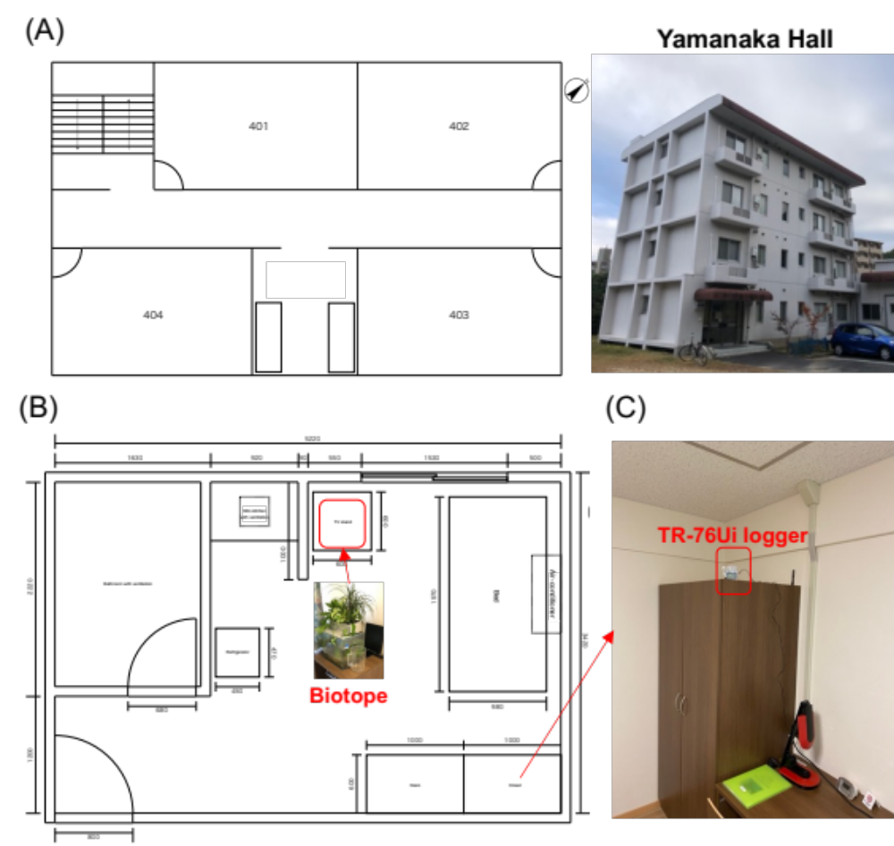
Figure S1. Layout and monitoring setup in residential units at Yamanaka Hall. (A) Ground plan of residential units (Units #401, 402, and 403): Displays the configuration of three residential units located on the same floor, each equipped with essential furnishings and appliances such as beds, desks, refrigerators, air conditioners, and television stands. This plan provides a comprehensive visual representation of the living spaces used in the study. (B) Detailed layout of a representative unit: Shows precise locations of the biotope, furniture, and appliances within one of the units to illustrate typical setup and monitoring conditions. (C) Monitoring setup within the rooms: Displays the placement of the TR-76Ui logger used for measuring air temperature, humidity, and CO₂ concentrations, highlighting its location relative to other room elements to ensure accurate environmental monitoring

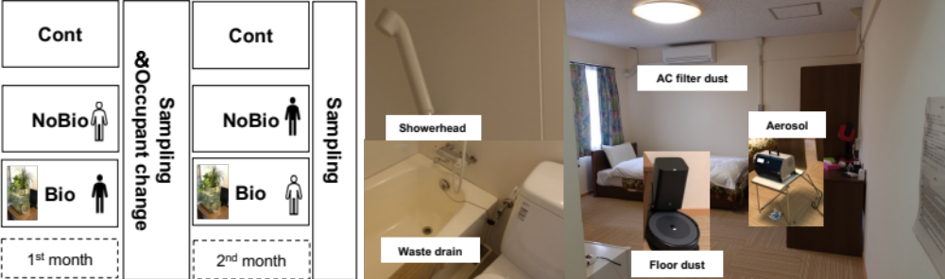
Figure S2. Sampling locations and methods in the controlled indoor environment. This figure provides a visual overview of the microbial sampling methods used throughout the study, highlighting indoor dry sources (aerosols, air-conditioner (AC) filter dust, floor dust), and wet sources (showerhead, waste drain) in the bathroom. The panel illustrates the various sampling points within a representative residential unit to showcase the comprehensive approach taken to assess microbial dynamics across different environmental interfaces
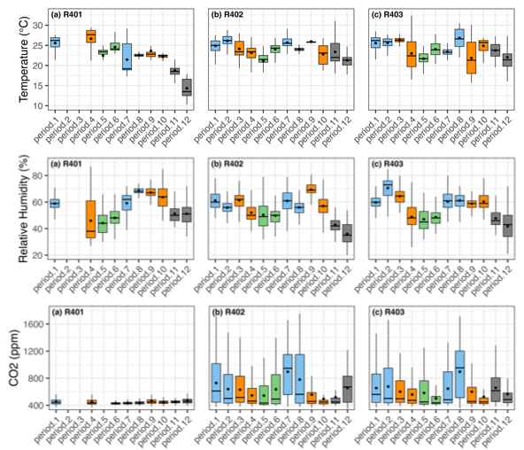
Figure S3. Boxplots of indoor environmental quality parameters––including temperature (℃), relative humidity (%) and CO₂ concentration (ppm)––across 12 monthly participation periods in three residential units (R401, R402, R403). Each panel displays the distribution of values for one unit across period.1 to period.12. Each period corresponds to the sampling months listed in Table S3. Black circles indicate the mean values for each period. Seasonal color coding is applied for visual clarity: light blue = summer, orange = autumn, green = spring, and gray = winter
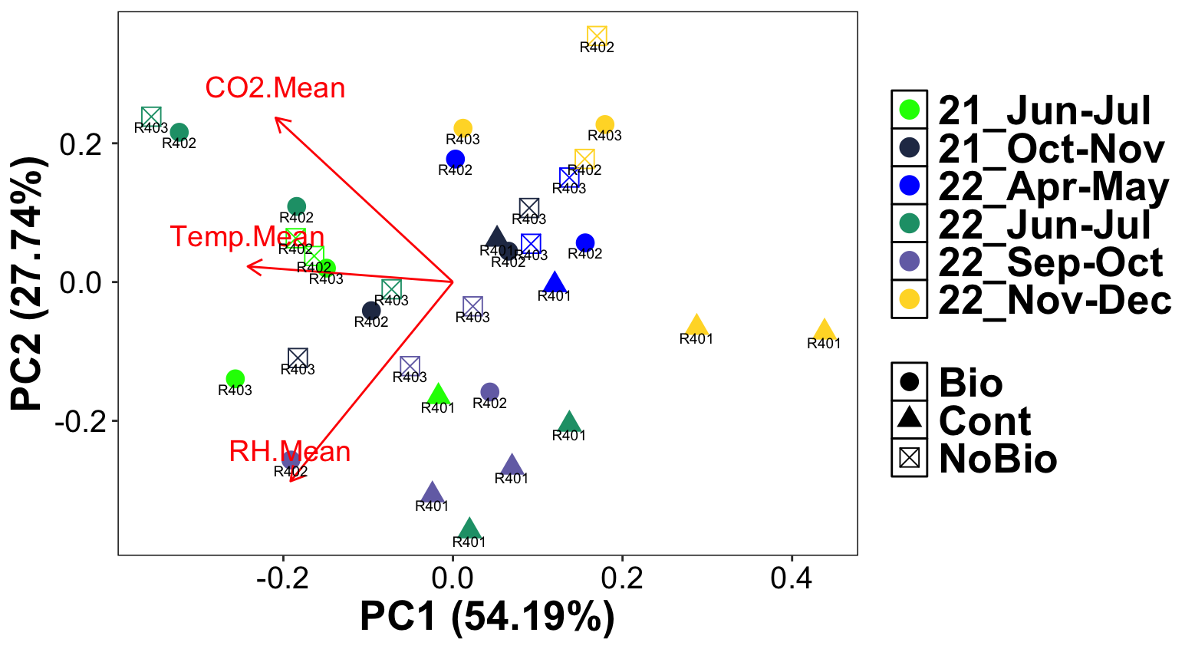
Figure S4. Principal Component Analysis (PCA) of environmental parameters. PCA plot showing the mean values of environmental parameters (temperature, relative humidity, CO₂) in three residential units during all participation periods

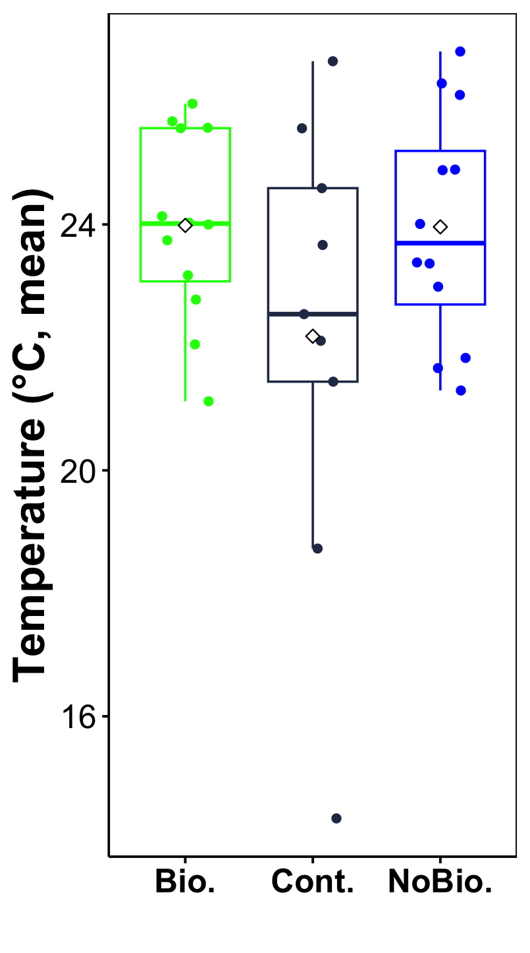
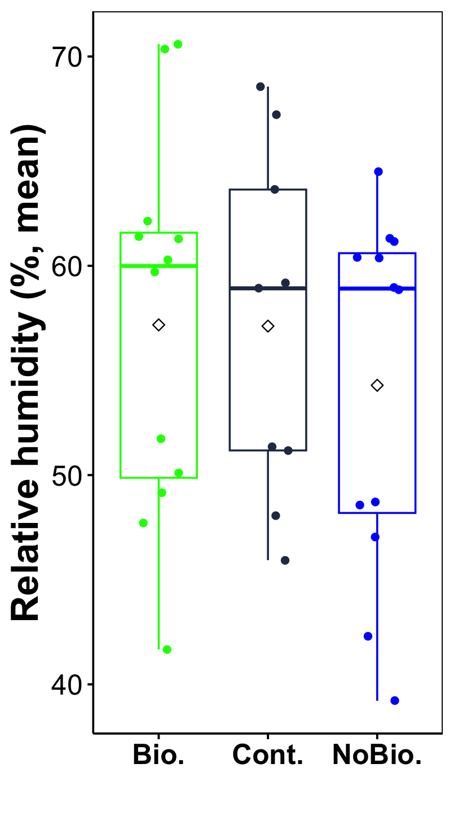
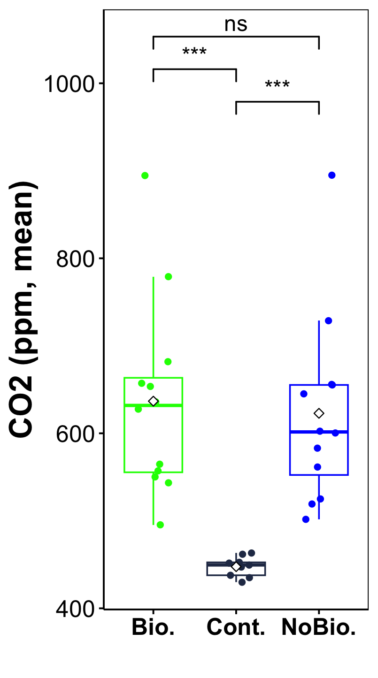
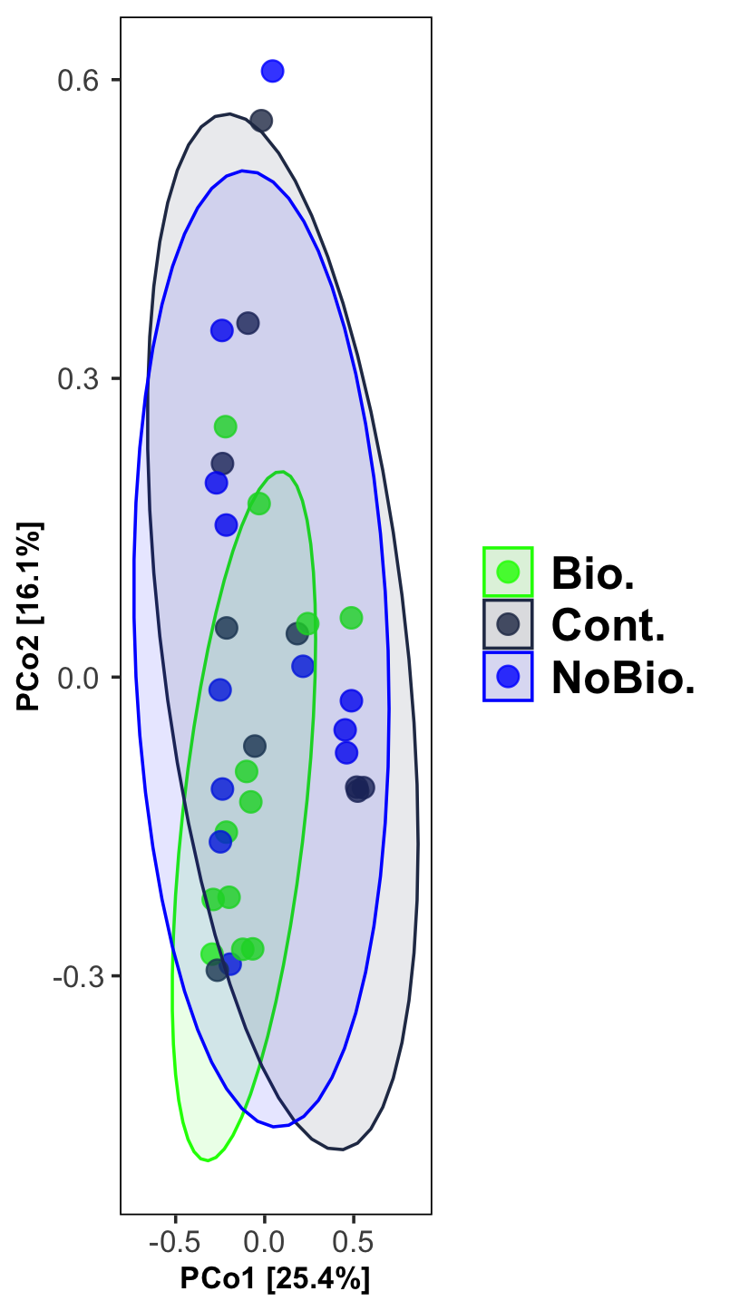
Figure S5. Comparison of mean values of indoor air temperature, relative humidity and CO₂ between control (Cont.), no-biotope (NoBio.) and biotope (Bio.) units across different participation periods

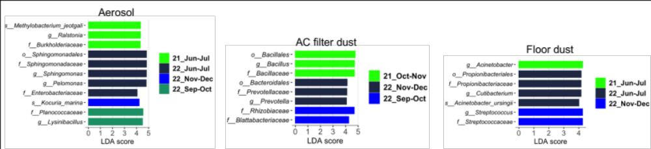
Figure S6. LEfSe of biologically significant bacterial taxa (P <0.01 by Kruskal-Wallis test; logarithmic LDA score of >4.0) between six participation periods for aerosols, AC filter dust, and floor dust sample sources that showed significant difference in all groups based on PERMANOVA test (Figure 3)

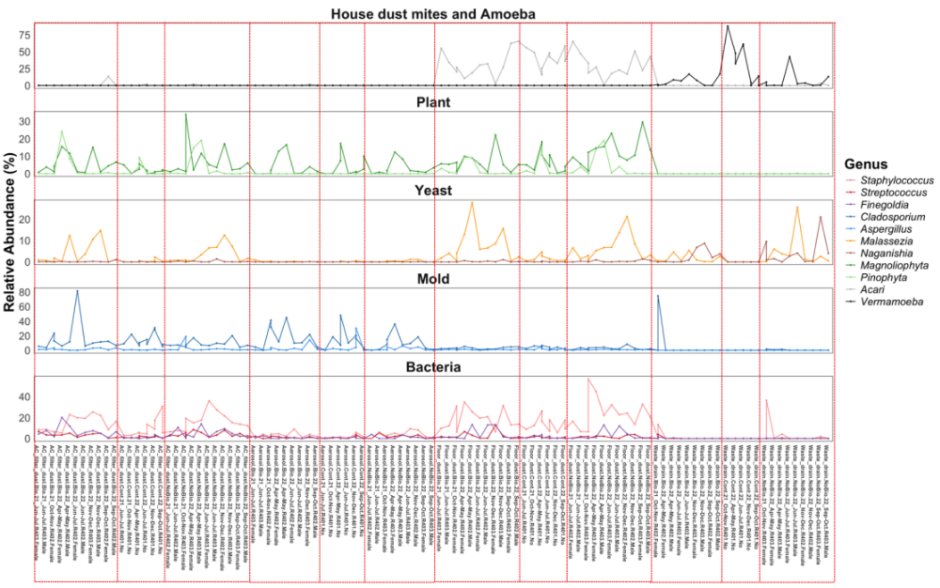
Figure S7. Relative abundance of major bacterial and eukaryotic genera across all samples except showerhead. The 11 major genera were categorized into five groups representing opportunistic taxa or pollen: Bacteria, Mold, Yeast, Plant, and House dust mites and Amoeba. Each panel represents one group and shows how genus composition fluctuates across different sample sources (aerosol, AC filter dust, floor dust and waste drain) collected in various units and months

(A)
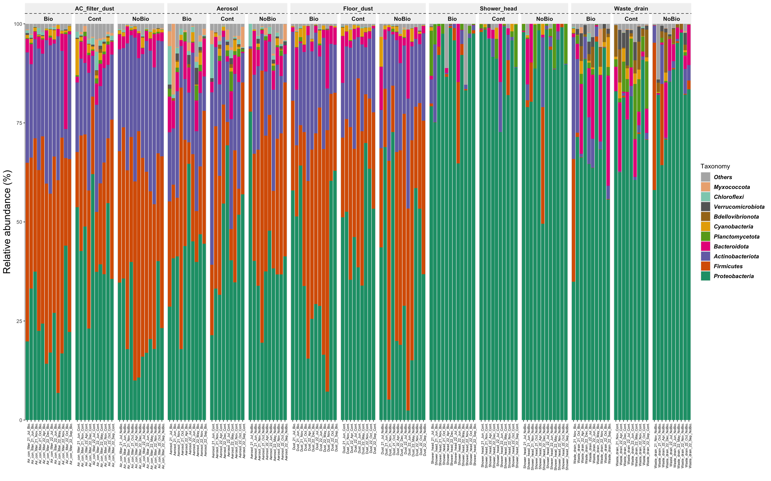
(B)
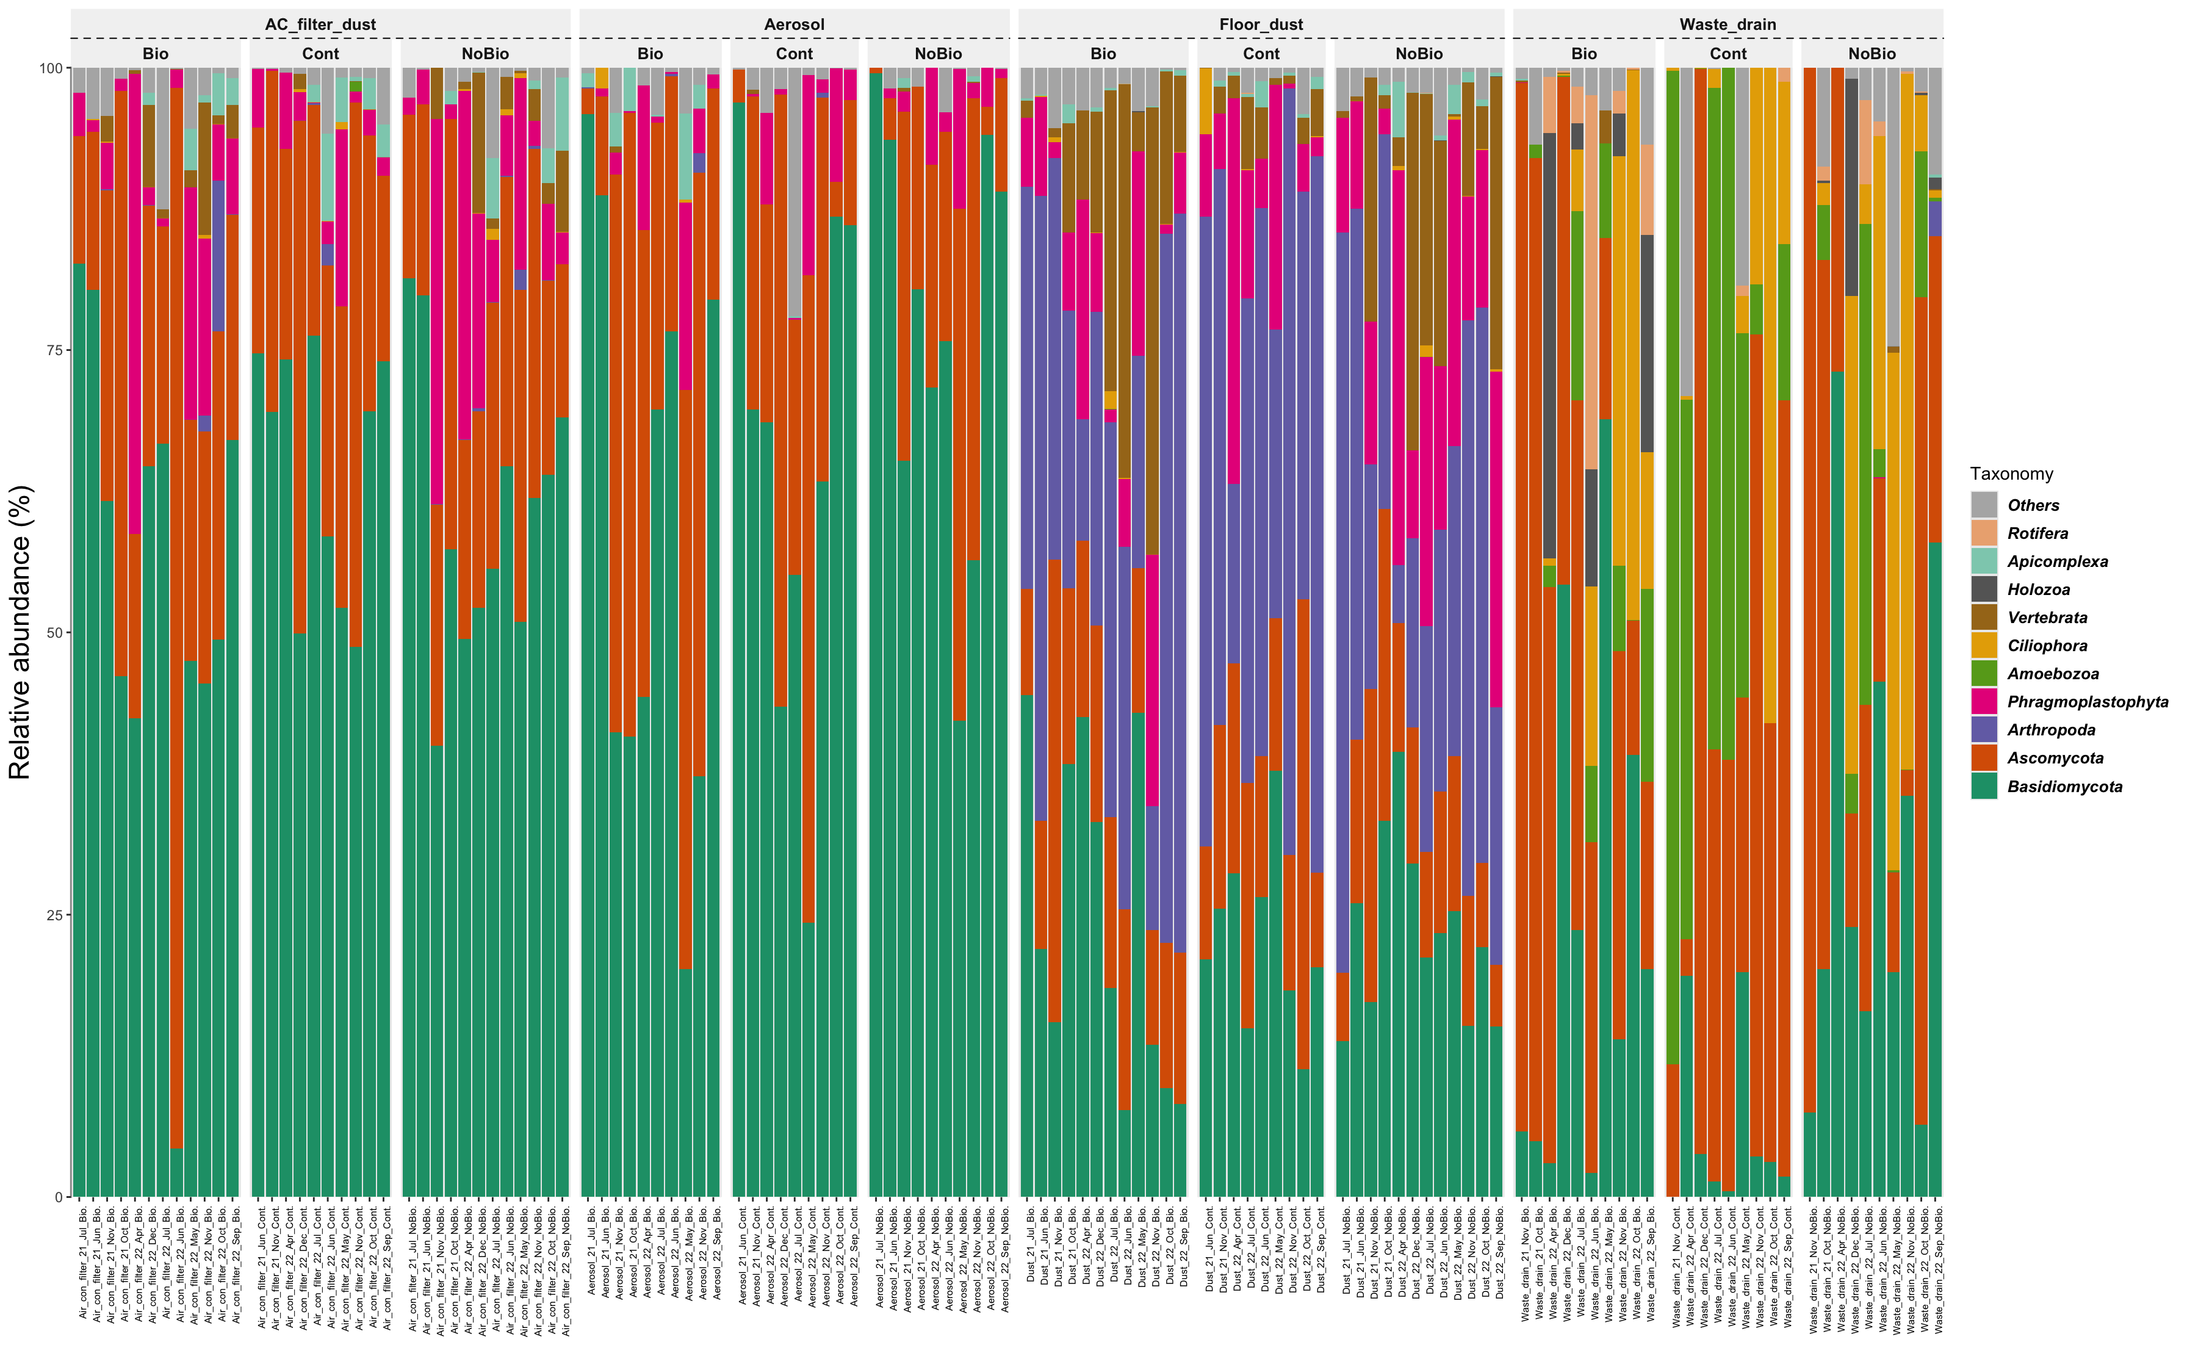
(C)
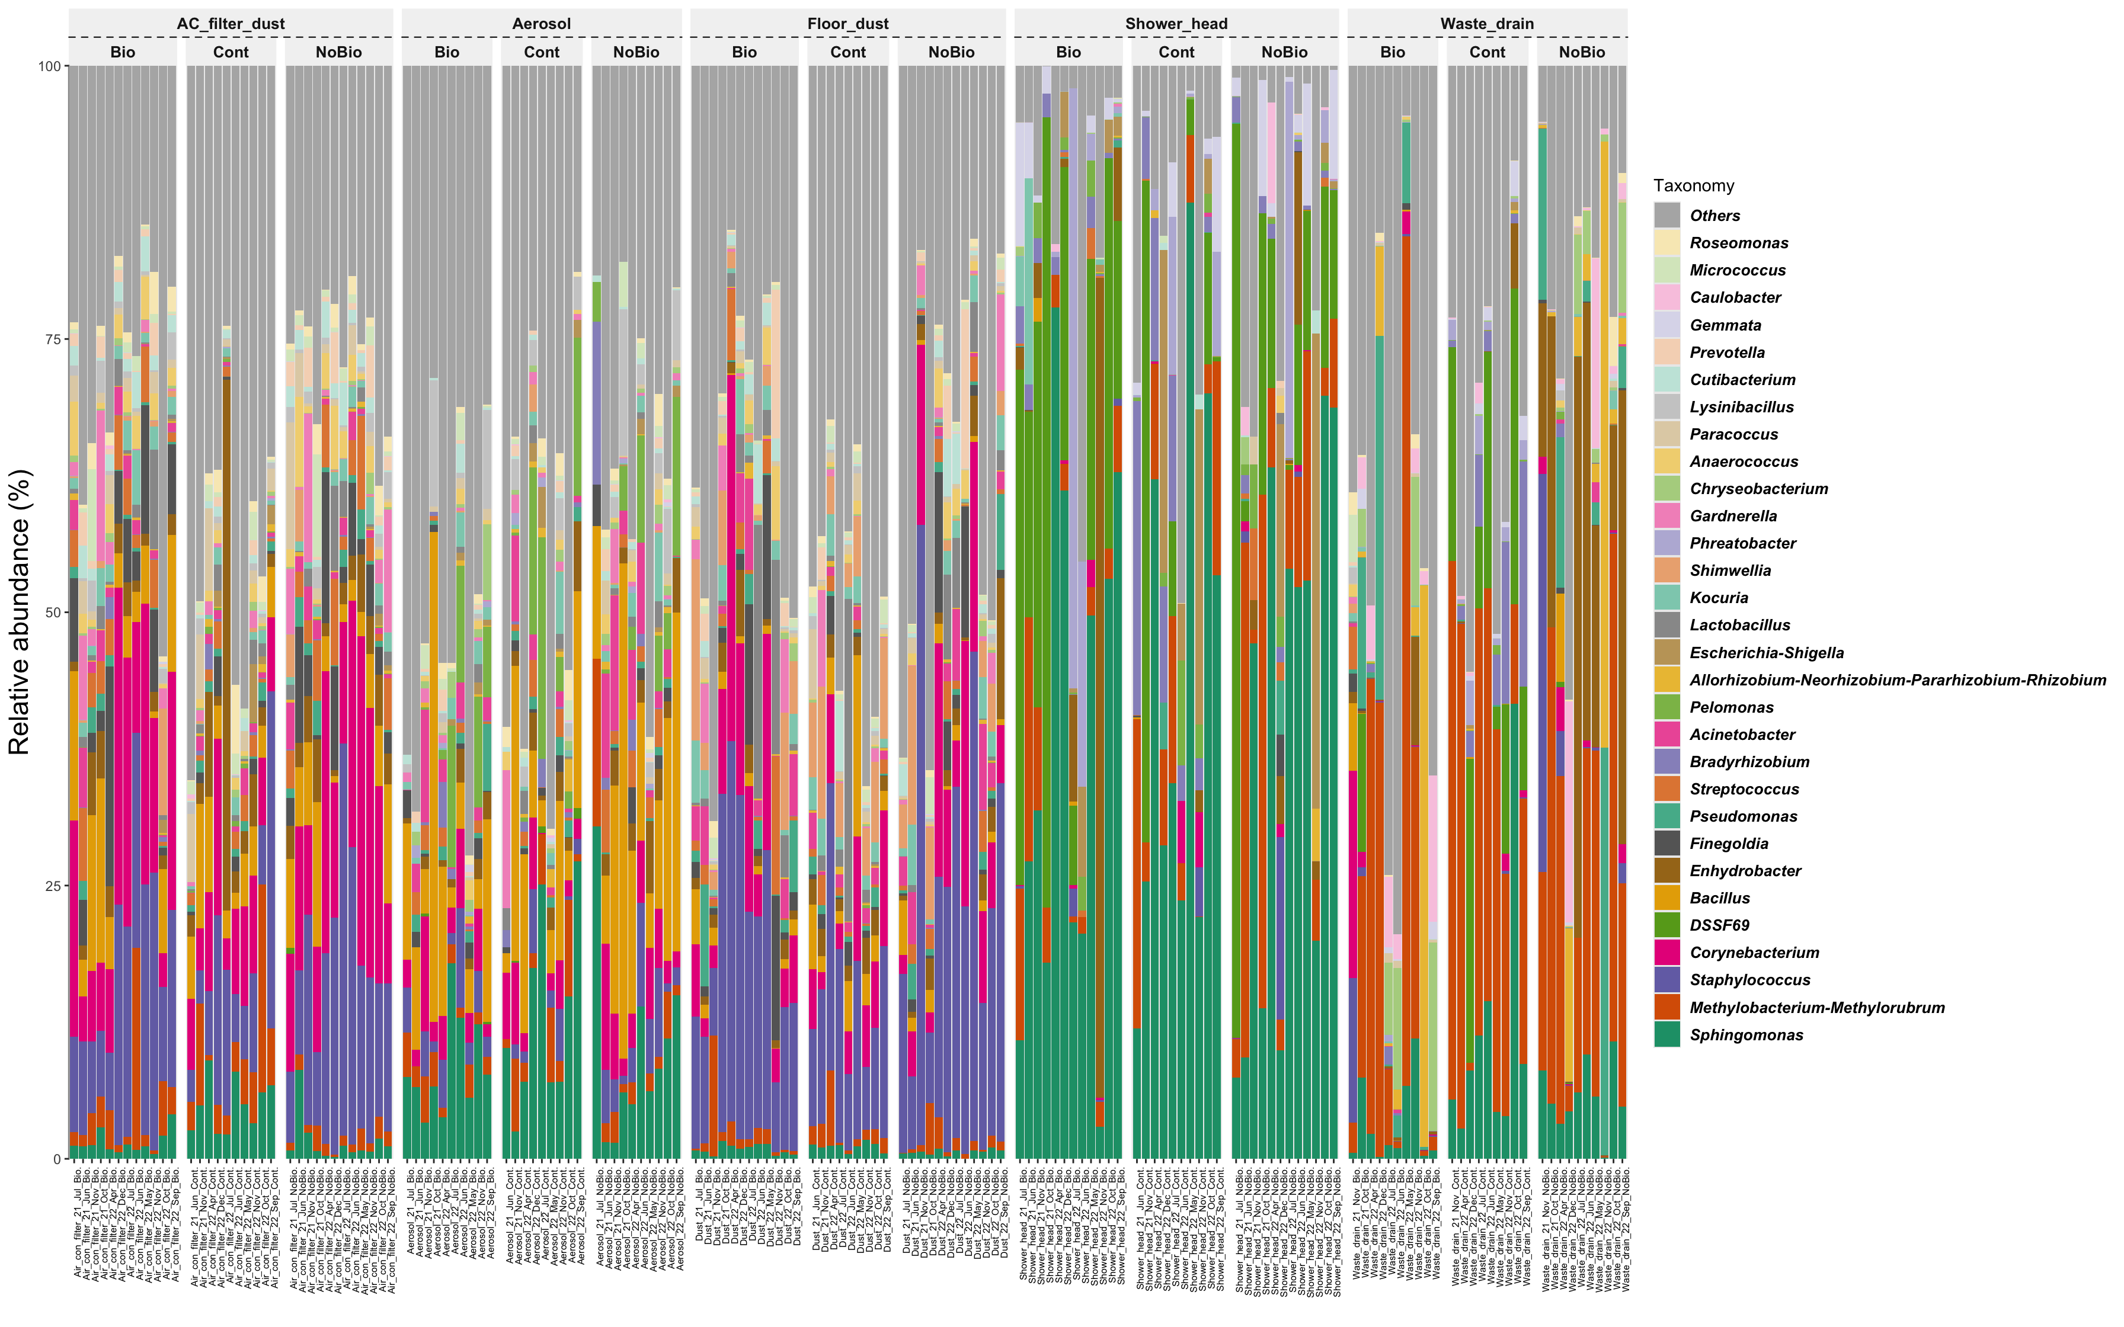
(D)
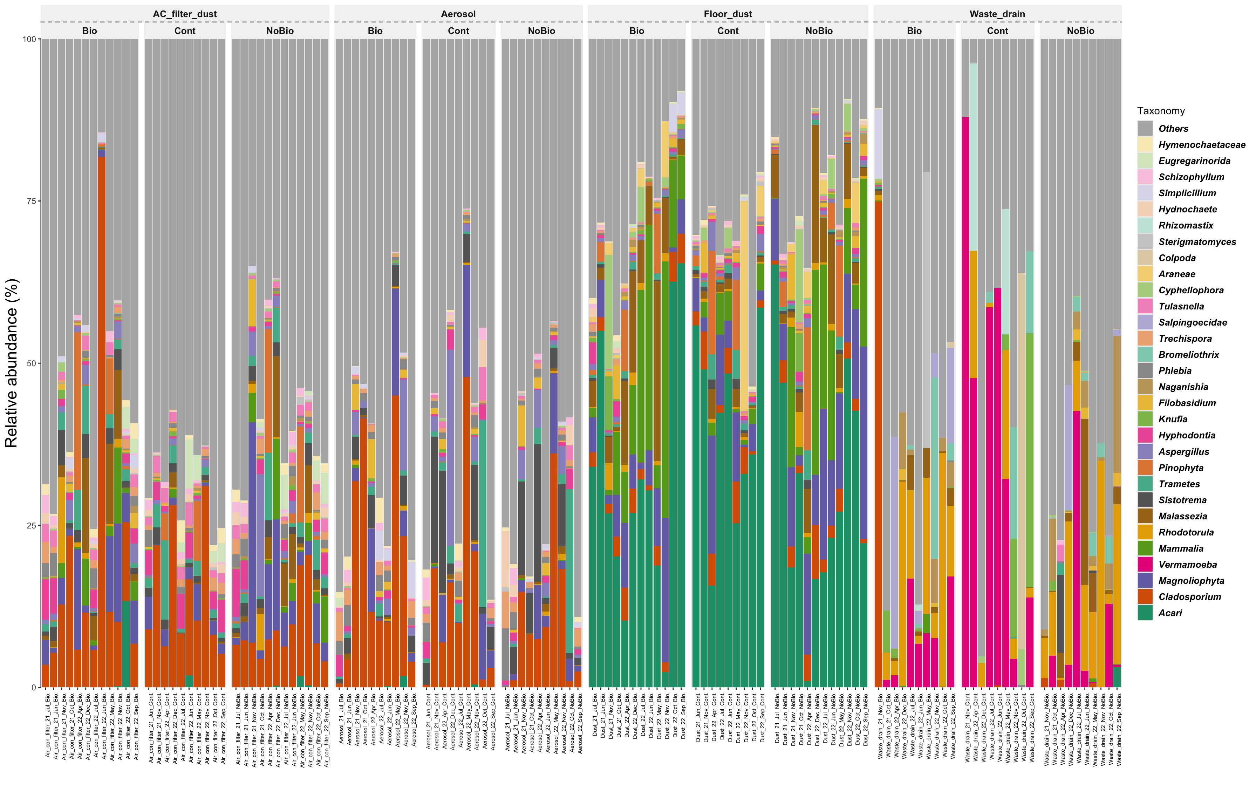
Figure S8. Relative abundance of bacterial and eukaryotic compositions across all samples.
(A) Relative abundance of the top 10 bacterial phyla.
(B) Relative abundance of the top 10 eukaryotic phyla.
(C) Relative abundance of the top 30 bacterial genera.
(D) Relative abundance of the top 30 eukaryotic genera.
"Others" represents minor or unclassified taxa not included in the top-ranked groups.

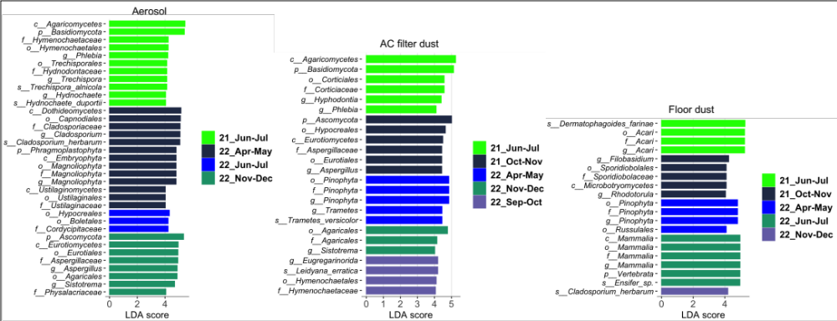
Figure S9. LEfSe of biologically significant eukaryotic taxa (P <0.01 by Kruskal-Wallis test; logarithmic LDA score of >4.0) between six participation periods for aerosols, AC filter dust, floor dust sample sources that showed significant difference in all groups based on PERMANOVA test (Figure 6)

