Supplementary material
Table S1. Significant dispersion and selection factors (p < 0.01 and R² values) based on PERMANOVA (adonis) for microbial (prokaryotic, fungal and protistan) abundance. R² values for non-significant factors are not shown. Factors with no significance detected for any of the three microbial communities are not shown. Statistically significant p-values (p < 0.01) are indicated in bold. Asterisk (*) marks factors with a slight significance, p = 0.011.
Theory | Factor | Prokaryotic abundance |  | Fungal  abundance |  | Protistan  abundance
Theory | Factor | p-value | R² value | p-value | R² value | p-value | R² value
DISPERSION | Location | 0.001 | 46.919 | 0.001 | 49.092 | 0.001 | 51.253
DISPERSION | Region | 0.001 | 13.803 | 0.001 | 18.503 | 0.001 | 15.59
DISPERSION | Grain | 0.001 | 17.369 | 0.001 | 15.153 | 0.001 | 17.231
DISPERSION | Depth | 0.001 | 9.55 | 0.001 | 10.859 | 0.001 | 7.34
SELECTION | Contamination | 0.013 |  | 0.008 | 4.438 | 0.026
SELECTION | Disturbance level | 0.001 | 22.574 | 0.001 | 22.639 | 0.001 | 22.623
SELECTION | Temperature sediment | 0.001 | 9.132 | 0.001 | 6.568 | 0.001 | 6.488
SELECTION | Temperature bottom water layer | 0.001 | 8.849 | 0.001 | 12.031 | 0.001 | 10.966
SELECTION | Redox sediment | 0.068 |  | 0.004 | 4.756 | 0.043
SELECTION | Salinity | 0.002 | 4.797 | 0.001 | 5.239 | 0.018
SELECTION | Distance from shore (m) | 0.034 |  | 0.002 | 5.8 | 0.01 | 4.281
SELECTION | Hg | 0.034 |  | 0.001 | 5.518 | 0.011* | 4.289
SELECTION | Cu | 0.097 |  | 0.005 | 4.176 | 0.079
SELECTION | Bi | 0.017 |  | 0.001 | 6.087 | 0.003 | 5.861
SELECTION | Zn | 0.125 |  | 0.001 | 5.308 | 0.076
SELECTION | Cd | 0.778 |  | 0.008 | 4.436 | 0.082
SELECTION | Total nitrogen | 0.025 |  | 0.003 | 5.017 | 0.039
SELECTION | Total organic carbon | 0.06 |  | 0.001 | 5.811 | 0.009 | 4.587
SELECTION | Cu bioavailability | 0.2 |  | 0.011 | 4.064 | 0.103
SELECTION | As bioavailability | 0.029 |  | 0.001 | 6.904 | 0.003 | 5.682
SELECTION | Sb bioavailability | 0.037 |  | 0.009 | 4.274 | 0.052

Table S2. Significant dispersion and selection factors (p < 0.01 and R² values) based on PERMANOVA (adonis) for microbial (prokaryotic, fungal and protistan) incidence. R² values for non-significant factors are not shown. Factors with no significance detected for any of the three microbial communities are not shown. Statistically significant p-values (p < 0.01) are indicated in bold. Asterisk (*) marks factors with a slight significance, p = 0.011.
Theory | Factor | Prokaryotic incidence |  | Fungal incidence |  | Protistan incidence
Theory | Factor | p-value | R² value | p-value | R² value | p-value | R² value
DISPERSION | Location | 0.001 | 30.699 | 0.001 | 33.7 | 0.001 | 44.636
DISPERSION | Region | 0.001 | 9.558 | 0.001 | 12.898 | 0.001 | 14.997
DISPERSION | Grain | 0.001 | 11.477 | 0.001 | 12.351 | 0.001 | 16.148
DISPERSION | Depth | 0.001 | 5.262 | 0.001 | 6.042 | 0.001 | 6.363
SELECTION | Contamination | 0.008 | 3.374 | 0.026 |  | 0.026
SELECTION | Disturbance level | 0.001 | 15.506 | 0.001 | 15.001 | 0.001 | 19.448
SELECTION | Temperature sediment | 0.001 | 5.366 | 0.001 | 5.106 | 0.001 | 6.488
SELECTION | Temperature bottom water layer | 0.001 | 5.789 | 0.001 | 9.022 | 0.001 | 10.966
SELECTION | Salinity | 0.003 | 3.201 | 0.005 | 3.314 | 0.028
SELECTION | Distance from shore (m) | 0.061 |  | 0.005 | 3.391 | 0.013
SELECTION | Bi | 0.009 | 3.266 | 0.001 | 4.219 | 0.001 | 5.51
SELECTION | Total organic carbon | 0.127 |  | 0.051 |  | 0.011* | 4.563
SELECTION | As bioavailability | 0.011* | 3.119 | 0.015 |  | 0.007 | 4.624

Table S3. Primers used for amplicon sequencing targeting prokaryotes, fungi and protists. Sequencing was performed by Illumina NovaSeq PE250 platform at Novogene Bioinformatics Co., Ltd., Beijing, China with in-house methods.
Target gene | Target community | Primer | Forward/Reverse | 5’ -> 3’ | Amplicon size (bp) | Reference
16S rRNA  V4 region* | Prokaryotes | 515F | Forward | 5′-GTGCCAGCMGCCGCGGTAA-3′ | ~300 bp | Caporaso et al., 2011
16S rRNA  V4 region* | Prokaryotes | 806R | Reverse | 5’-GGACTACHVGGGTWTCTAAT-3′ | ~300 bp | Caporaso et al., 2011
18S rRNA  V7-V8 region | Fungi | FF390 | Forward | 5′-CGATAACGAACGAGACCT-3′ | ~390 bp | Banos et al., 2018
18S rRNA  V7-V8 region | Fungi | FR1 | Reverse | 5′-ANCCATTCAATCGGTANT-3′ | ~390 bp | Banos et al., 2018
18S rRNA  V9 region | Protists | 1391F | Forward | 5′-GTACACACCGCCCGTC-3′ | ~200 bp | Stoeck et al., 2010
18S rRNA  V9 region | Protists | EukB | Reverse | 5′-TGATCCTTCTGCAGGTTCACCTAC-3’ | ~200 bp | Stoeck et al., 2010
*in-house primers

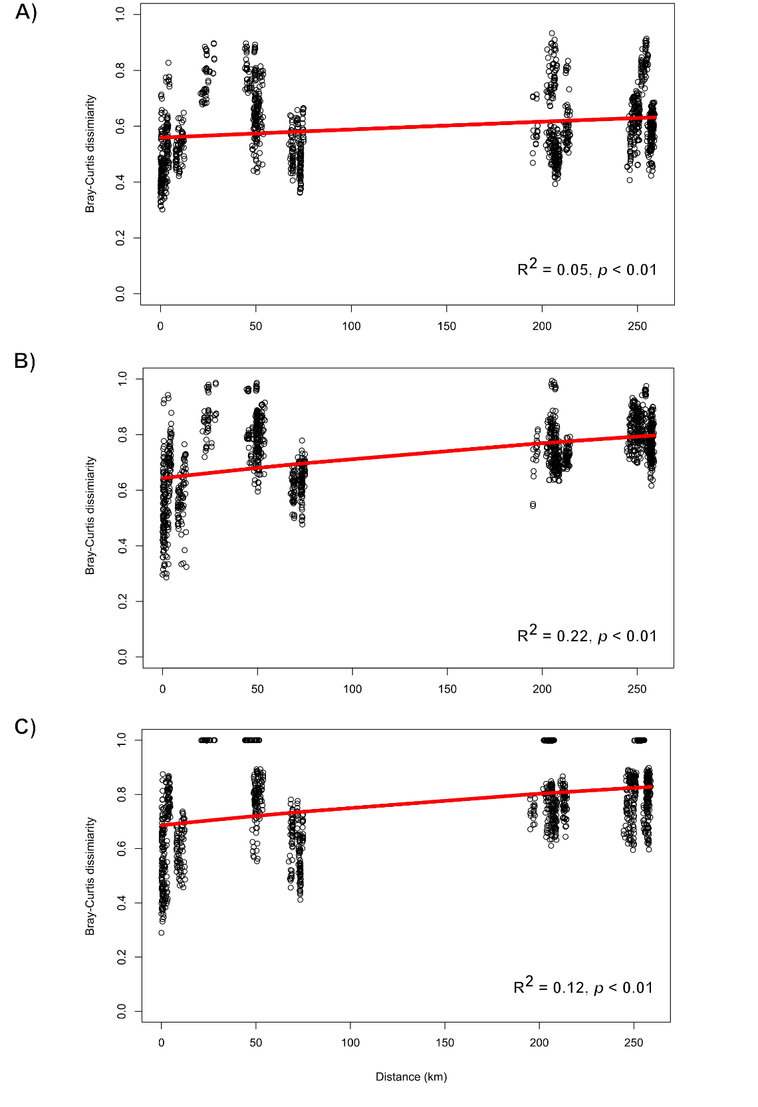
Fig. S1. Distance-decay relationships of prokaryotic (A), fungal (B), and protistan (C) community dissimilarities (Bray-Curtis) and geographic distances (Haversine method).
Table S4. Alpha diversity for each microbial community (prokaryotes, fungi, protists) expressed as Hill numbers (effective number of species) with order q=1 (effective Shannon’s diversity).
Sample | Prokaryotes | Fungi | Protists
BA1 | 1028.322 | 67.38196 | 156.0539
BA2 | 969.2717 | 31.76386 | 131.9107
BA5 | 788.2288 | 16.83881 | 108.1654
BA6 | 786.3821 | 24.92157 | 99.77963
BA7 | 722.5635 | 11.04638 | 128.5471
BA8 | 712.7195 | 18.50491 | 145.01
BA9 | 837.7752 | 23.30558 | 141.4153
BA10 | 885.4655 | 22.08556 | 115.1539
BA11 | 724.8897 | 38.44581 | 142.5173
CK1 | 762.4956 | 41.71771 | 139.4257
CK2 | 749.3091 | 42.89203 | 100.3555
CZ1 | 750.2198 | 30.59684 | 58.64873
CZ2 | 1462.193 | 26.61689 | 148.7015
PU1 | 695.9785 | 37.82485 | 81.093
PU2 | 911.2107 | 51.0873 | 73.75435
PU3 | 857.0545 | 70.11739 | 85.81726
PU4 | 900.2389 | 32.68017 | 124.3695
PU5 | 906.9921 | 40.02286 | 119.6625
PU6 | 752.1926 | 44.03045 | 92.35991
PU7 | 627.8119 | 45.31555 | 89.09762
RI1 | 824.91 | 55.32321 | 133.5358
RI2 | 834.5203 | 74.47977 | 29.36872
RI3 | 1000.385 | 60.31537 | 78.72272
RI4 | 1013.701 | 51.28229 | 47.16976
RI5 | 837.3075 | 81.50155 | 81.52693
RI6 | 825.0262 | 22.81781 | 130.8654
RI7 | 681.1503 | 65.66065 | 94.07216
S1 | 817.0058 | 39.0519 | 89.24113
S2 | 575.2992 | 52.95937 | 75.82959
S3 | 822.7859 | 54.08304 | 73.53231
S4 | 940.2136 | 60.25563 | 108.1646
S5 | 905.9193 | 42.98894 | 80.86114
S6 | 847.5583 | 50.28586 | 116.6324
S7 | 968.6845 | 49.51761 | 84.40326
ST1 | 827.064 | 33.65992 | 101.894
ST2 | 755.9628 | 80.59492 | 80.80169
ST3 | 726.9574 | 78.89804 | 125.4001
ST7 | 654.2583 | 71.39358 | 34.63511
ST8 | 415.7062 | 102.6726 | 59.28887
ST10 | 733.4172 | 138.4677 | 90.70567
VR1 | 776.0174 | 89.50335 | 110.8758
VR2 | 1018.26 | 77.59774 | 97.18175
VR3 | 861.7247 | 130.6745 | 52.28999
VR4 | 754.4442 | 73.15551 | 33.60977
VR5 | 439.2392 | 84.06514 | 65.77055
VR7 | 763.5509 | 65.52817 | 130.6928
VR9 | 786.7423 | 63.35646 | 114.448
RA1 | 771.1618 | 177.3358 | 108.8386
RA3 | 409.9131 | 14.61423 | 89.73914
RA5 | 688.3503 | 86.54776 | 91.65741
RA7 | 740.2222 | 114.1543 | 109.2702
RA8 | 720.9462 | 111.5372 | 92.99131

Table S5. Bioavailable fraction of metals per gram of sediment (ng/g).
Sample ID | Cu | Zn | As | Cd | Sb | Pb
BA1 | 37.28571 | 1862.143 | 212.4286 | 4.285714 | 5.571429 | 98.71429
BA2 | 39.28571 | 1320.143 | 230.4286 | 3.285714 | 9.571429 | 124.7143
BA5 | 33.28571 | 516.1429 | 252.4286 | 0 | 6.571429 | 173.7143
BA6 | 27.28571 | 285.1429 | 288.4286 | 0 | 2.571429 | 101.7143
BA7 | 42.28571 | 411.1429 | 225.4286 | 0.285714 | 5.571429 | 107.7143
BA8 | 46.28571 | 209.1429 | 284.4286 | 0 | 5.571429 | 90.71429
BA9 | 54.28571 | 1006.143 | 227.4286 | 3.285714 | 4.571429 | 131.7143
BA10 | 38.28571 | 1175.143 | 211.4286 | 1.285714 | 3.571429 | 112.7143
BA11 | 20.28571 | 3165.143 | 189.4286 | 4.285714 | 19.57143 | 239.7143
CK1 | 25.28571 | 380.1429 | 150.4286 | 3.285714 | 7.571429 | 11.71429
CK2 | 62.28571 | 345.1429 | 209.4286 | 6.285714 | 14.57143 | 18.71429
CZ1 | 31.28571 | 76.14286 | 272.4286 | 0 | 35.57143 | 44.71429
CZ2 | 16.28571 | 130.1429 | 239.4286 | 0 | 34.57143 | 36.71429
PU1 | 92.28571 | 10195.14 | 364.4286 | 6.285714 | 29.57143 | 1034.714
PU2 | 71.28571 | 13359.14 | 352.4286 | 6.285714 | 36.57143 | 1102.714
PU3 | 8.285714 | 219043.1 | 74.42857 | 4.285714 | 138.5714 | 31532.71
PU4 | 73.28571 | 6276.143 | 345.4286 | 0 | 17.57143 | 839.7143
PU5 | 118.2857 | 8751.143 | 356.4286 | 3.285714 | 12.57143 | 1141.714
PU6 | 82.28571 | 4622.143 | 269.4286 | 2.285714 | 32.57143 | 725.7143
PU7 | 74.28571 | 3748.143 | 234.4286 | 1.285714 | 26.57143 | 536.7143
RI1 | 66.28571 | 13594.14 | 157.4286 | 13.28571 | 9.571429 | 857.7143
RI2 | 91.28571 | 33243.14 | 345.4286 | 22.28571 | 56.57143 | 1785.714
RI3 | 72.28571 | 21268.14 | 264.4286 | 16.28571 | 45.57143 | 1338.714
RI4 | 59.28571 | 16009.14 | 279.4286 | 10.28571 | 43.57143 | 626.7143
RI5 | 34.28571 | 15391.14 | 432.4286 | 9.285714 | 46.57143 | 920.7143
RI6 | 30.28571 | 3530.143 | 225.4286 | 6.285714 | 21.57143 | 376.7143
RI7 | 42.28571 | 1876.143 | 187.4286 | 6.285714 | 2.571429 | 175.7143
S1 | 348 | 3808.333 | 2057.667 | 13 | 41.33333 | 746.3333
S2 | 79.28571 | 3741.143 | 1025.429 | 10.28571 | 35.57143 | 817.7143
S3 | 88.28571 | 3940.143 | 856.4286 | 8.285714 | 62.57143 | 918.7143
S4 | 231.2857 | 16496.14 | 1509.429 | 17.28571 | 169.5714 | 2320.714
S5 | 170.2857 | 18989.14 | 1480.429 | 5.285714 | 47.57143 | 2051.714
S6 | 33.28571 | 10785.14 | 506.4286 | 2.285714 | 4.571429 | 278.7143
S7 | 29.28571 | 3681.143 | 408.4286 | 0 | 6.571429 | 153.7143
ST1 | 41.28571 | 3425.143 | 437.4286 | 0 | 8.571429 | 102.7143
ST2 | 25.28571 | 23810.14 | 320.4286 | 3.285714 | 34.57143 | 838.7143
ST3 | 98.28571 | 4270.143 | 251.4286 | 5.285714 | 13.57143 | 122.7143
ST7 | 178.2857 | 14881.14 | 359.4286 | 26.28571 | 46.57143 | 297.7143
ST8 | 33.28571 | 6614.143 | 217.4286 | 0 | 37.57143 | 140.7143
ST10 | 30.28571 | 24679.14 | 403.4286 | 9.285714 | 30.57143 | 291.7143
VR1 | 110.2857 | 12420.14 | 306.4286 | 2.285714 | 12.57143 | 170.7143
VR2 | 12.28571 | 14697.14 | 192.4286 | 0 | 32.57143 | 47.71429
VR3 | 104.2857 | 14653.14 | 76.42857 | 3.285714 | 20.57143 | 83.71429
VR4 | 54.28571 | 16734.14 | 198.4286 | 1.285714 | 43.57143 | 89.71429
VR5 | 23.28571 | 8706.143 | 486.4286 | 0 | 74.57143 | 62.71429
VR7 | 139.2857 | 1762.143 | 308.4286 | 2.285714 | 6.571429 | 114.7143
VR9 | 51.28571 | 2711.143 | 208.4286 | 0.285714 | 19.57143 | 90.71429
RA1 | 50.28571 | 511.1429 | 71.42857 | 22.28571 | 0 | 2.714286
RA3 | 298.2857 | 471.1429 | 102.4286 | 15.28571 | 0 | 1.714286
RA5 | 14.28571 | 1113.143 | 164.4286 | 6.285714 | 0.571429 | 3.714286
RA7 | 24.28571 | 299.1429 | 160.4286 | 2.285714 | 0.571429 | 10.71429
RA8 | 22.28571 | 165.1429 | 125.4286 | 4.285714 | 0 | 1.714286

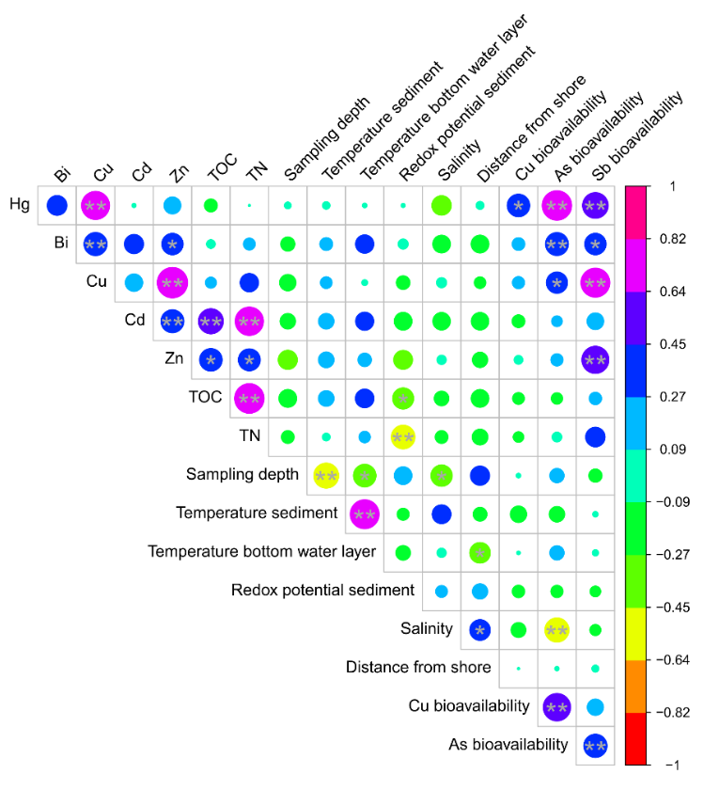
Fig. S2. Correlogram showing Pearson’s correlation among significant selection factors (PERMANOVA, p < 0.01). Cell colors indicate positive and negative Pearson correlations, respectively. Asterisks indicate significant correlation (*. p < 0.01; **. p < 0.001). Diagonal showing a correlation of 1 is not presented.

Table S6. Significant selection factors (heavy metals) separated into two groups (low and high) based on median concentration used in Mantel’s test.
Sample | Hg | Cd | Bi | Cu | Zn | Disturbance level
BA1 | LOW | LOW | LOW | LOW | LOW | LOW
BA2 | LOW | LOW | LOW | LOW | LOW | LOW
BA5 | LOW | LOW | LOW | LOW | LOW | LOW
BA6 | LOW | LOW | LOW | LOW | LOW | LOW
BA7 | LOW | LOW | LOW | LOW | LOW | LOW
BA8 | LOW | LOW | LOW | LOW | LOW | LOW
BA9 | LOW | LOW | LOW | LOW | LOW | LOW
BA10 | LOW | LOW | LOW | LOW | LOW | LOW
BA11 | LOW | HIGH | HIGH | HIGH | HIGH | HIGH
CK1 | LOW | LOW | LOW | LOW | LOW | LOW
CK2 | LOW | LOW | LOW | LOW | LOW | LOW
CZ1 | LOW | LOW | LOW | LOW | LOW | LOW
CZ2 | LOW | LOW | LOW | LOW | LOW | LOW
PU1 | HIGH | LOW | HIGH | HIGH | HIGH | HIGH
PU2 | HIGH | HIGH | HIGH | HIGH | HIGH | HIGH
PU3 | HIGH | HIGH | HIGH | HIGH | HIGH | HIGH
PU4 | HIGH | LOW | HIGH | HIGH | LOW | HIGH
PU5 | HIGH | LOW | HIGH | HIGH | HIGH | HIGH
PU6 | HIGH | LOW | LOW | LOW | LOW | HIGH
PU7 | HIGH | LOW | LOW | LOW | LOW | LOW
RI1 | HIGH | LOW | LOW | HIGH | LOW | HIGH
RI2 | HIGH | HIGH | HIGH | HIGH | HIGH | HIGH
RI3 | HIGH | HIGH | LOW | HIGH | HIGH | HIGH
RI4 | HIGH | HIGH | HIGH | HIGH | HIGH | HIGH
RI5 | HIGH | HIGH | HIGH | LOW | HIGH | HIGH
RI6 | HIGH | LOW | LOW | LOW | LOW | LOW
RI7 | HIGH | LOW | HIGH | LOW | LOW | LOW
S1 | HIGH | HIGH | HIGH | HIGH | HIGH | HIGH
S2 | HIGH | HIGH | HIGH | HIGH | HIGH | HIGH
S3 | HIGH | HIGH | HIGH | HIGH | HIGH | HIGH
S4 | HIGH | HIGH | HIGH | HIGH | HIGH | HIGH
S5 | HIGH | HIGH | HIGH | HIGH | HIGH | HIGH
S6 | HIGH | HIGH | HIGH | LOW | HIGH | HIGH
S7 | HIGH | HIGH | HIGH | HIGH | HIGH | HIGH
ST1 | HIGH | HIGH | HIGH | HIGH | HIGH | HIGH
ST2 | LOW | HIGH | HIGH | HIGH | HIGH | HIGH
ST3 | LOW | HIGH | HIGH | LOW | LOW | LOW
ST7 | LOW | HIGH | HIGH | HIGH | HIGH | HIGH
ST8 | LOW | HIGH | HIGH | HIGH | HIGH | HIGH
ST10 | HIGH | HIGH | HIGH | HIGH | HIGH | HIGH
VR1 | LOW | HIGH | HIGH | HIGH | HIGH | HIGH
VR2 | HIGH | HIGH | HIGH | HIGH | HIGH | HIGH
VR3 | LOW | HIGH | LOW | HIGH | HIGH | HIGH
VR4 | HIGH | HIGH | LOW | HIGH | HIGH | HIGH
VR5 | HIGH | HIGH | HIGH | HIGH | HIGH | HIGH
VR7 | LOW | LOW | LOW | LOW | LOW | LOW
VR9 | HIGH | HIGH | LOW | LOW | LOW | LOW
RA1 | LOW | LOW | LOW | LOW | LOW | LOW
RA3 | LOW | LOW | LOW | LOW | LOW | LOW
RA5 | LOW | LOW | LOW | LOW | LOW | LOW
RA7 | LOW | LOW | LOW | LOW | LOW | LOW
RA8 | LOW | LOW | LOW | LOW | LOW | LOW

Table S7. Mean Mantel r values for each microbial community interaction and five tested pollutants.
Interaction | Pollutant | Pollution level | Mean Mantel r | p value
Prokaryote-Fungi | Hg | HIGH | 0.690606 | 0.001
Prokaryote-Protist | Hg | HIGH | 0.659852 | 0.001
Fungi-Protist | Hg | HIGH | 0.81294 | 0.001
Prokaryote-Fungi | Hg | LOW | 0.807024 | 0.001
Prokaryote-Protist | Hg | LOW | 0.834625 | 0.001
Fungi-Protist | Hg | LOW | 0.808635 | 0.001
Prokaryote-Fungi | Cd | HIGH | 0.663318 | 0.001
Prokaryote-Protist | Cd | HIGH | 0.650176 | 0.001
Fungi-Protist | Cd | HIGH | 0.74705 | 0.001
Prokaryote-Fungi | Cd | LOW | 0.834983 | 0.001
Prokaryote-Protist | Cd | LOW | 0.843433 | 0.001
Fungi-Protist | Cd | LOW | 0.838388 | 0.001
Prokaryote-Fungi | Bi | HIGH | 0.690551 | 0.001
Prokaryote-Protist | Bi | HIGH | 0.623018 | 0.001
Fungi-Protist | Bi | HIGH | 0.760181 | 0.001
Prokaryote-Fungi | Bi | LOW | 0.808521 | 0.001
Prokaryote-Protist | Bi | LOW | 0.848967 | 0.001
Fungi-Protist | Bi | LOW | 0.832615 | 0.001
Prokaryote-Fungi | Cu | HIGH | 0.73595 | 0.001
Prokaryote-Protist | Cu | HIGH | 0.721962 | 0.001
Fungi-Protist | Cu | HIGH | 0.786692 | 0.001
Prokaryote-Fungi | Cu | LOW | 0.792182 | 0.001
Prokaryote-Protist | Cu | LOW | 0.809376 | 0.001
Fungi-Protist | Cu | LOW | 0.819788 | 0.001
Prokaryote-Fungi | Zn | HIGH | 0.713162 | 0.001
Prokaryote-Protist | Zn | HIGH | 0.691412 | 0.001
Fungi-Protist | Zn | HIGH | 0.774209 | 0.001
Prokaryote-Fungi | Zn | LOW | 0.798725 | 0.001
Prokaryote-Protist | Zn | LOW | 0.824007 | 0.001
Fungi-Protist | Zn | LOW | 0.813276 | 0.001

