Relative abundances of bacterial phyla are strong indicators of community-scale microbial growth rates in soil
Supplementary Methods
Quantitative stable isotope probing (qSIP)
The qSIP dataset we used has been described previously [1–3]. Briefly, soils for the qSIP experiment were collected at 10 cm depth from four ecosystems in northern Arizona and incubated for one week under three different experimental treatments: C addition (1 mg glucose C g soil⁻¹), C+N addition (glucose + 0.1 mg [NH₄]₂SO₄ g soil-1), and no additions (control). All treatments were provided ¹⁸O water (97 atom%) to enable isotopic labelling of microbial DNA. After the incubation, DNA was extracted from the soils and then subjected to isopycnic CsCl density gradient centrifugation in 3.3 mL OptiSeal tubes in an Optima Max ultracentrifuge (Beckman Coulter, Brea, CA, USA) equipped with a Beckman TLN-100 rotor at 127,000 × g for 72 h at 18 ºC. Each sample was then split into ~20 ~150 µL fractions and the density of the fractions measured using a handheld refractometer. The abundance of bacterial 16S rRNA genes was measured in the density fractions using qPCR with the 515F/806R primer set. Following qPCR, the 16S V4 region was sequenced, also using the 515F/806R primers, on an Illumina MiSeq. Raw sequences can be accessed at PRJNA521534. Raw sequences were processed using DADA2 [4] and taxonomy assigned to the resulting amplicon sequence variants (ASVs) using a naïve-bayes classifier [5] trained on the SILVA database (version 132) [6]. ASVs were removed from downstream analysis if they failed to appear in two of the three replicates of a site × treatment combination and at least five of the fractions within each of those two replicates [7]. The molecular weight of the DNA of each ASV was then calculated according to the qSIP equations [8] and the DNA molecular weights used to estimate growth rates of each taxon using an exponential growth model [7,9]. This ultimately yielded 2,277 ASVs with growth rate estimates. To facilitate comparison with the genomic data, we calculated the average growth rates of each bacterial genus present (279 genera total). We did this for each experimental treatment separately (C, C+N, and control) and for all treatments averaged together.
Metagenomic growth estimates (gRodon2)
As a community-level analogue of the genomic growth rate estimates, we used a global dataset of soil metagenomes to estimate community-average growth potential of soil bacterial communities. The metagenome dataset has been described previously [10] and the raw sequences are available at PRJEB18701. As described previously, we predicted community average maximum growth rates for the metagenomes using gRodon2 [11]. Briefly, we assembled the metagenomes using megahit [12], predicted protein coding regions in the contigs using prodigal [13] and identified ribosomal protein genes in the coding regions using blastn [14] with a previously constructed database of ribosomal protein gene sequences [15]. We aligned the metagenomic sequence reads to the predicted coding regions using bwa mem [16] and quantified coverage of the predicted genes using samtools [17]. We then used the gRodon2 model to estimate the community average maximum growth rates, which considers codon usage bias in highly expressed ribosomal protein genes and the relative coverages of genes in the community [18,19]. To relate the growth rates to the taxonomic composition of the communities, we used a dataset of 16S rRNA gene amplicons (V4 region) generated from the same soils [10]. The amplicons were produced using the 515F/806R primer set and sequenced on an Illumina MiSeq. The raw amplicon sequences are available at PRJEB19856. We processed the sequences using DADA2 [4] and classified ASVs using a naïve-bayes classifier [5] trained on the SILVA database (version 138) [6] in the QIIME2 environment [20].

Supplementary Tables
Supplementary Table S1
Category | R² | Taxon | Importance (% MSE increase)
Genus | 80.7 | Ellin 6067 | 34.0
Genus | 80.7 | Vicinamibacteraceae | 26.5
Genus | 80.7 | Ferruginibacter | 26.5
Genus | 80.7 | Sphingomonas | 24.4
Genus | 80.7 | Devosia | 19.9
Genus | 80.7 | Edaphobacter | 18.9
Family | 79.8 | Sphingomonadaceae | 36.9
Family | 79.8 | Nitrosomonadaceae | 25.4
Family | 79.8 | Rhizobiaceae | 24.4
Family | 79.8 | Oxalobacteraceae | 23.5
Family | 79.8 | Vicinamibacteraceae | 23.1
Family | 79.8 | Devosiaceae | 21.2
Order | 79.8 | Sphingomonadales | 42.4
Order | 79.8 | Burkhoderiales | 38.9
Order | 79.8 | Vicinamibacterales | 30.1
Order | 79.8 | Micrococcales | 25.9
Order | 79.8 | Acidobacterales | 25.5
Order | 79.8 | Caulobacerales | 24.6
Class | 78.3 | Alphaproteobacteria | 55.1
Class | 78.3 | Gammaproteobacteria | 47.6
Class | 78.3 | Verrucomicrobiae | 38.0
Class | 78.3 | Vicinamibacteria | 33.9
Class | 78.3 | Acidobacteriae | 31.6
Class | 78.3 | Subgroup 11 | 28.0
Phylum | 63.6 | Proteobacteria | 96.5
Phylum | 63.6 | Verrucomicrobia | 43.3
Phylum | 63.6 | Acidobacteria | 42.3
Phylum | 63.6 | Firmicutes | 32.5
Phylum | 63.6 | Actinobacteria | 25.7
Phylum | 63.6 | Bacteroidetes | 23.1
Supplementary Table S1: Random Forest regression models for the separate taxonomic categories with community average growth as the response. Shown are the model R² values and the top six important taxa for each of the models. Importance was calculated as the increase in model error when each respective genus was randomly shuffled across the dataset.

Supplementary Figures

Supplementary Figure S1

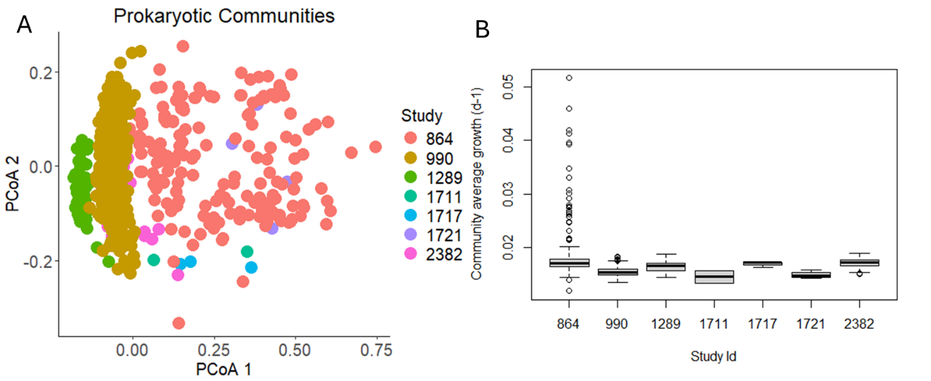
Supplementary Fig. S1: Preliminary exploration of the EMP communities and their expected community average growth rates. Study ID 864 had unusual bacterial communities (A) with many extreme outliers in growth rates (B). Thus, we initially chose to exclude this study from our analyses.

Supplementary Fig. S2
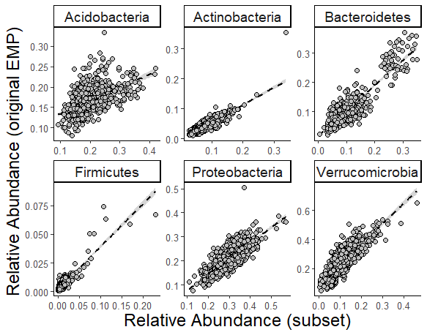
Supplementary Fig. S2: Correlations between phylum relative abundances in the qSIP-subset communities and the original full EMP communities.

Supplementary Figure S3
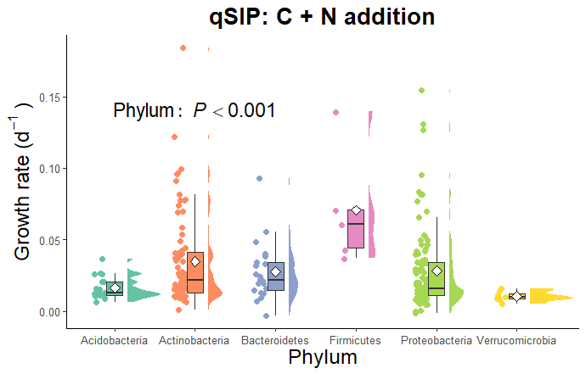
Supplementary Fig. S3: Distributions of growth rates of bacterial genera within the six dominant soil phyla. Shown are the growth rates from the experimental qSIP treatment with C+N addition. White diamonds represent mean values and the P value shown is from a generalized linear model with gamma distribution and log link function.

Supplementary Figure S4
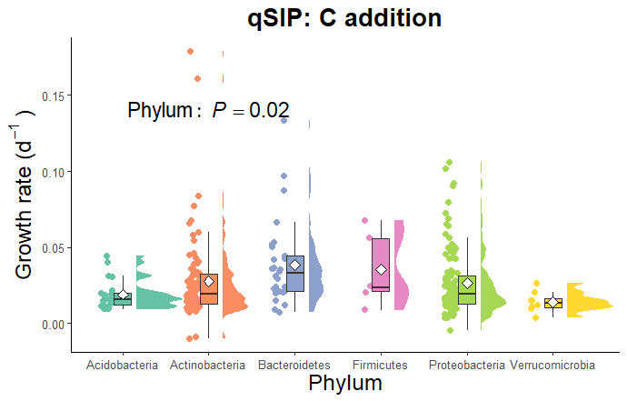
Supplementary Fig. S4: Distributions of growth rates of bacterial genera within the six dominant soil phyla. Shown are the growth rates from the experimental qSIP treatment with C addition. White diamonds represent mean values and the P value shown is from a generalized linear model with gamma distribution and log link function.

Supplementary Figure S5
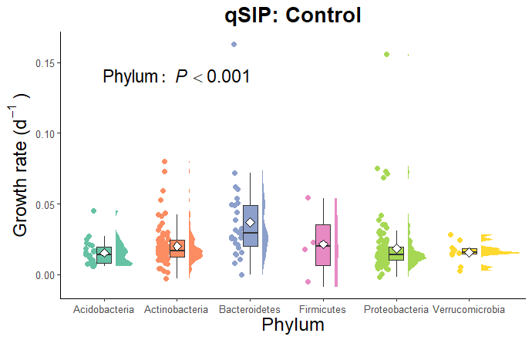
Supplementary Fig. S5: Distributions of growth rates of bacterial genera within the six dominant soil phyla. Shown are the growth rates from the experimental qSIP treatment with no additions (control). White diamonds represent mean values and the P value shown is from a generalized linear model with gamma distribution and log link function.

Supplementary Fig. S6
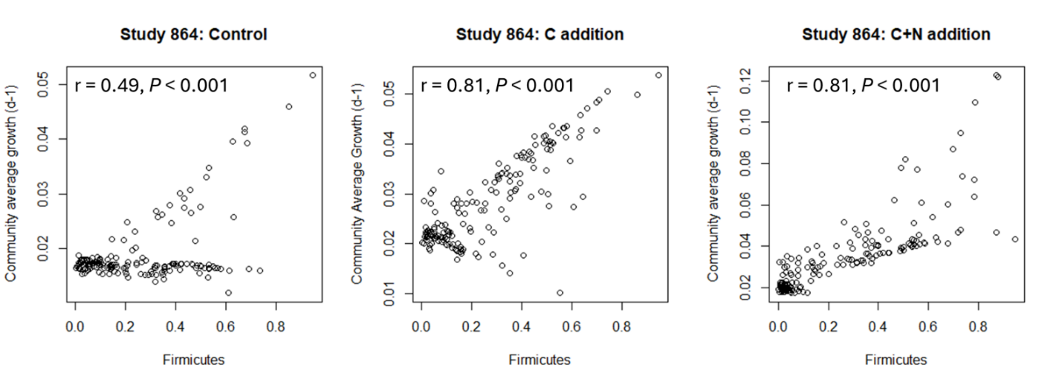
Supplementary Fig. S6: Correlations between community average growth and the relative abundance of Firmicutes within EMP Study 864. The correlation coefficients and P values shown are from Pearson correlation analysis.

Supplementary Figure S7
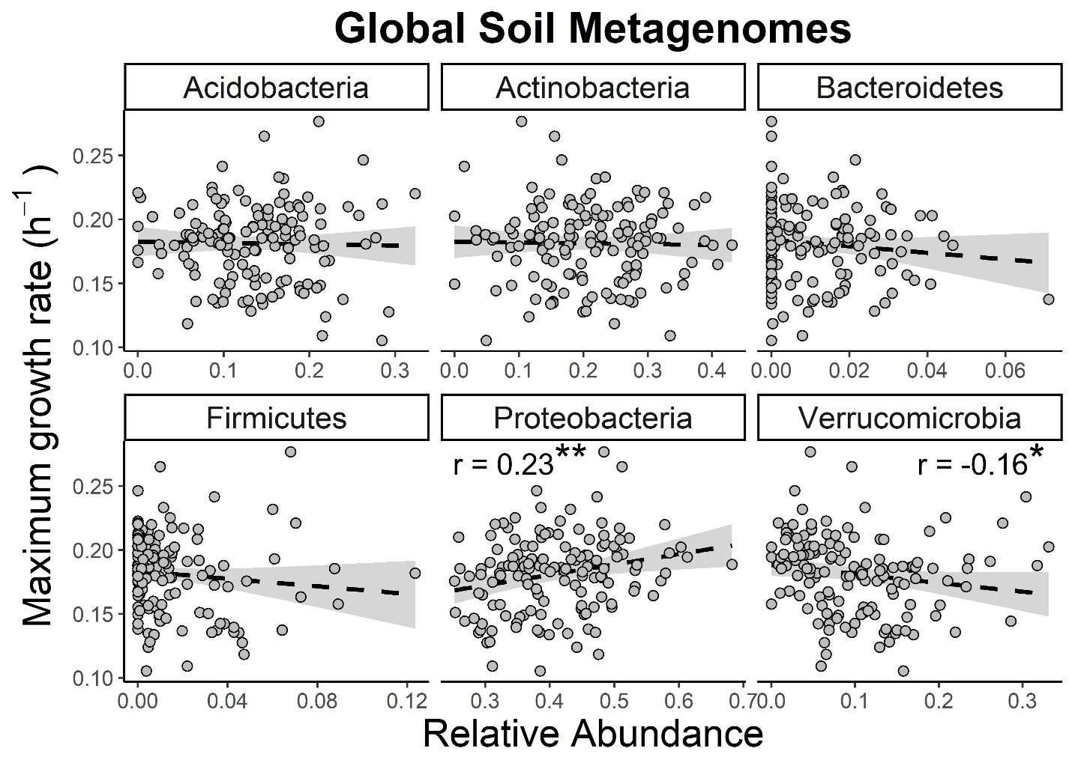

Supplementary Fig S7: Maximum community-average growth rates of soil bacterial communities predicted from a global dataset of soil metagenomes using the gRodon2 codon usage bias model. Correlation coefficients are from Pearson correlation analysis. Asterisks indicate significant correlations at the following levels: * P < 0.05, ** P < 0.01.

Supplementary Figure S8
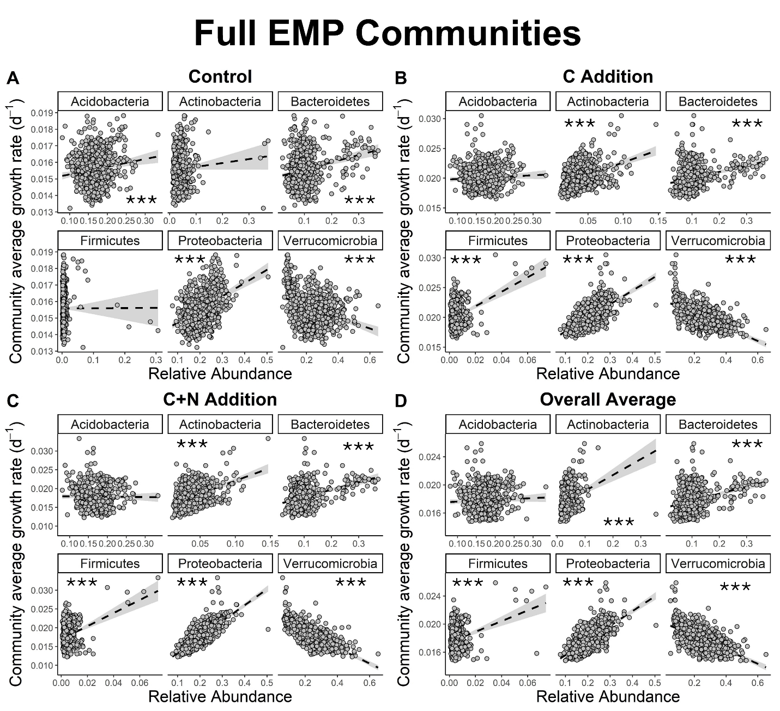
Supplementary Fig. S8: Correlations between phylum relative abundances in the full EMP communities and expected community-average growth rates. Shown are community growth rates for the control (no addition) treatment (A), the glucose-C addition treatment (B), the C + N addition treatment (C) and the overall average growth across all experimental treatments (D). Correlation coefficients are from Pearson correlation analysis. Asterisks indicate significant correlations at the following levels: *** P < 0.001.

Supplementary Figure S9
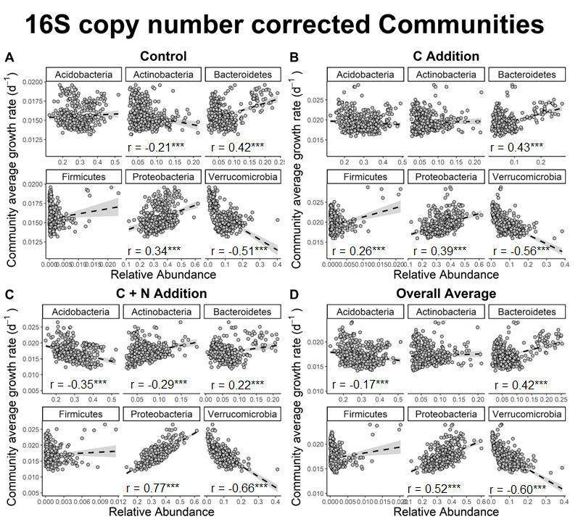
Supplementary Fig. S9: Correlations between phylum relative abundances in the 16S copy number corrected communities and expected community-average growth rates. Shown are community growth rates for the control (no addition) treatment (A), the glucose-C addition treatment (B), the C + N addition treatment (C) and the overall average growth across all experimental treatments (D). Correlation coefficients are from Pearson correlation analysis. Asterisks indicate significant correlations at the following levels: *** P < 0.001.

Supplementary Figure S10
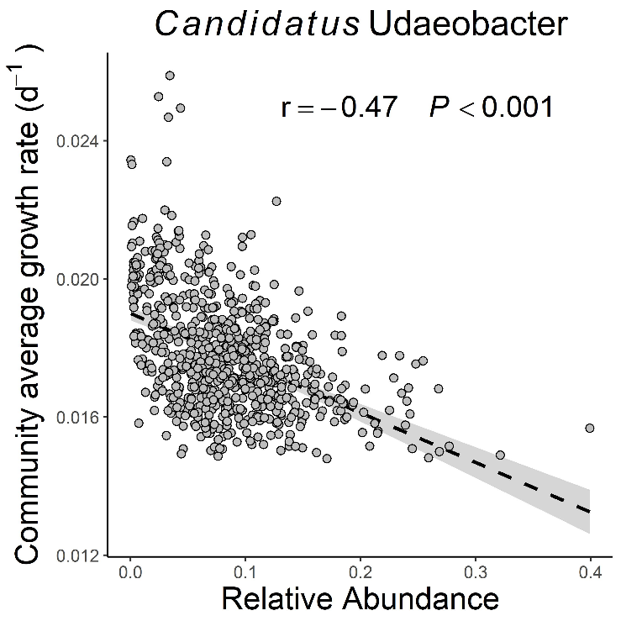
Supplementary Figure S10: Correlation between community average growth and the relative abundance of the Verrucomicrobia group Candidatus Udaeobacter. The correlation coefficients and P values shown are from Pearson correlation analysis.

Supplementary Figure S11
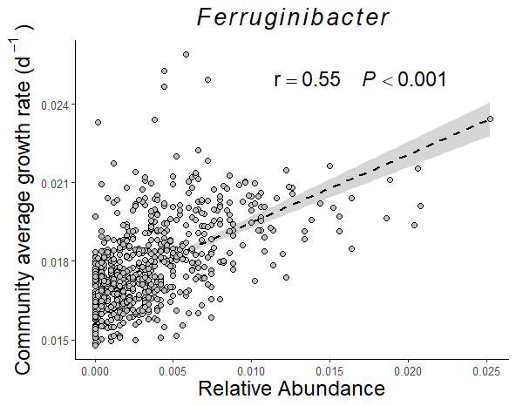
Supplementary Fig. S11: Correlation between community average growth and the relative abundance of the Bacteroidetes group Ferruginibacter. The correlation coefficients and P values shown are from Pearson correlation analysis.

Supplementary Figure S12
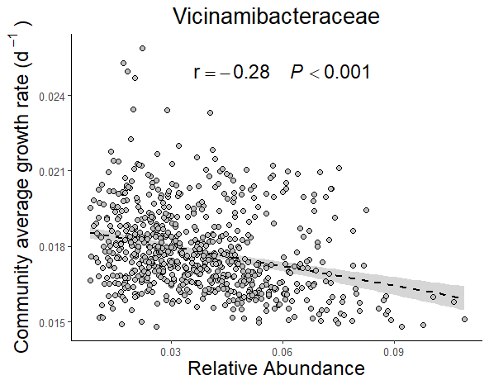
Supplementary Fig. S12: Correlations between community average growth and the relative abundance of the Acidobacteria group Vicinamibacteraceae. The correlation coefficients and P values shown are from Pearson correlation analysis.

References
1. Morrissey EM, Mau RL, Hayer M, Liu X-JA, Schwartz E, Dijkstra P, et al. Evolutionary history constrains microbial traits across environmental variation. Nat Ecol Evol. 2019;3:1064–9.
2. Morrissey EM, Mau RL, Schwartz E, McHugh TA, Dijkstra P, Koch BJ, et al. Bacterial carbon use plasticity, phylogenetic diversity and the priming of soil organic matter. The ISME Journal. 2017;11:1890–9.
3. Li J, Mau RL, Dijkstra P, Koch BJ, Schwartz E, Liu X-JA, et al. Predictive genomic traits for bacterial growth in culture versus actual growth in soil. The ISME Journal. 2019;13:2162–72.
4. Callahan BJ, McMurdie PJ, Rosen MJ, Han AW, Johnson AJA, Holmes SP. DADA2: High-resolution sample inference from Illumina amplicon data. Nat Methods. 2016;13:581–3.
5. Pedregosa F, Varoquaux G, Gramfort A, Michel V, Thirion B, Grisel O, et al. Scikit-learn: Machine Learning in Python. J Mach Learn Res. 2011;12:2825–30.
6. Quast C, Pruesse E, Yilmaz P, Gerken J, Schweer T, Yarza P, et al. The SILVA ribosomal RNA gene database project: improved data processing and web-based tools. Nucleic Acids Res. 2013;41:D590–6.
7. Stone BW, Blazewicz SJ, Koch BJ, Dijkstra P, Hayer M, Hofmockel KS, et al. Nutrients strengthen density dependence of per-capita growth and mortality rates in the soil bacterial community. Oecologia. 2023;201:771–82.
8. Hungate BA, Mau RL, Schwartz E, Caporaso JG, Dijkstra P, van Gestel N, et al. Quantitative Microbial Ecology through Stable Isotope Probing. Schloss PD, editor. Appl Environ Microbiol. 2015;81:7570–81.
9. Koch BJ, McHugh TA, Hayer M, Schwartz E, Blazewicz SJ, Dijkstra P, et al. Estimating taxon-specific population dynamics in diverse microbial communities. Ecosphere. 2018;9:e02090.
10. Bahram M, Hildebrand F, Forslund SK, Anderson JL, Soudzilovskaia NA, Bodegom PM, et al. Structure and function of the global topsoil microbiome. Nature. 2018;560:233–7.
11. Osburn ED, McBride SG, Bahram M, Strickland MS. Global patterns in the growth potential of soil bacterial communities. Nat Commun. 2024;15:6881.
12. Li D, Liu C-M, Luo R, Sadakane K, Lam T-W. MEGAHIT: an ultra-fast single-node solution for large and complex metagenomics assembly via succinct de Bruijn graph. Bioinformatics. 2015;31:1674–6.
13. Hyatt D, Chen G-L, LoCascio PF, Land ML, Larimer FW, Hauser LJ. Prodigal: prokaryotic gene recognition and translation initiation site identification. BMC Bioinformatics. 2010;11:119.
14. Camacho C, Coulouris G, Avagyan V, Ma N, Papadopoulos J, Bealer K, et al. BLAST+: architecture and applications. BMC Bioinformatics. 2009;10:421.
15. Vieira-Silva S, Rocha EPC. The Systemic Imprint of Growth and Its Uses in Ecological (Meta)Genomics. PLOS Genetics. 2010;6:e1000808.
16. Li H, Durbin R. Fast and accurate short read alignment with Burrows–Wheeler transform. Bioinformatics. 2009;25:1754–60.
17. Li H, Handsaker B, Wysoker A, Fennell T, Ruan J, Homer N, et al. The Sequence Alignment/Map format and SAMtools. Bioinformatics. 2009;25:2078–9.
18. Weissman JL, Hou S, Fuhrman JA. Estimating maximal microbial growth rates from cultures, metagenomes, and single cells via codon usage patterns. Proceedings of the National Academy of Sciences. 2021;118:e2016810118.
19. Weissman JL, Peras M, Barnum TP, Fuhrman JA. Benchmarking Community-Wide Estimates of Growth Potential from Metagenomes Using Codon Usage Statistics. mSystems. 2022;7:e00745-22.
20. Bolyen E, Rideout JR, Dillon MR, Bokulich NA, Abnet CC, Al-Ghalith GA, et al. Reproducible, interactive, scalable and extensible microbiome data science using QIIME 2. Nat Biotechnol. 2019;37:852–7.

