Figure S1 Sample collection, work flow, and relative abundance of the top 10 most abundant genera in stem samples from CO39 and Y33R. (A) Rice blast disease on CO39 (susceptible) or Y33R (resistant) cultivar in the field trial. The rice seeds was planted in a blast disease nursery garden in Yangjiang Institute of Agricultural Sciences (Baisha) Experimental Base (111°50′E, 21°52′N). Rice seedlings of each cultivar were planted in three randomized plots (approximately 20 m² each, accommodating around 50 seedlings). (B) Experimental procedure for bacterial microbiota identification, isolation, and application for enhancing rice resistance,visualized by using BioRender. (C) Relative abundance of the top 10 most abundant genera in stem samples from CO39 and Y33R.

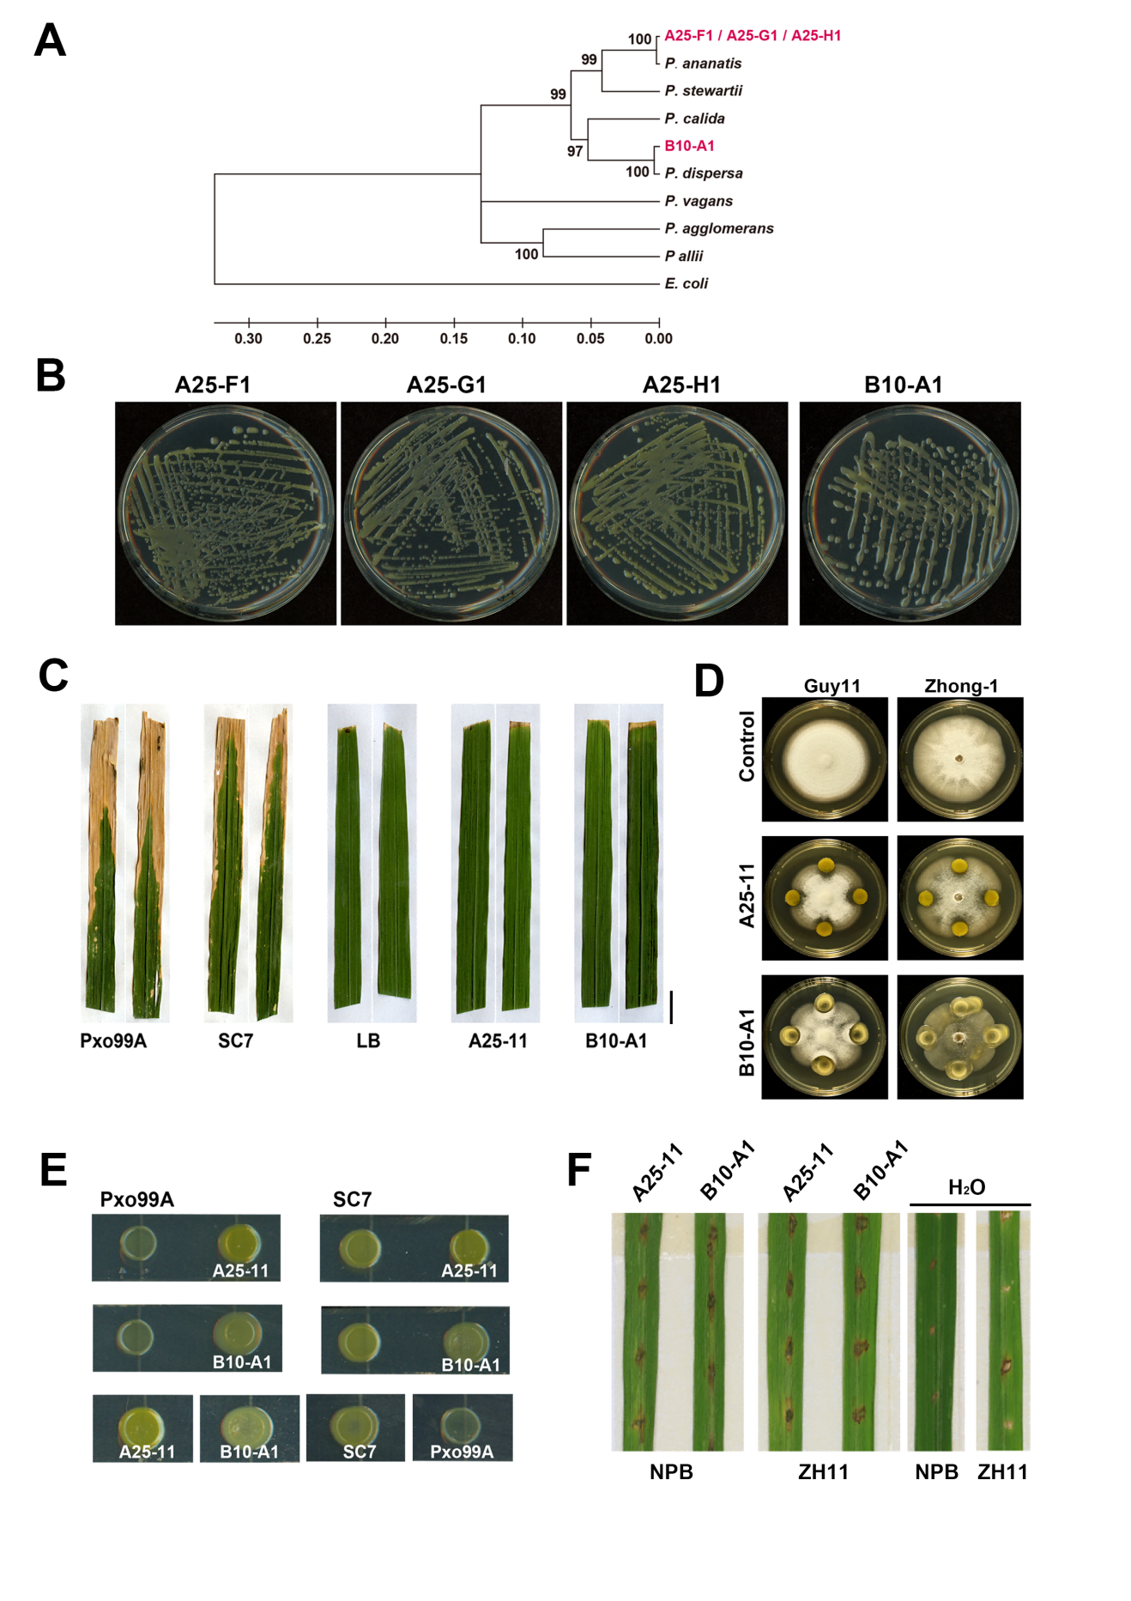
Figure S2 Characterization of the isolated Pantoea strains. (A) Phylogenetic analysis based on 16S rRNA, gyrB, leuS, and rpoB gene sequences. Scale bar represents evolutionary distance. (B) Colony morphology of Pantoea strains. (C) Pathogenicity assay for A25-11 and B10-A1 using the leaf clipping inoculation method [1]. Pxo99A and SC7 served as positive controls and LB as a blank control. The inoculated seedlings grew under 22°C and moisture ≥ 90% for 14 d and then the inoculated leaves were cut and photographed, for documenting blight symptoms. Scale bar, 1 cm. (D) Confrontation culture of A25-11 or B10-A1 with M. oryzae strain Guy11 or Zhong1. Photographs were taken at 7 dpi. (E) Confrontation culture of A25-11 or B10-A1 with bacterial pathogen SC7 or Pxo99A. (F) Lesion mimic caused by A25-11 or B10-A1 on the detached leaves of rice cultivar Nipponbare (NPB) or Zhonghua11 (ZH11). Photographs were taken at 5 dpi.

Figure S3 Growth promotion capacity of A25-H1 and B10-A1. (A) A25-H1 and B10-A1 strains were inoculated on Pikovskaya (PVK), Nitrogen-Free Bromothymol Blue (NFB) and blue agar medium containing Chrome Azurol S (CAS; 60.5 mg/L), respectively. Appearance of the transparent halo zones, blue color, and red/orange coloration respectively indicates phosphate-solubilizing, nitrogen-fixing, and siderophore-producing capabilities. (B) Visualization of IAA by using the Salkowski reagent. Top panel: serially diluted IAA solution (50, 5, 0.5 μg/ml). TSB served as a negative control. (C) Mass spectrometry peaks corresponding to IAA detected in IAA standard (0.1 pmol), extracellular and intracellular extracts of A25-H1 and B10-A1 grown in TSB supplemented with tryptophan (1 mg/mL). TSB served as a mock control (no IAA production). (D) Expression profiling of OsEXPA7, OsEXPB3 and OsEXPB7 in the detached rice leaves without treatment (mock) or treated with LB (blank control), A25-11 (O.D.₆₀₀ = 0.5), B10-A1 (O.D.₆₀₀ = 0.5) or IAA (100 μM, positive control), for 2 h. Relative folds were calculated by using 2^{−ΔΔCT} method [2], with OsUBQ as an internal control. Gene expression level in untreated leaves (mock) was set as “1”. Mean ± S.D. was derived from three independent biological repeats. **, ***: p < 0.01, p < 0.001 vs mock respectively (Student's t test).

Figure S4 Comparative genome analysis with A25-H1 and selected P. ananatis strains. (A) Phylogenetic analysis at genome level was performed using OrthoFinder (v3.0.1). The 18 P. ananatis 0genomes were retrieved from the NCBI genome database. Red fonts represent pathogenic strains, green for plant growth-promoting (PGP) strains, and black for strains of unknown function. *** denotes to A25-H1 strain. (B) Detection of MCP II gene in P. ananatis strains SC7, A25-F1, A25-G1, and A25-H1.

Table S1 Presence of MCPII in P.ananatis strains.
Strain name | Genome ID | Functions | MCPII presence
1.38 | GCA_002224035.1 | PGP | Yes
AMG501 | GCA_002215245.1 | PGP | Yes
YJ76 | GCA_002224585.2 | PGP | Yes
R100 | GCA_001543055.1 | PGP | Yes
ARC272 | GCA_003231545.1 | Pathogen | No
NS311 | GCA_001475725.1 | Pathogen | No
PA13 | GCA_000233595.1 | Pathogen | No
TZ39 | GCA_019720835.1 | Pathogen | No

References
[1] Ke Y, Hui S, Yuan M. Xanthomonas oryzae pv. oryzae inoculation and growth rate on rice by leaf clipping method. Bio Protoc. 2017;7(19):e2568.
[2] Livak KJ, Schmittgen TD. Analysis of relative gene expression data using real-time quantitative PCR and the 2(-Delta Delta C(T)) method. Methods. 2001;25(4):402-408.

