Supplementary materials

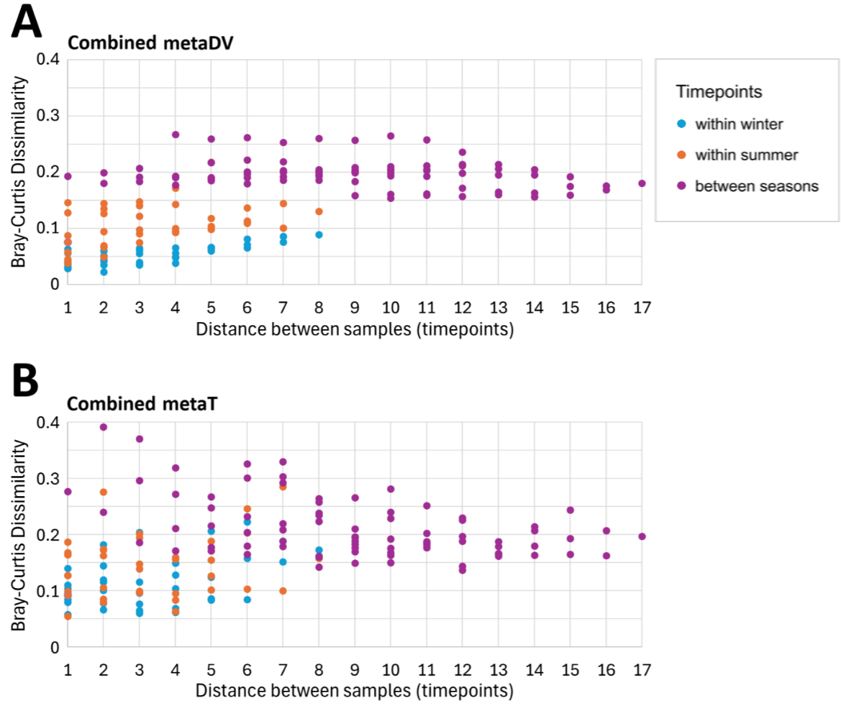
Figure S1. Pairwise Bray-Curtis dissimilarity (BCD) scatterplots of taxonomic abundances across timepoints, delineating inter-seasonal and intra-seasonal relationships. (A) Metagenomic and metaviromic DNA. (B) Metatranscriptomic RNA. The x-axis shows the distance between timepoints (e.g., distance = 1 for consecutive timepoints like T1 vs T2; distance = 2 for timepoints separated by one intermediate sample like T1 vs T3).

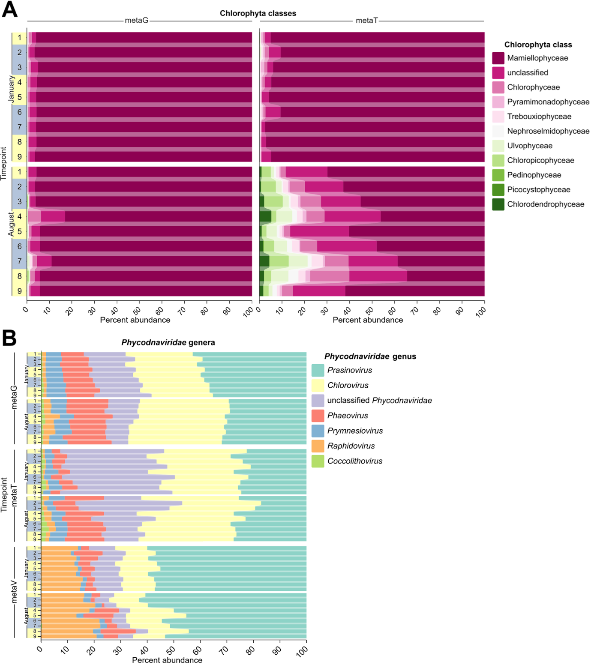
Figure S2. Temporal dynamics of Chlorophyta classes and Phycodnaviridae genera. (A) Relative abundance of Chlorophyta classes across metaG and metaT fractions during January and August sampling periods. Each row represents a daily timepoint, numbered 1-9 for each sampling period. (B) Relative abundance of Phycodnaviridae genera across metagenomic (metaG), metatranscriptomic (metaT), and metavirome (metaV) fractions during January and August. Yellow/grey shading along the y-axes indicates daytime/nighttime.

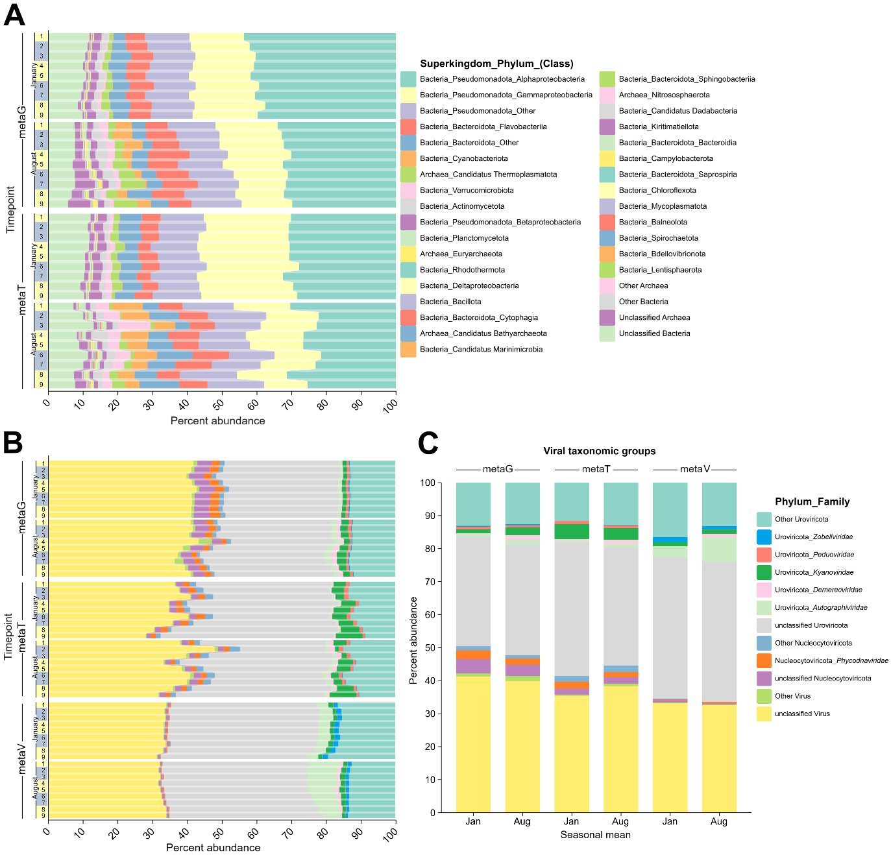
Figure S3. Bar plots of prokaryotic and viral taxonomic group relative abundance by timepoint/season and metaG/T/V. (A) Prokaryotic groups. Taxa are grouped by superkingdom, phylum and in some cases class. (B) Viral groups. Viral taxonomic group changes by timepoint. Taxa are grouped by phylum and family. (C) Viral taxonomic group changes averaged by season. Yellow/grey shading along the y-axes indicates daytime/nighttime.

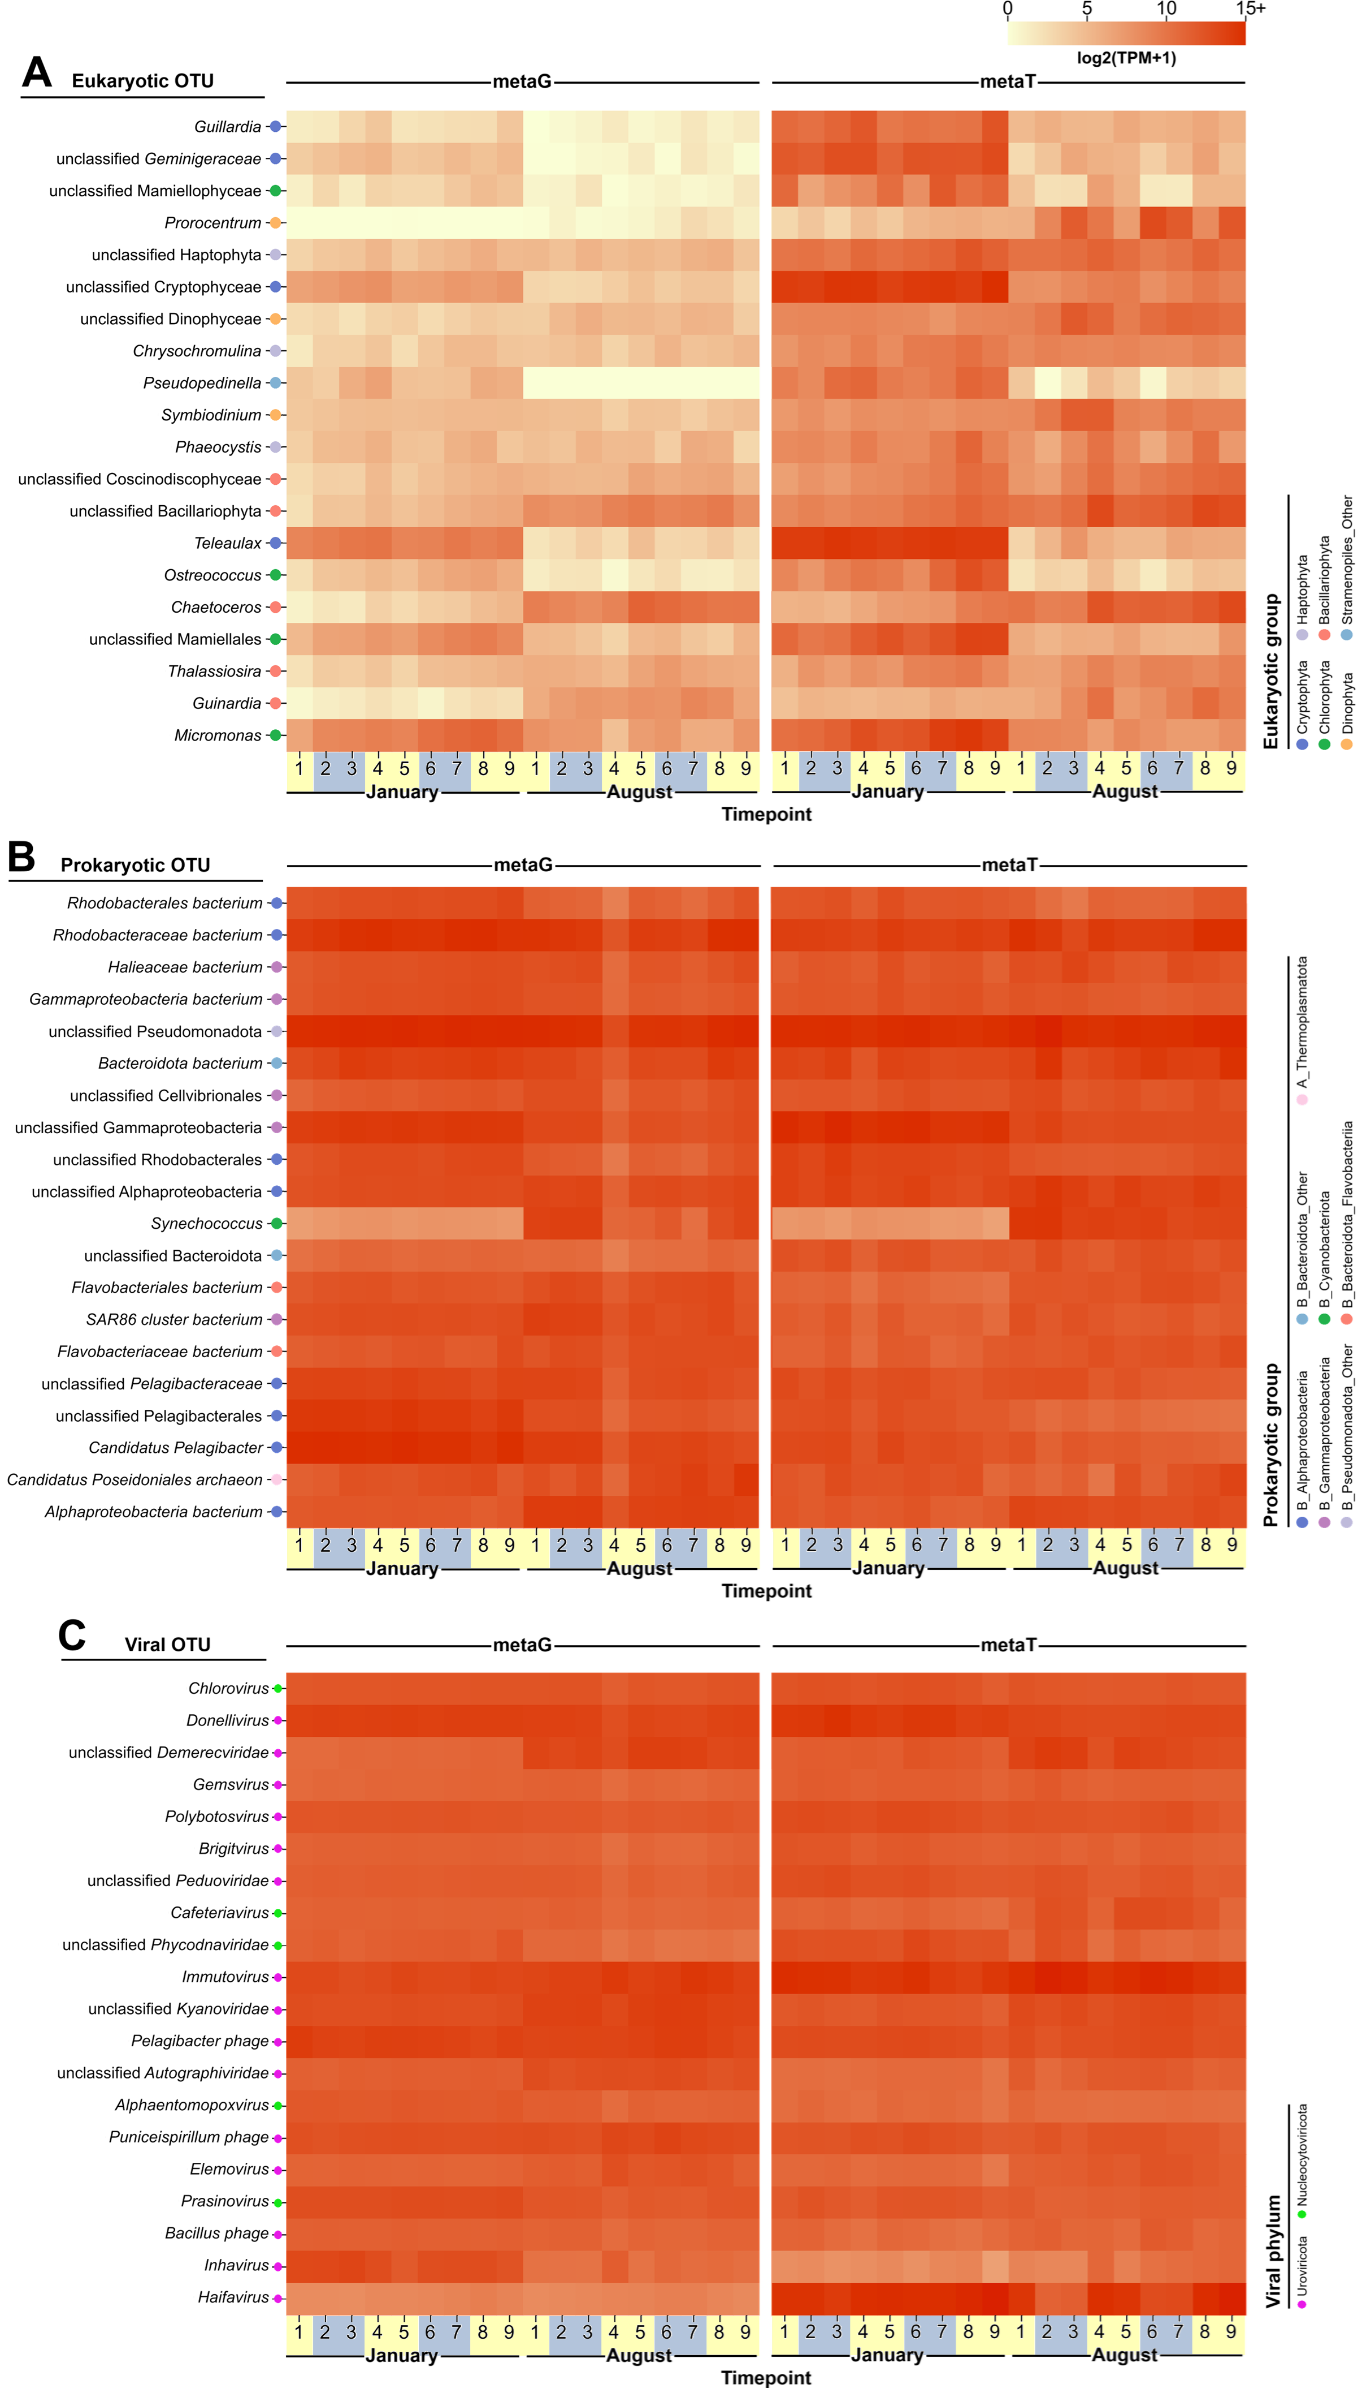
Figure S4. Top 20 most abundant temporal abundance heatmaps [log₂(TPM+1)] of OTUs by timepoint for each season, supergroup, and metaG/T. OTUs are clustered by their relative expression pattern as in Figure X. All three heatmaps follow the same abundance scale shown above (A) Eukaryotic OTUs. Eukaryotic group is indicated by coloured dot. (B) Prokaryotic OTUs. Prokaryotic group is indicated by coloured dot. (C) Cellular fraction viral OTUs. Viral phyla are indicated by coloured dot. Yellow/grey shading along the x-axes indicates daytime/nighttime.

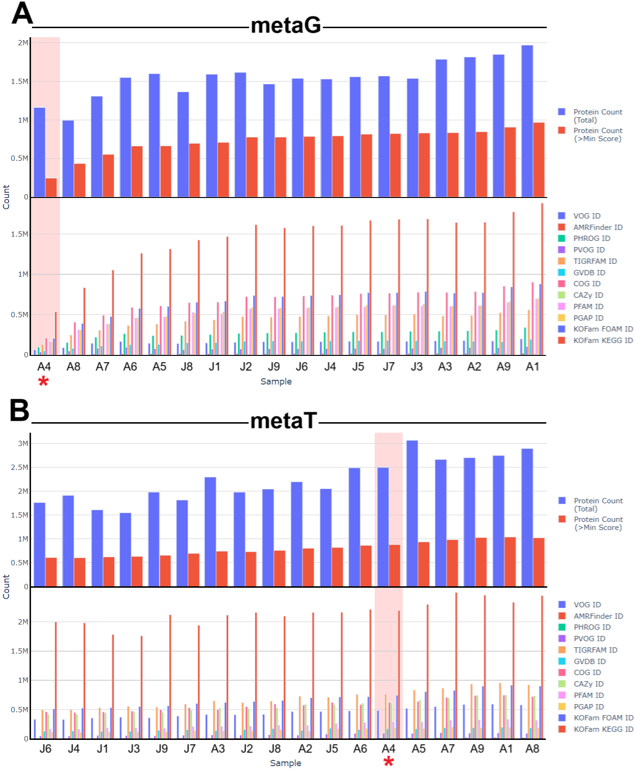
Figure S5. Statistics of the functional annotation of all sample proteins, as outputted by MetaCerberus, in the (A) metaG fraction, and (B) metaT fraction. The top graphs display the total inputted protein counts and protein counts that passed quality thresholds (this is the value by which the samples are ordered on the x-axis), whereas the bottom graphs show total counts annotated against each gene ontology database. J=January, A=August. August timepoint 4, discussed in-text, is highlighted in red.

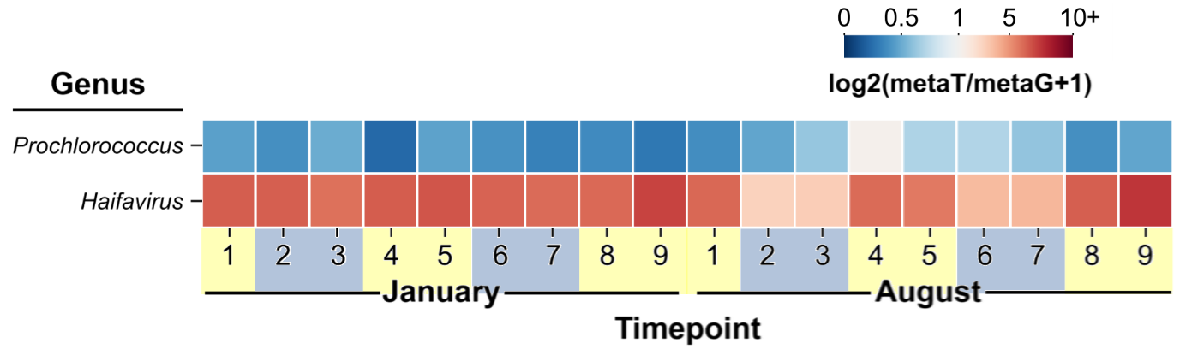
Figure S6. Heatmap of log₂(metaT/metaG+1) expression ratios for Prochlorococcus and Haifavirus. Yellow/grey shading along the x-axis indicates daytime/nighttime.

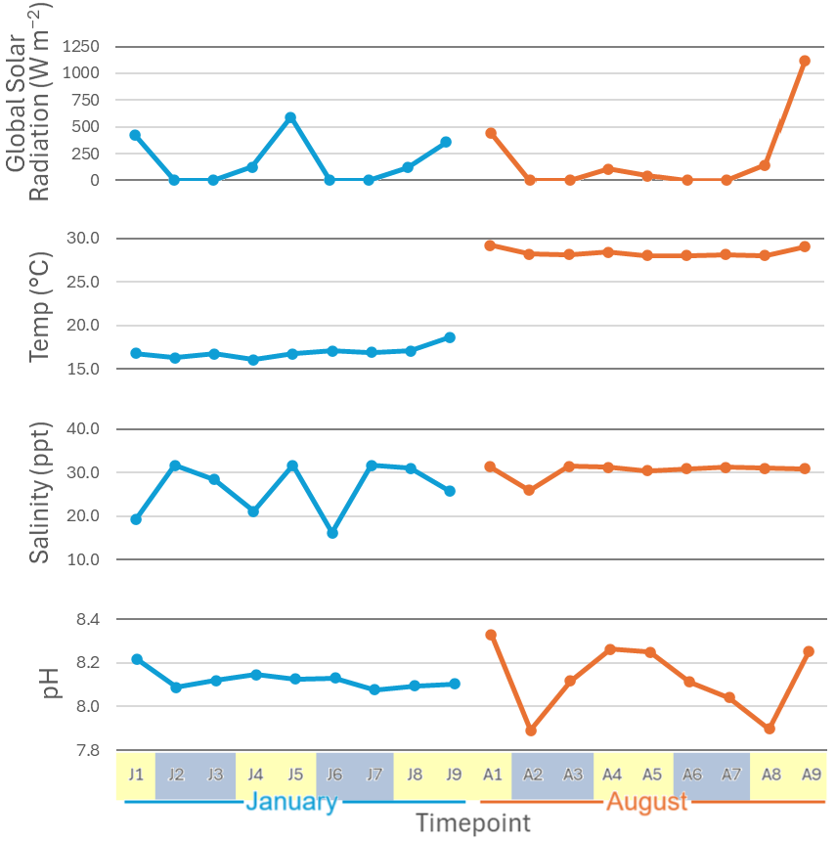
Figure S7. Non-collinear environmental measurements used in this study, per timepoint and season. Yellow/grey shading indicates daytime/nighttime.
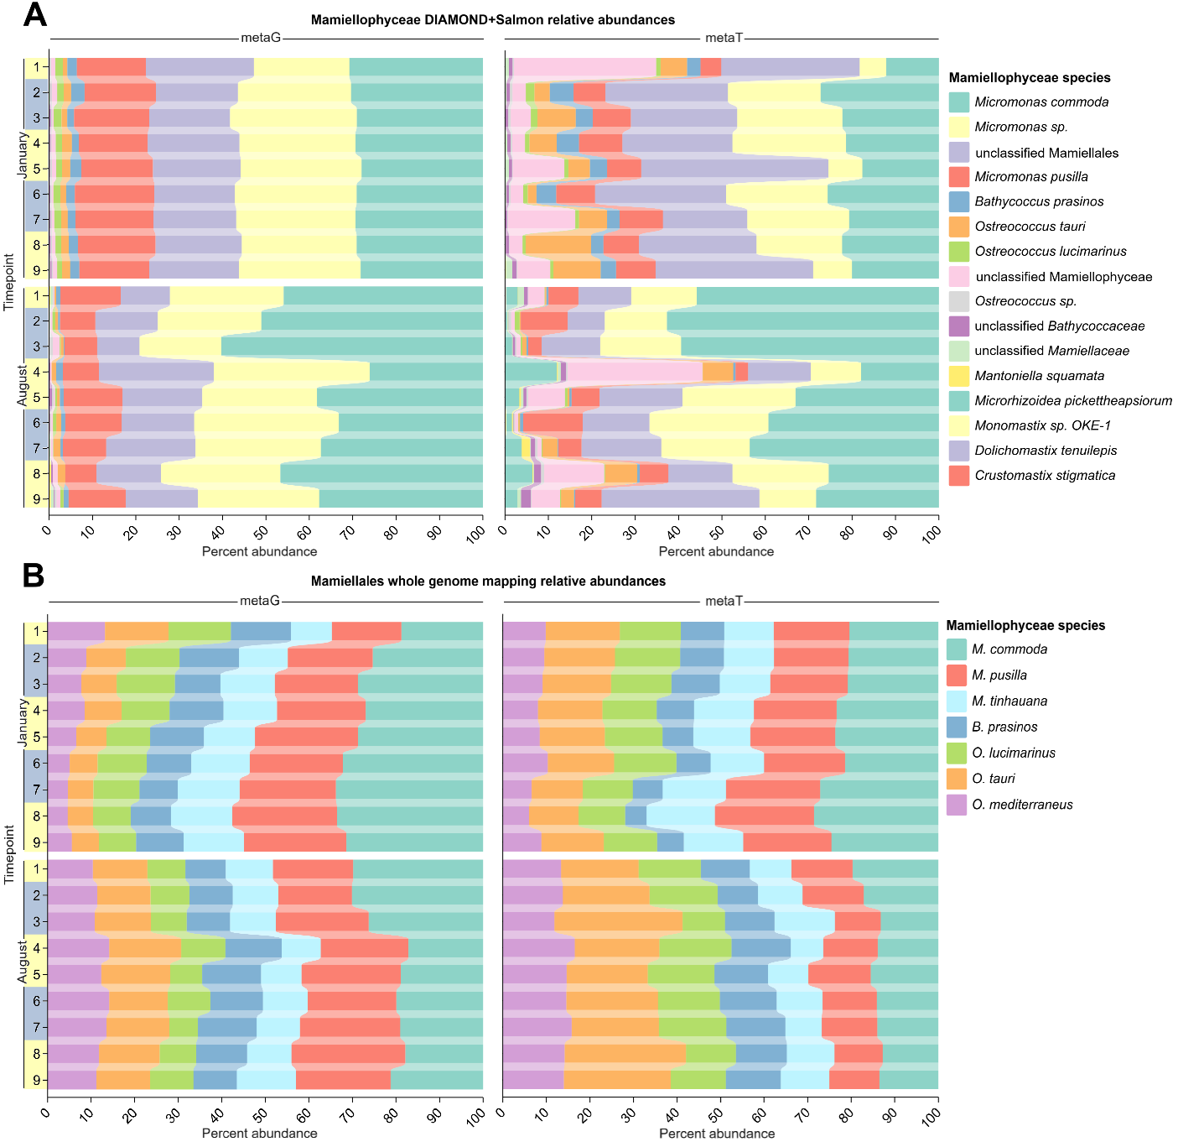
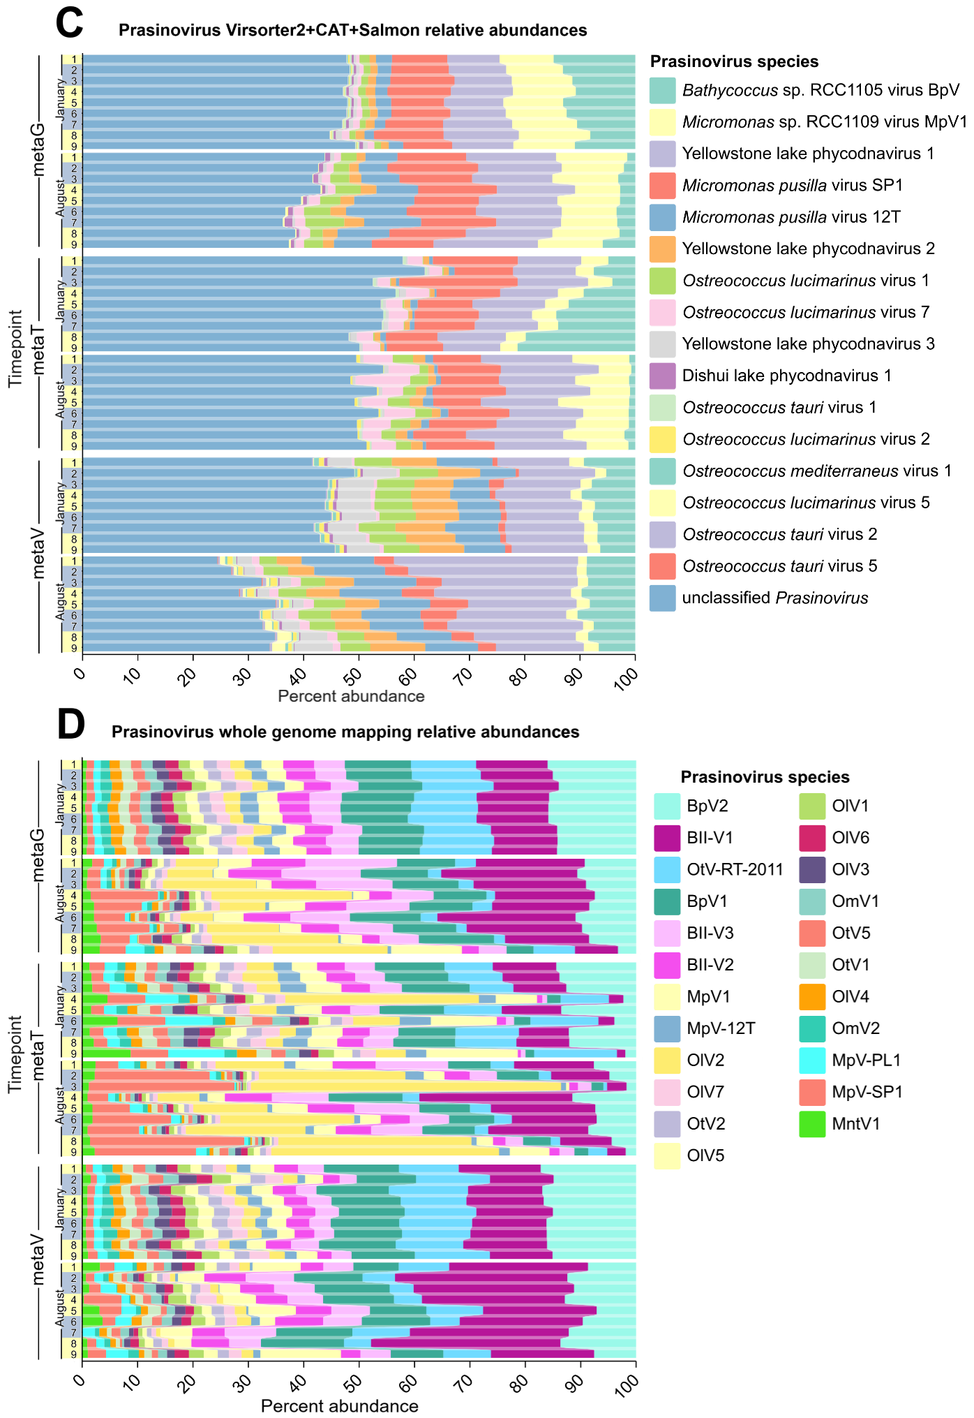

Figure S8. Comparative analysis of Mamiellophyceae and Prasinovirus species relative abundances using two different methods. (A) Mamiellophyceae species relative abundances, results from Prodigal ORF prediction-based annotation with DIAMOND against the NCBI-nr and Salmon TPM abundances, converted to percentages for each timepoint. (B) Mamiellophyceae species relative abundances, results from BBMap 99% identity read mapping to whole genomes calculated as TPM for each timepoint. (C) Prasinovirus species relative abundances, results from Prodigal ORF prediction-based annotation with CAT against the RefSeq database and Salmon TPM abundances, converted to percentages for each timepoint. (D) Prasinovirus species relative abundances, results from BBMap 99% identity read mapping. Yellow/grey shading along the y-axes indicates daytime/nighttime.

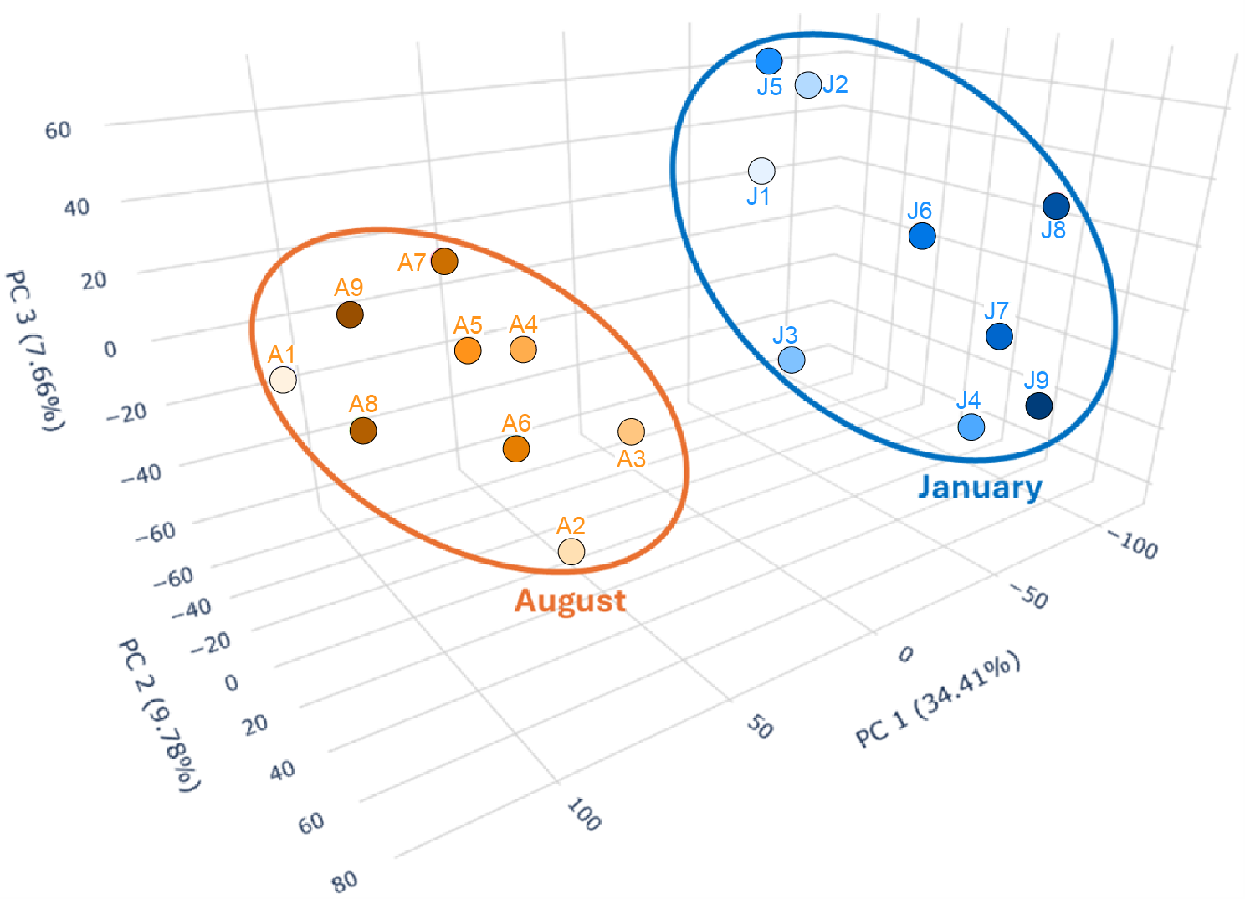
Figure S9. KOFam-KEGG functional PCA plot of gene expression. Timepoints and seasonal clusters are labelled (J=January/winter, A=August/summer). Colors represent temporal progression from light (early timepoints) to dark (late timepoints) in the sampling series.

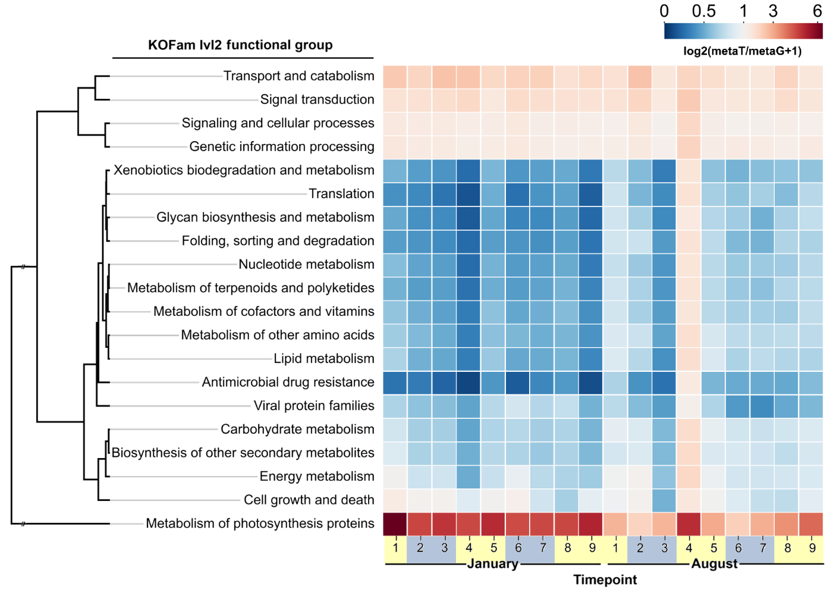
Figure S10. Heatmap of log₂(metaT/metaG+1) expression ratios for all abundant (>500 TPM) KOFams consolidated to level 2 annotations. Yellow/grey shading along the x-axis indicates daytime/nighttime.

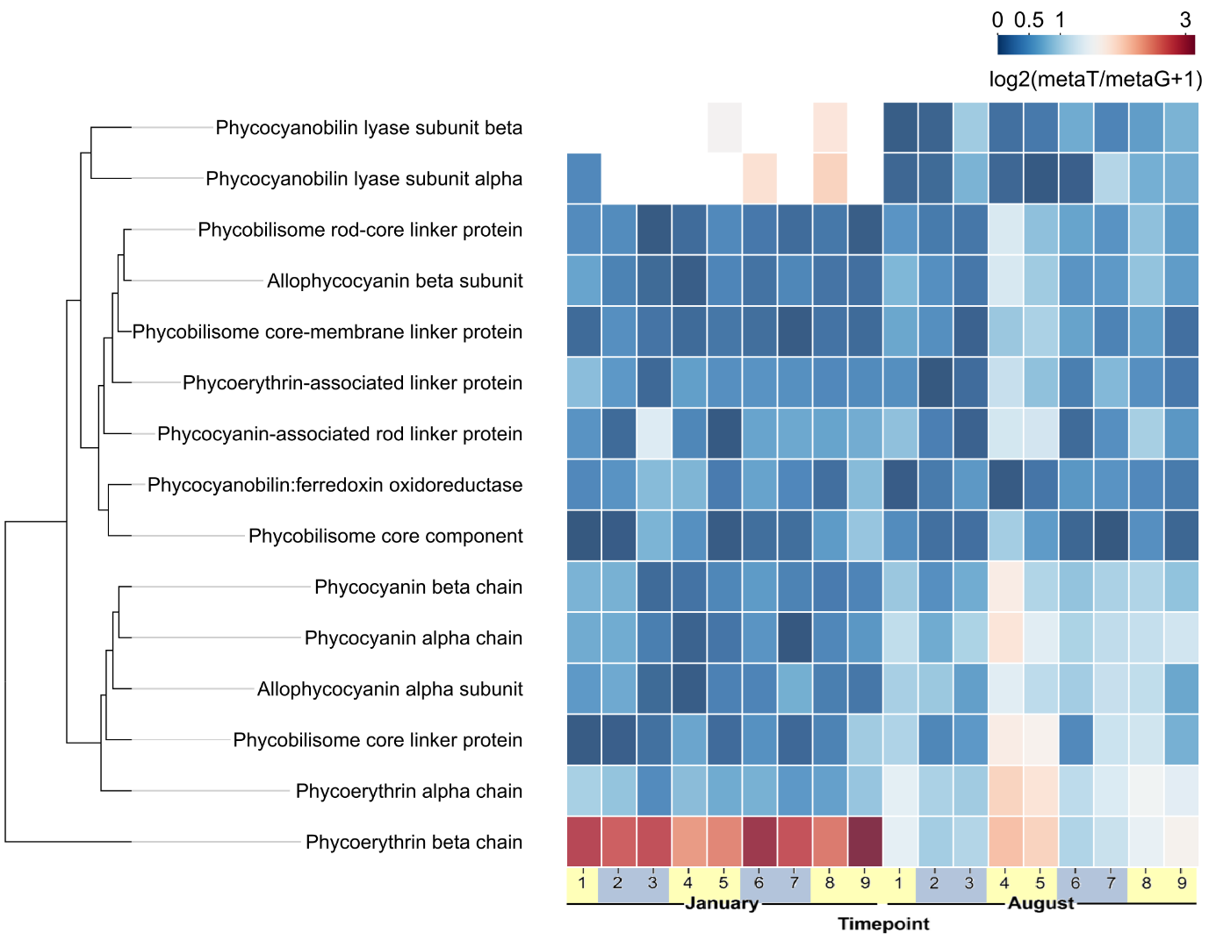
Figure S11. Heatmap of log₂(metaT/metaG+1) expression ratios for (low expression) phycobilisome components and associated proteins. Yellow/grey shading along the x-axis indicates daytime/nighttime.

TS1. Environmental variables. (A) Variables measured via YSI or chemical methods in this study. (B) Comparison of winter/summer values in the study data and EPD data, with variables that showed significant seasonal trend difference highlighted in red. (C) EPD trends for 2020-2022, with the approximate dates and values for 2021 highlighted in blue and orange for winter and summer, respectively.

A
Season | Timepoint | Temp (°C) | Pressure (mmHg) | DO (mg/L) | Conductivity (uS/cm) | Sal (ppt) | pH | Turbidity (NTU) | SiO3 | Chlorophyll
Winter (Jan) | T1 | 16.8 | 761.3 | 9.6 | 30701.7 | 19.3 | 8.2 | 2.93 | 0.17 | 3.30
Winter (Jan) | T2 | 16.3 | 761.9 | 8.1 | 48388.0 | 31.6 | 8.1 | 1.10 | 0.19 | 3.83
Winter (Jan) | T3 | 16.7 | 761.9 | 8.4 | 43912.0 | 28.4 | 8.1 | 3.91 | 0.17 | 2.98
Winter (Jan) | T4 | 16.1 | 761.4 | 9.1 | 33402.3 | 21.1 | 8.1 | 0.54 | 0.15 | 2.09
Winter (Jan) | T5 | 16.8 | 759.7 | 8.5 | 48407.0 | 31.6 | 8.1 | 1.89 | 0.16 | 3.89
Winter (Jan) | T6 | 17.1 | 759.9 | 8.4 | 25268.5 | 16.2 | 8.1 | 0.83 | 0.14 | 4.70
Winter (Jan) | T7 | 16.9 | 759.5 | 8.2 | 48369.7 | 31.6 | 8.1 | 1.24 | 0.16 | 2.04
Winter (Jan) | T8 | 17.1 | 760.0 | 8.1 | 47568.7 | 31.0 | 8.1 | 0.82 | 0.14 | 3.16
Winter (Jan) | T9 | 18.7 | 757.5 | 8.7 | 40110.3 | 25.8 | 8.1 | 0.41 | 0.14 | 3.83
Summer (Aug) | T1 | 29.2 | 757.8 | 7.6 | 48270.0 | 31.4 | 8.3 | 1.07 | 0.43 | 7.30
Summer (Aug) | T2 | 28.2 | 756.6 | 5.7 | 40601.3 | 26.0 | 7.9 | 0.56 | 0.40 | 6.26
Summer (Aug) | T3 | 28.1 | 756.9 | 6.6 | 48280.7 | 31.4 | 8.1 | 2.02 | 0.33 | 7.32
Summer (Aug) | T4 | 28.4 | 757.8 | 6.8 | 48027.3 | 31.2 | 8.3 | 1.12 | 0.32 | 6.09
Summer (Aug) | T5 | 28.0 | 756.8 | 7.0 | 46936.7 | 30.4 | 8.3 | 1.15 | 0.27 | 9.74
Summer (Aug) | T6 | 28.0 | 756.3 | 7.3 | 47519.7 | 30.8 | 8.1 | 1.10 | 0.31 | 9.27
Summer (Aug) | T7 | 28.1 | 756.3 | 6.7 | 47966.0 | 31.2 | 8.0 | 1.09 | 0.31 | 10.23
Summer (Aug) | T8 | 28.0 | 756.5 | 6.1 | 47771.7 | 31.0 | 7.9 | 0.94 | 0.37 | 2.88
Summer (Aug) | T9 | 29.0 | 755.7 | 7.2 | 47553.0 | 30.8 | 8.3 | 1.33 | 0.25 | 5.10

B
 | Temp (°C) | DO (mg/L) | Sal (ppt) | pH | Turbidity | Chlorophyll | SiO3 | Nitrate | Phosphate
Winter | 16.9 | 8.6 | 26.3 | 8.1 | 1.52 | 3.31 | 0.16 | 0.00 | 0.00
Summer | 28.3 | 6.8 | 30.5 | 8.1 | 1.15 | 7.13 | 0.33 | 0.00 | 0.00
EPD 06/01/2021 | 17.5 | 6.3 | 31.2 | 7.8 | 2.5 | 6.7 | 0.63 | 0.05 | 0.002
EPD 15/09/2021 | 29.9 | 5.3 | 32.1 | 8.1 | 9.1 | 0.7 | 0.39 | 0.02 | 0.022

C
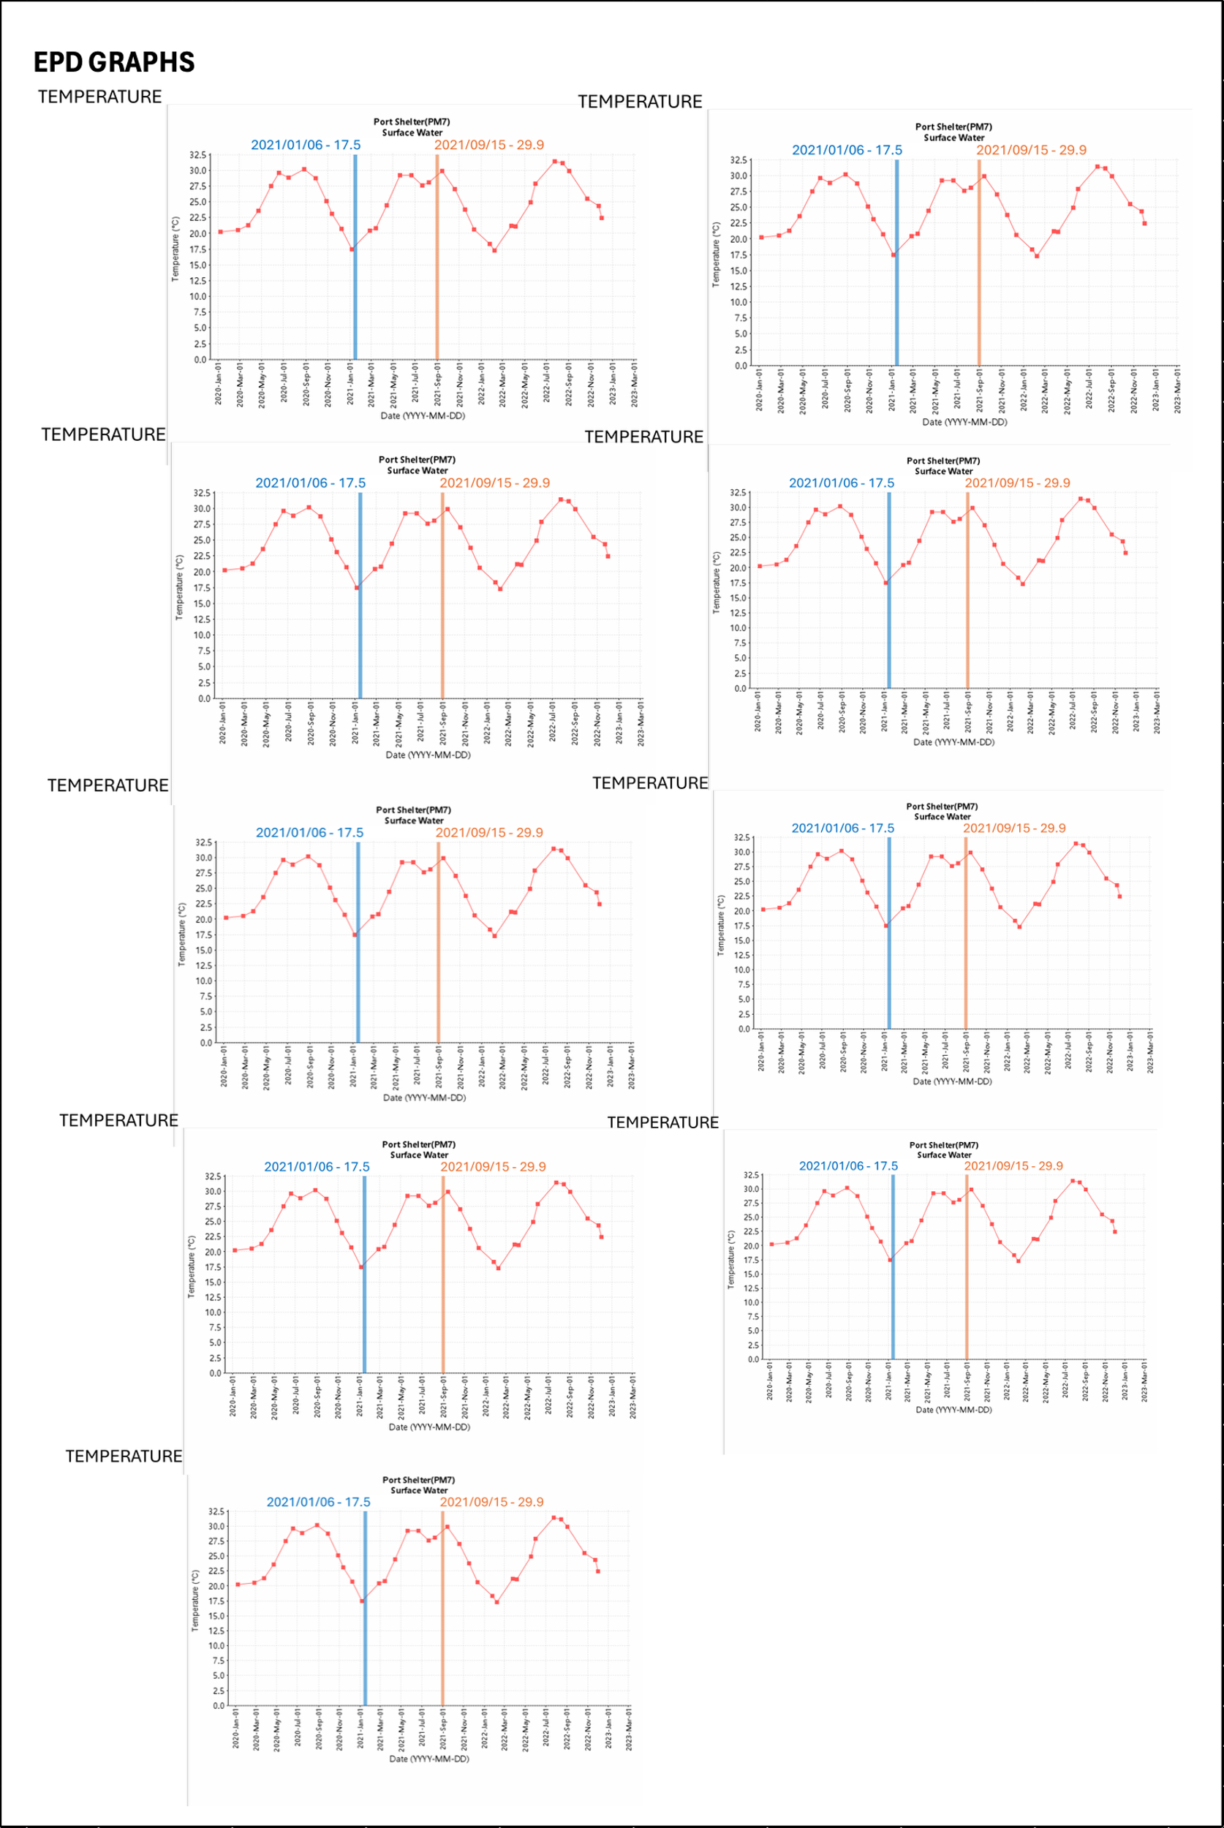
TS2. Environmental variable values, their pairwise SRCC and corresponding p-values. Values and variables for which significant correlations above 0.7 were found and which were subsequently removed from further study are highlighted in red.

Season | Timepoint |  | Temp (°C) |  | Pressure (mmHg) |  | DO (mg/L) |  | Conductivity (uS/cm) |  | Sal (ppt) |  | pH |  | Global Solar Radiation (W/m2)
Winter (Jan) | T1 |  | 16.8 |  | 761.3 |  | 9.6 |  | 30701.7 |  | 19.3 |  | 8.2 |  | 419
Winter (Jan) | T2 |  | 16.3 |  | 761.9 |  | 8.1 |  | 48388.0 |  | 31.6 |  | 8.1 |  | 0
Winter (Jan) | T3 |  | 16.7 |  | 761.9 |  | 8.4 |  | 43912.0 |  | 28.4 |  | 8.1 |  | 0
Winter (Jan) | T4 |  | 16.1 |  | 761.4 |  | 9.1 |  | 33402.3 |  | 21.1 |  | 8.1 |  | 122
Winter (Jan) | T5 |  | 16.8 |  | 759.7 |  | 8.5 |  | 48407.0 |  | 31.6 |  | 8.1 |  | 592
Winter (Jan) | T6 |  | 17.1 |  | 759.9 |  | 8.4 |  | 25268.5 |  | 16.2 |  | 8.1 |  | 0
Winter (Jan) | T7 |  | 16.9 |  | 759.5 |  | 8.2 |  | 48369.7 |  | 31.6 |  | 8.1 |  | 0
Winter (Jan) | T8 |  | 17.1 |  | 760.0 |  | 8.1 |  | 47568.7 |  | 31.0 |  | 8.1 |  | 119
Winter (Jan) | T9 |  | 18.7 |  | 757.5 |  | 8.7 |  | 40110.3 |  | 25.8 |  | 8.1 |  | 358
Summer (Aug) | T1 |  | 29.2 |  | 757.8 |  | 7.6 |  | 48270.0 |  | 31.4 |  | 8.3 |  | 441
Summer (Aug) | T2 |  | 28.2 |  | 756.6 |  | 5.7 |  | 40601.3 |  | 26.0 |  | 7.9 |  | 0
Summer (Aug) | T3 |  | 28.1 |  | 756.9 |  | 6.6 |  | 48280.7 |  | 31.4 |  | 8.1 |  | 0
Summer (Aug) | T4 |  | 28.4 |  | 757.8 |  | 6.8 |  | 48027.3 |  | 31.2 |  | 8.3 |  | 105
Summer (Aug) | T5 |  | 28.0 |  | 756.8 |  | 7.0 |  | 46936.7 |  | 30.4 |  | 8.3 |  | 41
Summer (Aug) | T6 |  | 28.0 |  | 756.3 |  | 7.3 |  | 47519.7 |  | 30.8 |  | 8.1 |  | 0
Summer (Aug) | T7 |  | 28.1 |  | 756.3 |  | 6.7 |  | 47966.0 |  | 31.2 |  | 8.0 |  | 0
Summer (Aug) | T8 |  | 28.0 |  | 756.5 |  | 6.1 |  | 47771.7 |  | 31.0 |  | 7.9 |  | 144
Summer (Aug) | T9 |  | 29.0 |  | 755.7 |  | 7.2 |  | 47553.0 |  | 30.8 |  | 8.3 |  | 1122
SRCC
 |  | Temp. |  | Pressure |  | DO |  | Cond. |  | Salinity |  | pH |  | GSR
Temp. |  | 1
Pressure |  | -0.785 |  | 1
DO |  | -0.736 |  | 0.704 |  | 1
Cond. |  | 0.152 |  | -0.073 |  | -0.317 |  | 1
Salinity |  | 0.148 |  | -0.069 |  | -0.310 |  | 0.996 |  | 1
pH |  | 0.214 |  | 0.098 |  | 0.231 |  | 0.014 |  | 0.006 |  | 1
GSR |  | 0.125 |  | -0.053 |  | 0.300 |  | -0.010 |  | -0.047 |  | 0.449 |  | 1
p-value
 |  | Temp. |  | Pressure |  | DO |  | Cond. |  | Salinity |  | pH |  | GSR
Temp. |  | 0
Pressure |  | <0.001 |  | 0
DO |  | <0.001 |  | <0.01 |  | 0
Cond. |  | 0.55 |  | 0.77 |  | 0.20 |  | <0.001
Salinity |  | 0.56 |  | 0.79 |  | 0.21 |  | <0.001 |  | 0
pH |  | 0.39 |  | 0.70 |  | 0.36 |  | 0.96 |  | 0.98 |  | 0
GSR |  | 0.62 |  | 0.83 |  | 0.23 |  | 0.97 |  | 0.85 |  | 0.06 |  | 0

TS3. Investigation into the taxonomic annotation of August timepoint 4 (highlighted in red) versus the rest. J=January/winter, A=August/summer.
metaG annotation | J1 | J2 | J3 | J4 | J5 | J6 | J7 | J8 | J9 | A1 | A2 | A3 | A4 | A5 | A6 | A7 | A8 | A9
% Unclassified Eukaryota | 0.7 | 0.4 | 0.2 | 0.3 | 0.2 | 0.3 | 0.2 | 0.3 | 0.2 | 0.2 | 0.3 | 0.3 | 4.0 | 0.6 | 0.6 | 0.6 | 0.4 | 0.2
% Unclassified Prokaryota | 12.2 | 11.7 | 11.2 | 10.5 | 11.3 | 10.7 | 10.1 | 9.3 | 10.2 | 9.2 | 9.0 | 9.9 | 9.1 | 10.3 | 11.5 | 13.2 | 9.7 | 12.0
Unannotated count | 5314.7 | 5649.0 | 6043.3 | 5916.9 | 6036.7 | 5674.7 | 6023.7 | 6043.6 | 6108.7 | 6221.6 | 5939.8 | 5815.9 | 4280.9 | 4353.4 | 5683.8 | 5075.2 | 5569.7 | 6098.5
Total TPM | 288061 | 333617 | 374216 | 362439 | 377589 | 346249 | 377721 | 362790 | 384116 | 348038 | 334179 | 328676 | 102797 | 248586 | 264703 | 245760 | 314810 | 351236
% Unannotated | 1.8 | 1.7 | 1.6 | 1.6 | 1.6 | 1.6 | 1.6 | 1.7 | 1.6 | 1.8 | 1.8 | 1.8 | 4.2 | 1.8 | 2.1 | 2.1 | 1.8 | 1.7
metaT annotation | J1 | J2 | J3 | J4 | J5 | J6 | J7 | J8 | J9 | A1 | A2 | A3 | A4 | A5 | A6 | A7 | A8 | A9
% Unclassified Eukaryota | 11.6 | 9.5 | 8.2 | 10.0 | 11.7 | 7.6 | 11.4 | 11.8 | 13.9 | 3.0 | 1.0 | 2.5 | 9.9 | 4.4 | 2.8 | 3.8 | 8.2 | 10.3
% Unclassified Prokaryota | 10.0 | 9.4 | 10.2 | 8.6 | 8.7 | 9.1 | 7.5 | 6.5 | 6.4 | 7.6 | 10.2 | 12.7 | 6.6 | 10.2 | 11.1 | 10.4 | 7.9 | 8.8
Unannotated count | 44634.0 | 37209.6 | 33783.6 | 53471.2 | 39951.0 | 44817.9 | 42002.9 | 54273.6 | 70218.1 | 20550.5 | 21890.4 | 22220.8 | 32130.3 | 22712.5 | 19271.8 | 20734.4 | 35423.2 | 37879.2
Total TPM | 440182 | 373296 | 476196 | 374727 | 447712 | 437801 | 406520 | 435327 | 473406 | 371013 | 437935 | 343616 | 349448 | 319148 | 326849 | 321756 | 396196 | 436597
% Unannotated | 10.1 | 10.0 | 7.1 | 14.3 | 8.9 | 10.2 | 10.3 | 12.5 | 14.8 | 5.5 | 5.0 | 6.5 | 9.2 | 7.1 | 5.9 | 6.4 | 8.9 | 8.7

TS4. Outside-p-value-threshold Prasinovirus-Mamiellophyceae OTU co-occurrences not included in the winter network. LS=local similarity score.
 | Mamiellophyceae OTU | LS | p-value | delay
Prasinovirus | Ostreococcus | -0.607 | 0.221 | 0
Prasinovirus | unclassified Bathycoccaceae | -0.592 | 0.256 | 0
Prasinovirus | unclassified Mamiellaceae | -0.537 | 0.392 | -1
Prasinovirus | Micromonas | -0.511 | 0.386 | -1
Prasinovirus | Bathycoccus | -0.504 | 0.566 | 0
Prasinovirus | unclassified Mamiellales | -0.451 | 0.707 | 0
Prasinovirus | unclassified Mamiellophyceae | -0.418 | 0.856 | 0

