Supporting Information

Investigating the core microbiome concept: Daphnia as a case study
Aditi Gurung¹, Martijn Callens², François Massol³,Caroline Souffreau¹, Shinjini Mukherjee⁴, Shira Houwenhuyse⁵, Robby Stoks⁶, Luc De Meester^{1,7,8}* & Ellen Decaestecker⁹*
Author affiliations:
¹ Department of Biology, Laboratory of Freshwater Ecology, Evolution and Conservation, Division of Ecology, Evolution and Biodiversity Conservation, KU Leuven, Leuven 3000, Belgium.
² Animal Science Unit, Flanders Research Institute for Agriculture, Fisheries and Food (ILVO), Oostende 8400, Belgium
³ Sorbonne Université, Université Paris Cité, Université Paris Est Créteil, CNRS, INRAE, IRD, Institut d’Ecologie et des Sciences de l’Environnement de Paris (UMR7618), 75005 Paris, France.
⁴ Department of Human Genetics, Laboratory of Reproductive Genomics, KU Leuven, Leuven 3000, Belgium.
⁵ Department of Biochemistry and Microbiology, Faculty of Sciences, Ghent University, Ghent 9000, Belgium
⁶ Laboratory of Evolutionary Stress Ecology and Ecotoxicology, KU Leuven, B-3000 Leuven, Belgium
⁷ Department Evolutionary and Integrative Ecology, Research group Evolving metacommunities, Leibniz Institute of Freshwater Ecology and Inland Fisheries, Berlin 12587, Germany.
⁸ Institute of Biology, Freie Universität Berlin D-14195, Berlin, Germany.
⁹ Laboratory of Aquatic Biology, Interdisciplinary Research Facility Life Sciences, KU Leuven, KULAK, Campus Kortrijk, B-8500 Kortrijk, Belgium.

Corresponding author: Luc De Meester, Ellen Decaestecker
Email: luc.demeester@igb-berlin.de
ellen.decaestecker@kuleuven.be

This PDF file includes:

Supporting text
Figures S1 to S4
Tables S1 and S3
SI references

Table S1: Summary overview of definitions of the core microbiome in the literature.
No. | Term | Definition | Author/Reference
1. | Core microbiome | “The core human microbiome is the set of genes present in a given habitat in all or the vast majority of humans. Habitat can be defined over a range of scales, from the entire body to a specific surface area, such as the gut or a region within the gut” | [1]
2. | Substantial core model | As per this definition, the majority of individuals in a population have shared taxa that constitute a substantial portion of their microbiome | [2]
3. | Minimal core model | “All individuals share a few components, and any individual shares many components with a few other individuals, but very little is shared across all individuals” | [2]
4. | No core model | “Nothing is shared by all individuals, and most diversity is unique to a given individual” | [2]
5. | Gradient model | “Individuals next to each other on a gradient, for example, age or obesity, share many components, but individuals at opposite ends share little or nothing” | [2]
6. | Subpopulation model | “Different subpopulations, for example, those defined by geography or disease, have different cores, but nothing is shared across subpopulations” | [2]
7. | Common core | “The component of the microbiome that is found across a considerable proportion of hosts within a defined host population or species” | [3]
8. | Temporal core | “A temporally stable or predictable component of the microbiota” | [3]
9. | Ecological core | “The component of the microbiome that is disproportionally important for shaping the organization and diversity of the ecological community” | [3]
10. | Functional core | “The component of the microbiome that performs essential biological functions to the host, usually in respect to their biochemical, physiological or ecological services to the host” | [3]
11. | Host-adapted core | “A set of microbes that has coevolved with the host species or subpopulation and whose presence increases host fitness in at least some ecological contexts” | [3]

Table S2: List of studies collected for the meta-analysis. The green color indicates studies that were selected for the meta-analysis (i.e., studies with V4 region)

No. | Daphnia species | Clones | Treatment | Sample type | Country | Origin | Primers | Variable region | DNA extraction | Sequencing platform | Sequencing depth | Acc. no | Reference | Selection
1. | D. magna | OM2NF2, T9, B7, KNO1504  10 animals pooled per replicate per clone | Treatment with toxic cyanobacteria | Gut | OHZ, Knokke, Heverlee, Belgium | Laboratory | 515F-806R | V4 | Power soil DNA isolation kit, MOBIO Laboratories | v2 PE500 kit, Illumina Miseq platform-2 × 250-nt paired-end reads | Average of 51,176 reads/sample | PRJNA398629 | Macke et al., 2017[4] | selected
2. | D. magna | BSW7, OM2F8  10 animals pooled per replicate per clone | Effect of microbial inoculum | Gut | Bysjön Lake,Sweden Heverlee Belgium | Laboratory | 515F-806R | V4 | Power soil DNA isolation kit, MOBIO Laboratories | v2 PE500 kit, Illumina Miseq platform-2 × 250-nt paired-end reads | Average of 51,176 reads/sample | PRJNA398630 | Macke et al., 2017[4] | selected
3. | D. magna | NIES  3 pooled adult Daphnia per relicate per sample | Oxytetracycline exposure | Whole animal | Tsukuba, Japan | Laboratory | 515F-806R | V4 | Quick Genomic DNA prep | v2 PE500 kit, Illumina Miseq platform-2 × 250-nt paired-end reads | Average of 96,833 reads/sample | PRJNA413666 | Callens et al., 2018[5] | selected
4. | D. magna | G2, G6, G9  10 Daphnia guts were collected from each recipient population | Effect of microbial source | Gut | OHZ, Heverlee, Belgium, | Laboratory | 515F-806R | V4 | Power soil DNA isolation kit, MOBIO Laboratories | v2 PE500 kit, Illumina Miseq platform-2 × 250-nt paired-end reads | Average of 27,766 reads per sample | PRJNA498431 | Macke et al., 2020[6] | selected
5. | D. magna | G1, G2, G3, G4, G5, G6, G7, G8, G9  10 Daphnia guts were collected from each recipient population | Effect of diet (Scendesmus vs. Microcystis) | Gut | OHZ, Knokke, Heverlee, Belgium, Bysjön Lake,Sweden | Laboratory | 515F-806R | V4 | Power soil DNA isolation kit, MOBIO Laboratories | v2 PE500 kit, Illumina Miseq platform-2 × 250-nt paired-end reads | Average 29,427 reads per sample | PRJNA498417 | Macke et al., 2020[6] | selected
6. | D. magna | BSW7,F clone, KNO, OM2, NIES  guts of three individuals were dissected and pooled per replicate per clone | Composition of environmental bacteria | Gut | Bysjön Lake, Sweden, Knokke, Heverlee, Belgium, Tsukuba Japan | Laboratory | 515F-806R | V4 | Phenol-Chloroform-Isoamylalcohol Extraction | v2 PE500 kit, Illumina Miseq platform-2 × 250-nt paired-end reads | Average 38 688 reads per sample |  | Callens et al., 2020 [7] | selected
7. | D. magna | 8A  D. magna from each treatment were pooled in sets of 10 in 1.5-ml microcentrifuge tubes for DNA extraction and processing (n = 4 per treatment). | Sulfamethoxazole, Erythromycin, Aztreonam exposure | Whole animal | Leitholm UK | Laboratory | 515F-806R | V4 | DNeasy Blood and TissueKit (Qiagen) | v2 PE500 kit, Illumina Miseq platform-2 × 250-nt paired-end reads |  | PRJNA543842 | R Cooper et al., 2020 [8] | selected
8. | D. magna | BH, ZWE, L, K, OM2, T8,  10 individuals pooled per replicate per clone for recipients gut isolation and 25 individuals per donor region × diet combination were randomly isolated for gut dissection for donor population | Role of local microbiome on exposure to toxic Microcystis | Gut | Kortrijk, Leuven, OHZ, Heverlee Belgium | Laboratory | 515F-806R | V4 | Power soil DNA isolation kit, MOBIO Laboratories | v2 PE500 kit, Illumina Miseq platform-2 × 250-nt paired-end reads | Average 24,536.38 reads per sample | PRJNA690081 | Houwenhuyse et al., 2021 [9] | selected
9. | D. magna | DM1, DM2, DM3, DM4, DM5, DM15, DM18, DM19, DM20, DM22, DM23  20-25 guts from each sample pooled together per genotype | Lab microbiome vs natural microbiome | Gut | Bysjön Lake Sweden | Laboratory and natural | 515F-806R | V4 | DNeasy Power Soil ProDNA kit (Qiagen) | v2 PE500 kit, Illumina Miseq platform-2 × 250-nt paired-end reads |  | PRJNA748877 | Hegg et al., 2021 [10] | selected
10. | D. magna | 8A  sets of five individuals for DNA extraction and microbiome sequencing (n = 4 per treatment per generation) | Multigenerational effects of antibiotic exposure | Whole animal | Leitholm UK | Laboratory | 515F-806R | V4 | DNeasy Power Soil ProDNA kit (Qiagen) | v2 PE500 kit, Illumina Miseq platform-2 × 250-nt paired-end reads |  | PRJNA703930 | R Cooper et al., 2021 [11] | selected
11. | D. magna | MS, KP, KNO, OM2, T8  Guts from 6 daphnids per replicate were pooled together | The role of microbiome on parasite re-exposure | Gut | OHZ, Knokke, Heverlee Belgium | Laboratory | 515F-806R | V4 | Power soil DNA isolation kit, MOBIO Laboratories | v2 PE500 kit, Illumina Miseq platform-2 × 250-nt paired-end reads | Average of 31,883,25 reads per sample | PRJNA688519 | Bulteel et al., 2021 [12] | selected
12. | D. magna, D. dentifera  DM were pooled in sets of 5 individuals (n = 10 samples per time point) & DD in sets of 10 individuals (n = 10 samples per time point) for DNA extraction | DM, DD | Effect of daily feeding rythm | Whole animal | Nebraska USA | Laboratory | 515F-806R | V4 | Qiagen DNeasy Blood and Tissue Kit | v2 PE500 kit, Illumina Miseq platform-2 × 250-nt paired-end reads |  | PRJNA715454 | Pfenning butterworth et al., 2022 [13] | selected
13. | D. magna | Klon 5  5 animals per replicate per pooled and individual? | Effect of trimethoprim treatment | Whole animal | Berlin, Germany | Laboratory | fD1-926R | V1 | 10% chelex extraction | 96-capillary ABI3730XL DNA analyzer | Good’s coverage (~85-95%) | KM603394  - KM603467 | Gorokhova et al., 2015 [14] | Not selected
14. | D. magna | KNO15.04  15 Daphnia pooled for whole microbiome samples and dissected guts of 15 daphnids were pooled for gut microbiome analysis | Variation in food availability | Gut, Whole animal | Knokke, Belgium | Laboratory | 343F-798R | V3-V4 | Phenol-chloroform extraction | 454 pyrosequencing |  | LN869908-LN869916 | Callens et al., 2016 [15] | Not selected
15. | D. magna | MN  DNA extracted from individual ephippia | Ephippia-associated microbiota | Ephippium | Munich, Germany |  | 341F, 785R | V3 | Power soil DNA isolation kit, MOBIO Laboratories | Illumina MiSeq (reagent kit v3, 300 bp paired-end reads). | Rarefaction depth: 26,307 reads | PRJEB20984 | Mushegian et al., 2017 [16] | Not selected
16. | D. magna | FI−N−47−20  RU-RM1-009  RU-BOL1-1  RU-KOR1-1  FI-FHS2-11-8  FI-FUT1-2-1  FR-C1-1  IT-ISR1-8  GB-EL75-69  SE-EL75-69  SE-G1-9  BY-G1-9  IL-M1-8  FI-FSP1-16-2  BE-OM-2  CH-H-149  DE-K35-Mu11  RU-YAK1-1  IR-GG1-7  Individual daphnids taken from each sample per clone | Combined effect of temperatura and host clonal line | Whole animal | Finland, Russia, France, Italy,UK, Sweden, Belarus, Israel, Belgium, Switzerland, Iran, Germany | Laboratory | positions  327–969bp | V3-V5 | CTAB-based isolation | 454 LibL sequencing technology (Roche, Switzerland) | Rarefaction depth: 2511 reads per sample |  | Sullam K et al., 2017 [17] | Not selected
17. | D. magna | CH.H.149  Individual daphnids extracted per clone per sample | Temporal dynamics of microbiota before and after host death | Whole animal | Switzerland | Laboratory | 341F, 785R | V3-V4 | CTAB-based isolation | 300-bp paired-end run, Illumina MiSeq (440nt) | Rarefaction: 15,390 reads each | PRJEB26643  ERS2473695–ERS2473793 | Preiswerk D et al., 2018 [18] | Not selected
18. | D. magna | BE-OHZ-M5,  BE-OHZ-M10,  QTL-IXF-1,  FI-Xinb3,  DE-K35-Iinb1,  HU-HO-2,  IR-GG1-1,  IL-M1-1  Two daphnids each per genotype | Role of gut microbiome in parasitic tolerance (P. ramosa | Whole animal | Belgium, Germany, Finland, Hungary, Iran, Jerusalem,  Switzerland | Laboratory | F (5′-ACACGGYCCARACTCCTAC-3′) and R (5′-TTGCWTCGAATTAAWCCAC-3′) | V3-V5 | DNeasy Blood and Tissue Kit (Qiagen, Netherlands) | 454 GS-FLX instrument with LibL Titanium chemistry (Roche, USA) | Rarefaction: 3893 sequence depth | PRJNA407858 | Sison-magnus et al., 2018 [19] | Not selected
19. | D. magna | F2.82, F2.918, BE.OHZ.T10, BE.WE.G59, CZ.N1.1, CZ.N2.6, DE.K35.Mu10,DE.KA.F28, ES.DO1.1, I-F1, NO.V.7, TR.EG.1  DNA extracted from single animals per clone | Exposure to natural desiments | Whole animal | Belgium, Germany, Turkey, Norway, Czech Republic, Spain | Laboratory | 341F, 785R | V3-V4 | CTAB based isolation | Illumina MiSeq platform | Minimum 5,000 total reads per sample | PRJEB30308 | Mushegian et al., 2019 [20] | Not selected
20. | D. magna | CAY,  DE-K35-Iinb1,  FI-Xinb3  8-10 individuals per replicate per sample per clone | Mercury stress | Whole animal | USA, Germany, Finland | Laboratory | 515F-806R | V4 | DNeasy Blood and Tissue Kit (Qiagen, Germantown, MD) | MiSeq Illumina sequencing platform | Maximum depth of 12030 sequences | PRJNA421566 | JC Fong et al., 2019 [21] | Awaiting submission of sequences, no response from author
21. | D. magna | FA, FB, FC,  IA, IB, IC,  GA, GB, GC  Individual animals used for DNA extraction | Temp dependent effects in lab-reared vs native pops. | Whole animal | Finland, Israel, Germany | Laboratory | 341F-785R | V3-V4 | Zymo Research Fungal/Bacterial DNA Microprep kit (#D6007) | V3 PE600 kit, Illumina Miseq platform-2 × 250-nt paired-end reads | Rarefaction depth: 15,000 reads per sample |  | JF Bricker et al., 2020 [22] | Not selected
22. | D. magna | Clone 5  4 individuals pooled per replicate | Ciprofloxacin exposure | Gut | Berlin, Germany | Laboratory | 341F, 805R | V3-V4 | 10% Chelex extraction | MiSeq V3 reagent kit (600-cycles) Illumina MiSeq platform | Zhang Huang’s index : (99.8 ± 0.001%, mean ± SD) | PRJNA560134 | Motiei et al., 2020 [23] | Not selected
23. | D. pulex | LD33  30 individuals per treatment | Multiple stressor exposure: Copper/Predator cues, antibiotics (Amp, Kanamycin sulphate) | Gut | UK | Laboratory |  | 16S rDNA sequencing (RTL Genomics, Texas, USA) |  |  |  |  | SA Sadeq et al., 2020 [24] | No response from author, Not selected
24. | D. magna | LRV3.5_15, LRV13.5_1, LRV13_2 & P-IT  20 individuals pooled per genotype | Effect of glyphosate | Gut | Denmark,Verbania Italy | Laboratory |  | V1 region | Power Soil DNA Isolation Kit MoBio (Thermo Fisher Scientific) | 250 bp sequencing, Illumina MiSeq platform | Rarefaction depth: 13,439 reads per sample | PRJNA606209- | A Suppa et al., 2020 [25] | Not selected
25. | D. magna | Strauss  15 individuals per replicate per treatment | Effect of poor vs rich diet and, antibiotic exposure (tetracycline HCl) | Gut | China | Laboratory | 338F, 806R | V3-V4 | E.Z.N.A.® soil DNA Kit (Omega Bio-tek, Norcross, GA, U.S.) | MiSeq V3 reagent kit (600-cycles) Illumina MiSeq platform |  | PRJNA561047 | S. Akbar et al., 2020 [26] | Not selected
26. | D. magna | NIES  5 individuals per treatment | Exposure to dragonfruit oligosaccharides |  | Tsukuba Japan |  |  |  |  |  |  | PRJNA597416 | Sangkuanun et al., 2020 [27] | No response from author,Not selected
27. | D. magna | Laboratory reared clones  20-25 guts were isolated for each sample | Effect of predator kairomone exposure | Gut | China | Laboratory | 27F-1492R | 16S rRNA | HiPure Soil DNA Kits (Magen, Guangzhou, China) | PacBio Sequel platform |  | Pre-print | Liu et al., 2021 [28] | Not selected
28. | D. magna | 260 guts of D. magna from each experimental group were extracted | Exposure to nutrient imbalanced algal diet | Gut | Hong Kong | Laboratory | 341F, 787R | V3-V4 | PureLink Genomic DNA kit (Invitrogen) | Illumina Hiseq 2500 System-2× 250 bp paired-end reads | 26,418 to 47,344 reads across all samples | PRJNA597965 | Ying Dong Li et al., 2021 [29] | Not selected
29. | D. magna | CH  15-18 guts were isolated for each sample in triplicate | Elevated temp, Microcystis exposure | Gut | China | Laboratory | 338F, 806R | V3-V4 | E.Z.N.A.® soil DNA Kit (Omega Bio-tek) | MiSeq V3 reagent kit (600-cycles) Illumina MiSeq platform |  | PRJNA660107 | S Akbar et al., 2021 [30] | Not selected
30. | D. magna | G1, G2  20 guts were isolated per replicate treatment for microbiome analysis | Diet and médium associated microbes | Gut | China | Laboratory | 338F, 806R | V3-V4 | E.Z.N.A.® soil DNA Kit (Omega Bio-tek) | MiSeq V3 reagent kit (600-cycles) ,Illumina MiSeq platform |  | PRJNA737109 | S Akbar et al., 2021 [31] | Not selected
31. | D. magna | Strauss  7 to 10 guts/sample | Gut microbiome link to host development growth and neutral communication | Gut | Berlin, Germany | Laboratory | 341F, 805R | V3-V4 | DNeasy PowerBiofilm extraction kit (Qiagen) | Illumina NovaSeq 6000 platform (2 × 250 bp paired-end) | Mean read depth per sample of 43,192 sequences | PRJNA694094 | RE Shehawy et al., 2021 [32] | Not selected
32. | D. galeata | GR_020, GR_023, GR_024, GR_025, GR_052, GR_053, GR_054, GR_055  Twenty adult Daphnia per replicate per clone | Effect of host genotype on host associated bacterial communities | Gut and whole animal | Greifensee Switzerland | Laboratory | 341F, 806R | V3-V4 | Qiagen Blood & Tissue kit | Novogene UK | Rarefaction depth: 55,000 reads | https://doi.org/10.25678/0005DS | A Rajarajan et al., 2023 [33] | Not selected
33. | D. magna | C3, B, D, H | Effect of pesticide exposure | Whole animal | Belgium | Laboratory | F9-R19 | V3-V4 | NucleoSpin Tissue Kit MacheryNagel | MiSeq V3 reagent kit (600-cycles), Illumina MiSeq platform |  | Unpublished study from the lab |  | Not selected
34. | D. magna | UKw | Effect of pesticide tolerance | Gut | Belgium | Laboratory | F9-R19 | V3-V4 | NucleoSpin Tissue Kit MacheryNagel | MiSeq V3 reagent kit (600-cycles)2, Illumina MiSeq platform |  | Unpublished study from the lab |  | Not selected

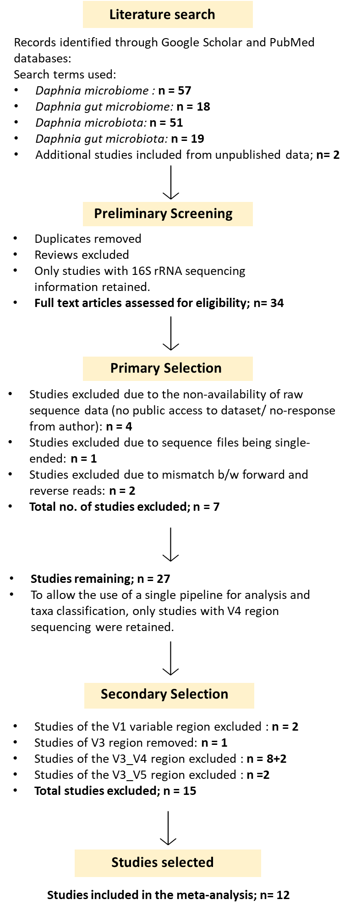
Figure S1: Schematic diagram of the workflow of the literature search and screening criteria for the selection of Daphnia microbiome studies for our analysis on core microbiome (adaptation of the PRISMA diagram, based on Moher et al. [34]). This analysis resulted in the selection of 12 studies that included a total of 656 samples originating from five countries, involving the gut as well as whole-body microbiomes of host animals directly collected from their source habitat as well as cultured in the laboratory. All studies involved the same host species, D. magna.
Assessing methodological contributions to country level clustering
To further examine whether methodological differences among studies could contribute to the observed clustering by country, an additional PERMANOVA was performed, where both country and study and their interaction effects were tested. Both variables significantly explained variation in microbiome composition, suggesting that part of the clustering by country may reflect study specific methodological variation, such as the type of DNA extraction kits used.

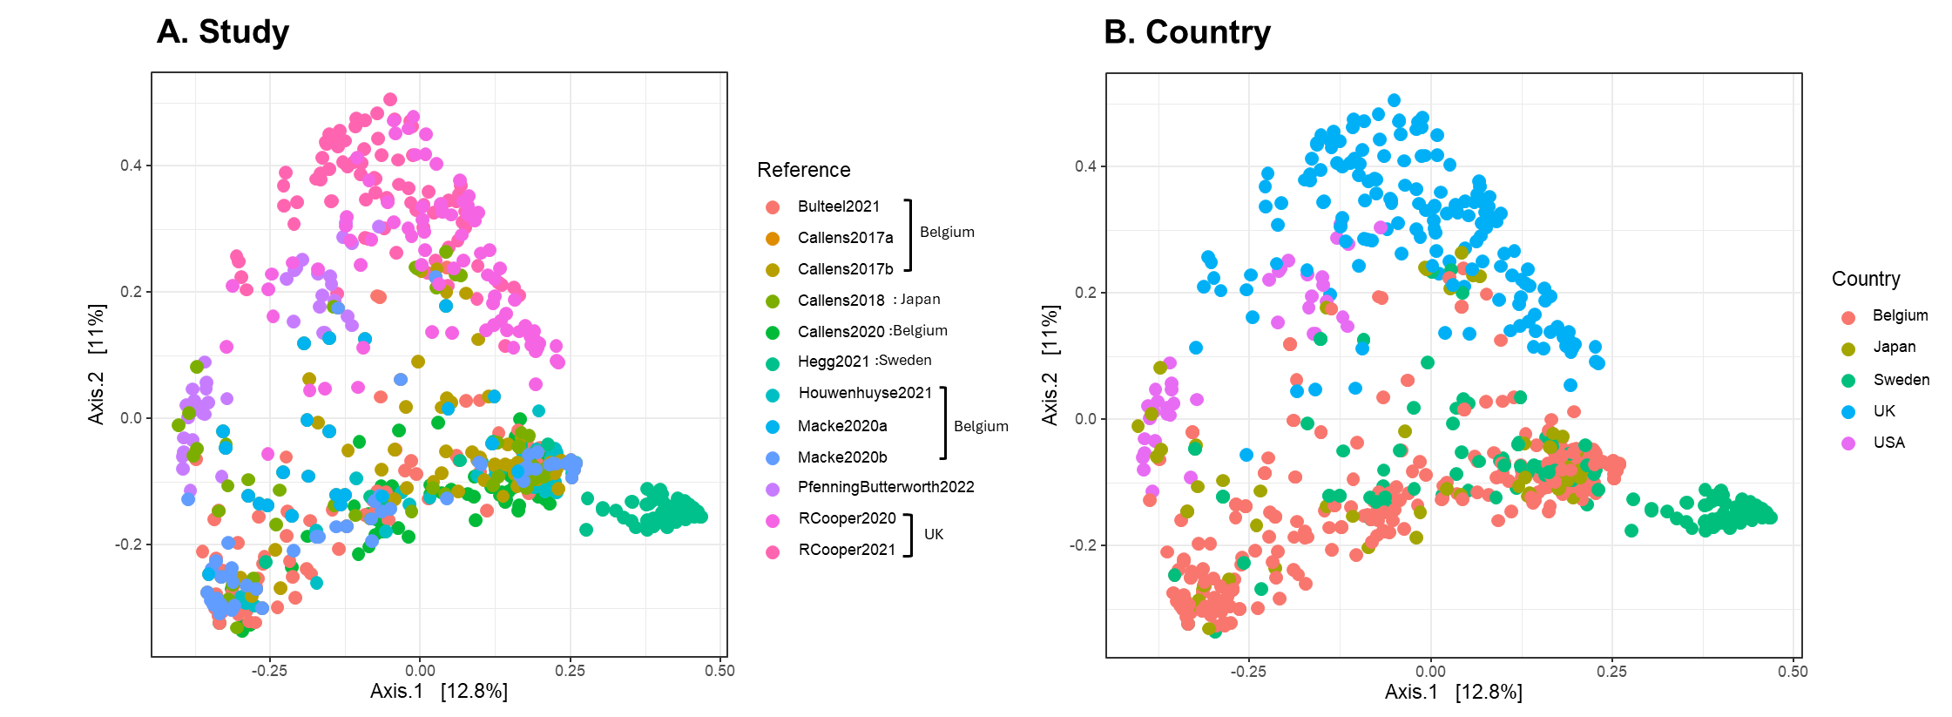
Figure S2: Multidimensional scaling (MDS) of the microbiome data of all samples based on Bray Curtis dissimilarity index illustrating differences in microbial communities between the variables A) Study and B) Country. Distances between points represent dissimilarities in microbial community composition, with closer points indicating more similar microbiomes.
Table S3: Results of PERMANOVA, based on Bray Curtis Beta diversity metric assessing the amount of variation in microbiome community composition that can be explained by the categorization variables- country and study.
Variable | Df | SumofSqs | R² | F | Pr(>F)
Country | 4 | 42.051 | 0.16054 | 39.3056 | 0.001
Study | 9 | 43.206 | 0.16495 | 17.9491 | 0.001
Country: Study | 3 | 1.221 | 0.00466 | 1.5219 | 0.005
Residual | 656 | 175.453 | 0.66985

- Core microbiome in the combined dataset: all gut samples of laboratory and field origin
A total of 423 Daphnia gut microbiomes comprising both laboratory-cultured and field-grown animals were analyzed. This dataset comprised a total of 14,743,383 read counts representing 116,500 OTUs belonging to 957 genera and 29 phyla. From a higher-level analysis conducted at the “phylum” and “order” levels, four phyla were detected in 90% of these samples: Proteobacteria, Bacteroidetes, Actinobacteria and Firmicutes. At the order level, these were Burkholderiales, Chitinophagales, Flavobacteriales, Micrococcales, Rhizobiales and Bacillales. The same groups also met the double criterion of 10⁻⁴ relative abundances and 90% prevalence. The more stringent thresholds of 10⁻³ and 90% prevalence were met by the phyla Proteobacteria, Bacteroidetes and Actinobacteria and the orders Burkholderiales, Rhizobiales, and Micrococcales. Only the phylum Proteobacteria and order Burkholderiales met the 10⁻² relative abundance threshold at 90% prevalence. No taxa were detected on the basis of the relative abundance criteria alone in 99% of the samples.
At the OTU level, no taxa were detected at a 99% prevalence. Limnohabitans planktonicus (OTU1) was detected in the gut samples and was by far the most prevalent group in the digestive tract of Daphnia magna (90% prevalence). Other prevalent bacterial groups, identified at 80% prevalence, included Ideonella paludis and Variovorax sp. (OTU4) (both belonging to the family Comamonadaceae), Staphylococcus sp. (OTU41), unclassified Microbacteriaceae (OTU34) and Escherichia/Shigella sp. (OTU13). The results from the combined prevalence and relative abundance-based thresholds were quite aligned with the prevalence-defined thresholds. Only one OTU, Limnohabitans planktonicus (OTU 1), met the relative abundance threshold of 10⁻³ in 90% of the samples. Other members identified at 50% prevalence for a detection threshold of 10⁻⁴ included Formosimonas sp., Ideonella paludis, Variovorax sp., Pseudomonas sp., Escherichia/Shigella sp., Shinella sp., Emticicia sp., Streptococcus sp., Staphylococcus sp. and unclassified Chitinophagaceae, Rhodobacteriaceae and Comamonadaceae. At a detection threshold of 10⁻⁻³, Formosimonas sp., Variovorax sp., Ideonella paludis, Escherichia/Shigella sp. and unclassified Chitinophagaceae were detected in 50% of the samples. For an assigned threshold of 10⁻², Limnohabitans planktonicus was identified only at 50% prevalence.

- Microbial community composition
To gain an overview of the microbial composition at the different levels of categorization, namely based on countries, sample type and origin, stacked barplots were constructed using the packages microbiome, phyloseq and MicroViz in R. Taxonomic aggregation was carried out at the “Phylum” level to ease visualization and summarization of the top 5 phyla in the community. The top 5 phyla were selected based on their total count abundance in the dataset. To effectively ensure visualization of within-group compositional variation, individual samples are presented without averaging, allowing all samples in each group to be displayed. Additionally, samples were sorted by similarity based on the Bray Curtis distance measure.
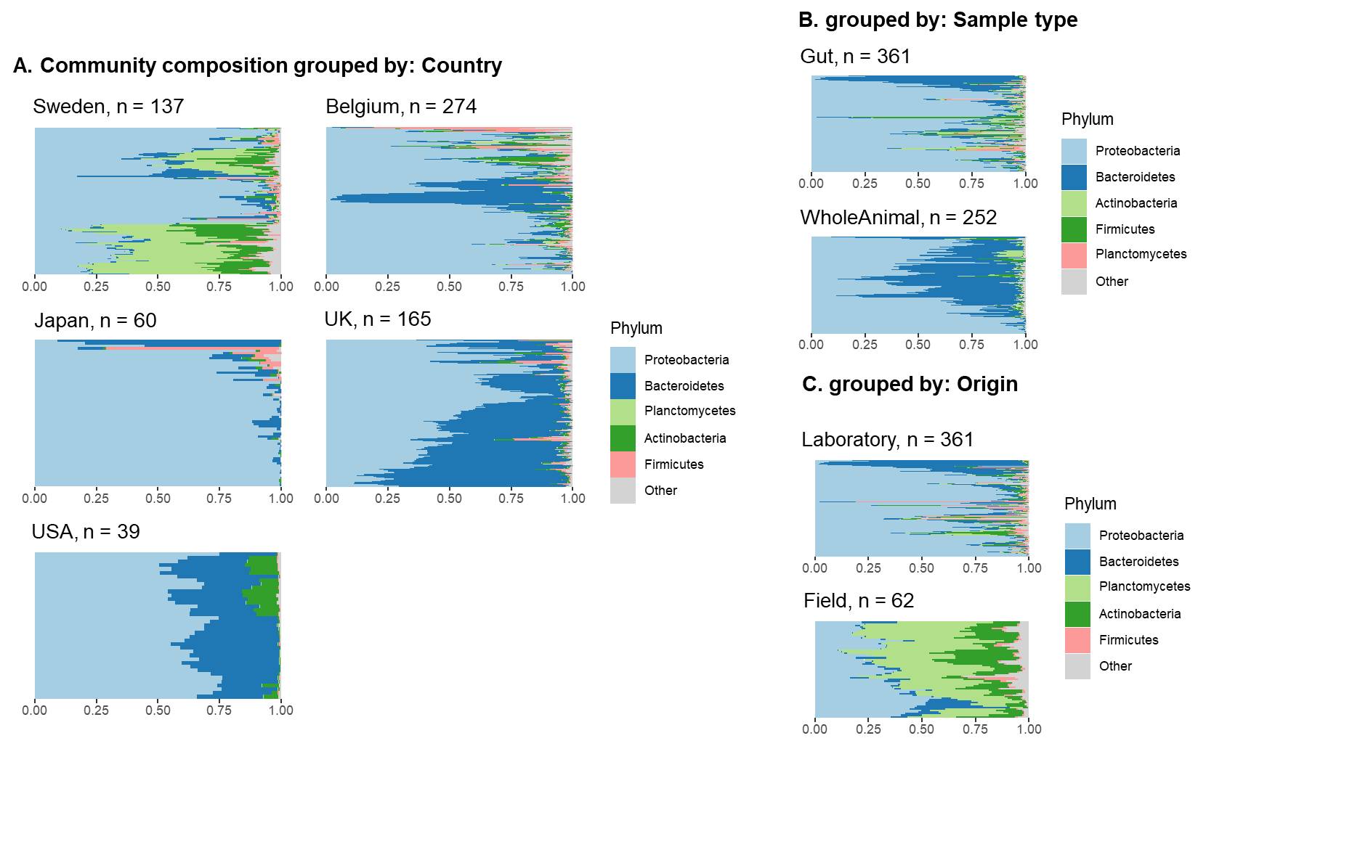
Figure S3: Stacked bar plots representing within-group variation in microbiome composition at the “Phylum” level for the following categorization. A) grouped by Country B) Sample type i.e., gut microbiome and whole microbiome (of laboratory reared animals only) C) Origin i.e., laboratory cultured or field collected samples (for gut samples only).

- Comparison of microbiome composition of laboratory and field samples originating from Lake Bysjön (Sweden)
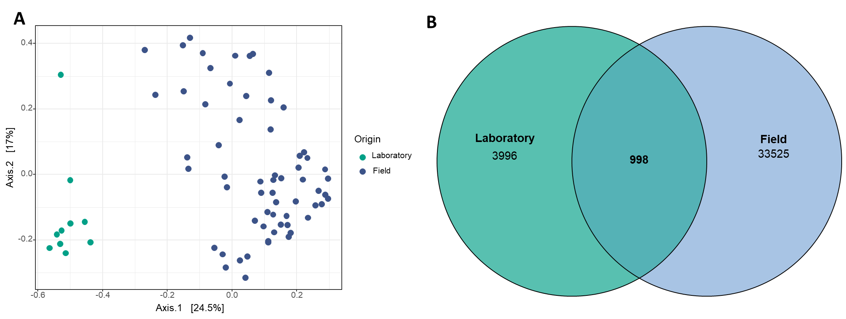
Figure S4: Comparison of laboratory-cultured samples with that of field-grown samples of the Sweden dataset (A) MDS plot highlighting the microbiome community composition of laboratory-cultured clones versus field-grown clones all derived from the same lake (Lake Bysjön, Sweden) (B) Venn diagram representing shared membership between the two sources of origin. From a total of 39,810 OTUs, there occurred an overlap of 998 OTUs exhibiting a 2.5% shared membership between these environments.

References
1. Turnbaugh PJ, Ley RE, Hamady M, Fraser-Liggett CM, Knight R, Gordon JI. The Human Microbiome Project. Nature. 2007;449:804–10.
2. Hamady M, Knight R. Microbial community profiling for human microbiome projects: Tools, techniques, and challenges. Genome Res. 2009;19:1141–52.
3. Risely A. Applying the core microbiome to understand host–microbe systems. J Anim Ecol. 2020;89:1549–58.
4. Macke E, Callens M, De Meester L, Decaestecker E. Host-genotype dependent gut microbiota drives zooplankton tolerance to toxic cyanobacteria. Nat Commun. 2017;8:1608.
5. Callens M, Watanabe H, Kato Y, Miura J, Decaestecker E. Microbiota inoculum composition affects holobiont assembly and host growth in Daphnia. Microbiome. 2018;6:56.
6. Macke E, Callens M, Massol F, Vanoverberghe I, De Meester L, Decaestecker E. Diet and Genotype of an Aquatic Invertebrate Affect the Composition of Free-Living Microbial Communities. Front Microbiol. 2020; 11:380
7. Callens M, De Meester L, Muylaert K, Mukherjee S, Decaestecker E. The bacterioplankton community composition and a host genotype dependent occurrence of taxa shape the Daphnia magna gut bacterial community. FEMS Microbiol Ecol. 2020;96:fiaa128.
8. Cooper RO, Vavra JM, Cressler CE. Targeted Manipulation of Abundant and Rare Taxa in the Daphnia magna Microbiota with Antibiotics Impacts Host Fitness Differentially. mSystems. 2021;6:10.1128/msystems.00916-20.
9. Houwenhuyse S, Stoks R, Mukherjee S, Decaestecker E. Locally adapted gut microbiomes mediate host stress tolerance. ISME J. 2021;15:2401–14.
10. Hegg A, Radersma R, Uller T. A field experiment reveals seasonal variation in the Daphnia gut microbiome. Oikos. 2021;130:2191–201.
11. Cooper RO, Tjards S, Rischling J, Nguyen DT, Cressler CE. Multiple generations of antibiotic exposure and isolation influence host fitness and the microbiome in a model zooplankton species. FEMS Microbiol Ecol. 2022; 10: p.fiac082
12. Bulteel L, Houwenhuyse S, Declerck SAJ, Decaestecker E. The Role of Microbiome and Genotype in Daphnia magna upon Parasite Re-Exposure. Genes. 2021;12:70.
13. Pfenning-Butterworth A, Cooper RO, Cressler CE. Daily feeding rhythm linked to microbiome composition in two zooplankton species. PLOS ONE. 2022;17:e0263538.
14. Gorokhova E, Rivetti C, Furuhagen S, Edlund A, Ek K, Breitholtz M. Bacteria-Mediated Effects of Antibiotics on Daphnia Nutrition. Environ Sci Technol. 2015;49:5779–87.
15. Callens M, Macke E, Muylaert K, Bossier P, Lievens B, Waud M, et al. Food availability affects the strength of mutualistic host–microbiota interactions in Daphnia magna. ISME J.2016; 10:911-20.
16. Mushegian AA, Walser J-C, Sullam KE, Ebert D. The microbiota of diapause: How host–microbe associations are formed after dormancy in an aquatic crustacean. J Anim Ecol. 2018;87:400–13.
17. Sullam KE, Pichon S, Schaer TMM, Ebert D. The Combined Effect of Temperature and Host Clonal Line on the Microbiota of a Planktonic Crustacean. Microb Ecol. 2018;76:506–17.
18. Preiswerk D, Walser J-C, Ebert D. Temporal dynamics of microbiota before and after host death. ISME J.
19. Sison-Mangus MP, Metzger CMJA, Ebert D. Host genotype-specific microbiota do not influence the susceptibility of D. magna to a bacterial pathogen. Sci Rep. 2018;8:9407.
20. Mushegian AA, Arbore R, Walser J-C, Ebert D. Environmental Sources of Bacteria and Genetic Variation in Behavior Influence Host-Associated Microbiota. Appl Environ Microbiol. 2019;85:e01547-18.
21. Fong JC, De Guzman BE, Lamborg CH, Sison-Mangus MP. The Mercury-Tolerant Microbiota of the Zooplankton Daphnia Aids in Host Survival and Maintains Fecundity under Mercury Stress. Environ Sci Technol. 2019;53:14688–99.
22. Frankel-Bricker J, Song MJ, Benner MJ, Schaack S. Variation in the Microbiota Associated with Daphnia magna Across Genotypes, Populations, and Temperature. Microb Ecol. 2020;79:731–42.
23. Motiei A, Brindefalk B, Ogonowski M, El-Shehawy R, Pastuszek P, Ek K, et al. Disparate effects of antibiotic-induced microbiome change and enhanced fitness in Daphnia magna. PLoS One. 2020;15:e0214833.
24. Sadeq SA, Mills RIL, Beckerman AP. The microbiome mediates the interaction between predation and heavy metals. Science of The Total Environment. 2021;775:145144.
25. Suppa A, Kvist J, Li X, Dhandapani V, Almulla H, Tian AY, et al. Roundup causes embryonic development failure and alters metabolic pathways and gut microbiota functionality in non-target species. Microbiome. 2020;8:170.
26. Akbar S, Gu L, Sun Y, Zhou Q, Zhang L, Lyu K, et al. Changes in the life history traits of Daphnia magna are associated with the gut microbiota composition shaped by diet and antibiotics. Sci Tot Environ. 2020;705:135827.
27. Sangkuanun T, Wichienchot S, Kato Y, Watanabe H, Peerakietkhajorn S. Oligosaccharides derived from dragon fruit modulate gut microbiota, reduce oxidative stress and stimulate toll-pathway related gene expression in freshwater crustacean Daphnia magna. Fish Shellfish Immunol. 2020;103:126–34.
28. Liu Q, Akbar S, Ding Z, Zhou Q, Gu L, Sun Y, et al. Anti-predation Defense Traits of Daphnia are Associated With the Gut Microbiota Composition Shaped by Fish Kairomone [Internet]. Research Square; 2021 [cited 2025 Jan 22]. Available from: https://www.researchsquare.com/article/rs-757585/v1
29. Li Y, Xu Z, Liu H. Nutrient-imbalanced conditions shift the interplay between zooplankton and gut microbiota. BMC Genomics. 2021;22:37.
30. Akbar S, Huang J, Zhou Q, Gu L, Sun Y, Zhang L, et al. Elevated temperature and toxic Microcystis reduce Daphnia fitness and modulate gut microbiota. Environmental Pollution. 2021;271:116409.
31. Akbar S, Li X, Ding Z, Liu Q, Huang J, Zhou Q, et al. Disentangling Diet- and Medium-Associated Microbes in Shaping Daphnia Gut Microbiome. Microb Ecol. 2022;84:911–21.
32. El-Shehawy R, Luecke-Johansson S, Ribbenstedt A, Gorokhova E. Microbiota-Dependent and -Independent Production of l-Dopa in the Gut of Daphnia magna. mSystems. 2021;6:e00892-21.
33. Rajarajan A, Wolinska J, Walser J-C, Dennis SR, Spaak P. Host-Associated Bacterial Communities Vary Between Daphnia galeata Genotypes but Not by Host Genetic Distance. Microb Ecol. 2023;85:1578–89.
34. Moher D, Liberati A, Tetzlaff J, Altman DG, PRISMA Group. Preferred reporting items for systematic reviews and meta-analyses: the PRISMA statement. PLoS Med. 2009;6:e1000097.

