Supplementary Material

High nitrogen-induced changes in rhizosphere microbial community structure can modulate disease susceptibility to the rice blast

Mehwish Roy^{1†}, Gnanendra Shanmugam¹, Suvin Park¹, Hanhong Bae¹, Kihyuck Choi^{2*}, and Junhyun Jeon^{1, 3*}

¹Department of Biotechnology, Yeungnam University, Gyeongsan 38541, Gyeongbuk, Republic of Korea
²Department of Applied Bioscience, Dong-A University, Busan 49315, Republic of Korea
³Plant Immunity Research Center, Seoul National University, Seoul 08826, Republic of Korea

†Current address: Department of Applied Bioscience, Dong-A University, Busan 49315, Republic of Korea

*Correspondence to Kihyuck Choi and Junhyun Jeon
Phone) +82-51-200-7586 and +82-53-810-3030
Fax) +82-51-200-7505 and +82-53-810-4769
E-mail) hyuck1857@dau.ac.kr and jjeon@yu.ac.kr

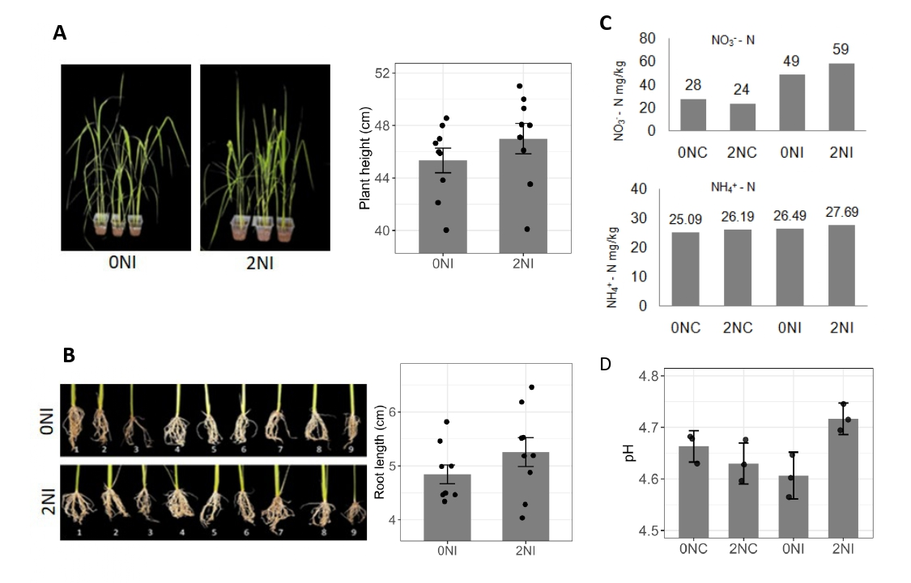
Figure S1. Phenotypic traits of rice plant including plant height (A) and root length (B) in response to nitrogen treatment upon pathogen inoculation. Bars represent the mean of 9 technical replicates (n=9) with their corresponding standard error. Comparisons were made between the samples using t-test and no significant difference was observed. C Soil nitrate-nitrogen (NO₃⁻-N) concentration in control (0NC, 2NC) and inoculated (0NI, 2NI) plants. Ammonium-nitrogen (NH₄⁺-N) concentration in control (0NC, 2NC) and inoculated (0NI, 2NI) plants. D Soil pH in control (0NC, 2NC) and inoculated (0NI, 2NI) plants.

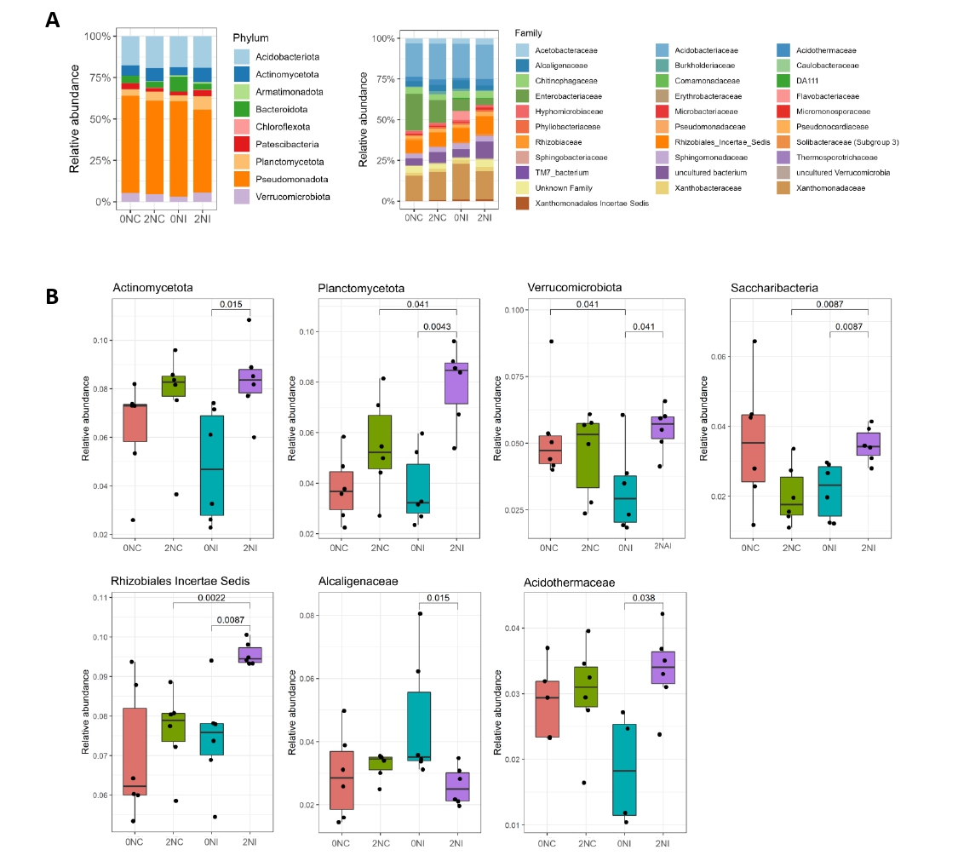
Figure S2. Relative abundance of bacterial taxa in the rice rhizosphere under nitrogen and infection treatments. A Stacked bar plots showing the relative abundance (> 0.01) of bacterial taxa at the phylum and family levels across treatments (0NC, 2NC, 0NI, 2NI). B Boxplots showing significant differences (Kruskal–Wallis test, p < 0.05) in the relative abundance of selected rhizosphere bacterial taxa at the phylum and family levels under 0N and 2N regimes in control and inoculated plants.

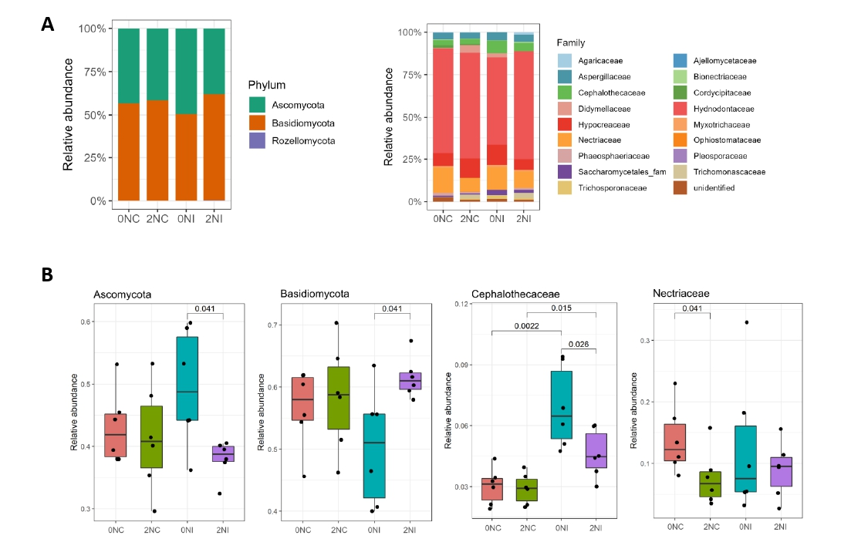
Figure S3. Relative abundance of fungal taxa in the rice rhizosphere under nitrogen and infection treatments. A Stacked bar plots showing the relative abundance (> 0.01) of fungal taxa at the phylum and family levels across treatments (0NC, 2NC, 0NI, 2NI). B Boxplots showing significant differences (Kruskal–Wallis test, p < 0.05) in the relative abundance of selected rhizosphere bacterial taxa at the phylum and family levels under 0N and 2N regimes in control and inoculated plants.

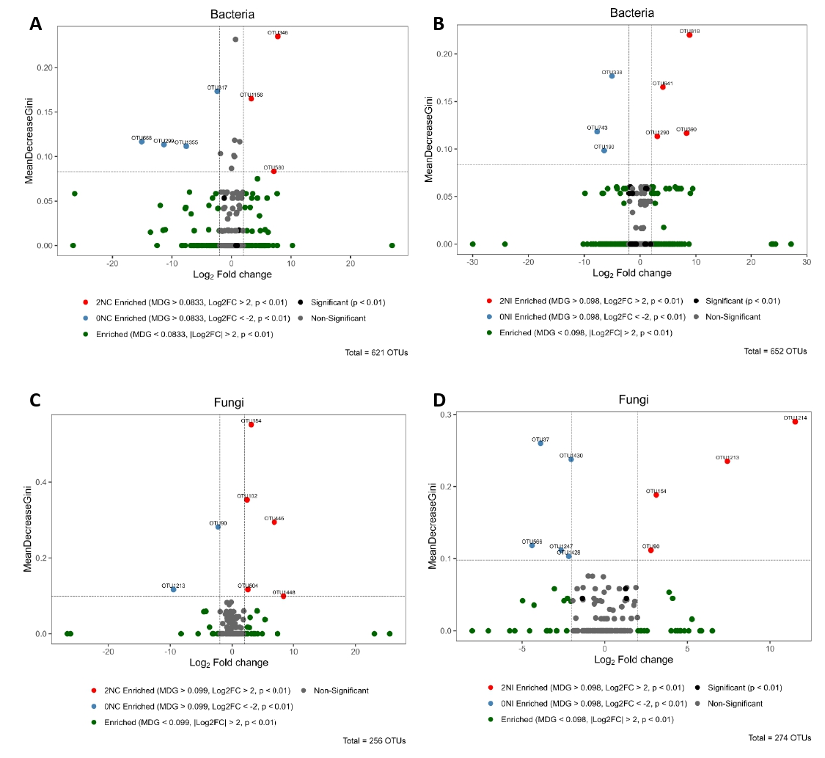
Figure S4. Identification of key bacterial and fungal OTUs associated with control and pathogen-inoculated conditions through combined analysis using DESeq2 and Random Forest classification. A Bacterial control treatment comparison (0NC vs 2NC). B bacterial pathogen-inoculated treatment comparison (0NI vs 2NI). C Fungal control treatment comparison (0NC vs 2NC). D Fungal pathogen-inoculated treatment comparison (0NI vs 2NI). Dotted lines indicate Mean Decrease Gini (MDG) threshold and Log2 fold change.

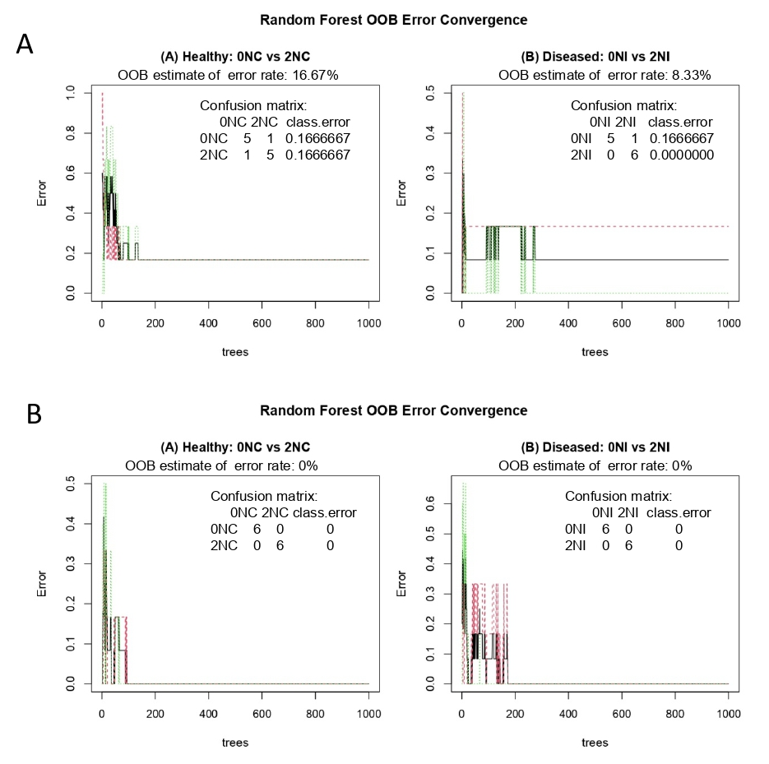
Figure S5. Random Forest model performance for bacterial and fungal communities. Out-of-bag (OOB) error convergence plots and confusion matrices for Random Forest classification distinguishing control (0NC vs 2NC) and infected (0NI vs 2NI) samples based on bacterial (A) and fungal (B) OTU profiles (ntree = 1000). The y-axis shows the OOB classification error and the x-axis shows the number of trees; the final OOB error rate and corresponding confusion matrix are indicated within each plot.

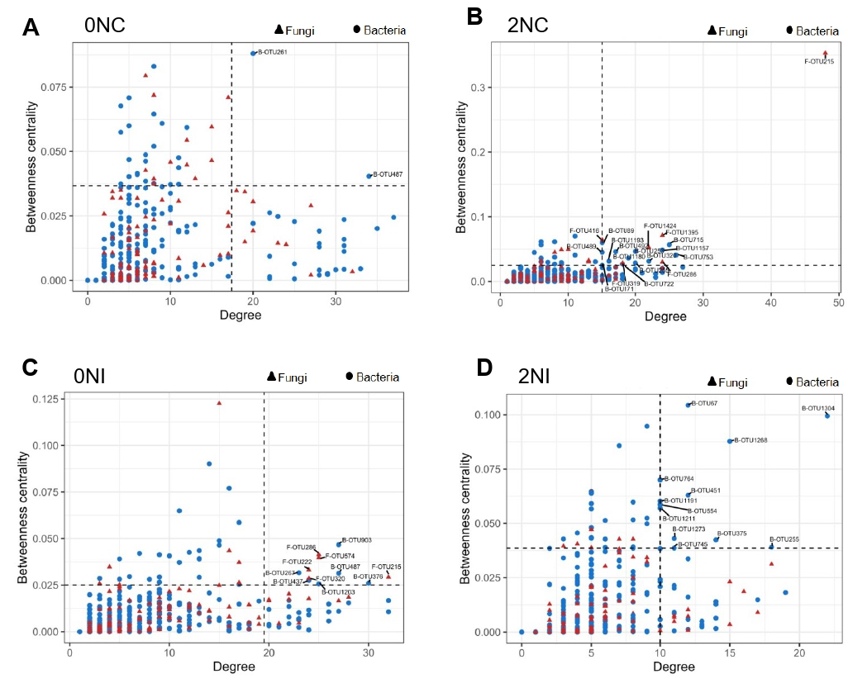
Figure S6. The bacterial and fungal hub OTUs A Hub OTUs of 0NC regime in control plants. Dashed lines indicate the threshold estimated by the values which top 10% of nodes showed (degree > 17 and betweenness centrality > 0.036) B Hub OTUs of 2NC regime in control plants. Dashed lines indicate the threshold estimated by the values which top 10% of nodes showed (degree > 15 and betweenness centrality > 0.024) C Hub OTUs of 0NI regime in inoculated plants. Dashed lines indicate the threshold estimated by the values which top 10% of nodes showed (degree > 19 and betweenness centrality > 0.025) D Hub OTUs of 2NI regime in inoculated plants. Dashed lines indicate the threshold estimated by the values which top 10% of nodes showed (degree > 10 and betweenness centrality > 0.038).

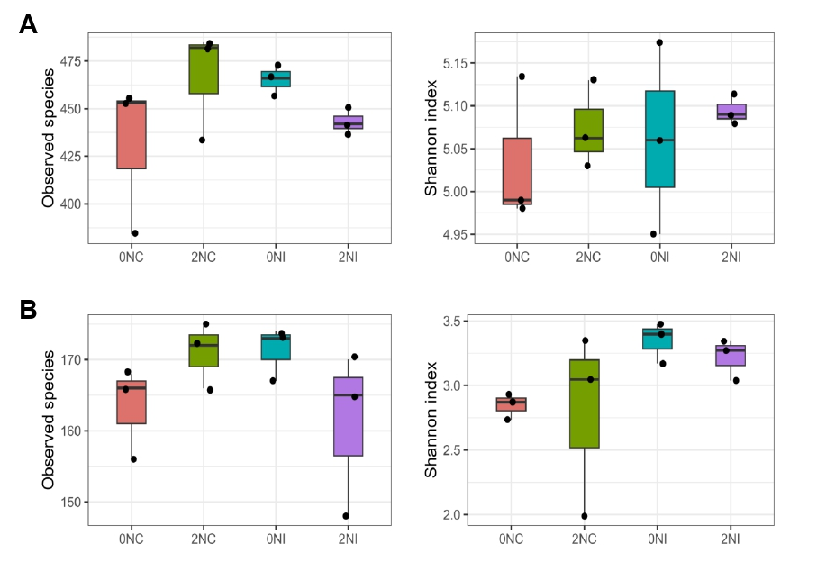
Figure S7. Boxplots illustrating the patterns of bacterial (A) and fungal (B) alpha diversity, as measured by species richness and Shannon index. The boxes represent the interquartile range (75th to 25th percentile) of the data (n = 3), with the median value depicted as a line within the box. Outliers are indicated by dots.

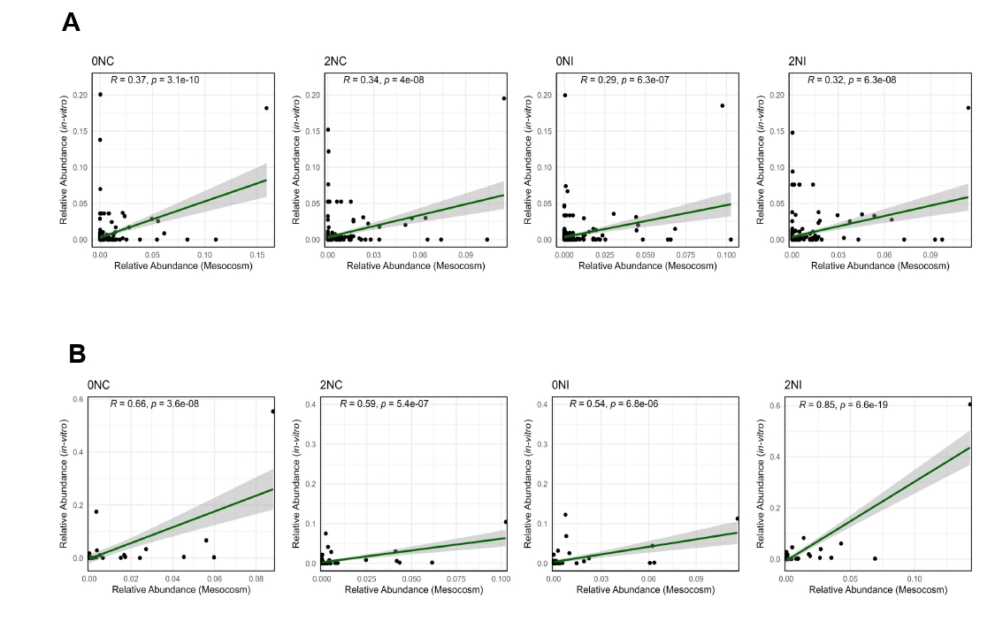
Figure S8. Correlation analysis comparing bacterial and fungal relative abundance at family level between in-vitro and mesocosm experiment under different nitrogen and pathogen treatments (0NC, 2NC, 0NI, and 2NI). A For bacteria, each data point represents relative abundance of individual families, comparing their abundance from in-vitro (y-axis) versus mesocosm (x-axis) experiment. B For fungi, each data point represents relative abundance of individual families, comparing their abundance from in-vitro (y-axis) versus mesocosm (x-axis) experiment. Pearson correlation analysis was performed to assess the relationship between the two experiments, visualized with linear regression (green line) and 95% confidence interval (gray shading).

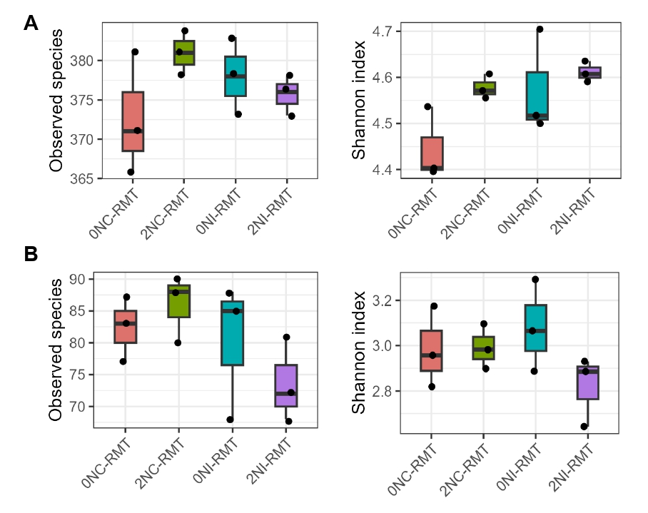
Figure S9. Boxplots illustrating the patterns of bacterial (A) and fungal (B) alpha diversity, as measured by species richness and Shannon index. The boxes represent the interquartile range (75th to 25th percentile) of the data (n = 3), with the median value depicted as a line within the box. Outliers are indicated by dots.

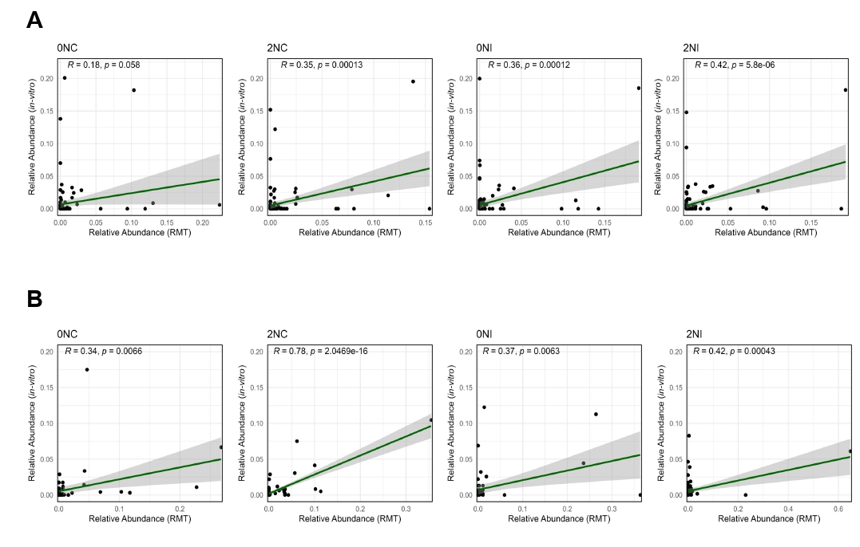
Figure S10. Correlation analysis comparing bacterial and fungal relative abundance at family level between in-vitro and rhizosphere microbiome transplant (RMT) experiment under different nitrogen and pathogen treatments (0NC, 2NC, 0NI, and 2NI). A For bacteria, each data point represents relative abundance of individual families, comparing their abundance from in-vitro (y-axis) versus RMT (x-axis) experiment. B For fungi, each data point represents relative abundance of individual families, comparing their abundance from in-vitro (y-axis) versus RMT (x-axis) experiment. Pearson correlation analysis was performed to assess the relationship between the two experiments, visualized with linear regression (green line) and 95% confidence interval (gray shading).

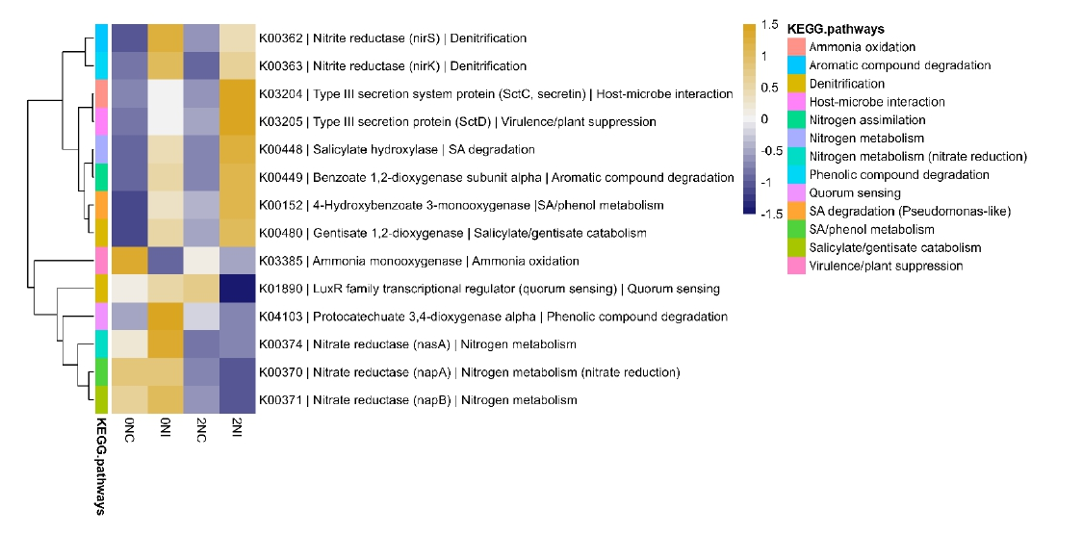
Figure S11. Heatmap showing predicted KEGG functional profiles of rhizosphere microbial communities across treatments based on Tax4Fun analysis of RMT. The heatmap displays the relative abundance (z-score normalized) of selected KEGG orthologs (KOs) across four treatment groups (0NC, 0NI, 2NC, 2NI). Color intensity represents functional enrichment (yellow: high, blue: low), and hierarchical clustering was applied for functions. KEGG pathway categories are color-coded in the sidebar.

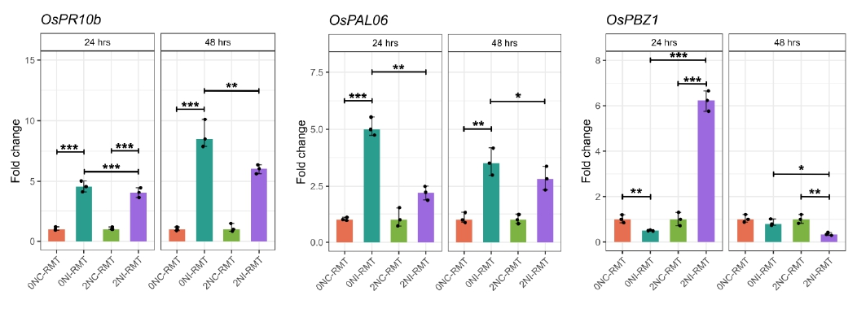
Figure S12. Induction of defense-related genes in RMT-treated rice plants in control (0NC-RMT and 2NC-RMT) and inoculated plants (0NI-RMT and 2NI-RMT) at 24- and 48- hpi. The expression values were normalized to the rice ubiquitin5 gene. Bars represent the mean of the three technical replicates with their corresponding standard error. Comparisons were made between the samples using one-way ANOVA followed by post hoc Tukey’s test. Asterisks indicate significant differences with p-values < 0.05 (*), < 0.01 (**) and < 0.001 (***).

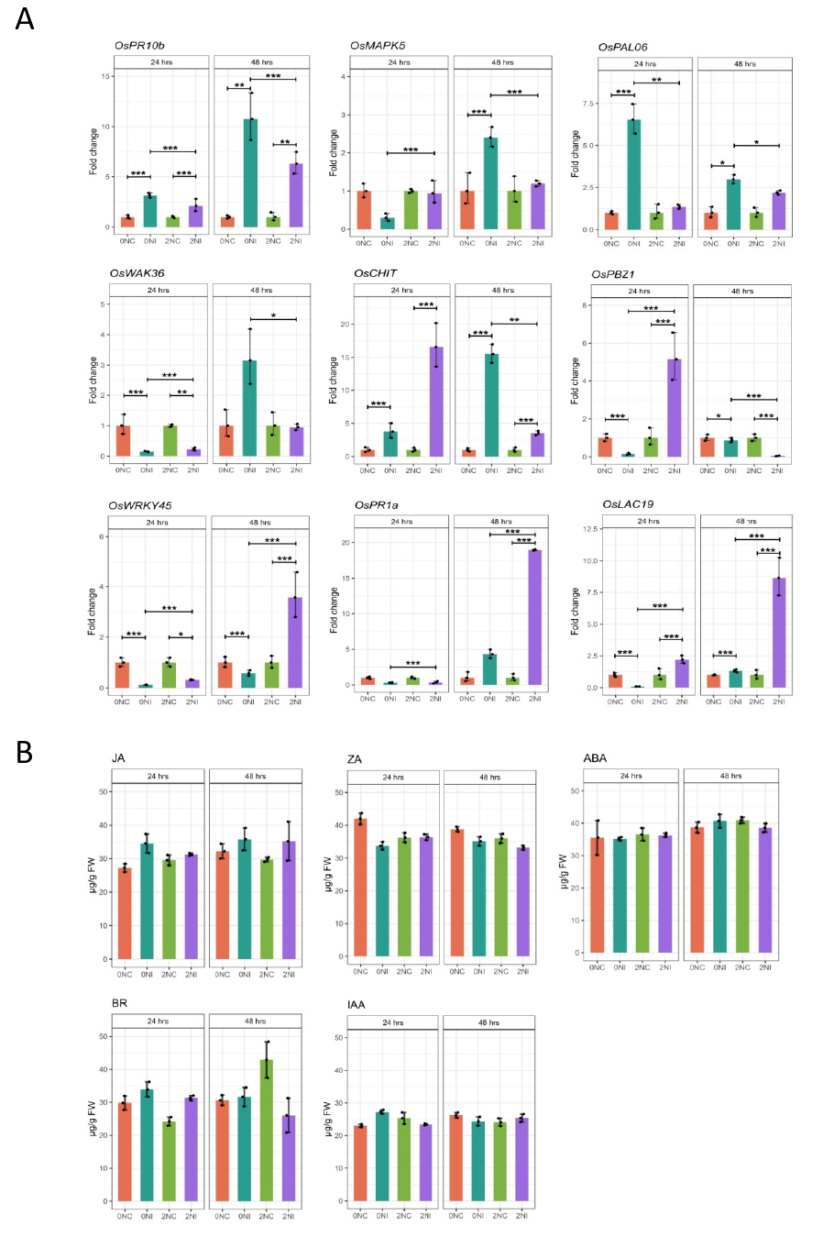
Figure S13. A Expression of defense-related genes in rice plants under control (0NC and 2NC) and inoculated (0NI and 2NI) conditions at 24 and 48 h post-inoculation (hpi). The expression values were normalized to the rice ubiquitin5 gene. Bars represent the mean of the three technical replicates (n=3) with their corresponding standard error. B Expression of plant defense and growth regulating hormones in rice plants treated with 0N and 2N nitrogen regime from control and inoculated plants at 24- and 48- hpi. Bars represent the mean of the three technical replicates with their corresponding standard error. “FW” represents fresh weight of plant samples. “JA” represents jasmonic acid, “ZA” represents zeatin, “ABA” represents abscisic acid, “BR” represents brassinosteroids and “IAA” represents indole-3-acetic acid. Comparisons were made between the samples using one-way ANOVA followed by post hoc Tukey’s test. Asterisks indicate significant differences with p-values < 0.05 (*), < 0.01 (**) and < 0.001 (***).

