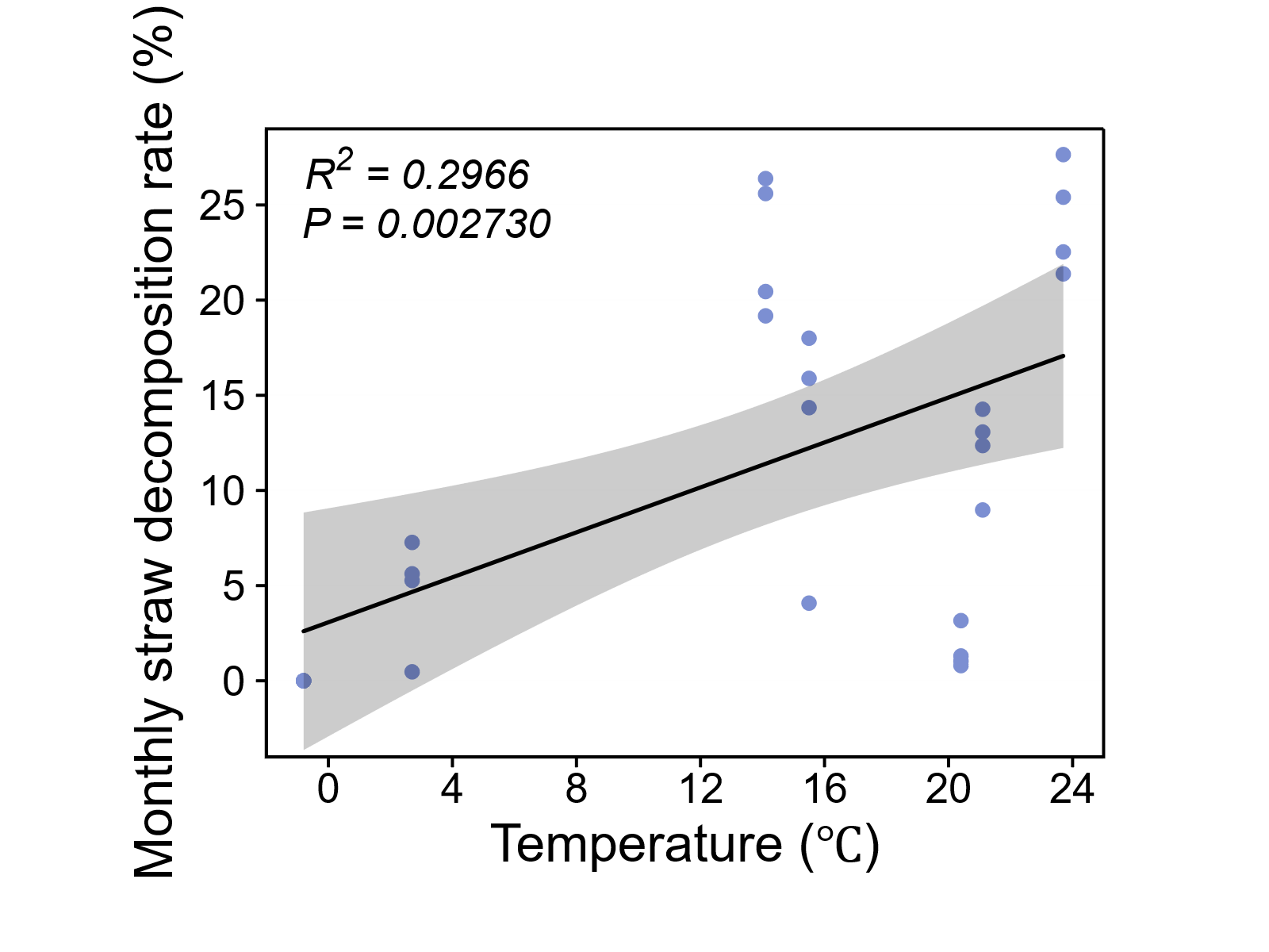
Figure S1. Linear fitting of monthly straw decomposition rate against corresponding monthly average temperature (n=4 per month).

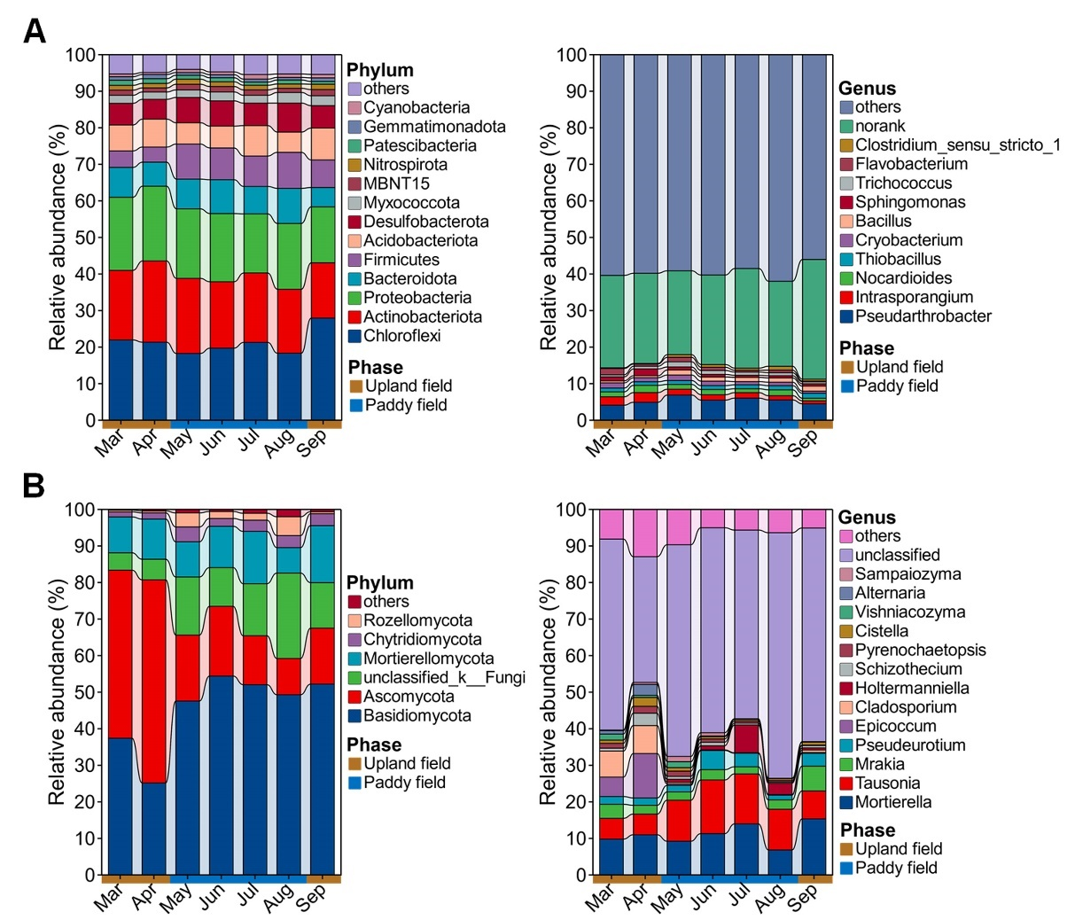
Figure S2. Composition and succession of bacteria (A) and fungi (B) at phylum and genus level in paddy soil from March to September. Phyla and genera with relative abundance less than 1% are grouped into others. In genera with relative abundance greater than 1%, norank and unclassified genera are respectively grouped into norank and unclassified. Each month comprises four biological replicates (n=4).

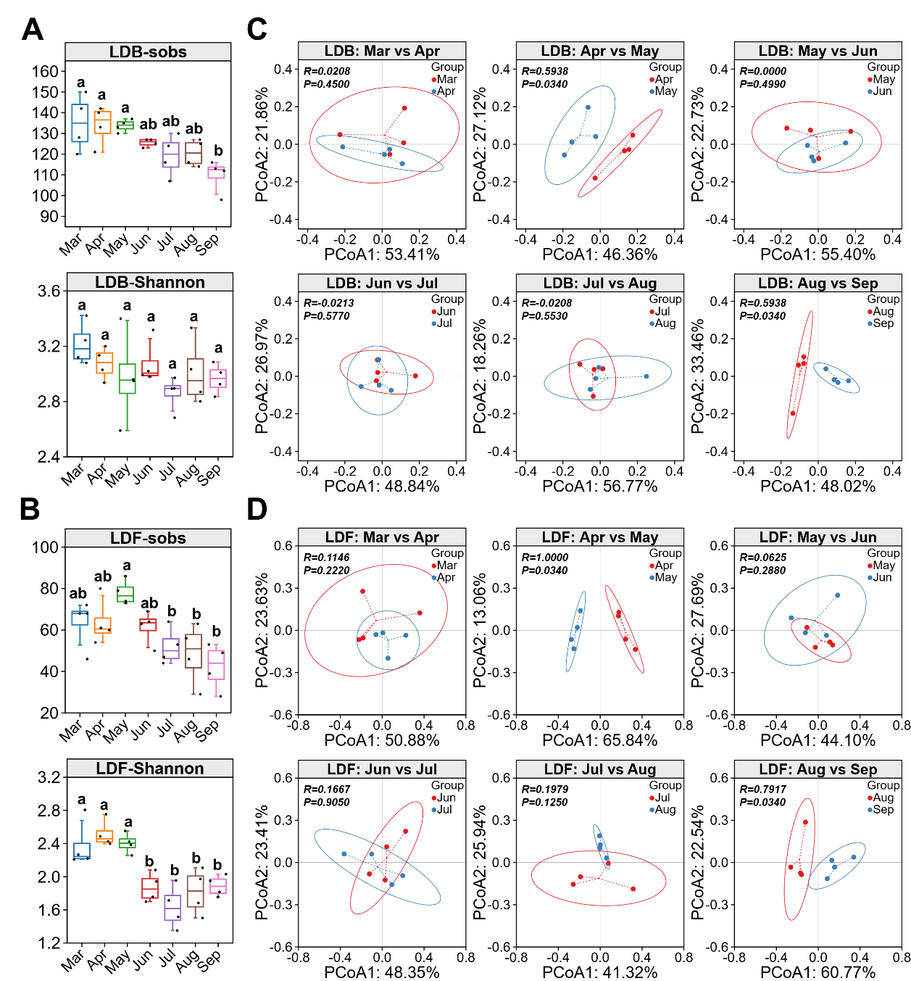
Figure S3. The comparison of lignocellulose-degrading microbial consortia diversity in paddy soil from March to September. Dynamic changes in the sobs index and Shannon index of lignocellulose-degrading bacterial (A) and fungal (B) consortia. Different lowercase letters indicate significant differences (P<0.05). Principal coordinate analysis (PCoA) of lignocellulose-degrading bacterial (C) and fungal (D) consortia between each month and the following month. Each month comprises four biological replicates (n=4).

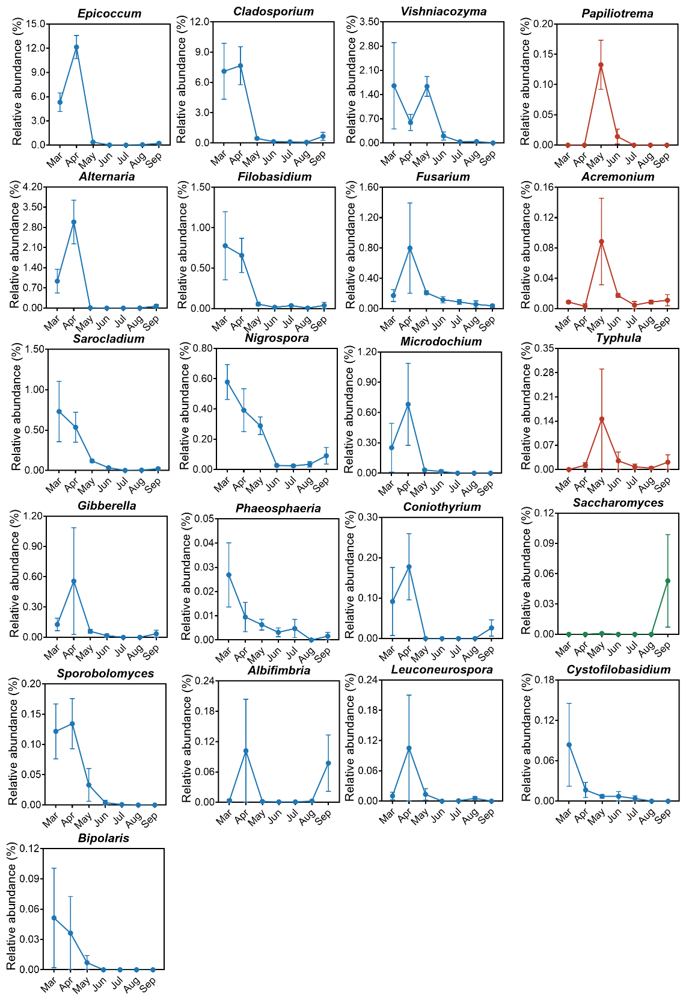
Figure S4. The changes in relative abundance of each genus in the lignocellulose-degrading fungal consortia from March to September. The blue line indicates that the genus has a higher relative abundance in March and April, the green line indicates a higher relative abundance in September, and the red line indicates a higher relative abundance during the paddy field phase (May to August). Data are presented as mean±standard deviation (n=4).

Table S1 Lignocellulolytic enzyme activities of bacterial isolates obtained in this study (n=3).
Genus | Strain | EI (mean±SD)
Genus | Strain | Cellulase | Hemicellulase | Laccase | Peroxidase
Pseudarthrobacter | P. psychrotolerans CKON-4 | 0 | 1.36±0.16 | 3.46±0.22 | 3.34±0.22
Bacillus | B. amyloliquefaciens ZJ10-1 | 4.48±0.46 | 4.34±0.34 | 0 | 3.35±0.13
Bacillus | B. amyloliquefaciens Kc-5 | 3.62±0.24 | 3.18±0.17 | 0 | 2.30±0.17
Bacillus | B. australimaris HT4.5 | 3.51±0.31 | 0±0 | 1.22±0.12 | 2.27±0.12
Bacillus | B. licheniformis B371 | 3.52±0.21 | 2.61±0.27 | 0 | 2.36±0.31
Bacillus | B. licheniformis ZJ10-2 | 4.49±0.07 | 4.28±0.17 | 0 | 1.74±0.23
Bacillus | B. megaterium CKOB-6 | 0 | 1.52±0.06 | 2.64±0.21 | 1.68±0.10
Bacillus | B. paralicheniformis B373 | 2.32±0.25 | 3.27±0.12 | 0 | 3.32±0.22
Bacillus | B. pumilus HT2.5 | 4.11±0.13 | 0±0 | 0 | 0
Bacillus | B. subtilis subsp. subtilis ZJ10-3 | 3.28±0.07 | 3.37±0.4 | 0 | 3.23±0.27
Lysobacter | L. enzymogenes Li026 | 4.59±0.15 | 0 | 0 | 2.89±0.05
Pseudomonas | P. fluorescens Z3 | 4.38±0.19 | 1.78±0.11 | 0 | 0
 | P. mandelii Z3.1 | 0 | 0 | 0 | 3.18±0.20
 | P. tolaasii Z3.2 | 0 | 1.8±0.17 | 0 | 0
Sphingomonas | Sphingomonas sp. HT39 | 0 | 0 | 0 | 5.05±0.25

Table S2 Lignocellulolytic enzyme activities of fungal isolates obtained in this study (n=3).
Genus | Strain | EI (mean±SD)
Genus | Strain | Cellulase | Hemicellulase | Laccase | Peroxidase
Acremonium | A. tubakii HT16 | 2.58±0.50 | 0 | 1.48±0.20 | 0
Aspergillus | A. niger CTAn-1 | 4.67±0.42 | 0 | 0 | 0
 | A. niger RL2-2 | 5.02±0.25 | 3.71±0.20 | 1.23±0.14 | 0
Cladosporium | Cladosporium sp. F28-2 | 0 | 0 | 2.38±0.24 | 1.42±0.17
Fusarium | F. verticillioides HT6 | 4.62±0.45 | 3.22±0.18 | 0 | 3.43±0.23
Paracremonium | P. binnewijzendii HT5 | 1.34±0.22 | 0 | 0 | 0
Penicillium | P. oxalicum F37-6 | 0 | 3.69±0.23 | 3.48±0.64 | 0
 | P. oxalicum HT3 | 4.83±0.43 | 3.33±0.26 | 1.46±0.37 | 0
Talaromyces | T. assiutensis HT10 | 2.67±0.84 | 3.62±0.40 | 1.37±0.20 | 0
 | T. trachyspermus HT12 | 3.61±0.72 | 0 | 2.15±0.38 | 0
 | Talaromyces sp. HT18 | 4.67±0.50 | 0 | 3.37±0.25 | 0
 | Talaromyces sp. HT18-2 | 3.81±0.91 | 0 | 0 | 0
 | Talaromyces sp. HT5-2 | 0 | 3.47±0.42 | 1.48±0.20 | 0
Trichoderma | T. citrinoviride TC422 | 2.88±0.64 | 0 | 2.56±0.24 | 0
 | T. harzianum Li042 | 2.30±0.27 | 0 | 0 | 0
 | T. harzianum Li043 | 4.84±0.57 | 3.44±0.30 | 1.18±0.07 | 2.47±0.22
 | T. harzianum Li044 | 4.55±0.86 | 0 | 0 | 2.53±0.17
 | T. harzianum HT14 | 5.24±0.12 | 0 | 4.00±0.23 | 0
 | T. harzianum HT17-2 | 4.97±0.77 | 3.30±0.23 | 0 | 0
 | T. koningiopsis TK8985 | 4.13±0.89 | 3.38±0.19 | 0 | 0
 | T. longibrachiatum GDTL01 | 5.02±0.73 | 0 | 1.34±0.21 | 0
 | T. longibrachiatum Li097 | 4.67±0.50 | 2.34±0.21 | 1.53±0.17 | 0
 | T. longibrachiatum RC4 | 3.56±0.30 | 0 | 3.33±0.27 | 0
 | T. reesei Li046 | 4.89±0.47 | 0 | 1.32±0.27 | 3.43±0.29
 | T. viride Li045 | 4.67±0.21 | 0 | 3.01±0.27 | 3.06±0.51
 | T. viride IMTV002 | 4.54±0.27 | 2.36±0.25 | 2.20±0.43 | 3.69±0.41
 | T. yunnanense Ty0X5 | 5.04±0.38 | 3.67±0.16 | 0 | 3.76±0.27
 | T. yunnanense Ty0X6 | 2.49±0.20 | 3.42±0.40 | 0 | 0
 | Trichoderma sp. ZJ10-4 | 5.12±0.30 | 3.27±0.18 | 0 | 0

