Manuscript title: Contribution of researchers in Arab countries to research publications on Neglected Tropical Diseases (2001 – 2020)
Appendix 1: List of Arab countries (arranged alphabetically) and their population size [1]
Country | Population (*10³)
Comoros | 907.419
Djibouti | 1016.097
Bahrain | 1783.983
Qatar | 2979.915
Kuwait | 4380.326
Mauritania | 4901.981
Oman | 5323.993
Palestine | 5345.541
Lebanon | 6684.849
Libya | 7040.745
United Arab Emirates | 10081.785
Jordan | 10300.869
Tunisia | 12046.656
Somalia | 16841.795
Syria | 19364.809
Yemen | 31154.867
Saudi Arabia | 35844.909
Morocco | 37772.756
Iraq | 42164.965
Algeria | 45350.148
Sudan | 45992.020
Egypt | 106156.692

Geographical location of Arab countries (green color) in the world map

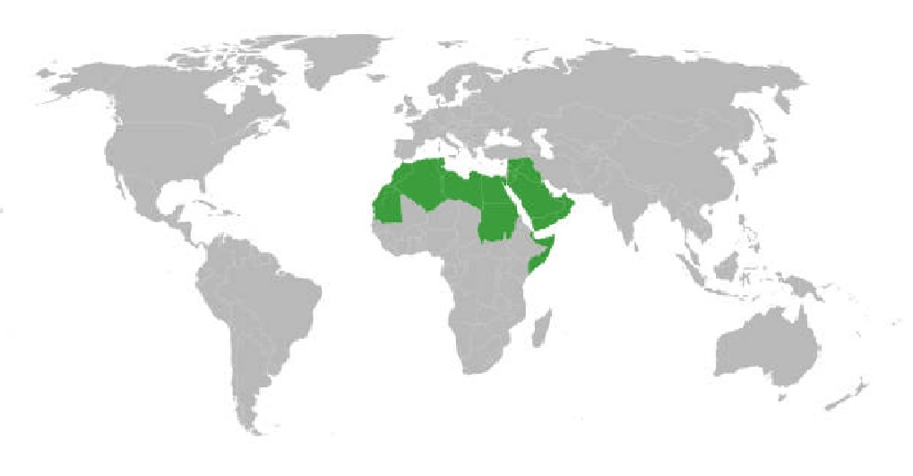

1. World Population Review: Arab countries Available from: https://worldpopulationreview.com/country-rankings/arab-countries. Accessed April 21, 2022.

