1. People living in Canada come from different cultural and racial backgrounds. Please read all the categories and select all that apply.
Aboriginal decent (e.g., North American Indian, Métis or Inuit (Eskimo))
White
Chinese
South Asian (e.g., East Indian, Pakistani, Sri Lankan, etc…)
Black (e.g., African, Haitian, Jamaican, Somali, etc…)
Filipino
Latin American
South East Asian (e.g., Vietnamese, Cambodian, Malaysian, Laotian, etc…)
Arab
West Asian (e.g., Iranian, Lebanese, Moroccan, Afghan, etc…)
Korean
Japanese
Other
If you selected other above, please specify. Otherwise skip to the next question._________________

2. What is the highest degree, certificate, or diploma you have obtained?
High school or less than high school education
Trade certificate or diploma from a vocational school or apprenticeship training
Non-university certificate or diploma from a community college, CEGEP, school of nursing,
University certificate below bachelor’s level
Bachelor’s degree
University degree or certificate above bachelor’s degree

3. What is the highest degree, certificate, or diploma your spouse or common-law partner has obtained?
Not applicable since I do not have a spouse or partner
High school or less than high school education
Trade certificate or diploma from a vocational school or apprenticeship training
Non-university certificate or diploma from a community college, CEGEP, school of nursing,
University certificate below a bachelor’s level
Bachelor’s degree
University degree or certificate above a bachelor’s degree

4. What is your marital status?
Single
Married
Living common-law
Widowed
Separated
Divorced

5. Would you consider your family to be a single or dual income family?
single income family
dual income family – both working full time
dual income family – only one of us is working full time
dual income family – both working part time
Not working at the present time

6 What is your best estimate of the TOTAL income, before taxes and deductions, of all household members from all sources in the past 12 months?
$0 – $20,000
$20,001 – $30,000
$30,001 – $40,000
$40,001 – $50,000
$50,001 – $60,000
$60,001 – $70,000
$70,001 – $80,000
$80,001 – $90,000
$90,001 – $100,000
$100,001 – $120,000
$120,001 – $140,000
$140,001 – $160,000
$160,001 – or above

7.The following questions ask about the number of people in your household. Please read each question carefully. If the question does not apply to you, select 0.
How many adults 18 years of age or older live in your household?
1 (yourself only)
2
3
4
5
6 or more

How many children between 12 and 17 years of age live in your household?
0
1
2
3
4
5
6 or more

How many children between 5 and 11 years of age live in your household?
0
1
2
3
4
5
6 or more

How many children 4 years of age or younger live in your household?
0
1
2
3
4
5
6 or more

The next questions will ask about food availability in your home.

1. Did you have bacon or sausage in your home in the PAST WEEK?
No
Yes If “yes” What type of bacon or sausage did you have in your home in the PAST WEEK?
Regular
Reduced fat
2. Did you have cookies, pies, cakes, or snack cakes in your home in the PAST WEEK?
No
Yes If “yes” What type of cookies, pies, cakes, or snack cakes did you have in your home in the PAST WEEK?
Regular
Low fat
- Did you have chips (e.g., potato, corn, tortilla or Doritos chips) in your home in the PAST WEEK?
No
Yes If “yes” what type of chips (e.g., potato, corn, tortilla or Doritos chips) did you have in your home in the PAST WEEK?
Regular
Reduced fat or baked
- Did you have ice cream or frozen yogurt in your home in the PAST WEEK?
No
Yes If “yes” What type of ice cream/frozen yogurt did you have in your home in the PAST WEEK?
Regular
Low fat

5. Did you have granola bars in your home in the PAST WEEK?
No
Yes If “yes” What type of granola bars did you have in your home in the PAST WEEK?
Regular
Low fat or fat free
6. Did you have TV dinners or frozen entrees in your home in the PAST WEEK?
No
Yes If “yes” What type of TV dinners or frozen entrees did you have in your home in the PAST WEEK? Regular
Reduced fat
7. Did you have hot dogs in your home in the PAST WEEK?
No
Yes If “yes” What type of hot dogs did you have in your home in the PAST WEEK?
Regular
Reduced fat
8. Did you have sodas or soft drinks in your home in the PAST WEEK?
No
Yes If “yes” What type sodas or soft drinks did you have in your home in the PAST WEEK?
Regular
Reduced calories or sugar free

Please indicate the extent to which you never, sometimes, often, or always do the following:
 | Never | Sometimes | Often | Always
- I want to hear about my child’s problems
- I make sure my child tells me where he/she is going
- I usually know where my child is after school
- I tell my child when he/she does a good job on things
- I am interested in my child’s school work
- I check to see if my child does his/her homework
- I often ask my child what he/she does with friends
- I make my child feel better when he/she is upset
- I tell my child that I like my child just the way he/she is
- I am usually pleased with how my child behaves
- I tell my child times when he/she must come home
- It is hard for me to say ‘no’ to my child
- I am always telling my child what to do
- I make rules without asking my child what he/she thinks
- I forget the rules I make for my child
- I can be talked into things easily

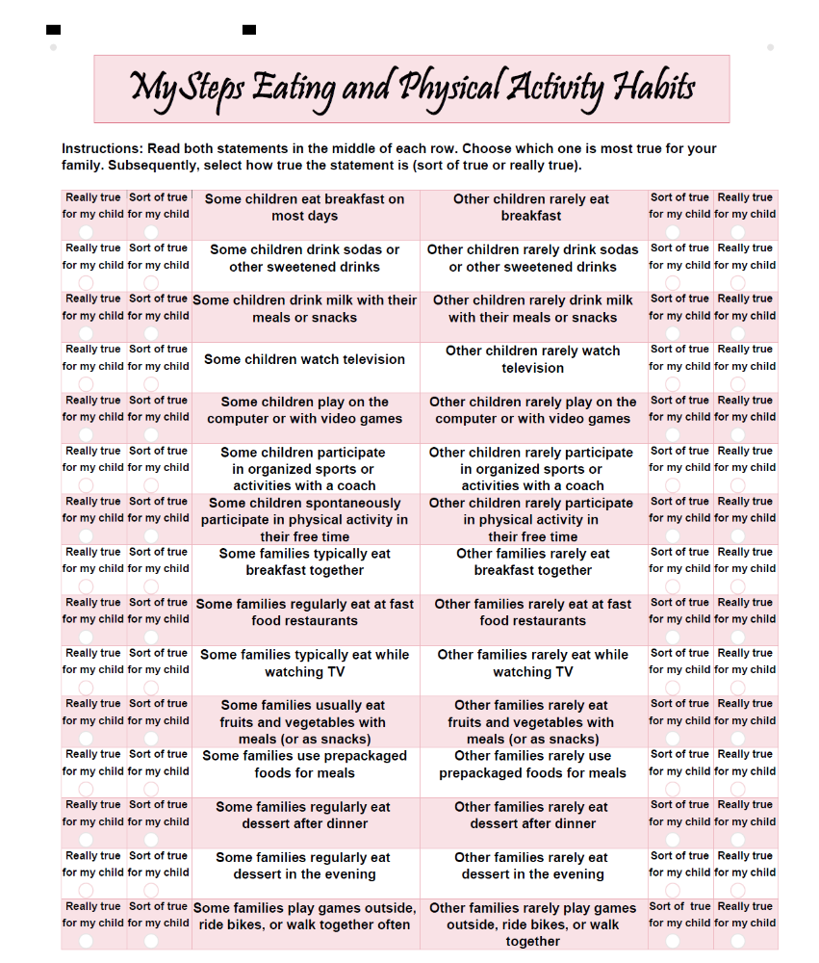

Now that we have asked about your friends, we will ask the same questions about your PARENTS.
 | Never | Sometimes | Frequently | Always
My parents eat vegetables when I am with them
My parents eat fruits when I am with them
My parents eat salad at a restaurant when I am with them
My parents eat low fat snacks when I am with them
My parents eat low fat dressings with salads when I am with them

