Online Supplemental Material
prepared for
Diet Quality, Weight Loss, and Diabetes Incidence in the
Diabetes Prevention Program (DPP)
Benjamin T. Allaire, MS, Ashley H. Tjaden, MPH, Elizabeth M. Venditti PhD, John W. Apolzan, PhD, Dana Dabelea, MD, PhD, Linda M. Delahanty, Sharon L. Edelstein, ScM, Mary A. Hoskin, MS, RD, Karla A. Temple, PhD, RDN Judith Wylie-Rosett, EdD, Lindsay M. Jaacks, PhD, DPP Research Group

CONSORT Diagram outlining participant data availability for this analysis

3234
Participants randomized
Lifestyle
1079

Metformin
1073
Placebo
1082
Baseline FFQ Completed: 1054
Baseline FFQ Completed: 1057
Baseline FFQ Completed:
1064
Year 1 FFQ Completed: 964
Year 1 FFQ Completed: 977
Year 1 FFQ Completed: 973

Supplemental Table 1. Summary of AHEI calculation and modifications from Chiuve et al AHEI-2010

Component | Criteria for minimum score (0) | Criteria for maximum score (10)
Vegetables, servings/day | 0 | ≥5
Fruit, servings/day | 0 | ≥4
Whole grains, servings/day ¹ | 0
Women |  | 4
Men |  | 5
Sugar-sweetened beverages and fruit juice, servings/day | ≥1 | 0
Nuts and legumes, servings/day | 0 | ≥1
Red/processed meat, servings/day | ≥1.5 | 0
trans Fat,% of energy | ≥4 | ≤0.5
Long-chain (n-3) fats (EPA + DHA), mg/d | 0 | 250
PUFA,% of energy | ≤2 | ≥10
Sodium, mg/day | Highest decile | Lowest decile
Alcohol, drinks/d
Women | ≥2.5 | 0.5–1.5
Men | ≥3.5 | 0.5–2.0
Total | 0 | 110
¹ Original AHEI score used daily servings of whole grains, which was not available in DPP/DPPOS. Instead, daily servings of high-fiber grains and breads was used.

Supplemental Table 2 Baseline Demographics, Participant Characteristics, and AHEI Baseline and Year 1 Scores by Race/Ethnicity.

 | All | Caucasian | African Am | Hispanic | Am Indian | Asian
 | N=2914 | N=1614 | N=564 | N=460 | N=154 | N=122 | p-value
Demographics
Age (years) | 50.8 ± 10.6 | 52.3 ± 10.8 | 50.4 ± 10.0 | 48.6 ± 10.0 | 44.3 ± 9.7 | 51.0 ± 9.8 | <.001
Female (n, %) | 1967 (67.5%) | 1051 (65.1%) | 421 (74.6%) | 308 (67.0%) | 136 (88.3%) | 51 (41.8%) | <.001
Education (years) | 14.8 ± 3.1 | 15.5 ± 2.6 | 14.8 ± 2.9 | 12.6 ± 4.0 | 13.3 ± 2.6 | 15.8 ± 2.8 | <.001
Current Smoker (n, %) | 181 (6.2%) | 70 (4.3%) | 60 (10.6%) | 35 (7.6%) | 11 (7.1%) | 5 (4.1%) | <.001
Family Hx Diab (n, %) | 2018 (69.3%) | 1089 (67.6%) | 412 (73.0%) | 318 (69.1%) | 115 (74.7%) | 84 (68.9%) | 0.087
Hypertension* (n, %) | 832 (28.6%) | 460 (28.5%) | 202 (35.8%) | 101 (22.0%) | 21 (13.6%) | 48 (39.3%) | <.001
Characteristics
BMI (kg/m²) | 33.9 ± 6.6 | 34.1 ± 6.8 | 35.3 ± 7.0 | 33.2 ± 5.7 | 33.2 ± 5.8 | 29.1 ± 4.4 | <.001
Waist (cm) | 105.1 ± 14.4 | 106.3 ± 14.8 | 106.7 ± 14.5 | 101.4 ± 12.7 | 104.7 ± 12.5 | 95.3 ± 10.8 | <.001
Waist-to-Hip | 0.92 ± 0.09 | 0.93 ± 0.09 | 0.92 ± 0.09 | 0.92 ± 0.08 | 0.92 ± 0.08 | 0.94 ± 0.08 | 0.359
Fasting Glucose (mg/dl) | 106.4 ± 8.2 | 106.7 ± 8.2 | 107.7 ± 8.1 | 106.0 ± 8.0 | 99.5 ± 7.9 | 107.0 ± 7.5 | <.001
2-Hour Glucose (mg/dl) | 164.6 ± 17.0 | 164.9 ± 16.8 | 164.5 ± 17.8 | 163.4 ± 16.8 | 163.4 ± 17.0 | 166.3 ± 17.0 | 0.306
HbA1c (%) | 5.9 ± 0.5 | 5.8 ± 0.4 | 6.2 ± 0.6 | 5.9 ± 0.5 | 5.9 ± 0.4 | 6.0 ± 0.4 | <.001
Total energy intake (kcal) | 1901.4  [1459.8 , 2565.4] | 1892.4  [1471.3 , 2486.0] | 1782.0  [1381.3 , 2476.5] | 2097.6  [1582.8 , 2942.7] | 2204.2  [1558.4 , 3033.8] | 1676.9  [1267.7 , 2300.4] | <.001
Leisure MET Hrs | 9.9  [3.9 , 20.7] | 10.2  [4.1 , 20.2] | 9.5  [3.2 , 18.9] | 8.1  [3.5 , 20.3] | 15.7  [4.8 , 29.4] | 10.2  [3.7 , 20.7] | <.001
AHEI Scores
DPP Baseline | 44.2 ± 10.4 | 44.8 ± 10.5 | 42.7 ± 9.9 | 45.3 ± 10.3 | 37.2 ± 8.8 | 47.6 ± 10.1 | <.001
DPP Year 1 | 46.4 ± 10.2 | 47.1 ± 10.3 | 44.6 ± 9.5 | 48.3 ± 10.1 | 38.7 ± 7.5 | 49.5 ± 9.2 | <.001
Difference Baseline to Year 1 | 2.3 ± 8.8 | 2.3 ± 8.7 | 1.8 ± 8.3 | 3.0 ± 9.7 | 1.5 ± 8.5 | 1.9 ± 8.2 | 0.214
Data are n (%), mean±SD, or median [Q1, Q3]. *Hypertension is defined as meeting any of three criteria: SBP ≥140 mmHg, diastolic blood pressure (DBP) ≥90 mmHg, or taking medications that lower blood pressure

Supplemental Figure 1. Hazard ratios (HRs) for diabetes onset over 3.2 years of follow-up in DPP defined by meeting thresholds of percentage change at 1 year compared with those meeting neither of the goals (group 1).

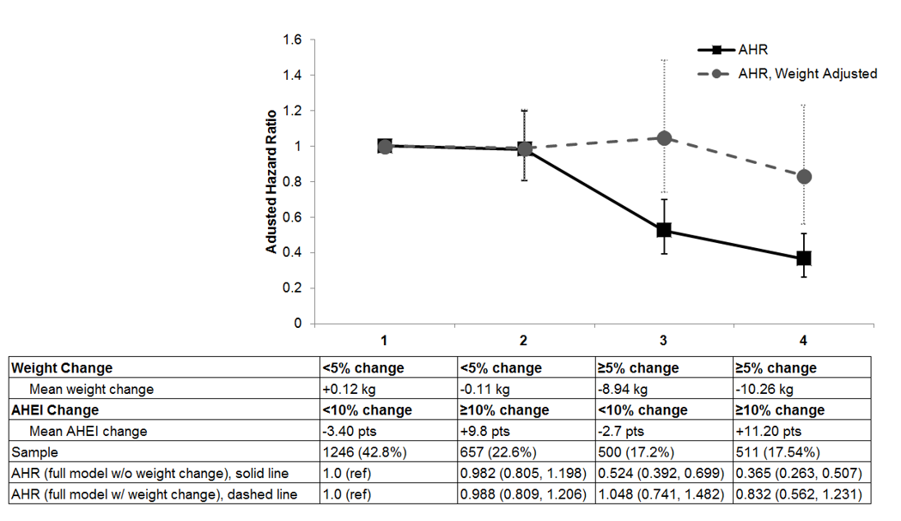
All treatment groups combined. The solid line is adjusted for baseline covariates (age, sex, BMI, MET hours, total energy intake, fasting and 2hr glucose) as well as change from baseline to year 1 of MET hours and total energy intake; the dashed line is also adjusted for weight change as a continuous measure from baseline to year 1 within group. Without weight change, the effect of dietary quality is statistically significant. When it is added to the model, the statistical significance goes away. Solid line, adjusted HRs (AHRs) (full model without weight change); Dashed line, AHRs for full model with weight change included.

Supplemental Figure 2.
Hazard ratios (HRs) for diabetes onset over 3.2 years of follow-up in DPP defined by meeting thresholds of percentage change at 1 year compared with those meeting neither of the goals (group 1), among ILS participants only.
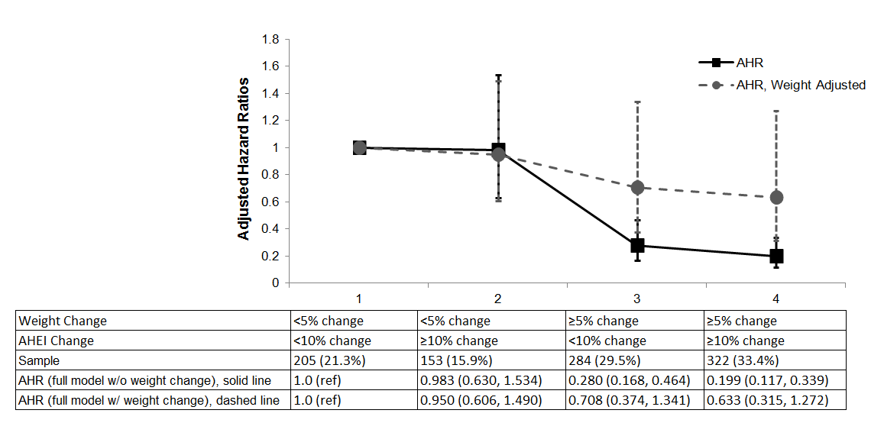

Among ILS participants. The solid line is adjusted for baseline covariates (age, sex, BMI, MET hours, total energy intake, fasting and 2-hr glucose) as well as change from baseline to year 1 of MET hours and total energy intake; the dashed line is also adjusted for weight change as a continuous measure from baseline to year 1 within group. Without weight change, the effect of dietary quality is statistically significant. When it is added to the model, the statistical significance goes away. Solid line, adjusted HRs (AHRs) (full model without weight change); Dashed line, AHRs for full model with weight change included.

Supplemental Table 3.
Associations of AHEI change quintile on weight change from baseline to year 1 among participants of the Diabetes Prevention Program (n=2914).
Quintile | N | Mean AHEI Change | Beta Coefficient | Standard Error | p-value
1st | 582 | -9.79 points | 0.000 (ref) | Ref | Ref
2nd | 583 | -2.06 points | -0.401 | 0.331 | 0.2264
3rd | 583 | +2.14 points | -0.404 | 0.342 | 0.2378
4th | 583 | +6.43 points | -1.328 | 0.347 | 0.0001
5th | 583 | +14.54 points | -2.357 | 0.359 | <0.0001

Linear regression models adjusted for treatment group, baseline values of AHEI, age, sex, race/ethnicity, education, smoking status, family history of diabetes, alcohol use, BMI, MET hours, total energy intake as well as change from baseline to year one of AHEI, MET hours, and total energy intake.

Supplemental Table 4.
Effect of change in AHEI (per 10-point increase) from baseline to year 1 on weight change (kg) over 3.2 years of follow-up in DPP (n=2914).

 | Beta Coefficient | Standard Error | p-value
All participants*† | -0.597 | 0.070 | <0.0001
Stratified Models
Treatment group
Lifestyle† | -0.740 | 0.141 | <0.0001
Metformin† | -0.335 | 0.095 | 0.0005
Placebo† | -0.255 | 0.080 | 0.0016
Racial/ethnic group
Caucasian* | -0.688 | 0.110 | <0.0001
African American* | -0.324 | 0.127 | 0.0108
Hispanic* | -0.856 | 0.139 | <.0001
American Indian* | -0.103 | 0.242 | 0.6716
Asian* | -0.158 | 0.1652 | 0.3408

Mixed linear regression models adjusted for baseline values of AHEI, age, sex, education, smoking status, family history of diabetes, alcohol use, BMI, MET hours, total energy intake. *Also adjusted for treatment group. †Also adjusted for race/ethnicity.

Pennington Biomedical Research Center
(Baton Rouge, LA)
George A. Bray, MD*
Kishore Gadde, MD*
Iris W. Culbert, BSN, RN, CCRC**
Jennifer Arceneaux RN, BSN**
Annie Chatellier, RN, CCRC**
Amber Dragg RD, LDN**
Catherine M. Champagne, PhD, RD
Crystal Duncan, LPN
Barbara Eberhardt, RD, LDN
Frank Greenway, MD
Fonda G. Guillory, LPN
April A. Herbert, RD
Michael L. Jeffirs, LPN
Betty M. Kennedy, MPA
Erma Levy, RD
Monica Lockett, LPN
Jennifer C. Lovejoy, PhD
Laura H. Morris, BS
Lee E. Melancon, BA, BS
Donna H. Ryan, MD
Deborah A. Sanford, LPN
Kenneth G. Smith, BS, MT
Lisa L. Smith, BS
Julia A. St.Amant, RTR
Richard T. Tulley, PhD
Paula C. Vicknair, MS, RD
Donald Williamson, PhD
Jeffery J. Zachwieja, PhD
University of Chicago (Chicago, IL)
Kenneth S. Polonsky, MD*
Janet Tobian, MD, PhD*
David A. Ehrmann, MD*
Margaret J. Matulik, RN, BSN**
Bart Clark, MD
Kirsten Czech, MS
Catherine DeSandre, BA
Ruthanne Hilbrich, RD
Wylie McNabb, EdD
Ann R. Semenske, MS, RD
Jefferson Medical College (Philadelphia, PA)
Jose F. Caro, MD*
Kevin Furlong, DO*
Barry J. Goldstein, MD, PhD*
Pamela G. Watson, RN, ScD*
Kellie A. Smith, RN, MSN**
Jewel Mendoza, RN, BSN**
Wendi Wildman, RN**
Renee Liberoni, MPH
John Spandorfer, MD
Constance Pepe, MS, RD
University of Miami (Miami, FL)
Richard P. Donahue, PhD*
Ronald B. Goldberg, MD*
Ronald Prineas, MD, PhD*
Jeanette Calles, MSEd**
Juliet Ojito, RN**
Patricia Rowe, MPA**
Paul Cassanova-Romero, MD
Sumaya Castillo-Florez, MPH
Hermes J. Florez, MD
Anna Giannella, RD, MS**
Lascelles Kirby, MS
Carmen Larreal
Olga Lara
Valerie McLymont, RN
Jadell Mendez
Arlette Perry, PhD
Patrice Saab, PhD
Beth Veciana
The University of Texas Health Science Center
(San Antonio, TX)
Steven M. Haffner, MD, MPH*
Helen P. Hazuda, PhD*
Maria G. Montez, RN, MSHP, CDE**
Kathy Hattaway, RD, MS
Carlos Lorenzo, MD, PhD
Arlene Martinez, RN, BSN, CDE
Tatiana Walker, RD, MS, CDE
University of Colorado (Denver, CO)
Dana Dabelea, MD, PhD*
Richard F. Hamman, MD, DrPH*
Patricia V. Nash, MS**
Sheila C. Steinke, MS**
Lisa Testaverde, MS**
Denise R. Anderson, RN, BSN
Larry B. Ballonoff, MD
Alexis Bouffard, MA, RN, BSN
Brian Bucca OD, FAOO
B. Ned Calonge, MD, MPH
Lynne Delve
Martha Farago, RN
James O. Hill, PhD
Shelley R. Hoyer, BS
Tonya Jenkins, RD, CDE
Bonnie T. Jortberg, MS, RD, CDE
Dione Lenz, RN, BSN, CDE
Marsha Miller, MS, RD
Leigh Perreault, MD
David W. Price, MD
Judith G. Regensteiner, PhD
Helen Seagle, MS, RD
Carissa M. Smith, BS
Brent VanDorsten, PhD
Joslin Diabetes Center (Boston, MA)
Edward S. Horton, MD*
Kathleen E. Lawton, RN**
Catherine S. Poirier, RN, BSN**
Kati Swift, RN, BSN**
Ronald A. Arky, MD
Marybeth Bryant
Jacqueline P. Burke, BSN
Enrique Caballero, MD
Karen M. Callaphan, BA
Barbara Fargnoli, RD
Therese Franklin
Om P. Ganda, MD
Ashley Guidi, BS
Mathew Guido, BA
Sharon D. Jackson, MS, RD, CDE
Alan M. Jacobsen, MD
Lori Lambert, MS, RD, LD
Sarah Ledbury, Med, RD
Margaret Kocal, RN, CDE
Lyn M. Kula, RD
Maureen A. Malloy, BS
Maryanne Nicosia, MS, RD
Cathryn F. Oldmixon, RN
Jocelyn Pan, BS, MPH
Marizel Quitingon
Stacy Rubtchinsky, BS
Jessica Sansoucy, BS
Dana Schweizer, BSN
Ellen W. Seely, MD
Donald Simonson, MD
Fannie Smith, MD
Caren G. Solomon, MD, MPH
Jeanne Spellman, RD
James Warram, MD
VA Puget Sound Health Care System and University of Washington (Seattle, WA)
Steven E. Kahn, MB, ChB*
Brenda K. Montgomery, RN, BSN, CDE**
Wilfred Fujimoto, MD
Robert H. Knopp, MD
Edward W. Lipkin, MD
Michelle Marr, BA
Ivy Morgan-Taggart
Anne Murillo, BS
Dace Trence, MD
Lonnese Taylor, RN, BS
April Thomas, RD, MPH, CDE
Elaine C. Tsai, MD, MPH
University of Tennessee (Memphis, TN)
Samuel Dagogo-Jack, MD, MSc, FRCP, FACP*
Abbas E. Kitabchi, PhD, MD, FACP*
Mary E. Murphy, RN, MS, CDE, MBA**
Laura Taylor, RN, BSN, CDE**
Jennifer Dolgoff, RN, BSN**
William B. Applegate, MD, MPH
Michael Bryer-Ash, MD
Debra Clark, LPN
Sandra L. Frieson, RN
Uzoma Ibebuogu, MD
Raed Imseis, MD
Helen Lambeth, RN, BSN
Lynne C. Lichtermann, RN, BSN
Hooman Oktaei, MD
Harriet Ricks
Lily M.K. Rutledge, RN, BSN
Amy R. Sherman, RD, LD
Clara M. Smith, RD, MHP, LDN
Judith E. Soberman, MD
Beverly Williams-Cleaves, MD
Northwestern University’s Feinberg School of Medicine (Chicago, IL)
Boyd E. Metzger, MD*
Mark E. Molitch, MD*
Mariana K. Johnson, MS, RN**
Daphne T. Adelman, MBA, RN
Catherine Behrends
Michelle Cook, MS
Marian Fitzgibbon, PhD
Mimi M. Giles, MS, RD
Deloris Heard, MA
Cheryl K.H. Johnson, MS, RN
Diane Larsen, BS
Anne Lowe, BS
Megan Lyman, BS
David McPherson, MD
Samsam C. Penn, BA
Thomas Pitts, MD
Renee Reinhart, RN, MS
Susan Roston, RN, RD
Pamela A. Schinleber, RN, MS
Massachusetts General Hospital (Boston, MA)
David M. Nathan, MD*
Charles McKitrick, BSN**
Heather Turgeon, BSN**
Mary Larkin, MSN**
Kathy Abbott
Ellen Anderson, MS, RD
Laurie Bissett, MS, RD
Kristy Bondi, BS
Enrico Cagliero, MD
Jose C. Florez, MD, PhD+
Kali D’Anna
Linda Delahanty, MS, RD
Valerie Goldman, MS, RD
Peter Lou, MD
Alexandra Poulos
Elyse Raymond, BS
Christine Stevens, RN
Beverly Tseng
University of California-San Diego (La Jolla, CA)
Jerrold M. Olefsky, MD*
Elizabeth Barrett-Connor, MD*
Mary Lou Carrion-Petersen, RN, BSN**
Madeline Beltran, RN, BSN, CDE
Lauren N. Claravall, BS
Jonalle M. Dowden, BS
Steven V. Edelman, MD
Robert R. Henry, MD
Javiva Horne, RD
Marycie Lamkin, RN
Simona Szerdi Janesch, BA
Diana Leos
Sunder Mudaliar, MD
William Polonsky, PhD
Jean Smith, RN
Jennifer Torio-Hurley
Karen Vejvoda, RN, BSN, CDE, CCRC
Columbia University (New York, NY)
F. Xavier Pi-Sunyer, MD*
Jane E. Lee, MS**
David B. Allison, PhD
Nnenna Agharanya
Nancy J. Aronoff, MS, RD
Maria Baldo
Jill P. Crandall, MD
Sandra T. Foo, MD
Susan Hagamen, MS, RN, CDE
Jose A. Luchsinger, MD, MPH
Carmen Pal, MD
Kathy Parkes, RN
Mary Beth Pena, RN
Ellen S. Rooney, BA
Gretchen E.H. Van Wye, MA
Kristine A. Viscovich, ANP
Indiana University (Indianapolis, IN)
David G. Marrero, PhD*
Kieren J. Mather, MD*
Melvin J. Prince, MD*
Susie M. Kelly, RN, CDE**
Marcia A. Jackson**
Gina McAtee**
Paula Putenney, RN**
Ronald T. Ackermann, MD
Carolyn M. Cantrell
Yolanda F. Dotson, BS
Edwin S. Fineberg, MD
Megan Fultz
John C. Guare, PhD
Angela Hadden
James M. Ignaut, MA
Marion S. Kirkman, MD
Erin O’Kelly Phillips
Beverly D. Porter, MSN
Paris J. Roach, MD
Nancy D. Rowland, BS, MS
Madelyn L. Wheeler, RD
Medstar Research Institute (Washington, DC)
Vanita Aroda, MD*
Robert E. Ratner, MD*
Gretchen Youssef, RD, CDE**
Sue Shapiro, RN, BSN, CCRC**
Catherine Bavido-Arrage, MS, RD, LD
Geraldine Boggs, MSN, RN
Marjorie Bronsord, MS, RD, CDE
Ernestine Brown
Wayman W. Cheatham, MD
Susan Cola
Cindy Evans
Peggy Gibbs
Tracy Kellum, MS, RD, CDE
Renee Wiggins, RD
Milvia Lagarda
Lilia Leon
Claresa Levatan, MD
Milajurine Lindsay
Asha K. Nair, BS
Maureen Passaro, MD
Angela Silverman
Gabriel Uwaifo, MD
Debra Wells-Thayer, NP, CDE
University of Southern California/UCLA Research Center (Alhambra, CA)
Mohammed F. Saad, MD*
Karol Watson, MD*
Maria Budget**
Sujata Jinagouda, MD**
Medhat Botrous, MD**
Khan Akbar, MD
Claudia Conzues
Perpetua Magpuri
Kathy Ngo
Amer Rassam, MD
Debra Waters
Kathy Xapthalamous
Washington University (St. Louis, MO)
Julio V. Santiago, MD*
Samuel Dagogo-Jack, MD, MSc, FRCP, FACP*
Neil H. White, MD, CDE*
Angela L. Brown, MD*
Samia Das, MS, MBA, RD, LD**
Prajakta Khare-Ranade, MSc, RDN, LD**
Tamara Stich, RN, MSN, CDE**
Ana Santiago, RN
Edwin Fisher, PhD
Emma Hurt, RN
Tracy Jones, RN
Michelle Kerr, RD
Lucy Ryder, RN
Cormarie Wernimont, RD, LD
Johns Hopkins School of Medicine
(Baltimore, MD)
Sherita Hill Golden, MD, MHS, FAHA*
Christopher D. Saudek, MD*
Vanessa Bradley, BA**
Emily Sullivan, MEd, RN**
Tracy Whittington, BS**
Caroline Abbas
Adrienne Allen
Frederick L. Brancati, MD, MHS
Sharon Cappelli
Jeanne M. Clark, MD
Jeanne B. Charleston, RN, MSN
Janice Freel
Katherine Horak, RD
Alicia Greene
Dawn Jiggetts
Deloris Johnson
Hope Joseph
Kimberly Loman
Henry Mosley
John Reusing
Richard R. Rubin, PhD
Alafia Samuels, MD
Thomas Shields
Shawne Stephens
Kerry J. Stewart, EdD
LeeLana Thomas
Evonne Utsey
Paula Williamson
University of New Mexico (Albuquerque, NM)
David S. Schade, MD*
Karwyn S. Adams, RN, MSN**
Janene L. Canady, RN, CDE**
Carolyn Johannes, RN, CDE**
Claire Hemphill, RN, BSN**
Penny Hyde, RN, BSN**
Leslie F. Atler, PhD
Patrick J. Boyle, MD
Mark R. Burge, MD
Lisa Chai, RN
Kathleen Colleran, MD
Ysela Gonzales
Doris A. Hernandez-McGinnis
Patricia Katz, LPN
Carolyn King, Med
Amer Rassam, MD
Sofya Rubinchik, MD
Willette Senter, RD
Debra Waters, PhD
Albert Einstein College of Medicine (Bronx, NY)
Jill Crandall, MD*
Harry Shamoon, MD*
Janet O. Brown, RN, MPH, MSN**
Gilda Trandafirescu, MD**
Elsie Adorno, BS
Liane Cox, MS, RD
Helena Duffy, MS, C-ANP
Samuel Engel, MD
Allison Friedler, BS
Angela Goldstein, FNP-C, NPP, CSW
Crystal J. Howard-Century, MA
Jennifer Lukin, BA
Stacey Kloiber, RN
Nadege Longchamp, LPN
Helen Martinez, RN, MSN, FNP-C
Dorothy Pompi, BA
Jonathan Scheindlin, MD
Elissa Violino, RD, MS
Elizabeth A. Walker PhD, RN
Judith Wylie-Rosett, EdD, RD
Elise Zimmerman, RD, MS
Joel Zonszein, MD
University of Pittsburgh (Pittsburgh, PA)
Trevor Orchard, MD*
Rena R. Wing, PhD*
Susan Jeffries, RN, MSN**
Gaye Koenning, MS, RD**
M. Kaye Kramer, BSN, MPH**
Marie Smith, RN, BSN**
Susan Barr, BS
Catherine Benchoff
Miriam Boraz, PhD
Lisa Clifford, BS
Rebecca Culyba, BS
Marlene Frazier
Ryan Gilligan, BS
Stephanie Guimond, BS
Susan Harrier, MLT
Louann Harris, RN
Andrea Kriska, PhD
Qurashia Manjoo, MD
Monica Mullen, MHP, RD
Alicia Noel, BS
Amy Otto, PhD
Jessica Pettigrew, CMA
Debra Rubinstein, MD
Linda Semler, MS, RD
Cheryl F. Smith, PhD
Elizabeth Venditti, PhD
Valarie Weinzierl, MPH
Katherine V. Williams, MD, MPH
Tara Wilson, BA
University of Hawaii (Honolulu, HI)
Richard F. Arakaki, MD*
Renee W. Latimer, BSN, MPH** Narleen K. Baker-Ladao, BS**
Mae K. Isonaga, RD, MPH**
Ralph Beddow, MD
Nina E. Bermudez, MS
Lorna Dias, AA
Jillian Inouye, RN, PhD
Marjorie K. Mau, MD
John S. Melish, MD
Kathy Mikami, BS, RD
Pharis Mohideen, MD
Sharon K. Odom, RD, MPH
Raynette U. Perry, AA
Robin E. Yamamoto, CDE, RD
Southwest American Indian Centers
(Phoenix, AZ; Shiprock, NM; Zuni, NM)
William C. Knowler, MD, DrPH*+
Norman Cooeyate**
Mary A. Hoskin, RD, MS**
Carol A. Percy, RN, MS**
Alvera Enote**
Camille Natewa**
Kelly J. Acton, MD, MPH
Vickie L. Andre, RN, FNP
Rosalyn Barber
Shandiin Begay, MPH
Peter H. Bennett, MB, FRCP
Mary Beth Benson, RN, BSN
Evelyn C. Bird, RD, MPH
Brenda A. Broussard, RD, MPH, MBA, CDE
Brian C. Bucca, OD, FAAO
Marcella Chavez, RN, AS
Sherron Cook
Jeff Curtis, MD
Tara Dacawyma
Matthew S. Doughty, MD
Roberta Duncan, RD
Charlotte Dodge
Cyndy Edgerton, RD
Jacqueline M. Ghahate
Justin Glass, MD
Martia Glass, MD
Dorothy Gohdes, MD
Wendy Grant, MD
Robert L. Hanson, MD, MPH
Ellie Horse
Louise E. Ingraham, MS, RD, LN
Merry Jackson
Priscilla Jay
Roylen S. Kaskalla
David Kessler, MD
Kathleen M. Kobus, RNC-ANP
Jonathan Krakoff, MD
Jason Kurland, MD
Catherine Manus, LPN
Cherie McCabe
Sara Michaels, MD
Tina Morgan
Yolanda Nashboo
Julie A. Nelson, RD
Steven Poirier, MD
Evette Polczynski, MD
Christopher Piromalli, DO
Mike Reidy, MD
Jeanine Roumain, MD, MPH
Debra Rowse, MD
Robert J. Roy
Sandra Sangster, RD
Janet Sewenemewa
Miranda Smart
Darryl Tonemah, PhD
Rachel Williams, FNP
Charlton Wilson, MD
Michelle Yazzie
George Washington University Biostatistics Center (DPP Coordinating Center Rockville, MD)
Raymond Bain, PhD*
Sarah Fowler, PhD*
Marinella Temprosa, PhD*
Michael D. Larsen, PhD*
Tina Brenneman**
Sharon L. Edelstein, ScM**
Solome Abebe, MS
Julie Bamdad, MS
Melanie Barkalow
Joel Bethepu, MPH
Tsedenia Bezabeh, MS
Nicole Butler, MPH
Jackie Callaghan
Caitlin E. Carter, MPH
Costas Christophi, PhD
Gregory M. Dwyer, MPH
Mary Foulkes, PhD
Yuping Gao
Robert Gooding
Adrienne Gottlieb
Kristina L. Grimes
Nisha Grover-Fairchild, MPH
Lori Haffner, MS
Heather Hoffman, PhD
Kathleen Jablonski, PhD
Steve Jones
Tara L. Jones
Richard Katz, MD
Preethy Kolinjivadi, MS
John M. Lachin, ScD
Yong Ma, PhD
Pamela Mucik
Robert Orlosky
Qing Pan, PhD
Susan Reamer
James Rochon, PhD
Alla Sapozhnikova
Hanna Sherif, MS
Charlotte Stimpson
Ashley Hogan Tjaden, MPH
Fredricka Walker-Murray
Lifestyle Resource Core
Elizabeth M. Venditti, PhD*
Andrea M. Kriska, PhD
Linda Semler, MS, RD, LDN
Valerie Weinzierl, MPH
Central Biochemistry Laboratory (Seattle, WA)
Santica Marcovina, PhD, ScD*
Jessica Harting**
F. Alan Aldrich**
John Albers, PhD
Greg Strylewicz, PhD
NIH/NIDDK (Bethesda, MD)
R. Eastman, MD
Judith Fradkin, MD
Sanford Garfield, PhD
Christine Lee, MD, MS
Centers for Disease Control & Prevention
(Atlanta, GA)
Edward Gregg, PhD
Ping Zhang, PhD
Nutrition Coding Center (Columbia, SC)
Elizabeth Mayer-Davis, PhD*
Robert R. Moran, PhD**

