GASTROINTESTINAL SYMPTOMS EVALUATION
Date/ day________________________________________________

Instruction : If you feel pain following the product administration, please rate the symptoms by putting a mark (√) on the listed table below. If you do not feel anything, please put a mark (√) on “none”.

Symptoms | None | Mild | Moderate | Severe
Abdominal pain
Borborygmi
Nausea
Vomiting
Bloating
Flatulence

Comments: ________________________________________________________________________________________________________________________________________________________________________________________________________________________________
BRISTOL STOOL CHART
Date/ day________________________________________________

Please tick one of the types of the stool form which closely describe your stool form

Type | Description | Image
Type 1 | Separate hard lumps, like nuts | 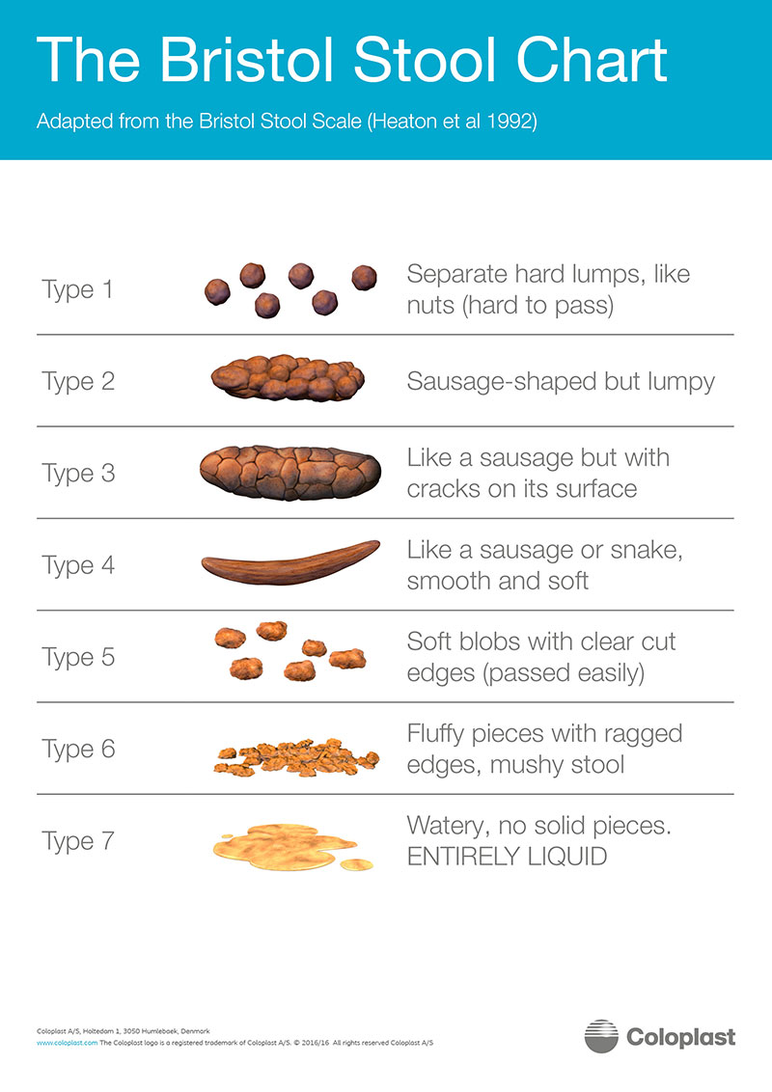
Type 2 | Sausage-shaped but lumpy
Type 3 | Like sausage or snake but with cracks on its surface
Type 4 | Like sausage or snake, smooth and soft
Type 5 | Soft blobs with clear-cut edges
Type 6 | Fluffy pieces with ragged edges, a mushy tool
Type 7 | Watery, no solid pieces

Comments (Time of the day, Amount, other symptoms): ________________________________________________________________________________________________________________________________________________________________________________________________________________________________

Instruction for booklet recording and lifestyle during participate the research
- Dietary record: please record your daily food intake 3 days/week, 2 weekdays and 1 weekend day. Choose any days in the week as you desire. The dietary record should include date, list of foods and beverages, and food ingredients.
- Gastrointestinal symptoms evaluation: please record your gastrointestinal symptoms 1 day/week. If any unusual symptom occurs, note the frequency of that symptom.
- Bristol stool chart: please record your stool form 1 day/week. If any unusual symptom occurs, note the frequency of that symptom.
- Please maintain your physical activity, exercise, and keep your food intake unchanged during the intervention period.
- Refrain from drinking alcoholic beverages and smoking during the intervention period.
- Refrain from using any food supplements during intervention period.

