Supplementary Table 1: Key terms used for literature search
Sr No | Theme | Key terms
#1 | Probiotics/prebiotics | (((((((((Probiotic[MeSH Major Topic]) OR (Probiotic*[Title/Abstract])) OR (Prebiotic*[Title/Abstract])) OR (Synbiotic*[Title/Abstract])) OR (Lactobacill*[Title/Abstract])) OR (bifidobacter*[Title/Abstract])) OR (Oligosaccharide*)) OR (saccharomyces boulardii)) OR (Bacillus coagulans)) OR (Inulin)
#2 | Anemia | (((((((((((((((Anemia[Title/Abstract]) OR (anaemia[Title/Abstract])) OR ("Anemia"[Mesh])) OR (anemia*)) OR (anemic)) OR (anaemic)) OR (iron deficiency[Title/Abstract])) OR ("Anemia, Iron-Deficiency"[Mesh])) OR (Anemia, Iron-Deficiency)) OR (iron deficien*)) OR (low iron)) OR (iron deplet*)) OR ("Iron-Deficiency Anemia")) OR ("Iron Deficiency Anemia")) OR (Nutritional Anemia[Title/Abstract])) OR ("Anemia, Hypochromic"[Mesh])
#3 | Final Search Strategy | #1 AND #2
#4 | Limits | English

Supplementary Table 2: Study characteristics
Refid | User | Author name | Year of publication | Country | Design | Setting -> Women in reproductive age | NParticipants | Age group of participants | Type of intervention | Category of intevention | Intervention in the test group | Type of study outcomes -> Increase in iron absorption | Type of study outcomes -> Improvement in blood markers for IDA | Type of study outcomes -> Gastrointestinal adverse effects | Details of study outcomes | Comments
173 | Anju.Sinha | Nadja Mikulic | 2021 | kenya | Randomised cross over study | Children | 23 | 6–14 months; | Fortification | Prebiotic + Iron | 1) 2.5 mg 57 FeFum + 2.5 mg NaFeEDTA (as 1 mg of 58 Fe and 1.5 mg of 56 Fe), with 7.5 g GOS; and 2) 5.0 mg FeSO 4 (as 2 mg of 54 Fe and 3 mg of 56 Fe),with 7.5 g GOS. | Increase in iron absorption |  |  | iron-deficient Kenyan infants, the addition of GOS to iron-fortified complementary food in a single meal did not significantly increase iron absorption, in contrast to previous studies showing an enhancing effect of GOS after prior consumption of GOS for several weeks.
279 | Anju.Sinha | Siti Helmyati | 2020 | Indonesia | Randomized controlled trial | Children | 59 | 8-12 | Fortification | Synbiotic + Iron | iron supplement syrup (IS) , 10 mg iron/day, 2 times a week for 3 months. | Increase in iron absorption | Improvement in blood markers for IDA |  | body weight and height, hemoglobin and serum ferritin levels, and total number of Lactobacilli, Enterobacteria, Bifidobacteria, and Escherichia coli
324 | Anju.Sinha | Gerald M. Rosen | 2019 | USA | Randomized controlled trial | Children | 52 | 5-18years | Supplementation | Probiotic + Iron | Iron treatment of 3mg/kg/day of elemental iron upto a maximum daily dose of 65mg elemental iron with generic ferrous sulfate 325mg(provided by Major Pharmaceuticals,Livona, Michigan) or ferrous sulfate 15mg elemental iron/mL (provided by Akorn Inc, Lake Forest, Illinois), and vitaminC, (generic ascorbic acid 250mg for children >5years of age, 125mg for children<5years of age; provided by Major Pharmaceuticals) and 10 x 10 colony forming units of the probiotic LP299v (provided by Jarrow Formulas, Inc, Los Angeles, California) | Increase in iron absorption |  |  | Treatment with low-dose ferrous sulfate is well-tolerated and effective in correcting iron deficiency in children. However, the probiotic LP299v did not enhance treatment.
355 | Anju.Sinha | Ferus | 2018 | Poland | Randomized controlled trial | Children | 34 | Children 4-18 years | Supplementation | Prebiotic + Iron | oligofructose-enriched inulin (10 g orally/day; Orafti® Synergy 1, Beneo, Tienen, Belgium). |  | Improvement in blood markers for IDA |  | serum hepcidin concentration after the intervention was significantly decreased by 60.9% (p = 0.046) in the Synergy 1 group, whereas no significant difference was observed in the placebo group
390 | Ashwini.Parge | Daniela Paganini | 2017 | Kenya | Randomized controlled trial | Children | 155 | 6.5 months - 9.5 months | Supplementation | Prebiotic + Iron | MNP with FeFum [2.5 mg] with NaFeEDTA [2.5 mg] with GOS [ 7.5 g] daily for 4 months. | Increase in iron absorption | Improvement in blood markers for IDA | Gastrointestinal adverse effects | Anaemia decreased by ≈50% in the Fe and FeGOS groups (p<0.001). Compared with the control or FeGOS group, in the Fe group there were (1) lower abundances of Bifidobacterium and Lactobacillus and higher abundances of Clostridiales (p<0.01); (2) higher abundances of virulence and toxin genes (VTGs) of pathogens (p<0.01); (3) higher plasma intestinal fatty acid-binding protein (a biomarker of enterocyte damage) (p<0.05); and (4) a higher incidence of treated RTIs (p<0.05). In contrast, there were no significant differences in these variables comparing the control and FeGOS groups, with the exception that the abundance of VTGs of all pathogens was significantly lower in the FeGOS group compared with the control and Fe groups (p<0.01)
419 | Ashwini.Parge | Daniela Paganini | 2017 | Kenya | Randomized controlled trial | Children | 50 | 6 to 14 months | Fortification | Prebiotic + Iron | MNP containing Fefum [2.5 mg] + NaFeEDTA [2.5 mg] + Ascorbic acid [30 mg]+ Vitamins+ Minerals+ Maltodextrin [10.5 g] | Increase in iron absorption | Improvement in blood markers for IDA | Gastrointestinal adverse effects | : There was a significant group-by-compound interaction on iron absorption (P = 0.011). The median percentages of fractional iron absorption from FeFum+NaFeEDTA and from FeSO4 in the Fe group were 11.6% (IQR: 6.9–19.9%) and 20.3% (IQR: 14.2– 25.7%), respectively, (P , 0.001) and, in the Fe+GOS group, were 18.8% (IQR: 8.3–37.5%) and 25.5% (IQR: 15.1–37.8%), respectively (P = 0.124). Between groups, iron absorption was greater from the FeFum+NaFeEDTA (P = 0.047) in the Fe+GOS group but not from the FeSO4 (P = 0.653). The relative iron bioavailability from FeFum+NaFeEDTA compared with FeSO4 was higher in the Fe+GOS group than in the Fe group (88% compared with 63%; P = 0.006). There was a significant time-by-group interaction on Bifidobacterium spp. (P = 0.008) and Lactobacillus/Pediococcus/Leuconostoc spp. (P = 0.018); Lactobacillus/Pediococcus/Leuconostoc spp. decreased in the Fe group (P = 0.013), and there was a nonsignificant trend toward higher Bifidobacterium spp. in the Fe+GOS group (P = 0.099). At 3 wk, iron absorption was negatively correlated with fecal pH (P , 0.001) and positively correlated with Lactobacillus/Pediococcus/ Leuconostoc spp. (P = 0.001).
621 | Ashwini.Parge | Rina Agustina | 2013 | Indonesia | Randomized controlled trial | Children | 494 | 1 to 6 years | Fortification | Probiotic | regular calcium plus 5 3 108 CFU/d Lactobacillus casei CRL 431 (casei group), or regular calcium plus 5 3 108 CFU/d Lactobacillus reuteri DSM 17938 (reuteri group). 180 mL of low-lactose milk twice daily |  |  |  | The effect on growth was evaluated by calculating differences in weight, height, weight-for-age Z-score (WAZ), and height-for-age Z-score (HAZ) at the study end (6-mo intervention) minus baseline (month 0). The HAZ and WAZ were calculated on the basis of the WHO Child Growth Standards (48) by using the WHO anthropometric software 2005 and 2007. In addition, using the consecutive monthly anthropometric measurements, the mean change and difference in monthly weight and height growth velocities as well as WAZ and HAZ were analyzed by using a longitudinal regression model (months 0, 1, 2, 3, 4, 5, and 6). Stunting was defined as HAZ < 22 SD and underweight as WAZ < 22 SD (2). Changes in the proportion of underweight and stunted children from baseline to study end were calculated. Iron and zinc status was assessed by comparing the estimated means of the differences (end 2 baseline) between and within treatment groups. Changes in the proportion of anemic, iron-deficient anemic, and zincdeficient children were calculated. For the outcomes on blood variables, the RC group was pooled with the probiotic groups (casei and reuteri) as 1 calcium-supplemented group and compared with the LC groupThe reuteri group experienced significantly greater weight gain (1160 6 650 g; P = 0.03) and WAZ change (0.14 6 0.28 Z; P = 0.03) after 6 mo of intervention compared with the RC group (960 6 740 g and 0.06 6 0.31 Z, respectively). The significant mean difference in weight gain and WAZ change between reuteri and RC groups was 220 g and 0.09 Z, respectively. Compared with the RC group, the reuteri group had a significantly higher mean monthly weight [adjusted difference: 0.03 (95% CI: 0.002, 0.05) kg/mo; P = 0.04] and height velocity (P = 0.04) (Table 4). In the casei group, the mean monthly weight velocity was significantly higher compared with the RC group
738 | Ashwini.Parge | Sunil Sazawal | 2010 | India[ New Delhi] | Randomized controlled trial | Children | 624 | 1 to 4 years | Fortification | Synbiotic | 1.9 107 colony-forming unit/day of probiotic B lactis HN019 and 2.4 g of prebiotic oligosaccharides for 1 year. |  | Improvement in blood markers for IDA |  | we present the results of a 1-year intervention of probiotic-fortified milk on growth and iron deficiency. Of 651 eligible children identified for the study, 27 (parent or caretaker) refused to participate. In all, 624 children were enrolled in the trial. Children were randomly allocated to B lactis HN019 and prebioticfortified milk group (PP; n ¼ 312) and to Co milk group (n ¼ 312) (Fig. 1). At enrollment, children assigned to the 2 groups were comparable for SES, demographic descriptors, body iron stores, anemia, and growth parametersCompared with the consumption of Co milk, consumption of PP milk resulted in a 45% (95% CI 11%, 66%; P ¼ 0.01) lower risk of being anemic and iron deficient. No significant effect of fortified milk was observed on iron status indicators such as Hb, ZnPP, RDW, sFr, and sTfr levels. Both study groups were similar at baseline. Compliance was high (>85%) and did not vary by intervention groups. As compared with nonfortified milk, consumption of probiotic- and prebiotic-fortified milk for a period of 1 year reduced the risk of being anemic and iron deficient by 45% (95% CI 11%, 66%; P ¼ 0.01) and increased weight gain by 0.13 kg/year (95% CI 0.03, 0.23; P ¼ 0.02) . The mean weight velocity among children consuming PP milk was higher than that in children consuming Co milk by 0.13 kg/year (95% CI 0.03–0.23; P ¼ 0.02). There was no significant difference in change in z scores (baseline to end of the study) between the 2 groups . In this study, we found a significant beneficial effect on weight velocity and a 45% lower risk of being iron deficient of the consumption of probiotic- and prebiotic-fortified milk for 1 year. No effect was observed on individual iron deficiency indicators or on other anthropometric z scores
759 | Ashwini.Parge | Do Thi Kim Lien | 2009 | Vietnam | Randomized controlled trial | Children | 444 | 7 to 8 years | Fortification | Prebiotic | Two servings of 250 ml milk in the morning of each class day (6 days a week) for six months, except for holidays. Fortified milk contained (partly) vegetable fat, inulin ,milk calcium ,iron pyrophosphate, sodium selenite, zinc sulphate, manganese sulphate, potassium iodide, vitamins A, D3, E, K1, B1, B2, B3, B6, B12, folic acid, calcium D-pantothenate, biotin, sodium ascorbate, and taurine | Increase in iron absorption | Improvement in blood markers for IDA |  | A total of 454 children aged 7 to 8 years attending three primary schools in the Northern delta province of Vietnam were either provided with regular milk, milk fortified with vitamins, minerals and inulin or served as a reference control group. Children were monitored for anthropometrics, (micro)-nutritional status, faecal microbiota composition, school performance, and health indices. Both weightfor-age (WAZ) and height-for-age (HAZ) significantly improved during 6 months of milk intervention; and underweight and stunting dropped by 10% in these groups. During intervention the incidence of anemia decreased and serum ferritin levels increased significantly in all groups. Serum zinc levels increased and consequently the incidence of zinc deficiency improved significantly in all three groups. Serum retinol levels and urine iodine levels remained stable upon intervention with fortified milk whereas in the control group the incidence of iodine deficiency increased. Bifidobacteria composed less than 1% of the total faecal bacteria. After three months of milk intervention total bacteria, bifidobacteria and Bacteroides sp. increased significantly in both milk and inulin fortified milk groups. Children in the milk consuming groups had significantly better short-term memory scores. Parent reported that health related quality of life status significantly improved upon milk intervention. In conclusion, (fortified) milk consumption benefited the children in rural Vietnam including lowering the occurrence of underweight and stunting, improving micronutrients status and better learning indicators as well as improving the quality of life
813 | aditi.apte | Silva | 2008 | Brazil | Nonrandomized Controlled trial | Children | 190 | 2-5 years | Fortification | Probiotic + Iron | Fermented milk with L acidophilus and 3 mg of iron amino acid chelate, 80 ml once daily for 101 days |  | Improvement in blood markers for IDA |  | The levels of red blood cells, hemoglobin, and hematocrit decreased (P b .001) in both groups (test and control) but remained within the reference range. The children fed the probiotic milk beverage exhibited higher red blood cell status and a positive correlation between iron intake and hemoglobin. An increased serum ferritin level was observed in the control group (P b .001).
856 | aditi.apte | Mohammad | 2006 | Egypt | Randomized controlled trial | Children | 24 | Approx 10-12 years | Fortification | Probiotic | Probiotic yogurt containing activated La1 (5*109 colony forming units) for 42 days |  | Improvement in blood markers for IDA |  | The consumption of the probiotic yoghurt was also associated with a significant (x2/8.0; PB/0.01) reduction in the percentage prevalence of anemia (hemoglobin B/120 g/l) (table 1)
1213 | aditi.apte | Owolabi | 2021 | Nigeria | Randomized controlled trial | Children | 184 | 12-36 months | Fortification | Probiotic + Iron | The three groups received a multi-nutrient fortified dairy-based drink (Peak 123, FrieslandCampina Wamco, Lagos, Nigeria), in amounts of 200, 400 or 600 mL per day. |  | Improvement in blood markers for IDA | Gastrointestinal adverse effects | All three dosages reduced anaemia prevalence, to 47%, 27% and 18%, respectively. ID and IDA prevalence was low and did not significantly decrease over time. Regarding gut microbiota, Enterobacteriaceae decreased over time without differences between groups, whereas Bifidobacteriaceae and pathogenic E. coli were not affected.
1494 | aditi.apte | Manoppo | 2019 | Indonesia | Randomized controlled trial | Children | 66 | 5-12 years | Supplementation | Probiotic + Iron | FeSO4 60 mg of elemental iron *2 + L. reuteri DSM 17938 for 14 days |  | Improvement in blood markers for IDA |  | After 14 days of intervention, mean Ret-He level in group 1 changed from 24.43±1.64 to 28.21±1.72 pg/ L (P=0.000). Mean Ret-He level in group 2 changed from 24.31±1.42 to 27.03±2.14 pg/L (P=0.000). Statistical analysis showed a significant increase in Ret-He levels in both groups; Ret-He levels were significantly higher in the experimental group than in the control group (P<0.05)
1827 | Ashwini.Parge | Nadja Mikulic | 2020 | Kenya | Randomised cross over study | Children | 25 | 3 to 6 months | Fortification | Prebiotic + Iron | Standardized maize-porridge test meals -1) meal A was fortified with 1.5 mg of iron as 54Fe-labeled FeSO4; 2) meal B was fortified with 1.42 mg of iron as 58Fe-labeled FeSO4 and 1.41 g of apo-Lf (containing 0.08 mg of unlabeled native iron); and 3) meal C was fortified with intrinsically 57Fe-labeled holo-Lf (containing 1.5 mg iron and 1.41 g Lf). All infants received all 3 test meals on Days 1, 4, and 7 | Increase in iron absorption |  |  | The main findings of this study in Kenyan infants consuming a non-inhibitory, maize-based test meal are: 1) the addition of apo-Lf significantly increased (+56%) iron absorption from FeSO4; 2) iron absorption from apo-Lf + FeSO4 was significantly greater than from holo-Lf; and 3) there was no significant difference in iron absorption from FeSO4 alone compared to holo-Lf. The FIA from the meal containing apo-Lf + FeSO4 (geometric mean, 9.8%; −SD and +SD, 5.4% and 17.5%) was higher than from the meals containing FeSO4 (geometric mean, 6.3%; −SD and +SD, 3.2% and 12.6%; P = 0.002) or holo-Lf (geometric mean, 5.0%; −SD and +SD, 2.8% and 8.9%; P. The amount of iron absorbed from holo-Lf was comparable to that of FeSO4, and the addition of apo-Lf to a test meal containing FeSO4 significantly increased (+56%) iron absorption. These findings suggest that Lf facilitates iron absorption in young infants. Because Lf binds iron with high affinity, it could be a safe way to provide iron to infants in low-income countries, where iron fortificants can adversely affect the gut microbiome and cause diarrhea
1834 | Ashwini.Parge | Ambra Giorgetti | 2022 | Kenya | Randomised cross over study | Children | 55 | 8 to 12 months | Fortification | Prebiotic + Iron | Each test meal portion consisted of 80.0 g unfortified maize porridge, composed of 5.7 g unfortified, refined maize flour, 2.5 g sugar, and 71.8 g bottled water. Test meal A[ FeFum control] contains 5.0 mg iron as FeFum. Test meal B [ FeFum +GOS] contains 5.0 mg iron as FeFum and 3.0 g of GOS. Test meal C [FeFum+ HMO] contains 5.0 mg iron as FeFum and 3.0 g HMO . 30 infants consumed 3 different test meals (A, B, and C) on alternate test meal days (days 2, 4, and 6) and 25 infants consumed 2 different test meals (A and C) on alternate test meal days (days 2 and 4). | Increase in iron absorption |  |  | The main findings of this study in partially breastfed Kenyan infants are as follows: 1) consumption of a single low dose of 3.0 g GOS significantly enhanced FIA from maize porridge fortified with FeFum; 2) the iron absorption–enhancing effect of GOS was independent of maternal HMO profile; 3) consumption of a single dose of 3.0 g HMO (2.0 g 2'-FL and 1.0 g LNnT) did not enhance FIA from the iron-fortified maize porridge, regardless of maternal HMO profile; and 4) maternal HMO profile did not predict FIA from the FeFum-fortified maize porridge. Of the 55 infants included, 49 were fed as instructed. FIA from the FeFumþGOS group [median (IQR) 22.2% (16.5%–25.9%)] was higher than that from the FeFum group [12.5% (9.5%–20.9%)] (P ¼ 0.005). FIA from the FeFumþHMO group was 13.3% (7.1%–24.4%) and did not differ from the FeFum group (P ¼ 0.923). Maternal HMO profile did not predict FIA or modulate the effects of GOS or HMO on FIA. Iron dialyzability ratios at pH 2 of FeFumþGOS to FeFum and FeFumþHMO to FeFum were 2.1 and 0.9 (P ¼ 0.001 and P ¼ 0.322), respectively

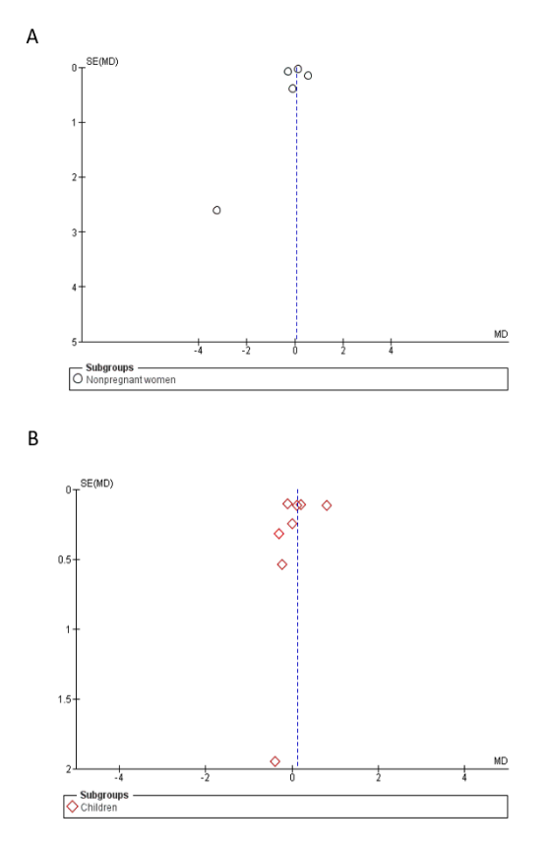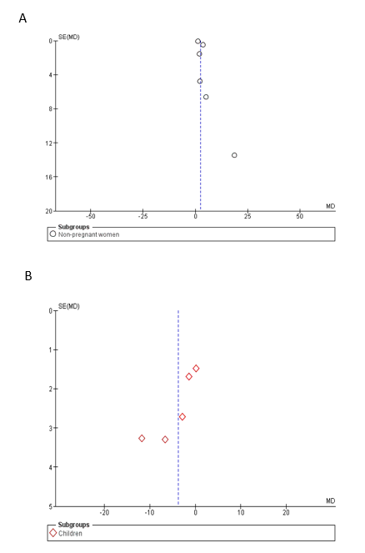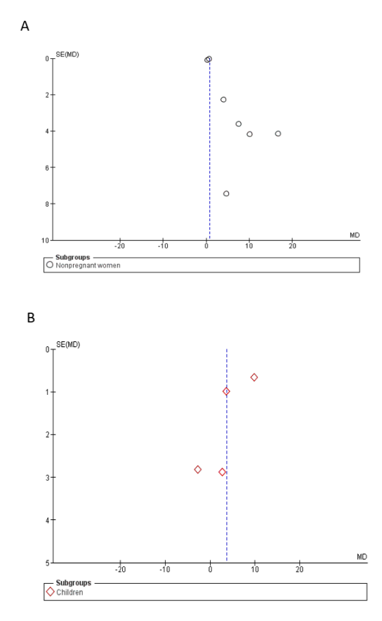
Supplementary figure 1: Funnel Plot- Supplementary Figure 2: Funnel Plot- Supplementary Figure 3: Funnel Plot-
Change in hemoglobin levels (gm/dl) Change in Ferritin levels (ng/ml) Fractional iron absorption (%)
A) Women A) Women A) Women
B) Children B) Children B) Children

