Content | Caption | Page
Table S1 | PRISMA checklist | 2-4
Table S2 | Literature search strategy | 5-7
Table S3 | NutriGrade evidence table for the effect of LCDs on TNF- and IL-6 levels. | 8
Fig. S1 | Forest plot showing the pooled effect size of low carbohydrate diets on TNF-α (pg/ml) levels using random effect model | 9
Fig. S2 | Forest plot showing the pooled effect size of low carbohydrate diets on IL-6 (pg/ml) levels using random effect model | 10
Fig. S3 | Forest plot showing the pooled effect size of low carbohydrate diets on TNF-α (pg/ml) levels and subgroup analysis based on the proportion of calories obtained from carbohydrate intake (<10%, 10-26% and 26-45%) | 11
Fig. S4 | Forest plot showing the pooled effect size of low carbohydrate diets on IL-6 (pg/ml) levels and subgroup analysis based on baseline IL-6 concentrations (≤2 pg/ml), using random effects model. | 12
Fig. S5 | Forest plot showing the pooled effect size of low carbohydrate diets on IL-6 (pg/ml) levels and subgroup analysis based on the proportion of calories obtained from carbohydrate intake (<10%, 10-26% and 26-45%) | 13

PRISMA checklist
Section and Topic | Item # | Checklist item | Location where item is reported
TITLE
Title | 1 | Identify the report as a systematic review. | Page 1
ABSTRACT
Abstract | 2 | See the PRISMA 2020 for Abstracts checklist. | Page 2
INTRODUCTION
Rationale | 3 | Describe the rationale for the review in the context of existing knowledge. | Page 3
Objectives | 4 | Provide an explicit statement of the objective(s) or question(s) the review addresses. | Page 4
METHODS
Eligibility criteria | 5 | Specify the inclusion and exclusion criteria for the review and how studies were grouped for the syntheses. | Page 5
Information sources | 6 | Specify all databases, registers, websites, organisations, reference lists and other sources searched or consulted to identify studies. Specify the date when each source was last searched or consulted. | Page 5
Search strategy | 7 | Present the full search strategies for all databases, registers and websites, including any filters and limits used. | Page 5
Selection process | 8 | Specify the methods used to decide whether a study met the inclusion criteria of the review, including how many reviewers screened each record and each report retrieved, whether they worked independently, and if applicable, details of automation tools used in the process. | Page 6
Data collection process | 9 | Specify the methods used to collect data from reports, including how many reviewers collected data from each report, whether they worked independently, any processes for obtaining or confirming data from study investigators, and if applicable, details of automation tools used in the process. | Page 6
Data items | 10a | List and define all outcomes for which data were sought. Specify whether all results that were compatible with each outcome domain in each study were sought (e.g. for all measures, time points, analyses), and if not, the methods used to decide which results to collect. | Page 6
Data items | 10b | List and define all other variables for which data were sought (e.g. participant and intervention characteristics, funding sources). Describe any assumptions made about any missing or unclear information. | Page 6
Study risk of bias assessment | 11 | Specify the methods used to assess risk of bias in the included studies, including details of the tool(s) used, how many reviewers assessed each study and whether they worked independently, and if applicable, details of automation tools used in the process. | Page 6
Effect measures | 12 | Specify for each outcome the effect measure(s) (e.g. risk ratio, mean difference) used in the synthesis or presentation of results. | Page 7
Synthesis methods | 13a | Describe the processes used to decide which studies were eligible for each synthesis (e.g. tabulating the study intervention characteristics and comparing against the planned groups for each synthesis (item #5)).
Synthesis methods | 13b | Describe any methods required to prepare the data for presentation or synthesis, such as handling of missing summary statistics, or data conversions.
Synthesis methods | 13c | Describe any methods used to tabulate or visually display results of individual studies and syntheses.
Synthesis methods | 13d | Describe any methods used to synthesize results and provide a rationale for the choice(s). If meta-analysis was performed, describe the model(s), method(s) to identify the presence and extent of statistical heterogeneity, and software package(s) used. | Page 7
Synthesis methods | 13e | Describe any methods used to explore possible causes of heterogeneity among study results (e.g. subgroup analysis, meta-regression). | Pages 7
Synthesis methods | 13f | Describe any sensitivity analyses conducted to assess robustness of the synthesized results. | Page 7
Reporting bias assessment | 14 | Describe any methods used to assess risk of bias due to missing results in a synthesis (arising from reporting biases). | Page 7
Certainty assessment | 15 | Describe any methods used to assess certainty (or confidence) in the body of evidence for an outcome. | Page 7
RESULTS
Study selection | 16a | Describe the results of the search and selection process, from the number of records identified in the search to the number of studies included in the review, ideally using a flow diagram. | Page 8, Fig 1
Study selection | 16b | Cite studies that might appear to meet the inclusion criteria, but which were excluded, and explain why they were excluded. | Page 8
Study characteristics | 17 | Cite each included study and present its characteristics. | Page 10, Table 2
Risk of bias in studies | 18 | Present assessments of risk of bias for each included study. | Page 13, Table 3
Results of individual studies | 19 | For all outcomes, present, for each study: (a) summary statistics for each group (where appropriate) and (b) an effect estimate and its precision (e.g. confidence/credible interval), ideally using structured tables or plots. | Page 15, Tables 4, 5 Figures S1, S2
Results of syntheses | 20a | For each synthesis, briefly summarise the characteristics and risk of bias among contributing studies. | Page 15
Results of syntheses | 20b | Present results of all statistical syntheses conducted. If meta-analysis was done, present for each the summary estimate and its precision (e.g. confidence/credible interval) and measures of statistical heterogeneity. If comparing groups, describe the direction of the effect. | Page 15
Results of syntheses | 20c | Present results of all investigations of possible causes of heterogeneity among study results. | Pages 16, 20 Tables 4, 5
Results of syntheses | 20d | Present results of all sensitivity analyses conducted to assess the robustness of the synthesized results. | Pages 16, 17
Reporting biases | 21 | Present assessments of risk of bias due to missing results (arising from reporting biases) for each synthesis assessed. | Page 20, Fig 2
Certainty of evidence | 22 | Present assessments of certainty (or confidence) in the body of evidence for each outcome assessed. | Page 22
DISCUSSION
Discussion | 23a | Provide a general interpretation of the results in the context of other evidence. | Pages 22-24
Discussion | 23b | Discuss any limitations of the evidence included in the review. | Page 25
Discussion | 23c | Discuss any limitations of the review processes used. | Page 25
Discussion | 23d | Discuss implications of the results for practice, policy, and future research. | Pages 25, 26
OTHER INFORMATION
Registration and protocol | 24a | Provide registration information for the review, including register name and registration number, or state that the review was not registered. | Page 5
Registration and protocol | 24b | Indicate where the review protocol can be accessed, or state that a protocol was not prepared. | Page 5
Registration and protocol | 24c | Describe and explain any amendments to information provided at registration or in the protocol. | Page 5
Support | 25 | Describe sources of financial or non-financial support for the review, and the role of the funders or sponsors in the review. | Page 27
Competing interests | 26 | Declare any competing interests of review authors. | Page 27
Availability of data, code and other materials | 27 | Report which of the following are publicly available and where they can be found: template data collection forms; data extracted from included studies; data used for all analyses; analytic code; any other materials used in the review. | Page 27

From: Page MJ, McKenzie JE, Bossuyt PM, Boutron I, Hoffmann TC, Mulrow CD, et al. The PRISMA 2020 statement: an updated guideline for reporting systematic reviews. BMJ 2021;372:n71. doi: 10.1136/bmj.n71. This work is licensed under CC BY 4.0. To view a copy of this license, visit https://creativecommons.org/licenses/by/4.0/
Table S2. Search strategy
Search strategy
PubMed
Search: ("Diet, Carbohydrate-Restricted"[Mesh] OR Carbohydrate Restricted*[Tiab] OR Diet, Carbohydrate Restricted*[Tiab] OR Diet, Low Carbohydrate*[Tiab] OR Diets, Low Carbohydrate*[Tiab] OR Carbohydrate Diet, Low*[Tiab] OR Carbohydrate Diets, Low*[Tiab] OR Low Carbohydrate*[Tiab] OR Low Carbohydrate Diet*[Tiab] OR Low Carbohydrate Diets*[Tiab] OR Carbohydrate-Restricted Diet*[Tiab] OR Carbohydrate Restricted Diet*[Tiab] OR Carbohydrate-Restricted Diets*[Tiab] OR Diets, Carbohydrate-Restricted*[Tiab] OR Carbohydrate-Restricted*[Tiab] OR Low-Carbohydrate Diet*[Tiab] OR Low-Carbohydrate*[Tiab] OR Diets, Low-Carbohydrate*[Tiab] OR "Diet, Ketogenic"[Mesh] OR Ketogenic Diet*[Tiab] OR Ketogenic*[Tiab] OR "Diet, Paleolithic"[Mesh] OR Paleolithic Diet*[Tiab] OR Paleo*[Tiab] OR Caveman*[Tiab] OR Caveman Diet*[Tiab] OR Hunter-Gatherer*[Tiab] OR Hunter Gatherer*[Tiab] OR Hunter-Gatherer Diet*[Tiab] OR atkins diet*[Tiab] OR diet, atkins*[tiab] OR modified atkins diet*[Tiab] OR MAD diet*[Tiab] OR "Diet, High-Protein Low-Carbohydrate"[Mesh] OR high-protein low-carbohydrate diet*[Tiab] OR very low carbohydrate diet*[Tiab] OR very low-carbohydrate diet*[Tiab]) AND (fasting glucose*[tiab] OR "Triglycerides"[Mesh] OR triacylglycerols*[tiab] OR "Lipoproteins, LDL"[Mesh] OR low-density lipoprotein*[tiab] OR LDL*[tiab] OR "Lipoproteins, HDL"[Mesh] OR high density lipoprotein*[tiab] OR Heavy Lipoproteins*[tiab] OR "Lipoproteins, VLDL"[Mesh] OR VLDL Lipoproteins*[tiab] OR Prebeta-Lipoproteins*[tiab] OR "insulin"[Mesh] OR fasting blood sugar*[tiab] OR "Hemoglobin A, Glycosylated"[tiab] OR HbA1c*[tiab] OR glycosylated hemoglobin*[tiab] OR "Glycated Hemoglobin A"[Mesh] OR adhesion molecules*[tiab] OR "Thrombosis"[Mesh] OR Thromboses*[tiab] OR Thrombus*[tiab] OR "cytokines"[Mesh] OR cytokine*[tiab] OR "E-Selectin"[Mesh] OR"P-Selectin"[Mesh] OR "inflammation"[Mesh] OR inflammatory markers*[Tiab] OR VCAM*[tiab] OR ICAM*[tiab] OR "selectins"[Mesh] OR "interleukins"[Mesh] OR interleukin*[tiab] OR IL6*[tiab] OR "Cell Adhesion Molecules"[Mesh] OR "Interleukin-6"[Mesh] OR IL-6*[tiab] OR Interleukin 6*[tiab] OR Tumor Necrosis Factor*[tiab] OR "Tumor Necrosis Factor-alpha"[Mesh] OR TNF alpha*[tiab] OR TNF-alpha*[tiab] OR Cachectin-Tumor Necrosis Factor*[tiab] OR TNF-alpha*[tiab] OR Tumor Necrosis Factor Ligand Superfamily Member 2*[tiab] OR Cachectin*[tiab] OR Cachectin Tumor Necrosis Factor*[tiab] OR TNF Superfamily, Member 2*[tiab] OR "Atherosclerosis"[Mesh] OR Atheroscleroses*[tiab] OR Atherogenesis*[tiab])
Embase
[(diet OR carbohydrate-restricted OR low carbohydrate diet/exp OR dietary carbohydrates OR ketogenic diet OR Atkins diet OR high protein diet) AND (inflammation OR inflammatory markers/exp OR interleukin-6 OR IL-6 OR Tumor necrosis factor-alpha OR TNF-alpha OR TNF-α] AND [randomized controlled trial]/lim AND [humans]/lim AND [embase]/lim”
Scopus
( TITLE-ABS-KEY ( "ketogenic" OR "ketogenic diet" OR "ketosis" OR "ketone bodies" OR "ketones" OR "low carbohydrate high-fat diet" OR "low carbohydrate ketogenic diet" OR "ketogenic low carbohydrate, high fat diet" OR "low carbohydrate diet" ) AND TITLE-ABS-KEY ( "inflammation" OR "inflammatory" OR "cytokine" OR "interleukin-6" OR "interleukin6" OR "IL-6" OR "IL6" OR "Tumor necrosis factor alpha" OR "Tumor necrosis factor-alpha" OR "Tumor necrosis factor" OR "TNF-alpha" OR "TNFalpha" OR "TNF-α" OR "TNFα" OR "CRP" OR "C-reactive protein" OR "high-sensitivity C-reactive protein" OR "hs-CRP" OR "adhesion molecules" OR "E-Selectin" OR "P-Selectin" OR "VCAM" OR "ICAM" OR "selectins" ) AND TITLE-ABS-KEY ( "randomized control trial" OR "randomized clinical trial" OR "randomized" OR "random*" ) )
Web of science
TS=(“ketogenic” or “ketogenic diet” or “ketosis” or “ketone bodies” or “ketones” or “low carbohydrate high-fat diet” or “low carbohydrate ketogenic diet” or “ketogenic low carbohydrate, high fat diet” or “low carbohydrate diet”))
TS=(“inflammation” or “inflammatory” or “cytokine” or “interleukin-6” or “interleukin6” or “IL-6” or “IL6” or “Tumor necrosis factor alpha” or “Tumor necrosis factor-alpha” or “Tumor necrosis factor” or “TNF-alpha” or “TNFalpha” or “TNF-α” or “TNFα” or “CRP” or “C-reactive protein” or “high-sensitivity C-reactive protein” or “hs-CRP”)
TS=("randomized control trial" or "randomized clinical trial" or "randomized" or "random*")
#1 AND #2 AND #3
Cochrane database
(Diet OR carbohydrate-restricted OR low carbohydrate diet OR dietary carbohydrates OR ketogenic diet OR Atkins diet OR high protein diet) AND (inflammation OR inflammatory markers OR interleukin-6 OR IL-6 OR Tumor necrosis factor-alpha OR TNF-alpha OR TNF-α) in Title Abstract Keyword - in Trials (Word variations have been searched)

Table S3- NutriGrade evidence table for the effect of LCDs on TNF- and IL-6 levels.
Certainty assessment
№ of studies (Num. participants) | Risk of bias, study quality, and study limitations | Precision | Heterogeneity | Directness | Publication bias | Funding bias | Study design | Total score
TNF-α
24 (1420) | 2 | 0 | 1 | 0 | 0 | 1 | 2 | 6.7
IL-6
28 (1725) | 2 | 1 | 0.7 | 0 | 1 | 1 | 2 | 7.7

Fig. S1. Forest plot showing the pooled effect size of low carbohydrate diets on TNF-α (pg/ml) levels using random effect model.

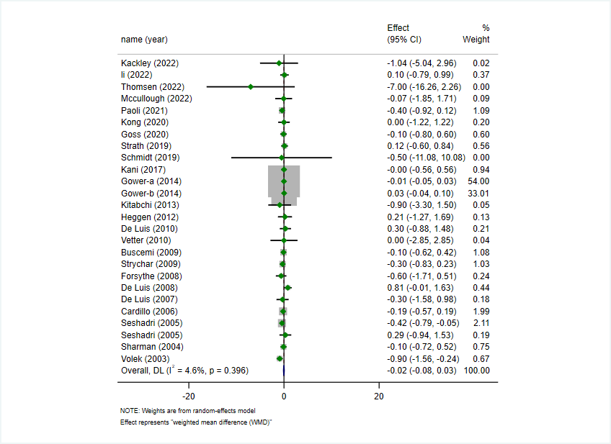

Fig. S2. Forest plot showing the pooled effect size of low carbohydrate diets on IL-6 (pg/ml) levels using random effect model

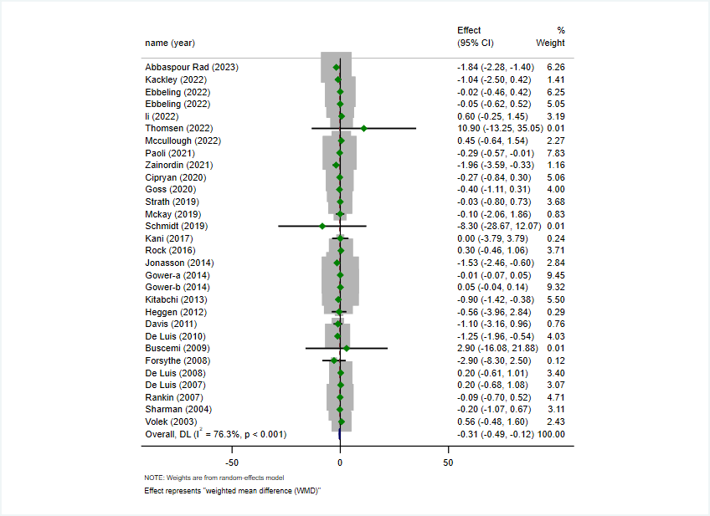

Fig. S3. Forest plot showing the pooled effect size of low carbohydrate diets on TNF-α (pg/ml) levels and subgroup analysis based on the proportion of calories obtained from carbohydrate intake (<10%, 10-26% and 26-45%)

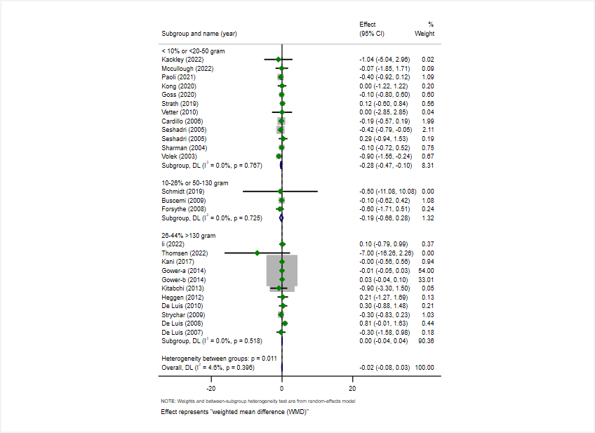

Fig. S4. Forest plot showing the pooled effect size of low carbohydrate diets on IL-6 (pg/ml) levels and subgroup analysis based on baseline IL-6 concentrations (≤2 pg/ml), using random effects model.

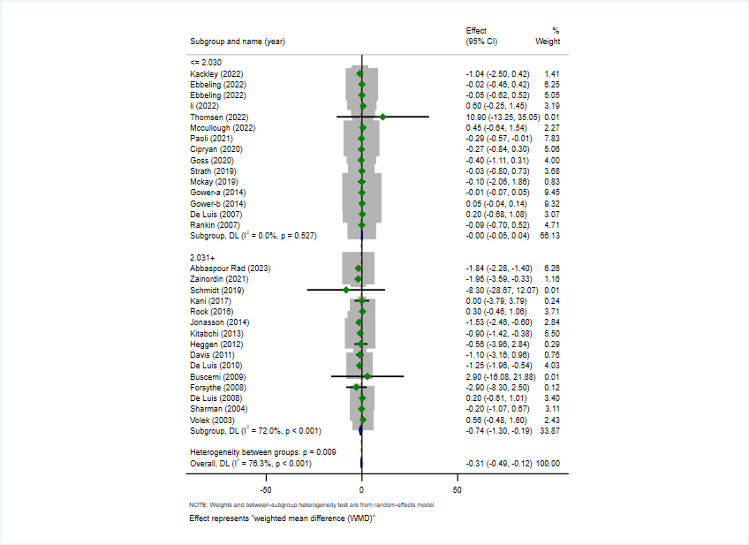

Fig. S5. Forest plot showing the pooled effect size of low carbohydrate diets on IL-6 (pg/ml) levels and subgroup analysis based on the proportion of calories obtained from carbohydrate intake (<10%, 10-26% and 26-45%).

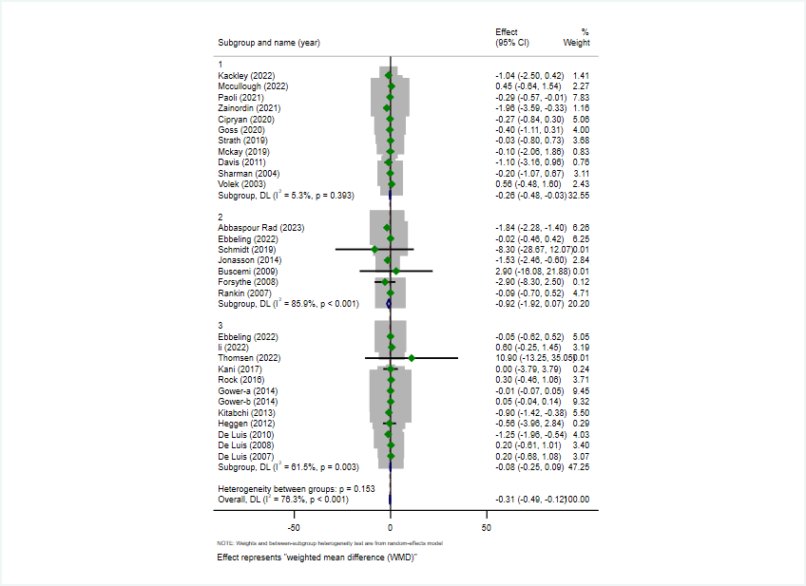
Note: the labels of “1, 2 and 3” described LCDs when carbohydrate intake was restricted to <10 % (20-50 g/d), 10-26% (50–130 g/day) and 26-44% (130–225 g/day), respectively.

