Supplementary Table 1. Detailed search terms in the databases
Database | Search term
PubMed | ("Dietary diversity"[Title/Abstract] OR "dietary diversity score"[Title/Abstract] OR "dietary score"[Title/Abstract] OR "DDS"[Title/Abstract] OR "diversity score"[Title/Abstract] OR "diet diversity"[Title/Abstract] OR "household dietary diversity"[Title/Abstract]) AND (‘Anemia’(Mesh) OR ‘Anemia’[Title/Abstract] OR ‘Anemias’[Title/Abstract] OR ‘Iron Deficiency Anemia’[Title/Abstract])
Scopus | (TITLE-ABS ("Dietary diversity") OR TITLE-ABS ("dietary diversity score") OR TITLE-ABS ("DDS") OR TITLE-ABS ("diversity score") OR TITLE-ABS ("diet diversity") OR TITLE-ABS ( "household dietary diversity")) AND ( TITLE-ABS (anemia) OR TITLE-ABS (anemias) OR TITLE-ABS (“iron AND deficiency AND anemia”))
ISI Web of Science | (TS=("Dietary diversity") OR TS=("dietary diversity score") OR TS=(DDS) OR TS=("diversity score") OR TS=("diet diversity") OR TS=("household dietary diversity")) AND (TS=(Anemia) OR TS=(Anemias) OR TS=("Iron Deficiency Anemia"))

Supplementary Table 2. List of excluded studies with the exclusion results.
list of studies excluded | Reason
Wemakor et al,2023(1); Hoteit et al, 2022 (2), Ahmed et al,2022(3); Shinde et al, 2021(4), Seyoum et al.2019(5), Stativa et al.2023(6), Murtaza et al. 2023(7), Liao et al. 2023(8), Castro et al.2023(9) | Required data not reported
Tezol et al.2023(10); Al-Bayyari et al.2020(11), Deng et al.2020(12), Seid et al. 2023(13), Delil et al. 2018(14) | Conducted on adults
Woldie et al.2015(15), Sodde et al.2023(16), Parbey et al. 2019(17) | Duplicate studies
Gebreyesus et al.2019, Regasa et al.2019, Mengistu et al.2019 | Without the essential data for meta-analysis

1. Wemakor A, Kwaako M, Abdul-Rahman A. Nutritional, health and socio-demographic determinants of anaemia in adolescent girls in Kumbungu District, Ghana. BMC nutrition. 2023;9(1):90.
2. Hoteit M, Mohsen H, Yazbeck N, Diab S, Sarkis J, Sacre Y, et al. Household Food Insecurity, Anemia, Malnutrition and Unfavorable Dietary Diversity among Adolescents: Quadruple Whammies in the Era of Escalating Crises in Lebanon. Nutrients. 2022;14(24).
3. Ahmed A, Mohammed A. Anemia and its associated factor among adolescent school girls in GODEY and DEGEHABUR council Somali region, eastern Ethiopia. BMC nutrition. 2022;8(1):55.
4. Shinde S, Madzorera I, Fawzi WW. Association of iron supplementation and dietary diversity with nutritional status and learning outcomes among adolescents: Results from a longitudinal study in Uttar Pradesh and Bihar, India. Journal of global health. 2021;11:04037.
5. Seyoum Y, Humblot C, Nicolas G, Thomas M, Baye K. Iron deficiency and anemia in adolescent girls consuming predominantly plant-based diets in rural Ethiopia. Scientific reports. 2019;9(1):17244.
6. Stativa E, Rus AV, Lee WC, Salinas KAD, Cossey HM, Lobo A, et al. Predictors of height in Romanian infants 6-23 months old: findings from a national representative sample. Journal of public health (Oxford, England). 2023;45(4):e714-e21.
7. Murtaza SF, Lee LJ, Usaini NN, Gan WY, Sulaiman N. Factors Associated With Anemia Among Orang Asli Children Aged Two to Six Years in Negeri Sembilan, Malaysia. Cureus. 2023;15(2):e35511
8. Murtaza SF, Lee LJ, Usaini NN, Gan WY, Sulaiman N. Factors Associated With Anemia Among Orang Asli Children Aged Two to Six Years in Negeri Sembilan, Malaysia. Cureus. 2023;15(2):e35511
9. Castro IRR, Anjos LAD, Lacerda EMA, Boccolini CS, Farias DR, Alves-Santos NH, et al. Nutrition transition in Brazilian children under 5 years old from 2006 to 2019. Cadernos de saude publica. 2023;39(Suppl 2):e00216622.

10. Tezol Ö, Mammadova S. Mother's Nutrition Literacy and Offspring Anemia: A Comparison Study in a Single Center. Turkish archives of pediatrics. 2023;58(6):638-45.
11. Al-Bayyari N, Al Sabbah H, Hailat M, AlDahoun H, Abu-Samra H. Dietary diversity and iron deficiency anemia among a cohort of singleton pregnancies: a cross-sectional study. BMC Public Health. 2024;24(1):1840.

12. Deng Q, Zhao T, Liu C, Kuang X, Zheng J, Wahlqvist ML, Li D. Dietary patterns and anemia morphology in young men and women in Shandong province, China. Asia Pac J Clin Nutr. 2020;29(3):513-22.

13. Seid A, Dugassa Fufa D, Weldeyohannes M, Tadesse Z, Fenta SL, Bitew ZW, Dessie G. Inadequate dietary diversity during pregnancy increases the risk of maternal anemia and low birth weight in Africa: A systematic review and meta-analysis. Food Sci Nutr. 2023;11(7):3706-17.
14. Delil R, Tamiru D, Zinab B. Dietary Diversity and Its Association with Anemia among Pregnant Women Attending Public Health Facilities in South Ethiopia. Ethiop J Health Sci. 2018;28(5):625-34.

15. Woldie H, Kebede Y, Tariku A. Factors Associated with Anemia among Children Aged 6-23 Months Attending Growth Monitoring at Tsitsika Health Center, Wag-Himra Zone, Northeast Ethiopia. Journal of nutrition and metabolism. 2015;2015:928632.
16. Sodde FM, Liga AD, Jabir YN, Tamiru D, Kidane R. Magnitude and predictors of anemia among preschool children (36-59 months) in Atingo town, Jimma, Ethiopia. Health science reports. 2023;6(6):e1358

17. Parbey PA, Tarkang E, Manu E, Amu H, Ayanore MA, Aku FY, et al. Risk Factors of Anaemia among Children under Five Years in the Hohoe Municipality, Ghana: A Case Control Study. Anemia. 2019;2019

18. Mengistu G, Azage M, Gutema H. Iron Deficiency Anemia among In-School Adolescent Girls in Rural Area of Bahir Dar City Administration, North West Ethiopia. Anemia. 2019;2019:1097547.
19. Regasa RT, Haidar JA. Anemia and its determinant of in-school adolescent girls from rural Ethiopia: a school based cross-sectional study. BMC women's health. 2019;19:1-7.
20. Gebreyesus SH, Endris BS, Beyene GT, Farah AM, Elias F, Bekele HN. Anaemia among adolescent girls in three districts in Ethiopia. BMC public health. 2019;19:1-11.

Supplementary Table 3. Quality assessment of included studies using the ROBINS-E tool.
First Author (Year) | D1 (Confounding) | D2 (Classification of Exposure) | D3 (Selection of Participants) | D4 (Deviation from Intended Interventions) | D5 (Missing Data) | D6 (Outcome Measurement) | D7 (Selective Reporting) | Overall Risk of Bias
Khanal (2024) | High risk | High risk | Some concerns | Not applicable | Low risk | Some concerns | Some concerns | High risk
Kumar (2023) | Very high risk | High risk | Some concerns | Not applicable | Some concerns | Some concerns | Some concerns | Very high risk
Zavala (2023) | Some concerns | High risk | Some concerns | Not applicable | Low risk | Low risk | Some concerns | Some concerns
Sodde (2023) | High risk | High risk | Some concerns | Not applicable | Low risk | Some concerns | Some concerns | High risk
Fentaw (2023) | Some concerns | High risk | Some concerns | Not applicable | Low risk | Some concerns | Some concerns | High risk
Kathuria (2023) | High risk | High risk | Some concerns | Not applicable | Some concerns | Some concerns | Some concerns | High risk
Mank (2022) | Some concerns | Some concerns | Some concerns | Not applicable | Low risk | Low risk | Some concerns | Some concerns
Lweno (2022) | Very high risk | High risk | Some concerns | Not applicable | Low risk | Some concerns | Some concerns | Very high risk
Tegegne (2022) | Some concerns | High risk | Some concerns | Not applicable | Low risk | Some concerns | Some concerns | High risk
Hiruy (2021) | Some concerns | High risk | Some concerns | Not applicable | Low risk | Some concerns | Some concerns | High risk
Said (2021) | High risk | High risk | Some concerns | Not applicable | Some concerns | Some concerns | Some concerns | High risk
Orsango (2021) | High risk | High risk | Low risk | Not applicable | Some concerns | Low risk | Some concerns | High risk
Alamneh(2021) | Some concerns | High risk | Some concerns | Not applicable | High risk | Some concerns | Some concerns | High risk
Molla (2020) | High risk | High risk | Some concerns | Not applicable | High risk | Some concerns | Some concerns | High risk
Tura (2020) | High risk | Very high risk | Some concerns | Not applicable | Very high risk | Some concerns | Some concerns | Very high risk
Fentie (2020) | High risk | High risk | Low risk | Not applicable | Low risk | Some concerns | Low risk | High risk
Fage (2020) | Some concerns | High risk | High risk | Not applicable | Some concerns | Low risk | Some concerns | High risk
Agustina (2020) | High risk | High risk | Some concerns | Not applicable | Low risk | Some concerns | Some concerns | High risk
Visser (2020) | High risk | High risk | Some concerns | Not applicable | Low risk | Some concerns | Some concerns | High risk
Malako (2019) | Some concerns | Some concerns | Some concerns | Not applicable | Some concerns | Some concerns | Some concerns | Some concerns
Alemayehu (2019) | Some concerns | High risk | Some concerns | Not applicable | Low risk | Some concerns | High risk | High risk
Parbey (2019) | High risk | High risk | Some concerns | Not applicable | Low risk | Some concerns | Some concerns | High risk
Gonete (2018) | Very high risk | Very high risk | High risk | Not applicable | Low risk | Some concerns | Some concerns | Very high risk
Malako (2018) | Some concerns | Some concerns | Some concerns | Not applicable | Low risk | Low risk | Some concerns | Some concerns
Gosdin (2018) | High risk | High risk | High risk | Not applicable | Low risk | Some concerns | Some concerns | High risk
Getaneh (2017) | High risk | Very high risk | Some concerns | Not applicable | Low risk | Some concerns | Some concerns | Very high risk
Tiku (2017) | Very high risk | Very high risk | Some concerns | Not applicable | High risk | Some concerns | Some concerns | Very high risk
Nair (2016) | High risk | High risk | Some concerns | Not applicable | Some concerns | High risk | Some concerns | High risk
Woldie (2015) | High risk | High risk | High risk | Not applicable | Some concerns | Some concerns | Low risk | High risk

D1 (Confounding): Evaluates whether key confounders (e.g., socioeconomic status, maternal education, dietary intake) were adjusted for in analyses. The final column provides the overall risk of bias, categorized as "Low risk," "Some concerns," "High risk," or "Very high risk."

D2 (Classification of Exposure): Assesses how dietary diversity was measured and the potential for measurement error (e.g., reliance on a single 24-hour recall).
D3 (Selection of Participants): Examines if participants were selected in a way that could introduce bias.
D4 (Deviation from Intended Interventions)
D5 (Missing Data): Considers whether missing data was properly handled to avoid bias.
D6 (Outcome Measurement): Evaluates whether anemia was accurately measured with minimal bias.
D7 (Selective Reporting): Reviews whether study results were selectively reported in a way that could influence conclusions.

Supplementary figure 1: Sensitivity analysis among the studies that evaluated the association between dietary diversity and anemia risk among 0 to 5 years old children
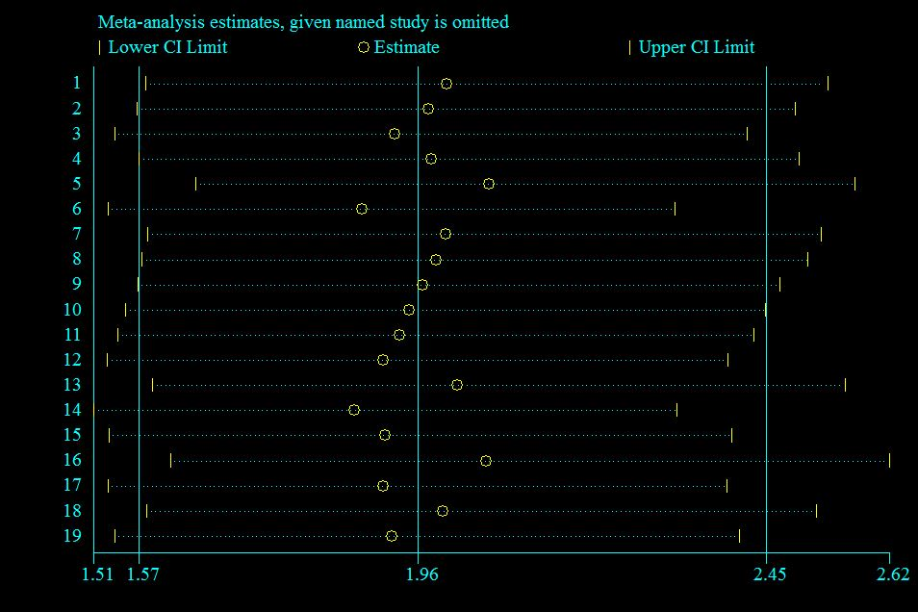

Supplementary figure 2: Sensitivity analysis among the studies that evaluated the association between dietary diversity and anemia risk among 6 to 18 years old children
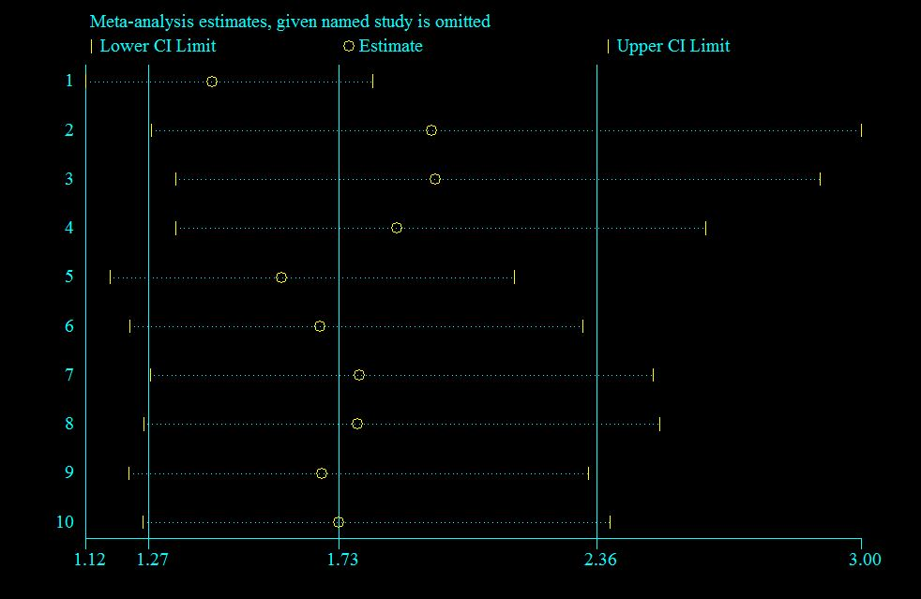

Section and Topic | Item # | Checklist item | Location where item is reported
TITLE |  |  | Page 1
Title | 1 | Identify the report as a systematic review.
ABSTRACT
Abstract | 2 | See the PRISMA 2020 for Abstracts checklist. | Page 2
INTRODUCTION
Rationale | 3 | Describe the rationale for the review in the context of existing knowledge. | 3
Objectives | 4 | Provide an explicit statement of the objective(s) or question(s) the review addresses. | 4
METHODS
Eligibility criteria | 5 | Specify the inclusion and exclusion criteria for the review and how studies were grouped for the syntheses. | 5
Information sources | 6 | Specify all databases, registers, websites, organisations, reference lists and other sources searched or consulted to identify studies. Specify the date when each source was last searched or consulted. | 4
Search strategy | 7 | Present the full search strategies for all databases, registers and websites, including any filters and limits used. | Supplementary Table 1
Selection process | 8 | Specify the methods used to decide whether a study met the inclusion criteria of the review, including how many reviewers screened each record and each report retrieved, whether they worked independently, and if applicable, details of automation tools used in the process. | 5-6
Data collection process | 9 | Specify the methods used to collect data from reports, including how many reviewers collected data from each report, whether they worked independently, any processes for obtaining or confirming data from study investigators, and if applicable, details of automation tools used in the process. | 6
Data items | 10a | List and define all outcomes for which data were sought. Specify whether all results that were compatible with each outcome domain in each study were sought (e.g. for all measures, time points, analyses), and if not, the methods used to decide which results to collect. | 5
Data items | 10b | List and define all other variables for which data were sought (e.g. participant and intervention characteristics, funding sources). Describe any assumptions made about any missing or unclear information. | 5
Study risk of bias assessment | 11 | Specify the methods used to assess risk of bias in the included studies, including details of the tool(s) used, how many reviewers assessed each study and whether they worked independently, and if applicable, details of automation tools used in the process. | 6
Effect measures | 12 | Specify for each outcome the effect measure(s) (e.g. risk ratio, mean difference) used in the synthesis or presentation of results. | 7, figure 2
Synthesis methods | 13a | Describe the processes used to decide which studies were eligible for each synthesis (e.g. tabulating the study intervention characteristics and comparing against the planned groups for each synthesis (item #5)). | 7
Synthesis methods | 13b | Describe any methods required to prepare the data for presentation or synthesis, such as handling of missing summary statistics, or data conversions. | 7
Synthesis methods | 13c | Describe any methods used to tabulate or visually display results of individual studies and syntheses. | 8
Synthesis methods | 13d | Describe any methods used to synthesize results and provide a rationale for the choice(s). If meta-analysis was performed, describe the model(s), method(s) to identify the presence and extent of statistical heterogeneity, and software package(s) used. | 8
Synthesis methods | 13e | Describe any methods used to explore possible causes of heterogeneity among study results (e.g. subgroup analysis, meta-regression). | 8
Synthesis methods | 13f | Describe any sensitivity analyses conducted to assess robustness of the synthesized results. | 8
Reporting bias assessment | 14 | Describe any methods used to assess risk of bias due to missing results in a synthesis (arising from reporting biases). | 8
Certainty assessment | 15 | Describe any methods used to assess certainty (or confidence) in the body of evidence for an outcome. | 9
RESULTS
Study selection | 16a | Describe the results of the search and selection process, from the number of records identified in the search to the number of studies included in the review, ideally using a flow diagram. | 9
Study selection | 16b | Cite studies that might appear to meet the inclusion criteria, but which were excluded, and explain why they were excluded. | Supplementary Table 2
Study characteristics | 17 | Cite each included study and present its characteristics. | 11
Risk of bias in studies | 18 | Present assessments of risk of bias for each included study. | 11 and Supplementary Table 3
Results of individual studies | 19 | For all outcomes, present, for each study: (a) summary statistics for each group (where appropriate) and (b) an effect estimate and its precision (e.g. confidence/credible interval), ideally using structured tables or plots. | Figure 2 and table 1
Results of syntheses | 20a | For each synthesis, briefly summarise the characteristics and risk of bias among contributing studies. | 11
Results of syntheses | 20b | Present results of all statistical syntheses conducted. If meta-analysis was done, present for each the summary estimate and its precision (e.g. confidence/credible interval) and measures of statistical heterogeneity. If comparing groups, describe the direction of the effect. | 11
Results of syntheses | 20c | Present results of all investigations of possible causes of heterogeneity among study results. | 10-12
Results of syntheses | 20d | Present results of all sensitivity analyses conducted to assess the robustness of the synthesized results. | 11 and Supplementary figures
Reporting biases | 21 | Present assessments of risk of bias due to missing results (arising from reporting biases) for each synthesis assessed. | 11
Certainty of evidence | 22 | Present assessments of certainty (or confidence) in the body of evidence for each outcome assessed. | 13
DISCUSSION
Discussion | 23a | Provide a general interpretation of the results in the context of other evidence. | 13
Discussion | 23b | Discuss any limitations of the evidence included in the review. | 18
Discussion | 23c | Discuss any limitations of the review processes used. | 18
Discussion | 23d | Discuss implications of the results for practice, policy, and future research. | 18
OTHER INFORMATION
Registration and protocol | 24a | Provide registration information for the review, including register name and registration number, or state that the review was not registered. | 4
Registration and protocol | 24b | Indicate where the review protocol can be accessed, or state that a protocol was not prepared. | 4
Registration and protocol | 24c | Describe and explain any amendments to information provided at registration or in the protocol. | Not applicable
Support | 25 | Describe sources of financial or non-financial support for the review, and the role of the funders or sponsors in the review. | 19
Competing interests | 26 | Declare any competing interests of review authors. | 19
Availability of data, code and other materials | 27 | Report which of the following are publicly available and where they can be found: template data collection forms; data extracted from included studies; data used for all analyses; analytic code; any other materials used in the review. | 19

