Supplementary Appendix 1: Search Strategies
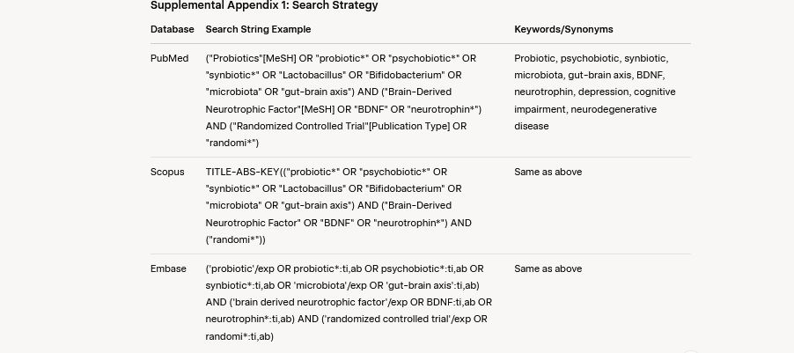

To ensure a comprehensive search, grey literature was explored using the following sources:
- Conference Proceedings: Searched via Web of Science Conference Proceedings Citation Index and Google Scholar using terms such as “probiotic,” “psychobiotic,” “BDNF,” and “gut-brain axis” to identify relevant abstracts or presentations from conferences (e.g., International Scientific Association for Probiotics and Prebiotics meetings).
- Theses and Dissertations: Searched through ProQuest Dissertations & Theses Global and DART-Europe with keywords including “probiotic supplementation,” “Brain-derived neurotrophic factor,” and “gut microbiota.”
- Reports: Searched OpenGrey and the Grey Literature Report for policy reports, technical reports, or white papers related to probiotics and neurotrophic factors.
- Clinical Trials: ClinicalTrials.gov was searched using terms like “probiotic” AND “BDNF” to identify registered but unpublished trials.
- Expert Consultation: Experts in probiotics and gut-brain axis research were contacted in April 2025 to identify additional unpublished or ongoing studies.
No additional studies meeting the inclusion criteria were identified from these grey literature sources, confirming the robustness of the primary database search.

