Vitamin D Metabolites and Gut Microbiota Dietary Index Are Associated with Reduced All-Cause Mortality in US Adults: Evidence from a National Population-Based Study

Qiang Zou¹, Bolin Fu¹, Yongsheng Gou¹, Gang Zhong³, Yalan Liu^{2,*}

¹ Department of Orthopedics, The First People’s Hospital of Shuangliu District, Chengdu 610200, China
² Nanan District Center for Disease Control and Prevention, Chongqing 401336, China
³ Department of Orthopedics, Orthopedic Research Institute, West China Hospital, Sichuan University, No. 37 Guo Xue Xiang, Chengdu, Sichuan, 610041, China
*Corresponding Author:
Yalan Liu
Nanan District Center for Disease Control and Prevention, Chongqing 401336, China
Email: 17321857829@163.com
ORCID: 0009-0000-2006-777X
Authors and Affiliations:
Qiang Zou
Department of Orthopedics, The First People’s Hospital of Shuangliu District, Chengdu 610200, China
Email:zouqiang0108@163.com
Bolin Fu
Department of Orthopedics,The First People’s Hospital of Shuangliu District, Chengdu 610200, China
Email: hxsongyueming@163.com
Yongsheng Gou
Department of Orthopedics,The First People’s Hospital of Shuangliu District, Chengdu 610200, China
Email: hxzhouzhongjie@163.com
Gang Zhong
Department of Orthopedics, Orthopedic Research Institute, West China Hospital, Sichuan University, No. 37 Guo Xue Xiang, Chengdu, Sichuan, 610041, China
Email: hxdrwanglei@163.com
Yalan Liu
Nanan District Center for Disease Control and Prevention, Chongqing 401336, China
Email: 17321857829@163.com
ORCID: 0009-0000-2006-777X

Supplementary Table1 Mediation analysis for the associations between 25-hydroxyvitamin D3 and survival
Independent variable | Mediator | Total effect |  | Indirect effect |  | Direct effect |  | Proportion mediated, % (95% CI)
Independent variable | Mediator | Coefficient (95% CI) | P value | Coefficient (95% CI) | P value | Coefficient (95% CI) | P value | Proportion mediated, % (95% CI)
25-hydroxyvitamin D3 | DI-GM | 5.59 (4.22, 7.14) | <0.001 | 0.21 (0.08, 0.35) | <0.001 | 5.38 (3.94, 6.91) | <0.001 | 3.7 (1.2, 7.1)
The mediation analyses were adjusted for age, gender, race, education level, body mass index, family income-to-poverty ratio (PIR), smoking, drinking, hypertension, diabetes, and history of cancer or malignancy.

Supplementary Table2 Mediation analysis for the associations between epi-25-hydroxyvitamin D3 and survival
Independent variable | Mediator | Total effect |  | Indirect effect |  | Direct effect |  | Proportion mediated, % (95% CI)
Independent variable | Mediator | Coefficient (95% CI) | P value | Coefficient (95% CI) | P value | Coefficient (95% CI) | P value | Proportion mediated, % (95% CI)
epi-25-hydroxyvitamin D3 | DI-GM | 56.97 (34.25, 79.20) | <0.001 | 1.50 (0.46, 2.76) | <0.001 | 55.47 (32.30, 77.39) | <0.001 | 2.6 (0.8, 5.0)
The mediation analyses were adjusted for age, gender, race, education level, body mass index, family income-to-poverty ratio (PIR), smoking, drinking, hypertension, diabetes, and history of cancer or malignancy.

Supplementary Table3 Mediation analysis for the associations between vtamin D and survival
Independent variable | Mediator | Total effect |  | Indirect effect |  | Direct effect |  | Proportion mediated, % (95% CI)
Independent variable | Mediator | Coefficient (95% CI) | P value | Coefficient (95% CI) | P value | Coefficient (95% CI) | P value | Proportion mediated, % (95% CI)
Vitamin D | DI-GM | 5.32 (3.86, 6.76) | <0.001 | 0.23 (0.07, 0.38) | <0.001 | 5.08 (3.60, 6.59) | <0.001 | 4.4 (1.1, 8.4)
The mediation analyses were adjusted for age, gender, race, education level, body mass index, family income-to-poverty ratio (PIR), smoking, drinking, hypertension, diabetes, and history of cancer or malignancy.

- 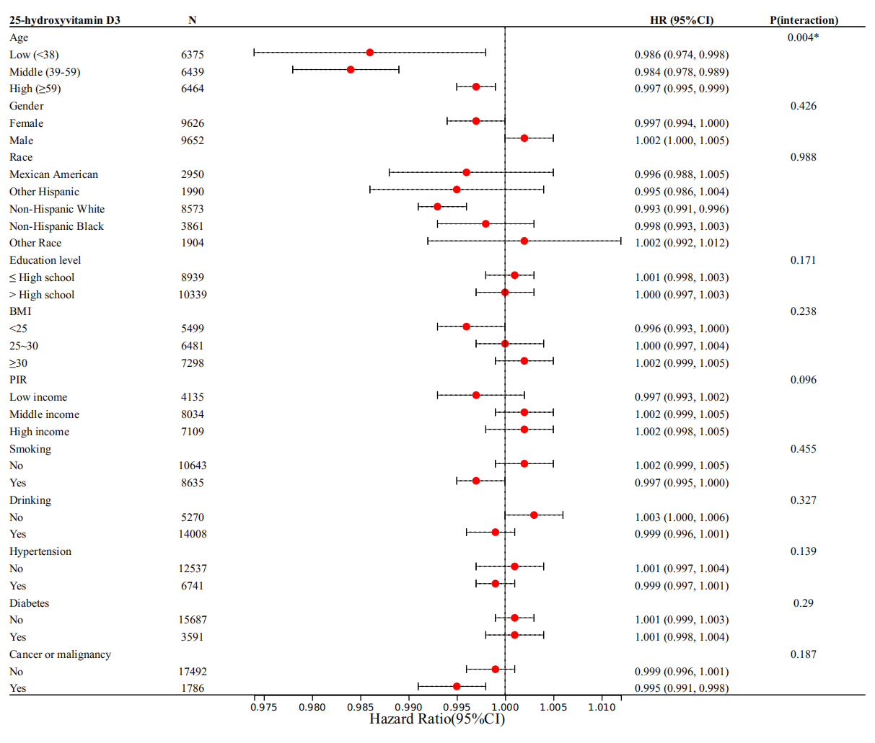
- 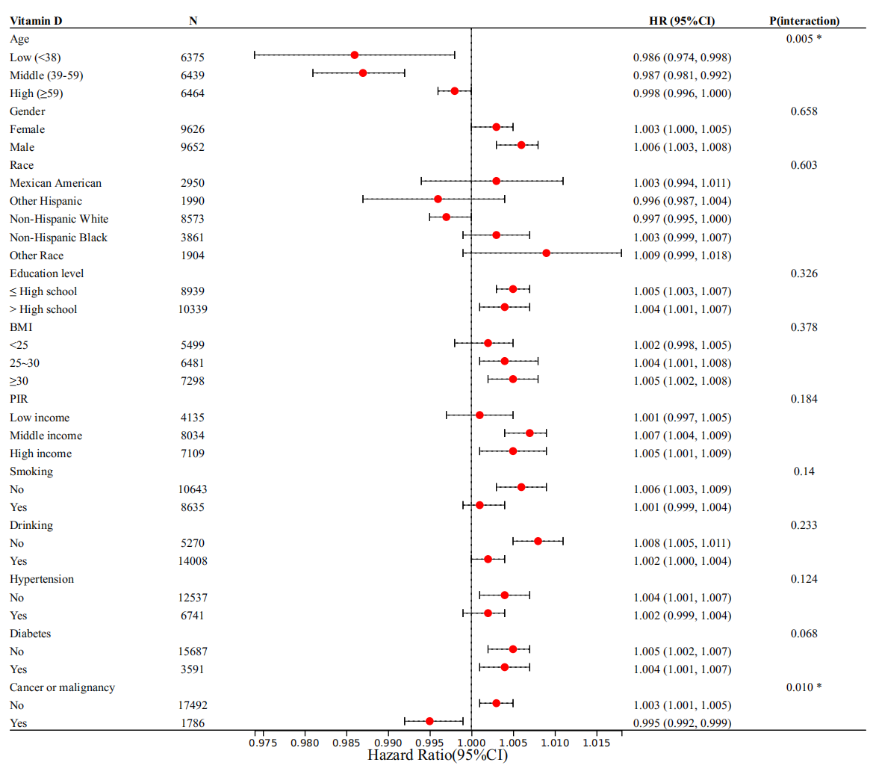
- 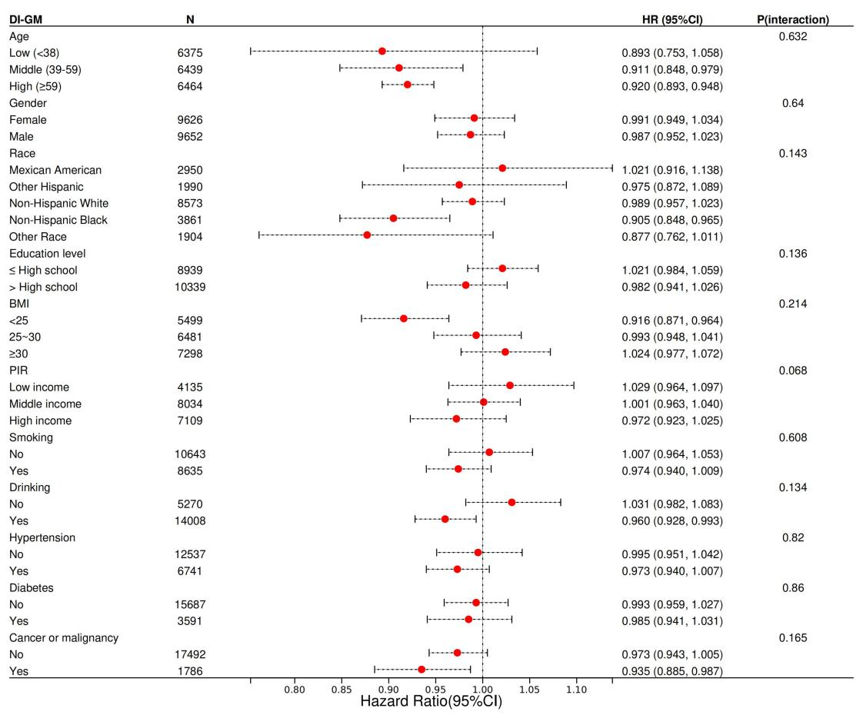
Supplementary Figure 1. Subgroup analyses of the association between vitamin D metabolites, DI-GM, and all-cause mortality among US adults in NHANES 2005–2018. Forest plots are presented for (A) 25-hydroxyvitamin D3, (B) 3-epi-25-hydroxyvitamin D3, (C) total vitamin D and (D) dietary index for gut microbiota (DI-GM). Forest plots show hazard ratios (HRs) and 95% confidence intervals (CIs) for all-cause mortality across stratified subgroups. Models were adjusted for age, gender, race, education level, body mass index (BMI), family income-to-poverty ratio (PIR), smoking status, drinking status, hypertension, diabetes, and history of cancer or malignancy—except for the variable used for stratification. P-values for interaction were calculated for each subgroup. Abbreviations: HR, hazard ratio; CI, confidence interval; BMI, body mass index; PIR, poverty income ratio. P<0.05 indicates statistically significant interaction.

