Supplementary File:
Supplementary Figure. 1S Distribution of participants by Channel category, n=143,878
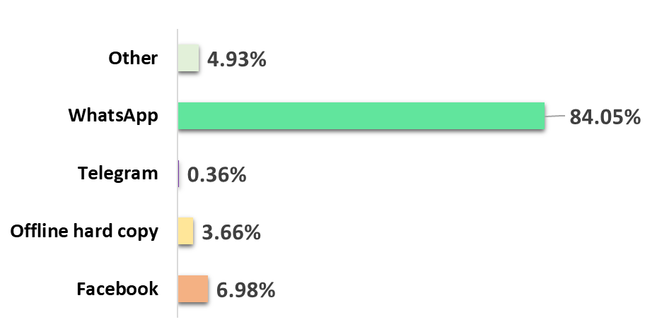
Table 1S Distribution of participants (online and offline) across Indian States/Union Territories
State | n | %
Andaman and Nicobar Islands | 62 | 0.04
Andhra Pradesh | 1,512 | 1.05
Arunachal Pradesh | 455 | 0.32
Assam | 3,392 | 2.36
Bihar | 5,263 | 3.67
Chhattisgarh | 2,762 | 1.92
Delhi | 17,046 | 11.85
Goa | 1,017 | 0.71
Gujarat | 1,554 | 1.08
Haryana | 51,070 | 35.49
Himachal Pradesh | 3,109 | 2.16
Jammu and Kashmir | 1,282 | 0.89
Jharkhand | 1,716 | 1.19
Karnataka | 2,172 | 1.51
Kerala | 4,414 | 3.07
Lakshadweep | 16 | 0.01
Madhya Pradesh | 4,966 | 3.45
Maharashtra | 5,627 | 3.91
Manipur | 334 | 0.23
Meghalaya | 410 | 0.28
Mizoram | 216 | 0.15
Nagaland | 493 | 0.34
Odisha | 2,301 | 1.60
Puducherry | 61 | 0.04
Punjab | 2,952 | 2.05
Rajasthan | 4,888 | 3.40
Sikkim | 113 | 0.08
Tamil Nadu | 2,761 | 1.92
Telangana | 909 | 0.63
Tripura | 191 | 0.13
Union Territory of Chandīgarh | 503 | 0.35
Territory of Dadra & Nagar Haveli | 87 | 0.06
Union Territory of Daman & Diu | 50 | 0.03
Uttar Pradesh | 10,294 | 7.15
Uttarakhand | 1,964 | 1.36
West Bengal | 2,069 | 1.44
NR | 5,875 | 4.08
Total | 1,43,906 | 100

Table 2S Food consumption (food and beverages) patterns of children
How many times a week do you take fruits and vegetables? | n | %
2 times a week | 9,333 | 12.38
3 times a week | 27,427 | 36.38
Never | 2,033 | 2.70
Occasionally | 11,417 | 15.15
once a day | 25,067 | 33.25
Other | 104 | 0.14
Total | 75,381 | 100
How many times a week do you take junk food?
2 times a week | 10,880 | 14.71
3 + times a week | 6,987 | 9.45
Never | 10,290 | 13.92
Occasionally | 36,829 | 49.80
once a day | 8,861 | 11.98
Other | 101 | 0.14
Total | 73,948 | 100
How many times a week do you take beverages?
2 times a week | 7,727 | 10.66
3 times a week | 5,379 | 7.42
Never | 18,214 | 25.12
Occasionally | 34,623 | 47.75
once a day | 6,462 | 8.91
Other | 102 | 0.14
Total | 72,507 | 100
Note: NR- non-response excluded while presenting frequency/percentage distribution

