Supplementary Figure S1. Survey-weighted prevalence estimates of underweight, normal weight, overweight, and obesity by region among women aged 15-49 years in Malawi

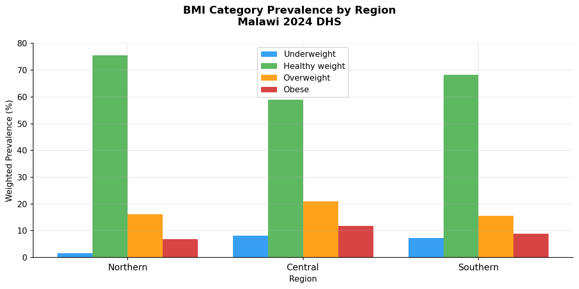Bars represent survey-weighted prevalence estimates of underweight, normal weight, overweight, and obesity across Malawi’s administrative regions. Body mass index (BMI) categories were defined according to World Health Organization criteria: underweight (<18.5 kg/m²), normal weight (18.5-24.9 kg/m²), overweight (25.0-29.9 kg/m²), and obesity (≥30.0 kg/m²). Estimates are unadjusted.

Supplementary Table S1. Stratified survey-weighted logistic regression models for overweight and obesity by urban and rural residence among women aged 15-49 years in Malawi
Variable | Urban (n=2,205) |  |  | Rural (n=7,081)
 | AOR | 95% CI | p-value | AOR | 95% CI | p-value
Overweight (BMI 25-<30)
Age group (ref: 15-19)
20-29 | 0.77 | 0.48-1.22 | 0.266 | 1.16 | 0.86-1.56 | 0.333
30-39 | 0.93 | 0.51-1.69 | 0.804 | 1.20 | 0.83-1.74 | 0.336
40-49 | 0.89 | 0.46-1.71 | 0.728 | 1.20 | 0.81-1.76 | 0.362
Region (ref: Southern)
Northern | 0.57 | 0.42-0.76 | <0.001 | 1.14 | 0.92-1.40 | 0.226
Central | 0.80 | 0.59-1.08 | 0.148 | 1.67 | 1.42-1.96 | <0.001
Wealth quintile (ref: Poorest)
Poorer | 0.04 | 0.00-0.42 | 0.007 | 1.23 | 0.98-1.54 | 0.080
Middle | 0.38 | 0.11-1.35 | 0.135 | 1.17 | 0.93-1.48 | 0.177
Richer | 0.48 | 0.16-1.47 | 0.201 | 1.03 | 0.82-1.31 | 0.779
Richest | 0.68 | 0.23-1.99 | 0.479 | 1.50 | 1.14-1.98 | 0.004
Education (ref: No education)
Primary | 1.26 | 0.52-3.06 | 0.602 | 1.17 | 0.87-1.57 | 0.291
Secondary | 1.68 | 0.70-4.06 | 0.247 | 1.11 | 0.79-1.56 | 0.532
Higher | 1.61 | 0.62-4.22 | 0.331 | 0.78 | 0.37-1.65 | 0.517
Marital status (ref: Never married)
Married/Living together | 1.24 | 0.72-2.13 | 0.432 | 0.71 | 0.49-1.03 | 0.068
Divorced/Separated/Widowed | 1.40 | 0.76-2.59 | 0.277 | 0.76 | 0.51-1.12 | 0.160
Employment (ref: Not employed)
Currently employed | 1.15 | 0.85-1.56 | 0.363 | 0.96 | 0.82-1.14 | 0.663
Worked in past year | 0.88 | 0.54-1.45 | 0.615 | 1.19 | 0.93-1.52 | 0.161
Parity (ref: 0)
1-2 | 0.75 | 0.44-1.27 | 0.281 | 1.19 | 0.82-1.73 | 0.365
3+ | 0.72 | 0.37-1.37 | 0.313 | 1.40 | 0.90-2.17 | 0.132
Contraceptive use (ref: No)
Yes | 1.08 | 0.83-1.42 | 0.559 | 0.95 | 0.82-1.11 | 0.547
Obesity (BMI ≥30)
Age group (ref: 15-19)
20-29 | 0.94 | 0.55-1.61 | 0.829 | 1.36 | 0.95-1.94 | 0.093
30-39 | 0.75 | 0.40-1.43 | 0.386 | 1.49 | 0.93-2.40 | 0.099
40-49 | 0.74 | 0.36-1.51 | 0.410 | 1.67 | 1.00-2.79 | 0.049
Region (ref: Southern)
Northern | 0.52 | 0.36-0.76 | <0.001 | 0.69 | 0.49-0.96 | 0.028
Central | 2.71 | 1.96-3.75 | <0.001 | 0.99 | 0.80-1.22 | 0.926
Wealth quintile (ref: Poorest)
Poorer | 8.06 | 0.86-75.85 | 0.068 | 1.12 | 0.81-1.55 | 0.504
Middle | 5.24 | 0.95-29.02 | 0.058 | 1.31 | 0.95-1.80 | 0.101
Richer | 7.40 | 1.43-38.27 | 0.017 | 1.67 | 1.23-2.29 | 0.001
Richest | 15.17 | 3.05-75.47 | <0.001 | 1.68 | 1.16-2.42 | 0.006
Education (ref: No education)
Primary | 0.57 | 0.26-1.26 | 0.167 | 1.45 | 0.94-2.24 | 0.093
Secondary | 0.59 | 0.26-1.30 | 0.190 | 1.99 | 1.24-3.17 | 0.004
Higher | 0.54 | 0.21-1.40 | 0.205 | 2.92 | 1.34-6.38 | 0.007
Marital status (ref: Never married)
Married/Living together | 1.22 | 0.62-2.38 | 0.566 | 0.82 | 0.52-1.30 | 0.402
Divorced/Separated/Widowed | 1.19 | 0.57-2.49 | 0.634 | 0.81 | 0.49-1.32 | 0.396
Employment (ref: Not employed)
Currently employed | 0.81 | 0.58-1.14 | 0.233 | 1.14 | 0.92-1.43 | 0.237
Worked in past year | 1.52 | 0.88-2.64 | 0.136 | 1.13 | 0.80-1.59 | 0.481
Parity (ref: 0)
1-2 | 1.10 | 0.57-2.11 | 0.782 | 0.86 | 0.53-1.40 | 0.534
3+ | 1.60 | 0.76-3.34 | 0.215 | 0.80 | 0.44-1.44 | 0.458
Contraceptive use (ref: No)
Yes | 0.67 | 0.49-0.91 | 0.011 | 0.89 | 0.73-1.10 | 0.282
Results are presented as adjusted odds ratios (AOR) with 95% confidence intervals (CI) from residence-stratified survey-weighted logistic regression models. Separate models were estimated for urban and rural women; therefore, residence was not included as a covariate within stratum-specific models. Reference categories were age 15-19 years, Southern region, poorest wealth quintile, no education, never married, not employed, parity 0, and no contraceptive use. Southern region used as a reference in stratified models to improve interpretability within residence strata and ensure compatibility of within-stratum effects. Some estimates, particularly in urban strata, should be interpreted with caution due to small sample sizes and sparse data, which may result in wide confidence intervals and unstable estimates.

Supplementary Figure S2. Survey-weighted prevalence estimates of underweight, overweight, and obesity by wealth quintile and place of residence among women aged 15-49 years in Malawi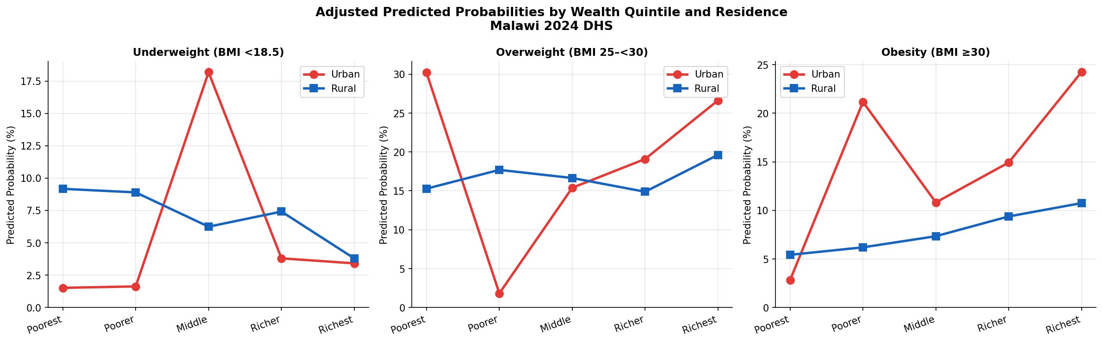
Figure shows survey-weighted prevalence estimates of underweight, overweight, and obesity across wealth quintiles, stratified by place of residence. Estimates represent observed prevalence within each wealth-by-residence subgroup. BMI categories were defined according to World Health Organization criteria.

Supplementary Table S2. Survey-weighted prevalence estimates of underweight, overweight, and obesity by education level and wealth quintile among women aged 15-49 years in Malawi
Education | Wealth Quintile | n | Underweight |  | Overweight |  | Obesity
 |  |  | % | 95% CI | % | 95% CI | % | 95% CI
No education | Poorest | 151 | 9.1 | 4.5-13.7 | 15.9 | 10.1-21.8 | 3.8 | 0.8-6.9
No education | Poorer | 139 | 10.6 | 5.5-15.8 | 14.7 | 8.9-20.6 | 7.9 | 3.4-12.4
No education | Middle | 125 | 7.3 | 2.7-11.8 | 12.3 | 6.5-18.0 | 1.6 | 0.0-3.8
No education | Richer | 104 | 4.8 | 0.7-8.9 | 14.8 | 8.0-21.6 | 7.1 | 2.1-12.0
No education | Richest | 56 | 3.6 | 0.0-8.5 | 22.2 | 11.3-33.1 | 27.8 | 16.1-39.6
Primary | Poorest | 1,225 | 9.0 | 7.4-10.6 | 15.5 | 13.5-17.5 | 5.4 | 4.1-6.7
Primary | Poorer | 1,141 | 8.4 | 6.8-10.0 | 18.4 | 16.2-20.7 | 5.6 | 4.3-6.9
Primary | Middle | 1,204 | 5.7 | 4.4-7.0 | 17.3 | 15.2-19.5 | 7.2 | 5.8-8.7
Primary | Richer | 1,209 | 8.3 | 6.7-9.8 | 15.1 | 13.1-17.2 | 9.5 | 7.9-11.2
Primary | Richest | 986 | 3.8 | 2.6-5.0 | 21.3 | 18.8-23.9 | 17.3 | 15.0-19.7
Secondary | Poorest | 143 | 10.4 | 5.4-15.4 | 13.8 | 8.1-19.4 | 7.2 | 3.0-11.5
Secondary | Poorer | 217 | 10.1 | 6.1-14.1 | 14.5 | 9.8-19.2 | 9.4 | 5.5-13.2
Secondary | Middle | 362 | 8.5 | 5.6-11.4 | 16.0 | 12.3-19.8 | 10.5 | 7.4-13.7
Secondary | Richer | 580 | 4.5 | 2.8-6.1 | 16.4 | 13.4-19.4 | 11.6 | 9.0-14.2
Secondary | Richest | 1,356 | 3.9 | 2.9-4.9 | 25.5 | 23.1-27.8 | 18.4 | 16.4-20.5
Higher | Richer | 12 | 0.0 | 0.0-0.0 | 7.6 | 0.0-22.6 | 32.4 | 5.9-58.8
Higher | Richest | 274 | 0.9 | 0.0-2.0 | 23.9 | 18.9-29.0 | 21.5 | 16.6-26.3
Values are presented as survey-weighted prevalence (%) with 95% confidence intervals (CIs). UW = underweight; OW = overweight; Ob = obese. Cells with unweighted n<10 were suppressed; estimates with n between 10-20 should be interpreted with caution. Higher education was concentrated in the richest quintile, limiting cross-classification in lower wealth groups. Confidence intervals were calculated using survey-weighted methods and should be interpreted cautiously in sparse cells. Normal weight not shown to focus on deviations from optimal BMI; however, distributions sum to 100% across categories.

Supplementary Figure S3. Heatmap of survey-weighted prevalence estimates of underweight, overweight, and obesity across education and wealth quintile subgroups among women aged 15-49 years in Malawi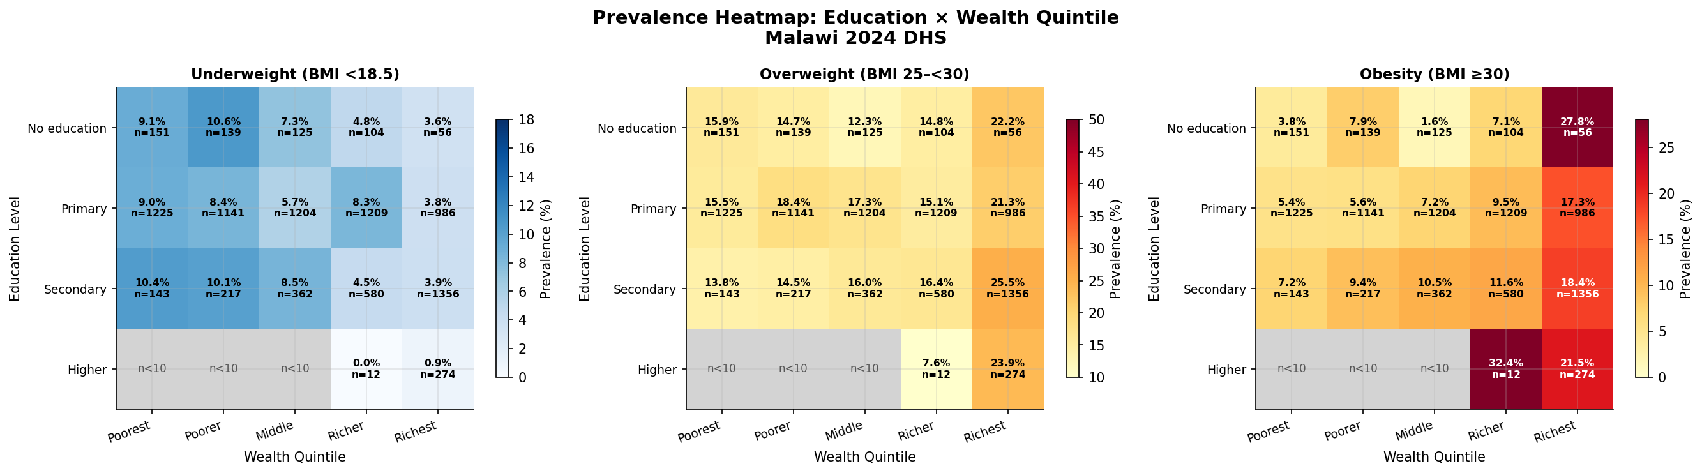
Heatmap showing survey-weighted prevalence estimates of underweight, overweight, and obesity across education and wealth quintile subgroups. Cell values indicate weighted prevalence (%) with unweighted sample sizes. Darker shading indicates higher prevalence. Cells with unweighted sample size <10 were suppressed. The heatmap highlights a clear socioeconomic gradient, with obesity increasing across wealth quintiles and higher education levels, while underweight is concentrated among lower socioeconomic groups.

