Appendix Table 1. Detailed Search Strategy Across Databases
Database | Search Strategy
PubMed | ("Heart Failure"[Mesh] OR "Cardiac Failure"[tiab] OR HF OR HFpEF OR HFrEF OR "chronic heart failure") AND ("Nutritional Support"[Mesh] OR "Dietary Supplements"[Mesh] OR "Food, Fortified"[Mesh] OR "Oral Nutritional Supplement" OR ONS OR "medically tailored meal" OR "fresh produce" OR "dietary counseling" OR "protein supplement" OR "amino acid supplement" OR "BCAA" OR "whey protein" OR "enteral nutrition" OR "high protein diet" OR "caloric restriction" OR "Mediterranean diet") AND ("Quality of Life"[Mesh] OR HRQoL OR KCCQ OR MLHFQ OR EQ-5D OR SF-36 OR "6-minute walk test" OR 6MWT OR 6MWD OR "handgrip strength" OR "Barthel Index" OR "Activities of Daily Living"[Mesh] OR frailty OR "physical function") AND (randomized controlled trial OR placebo OR clinical trial OR randomly OR trial) NOT (animals NOT humans)
Scopus | TITLE-ABS-KEY ("heart failure" OR "cardiac failure" OR HFrEF OR HFpEF OR "chronic heart failure") AND TITLE-ABS-KEY ("nutritional support" OR "dietary supplement" OR "oral nutritional supplement" OR ONS OR "medically tailored meal" OR "fresh produce" OR "dietary counseling" OR "protein supplement" OR "amino acid supplement" OR BCAA OR "whey protein" OR "enteral nutrition" OR "high protein diet" OR "caloric restriction" OR "mediterranean diet") AND TITLE-ABS-KEY ("quality of life" OR HRQoL OR KCCQ OR MLHFQ OR EQ-5D OR SF-36 OR "6-minute walk test" OR 6MWT OR 6MWD OR "handgrip strength" OR "Barthel Index" OR "activities of daily living" OR frailty OR "physical function") AND TITLE-ABS-KEY ("randomized controlled trial" OR randomized OR placebo OR clinical trial OR randomly OR trial) AND English
Web of Science | TS=("heart failure" OR "cardiac failure" OR HFrEF OR HFpEF OR "chronic heart failure") AND TS=("nutritional support" OR "dietary supplement" OR "oral nutritional supplement" OR ONS OR "medically tailored meal" OR "fresh produce" OR "dietary counseling" OR "protein supplement" OR "amino acid supplement" OR BCAA OR "whey protein" OR "enteral nutrition" OR "high protein diet" OR "caloric restriction" OR "mediterranean diet") AND TS=("quality of life" OR HRQoL OR KCCQ OR MLHFQ OR EQ-5D OR SF-36 OR "6-minute walk test" OR 6MWT OR 6MWD OR "handgrip strength" OR "Barthel Index" OR "activities of daily living" OR frailty OR "physical function") AND TS=("randomized controlled trial" OR randomized OR placebo OR clinical trial OR randomly OR trial); limited to English
Cochrane Library | (#1 Heart Failure MeSH OR keywords) AND (#2 Nutritional Support / Dietary Supplements/keywords) AND (#3 Quality of Life / functional outcomes terms) AND (#4 randomized controlled trial terms)
Embase | exp *heart failure/ OR keywords AND exp *nutritional support/ OR dietary supplement terms AND exp *quality of life/ OR functional outcome terms AND randomized controlled trial filters; limited to English and humans

Appendix Table 2. Detailed Quality assessment:
Study | Randomization Process | Deviations from Intended Interventions | Missing Outcome Data | Measurement of the Outcome | Selection of the Reported Result | Overall Risk of Bias | Comments
dos Santos 2023 | Some concerns | Low | High | Some concerns | Some concerns | High | Block randomization was reported, but allocation concealment was insufficiently described. Thirty-three participants were randomized and only 25 completed follow-up, with greater attrition in the placebo group. Handgrip assessor blinding was unclear.
Jafari-Vayghan 2019 | Low | Low | Some concerns | Low | Some concerns | Some concerns | Double-blind, placebo-controlled four-arm trial with independent sequence administration. Fourteen of 84 randomized participants did not complete follow-up, and the analysis appears to have been based on completers.
Azhar 2020 | Some concerns | High | High | High | Some concerns | High | Small open-label pilot with a no-contact control group. Post-randomization exclusions and incomplete follow-up were present. Functional outcomes were effort-dependent and assessed without adequate blinding.
Azhar 2021 | Some concerns | Low | Some concerns | Low | Some concerns | Some concerns | The supplement comparison was randomized and blinded, but allocation concealment and missing-data handling were incompletely reported. The status of the education-only group as a fully randomized comparator must be verified.
Cortés 2024 | Low | Low | Some concerns | High | Some concerns | High | Randomized open-label trial. Lack of blinding does not automatically affect objective mortality, but the 6MWT was effort-dependent and assessor blinding was not established. For mortality/readmission alone, the overall judgment would be “some concerns.”
Deutz 2016 | Low | Low | Low | Low | Low | Low | Double-blind, placebo-controlled, rigorous ITT analysis.
Evangelista 2021 | Some concerns | Some concerns | Some concerns | High | Some concerns | High | Open-label comparison of two active calorie-restricted diets. Functional outcomes may have been influenced by participants’ and assessors’ knowledge of treatment. It should not be included in the primary nutrition-versus-usual-care analysis.
Ezekowitz 2022 | Low | Low | Low | Some concerns | Some concerns | Some concerns | Randomization and follow-up were strong. The clinical-events committee was blinded, making mortality and cardiovascular outcomes low risk or close to low risk. QoL and 6MWT remain susceptible to participant awareness of dietary allocation.
Herrera-Martínez 2024 | Some concerns | Some concerns | High | High | Some concerns | High | Randomization and concealment were incompletely described. Differential losses and deaths occurred, and functional and self-reported outcomes were obtained in an open-label trial.
Hersberger 2021 | Low | Low | Some concerns | Some concerns | Some concerns | Some concerns | Randomized open-label trial. Mortality is objective and should not be rated high risk because of absent blinding. EQ-5D and possibly Barthel assessments are more susceptible to awareness of intervention assignment.
Hoseini 2022 | Low | Low | Some concerns | Low | Some concerns | Some concerns | Double-blind, placebo-controlled trial with appropriate outcome measurement. Seven of 92 randomized participants did not complete follow-up, and available-case handling requires concern for missing data.
Hotta 2021 | Some concerns | Low | Some concerns | High | Some concerns | High | Open-label pilot with insufficiently described allocation concealment. The 6MWT and handgrip outcomes were effort-dependent and measured without established assessor blinding. Small sample size alone is not a RoB 2 reason.
Hummel 2018 | Low | Low | Some concerns | High | Some concerns | High | Randomization was appropriate, but participants knew whether meals were delivered, and KCCQ was self-reported. For objective readmission outcomes, the judgment would be “some concerns,” not high risk.
Keith 2019 | Low | Low | Some concerns | Low | Some concerns | Some concerns | Double-blind, placebo-controlled multicenter trial. Secondary QoL and 6MWT outcomes had missing observations and were analyzed using available data. Correct publication year is 2019, not 2021.
Luu 2025 | Some concerns | Some concerns | High | High | Some concerns | High | Open-label trial. Fifty-one participants were reportedly randomized, but only 40 were analyzed without imputation. Handgrip strength was effort-dependent and vulnerable to lack of blinding. Correct publication year is 2025.
Motie 2013 | Low | High | Low | Low | Low | High | Open-label pilot; very small sample.
Pandey 2026 | Low | Low | Low | High | Some concerns | High | Randomized open-label factorial trial with good retention and intention-to-treat analysis. KCCQ was self-reported and susceptible to expectancy effects. For HF hospitalization or emergency visits alone, the overall judgment would be “some concerns.”
Pierce 2022 | Low | Low | Some concerns | Low | Some concerns | Some concerns | Randomized double-blind placebo-controlled trial. Blinding was appropriate, but early termination, missing outcome data, and choices among multiple intervention groups and outcomes require some concern pending protocol comparison.
Rozentryt 2010 | Low | Low | High | Low | Some concerns | High | Double-blind placebo-controlled trial. The 3:1 allocation ratio is not itself a source of bias. The major concern is the very small placebo group and substantial differential, potentially outcome-related missing data.
Sabbaghzadegan 2023 | Low | Some concerns | Some concerns | Low | Some concerns | Some concerns | Double-blind placebo-controlled trial, but adherence-based exclusions and a smaller analyzed sample than the randomized sample raise concern regarding deviations and missing data. Correct publication year is 2023.
Salmani 2021 | Low | High | High | Low | Some concerns | High | Double-blind placebo-controlled trial, but six randomized participants were excluded after allocation because of adherence, smoking, or death. Excluding a participant who died is especially problematic for an assignment-effect analysis. Correct publication year is 2021.
Bonilla-Palomas 2016 | Some concerns | Low | Low | Low | Some concerns | Some concerns | Open-label trial, but the outcomes were objective all-cause mortality and HF readmission with complete follow-up. Lack of blinding alone does not justify high risk. Allocation concealment and selective reporting should be verified from the protocol.

Appendix Table 3. Detailed Risk-of-Bias Assessment

Study or comparison | Intervention that differed between groups | Assigned category | Planned synthesis
dos Santos 2023 | Whey protein isolate | Protein/amino-acid/energy-dense ONS | Category-specific pooling where applicable
Jafari-Vayghan: BCAA arm | BCAA supplementation | Protein/amino-acid supplementation | Eligible for amino-acid category
Jafari-Vayghan: melatonin arm | Melatonin | Nutraceutical | Present within nutraceutical category
Jafari-Vayghan: melatonin + BCAA arm | Combined melatonin and BCAA | Mixed multicomponent intervention | Do not pool in a single-mechanism category
Azhar 2020 | Whey-protein supplementation, with or without exercise | Protein/amino-acid/energy-dense ONS | Category-specific pooling where applicable
Azhar 2021 | EAA or whey-protein supplementation | Protein/amino-acid supplementation | Combine clinically suitable active arms where appropriate
Cortés 2024 | Individualized diet, with ONS when required | Comprehensive individualized nutritional support | Comprehensive-support category
Deutz 2016 | High-protein HMB-containing ONS | Protein/amino-acid/energy-dense ONS | Classification does not resolve the separate HF-subgroup eligibility issue
Evangelista 2021 | High-protein versus standard-protein hypocaloric diet | Dietary-pattern/protein-modified diet | Active-versus-active comparison; narrative or separate analysis
Ezekowitz 2022 | Low-sodium dietary intervention and counselling | Dietary-pattern/counselling intervention | Dietary-pattern category
Herrera-Martínez 2024 | Hypercaloric, hyperproteic ONS added to Mediterranean diet and vitamin D | Protein/amino-acid/energy-dense ONS | Classify by the randomized difference: ONS
Hersberger 2021 | Protocol-guided individualized nutritional support | Comprehensive individualized nutritional support | Comprehensive-support category
Hoseini 2022 | Melatonin | Nutraceutical | Nutraceutical category
Hotta 2021 | Whey peptides and BCAAs | Protein/amino-acid/energy-dense ONS | Category-specific pooling
Hummel 2018 | Home-delivered DASH/sodium-restricted meals | Comprehensive food-based support | Food-based/support category
Keith 2019 | Thiamin | Nutraceutical | Nutraceutical category
Luu 2025 | High-energy, high-protein ONS | Protein/amino-acid/energy-dense ONS | Category-specific pooling
Kitzman 2016 | Caloric restriction | Dietary-pattern intervention | Dietary-pattern category
Pandey 2026 | Medically tailored meals or fresh-produce delivery | Comprehensive food-based support | Food-based/support category
Pierce 2022 | Ubiquinol, D-ribose, or both | Defined nutraceutical supplementation | Show individual comparisons; pool cautiously, if at all
Rozentryt 2010 | High-calorie, high-protein ONS | Protein/amino-acid/energy-dense ONS | Category-specific pooling
Sabbaghzadegan 2023 | Aloe vera gel | Nutraceutical | Nutraceutical category
Salmani 2021 | L-arginine | Protein/amino-acid supplementation | Amino-acid category
Bonilla-Palomas 2016 | Diet optimization, individualized recommendations, and ONS when needed | Comprehensive individualized nutritional support | Comprehensive-support category
ONS: oral nutritional supplement; BCAA: branched-chain amino acid; EAA: essential amino acid; HMB: β-hydroxy-β-methylbutyrate; DASH: Dietary Approaches to Stop Hypertension. Interventions were classified according to the principal component differing between randomized groups. Consequently, Herrera-Martínez 2024 was classified as an ONS intervention because both groups received Mediterranean-diet advice and vitamin D, while hypercaloric, hyperproteic ONS was added only to the intervention group. Cortés 2024 and Bonilla-Palomas 2016 were classified as comprehensive individualized nutritional-support programs because their interventions involved individualized dietary planning and supplementation when nutritional targets were not achieved. The manuscript currently uses “Motie 2013” in some locations but cites Kitzman 2016 in the reference list. Confirm the correct trial identity and use one name consistently before finalizing this table.

Appendix Figure 1. Exploratory quality-of-life analysis according to intervention category. Individual study effects are expressed as standardized mean differences with 95% confidence intervals. Positive values favor the intervention. Each category was represented by one independent study; therefore, no category-specific pooled estimates or within-category heterogeneity statistics were calculated. The overall random-effects diamond represents the exploratory average effect across heterogeneous nutritional strategies and should not be interpreted as supporting any individual intervention category.
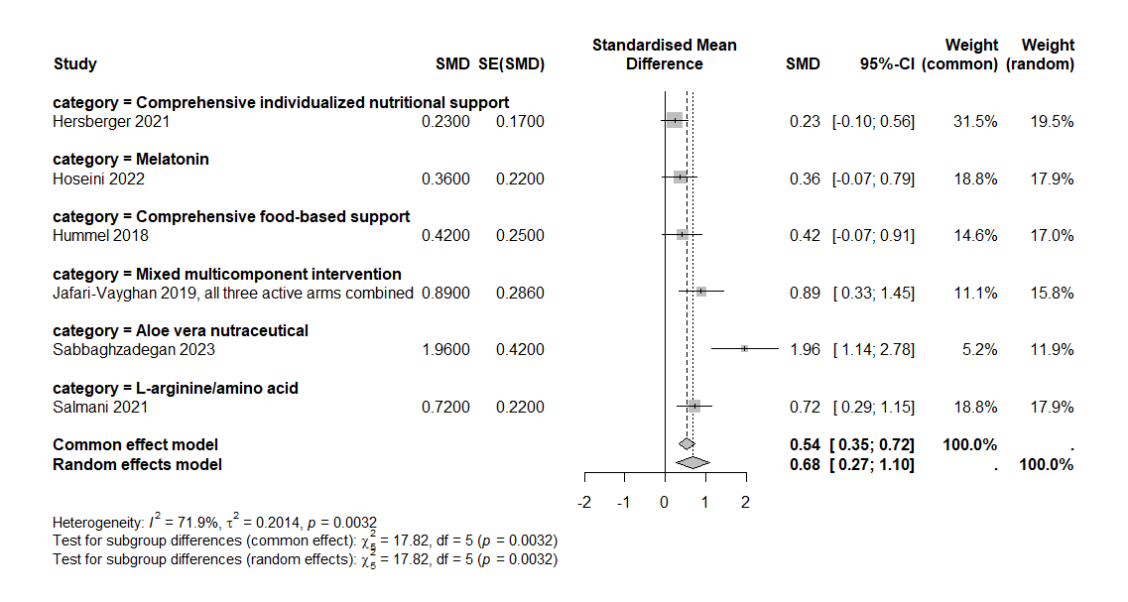

Appendix Figure 2. Exploratory six-minute walk test analysis according to intervention category. Individual study effects are expressed as Hedges’ g standardized mean differences with 95% confidence intervals. Positive values favor the intervention. Each category was represented by one independent study; therefore, the category-specific findings are descriptive and no category-specific pooled estimates were calculated.
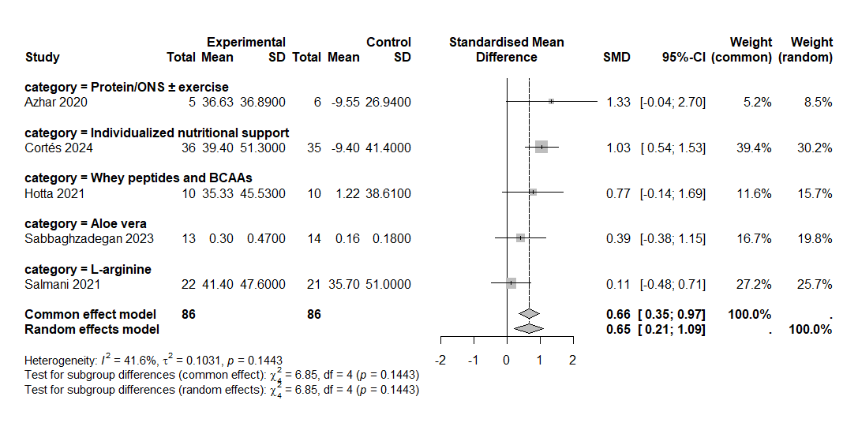

Appendix Figure 3. Funnel plot for quality-of-life outcomes.
Funnel plot of standardized mean differences for quality-of-life outcomes from six independent studies. Each point represents one study-level effect estimate plotted against its standard error. The vertical dashed line indicates the pooled random-effects estimate, and the diagonal lines represent pseudo-95% confidence limits. Some visual asymmetry was observed, mainly due to one small study with a comparatively large favorable effect; however, interpretation was limited by the small number of studies and substantial heterogeneity.
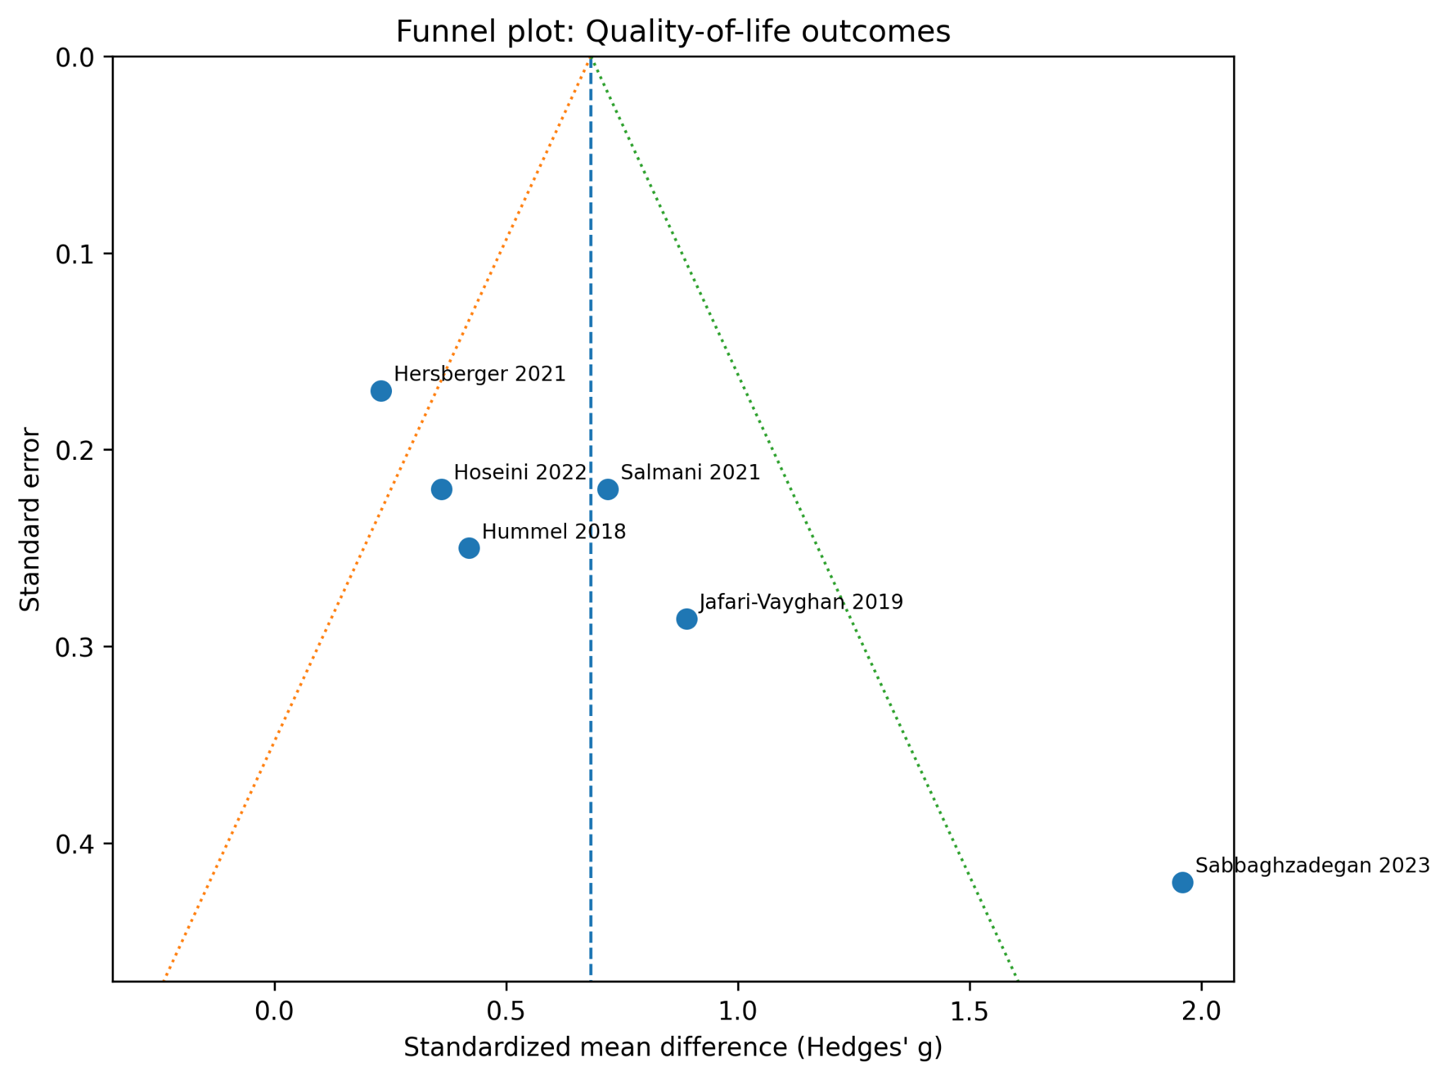

Appendix Figure 4. Funnel plot for six-minute walk test outcomes.
Funnel plot of Hedges’ g standardized mean differences for six-minute walk test outcomes from five studies. Each point represents one study-level effect estimate plotted against its standard error. The vertical dashed line indicates the pooled random-effects estimate, and the diagonal lines represent pseudo-95% confidence limits. No clear marked asymmetry was apparent, although the small number of studies limited reliable assessment of publication bias and other small-study effects.

