Supplementary material

Table S1 Model fit and parameter estimates of latent growth curve models.
Variable | Model Fit |  | Component | Measure | Estimate | 95% CI | p
 | p | CFI
Motor speed | <0.001 | 0.45 | Intercept | Mean | 45.4 | 43.9 – 46.9 | <0.001
 |  |  |  | Variance | 26.8 | 6.6 – 53.2 | 0.005
 |  |  | Linear slope | Mean | 3.2 | 2.3 – 4.1 | <0.001
 |  |  |  | Variance | -3.5 | -13.9 – 6.4 | 0.462
 |  |  | Intercept ↔ Linear slope | Covariance | -2.3 | -17.4 – 10.1 | 0.716
Processing speed | <0.001 | 0.41 | Intercept | Mean | 31.68 | 28.70 – 35.29 | <0.001
 |  |  |  | Variance | 65.29 | 25.28 – 107.01 | 0.001
 |  |  | Linear slope | Mean | 8.29 | 6.77 – 9.68 | <0.001
 |  |  |  | Variance | 1.94 | -13.98 – 17.69 | 0.827
 |  |  | Intercept ↔ Linear slope | Covariance | -14.72 | -38.50 – 7.61 | 0.223
Processing speed error | 0.053 | 0.00 | Intercept | Mean | 0.79 | 0.61 – 0.96 | <0.001
 |  |  |  | Variance | 0.08 | -0.85 – 0.83 | 0.850
 |  |  | Linear slope | Mean | 0.82 | 0.59 – 1.03 | <0.001
 |  |  |  | Variance | 0.35 | -1.20 – 0.27 | 0.275
 |  |  | Intercept ↔ Linear slope | Covariance | 0.13 | -0.44 – 0.91 | 0.668
Impulsivity | <0.001 | 0.00 | Intercept | Mean | 1.59 | 0.18 – 3.00 | 0.027
 |  |  |  | Variance | -18.40 | -29.40 - -7.39 | 0.001
 |  |  | Linear slope | Mean | 3.20 | 1.93 – 4.47 | <0.001
 |  |  |  | Variance | -14.96 | -23.97 - -5.96 | 0.001
 |  |  | Intercept ↔  Linear slope | Covariance | 15.84 (0.96) | 6.70 – 24.97 | <0.001
Abbreviations: DT, determination test; RT, reaction test.

Fig. S1 Correlation matrix of food groups and cognitive performance.
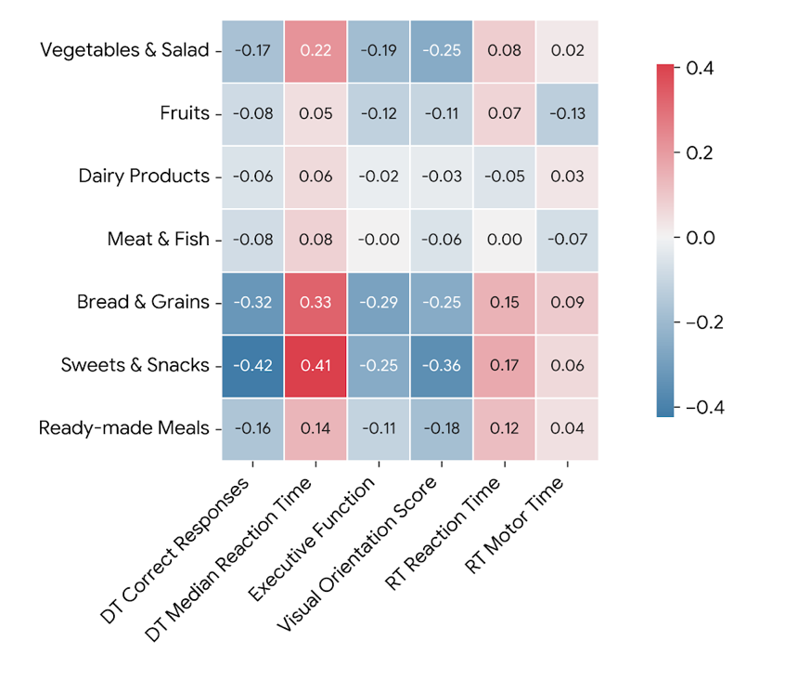

Fig. S2 Moderating effect of emotional well-being between PC1 and DT correct responses.

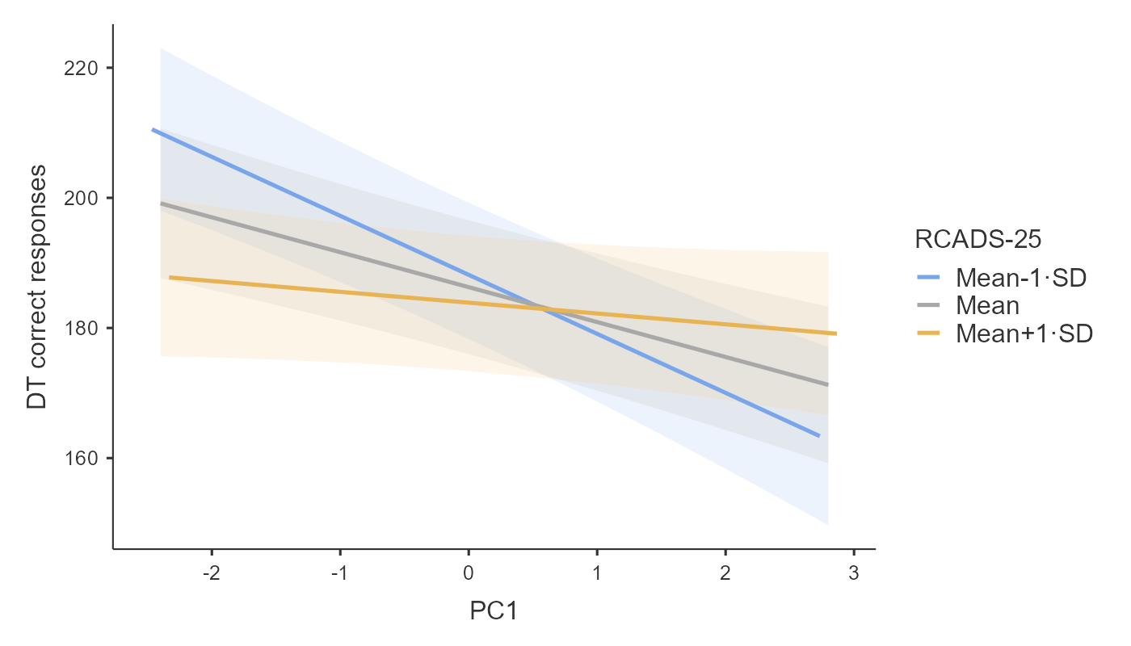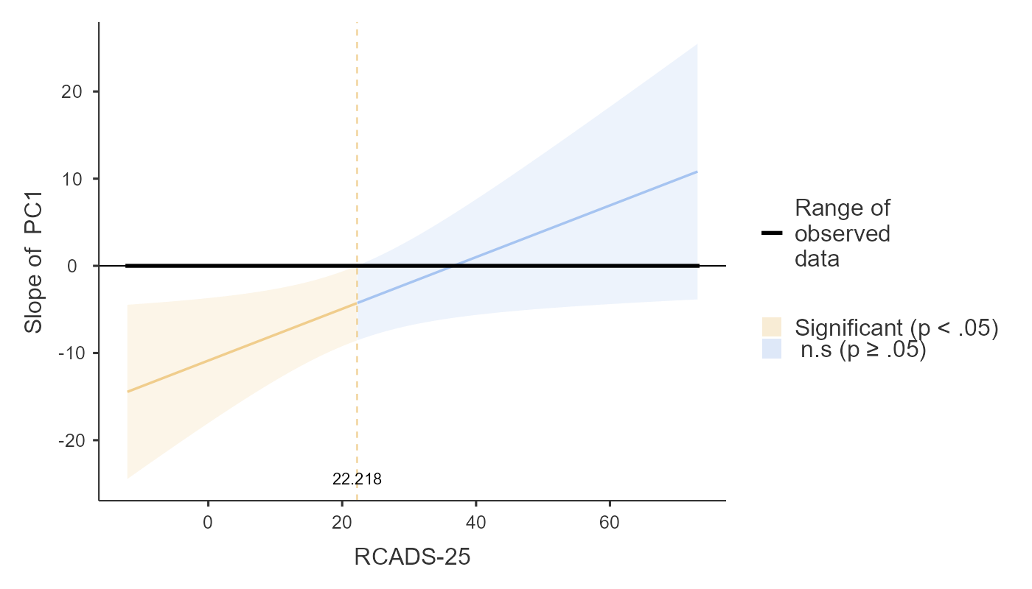
Abbreviations: DT, determination test; PC1, principal component 1; RCADS-25, The Revised Children's Anxiety and Depression Scale-25.

Fig. S3 Moderating role of WC between PC1 and executive functions.
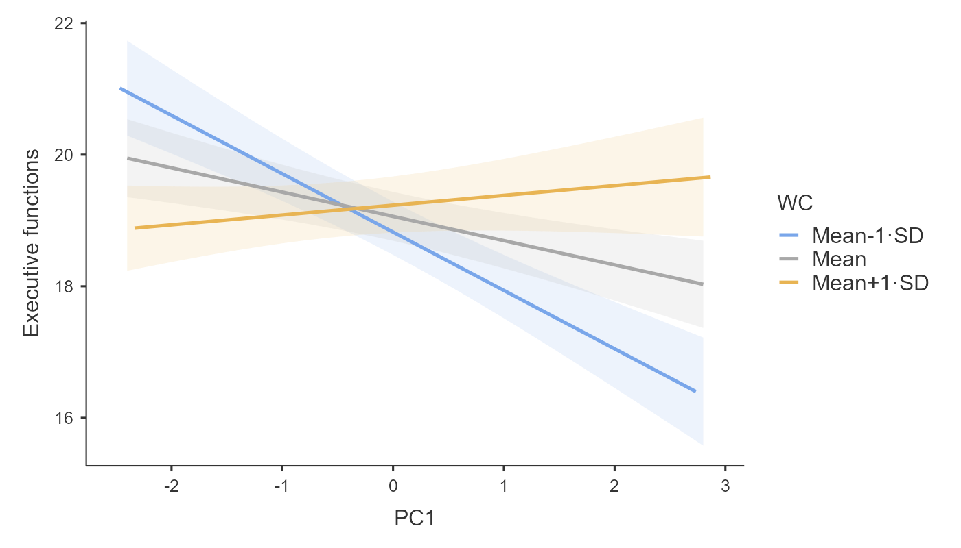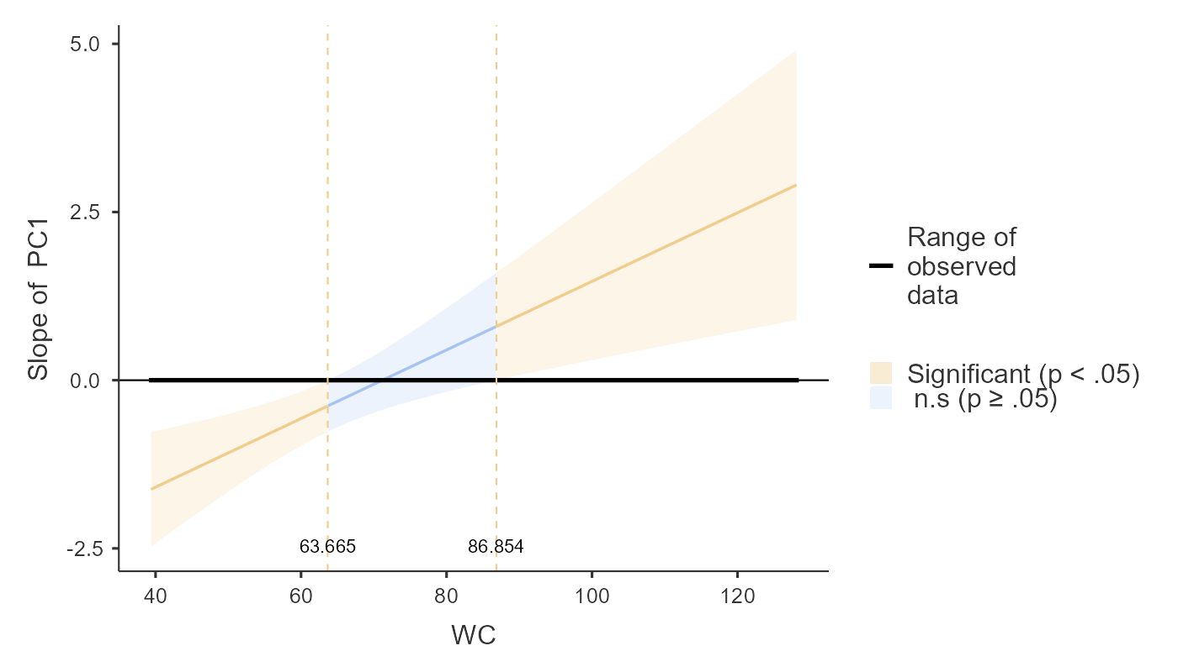
Abbreviations: PC1, principal component 1; WC, waist circumference.

Fig. S4 Moderating role of CRF between PC1 and visual orientation score.
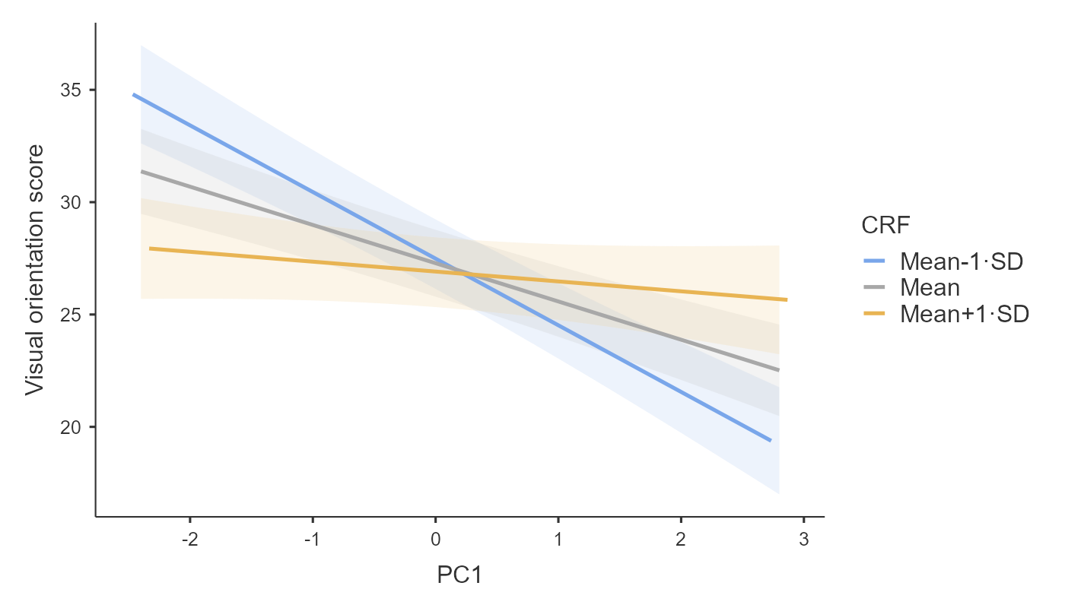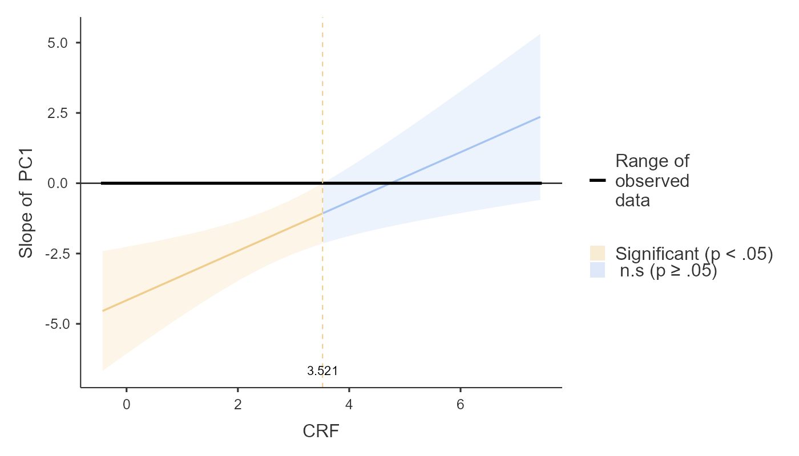
Abbreviations: CRF, cardiorespiratory fitness; PC1, principal component 1.

Fig. S5 Moderating role of LDL between glucose and DT median reaction time.
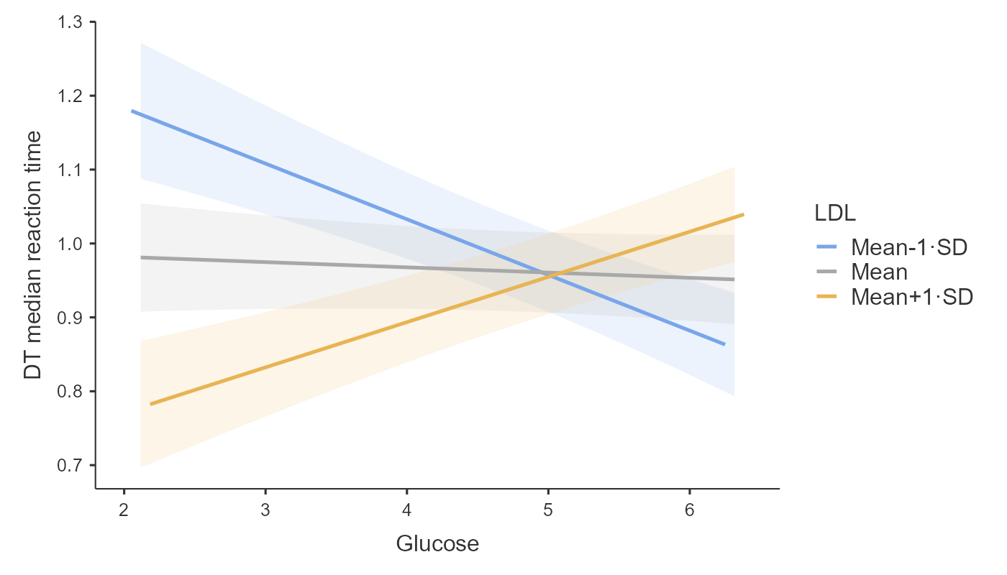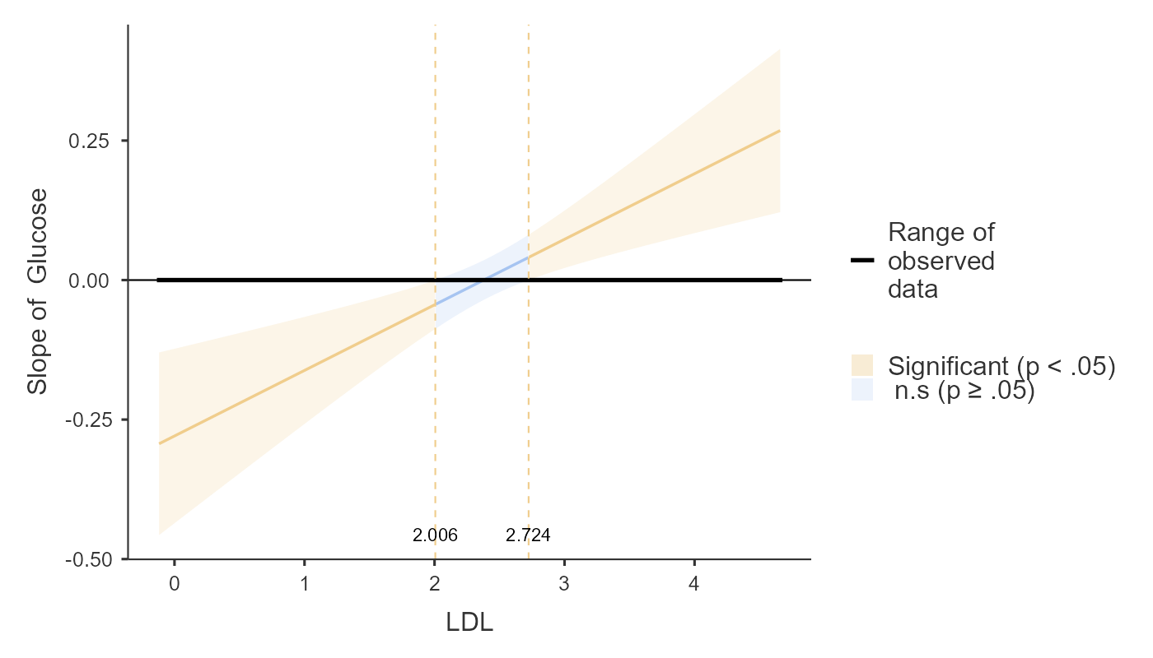
Abbreviations: DT, determination test; LDL, low-density lipoprotein.

Fig. S6 Moderating role of CRF between Systolic BP and RT reaction time.
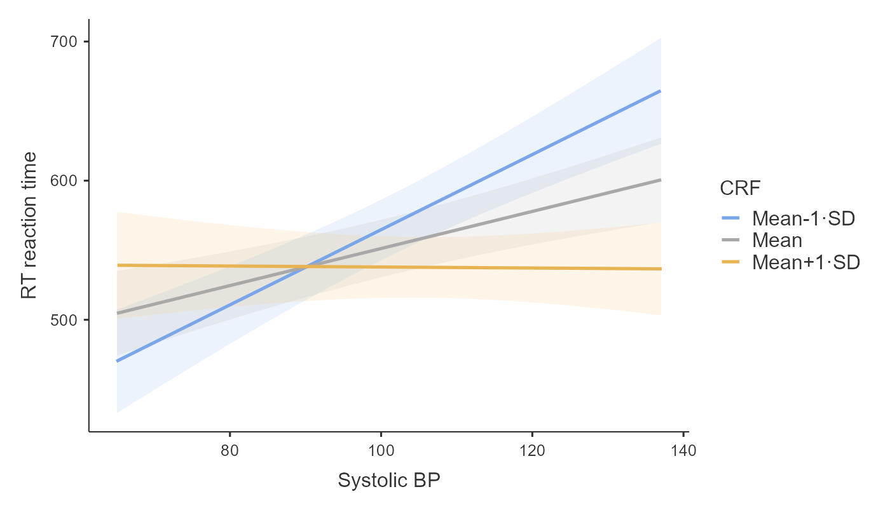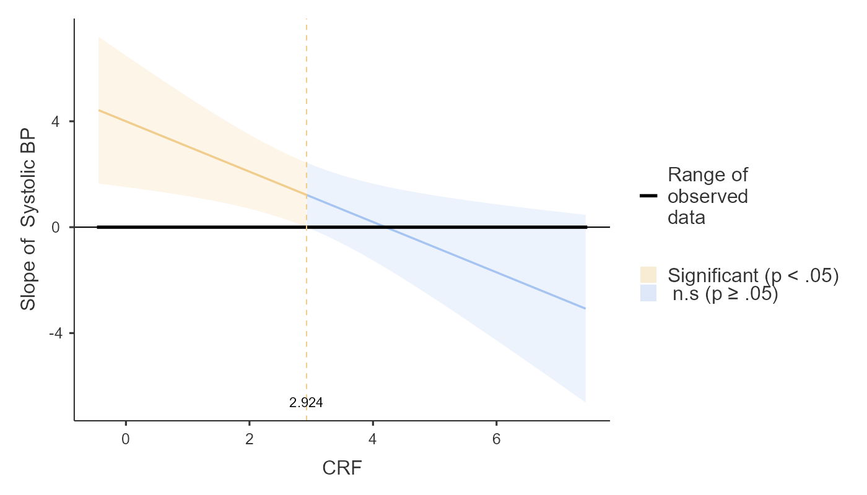
Abbreviations: RT, reaction test; BP, blood pressure; CRF, cardiorespiratory fitness.

