Intervention
The intervention consisted of nine monthly, individualized, home-based nutrition counseling sessions delivered over 9 months following enrollment. Each session lasted approximately 40–60 minutes and was conducted face-to-face in participants’ homes by trained WDA team leaders. Sessions were delivered flexibly, typically on weekends or religious holidays, to maximize participant availability. The intervention was grounded in the HBM, with counseling messages designed to address perceived susceptibility, severity, benefits, barriers, self-efficacy, and cues to action [1, 2]. The counseling guide was developed based on the 2021 World Health Organization (WHO) IYCF recommendations [3] and the 2021 IYCF Counseling Trainers’ Guide [4].
Counselors were WDA team leaders (two per cluster), each responsible for approximately 13–14 mothers with children. They are community-based volunteers within Ethiopia’s health extension system with prior experience in maternal and child health programs, including IYCF counseling [5]. All counselors received structured training consisting of a three-day pre-intervention training and a one-day refresher session conducted four months later. Training included lectures, demonstrations, and role-play exercises.
Training content focused on recommended IYCF practices, including timely introduction of complementary foods, preparation of thick and energy-dense porridges, dietary diversity, iron- and vitamin A-rich foods, minimum meal frequency, egg and/or flesh food consumption, hygiene, and feeding during and after illness. Counseling skills such as active listening, problem-solving, and confidence-building were also emphasized. Pre- and post-training assessments were used to evaluate counselors’ knowledge and counseling skills.
During each visit, a client-centered approach was used to assess existing complementary feeding practices and identify behavioral gaps. Counselors delivered tailored messages covering two to three prioritized topics per session. The intervention was supported by an illustrated nutrition counseling guide provided to mothers for home use, with assistance from literate household members when needed. HBM constructs were operationalized throughout counseling sessions by emphasizing, perceived risks and severity of child undernutrition, benefits of recommended feeding practices, addressing perceived barriers through problem-solving, and strengthening maternal self-efficacy through demonstrations and repeated follow-up [1, 2] (Fig 3). Intervention implementation was further supported by four MPH-trained supervisors who conducted monthly field visits and direct observations across all intervention clusters.
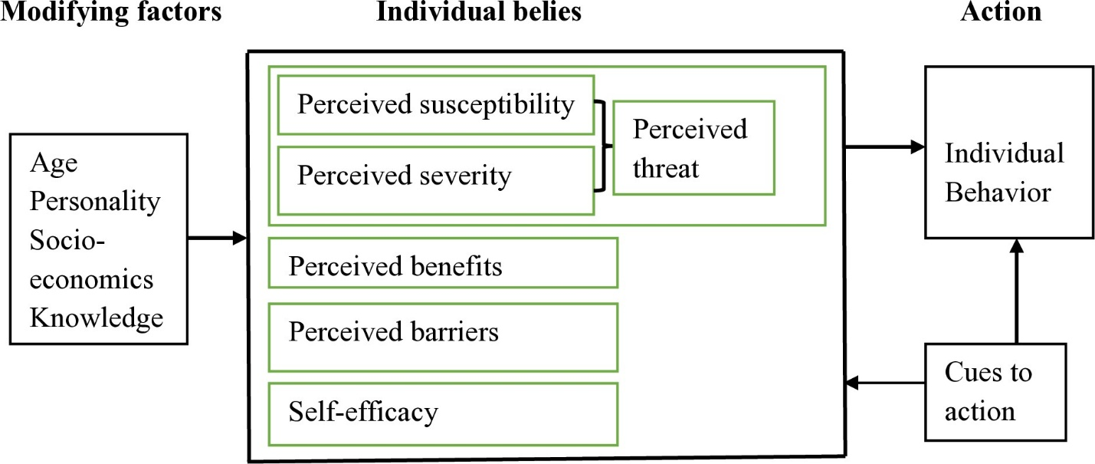
Figure 3. Conceptual framework of the nutrition counseling intervention based on Health Belief Model. The framework illustrates how modifying factors influence individual beliefs, which, together with cues to action, shape mothers’ complementary feeding practices.
A Job Aid: Food Intake – 6 to 24 Months [4], which includes 10 key dietary intake and feeding behavior indicators, was used during counseling sessions to assess complementary feeding practices. Mothers practicing recommended behaviors received positive reinforcement, while tailored counseling addressed identified gaps. Intervention delivery was uniform across clusters, with variations only in timing due to staggered enrollment.
The control group received routine counseling provided through existing government health services during antenatal care, postnatal visits, and child immunization sessions. This included general messages on continued breastfeeding up to two years and CFPs such as timely introduction of foods, dietary diversity, feeding frequency, hygiene, and feeding during and after illness, as outlined in national guidelines [6]. Both groups had access to routine services; however, only the intervention group received structured, theory-driven HBM-based nutrition counseling, including scheduled monthly follow-ups, standardized tools, and individualized behavior-focused support.
Intervention fidelity
Intervention fidelity was assessed using criteria developed by the investigators and guided by the National Institutes of Health (NIH) Behavior Change Consortium recommendations for treatment fidelity. The assessment focused on five domains: intervention design, training of WDA team leaders, delivery of nutrition counseling, participant receipt of the intervention, and enactment of acquired skills [7].
The intervention design was theory-driven, based on the HBM and WHO IYCF guidelines. Geographically non-adjacent clusters were selected to minimize contamination between study groups, and an equal number of clusters were allocated to intervention and control arms to ensure balance and reduce variability.
Training of WDA team leaders was fully implemented (100%). The training was conducted using a nutrition counseling guide and included group-based sessions, simulated counseling exercises, and competency assessments through pre- and post-training evaluations.
Process evaluation findings demonstrated implementation fidelity in a conflict-affected setting. Overall, 77.8% of planned counseling sessions were delivered, reflecting dose delivered. Among mothers enrolled in the intervention group (n = 401), 97.5% attended at least one counseling session, while 60.1% attended five or more sessions, reflecting participant adherence and dose received.
Delivery fidelity was assessed using a 10-item observation checklist applied to randomly selected counseling sessions. Each item was scored as Yes (1) or No (0), and fidelity was calculated as the proportion of items delivered according to the intervention guide. Across observed sessions, the overall delivery fidelity score was 66%. Key counseling messages were consistently delivered, including timely introduction of complementary foods (80%), dietary diversity (80%), minimum meal frequency (80%), preparation of thick and energy-dense complementary foods (80%), and promotion of egg and/or flesh food consumption (80%). Lower fidelity was observed for hygiene practices (60%), feeding during illness (60%), and responsive feeding practices (60%), with an average behavioral message fidelity of 72.5%.
No predefined fidelity threshold or cutoff value was established a priori; therefore, fidelity results are reported descriptively across domains rather than being classified as “high” or “low”. Participant receipt of the intervention was assessed through interviews evaluating mothers’ recall and understanding of counseling messages, knowledge of recommended feeding practices, and ability to demonstrate appropriate food preparation. Overall, 70% of mothers were able to recall at least four key counseling messages, indicating adequate comprehension of the intervention content. Detailed fidelity results are provided in Supplementary Tables.
Enactment of the intervention was explored through observation of complementary food preparation practices, including dietary diversity, hygiene, and responsive feeding behaviors. Intervention delivery and supervision were conducted under the constraints of an ongoing conflict setting, which affected mobility, scheduling consistency, and access to some clusters, and may have influenced intervention exposure and overall fidelity.
References
1. Glanz K, Rimer BK, Viswanath K: Health behavior: Theory, research, and practice: John Wiley & Sons; 2015.
2. Rosenstock IM: Historical origins of the health belief model. Health education monographs 1974, 2(4):328-335.
3. World Health Organization: Indicators for assessing infant and young child feeding practices: Definitions and measurement methods. Geneva: World Health Organization & UNICEF; 2021.
4. World Health Organization: Infant and young child feeding counselling: an integrated course trainer’s guide; 2021.
5. Yitbarek K, Abraham G, Morankar S: Contribution of women’s development army to maternal and child health in Ethiopia: a systematic review of evidence. BMJ open 2019, 9(5):e025937.
6. USAID: Training of trainers manual for counseling on maternal, infant, and young child nutrition: Ethiopia. Washington (DC): USAID; 2011.
7. Bellg AJ, Borrelli B, Resnick B, Hecht J, Minicucci DS, Ory M, Ogedegbe G, Orwig D, Ernst D, Czajkowski S: Enhancing treatment fidelity in health behavior change studies: best practices and recommendations from the NIH Behavior Change Consortium. Health psychology 2004, 23(5):443.

