Additional file 1

Funnel plots
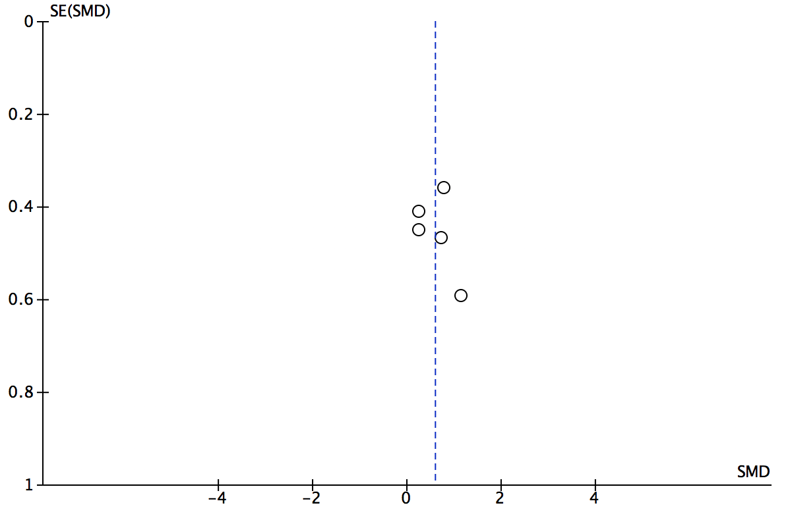
Additional file 1: Figure S1. Funnel plot of studies included for final analysis regarding development of cross sectional area.

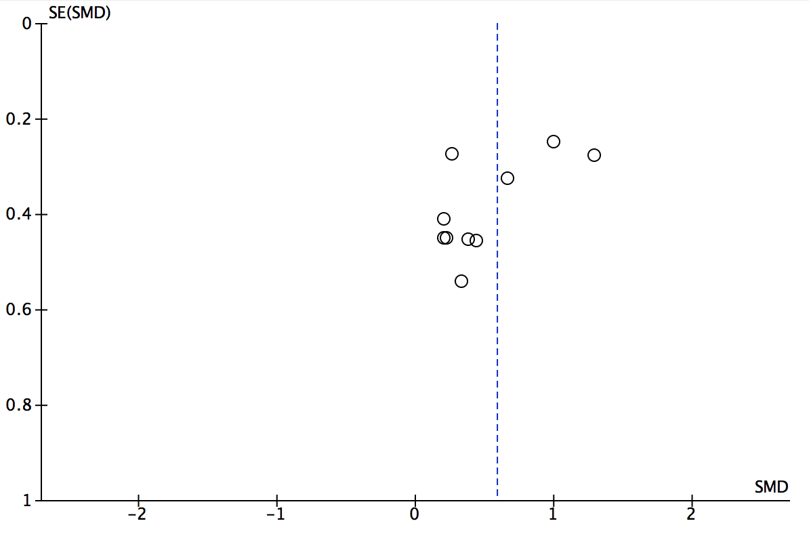
Additional file 1: Figure S2. Funnel plot of studies included for final analysis regarding development of muscle volume/mass.
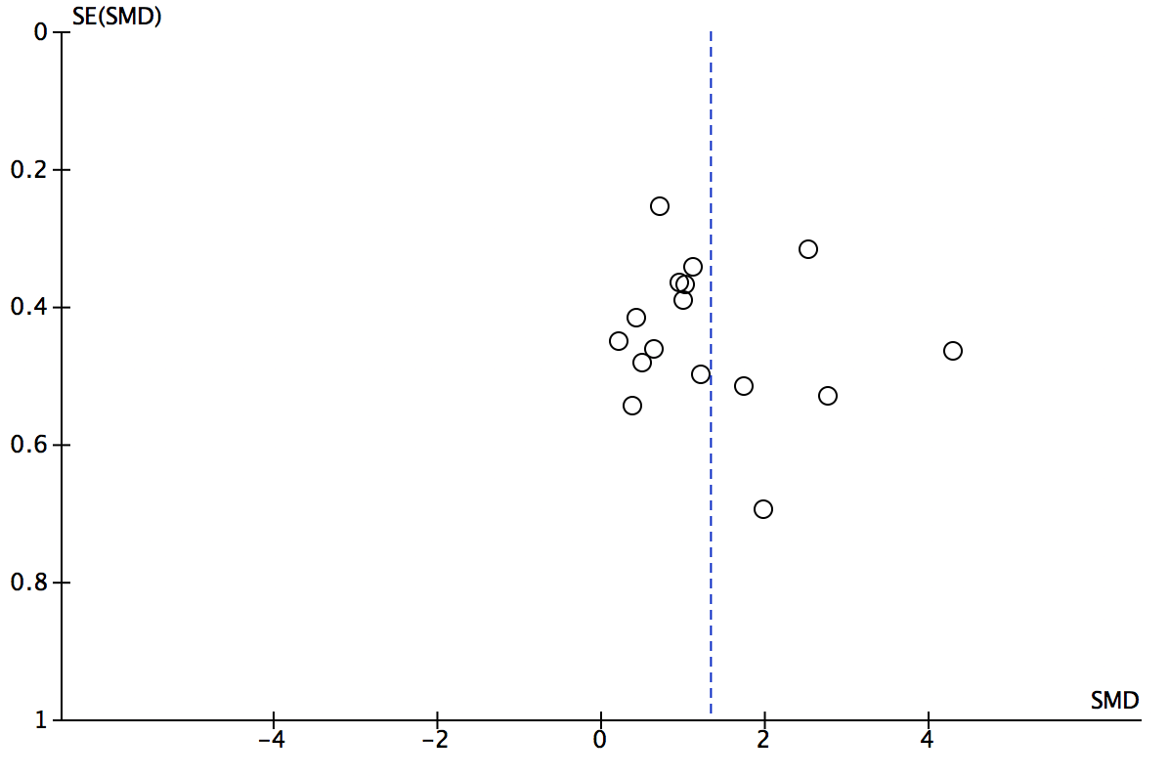
Additional file 1: Figure S3. Funnel plot of studies included for final analysis regarding development of maximal strength.

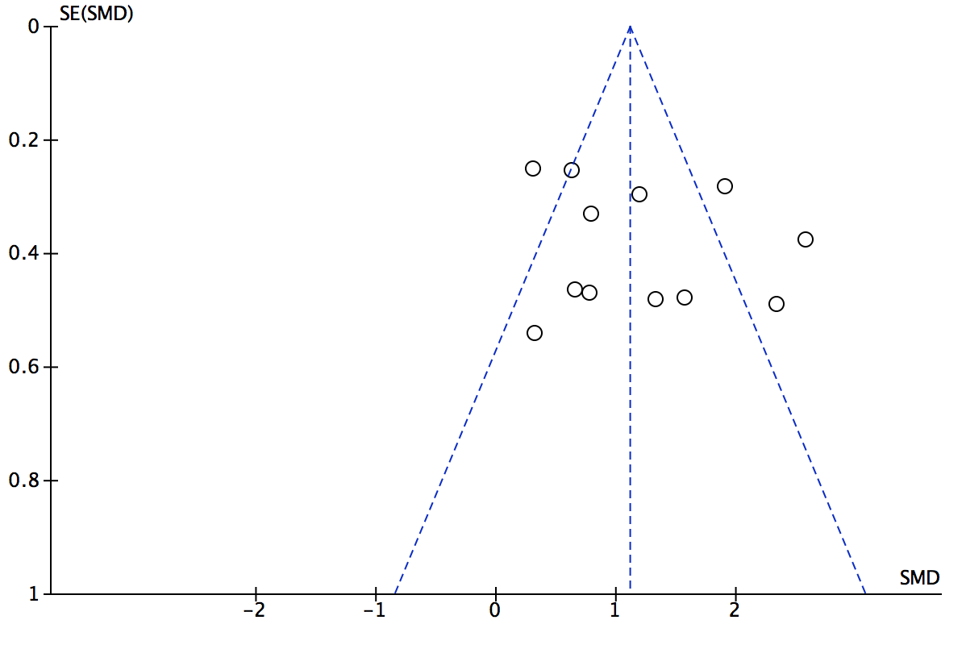
Additional file 1: Figure S4. Funnel plot of studies included for final analysis regarding development of power.

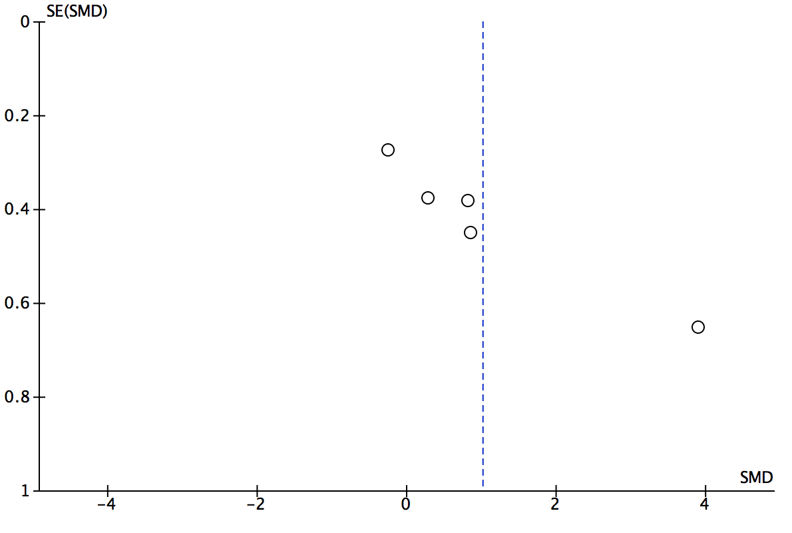
Additional file 1: Figure S5. Funnel plot of studies included for final analysis regarding development of functional tests in horizontal direction.

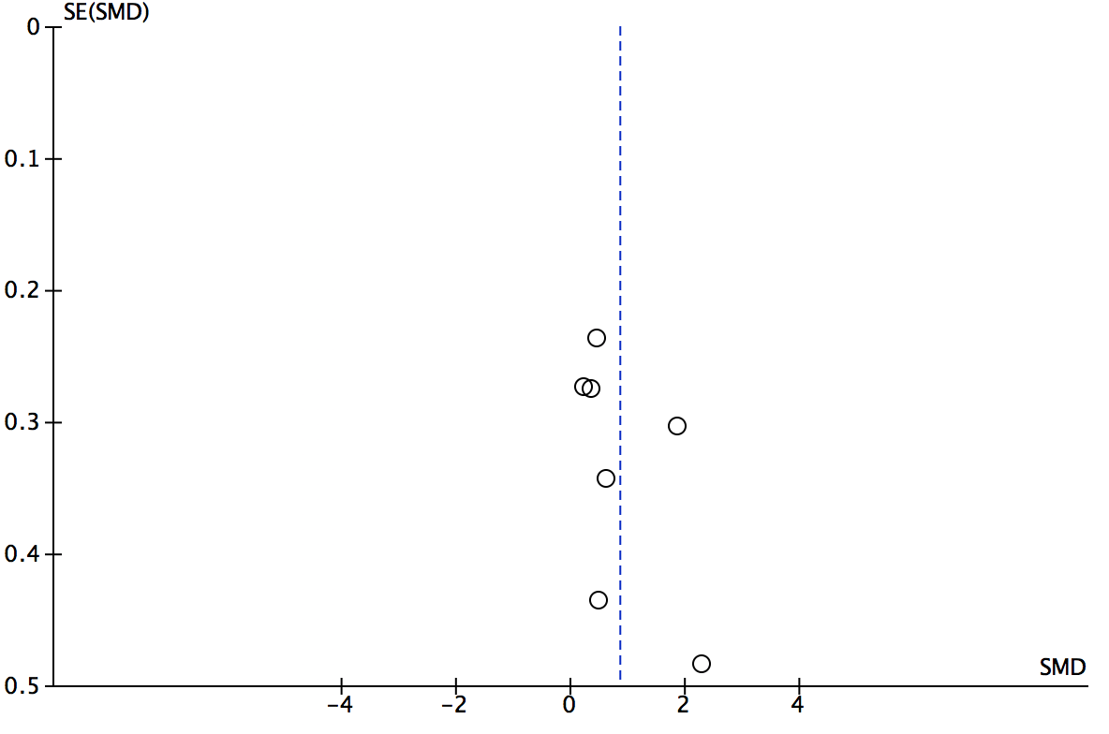
Additional file 1: Figure S6. Funnel plot of studies included for final analysis regarding development of functional tests in vertical direction.

