Supplementary material
Table A. LC chromatograms and MSMS spectra for each biomarker indicating the retention time, the ESI operation mode, the precursor ion mass ratio and selected fragmentation(s) mass ratio(s).
LC chromatogram/MSMS spectra
Major NTs
Acetylcholine t_{r} = 1.59 +ESI SRM ms2 146.00 → 60.00/87.00
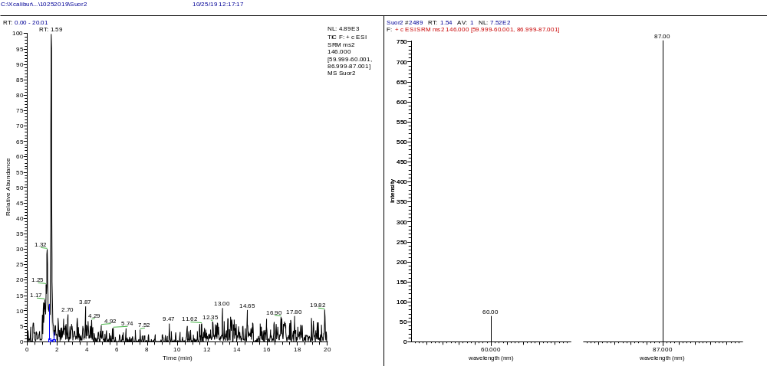
Biological amines
Dopamine t_{r} = 1.59 +ESI SRM ms2 154.00 → 91.00/137.00
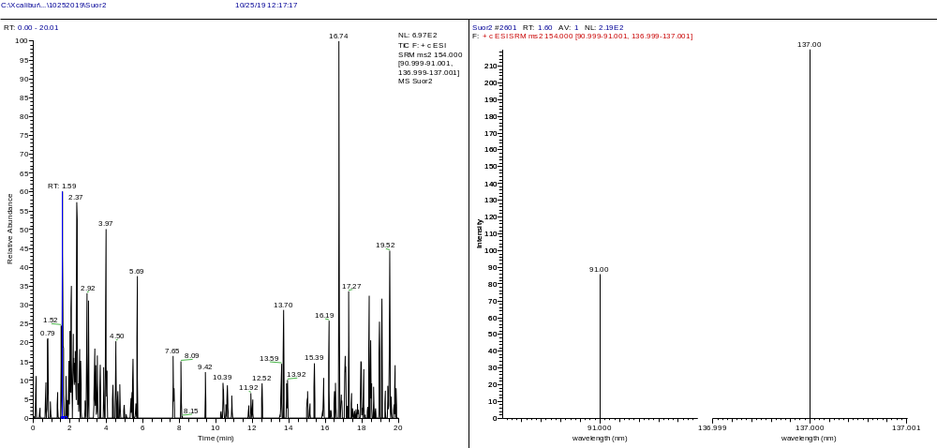
DOPAC (DA Met) t_{r} = 2.34 -ESI SRM ms2 167.00 → 122.00
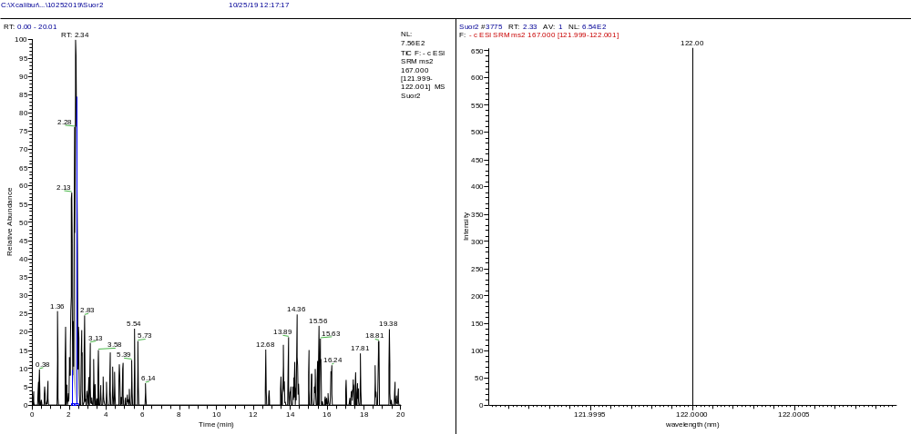
3-MT (DA Met) t_{r} = 1.59 +ESI SRM ms2 168.00 → 121.00
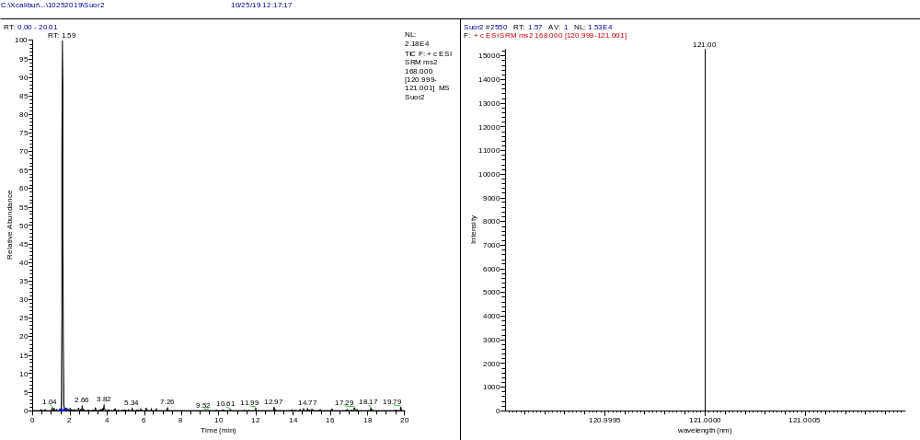
HVA (DA Met) t_{r} = 2.69 -ESI SRM ms2 181.00 → 122.00
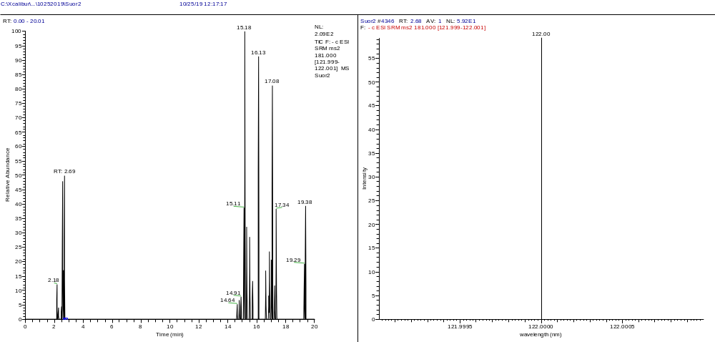
Epinephrine t_{r} = 1.59 +ESI SRM ms2 184.10 → 106.00/166.00
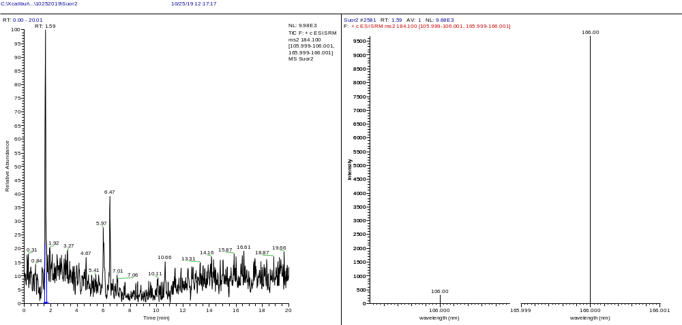
Norepinephrine t_{r} = 2.56 +ESI SRM ms2 170.00 → 107.00/135.00
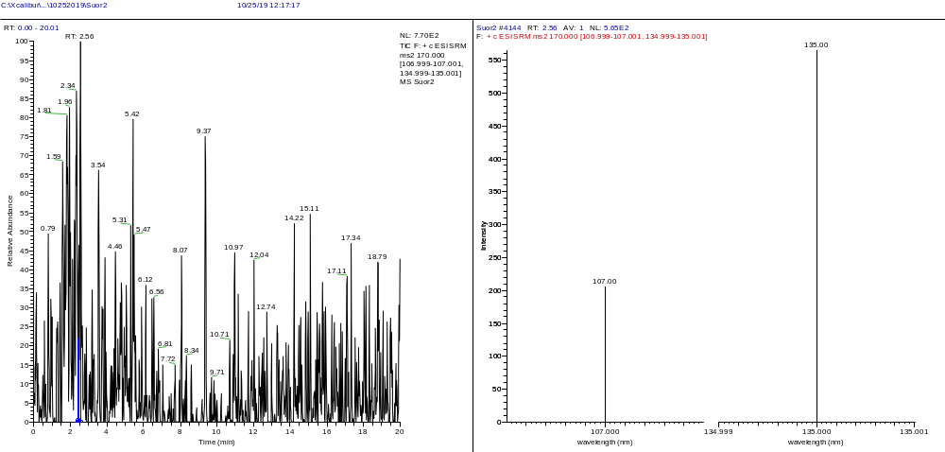
Serotonin (5-HT) t_{r} = 1.37 +ESI SRM ms2 177.00 → 115.00/160.00
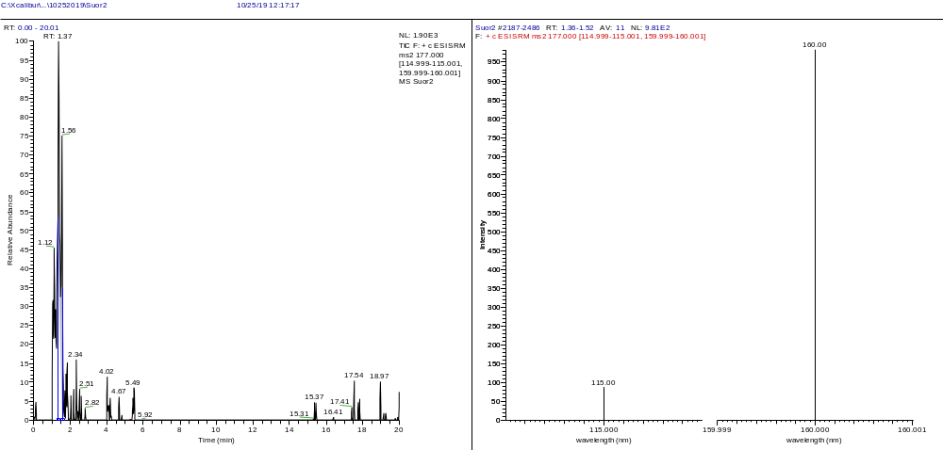
5-HIAA (5-HT Met) t_{r} = 1.58 -ESI SRM ms2 190.00 → 146.00
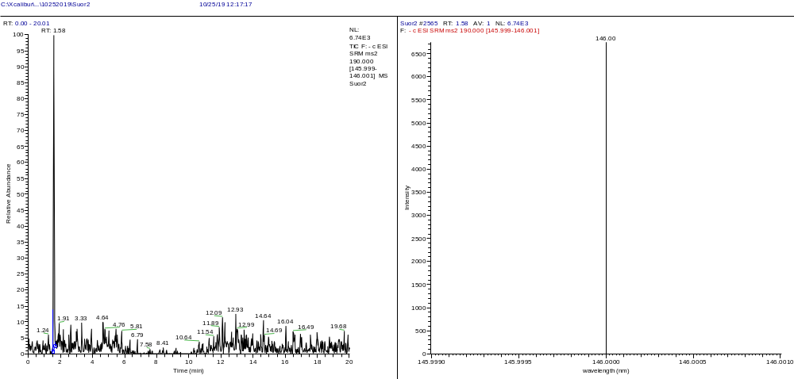
Amino acids
L-Glutamic Acid t_{r} = 1.57 +ESI SRM ms2 148.00 → 84.00/130.00
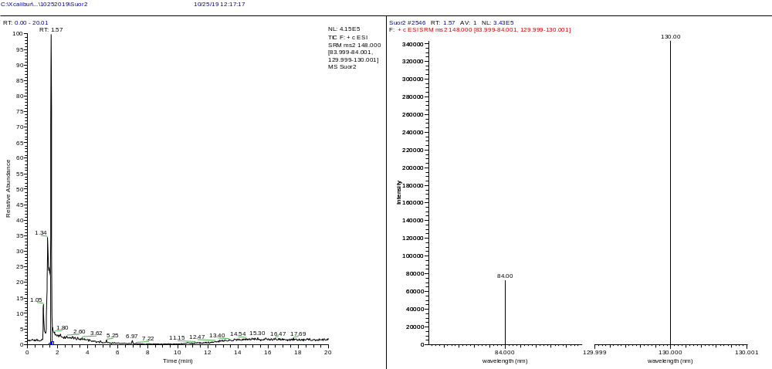
Purines
Adenosine t_{r} = 1.59 +ESI SRM ms2 268.00 → 136.00/170.00
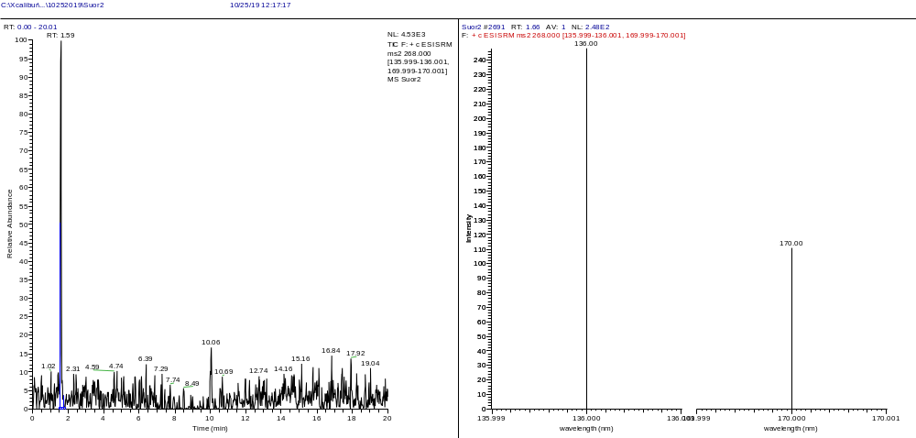
Other Biomarkers
Amino acid precursors of Biogenic Amines
L-Phenylalanine t_{r} = 1.59 +ESI SRM ms2 166.10 → 77.00/103.00/120.00/149.00
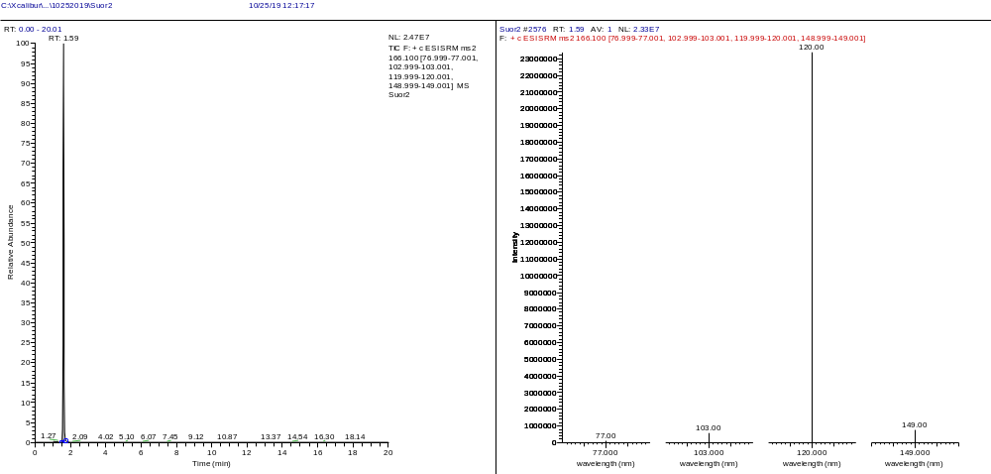
L-Tryptophan t_{r} = 1.64 +ESI SRM ms2 205.2 → 113.00/144.00/159.00/188.00/245.00
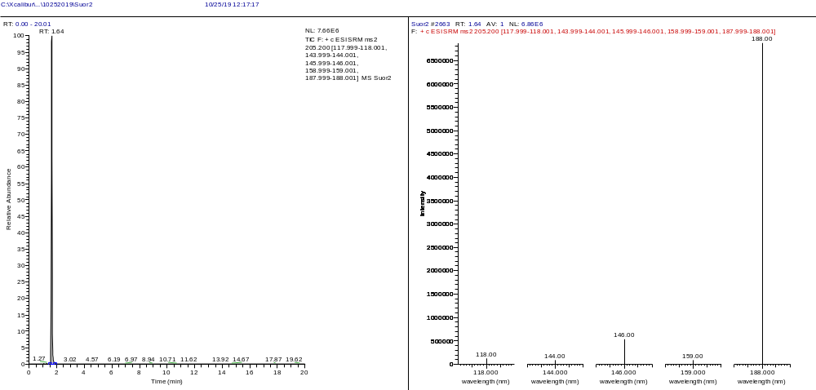
L-Tyrosine t_{r} = 1.59 +ESI SRM ms2 182.00 → 105.00/119.00/123.00/136.00/165.00
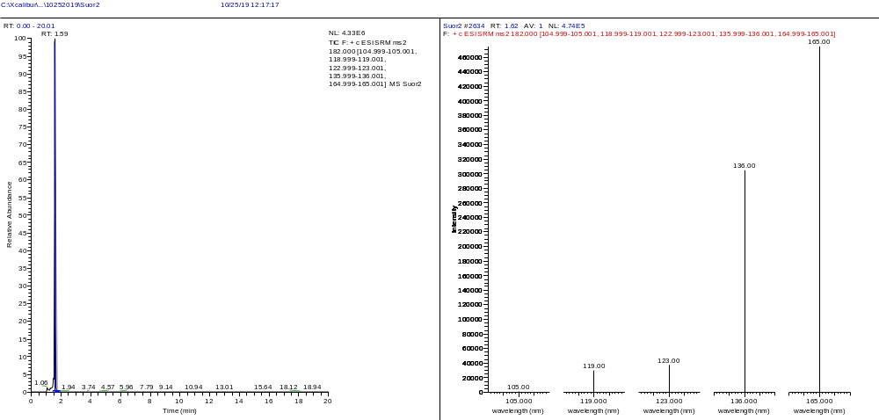
Ascorbic Acid t_{r} = 1.99 -ESI SRM ms2 175.00 → 87.00/115.00
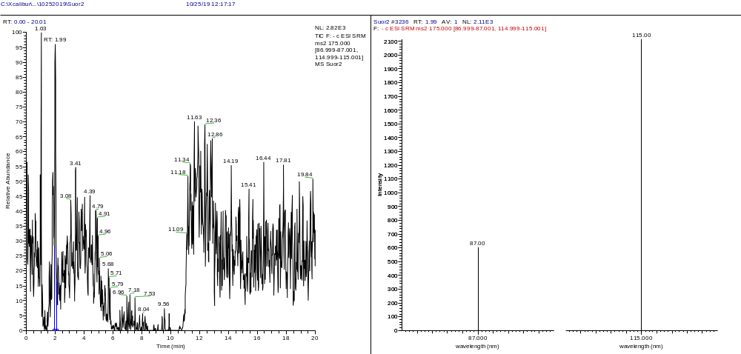
Other biomarkers
Amino acids
Creatine t_{r} = 1.59 +ESI SRM ms2 132.10 → 43.30/90.20
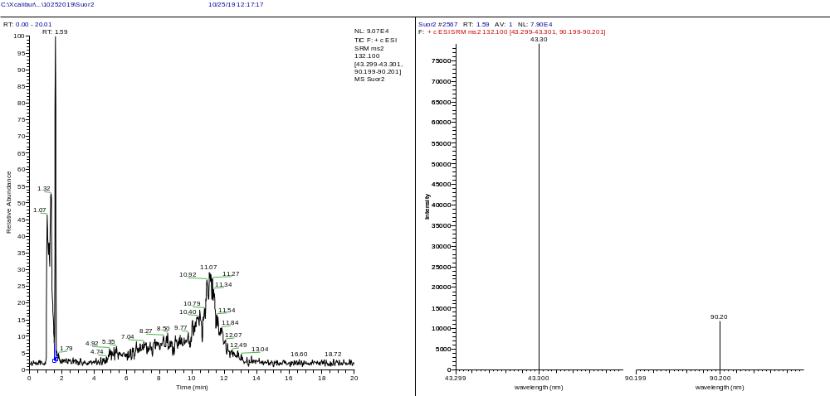
L-Glutamine t_{r} = 1.32 +ESI SRM ms2 147.00 → 84.00/85.00/103.00/121.00/130.00
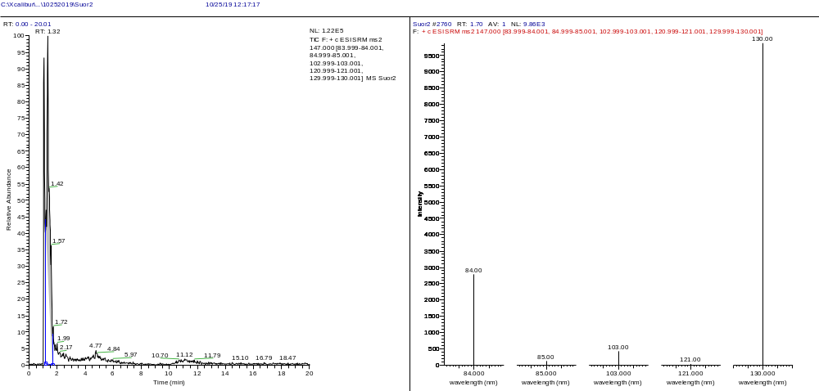
L-Histidine t_{r} = 1.32 +ESI SRM ms2 156.00 → 56.00/83.00/93.00/95.00/110.00
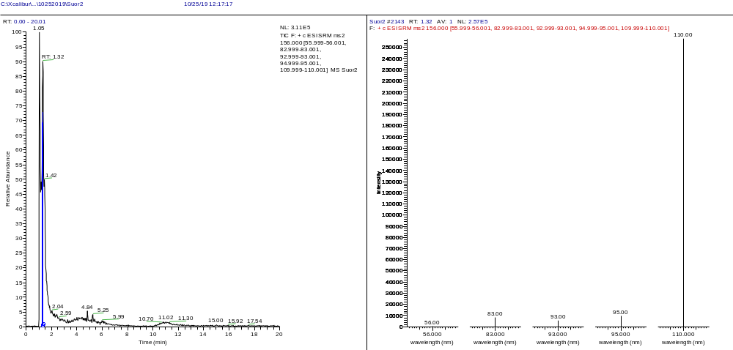
L-Isoleucine t_{r} = 1.59 +ESI SRM ms2 132.00 → 69.00
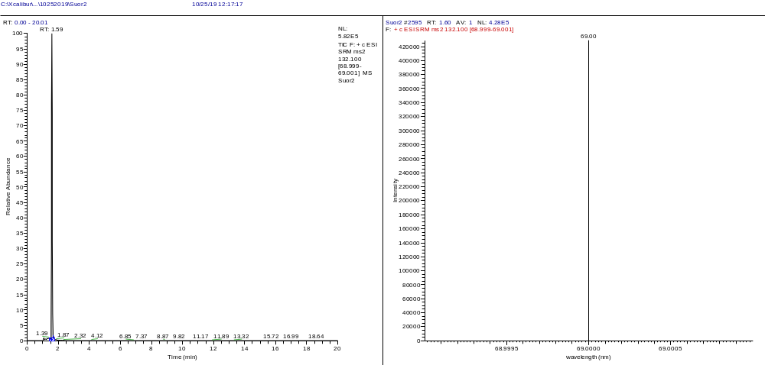
L-Leucine t_{r} = 1.59 +ESI SRM ms2 132.10 → 86.00
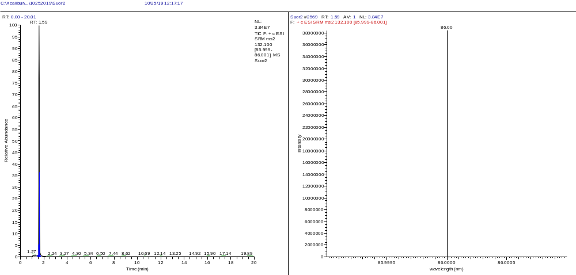
L-Lysine t_{r} = 1.05 +ESI SRM ms2 147.20 → 56.00/84.00/130.00
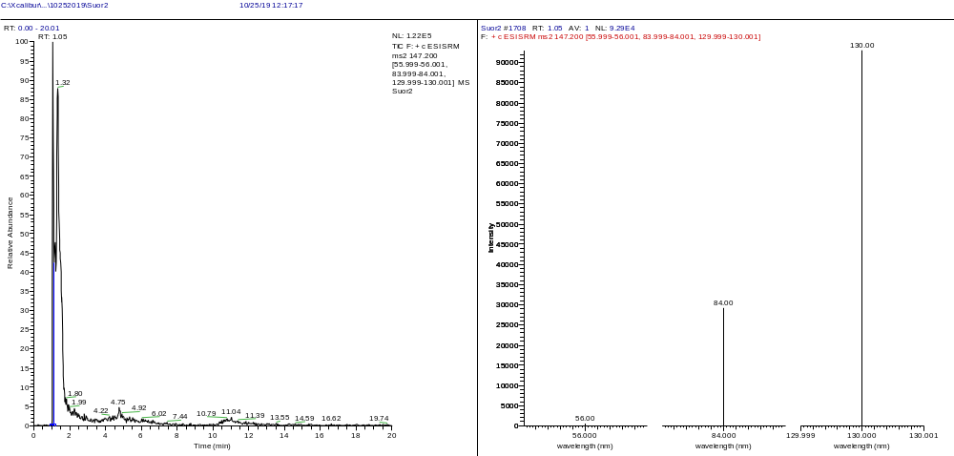
Carboxylic acids
Ascorbic Acid t_{r} = 1.99 -ESI SRM ms2 175.00 → 87.00/115.00
Lactic Acid t_{r} = 1.58 -ESI SRM ms2 89.00 → 43.00
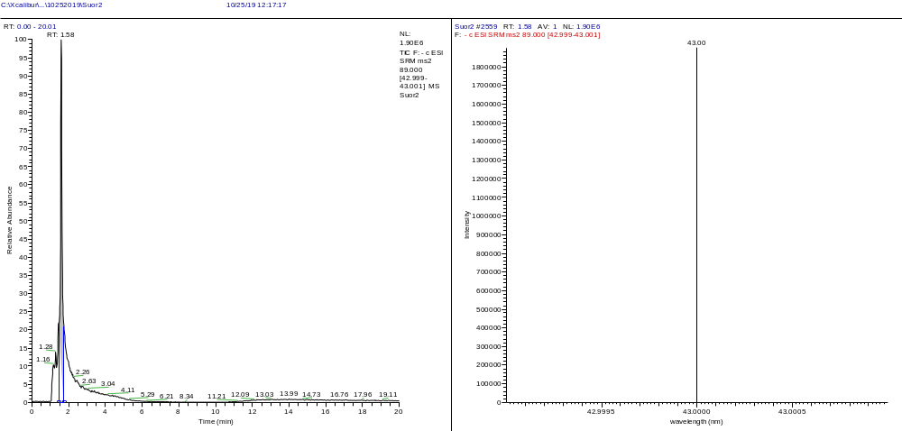
Carbohydrates
D-Glucose t_{r} = 1.58 -ESI SRM ms2 179.00 → 71.00/89.00
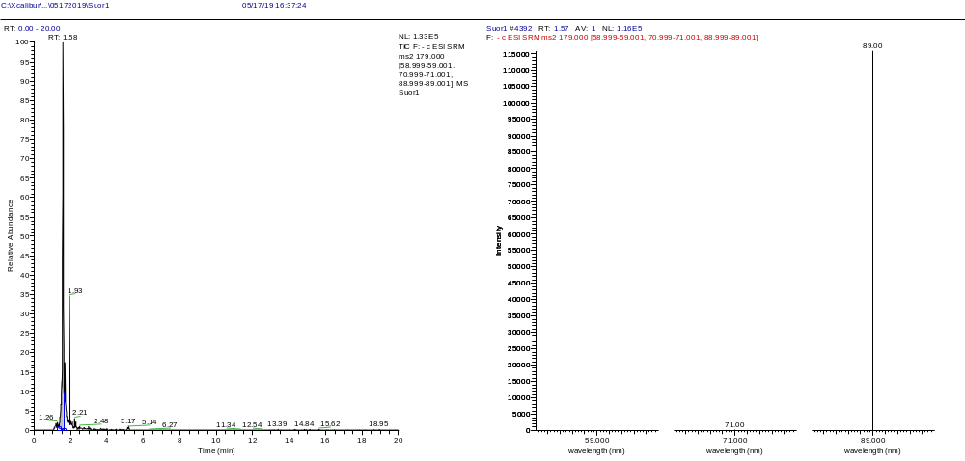
Breakdown product
Creatinine t_{r} = 1.32 +ESI SRM ms2 114.00 → 44.30/86.00
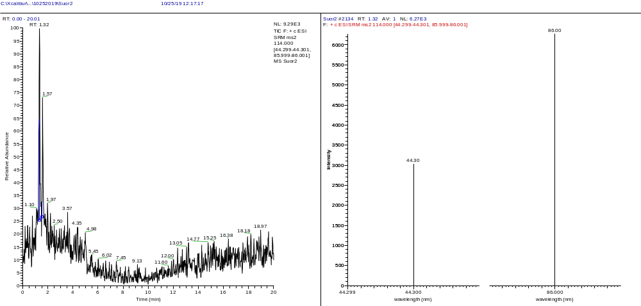
Steroid hormones
Cortisol t_{r} = 1.59 +ESI SRM ms2 363.10 → 121.00/309.00/327.00
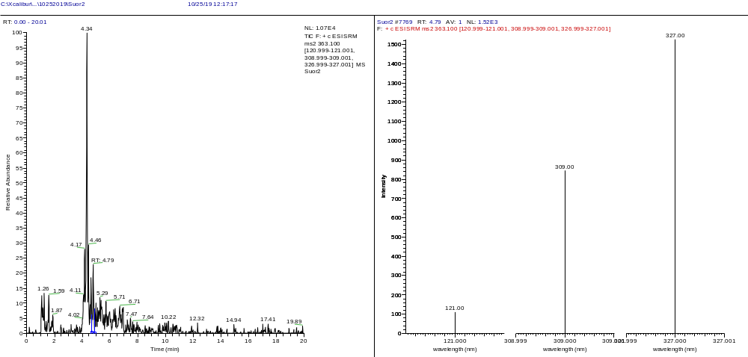
Cortisone t_{r} = 1.59 +ESI SRM ms2 361.00 → 163.00/343.00
