Additional file 1
Title: The effects of accumulated versus continuous exercise on postprandial glycemia, insulin, and triglycerides in adults: a systematic review and meta-analysis
Xiaoyuan Zhang, Chen Zheng, Robin S.T. Ho, Masashi Miyashita, Stephen H.S. Wong*
* Corresponding Author: Stephen H.S. Wong, Ph.D.
Department of Sports Science and Physical Education, The Chinese University of Hong Kong, Hong Kong, China; Email: hsswong@cuhk.edu.hk

Table S1 Search strategy (Medline¹)
- Search strategy for “randomized controlled trial”
((clinical[Title/Abstract] AND trial[Title/Abstract]) OR clinical trials as topic[MeSH Terms] OR clinical trial[Publication Type] OR random*[Title/Abstract] OR random allocation[MeSH Terms] OR therapeutic use[MeSH Subheading])
- Search strategy for “exercise”
((((exercise[MeSH Terms]) OR (exercis*[Title/Abstract]) OR
(physical activit*[Title/Abstract]) OR (physical activity[MeSH Terms]) OR
(walk*[Title/Abstract]) OR motor activity
(sports[MeSH Terms]) OR (sport*[Title/Abstract]) OR (fitness[Title/Abstract]) OR
(resistance training[MeSH Terms]) OR (weight training[Title/Abstract]) OR (weightlifting[Title/Abstract]) OR
(running[Title/Abstract]) OR (*cycling[Title/Abstract]) OR (swimming[Title/Abstract])) OR jog*
- Search strategy for “accumulated” or “continuous”
(continuous[Title/Abstract]) OR (Continu*) OR
((single bout*[Title/Abstract]) OR (long bout*[Title/Abstract]) OR (one bout*) OR
(multiple bout*[Title/Abstract]) OR (short* AND bout*[Title/Abstract]) OR (repeated bout*[Title/Abstract]) OR (accumulat*[Title/Abstract]) OR
(physical activity pattern*[Title/Abstract]) OR (exercise pattern*[Title/Abstract])) OR
“breaks” OR “breaking” OR “break*" OR
"interrupting" OR (intermittent[Title/Abstract]) OR
“intervals” OR "alternating" OR “Exercise snack*” OR “periodic exercise”
- Search strategy for “glucose” “insulin” or “lipid”
"glucose" OR "glycaemia" OR "glycemia" OR “*Glyc*mi*” OR
“Glucose intoleran*” OR
“*Insulin*” OR “Insulin sensitivity” OR “Insulin resistance” OR
"lipid*" OR "lipaemia" OR "lipemia" OR "*lip*mi*" OR
"triglycerides" OR "triglyceride*" OR “triacylglycerol” OR “triacylglyceride”
- Search strategy for “postprandial”
“postprandial” OR “post*prandial*” OR “post prandial” OR “postprandial period” OR “post*meal” OR “post meal” OR
post challenge[Title/Abstract]) OR postchallenge[Title/Abstract]) OR post-challenge[Title/Abstract]) OR post*challenge OR “post-load” OR peak[Title/Abstract]) OR Glucose Tolerance Test* OR OGTT OR “tolerance test*” OR “meal test*”
AUC[Title/Abstract] OR iAUC[Title/Abstract] OR area under the curve[Title/Abstract]) OR area under curve[Title/Abstract])
meal* OR breakfast OR lunch OR dinner OR drink* OR beverage* OR
OR continuous glucose monitoring OR interstitial glucose

¹ The search strategy was initially designed for Medline and was adapted for searching the other databases. Keywords were combined within-terms using the ‘OR’ operator, and the final search phrase was conducted by combining the five search terms using the ‘AND’ operator.

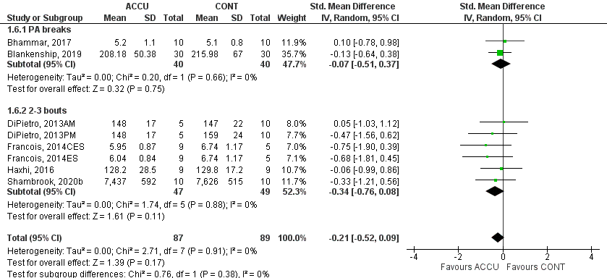

Fig.S1. Forest plot of comparison between accumulated and continuous exercise on 24-h glucose measures. ACCU, accumulated exercise; CONT, continuous exercise; PA breaks represents frequent brief bouts (e.g., 1–6 min) throughout the day at 20–60-min intervals (≥5 bouts); 2-3 bouts represents 2-3 short bouts of accumulated exercise.

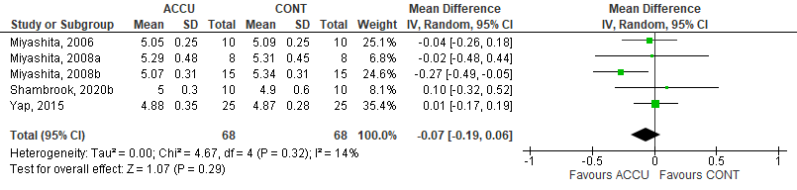

Fig.S2. Forest plot of comparison between accumulated and continuous exercise on second-morning fasting glucose. ACCU, accumulated exercise; CONT, continuous exercise.

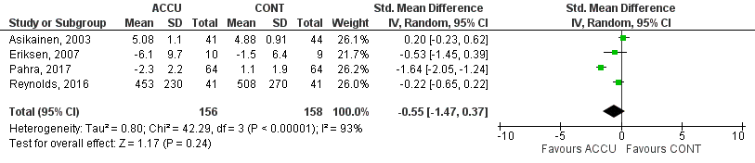

Fig.S3. Forest plot of comparison between long-term accumulated and continuous exercise intervention on postprandial glucose. ACCU, accumulated exercise; CONT, continuous exercise.

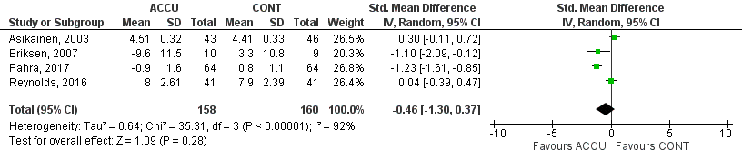

Fig.S4. Forest plot of comparison between long-term accumulated and continuous exercise intervention on fasting glucose. ACCU, accumulated exercise; CONT, continuous exercise.

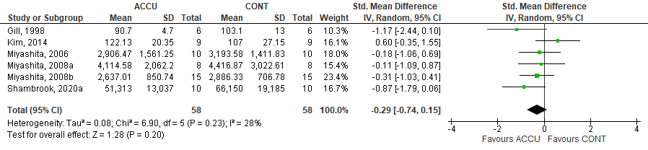

Fig.S5. Forest plot of comparison between accumulated and continuous exercise on second-morning postprandial insulin. ACCU, accumulated exercise; CONT, continuous exercise.

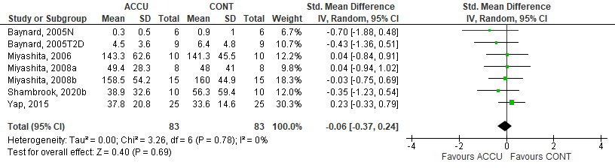

Fig.S6. Forest plot of comparison between accumulated and continuous exercise on second-morning fasting insulin. ACCU, accumulated exercise; CONT, continuous exercise.

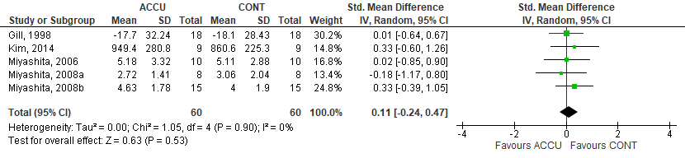

Fig.S7. Forest plot of comparison between accumulated and continuous exercise on second-morning postprandial triglycerides. ACCU, accumulated exercise; CONT, continuous exercise.

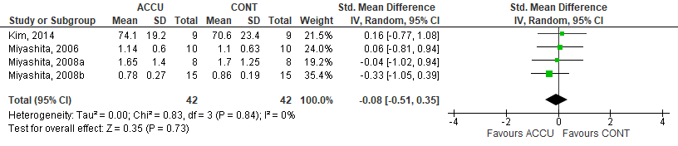

Fig.S8. Forest plot of comparison between accumulated and continuous exercise on second-morning fasting triglycerides. ACCU, accumulated exercise; CONT, continuous exercise.

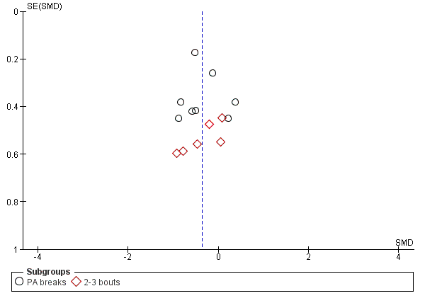

Fig.S9. Funnel plot of comparison between accumulated and continuous exercise on same-day postprandial glucose, stratified by exercise bouts. PA breaks represents frequent brief bouts (e.g., 1–6 min) throughout the day at 20–60-min intervals (≥5 bouts); 2-3 bouts represents 2-3 short bouts of accumulated exercise.

