Supplementary 5. Funnel plots for analyses of static balance with eyes open, dynamic balance and functional performance.
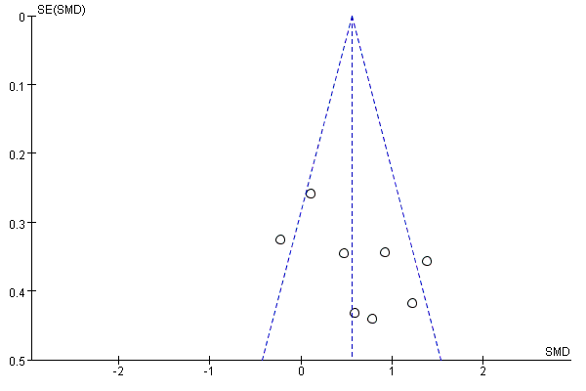
- Injured limb vs. control for static balance with eyes open
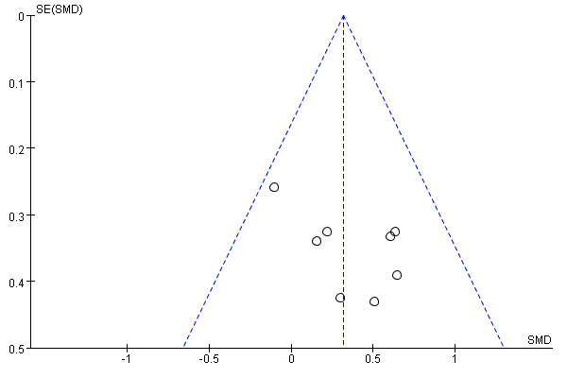
- Uninjured limb vs. control for static balance with eyes open
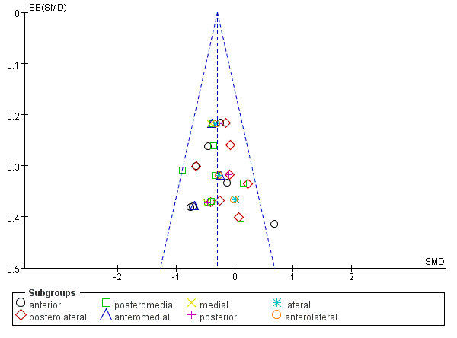
- Injured limb vs. control for dynamic balance
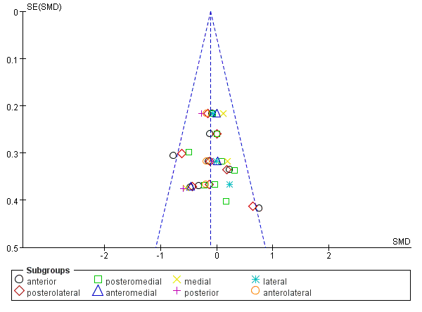
- Uninjured limb vs. control for dynamic balance
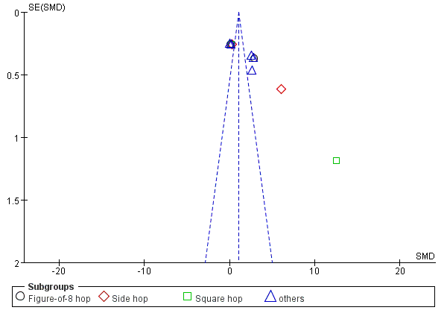
- Injured limb vs. control for functional performance
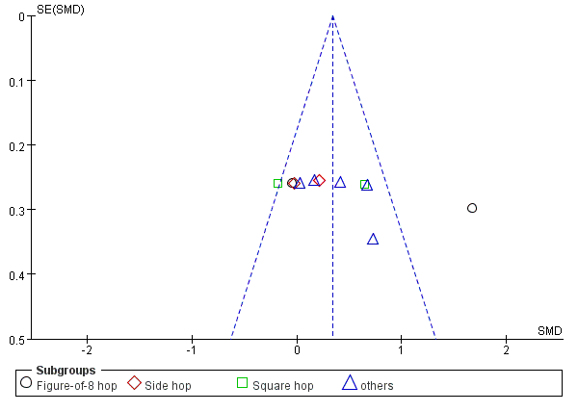
- Uninjured limb vs. control for functional performance

