SUPPLEMENTAL MATERIALS
Cardiorespiratory Fitness and Sleep, but not Physical Activity, are Associated with Functional Connectivity in Older Adults David Wing ^{1,2}, Bart Roelands ^{6,10,} Julie Loebach Wetherell ^{4,5}, Jeanne F Nichols^{1,2}, Romain Meeusen ^{6, 10,11}, Job G. Godino ^{1,2}, Joshua S. Shimony ⁹, Abraham Z. Snyder ⁹, Tomoyuki Nishino ³, Ginger E Nicol ³, Guy Nagels ⁸, Lisa T. Eyler ^{5,7}, and Eric J. Lenze ³

1 Herbert Wertheim School of Public Health and Human Longevity Science; University of California, San Diego
2 Exercise and Physical Activity Resource Center (EPARC); University of California, San Diego
3 Department of Psychiatry, Washington University School of Medicine, St. Louis, MO
4 Mental Health Service, VA San Diego Healthcare System
5 Department of Psychiatry, University of California, San Diego
6 Human Physiology & Sports Physiotherapy Research Group, Faculty of Physical Education and Physiotherapy, Vrije Universiteit Brussel, Brussels, Belgium
7 Desert-Pacific Mental Illness Research, Education, and Clinical Center, San Diego Veterans Administration Healthcare System, San Diego
8 Department of Neurology, UZ Brussel, Brussel, Belgium/Center for Neurosciences (C4N) Vrije Universiteit Brussel (VUB), Brussels, Belgium
9 Mallinckrodt Institute of Radiology, Washington University School of Medicine, St. Louis, MO
10: Brubotics, Vrije Universiteit Brussel, Brussels, Belgium
11: Department of Sports, Recreation, Exercise and Sciences, Community and Health Sciences; University of the Western Cape ,South Africa

Corresponding Author: David Wing. dwing@eng.ucsd.edu. 9500 Gilman Drive #0811. CALIT2/Atkinson Hall Room 3504. La Jolla, CA 92093-0811

Contents
SUPPLEMENTARY TABLES 4
Table 1: Difference in Variables of Interest by Site and Gender 4
Tables 2 and 3: Correlations 5
Behavioral/Physiological Variables of Interest 5
Functional Networks 6
Table 4: Talairach Locations and Designations to Networks Used 7
SUPPLEMENTARY FIGURES: 7
Seitzman and Voss Coordinates and ROI’s: Visual Representations 7
Default Mode Network 7
Executive Control Network 8
Dorsal Attentional Network 9
Salience Network 10
Sensory Networks 11
Supplementary Figure 6: Sample Size by Variable with Reason for Exclusion 12
Supplementary Figures 7-15: Histograms of Population Distributions (Full Sample) 12
Cardiorespiratory Fitness 12
Percentage Body Fat 12
Absolute Lean Tissue 13
Absolute Visceral Adipose Tissue Mass 14
Sleep Efficiency 14
Total Sleep Time 15
Wake After Sleep Onset_Total Minutes 15
Wake After Sleep Onset_Number of Awakenings 16
Total Movement Per Day 16
Supplementary Figures 16-24: Histograms of Population Distributions (UCSD Only) 17
Cardiorespiratory Fitness 17
Percentage Body Fat 18
Absolute Lean Tissue 18
Absolute Visceral Adipose Tissue Mass 19
Sleep Efficiency 20
Total Sleep Time 20
Wake After Sleep Onset_Total Minutes 21
Wake After Sleep Onset_Number of Awakenings 22
Total Movement Per Day 22
Supplementary Figures 25-33: Histograms of Population Distributions (WUSTL Only) 23
Cardiorespiratory Fitness 23
Percentage Body Fat 24
Absolute Lean Tissue 24
Absolute Visceral Adipose Tissue Mass 25
Sleep Efficiency 26
Total Sleep Time 26
Wake After Sleep Onset_Total Minutes 27
Wake After Sleep Onset_Number of Awakenings 28
Total Movement Per Day 28
Supplementary Figures 34-41: Scatterplots of Physiological/Behavioral Variables with FC Networks 29
Cardiorespiratory Fitness 29
Percentage Body Fat 30
Absolute Lean Tissue 30
Absolute Visceral Adipose Tissue Mass 31
Sleep Efficiency 31
Total Sleep Time 32
Wake After Sleep Onset_Total Minutes 32
Wake After Sleep Onset_Number of Awakenings 33
Non Significant Linear Regression of Unstandardized Residuals of behavioral variables and functional connectivity. 33
CRF: METS 33
Percent Body Fat 37
Visceral Adipose Tissue 42
Physical Activity (VM CPM) 46
Sleep Efficiency 50
Total Sleep Time 54
Wake After Sleep Onset Time 58
Wake After Sleep Onset Number 62

SUPPLEMENTARY TABLES

Table 1: Difference in Variables of Interest by Site and Gender
Supplementary Table 1: Mean Difference and Confidence Intervals for Significant Differences by Site and Gender
SITE: UCSD-WUSTL
 | P | Mean Difference (CI) | 95% CI (Low) | 95% CI (high)
Maximal Cardiovascular Fitness (METS) | <.001 | -1.0 | -1.4 | -0.7
DMN Connectivity | <.001 | 0.052 | 0.04 | 0.064
ECN Connectivity | <.001 | 0.034 | 0.029 | 0.04
DAN Connectivity | <.001 | 0.033 | 0.028 | 0.039
SAL Connectivity | <.001 | 0.088 | 0.07 | 0.107
MOT Connectivity | <.001 | 0.091 | 0.071 | 0.112
VIS Connectivity | <.001 | 0.061 | 0.049 | 0.073
BSDMN Connectivity | <.001 | 0.039 | 0.031 | 0.047
BSDAN Connectivity | <.001 | 0.028 | 0.016 | 0.04
Sex: Female-Male
Age (yrs) | 0.005 | -1.6 | -2.7 | -0.5
Maximal Cardiovascular Fitness (METS) | <.001 | -1.4 | -1.8 | -0.9
Body Fat (%) | <.001 | 9.4 | 7.9 | 10.9
Lean Tissue (g) | <.001 | -15307.6 | -16643.2 | -13972
Visceral Adipose Tissue (g) | <.001 | -1063 | -1240.4 | -885.6
Total Movement (VM CPM) | 0.026 | 135.5 | 16.6 | 254.5
DMN Connectivity | 0.019 | 0.019 | 0.003 | 0.034
Yrs=Years; METS= Metabolic Equivalent of Task; VM= Vector Magnitude; CPM= Counts per minute; g=grams; min= minutes; DMN = Default Mode Network; ECN = Executive Control Network; DAN = Dorsal Attentional Network; SAL = Salience Network; MOT = Motor Control Network; VIS = Visual Network; BS = Ben Sietzman defined network.

Tables 2 and 3: Correlations
Table 2: Correlations between
Behavioral/Physiological Variables of Interest
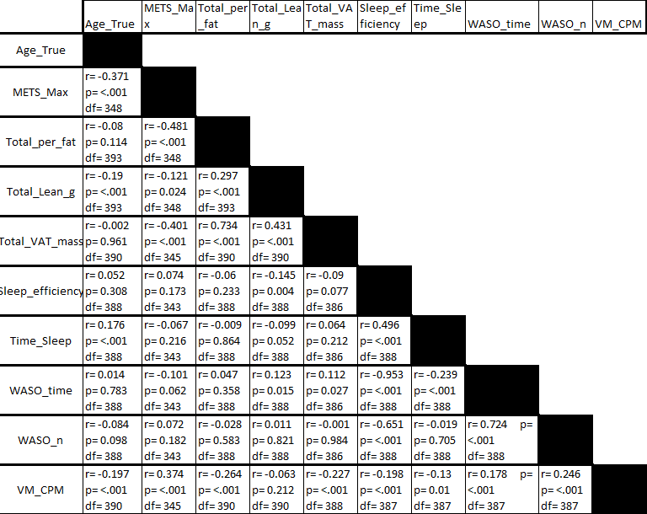
METS= Metabolic Equivalent of Task; VM= Vector Magnitude; CPM= Counts per minute; g=grams; WASO= Wake After Sleep Onset;

Table 3: Correlations between
Functional Networks

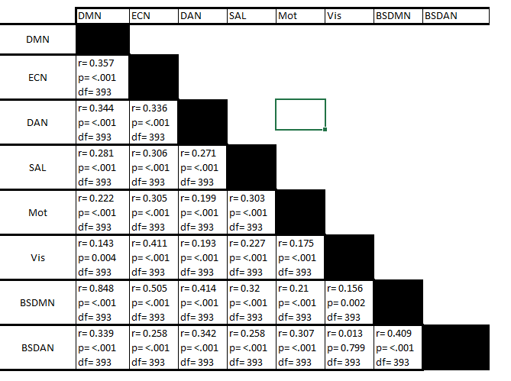
DMN = Default Mode Network; ECN = Executive Control Network; DAN = Dorsal Attentional Network; SAL = Salience Network; MOT = Motor Control Network; VIS = Visual Network; BS = Ben Sietzman defined network.

Table 4: Talairach Locations and Designations to Networks Used
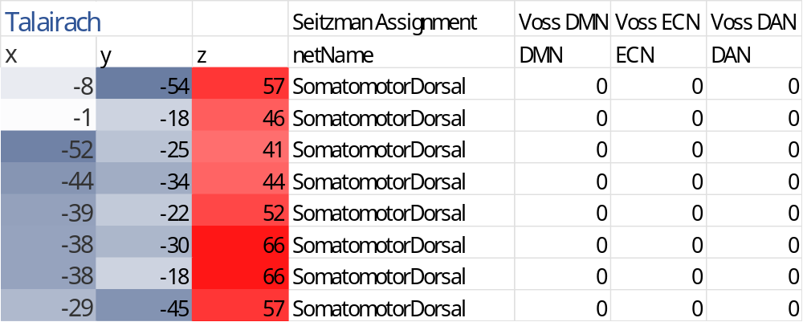

SUPPLEMENTARY FIGURES:

Seitzman and Voss Coordinates and ROI’s: Visual Representations
Supplementary Figure 1
Seitzman and Voss Coordinates and ROI’s

Default Mode Network
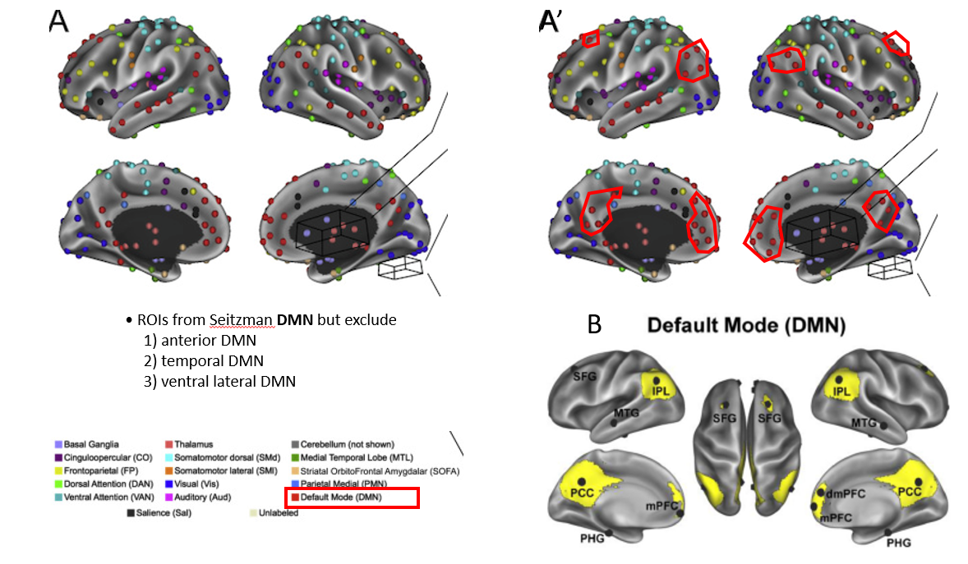A=Seitzman coordinates and associated ROI designations
B=Visual representation of Voss ROI designations
A’=Overlay of Voss visual representations on Seitzman coordinates/designations

Supplementary Figure 2
Seitzman and Voss Coordinates and ROI’s

Executive Control Network

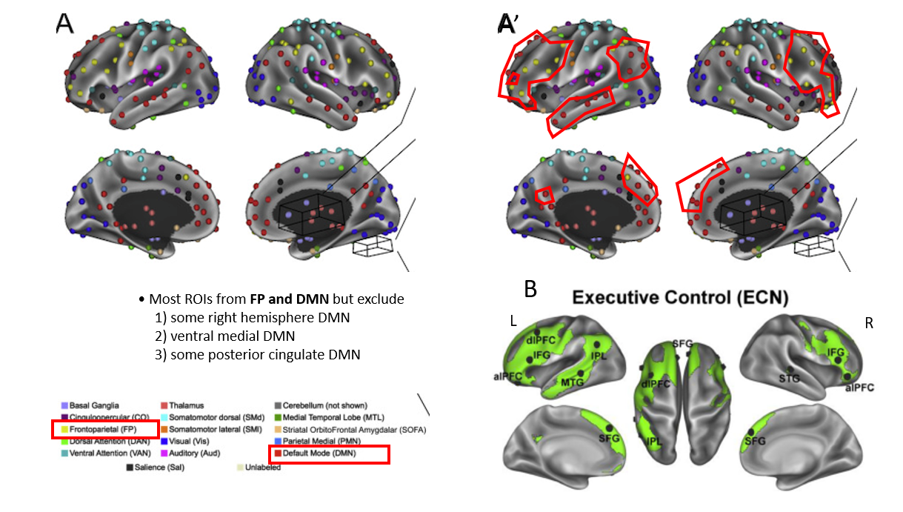A=Seitzman coordinates and associated ROI designations
B=Visual representation of Voss ROI designations
A’=Overlay of Voss visual representations on Seitzman coordinates/designations

Supplementary Figure 3
Seitzman and Voss Coordinates and ROI’s

Dorsal Attentional Network

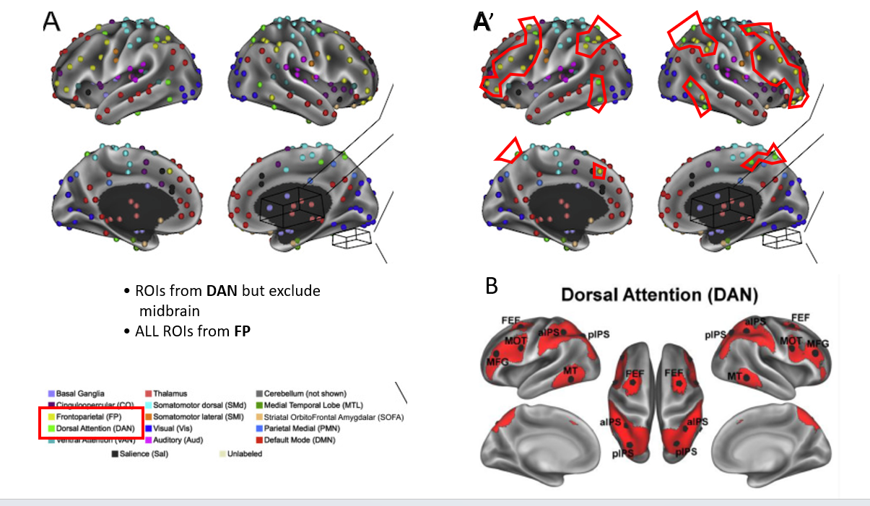
A=Seitzman coordinates and associated ROI designations
B=Visual representation of Voss ROI designations
A’=Overlay of Voss visual representations on Seitzman coordinates/designations

Supplementary Figure 4
Seitzman and Voss Coordinates and ROI’s

Salience Network

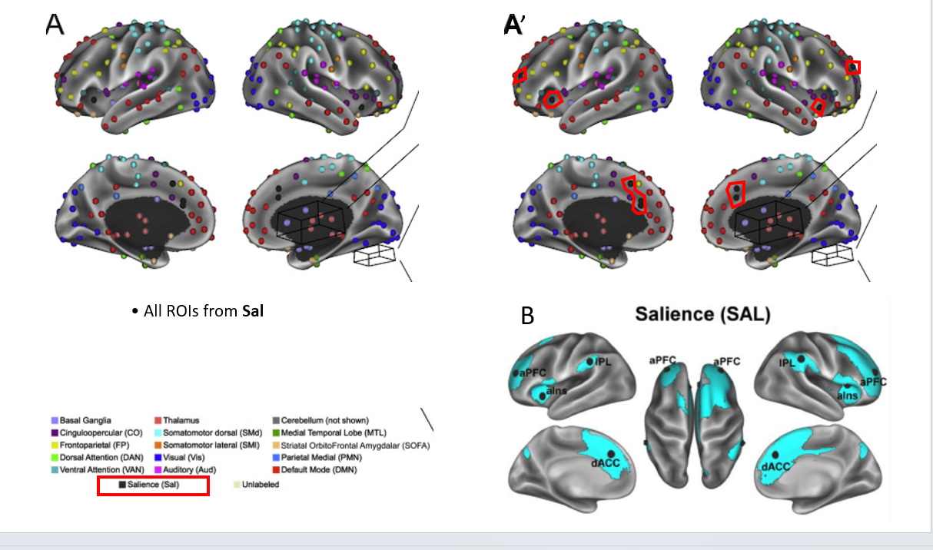

A=Seitzman coordinates and associated ROI designations
B=Visual representation of Voss ROI designations
A’=Overlay of Voss visual representations on Seitzman coordinates/designations

Supplementary Figure 5
Seitzman and Voss Coordinates and ROI’s

Sensory Networks
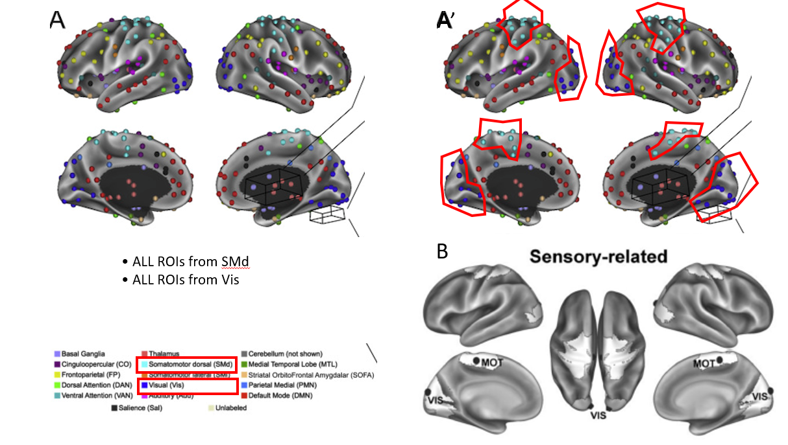

A=Seitzman coordinates and associated ROI designations
B=Visual representation of Voss ROI designations
A’=Overlay of Voss visual representations on Seitzman coordinates/designations

Supplementary Figure 6: Sample Size by Variable with Reason for Exclusion
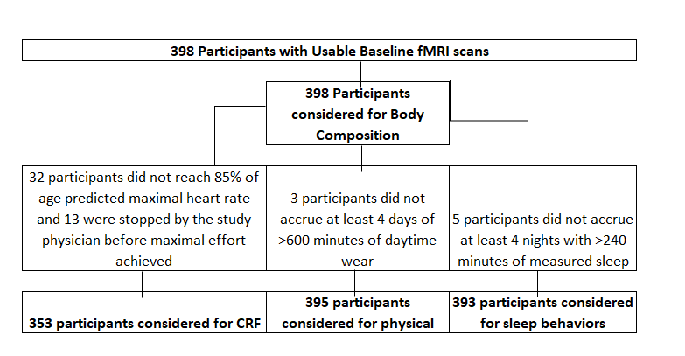

Supplementary Figures 7-15: Histograms of Population Distributions (Full Sample)

Cardiorespiratory Fitness
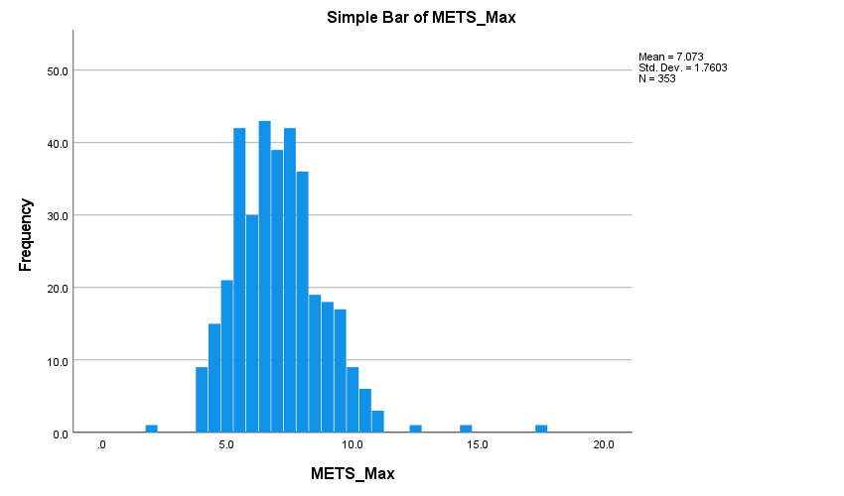

Percentage Body Fat

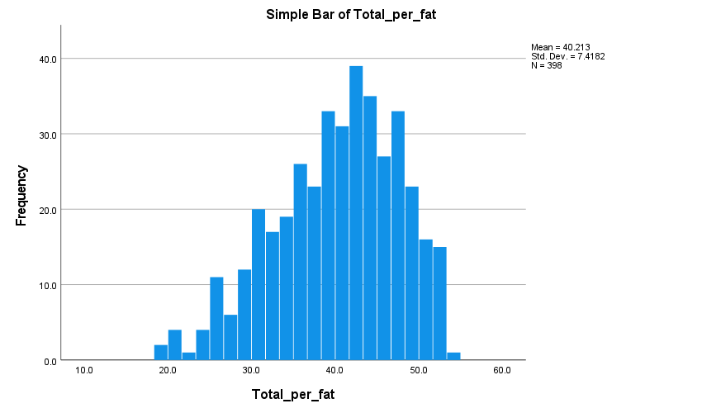

Absolute Lean Tissue

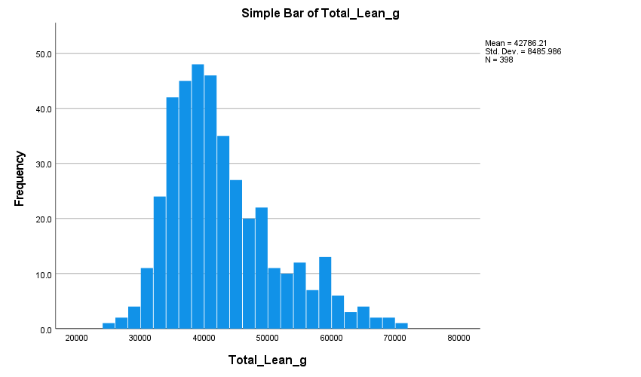

Absolute Visceral Adipose Tissue Mass
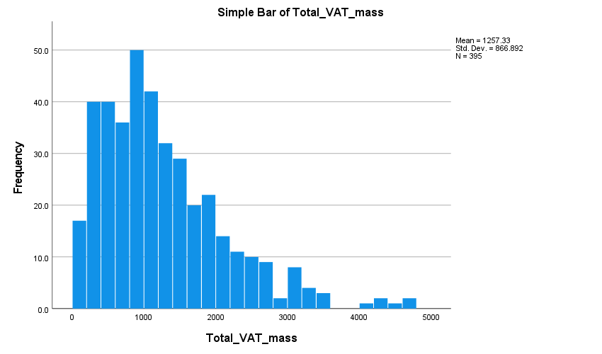

Sleep Efficiency

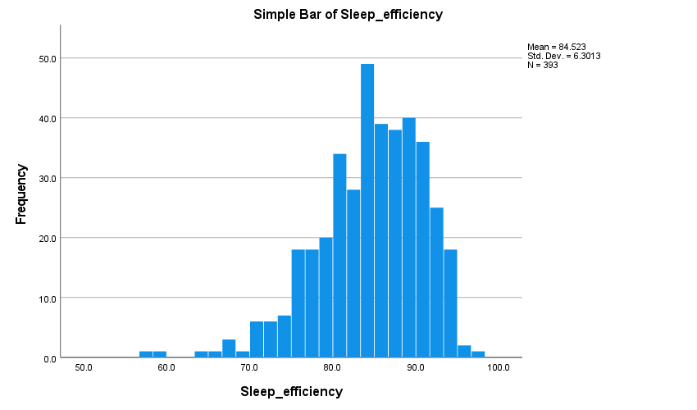

Total Sleep Time
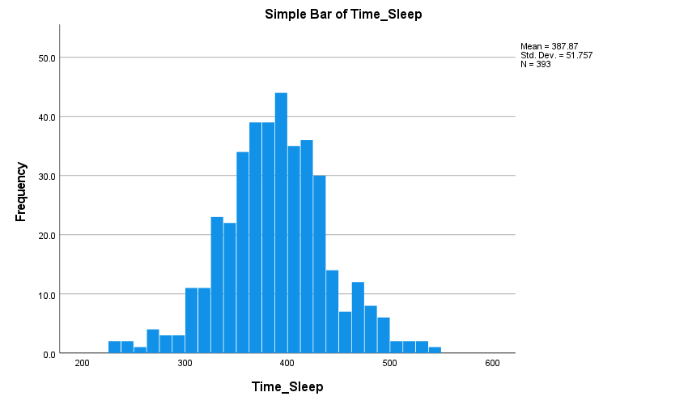

Wake After Sleep Onset_Total Minutes

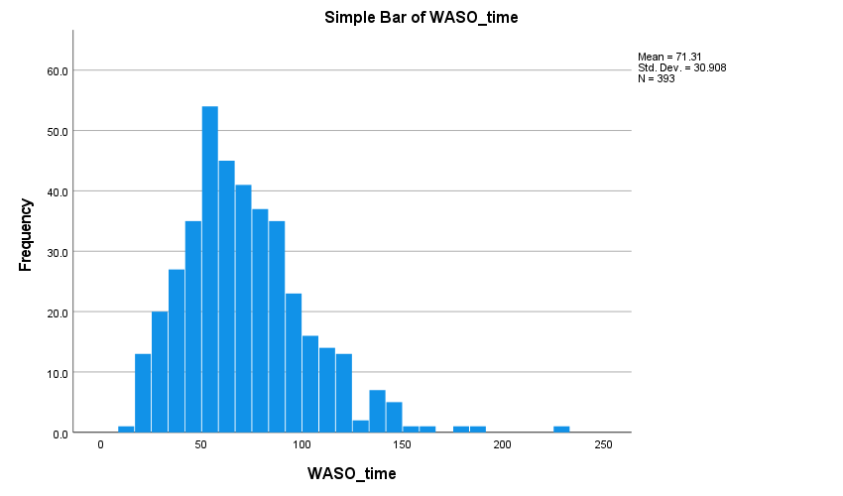

Wake After Sleep Onset_Number of Awakenings
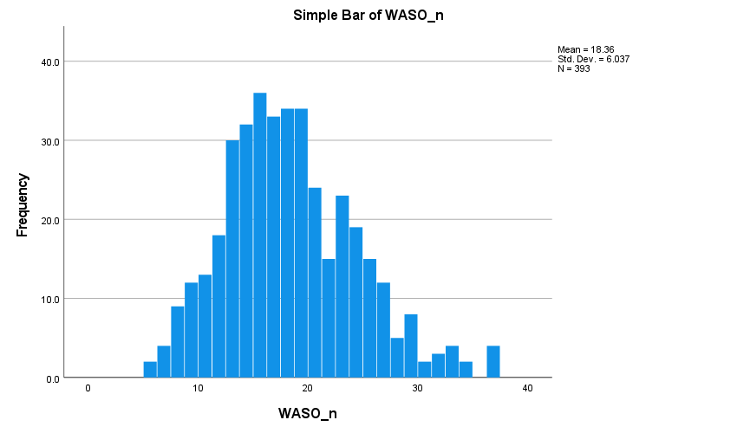

Total Movement Per Day

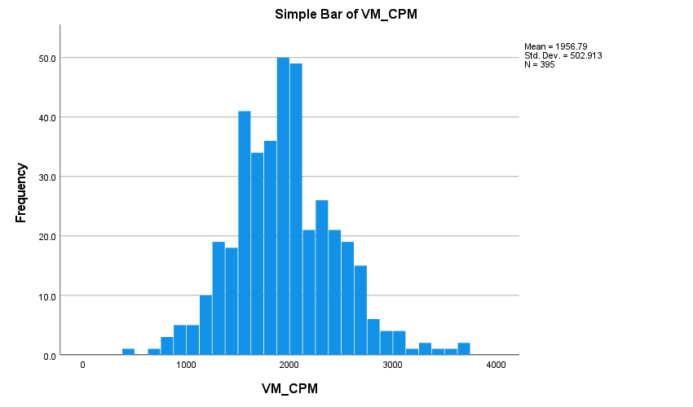

Supplementary Figures 16-24: Histograms of Population Distributions (UCSD Only)

Cardiorespiratory Fitness
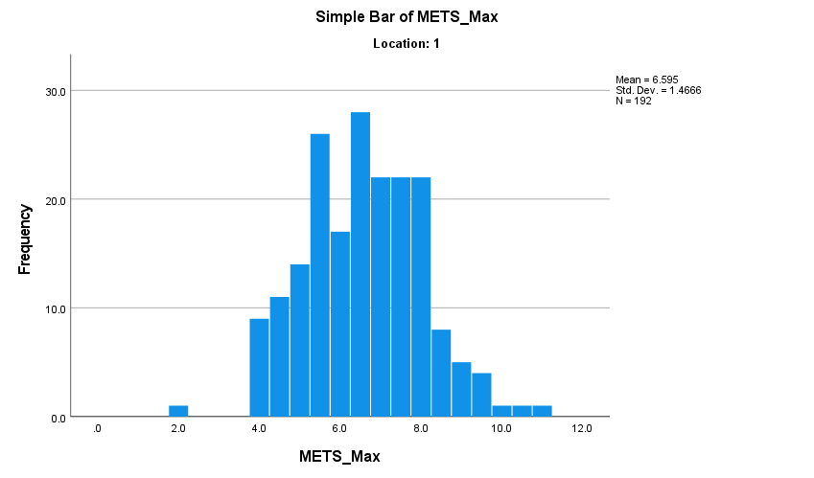

Percentage Body Fat
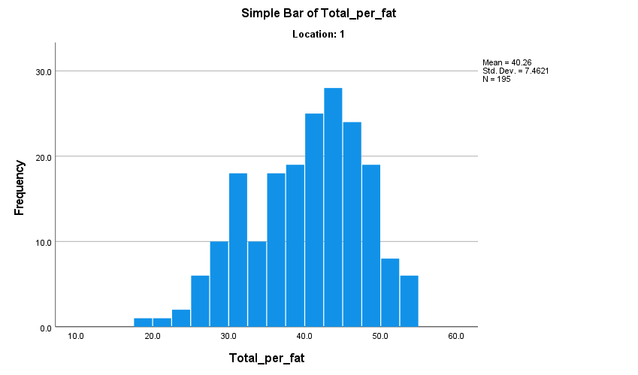

Absolute Lean Tissue
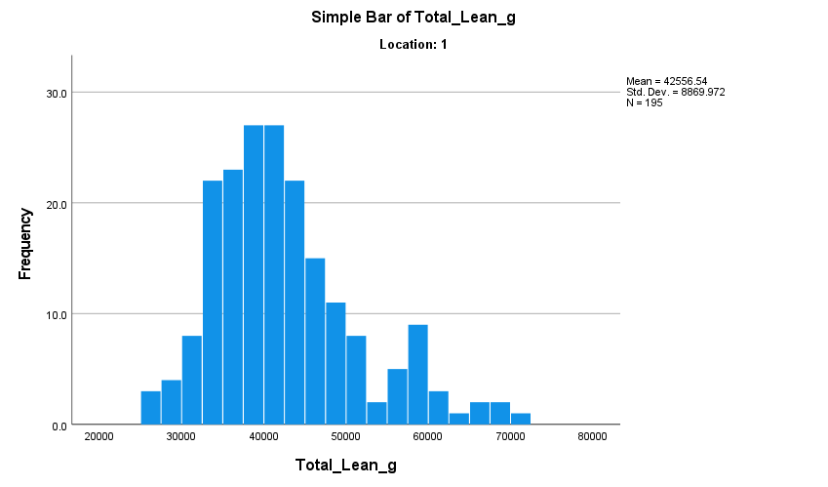

Absolute Visceral Adipose Tissue Mass
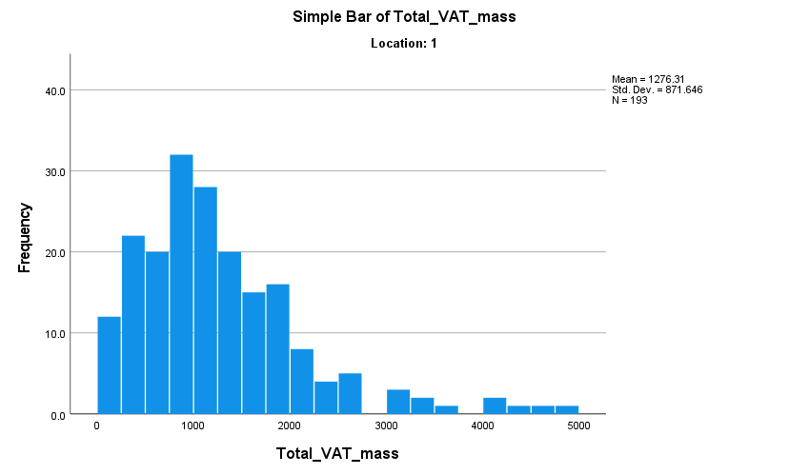

Sleep Efficiency
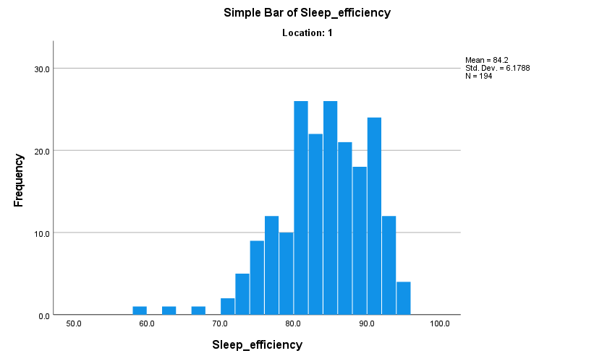

Total Sleep Time
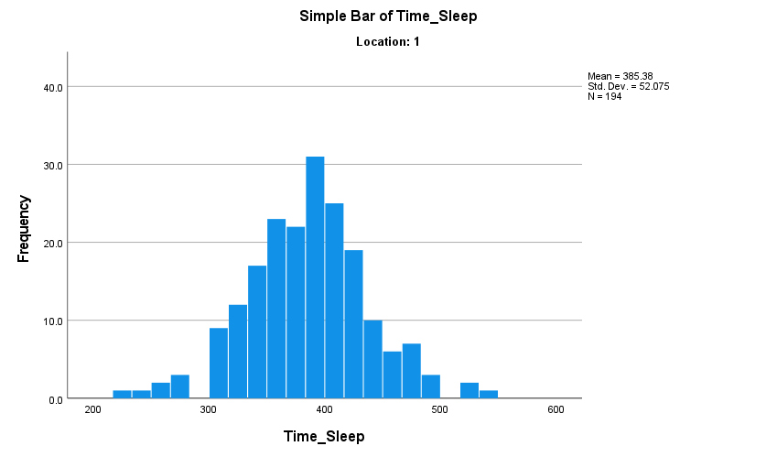

Wake After Sleep Onset_Total Minutes
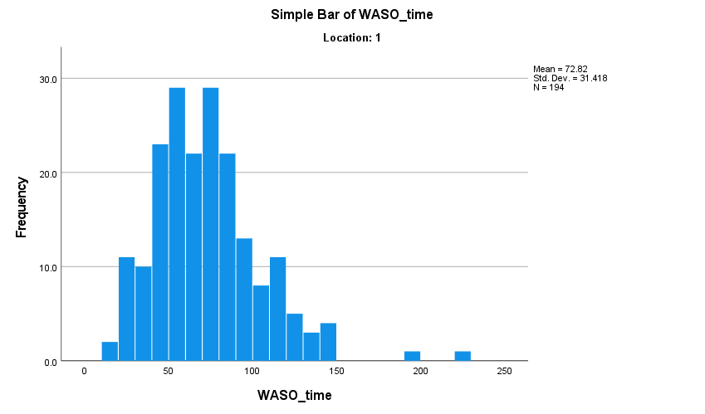

Wake After Sleep Onset_Number of Awakenings
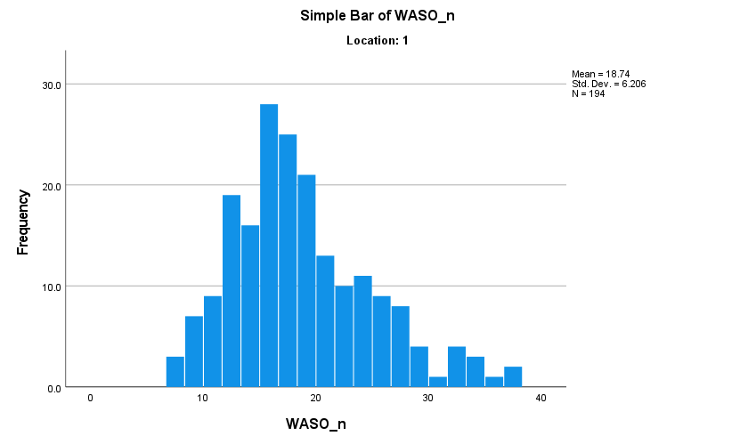

Total Movement Per Day
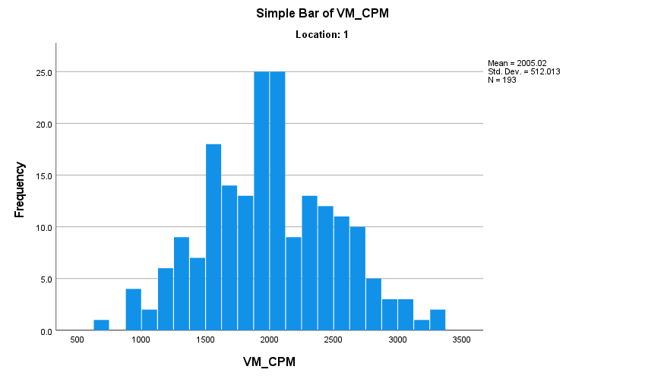

Supplementary Figures 25-33: Histograms of Population Distributions (WUSTL Only)

Cardiorespiratory Fitness
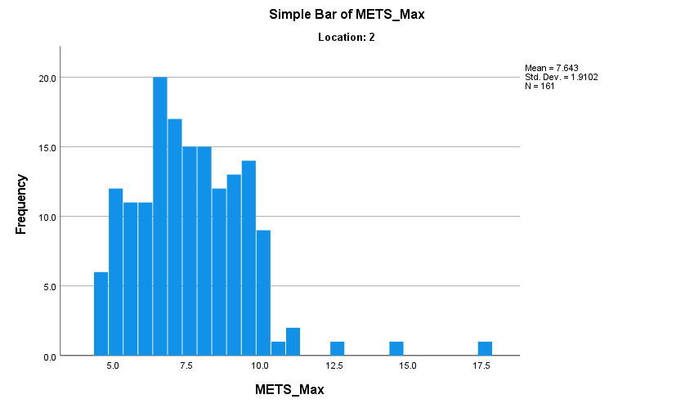

Percentage Body Fat
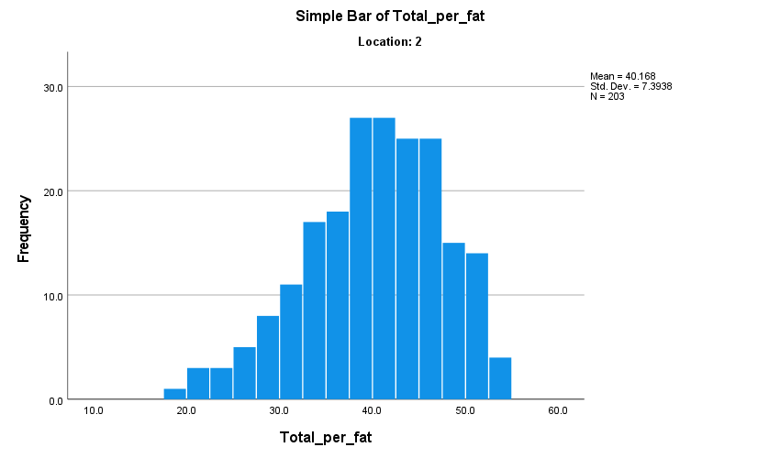

Absolute Lean Tissue
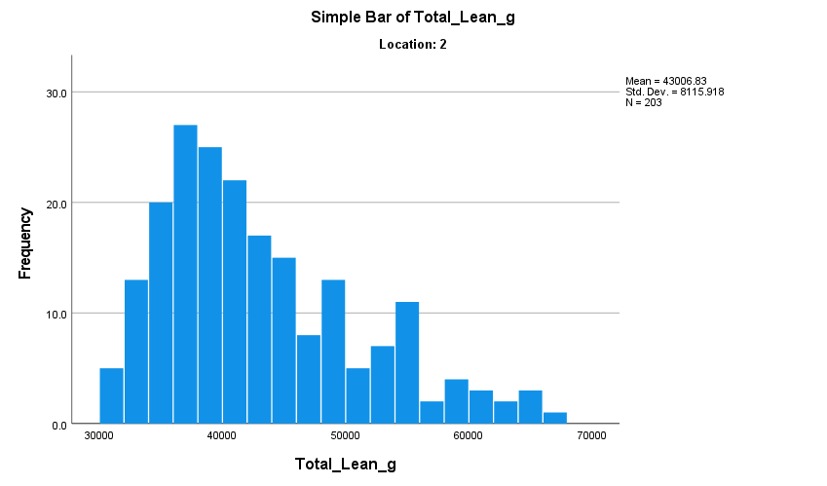

Absolute Visceral Adipose Tissue Mass
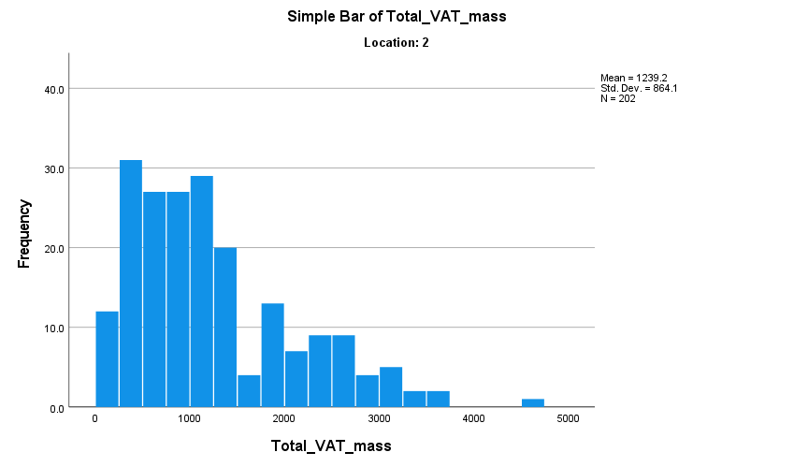

Sleep Efficiency
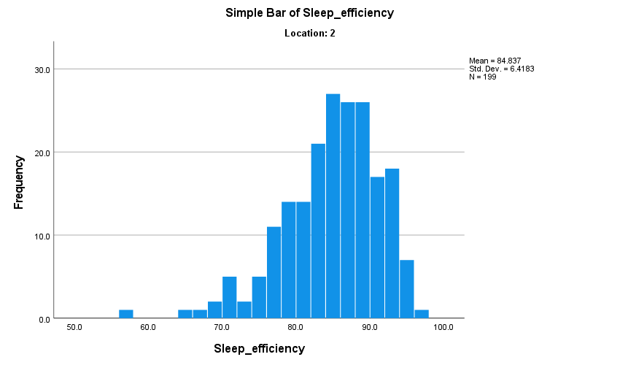

Total Sleep Time
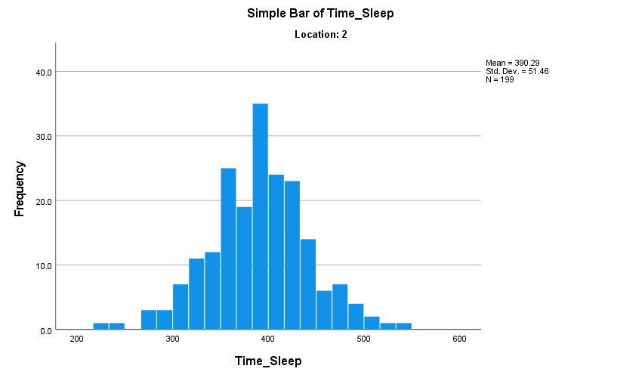

Wake After Sleep Onset_Total Minutes
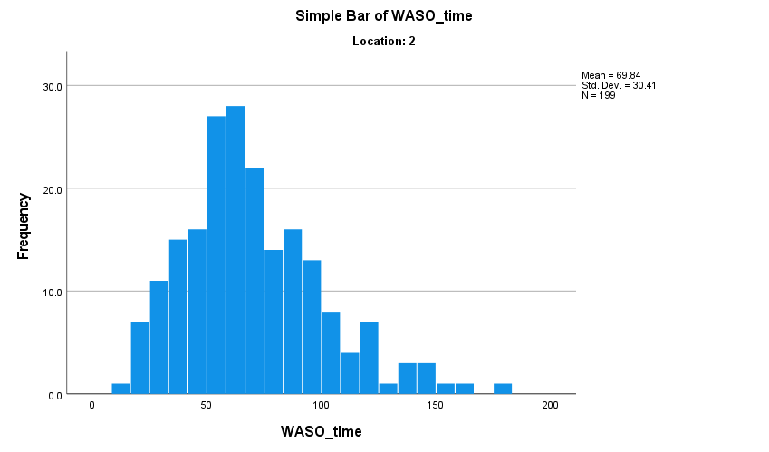

Wake After Sleep Onset_Number of Awakenings
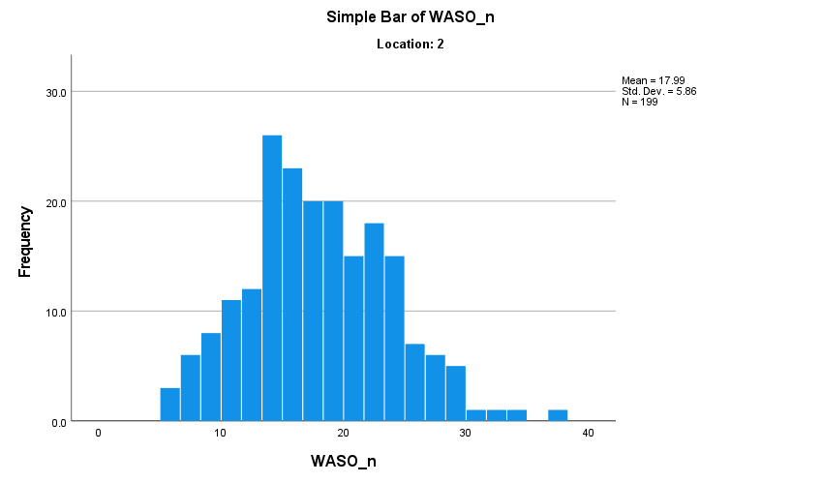

Total Movement Per Day
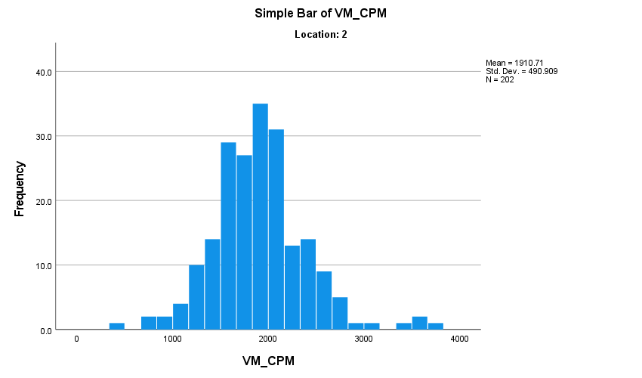

Supplementary Figures 34-41: Scatterplots of Physiological/Behavioral Variables with FC Networks

Cardiorespiratory Fitness
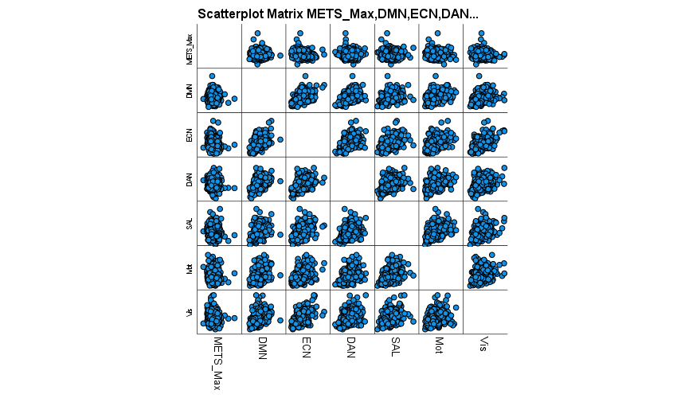

Percentage Body Fat
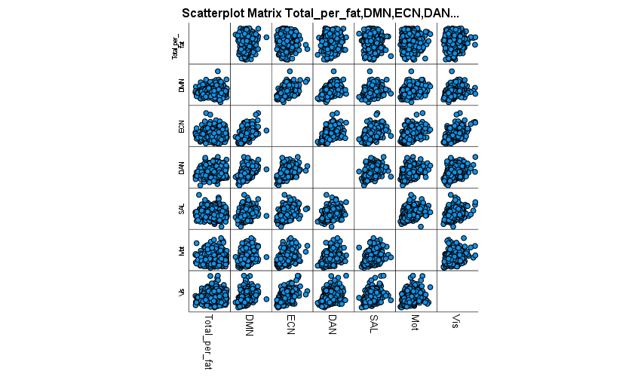

Absolute Lean Tissue
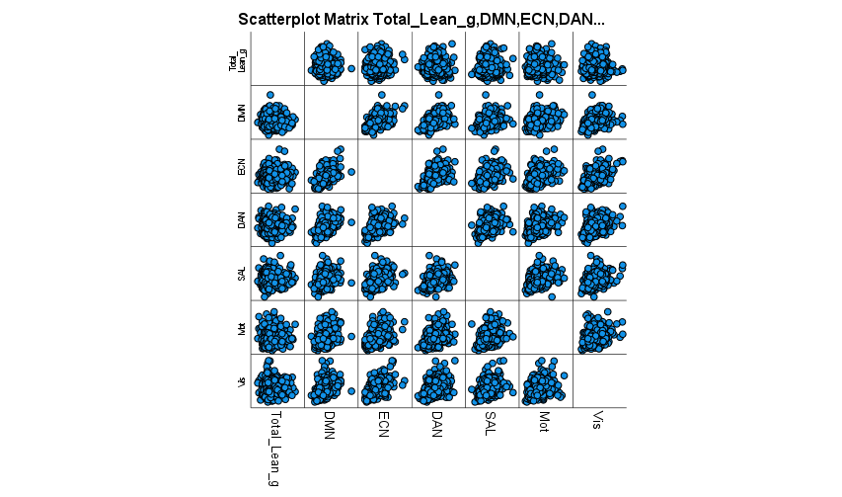

Absolute Visceral Adipose Tissue Mass
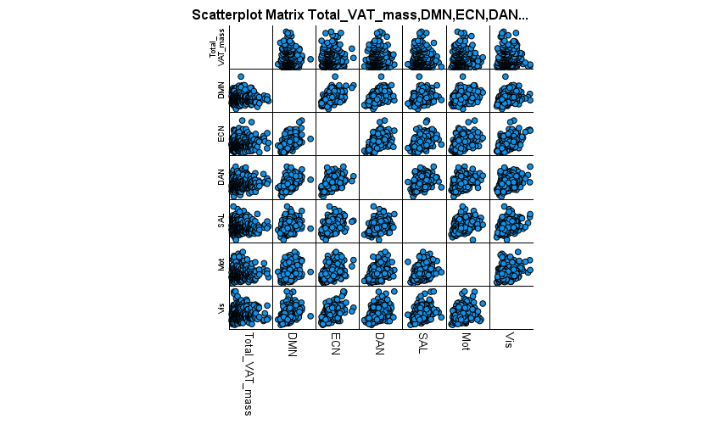

Sleep Efficiency
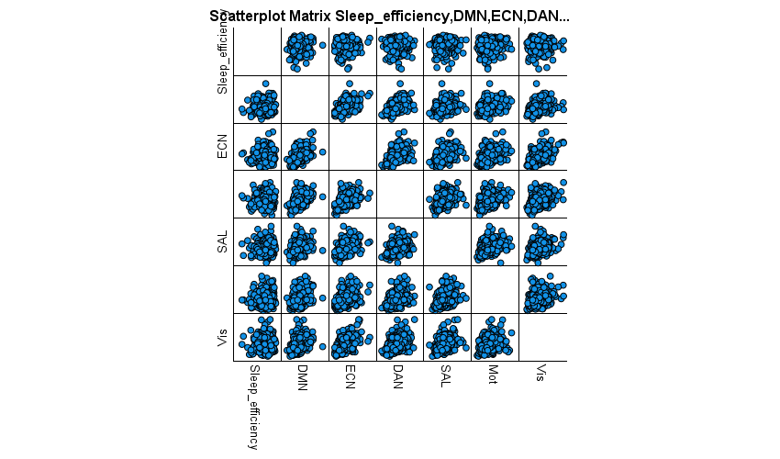

Total Sleep Time
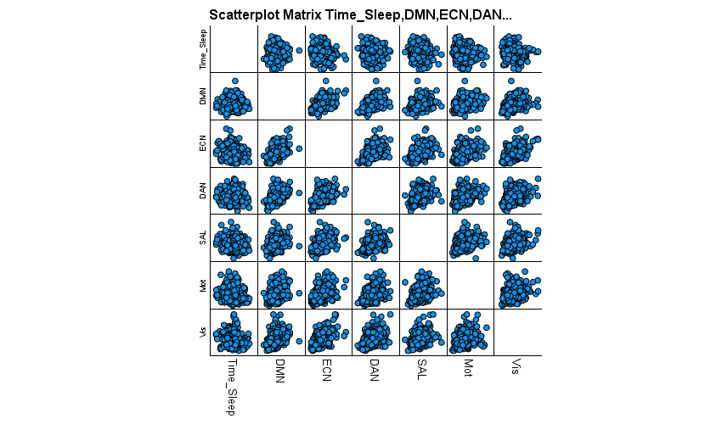

Wake After Sleep Onset_Total Minutes
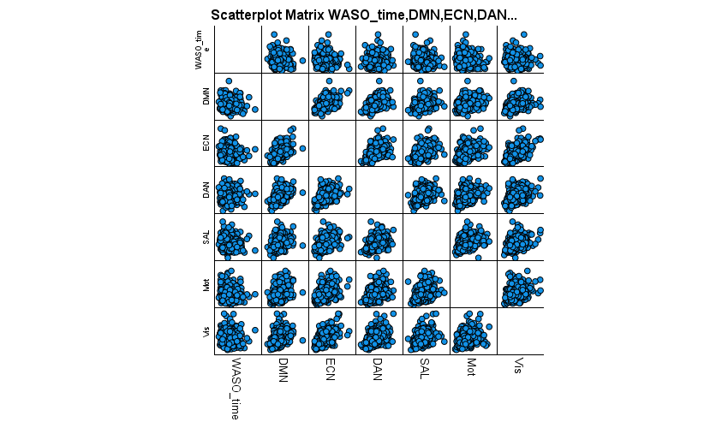

Wake After Sleep Onset_Number of Awakenings
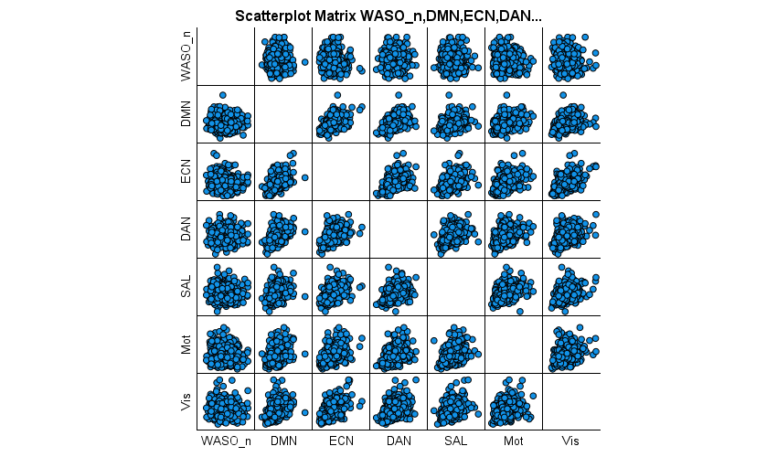

Non Significant Linear Regression of Unstandardized Residuals of behavioral variables and functional connectivity.
NOTE: These will always be in the same order. Specifically: DMN, ECN, DAN, SAL, BSDMN, BSDAN, MOT, VIS

CRF: METS

Model Summary^{b}
Model | R | R Square | Adjusted R Square | Std. Error of the Estimate
1 | .043ª | .002 | -.001 | .02796606
a. Predictors: (Constant), New Mets Residual
b. Dependent Variable: ECN Residual

Coefficientsª
Model |  | Unstandardized Coefficients |  | Standardized Coefficients | t | Sig.
 |  | B | Std. Error | Beta | t | Sig.
1 | (Constant) | .001 | .002 |  | .333 | .739
1 | New Mets Residual | -.001 | .001 | -.043 | -.797 | .426
a. Dependent Variable: ECN Residual

Model Summary^{b}
Model | R | R Square | Adjusted R Square | Std. Error of the Estimate
1 | .013ª | .000 | -.003 | .02886753
a. Predictors: (Constant), New Mets Residual
b. Dependent Variable: DAN Residual

Coefficientsª
Model |  | Unstandardized Coefficients |  | Standardized Coefficients | t | Sig.
 |  | B | Std. Error | Beta | t | Sig.
1 | (Constant) | .000 | .002 |  | -.108 | .914
1 | New Mets Residual | .000 | .001 | -.013 | -.236 | .814
a. Dependent Variable: DAN Residual

Model Summary^{b}
Model | R | R Square | Adjusted R Square | Std. Error of the Estimate
1 | .060ª | .004 | .001 | .08915250
a. Predictors: (Constant), New Mets Residual
b. Dependent Variable: SAL Residual

Coefficientsª
Model |  | Unstandardized Coefficients |  | Standardized Coefficients | t | Sig.
 |  | B | Std. Error | Beta | t | Sig.
1 | (Constant) | .000 | .005 |  | -.045 | .964
1 | New Mets Residual | .004 | .003 | .060 | 1.114 | .266
a. Dependent Variable: SAL Residual

Model Summary^{b}
Model | R | R Square | Adjusted R Square | Std. Error of the Estimate
1 | .093ª | .009 | .006 | .04087723
a. Predictors: (Constant), New Mets Residual
b. Dependent Variable: BSDMN Residual

Coefficientsª
Model |  | Unstandardized Coefficients |  | Standardized Coefficients | t | Sig.
 |  | B | Std. Error | Beta | t | Sig.
1 | (Constant) | .002 | .002 |  | .757 | .450
1 | New Mets Residual | .003 | .002 | .093 | 1.744 | .082
a. Dependent Variable: BSDMN Residual

Model Summary^{b}
Model | R | R Square | Adjusted R Square | Std. Error of the Estimate
1 | .022ª | .000 | -.002 | .06158743
a. Predictors: (Constant), New Mets Residual
b. Dependent Variable: BSDAN Residual

Coefficientsª
Model |  | Unstandardized Coefficients |  | Standardized Coefficients | t | Sig.
 |  | B | Std. Error | Beta | t | Sig.
1 | (Constant) | .002 | .003 |  | .610 | .542
1 | New Mets Residual | -.001 | .002 | -.022 | -.412 | .680
a. Dependent Variable: BSDAN Residual

Model Summary^{b}
Model | R | R Square | Adjusted R Square | Std. Error of the Estimate
1 | .038ª | .001 | -.001 | .10289775
a. Predictors: (Constant), New Mets Residual
b. Dependent Variable: MOT Residual

Coefficientsª
Model |  | Unstandardized Coefficients |  | Standardized Coefficients | t | Sig.
 |  | B | Std. Error | Beta | t | Sig.
1 | (Constant) | .001 | .006 |  | .095 | .924
1 | New Mets Residual | -.003 | .004 | -.038 | -.704 | .482
a. Dependent Variable: MOT Residual

Model Summary^{b}
Model | R | R Square | Adjusted R Square | Std. Error of the Estimate
1 | .028ª | .001 | -.002 | .06118516
a. Predictors: (Constant), New Mets Residual
b. Dependent Variable: VIS Residual

Coefficientsª
Model |  | Unstandardized Coefficients |  | Standardized Coefficients | t | Sig.
 |  | B | Std. Error | Beta | t | Sig.
1 | (Constant) | -7.010E-5 | .003 |  | -.021 | .983
1 | New Mets Residual | .001 | .002 | .028 | .520 | .604
a. Dependent Variable: VIS Residual

Percent Body Fat (Note: Salience Network Significant—included in main paper)

Model Summary
Model | R | R Square | Adjusted R Square | Std. Error of the Estimate
1 | .003ª | .000 | -.003 | .05986550
a. Predictors: (Constant), % Fat_Unstandardized Residual

Coefficientsª
Model |  | Unstandardized Coefficients |  | Standardized Coefficients | t | Sig.
 |  | B | Std. Error | Beta | t | Sig.
1 | (Constant) | 6.256E-17 | .003 |  | .000 | 1.000
1 | % Fat_Unstandardized Residual | -2.499E-5 | .000 | -.003 | -.052 | .958
a. Dependent Variable: DMN Residual

Model Summary
Model | R | R Square | Adjusted R Square | Std. Error of the Estimate
1 | .079ª | .006 | .004 | .02738308
a. Predictors: (Constant), % Fat_Unstandardized Residual

Coefficientsª
Model |  | Unstandardized Coefficients |  | Standardized Coefficients | t | Sig.
 |  | B | Std. Error | Beta | t | Sig.
1 | (Constant) | -8.593E-17 | .001 |  | .000 | 1.000
1 | % Fat_Unstandardized Residual | .000 | .000 | .079 | 1.583 | .114
a. Dependent Variable: ECN Residual

Model Summary
Model | R | R Square | Adjusted R Square | Std. Error of the Estimate
1 | .094ª | .009 | .006 | .02846201
a. Predictors: (Constant), % Fat_Unstandardized Residual

Coefficientsª
Model |  | Unstandardized Coefficients |  | Standardized Coefficients | t | Sig.
 |  | B | Std. Error | Beta | t | Sig.
1 | (Constant) | 3.637E-17 | .001 |  | .000 | 1.000
1 | % Fat_Unstandardized Residual | .000 | .000 | .094 | 1.880 | .061
a. Dependent Variable: DAN Residual

Model Summary
Model | R | R Square | Adjusted R Square | Std. Error of the Estimate
1 | .049ª | .002 | .000 | .04061267
a. Predictors: (Constant), % Fat_Unstandardized Residual

Coefficientsª
Model |  | Unstandardized Coefficients |  | Standardized Coefficients | t | Sig.
 |  | B | Std. Error | Beta | t | Sig.
1 | (Constant) | 1.459E-16 | .002 |  | .000 | 1.000
1 | % Fat_Unstandardized Residual | .000 | .000 | -.049 | -.982 | .326
a. Dependent Variable: BSDMN Residual

Model Summary
Model | R | R Square | Adjusted R Square | Std. Error of the Estimate
1 | .001ª | .000 | -.003 | .06078732
a. Predictors: (Constant), % Fat_Unstandardized Residual

Coefficientsª
Model |  | Unstandardized Coefficients |  | Standardized Coefficients | t | Sig.
 |  | B | Std. Error | Beta | t | Sig.
1 | (Constant) | -7.090E-17 | .003 |  | .000 | 1.000
1 | % Fat_Unstandardized Residual | -1.358E-5 | .000 | -.001 | -.028 | .978
a. Dependent Variable: BSDAN Residual

Model Summary
Model | R | R Square | Adjusted R Square | Std. Error of the Estimate
1 | .020ª | .000 | -.002 | .10167867
a. Predictors: (Constant), % Fat_Unstandardized Residual

Coefficientsª
Model |  | Unstandardized Coefficients |  | Standardized Coefficients | t | Sig.
 |  | B | Std. Error | Beta | t | Sig.
1 | (Constant) | 1.220E-16 | .005 |  | .000 | 1.000
1 | % Fat_Unstandardized Residual | .000 | .001 | .020 | .407 | .684
a. Dependent Variable: MOT Residual

Model Summary
Model | R | R Square | Adjusted R Square | Std. Error of the Estimate
1 | .089ª | .008 | .005 | .06037617
a. Predictors: (Constant), % Fat_Unstandardized Residual

Coefficientsª
Model |  | Unstandardized Coefficients |  | Standardized Coefficients | t | Sig.
 |  | B | Std. Error | Beta | t | Sig.
1 | (Constant) | 8.839E-17 | .003 |  | .000 | 1.000
1 | % Fat_Unstandardized Residual | .001 | .000 | .089 | 1.777 | .076
a. Dependent Variable: VIS Residual

Visceral Adipose Tissue (Note: Salience Network significant and included in main paper)

Model Summary
Model | R | R Square | Adjusted R Square | Std. Error of the Estimate
1 | .026ª | .001 | -.002 | .05979059
a. Predictors: (Constant), Unstandardized Residual

Coefficientsª
Model |  | Unstandardized Coefficients |  | Standardized Coefficients | t | Sig.
 |  | B | Std. Error | Beta | t | Sig.
1 | (Constant) | .001 | .003 |  | .168 | .867
1 | Unstandardized Residual | 2.081E-6 | .000 | .026 | .514 | .607
a. Dependent Variable: DMN Residual

Model Summary
Model | R | R Square | Adjusted R Square | Std. Error of the Estimate
1 | .070ª | .005 | .002 | .02741671
a. Predictors: (Constant), Unstandardized Residual

Coefficientsª
Model |  | Unstandardized Coefficients |  | Standardized Coefficients | t | Sig.
 |  | B | Std. Error | Beta | t | Sig.
1 | (Constant) | .000 | .001 |  | .125 | .901
1 | Unstandardized Residual | 2.566E-6 | .000 | .070 | 1.383 | .167
a. Dependent Variable: ECN Residual

Model Summary
Model | R | R Square | Adjusted R Square | Std. Error of the Estimate
1 | .080ª | .006 | .004 | .02859440
a. Predictors: (Constant), Unstandardized Residual

Coefficientsª
Model |  | Unstandardized Coefficients |  | Standardized Coefficients | t | Sig.
 |  | B | Std. Error | Beta | t | Sig.
1 | (Constant) | -4.140E-5 | .001 |  | -.029 | .977
1 | Unstandardized Residual | 3.068E-6 | .000 | .080 | 1.586 | .114
a. Dependent Variable: DAN Residual

Model Summary
Model | R | R Square | Adjusted R Square | Std. Error of the Estimate
1 | .111ª | .012 | .010 | .09113472
a. Predictors: (Constant), Unstandardized Residual

Coefficientsª
Model |  | Unstandardized Coefficients |  | Standardized Coefficients | t | Sig.
 |  | B | Std. Error | Beta | t | Sig.
1 | (Constant) | .001 | .005 |  | .159 | .874
1 | Unstandardized Residual | -1.360E-5 | .000 | -.111 | -2.205 | .028
a. Dependent Variable: SAL Residual

Model Summary
Model | R | R Square | Adjusted R Square | Std. Error of the Estimate
1 | .036ª | .001 | -.001 | .04056299
a. Predictors: (Constant), Unstandardized Residual

Coefficientsª
Model |  | Unstandardized Coefficients |  | Standardized Coefficients | t | Sig.
 |  | B | Std. Error | Beta | t | Sig.
1 | (Constant) | .000 | .002 |  | .180 | .857
1 | Unstandardized Residual | -1.940E-6 | .000 | -.036 | -.707 | .480
a. Dependent Variable: BSDMN Residual

Model Summary
Model | R | R Square | Adjusted R Square | Std. Error of the Estimate
1 | .026ª | .001 | -.002 | .06095895
a. Predictors: (Constant), Unstandardized Residual

Coefficientsª
Model |  | Unstandardized Coefficients |  | Standardized Coefficients | t | Sig.
 |  | B | Std. Error | Beta | t | Sig.
1 | (Constant) | .000 | .003 |  | .034 | .973
1 | Unstandardized Residual | 2.107E-6 | .000 | .026 | .511 | .610
a. Dependent Variable: BSDAN Residual

Model Summary
Model | R | R Square | Adjusted R Square | Std. Error of the Estimate
1 | .055ª | .003 | .000 | .10170571
a. Predictors: (Constant), Unstandardized Residual

Coefficientsª
Model |  | Unstandardized Coefficients |  | Standardized Coefficients | t | Sig.
 |  | B | Std. Error | Beta | t | Sig.
1 | (Constant) | .000 | .005 |  | .055 | .956
1 | Unstandardized Residual | -7.460E-6 | .000 | -.055 | -1.084 | .279
a. Dependent Variable: MOT Residual

Model Summary
Model | R | R Square | Adjusted R Square | Std. Error of the Estimate
1 | .058ª | .003 | .001 | .06064417
a. Predictors: (Constant), Unstandardized Residual

Coefficientsª
Model |  | Unstandardized Coefficients |  | Standardized Coefficients | t | Sig.
 |  | B | Std. Error | Beta | t | Sig.
1 | (Constant) | .000 | .003 |  | .046 | .963
1 | Unstandardized Residual | 4.696E-6 | .000 | .058 | 1.144 | .253
a. Dependent Variable: VIS Residual

Physical Activity (VM CPM) (Note: Motor network significantly predicted. Included in main paper)

Model Summary
Model | R | R Square | Adjusted R Square | Std. Error of the Estimate
1 | .037ª | .001 | -.002 | .06083367
a. Predictors: (Constant), New PA Residual

Coefficientsª
Model |  | Unstandardized Coefficients |  | Standardized Coefficients | t | Sig.
 |  | B | Std. Error | Beta | t | Sig.
1 | (Constant) | .002 | .003 |  | .675 | .500
1 | New PA Residual | 4.925E-6 | .000 | .037 | .680 | .497
a. Dependent Variable: DMN Residual

Model Summary
Model | R | R Square | Adjusted R Square | Std. Error of the Estimate
1 | .059ª | .004 | .001 | .02794273
a. Predictors: (Constant), New PA Residual

Coefficientsª
Model |  | Unstandardized Coefficients |  | Standardized Coefficients | t | Sig.
 |  | B | Std. Error | Beta | t | Sig.
1 | (Constant) | .001 | .002 |  | .334 | .739
1 | New PA Residual | -3.664E-6 | .000 | -.059 | -1.101 | .272
a. Dependent Variable: ECN Residual

Model Summary
Model | R | R Square | Adjusted R Square | Std. Error of the Estimate
1 | .058ª | .003 | .000 | .02882188
a. Predictors: (Constant), New PA Residual

Coefficientsª
Model |  | Unstandardized Coefficients |  | Standardized Coefficients | t | Sig.
 |  | B | Std. Error | Beta | t | Sig.
1 | (Constant) | .000 | .002 |  | -.108 | .914
1 | New PA Residual | 3.680E-6 | .000 | .058 | 1.072 | .284
a. Dependent Variable: DAN Residual

Model Summary
Model | R | R Square | Adjusted R Square | Std. Error of the Estimate
1 | .038ª | .001 | -.001 | .08924673
a. Predictors: (Constant), New PA Residual

Coefficientsª
Model |  | Unstandardized Coefficients |  | Standardized Coefficients | t | Sig.
 |  | B | Std. Error | Beta | t | Sig.
1 | (Constant) | .000 | .005 |  | -.045 | .964
1 | New PA Residual | 7.590E-6 | .000 | .038 | .714 | .476
a. Dependent Variable: SAL Residual

Model Summary
Model | R | R Square | Adjusted R Square | Std. Error of the Estimate
1 | .035ª | .001 | -.002 | .04103218
a. Predictors: (Constant), New PA Residual

Coefficientsª
Model |  | Unstandardized Coefficients |  | Standardized Coefficients | t | Sig.
 |  | B | Std. Error | Beta | t | Sig.
1 | (Constant) | .002 | .002 |  | .754 | .451
1 | New PA Residual | 3.155E-6 | .000 | .035 | .646 | .519
a. Dependent Variable: BSDMN Residual

Model Summary
Model | R | R Square | Adjusted R Square | Std. Error of the Estimate
1 | .073ª | .005 | .002 | .06143886
a. Predictors: (Constant), New PA Residual

Coefficientsª
Model |  | Unstandardized Coefficients |  | Standardized Coefficients | t | Sig.
 |  | B | Std. Error | Beta | t | Sig.
1 | (Constant) | .002 | .003 |  | .612 | .541
1 | New PA Residual | 9.928E-6 | .000 | .073 | 1.357 | .176
a. Dependent Variable: BSDAN Residual

Model Summary
Model | R | R Square | Adjusted R Square | Std. Error of the Estimate
1 | .063ª | .004 | .001 | .06108888
a. Predictors: (Constant), New PA Residual

Coefficientsª
Model |  | Unstandardized Coefficients |  | Standardized Coefficients | t | Sig.
 |  | B | Std. Error | Beta | t | Sig.
1 | (Constant) | -7.010E-5 | .003 |  | -.021 | .983
1 | New PA Residual | -8.481E-6 | .000 | -.063 | -1.166 | .244
a. Dependent Variable: VIS Residual

Sleep Efficiency (Note: Both Salience and Motor Network Significantly Predicted and included in main paper)

Model Summary
Model | R | R Square | Adjusted R Square | Std. Error of the Estimate
1 | .048ª | .002 | -.001 | .06080337
a. Predictors: (Constant), New Sleep % Residual

Coefficientsª
Model |  | Unstandardized Coefficients |  | Standardized Coefficients | t | Sig.
 |  | B | Std. Error | Beta | t | Sig.
1 | (Constant) | .002 | .003 |  | .676 | .500
1 | New Sleep % Residual | .000 | .001 | .048 | .898 | .370
a. Dependent Variable: DMN Residual

Model Summary
Model | R | R Square | Adjusted R Square | Std. Error of the Estimate
1 | .030ª | .001 | -.002 | .02797936
a. Predictors: (Constant), New Sleep % Residual

Coefficientsª
Model |  | Unstandardized Coefficients |  | Standardized Coefficients | t | Sig.
 |  | B | Std. Error | Beta | t | Sig.
1 | (Constant) | .001 | .002 |  | .333 | .739
1 | New Sleep % Residual | .000 | .000 | .030 | .554 | .580
a. Dependent Variable: ECN Residual

Model Summary
Model | R | R Square | Adjusted R Square | Std. Error of the Estimate
1 | .052ª | .003 | .000 | .02883143
a. Predictors: (Constant), New Sleep % Residual

Coefficientsª
Model |  | Unstandardized Coefficients |  | Standardized Coefficients | t | Sig.
 |  | B | Std. Error | Beta | t | Sig.
1 | (Constant) | .000 | .002 |  | -.108 | .914
1 | New Sleep % Residual | .000 | .000 | .052 | .959 | .338
a. Dependent Variable: DAN Residual

Model Summary
Model | R | R Square | Adjusted R Square | Std. Error of the Estimate
1 | .103ª | .011 | .008 | .04083887
a. Predictors: (Constant), New Sleep % Residual

Coefficientsª
Model |  | Unstandardized Coefficients |  | Standardized Coefficients | t | Sig.
 |  | B | Std. Error | Beta | t | Sig.
1 | (Constant) | .002 | .002 |  | .757 | .449
1 | New Sleep % Residual | .001 | .000 | .103 | 1.922 | .055
a. Dependent Variable: BSDMN Residual

Model Summary
Model | R | R Square | Adjusted R Square | Std. Error of the Estimate
1 | .101ª | .010 | .007 | .06128720
a. Predictors: (Constant), New Sleep % Residual

Coefficientsª
Model |  | Unstandardized Coefficients |  | Standardized Coefficients | t | Sig.
 |  | B | Std. Error | Beta | t | Sig.
1 | (Constant) | .002 | .003 |  | .613 | .540
1 | New Sleep % Residual | .001 | .001 | .101 | 1.887 | .060
a. Dependent Variable: BSDAN Residual

Model Summary
Model | R | R Square | Adjusted R Square | Std. Error of the Estimate
1 | .072ª | .005 | .002 | .06105031
a. Predictors: (Constant), New Sleep % Residual

Coefficientsª
Model |  | Unstandardized Coefficients |  | Standardized Coefficients | t | Sig.
 |  | B | Std. Error | Beta | t | Sig.
1 | (Constant) | -7.010E-5 | .003 |  | -.021 | .983
1 | New Sleep % Residual | -.001 | .001 | -.072 | -1.341 | .181
a. Dependent Variable: VIS Residual

Total Sleep Time (NOTE: Predictive of ECN. Included in main paper)

Model Summary
Model | R | R Square | Adjusted R Square | Std. Error of the Estimate
1 | .038ª | .001 | -.001 | .06083155

a. Predictors: (Constant), New TST Residual

Coefficientsª
Model |  | Unstandardized Coefficients |  | Standardized Coefficients | t | Sig.
 |  | B | Std. Error | Beta | t | Sig.
1 | (Constant) | .002 | .003 |  | .676 | .500
1 | New TST Residual | 4.515E-5 | .000 | .038 | .697 | .486

a. Dependent Variable: DMN Residual

Model Summary
Model | R | R Square | Adjusted R Square | Std. Error of the Estimate
1 | .011ª | .000 | -.003 | .02886808

a. Predictors: (Constant), New TST Residual

Coefficientsª
Model |  | Unstandardized Coefficients |  | Standardized Coefficients | t | Sig.
 |  | B | Std. Error | Beta | t | Sig.
1 | (Constant) | .000 | .002 |  | -.108 | .914
1 | New TST Residual | -6.341E-6 | .000 | -.011 | -.206 | .837

a. Dependent Variable: DAN Residual

Model Summary
Model | R | R Square | Adjusted R Square | Std. Error of the Estimate
1 | .055ª | .003 | .000 | .08917536

a. Predictors: (Constant), New TST Residual

Coefficientsª
Model |  | Unstandardized Coefficients |  | Standardized Coefficients | t | Sig.
 |  | B | Std. Error | Beta | t | Sig.
1 | (Constant) | .000 | .005 |  | -.045 | .964
1 | New TST Residual | -9.787E-5 | .000 | -.055 | -1.031 | .303

a. Dependent Variable: SAL Residual

Model Summary
Model | R | R Square | Adjusted R Square | Std. Error of the Estimate
1 | .071ª | .005 | .002 | .04095339

a. Predictors: (Constant), New TST Residual

Coefficientsª
Model |  | Unstandardized Coefficients |  | Standardized Coefficients | t | Sig.
 |  | B | Std. Error | Beta | t | Sig.
1 | (Constant) | .002 | .002 |  | .755 | .451
1 | New TST Residual | 5.761E-5 | .000 | .071 | 1.322 | .187

a. Dependent Variable: BSDMN Residual

Model Summary
Model | R | R Square | Adjusted R Square | Std. Error of the Estimate
1 | .001ª | .000 | -.003 | .06160256

a. Predictors: (Constant), New TST Residual

Coefficientsª
Model |  | Unstandardized Coefficients |  | Standardized Coefficients | t | Sig.
 |  | B | Std. Error | Beta | t | Sig.
1 | (Constant) | .002 | .003 |  | .610 | .542
1 | New TST Residual | 1.367E-6 | .000 | .001 | .021 | .983

a. Dependent Variable: BSDAN Residual

Model Summary
Model | R | R Square | Adjusted R Square | Std. Error of the Estimate
1 | .096ª | .009 | .006 | .10250036

a. Predictors: (Constant), New TST Residual

Coefficientsª
Model |  | Unstandardized Coefficients |  | Standardized Coefficients | t | Sig.
 |  | B | Std. Error | Beta | t | Sig.
1 | (Constant) | .001 | .006 |  | .095 | .924
1 | New TST Residual | .000 | .000 | -.096 | -1.783 | .075

a. Dependent Variable: MOT Residual

Model Summary
Model | R | R Square | Adjusted R Square | Std. Error of the Estimate
1 | .130ª | .017 | .014 | .06068895

a. Predictors: (Constant), New TST Residual

Coefficientsª
Model |  | Unstandardized Coefficients |  | Standardized Coefficients | t | Sig.
 |  | B | Std. Error | Beta | t | Sig.
1 | (Constant) | -7.010E-5 | .003 |  | -.022 | .983
1 | New TST Residual | .000 | .000 | -.130 | -2.437 | .015

a. Dependent Variable: VIS Residual

Wake After Sleep Onset Time (Note: Predictive of Salience and Motor Network. Included in main paper)

Model Summary
Model | R | R Square | Adjusted R Square | Std. Error of the Estimate
1 | .035ª | .001 | -.002 | .06083612
a. Predictors: (Constant), New WASO time Residual

Coefficientsª
Model |  | Unstandardized Coefficients |  | Standardized Coefficients | t | Sig.
 |  | B | Std. Error | Beta | t | Sig.
1 | (Constant) | .002 | .003 |  | .675 | .500
1 | New WASO time Residual | -7.117E-5 | .000 | -.035 | -.659 | .510
a. Dependent Variable: DMN Residual

Model Summary
Model | R | R Square | Adjusted R Square | Std. Error of the Estimate
1 | .080ª | .006 | .003 | .02790248
a. Predictors: (Constant), New WASO time Residual

Coefficientsª
Model |  | Unstandardized Coefficients |  | Standardized Coefficients | t | Sig.
 |  | B | Std. Error | Beta | t | Sig.
1 | (Constant) | .001 | .001 |  | .334 | .738
1 | New WASO time Residual | -7.366E-5 | .000 | -.080 | -1.487 | .138
a. Dependent Variable: ECN Residual

Model Summary
Model | R | R Square | Adjusted R Square | Std. Error of the Estimate
1 | .050ª | .002 | .000 | .02883403
a. Predictors: (Constant), New WASO time Residual

Coefficientsª
Model |  | Unstandardized Coefficients |  | Standardized Coefficients | t | Sig.
 |  | B | Std. Error | Beta | t | Sig.
1 | (Constant) | .000 | .002 |  | -.108 | .914
1 | New WASO time Residual | -4.740E-5 | .000 | -.050 | -.926 | .355
a. Dependent Variable: DAN Residual

Variables Entered/Removedª
Model | Variables Entered | Variables Removed | Method
1 | New WASO time Residual^{b} | . | Enter
a. Dependent Variable: BSDMN Residual
b. All requested variables entered.

Model Summary
Model | R | R Square | Adjusted R Square | Std. Error of the Estimate
1 | .082ª | .007 | .004 | .04092001
a. Predictors: (Constant), New WASO time Residual

Coefficientsª
Model |  | Unstandardized Coefficients |  | Standardized Coefficients | t | Sig.
 |  | B | Std. Error | Beta | t | Sig.
1 | (Constant) | .002 | .002 |  | .756 | .450
1 | New WASO time Residual | .000 | .000 | -.082 | -1.521 | .129
a. Dependent Variable: BSDMN Residual

Model Summary
Model | R | R Square | Adjusted R Square | Std. Error of the Estimate
1 | .105ª | .011 | .008 | .06126433
a. Predictors: (Constant), New WASO time Residual

Coefficientsª
Model |  | Unstandardized Coefficients |  | Standardized Coefficients | t | Sig.
 |  | B | Std. Error | Beta | t | Sig.
1 | (Constant) | .002 | .003 |  | .614 | .540
1 | New WASO time Residual | .000 | .000 | -.105 | -1.955 | .051
a. Dependent Variable: BSDAN Residual

Model Summary
Model | R | R Square | Adjusted R Square | Std. Error of the Estimate
1 | .051ª | .003 | .000 | .06113094
a. Predictors: (Constant), New WASO time Residual

Coefficientsª
Model |  | Unstandardized Coefficients |  | Standardized Coefficients | t | Sig.
 |  | B | Std. Error | Beta | t | Sig.
1 | (Constant) | -7.010E-5 | .003 |  | -.021 | .983
1 | New WASO time Residual | .000 | .000 | .051 | .940 | .348
a. Dependent Variable: VIS Residual

Wake After Sleep Onset Number (Note: Predicitive of ECN, SAL, and MOT networks. Included in main paper)

Model Summary
Model | R | R Square | Adjusted R Square | Std. Error of the Estimate
1 | .002ª | .000 | -.003 | .06087429
a. Predictors: (Constant), New Waso N Residual

Coefficientsª
Model |  | Unstandardized Coefficients |  | Standardized Coefficients | t | Sig.
 |  | B | Std. Error | Beta | t | Sig.
1 | (Constant) | .002 | .003 |  | .675 | .500
1 | New Waso N Residual | 2.064E-5 | .001 | .002 | .037 | .970
a. Dependent Variable: DMN Residual

Model Summary
Model | R | R Square | Adjusted R Square | Std. Error of the Estimate
1 | .030ª | .001 | -.002 | .02885711
a. Predictors: (Constant), New Waso N Residual

Coefficientsª
Model |  | Unstandardized Coefficients |  | Standardized Coefficients | t | Sig.
 |  | B | Std. Error | Beta | t | Sig.
1 | (Constant) | .000 | .002 |  | -.108 | .914
1 | New Waso N Residual | .000 | .000 | -.030 | -.552 | .581
a. Dependent Variable: DAN Residual

Model Summary
Model | R | R Square | Adjusted R Square | Std. Error of the Estimate
1 | .035ª | .001 | -.002 | .04103185
a. Predictors: (Constant), New Waso N Residual

Coefficientsª
Model |  | Unstandardized Coefficients |  | Standardized Coefficients | t | Sig.
 |  | B | Std. Error | Beta | t | Sig.
1 | (Constant) | .002 | .002 |  | .754 | .451
1 | New Waso N Residual | .000 | .000 | -.035 | -.650 | .516
a. Dependent Variable: BSDMN Residual

Model Summary
Model | R | R Square | Adjusted R Square | Std. Error of the Estimate
1 | .083ª | .007 | .004 | .06138882
a. Predictors: (Constant), New Waso N Residual

Coefficientsª
Model |  | Unstandardized Coefficients |  | Standardized Coefficients | t | Sig.
 |  | B | Std. Error | Beta | t | Sig.
1 | (Constant) | .002 | .003 |  | .612 | .541
1 | New Waso N Residual | -.001 | .001 | -.083 | -1.551 | .122
a. Dependent Variable: BSDAN Residual

Model Summary
Model | R | R Square | Adjusted R Square | Std. Error of the Estimate
1 | .043ª | .002 | -.001 | .06115159
a. Predictors: (Constant), New Waso N Residual

Coefficientsª
Model |  | Unstandardized Coefficients |  | Standardized Coefficients | t | Sig.
 |  | B | Std. Error | Beta | t | Sig.
1 | (Constant) | -7.010E-5 | .003 |  | -.021 | .983
1 | New Waso N Residual | .000 | .001 | -.043 | -.806 | .421
a. Dependent Variable: VIS Residual

