Electronic supplementary material Fig. S1 Details for evaluation of quality of included studies (using the SIGN and NOS)

Details of quality of included studies using the SIGN checklist

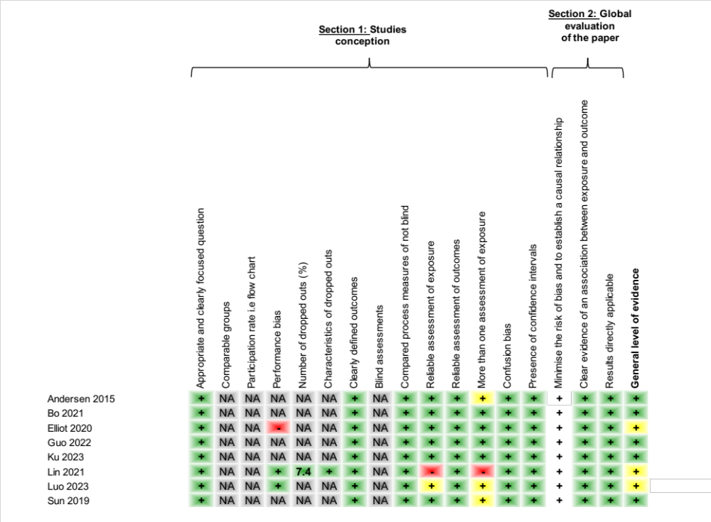

The NOS Checklist

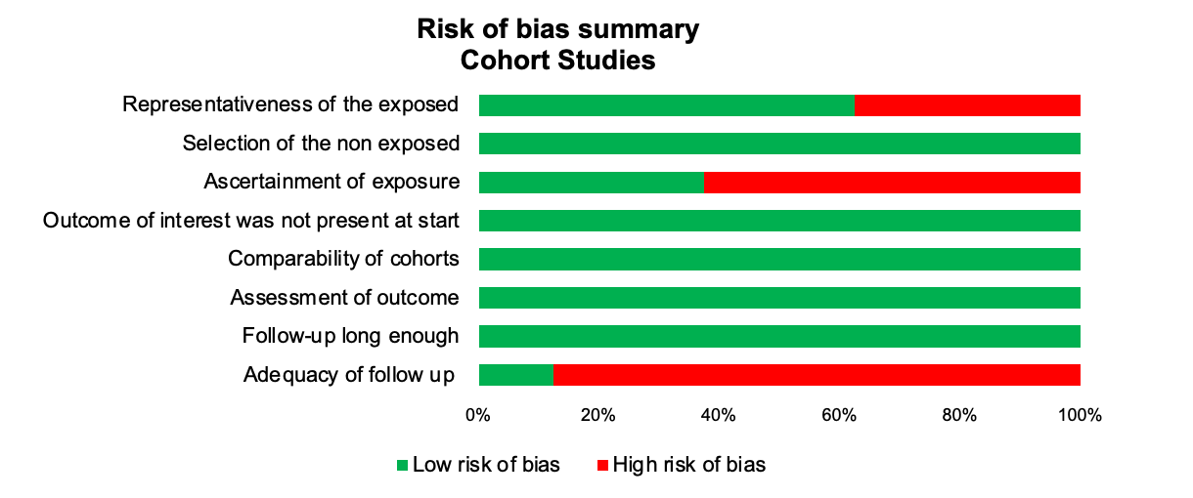

Details of quality of included studies using the NOS checklist

