Electronic supplementary material Fig. S3 Metafunnels for each meta-analysis: air pollution and no physical activity, physical activity and no pollution, physical activity in air pollution
Each circle represents a single study, with its corresponding effect size (x axis) and its associated standard error of the effect estimate (y-axis). Large high-powered studies are placed towards the top, and smaller low-powered studies towards the bottom. The plot should ideally resemble a pyramid or inverted funnel, with scatter due to sampling variation. Studies outside funnel plot are likely to present bias [110]

Air pollution and no physical activity
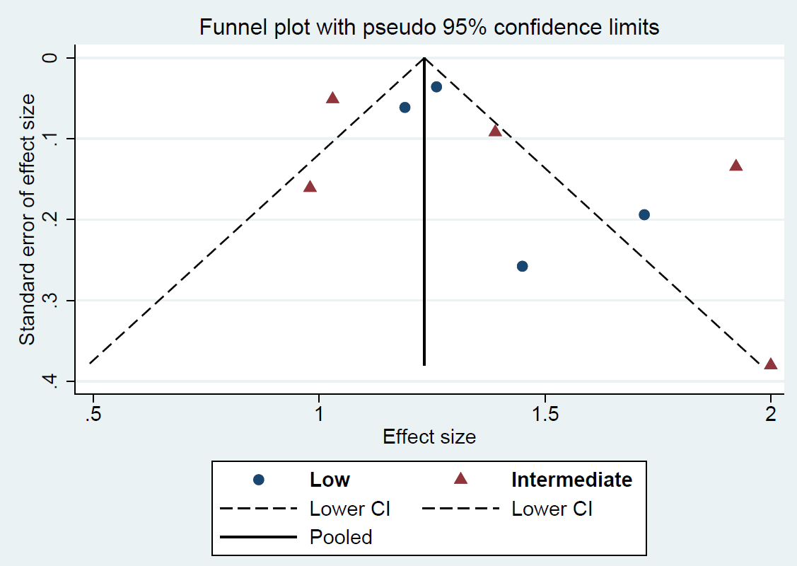

Physical activity and no pollution
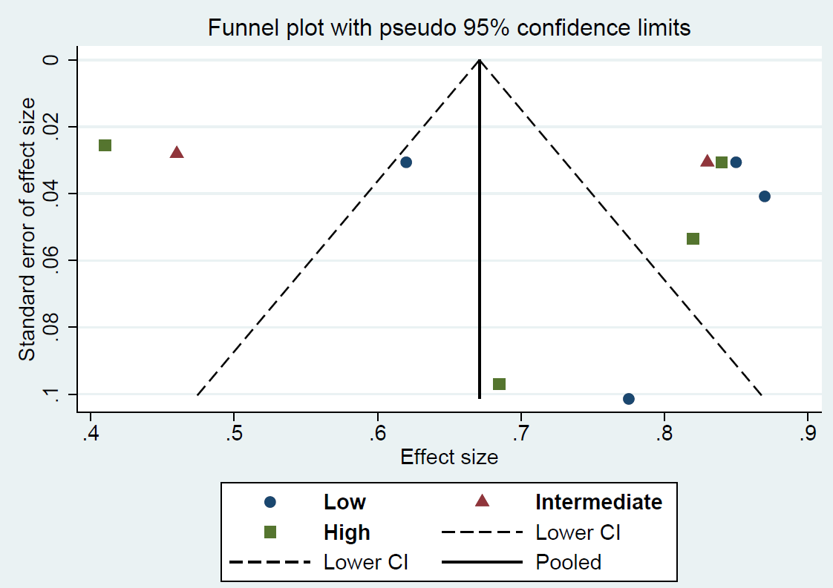

Physical activity in high air pollution
