Comparative efficacy of different exercise therapies for cardiorespiratory fitness in breast cancer survivors: a systematic review and Bayesian network meta-analysis
Xue Zhou ^{1, #}, Yao Yang ^{2, #}, Liwen Zhai², Jianing Gan², Conghui Li¹, Yi Zhu^{1,} *
¹The Fifth Affiliated Hospital of Zhengzhou University, Zhengzhou University, Zhengzhou, Henan, 450000, China;(Xue Zhou: zhouxue980708@163.com; Conghui Li: conghuili@163.com)
²Academy of Medical Sciences, Zhengzhou University, Zhengzhou, Henan, 450000, China; (Yao Yang：yangyao1030@163.com; Liwen Zhai: vermouth1012@163.com; Jianing Gan: gjn011205@gmail.com)
*Correspondence: Yi Zhu (E-mail: zhuyi1010@163.com)
#Xue Zhou and Yao Yang are the co-first authors

Supplementary materials
Supplementary material S1. Search strategy
Supplementary Table S1: Overview of the search strategy in databases
Search query in Pubmed
#1. ("Breast Neoplasms"[Mesh]) OR (breast cancer*[Title/Abstract]) OR (breast tumor*[Title/Abstract]) OR (breast neoplasms*[Title/Abstract])
#2. (((("Circuit-Based Exercise"[Mesh]) OR "Physical Endurance"[Mesh]) OR ( "Exercise"[Mesh] OR "Exercise Therapy"[Mesh] OR "Resistance Training"[Mesh] OR "High-Intensity Interval Training"[Mesh] ) ) OR ("Tai Ji"[Mesh])) OR ("Yoga"[Mesh])
#3.((((((((((exercise*[Title/Abstract]) OR (exercise therap*[Title/Abstract])) OR (aerobic exercise*[Title/Abstract])) OR (aerobic training*[Title/Abstract])) OR (Physical activity[Title/Abstract])) OR (physical exercise*[Title/Abstract])) OR (physical training[Title/Abstract])) OR (strength Training[Title/Abstract])) OR (resistance exercise*[Title/Abstract]) OR (exercise-based rehabilitation[Title/Abstract])) OR (Cardiac Rehabilitation[Title/Abstract])
#4. ((((Pilates[Title/Abstract]) OR (yoga[Title/Abstract])) OR (Tai Chi[Title/Abstract])) OR (Taiji[Title/Abstract])) OR (T'ai Chi[Title/Abstract])
#5. ((((((((high-intensity interval training*[Title/Abstract]) OR (high-intensity intermittent exercise*[Title/Abstract])) OR (high intensity exercise*[Title/Abstract])) OR (sprint interval training*[Title/Abstract])) OR (sprint interval exercise*[Title/Abstract])) OR (HIIT[Title/Abstract])) OR (moderate-intensity[Title/Abstract])) OR (moderate-intensity continuous training*[Title/Abstract])) OR (MICT[Title/Abstract])
#6. (((((Circuit Training[Title/Abstract]) OR (Circuit Based exercise*[Title/Abstract])) OR (combined training[Title/Abstract])) OR (combined exercise*[Title/Abstract])) OR (concurrent training[Title/Abstract])) OR (concurrent exercise*[Title/Abstract])
#7. #2 OR #3 OR #4 OR #5 OR #6
#8.(((((((((((Randomized Controlled Trial*[Title/Abstract]) OR (randomized controlled stud*[Title/Abstract])) OR (Controlled Clinical Trial*[Title/Abstract])) OR (Controlled Clinica stud*[Title/Abstract])) OR (Randomized Trial*[Title/Abstract])) OR (Clinical Trial*[Title/Abstract])) OR (RCT[Title/Abstract])) OR (RCTs[Title/Abstract])) OR ("Randomized Controlled Trial"[Publication Type])) OR ("Controlled Clinical Trial"[Publication Type])) OR ("Clinical Trial"[Publication Type])) OR ("Randomized Controlled Trials as Topic"[Mesh])
#9.(("Cardiorespiratory Fitness"[Mesh]) OR "Cardiovascular Diseases"[Mesh]) OR ((((((((((Cardiorespiratory[Title/Abstract]) OR (fitness[Title/Abstract])) OR (Cardiac[Title/Abstract])) OR (Cardio*[Title/Abstract])) OR (Cardiac Toxicity[Title/Abstract])) OR (Cardiotoxicit*[Title/Abstract])) OR (" cancer therapy-related cardiac dysfunction"[Title/Abstract])) OR (CTRCD[Title/Abstract])) OR (Cardiovascular[Title/Abstract])) OR (cardiopulmonary[Title/Abstract])
#10. #1 AND #7 AND #8 AND #9
Search query in Embase
#1.'breast cancer'/exp
#2.'breast near/1 tumor*':ab,ti OR 'breast cancer*':ab,ti OR 'breast near/1 neoplasms*':ab,ti
#3. #1 OR #2
#4.'exercise'/exp OR 'aerobic exercise'/exp OR 'anaerobic exercise'/exp OR 'circuit training'/exp OR 'continuous training'/exp OR 'endurance training'/exp OR 'high intensity exercise'/exp OR 'interval training'/exp OR 'low intensity exercise'/exp OR 'moderate intensity exercise'/exp OR 'resistance training'/exp OR 'Tai Chi'/exp OR 'yoga'/exp OR 'physical activity'/exp
#5.exercise*:ab,ti OR 'exercise therap*':ab,ti OR 'physical activity':ab,ti OR 'physical exercise*':ab,ti OR 'physical training':ab,ti OR 'aerobic exercise*':ab,ti OR 'anaerobic exercise*':ab,ti OR 'aerobic training*':ab,ti OR 'anaerobic training*':ab,ti OR 'strength training*':ab,ti OR 'resistance exercise*':ab,ti OR 'strength exercise*':ab,ti OR 'resistance training*':ab,ti OR 'endurance training*':ab,ti OR 'endurance exercise*':ab,ti OR 'exercise-based rehabilitation':ab,ti
#6. pilates:ab,ti OR yoga:ab,ti OR taiji:ab,ti OR 'tai chi':ab,ti
#7. hiit:ab,ti OR mict:ab,ti OR 'sprint near/1 (training* or exercise*)':ab,ti OR '(high or moderate or low) near/0 intensity near/1 (exercise* or training*)':ab,ti OR 'continuous training*':ab,ti OR 'interval training*':ab,ti
#8.'circuit training*':ab,ti OR 'combined training*':ab,ti OR 'combined exercise*':ab,ti OR 'concurrent training*':ab,ti OR 'circuit based exercise*':ab,ti
#9. #4 OR #5 OR #6 OR #7 OR #8
#10. 'clinical trial (topic)'/exp OR 'controlled clinical trial (topic)'/exp OR 'randomized controlled trial (topic)'/exp OR 'randomized controlled trial'/exp
#11.'randomized controlled trial*':ab,ti OR 'randomized controlled stud*':ab,ti OR 'controlled clinical trial*':ab,ti OR 'controlled clinical stud*':ab,ti OR 'randomized trial*':ab,ti OR 'clinical trial*':ab,ti OR rct*:ab,ti
#12. #10 OR #11
#13.'cardiorespiratory fitness'/exp OR 'cardiovascular parameters'/exp OR 'cardiovascular disease'/exp OR 'cardiotoxicity'/exp OR 'heart rehabilitation'/exp
#14. cardiorespiratory:ab,ti OR fitness:ab,ti OR cardiac:ab,ti OR 'cardiorespiratory fitness':ab,ti OR cardio*:ab,ti OR 'cardiac toxicity':ab,ti OR cardiotoxicit*:ab,ti OR 'cancer therapy-related cardiac dysfunction':ab,ti OR ctrcd:ab,ti OR cardiovascular:ab,ti OR cardiopulmonary:ab,ti OR 'cardiac rehabilitation':ab,ti OR 'cardio-oncology':ab,ti
#15. #13 OR #14
#16. #3 AND #9 AND #12 AND #15
Search query in Web of Science
#1. ALL=(“breast neoplasms” OR “breast cancer*” OR “breast tumor*”)
#2. ALL=(“exercise* OR “exercise therap*” OR “physical activity” OR “physical exercise* OR “physical training*” OR “exercise-based rehabilitation” OR “strength training*” OR “strength exercise*” OR “resistance exercise*” OR “resistance training*” OR “endurance training*” OR “endurance exercise*”)
#3. ALL=(pilates OR yoga OR taiji OR “tai chi”)
#4. ALL=(“aerobic exercise*” OR “anaerobic exercise*” OR “aerobic training” OR “anaerobic training*” OR HIIT OR MICT OR “sprint near/1 (training* or exercise*)” OR “(high or moderate or low) near/0 intensity near/1 (exercise* or training*)” OR “continuous training*” OR “interval training*”)
#5. ALL=(“circuit training*” OR “combined training*” OR “combined exercise*” OR “concurrent training*” OR “circuit based exercise*”)
#6. #2 OR #3 OR #4 OR #5
#7. ALL=(cardiorespiratory fitness OR cardiac OR cardio* OR “cardiac toxicity” OR cardiotoxicit* OR “cancer therapy-related cardiac dysfunction” OR CTRCD OR cardiovascular OR cardiopulmonary OR “cardiac rehabilitation” OR “cardio-oncology”)
#8. TS=(clinical trial* OR “controlled near/1 (trial* OR stud*) ” OR randomized controlled trial* OR randomized controlled stud* OR randomized trial* OR RCT*)
#9. #1 AND #6 AND #7 AND #8
Search query in Cochrane Library
#1. MeSH descriptor: [Breast Neoplasms] this term only
#2. (breast cancer* OR (breast near/1 tumor*) OR (breast near/1 neoplasms*)):ti,ab,kw
#3. #1 OR #2
#4. MeSH descriptor: [Physical Fitness] explode all trees
#5. MeSH descriptor: [Cardiorespiratory Fitness] explode all trees
#6. MeSH descriptor: [Cardiovascular Diseases] explode all trees
#7. (cardiorespiratory fitness OR cardiac OR cardio* OR “cardiac toxicit*” OR cardiotoxicit* OR “cancer therapy-related cardiac dysfunction” OR CTRCD OR cardiovascular OR cardiopulmonary OR “cardiac rehabilitation” OR cardio-oncology):ti,ab,kw
#8. #4 OR #5 OR #6 OR #7
#9. MeSH descriptor: [Exercise Therapy] explode all trees
#10. MeSH descriptor: [Exercise] explode all trees
#11. MeSH descriptor: [Physical Endurance] explode all trees
#12. MeSH descriptor: [Circuit-Based Exercise] explode all trees
#13. MeSH descriptor: [Resistance Training] explode all trees
#14. MeSH descriptor: [High-Intensity Interval Training] explode all trees
#15. MeSH descriptor: [Endurance Training] explode all trees
#16. MeSH descriptor: [Tai Ji] explode all trees
#17. MeSH descriptor: [Yoga] explode all trees
#18. (“exercise* OR “exercise therap*” OR “physical activity” OR “physical exercise* OR “physical training*” OR “exercise-based rehabilitation” OR “strength training*” OR “strength exercise*” OR “resistance exercise*” OR “resistance training*” OR “endurance training*” OR “endurance exercise*” OR pilates OR yoga OR taiji OR “tai chi”):ti,ab,kw
#19. (“aerobic exercise*” OR “anaerobic exercise*” OR “aerobic training” OR “anaerobic training*” OR HIIT OR MICT OR “sprint near/1 (training* or exercise*)” OR “(high or moderate or low) near/0 intensity near/1 (exercise* or training*)” OR “continuous training*” OR “interval training*”):ti,ab,kw
#20. (“circuit training*” OR “combined training*” OR “combined exercise*” OR “concurrent training*” OR “circuit based exercise*”):ti,ab,kw
#21. #9 OR #10 OR #11 OR #12 OR #13 OR #14 OR #15 OR #16 OR #17 OR #18 OR #19 OR #20
#22. MeSH descriptor: [Clinical Study] explode all trees
#23. MeSH descriptor: [Clinical Trial] explode all trees
#24. MeSH descriptor: [Randomized Controlled Trial] explode all trees
#25. (clinical trial* OR “controlled near/1 (trial* OR stud*) ” OR randomized controlled trial* OR randomized controlled stud* OR randomized trial* OR RCT*):ti,ab,kw
#26. #22 OR #23 OR #24 OR #25
#27. #3 AND #8 AND #21 AND #26
Search query in CINAHL
#1. (MH "Breast Neoplasms+") OR TI (breast cancer* OR (breast near/1 tumor*) OR (breast near/1 neoplasms*)) OR AB (breast cancer* OR (breast near/1 tumor*) OR (breast near/1 neoplasms*))
#2. (MH "Cardiorespiratory Fitness") OR (MH "Physical Fitness+") OR (MH "Cardiovascular Diseases+") OR (MH "Cardiotoxicity") OR (MH "Exercise Test, Cardiopulmonary") OR TI ( cardiorespiratory fitness OR cardiac OR cardio* OR “cardiac toxicit*” OR cardiotoxicit* OR “cancer therapy-related cardiac dysfunction” OR CTRCD OR cardiovascular OR cardiopulmonary OR “cardiac rehabilitation” OR cardio-oncology ) OR AB ( cardiorespiratory fitness OR cardiac OR cardio* OR “cardiac toxicit*” OR cardiotoxicit* OR “cancer therapy-related cardiac dysfunction” OR CTRCD OR cardiovascular OR cardiopulmonary OR “cardiac rehabilitation” OR cardio-oncology )
#3. (MH "Exercise+") OR (MH "Resistance Training") OR (MH "Therapeutic Exercise+") OR (MH "High-Intensity Interval Training") OR (MH "Endurance Training") OR (MH "Aerobic Exercises+") OR (MH "Physical Activity") OR (MH "Tai Chi") OR (MH "Yoga") OR TI ( “exercise* OR “exercise therap*” OR “physical activity” OR “physical exercise* OR “physical training*” OR “exercise-based rehabilitation” OR “strength training*” OR “strength exercise*” OR “resistance exercise*” OR “resistance training*” OR “endurance training*” OR “endurance exercise*” OR pilates OR yoga OR taiji OR “tai chi” ) OR AB ( “exercise* OR “exercise therap*” OR “physical activity” OR “physical exercise* OR “physical training*” OR “exercise-based rehabilitation” OR “strength training*” OR “strength exercise*” OR “resistance exercise*” OR “resistance training*” OR “endurance training*” OR “endurance exercise*” OR Pilates OR yoga OR taiji OR “tai chi” ) OR TI ( “aerobic exercise*” OR “anaerobic exercise*” OR “aerobic training” OR “anaerobic training*” OR HIIT OR MICT OR “sprint near/1 (training* or exercise*)” OR “(high or moderate or low) near/0 intensity near/1 (exercise* or training*)” OR “continuous training*” OR “interval training*” ) OR AB ( “aerobic exercise*” OR “anaerobic exercise*” OR “aerobic training” OR “anaerobic training*” OR HIIT OR MICT OR “sprint near/1 (training* or exercise*)” OR “(high or moderate or low) near/0 intensity near/1 (exercise* or training*)” OR “continuous training*” OR “interval training*” ) OR TI ( “circuit training*” OR “combined training*” OR “combined exercise*” OR “concurrent training*” OR “circuit based exercise*” ) OR AB ( “circuit training*” OR “combined training*” OR “combined exercise*” OR “concurrent training*” OR “circuit based exercise*” )
#4. (MH "Randomized Controlled Trials+") OR (MH "Clinical Trials+") TI ( clinical trial* OR “controlled near/1 (trial* OR stud*) ” OR randomized controlled trial* OR randomized controlled stud* OR randomized trial* OR RCT* ) OR AB ( clinical trial* OR “controlled near/1 (trial* OR stud*) ” OR randomized controlled trial* OR randomized controlled stud* OR randomized trial* OR RCT* )
#5. #1 AND #2 AND #3 AND #4

Supplementary material S2. CINeMA Assessment
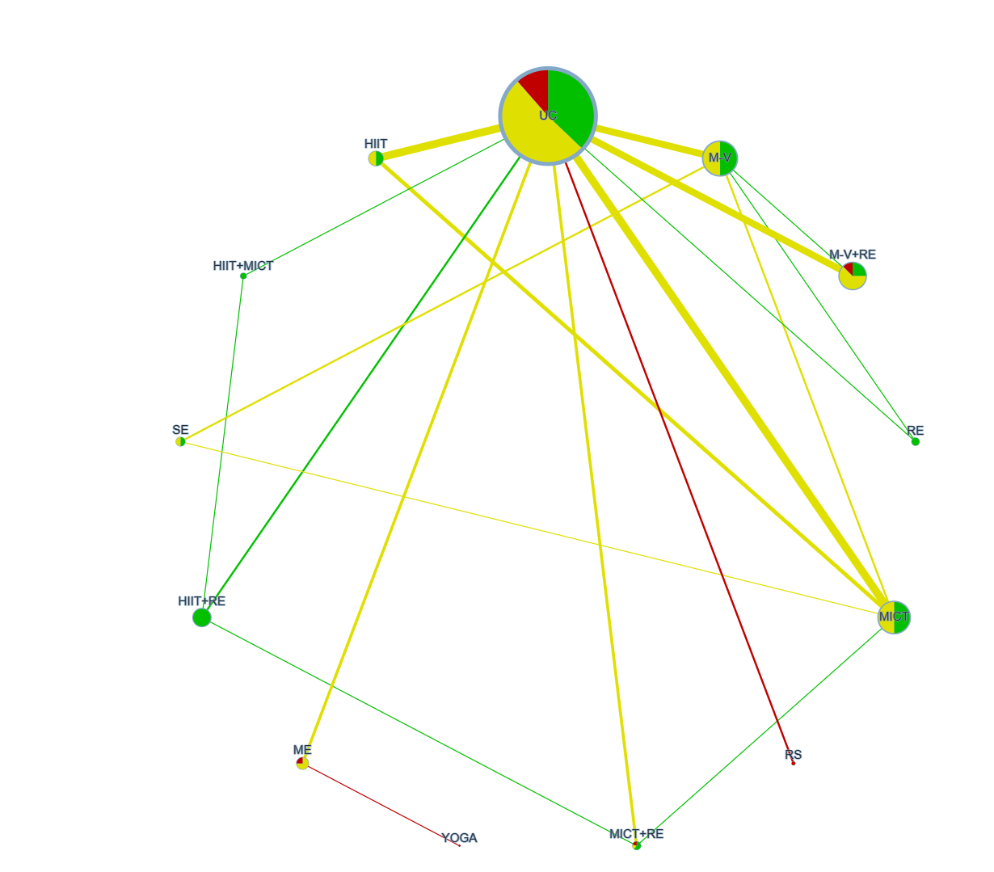
Supplementary Fig. S1 Risk of bias contribution by intervention group for improving cardiorespiratory fitness in breast cancer patients. Node size by sample size, node color by risk of bias, edge width by number of studies, and edge color by Average RoB.

Supplementary Fig. S2 Risk of bias contributions for the comparison of exercise interventions in improving cardiorespiratory fitness in breast cancer patients. The bar chart shows the contributions of each piece of study to the network estimate. White vertical lines separate the percentage contribution of different studies. Each bar shows the percentage contribution from studies judged to be at low (green), moderate (yellow), and high (red) risk of bias.

Supplementary Fig. S3 Certainty of indirect evidence from NMA
Supplementary material S3. The assessment results of models
Supplementary Table S2: Goodness-of-fit of the models
Model | Model fit (residual deviance)
Model | Dbar | pD | DIC | I^2
consistency model | 91.05179 | 78.44635 | 169.49814 | 2%
inconsistency model | 90.99511 | 79.85773 | 170.85284 | 2%
The differences in conditions (DIC) values < 5
The deviance information criteria (DIC) of the consistency model and the inconsistency model were compared, and the differences in conditions (DIC) values < 5.

Supplementary material S4. Node-splitting analysis
Supplementary Fig. S4 Node-splitting analysis in cardiorespiratory fitness. For those P values exceeding 0.05, consistency models were adopted for the network meta-analyses that followed.

Supplementary material S5. Convergence of model
Supplementary Table S3: Potential scale reduction factors
Potential scale reduction factors
Comparison | Point est. | Upper C.I.
d.UC.RE | 1 | 1
d.UC.MICT | 1 | 1
d.UC.M-V | 1 | 1
d.UC.HIIT | 1 | 1
d.UC.MICT+RE | 1 | 1
d.UC.M-V+RE | 1 | 1
d.UC.HIIT+RE | 1 | 1
d.UC.HIIT+MICT | 1 | 1
d.UC.ME | 1 | 1
d.UC.RS | 1 | 1
d.MICT.SE | 1 | 1
d.ME.YOGA | 1 | 1
sd.d | 1 | 1

Supplementary Fig. S5 Brooks-Gelman-Rubin diagnostic graph

Supplementary material S6. Ranks of various types of exercise in terms of cardiorespiratory fitness in breast cancer patients.
Supplementary Table S4. SUCRA values (%) of different exercise interventions for improving cardiorespiratory fitness in breast cancer patients. Higher SUCRA in cardiorespiratory fitness indicate better-performing interventions.
Type of exercise | SUCRA (%)
Usual care | 12.49
Resistance exercise | 34.05
Stretching exercise | 59.11
Moderate-intensity continuous training | 39.84
Moderate-to-vigorous aerobic exercise | 76.48
High-intensity interval training | 65.84
Moderate-intensity continuous training combined with resistance exercise | 44.81
Moderate-to-vigorous aerobic training combined with resistance exercise | 88.15
High-intensity interval training combined with resistance exercise | 44.22
High-intensity interval training combined with moderate-intensity continuous training | 79.69
Yoga | 16.90
Multimodal exercise training | 47.70
Recreational sports | 40.71

Supplementary Fig. S6 A rank histogram plot created using the ggplot2 R package applied to different exercise treatments for CRF illustrating probability that each treatment is ranked 1st through 13th (left to right).
Supplementary material S7. Network meta-regression analyses in terms of “exercise intervention during or after cancer treatment”.
Supplementary Table S5. The predictor values (B) of network meta-regression analyses (mean, 95% CrI). The covariate was considered to have indeed affected the NMA results when the 95% CrI of regression predictor B did not include zero.
 | Predictor | Mean | SD | Naive SE | Time-series SE
40RCTs | B | -1.6377 | 0.9500 | 0.003004 | 0.012335
38RCTs | B | -1.6798 | 0.9960 | 0.003150 | 0.013685
Supplementary Table S6. The predictor values (B) of network meta-regression analyses (mean, 95% CrI). The covariate was considered to have indeed affected the NMA results when the 95% CrI of regression predictor B did not include zero.
 | Predictor | 2.5% | 25% | 50% | 75% | 97.5%
40RCTs | B | -3.5424 | -2.26014 | -1.6284 | -1.007 | 0.2082
38RCTs | B | -3.6773 | -2.3311 | -1.6681 | -1.021 | 0.2559

Supplementary material S8. Comparison-adjusted funnel plot
Supplementary Fig. S7 Comparison-adjusted funnel plot

