Title: Does yoga therapy improve range of motion in shoulders of women recovering from breast cancer surgery? A Randomised Controlled Trial.
Journal name: Sports Medicine - Open
Wendy Wing Tak Lam^{1,2*}, Danielle Wing Lam Ng^{1,2}, Richard Fielding^{1,2}, Daniel YT Fong³, Ava Kwong⁴, Inda Soong⁵, Wendy Wing Lok Chan⁶, Vanessa Oi Kwan Chun⁷, Sara Fung⁷

¹ LKS Faculty of Medicine, School of Public Health, Centre for Psycho-Oncology Research and Training, The University of Hong Kong, Hong Kong, Hong Kong SAR, China
² LKS Faculty of Medicine, Jockey Club Institute of Cancer Care, The University of Hong Kong, Hong Kong, Hong Kong SAR, China
³LKS Faculty of Medicine, School of Nursing, The University of Hong Kong, Hong Kong SAR, China
⁴ LKS Faculty of Medicine, School of Clinical Medicine, Department of Surgery, The University of Hong Kong, Hong Kong SAR, China
⁵ Department of Clinical Oncology, Pamela Youde Nethersole Eastern Hospital, Hospital Authority, Hong Kong, Hong Kong SAR, China
⁶ LKS Faculty of Medicine, School of Clinical Medicine, Department of Clinical Oncology, The University of Hong Kong, Hong Kong SAR, China
^{7.}Department of Surgery, Kwong Wah Hospital, Hospital Authority, Hong Kong, Hong Kong SAR, China
*Corresponding Author:
Wendy Wing Tak Lam, Centre for Psycho-Oncology Research and Training, School of Public Health, Division of Behavioural Sciences, University of Hong Kong, Patrick Manson Building, 7 Sassoon Rd., Pok Fu Lam, Hong Kong.
Email: wwtlam@hku.hk
Supplementary Table 1. Yoga intervention

Gentle warm-up sequences (this set of sequences will help loosen the stiffness of the joints and muscles); it should not take more than five minutes.
- Shoulder rotation (all four directions) – 10 times for each direction
- Hip rotation (left and right – five times on each side)
- Side stretch (left and right, hold ten counts on each side)
- Twisting (left and right, five times on each side)
- Forward bend and backward bend (hold 5 to 10 counts, repeat three times)
- If possible, include the forward bend twisting (five times on each side)
Shoulder and upper back flexibility (these postures will help to loosen shoulder and neck stiffness). Each of the following postures should normally hold for 10 counts and should be performed on both sides if applicable.
- Shoulder rotation
- Shoulder stretch (placing one arm behind the head)
- Shoulder stretch (placing one arm across the chest)
- Holding a towel from the back and rotate the shoulders outward
- Pressing on the wall to stretch the shoulders
- Neck stretch (left, right, front, and back, then rotation clockwise, then anticlockwise)
- Twine the elbows together at the front (i.e. one elbow on top of the other) and raise the arms up as high as possible
Strength and balancing (These postures will help to improve core strength, thigh strength, arm strength, and balancing.)
- Chair pose (hold 10 counts, repeat twice)
- Variations of chair pose (if want further challenging) such as doing chair pose with heels up, eagle post (i.e. twine the legs in the chair pose)
- Balancing on one leg and lift another leg up to hip level (the leg can be bended or straight) – Hold for 10 counts, repeat twice, and do it on both legs)
- Aeroplane pose (hold 10 counts on each leg)
- Tree pose (hold 10 counts, repeat two times, do it on both legs)
- Sitting on the floor, straight back, raise both legs up with feet at the forehead level and arms up (Boat pose)
- Sitting on the floor, straight back, fists on the shoulders, legs together with feet pointing to the front, then lean back until feeling the vibration from the abdomen
- Similar to push up, but elbows on the floor (shoulder and elbow flexed at 90 degree angle ) (10 counts, repeat twice)

Back strengthening sequence
- Front and back bend warm up (see above)
- Twisting warm up (see above)
- Cat stretch (palms and keens on the floor, both wrists and shoulder should be in a straight line, same as hips and keens) (repeated five times each, pushing the back down and pushing the back up)
- Cat stretch with one leg up and the opposite hand up (hold 10 counts, repeat on both sides)
- Lie down on the floor facing down,
  - hands beside the shoulders, first lift the upper chest up, then both hands up (i.e. using the back muscle to hold upper body up) (hold for 10 counts, repeat 2 to 3 times)
  - Hands beside the chest, then slowly lift all the way up with only the pelvic and the legs on the floor – look up if possible (Cobra pose) (hold for 10 counts, repeat 2 to 3 times)
  - Straight arms stretching out, then lift one arm and one opposite leg up, look up (hold for 10 counts, repeat on both sides)
  - Same as c, but this time, both arms and legs up (hold for 10 counts)
- Finish with seated twisting to relieve the tension resulting from the backbend exercise
All the above sequences can be combined with breathing exercises.

Supplementary Table S2. Breathing exercise and relaxation control intervention

Breathing exercise (20 minutes)
- Practice diaphragmatic breathing: inhalation through the nose and exhalation through the mouth.
- Practice fast breathing (Kapalabhati): Breathe in and out through the nose, and each breath should be strong and quick.
- Practice alternate nostril breathing: Use the right thumb to close the right nostril, breath in through the left nostril, close both nostrils and hold the breath for 5 counts, and then open the right nostril and breath out. Repeat this step, inhale through the right nostril and exhale through the left nostril.
- Practice even breathing: inhale for 10 counts, hold for two counts, then slowly exhale
Progressive Muscle Relaxation (40 minutes)
Progressive muscle relaxation is an exercise that relaxes the mind and body by progressively tensing and relaxing the muscle groups throughout the body. You will tense each muscle group vigorously, but without straining, and then suddenly release the tension and feel relaxed. You will tense each muscle for approximately five seconds. If you have any pain or discomfort at any of the targeted muscle groups, feel free to omit that step or just notice the tension or pain in that part of the body. Throughout this exercise, you may visualize the tensing muscles and a wave of relaxation flowing over them as you release that tension. It is important to maintain breathing throughout the exercise.

Now let’s begin. Begin by finding a comfortable position, either sitting or lying down in a location where you will not be interrupted. Close your eyes. Allow your attention to focus solely on your body. If you begin to notice your mind wandering, bring it back to the muscles you are working on.

Take a deep breath through your abdomen, hold it for a few seconds, and exhale slowly. Again, as you breathe notice, your stomach rises, and your lungs are filled with air. As you exhale, imagine the tension in your body being released and flowing out. And again inhale…..and exhale. Feel your body is already relaxing. As you go through each step, remember to keep breathing.

We began by focusing on the muscles on the face. First, tighten the muscles in the forehead by raising the eyebrows as much as possible. Hold for approximately five seconds. It abruptly releases the feeling that tension has fallen away. Pause for approximately 10 seconds.

Now, frown as hard as you can, and notice the strain spreading through your forehead. Hold for approximately five seconds and release. Pause for 10 seconds.
Then, your eye muscles were tightened by squinting the eyelids tightly. Hold for approximately 5 s and release. Pause for approximately 10 seconds.

Next, Clench your jaw together firmly without hurting your teeth. Hold for 5 seconds and release. Pause for 10 seconds. Feel the contrast between tension and relaxation.
Now, smile widely, feeling your mouth and cheeks tense. Hold for approximately 5 s, and release, appreciating the softness of your face. Pause for approximately 10 seconds.

Gently pull your head back as if looking at the ceiling without straining the neck. Hold for approximately 5 s, and release, feeling the tension melts away. Pause for approximately 10 seconds.

Now, gently tilt your head down as if looking at your chest or touch the chest with your chin. Hold for approximately 5 s and release. Pause for approximately 10 seconds. Now feel the weight of your relaxed head and neck sink. Breathe in…and out. In…and out. Let go of all the stress In…and out.

Gently turn your neck to the right without straining it. Hold for 5 seconds and. Pause for 10 seconds.

Now to your neck to the left. Hold for 5 seconds and. Pause for 10 seconds. Breathe in...and out. Feel how your neck muscles are like when they are relaxed. Allow your whole head to settle in a comfortable position and keep it still.

Now, tightly but without straining, clench your fists and hold this position. Hold for approximately 5 s and release. Pause for approximately 10 s and let the tension move away.

Now, flex your biceps. Feel that builds up tension. You may even visualize muscle tightening. Hold for about five seconds, and release, enjoying that feeling of limpness. Breathe in and out.

Now, tighten your triceps by extending your arms and locking your elbows. Hold for approximately 5 s and release. Pause for approximately 10 seconds.

Now, lift your shoulders up as if they can touch your ear. Hold for approximately 5 s, and quickly release, feeling their heaviness. Pause for approximately 10 seconds.

Tense your upper back by pulling your shoulders back, trying to touch your shoulder blades. Hold for approximately 5 s and release. Pause for approximately 10 seconds.

Tighten your chest by taking a deep breath in, hold for about 5 seconds, and exhale, blowing out all tension. Pause for 10 seconds.

Tighten the muscles in the stomach by sucking in. Hold for approximately 5 s and release. Feel the difference between a tense and relaxed abdomen. Pause for about 10 seconds

Gently arches the lower back without straining. Hold for approximately 5 s and relax. Pause for approximately 10 seconds. Feel limpness in your upper body, letting go of tension and stress.
Tighten your buttocks and thighs by pressing your knees together, as if holding a penny between them. Hold for approximately 5 s and release. Pause for approximately 10 seconds. Feel the weight of your thigh and buttocks on a chair or bed.

Now flex your feet, pull your toes towards you, and feel tension in your calves. Hold for approximately 5 seconds, relax, and feel the weight of your legs sinking down. Pause for approximately 10 seconds.

Curl your toes while tensing your feet. Hold for approximately 5 s, release. Pause for approximately 10 seconds.

Raise your toes as much as possible. Hold for 5 s and release. Pause for 10 seconds. Let go of the tension in your feet.

Now imagine a wave of relaxation slowly spreading through your body, beginning at your head and going all the way down to your feet. Feeling the weight of the relaxed body. Breathing in and out.

Allow your attention to settle in the middle of your chest and just remain aware of the sensations and sounds you experience. Do not judge or react to thoughts or images that enter your mind. Instead, simply observing them as you would in a cloud. Note the calmness of the body. Stay like this for at least ten minutes.
When you are ready to get up, slowly move your hands and feet, head, side to side, turn to your side, and sit up. Try to retain the sense of calm and peace inside you.

Supplementary Figure 1a. Changes in shoulder circumduction scores over time between intervention groups

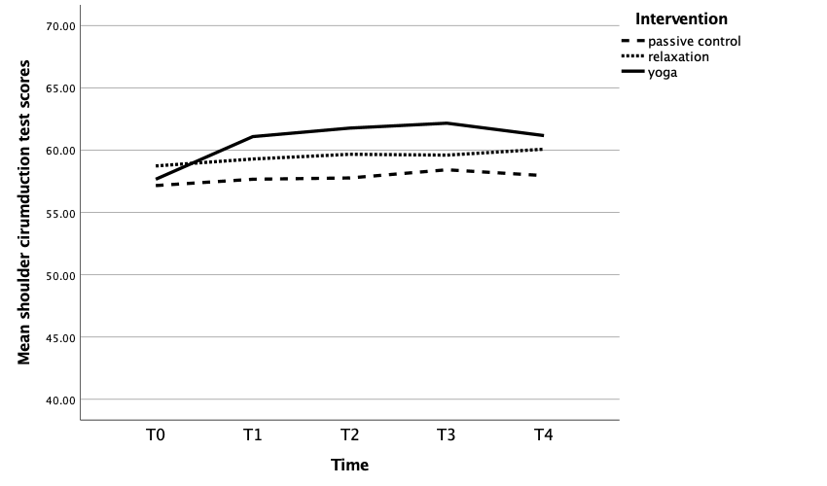

Supplementary Figure 1b Changes in Left side back scratch test scores over time between intervention groups

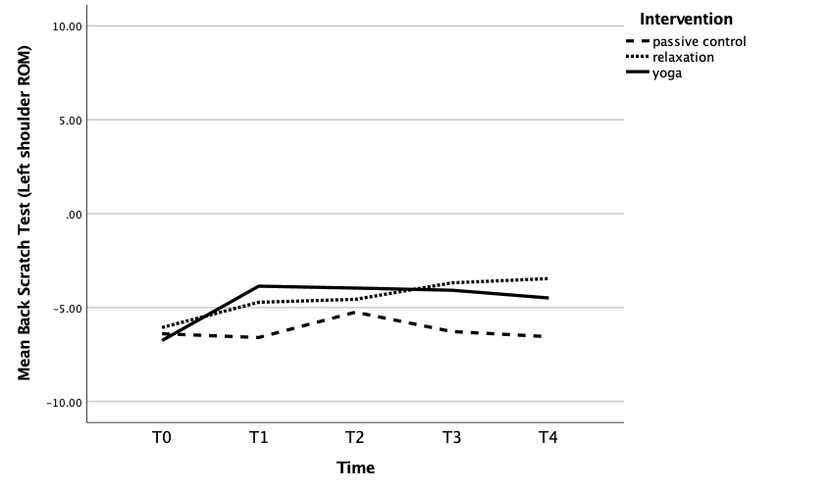
Supplementary Figure 1c. Changes in Right side back scratch test scores over time between intervention groups

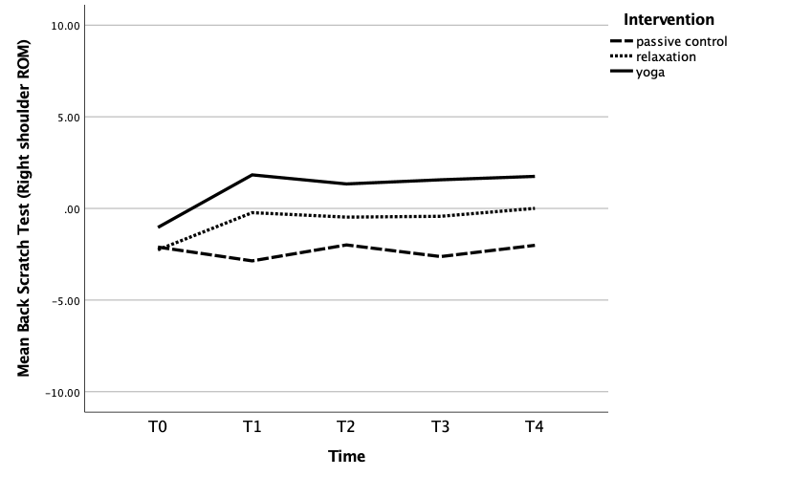

Supplementary Table S3. Linear Mixed-Effect Model analyses for primary outcomes adjusted with covariatesª

Shoulder Rotation Flexibility (n=424) | Time Point | Yoga (n= 142) Mean (SD) | Breathing exercise and relaxation (n= 142) Mean (SD) | Control (n= 140)  Mean (SD) | Estimate for Difference  Yoga Vs Breathing exercise and relaxation | 95% CI | P | Estimate for Difference  Yoga Vs Control | 95% CI | P | Estimate for Difference  Breathing exercise and relaxation Vs Control | 95% CI | P | Overall P for between-group difference
 | Baseline | 56.66  (11.95) | 57.46  (11.97) | 56.28  (11.79) | -0.80 | -3.04, 1.44 | 0.99 | 0.38 | -1.89, 2.65 | 0.99 | 1.18 | -1.11, 3.47 | 0.65 | 0.001
 | Immediate post-intervention | 60.09  (11.49) | 58.19  (11.52 | 57.05  (11.56) | 1.90 | -0.15, 3.96 | 0.08 | 3.04 | 0.92, 5.17 | 0.002 | 1.14 | -1.01, 3.29 | 0.61
 | 3-month | 60.59  (11.36) | 58.25  (11.43) | 56.95  (11.58) | 2.34 | 0.33, 4.35 | 0.016 | 3.64 | 1.54, 5.73 | <0.001 | 1.30 | -0.84, 3.44 | 0.44
 | 6-month | 60.86  (11.583) | 58.39  (11.62) | 57.91  (11.73) | 2.47 | 0.37, 4.57 | 0.015 | 2.94 | 0.77, 5.12 | 0.004 | 0.47 | -1.73, 2.68 | 0.99
 | 12-month | 60.21  (12.22) | 58.86  (12.42) | 57.28  (12.60) | 1.36 | -1.06, 3.77 | 0.53 | 2.92 | 0.42, 5.43 | 0.016 | 1.56 | -0.98, 4.12 | 0.42
Back scratch (Left) (n=437) | Time Point | Yoga (n= 148) Mean (SD) | Breathing exercise and relaxation (n= 146) Mean (SD) | Control (n= 143)  Mean (SD) | Estimate for Difference  Yoga Vs Breathing exercise and relaxation | 95% CI | P | Estimate for Difference  Yoga Vs Control | 95% CI | P | Estimate for Difference  Breathing exercise and relaxation Vs Control | 95% CI | P | Overall P for between-group difference
 | Baseline | -8.30  (16.66) | -7.93  (16.44) | -8.20  (16.08) | -0.36 | -3.17, 2.43 | 0.99 | -0.09 | -2.93, 2.74 | 0.99 | 0.27 | -2.60, 3.14 | 0.99 | 0.12
 | Immediate post-intervention | -5.56  (16.78) | -6.90  (16.58) | -8.35  (16.45) | 1.30 | -1.57, 4.17 | 0.83 | 2.75 | -0.18, 5.69 | 0.08 | 1.45 | -1.53, 4.44 | 0.73
 | 3-month | -5.51  (16.86) | -6.76  (16.67) | -7.89  (16.75) | 1.25 | -1.66, 4.17 | 0.91 | 2.39 | -0.62, 5.41 | 0.17 | 1.13 | -1.93, 4.20 | 0.99
 | 6-month | -5.86  (17.40) | -6.53  (17.20) | -8.34  (17.35) | 0.67 | -2.48, 3.83 | 0.99 | 2.47 | -0.78, 5.74 | 0.20 | 1.80 | -1.50, 5.11 | 0.57
 | 12-month | -5.67  (16.88) | -6.28  (16.72) | -8.74  (16.58) | 0.61 | -2.31, 3.53 | 0.99 | 3.07 | 0.80, 6.05 | 0.04 | 2.45 | -0.58, 5.49 | 0.16
Back scratch (Right) (n=437 | Time Point | Yoga (n= 147) Mean (SD) | Breathing exercise and relaxation (n= 146) Mean (SD) | Control (n= 144)  Mean (SD) | Estimate for Difference  Yoga Vs Breathing exercise and relaxation | 95% CI | P | Estimate for Difference  Yoga Vs Control | 95% CI | P | Estimate for Difference  Breathing exercise and relaxation Vs Control | 95% CI | P | Overall P for between-group difference
 | Baseline | -1.42  (15.43) | -2.79  (15.45) | -2.62  (15.00) | 1.37 | -1.23, 3.98 | 0.62 | 1.19 | -1.44, 3.83 | 0.83 | -0.17 | -2.84, 2.49 | 0.99 | 0.002
 | Immediate post-intervention | 1.16  (15.89) | -1.25  (15.97) | -2.71  (15.82) | 2.41 | -0.42, 5.25 | 0.13 | 3.88 | 0.96, 6.79 | 0.004 | 1.46 | -1.48, 4.42 | 0.70
 | 3-month | 0.78  (15.64) | -1.49  (15.72) | -2.74  (15.70) | 2.27 | -0.45, 5.00 | 0.13 | 3.53 | 0.70, 6.35 | 0.008 | 1.25 | -1.61, 4.12 | 0.88
 | 6-month | 0.72  (15.60) | -2.08  (15.66) | -3.16  (15.60) | 2.81 | 0.089, 5.52 | 0.04 | 3.89 | 1.09, 6.69 | 0.003 | 1.08 | -1.75, 3.92 | 0.99
 | 12-month | 1.13  (15.60) | -1.29  (15.68) | -2.73  (15.48) | 2.42 | -0.28, 5.13 | 0.09 | 3.86 | 1.09, 6.62 | 0.003 | 1.43 | -1.38, 4.24 | 0.68
- Adjusted for staging, type of surgery, age, had radiation therapy, side of surgery

