The effect of different psychological interventions on athletes' competitive anxiety: a systematic review and Bayesian network meta-analysis
Longhui Li ¹, Jingyi Wang ¹, Qiner Li ¹, Quan Fu ¹*.
¹ Capital University of Physical Education and Sports, Beijing, China
*Address correspondence to:
Capital University of Physical Education and Sports, Beijing, 100191, China.
Corresponding author email address: fuquan@cupes.edu.cn

Supplementary Material
Supplemental materials | Page
Supplementary Table 1: Search strategy | 2
Supplementary Table 2: Included interventions and their definitions | 3-4
Supplementary Table 3: Excluded studies | 5-8
Supplementary Table 4: Intervention replicability items | 9-23
Supplementary Table 5: Bias risk of each study | 24-25
Supplementary Table 6: Baseline comparison table | 25
Supplementary Table 7: Meta-regression of potential effect modifiers | 25
Supplementary Table 8. R-hat value and effective sample size of Bayesian network meta-analysis | 26
Supplementary Table 9: Model selection and consistency test results for subgroup analysis | 26-27
Supplementary Table 10: Node-splitting analysis for subgroup analysis | 27
Supplementary Table 11: R-hat value and effective sample size for subgroup analysis | 28-29
Supplementary Table 12: GRADE evidence quality assessment | 29-39
Supplementary Figure 1: Fixed model of residuals | 40
Supplementary Figure 2: Random model of residuals | 41
Supplementary Figure 3: Prior and posterior distribution plot of random effects model | 42
Supplementary Figure 4-6: Sensitivity analysis to exclude sparse nodes | 43-44
Supplementary Figure 7: Node splitting method | 45
Supplementary Figure 8. Ranking probability plot | 45
Supplementary Figure 9-11: Subgroup analysis of Cognitive | 46-47
Supplementary Figure 12-14: Subgroup analysis of somatic anxiety | 48-49
Supplementary Figure 15-17: Subgroup analysis of elite athletes | 50-51
Supplementary Figure 18-20: Subgroup analysis of semi-elite athletes | 51-52
Supplementary Figure 21-23: Subgroup analysis of junior athletes | 53-54
Supplementary Figure 24: ‘Comparison-adjusted’ funnel plot | 55
Supplementary Figure 25-28: Exploratory staged meta-regression | 55-58

Supplementary Table 1. Search strategy
Pubmed | ("psychological intervention*"[Title/Abstract]  OR "psychological skill*"[Title/Abstract]  OR "mental skill*"[Title/Abstract]  OR "psychological*"[Title/Abstract])  AND  ("competitive anxiety*"[Title/Abstract]  OR "anxiety*"[Title/Abstract]  OR "worry*"[Title/Abstract])  AND  ("athlete*"[Title/Abstract]  OR "sportsmen*"[Title/Abstract])  AND  ("Randomized Controlled Trial"[Publication Type]  OR "Controlled Clinical Trial"[Publication Type])  AND "English"[Language]
Embase | ('Psychological Intervention':ti,ab  OR 'Psychological Skill':ti,ab  OR 'mental skill*':ti,ab  OR 'Psychological':ti,ab)  AND  ('Competitive Anxiety':ti,ab  OR 'Anxiety':ti,ab  OR 'Worry':ti,ab)  AND  ('Athlete':ti,ab  OR 'Sportsmen':ti,ab)  AND [article]/lim  AND [english]/lim
WOS | TS=(Psychological Intervention OR Psychological Skill OR Mental Skill OR Psychological)  AND TS=(Competitive Anxiety OR Anxiety OR Worry)  AND TS=(Athlete OR Sportsmen)  Refined by:  Document Types: Article OR Review Article OR Clinical Trial  Languages: English

Supplementary Table 2. Included interventions and their definitions
 | Type | Definition
Psychological skills training | Imagery | Imagery is the symbolic mental rehearsal of physical activity, allowing athletes to visualize performance execution before actual engagement [1].
 | Goal-setting | Goal setting refers to the process of influencing athletes’ concentration, confidence, and effort by applying different types of goals (e.g., outcome, performance, and process goals), thereby enhancing performance and motivation [2].
 | Self-talk | Self-talk is defined as instructional or motivational internal speech used to manage attentional focus, enhance self-confidence, and regulate emotional states [3, 4].
 | Relaxation | Relaxation encompasses both unstructured and structured techniques that can be categorized as either muscle-to-mind (e.g., progressive muscular relaxation) or mind-to-muscle (e.g., transcendental meditation, autogenic relaxation). It is considered effective for regulating arousal and activation levels [5].
 | Psychological skills training package | A psychological skills training package refers to an intervention program incorporating two or more psychological skills [6].
Psychological training programs | Cognitive behavioral  therapy | CBT aims to address core beliefs and cognitive patterns underlying emotional responses, assisting athletes in modifying deeply ingrained interpretations of adversity and enhancing adaptability through cognitive restructuring [7].
 | Mindfulness | Mindfulness is a meditative practice involving deliberate and non-judgmental awareness of the present moment, including bodily sensations and emotional experiences [8].
 | Mindfulness Acceptance Commitment | MAC emphasizes the development of nonjudging mindful awareness, mindful attention, and experiential acceptance to support athletes in pursuing personally valued goals, rather than attempting to reduce or suppress internal psychological states [9].
 | Biofeedback | Biofeedback utilizes real-time physiological indicators (e.g., heart-rate variability, electrodermal activity, EEG) to provide feedback, enabling athletes to actively regulate physiological responses through relaxation, arousal, attention, etc. to optimize performance or alleviate anxiety [10].
 | Emotional intelligence coaching | Emotional intelligence coaching, based on the GROW model, guides participants in clarifying desired outcomes, current status, available options for change, and final actions, fostering improved understanding and application of emotional intelligence competencies [11].
- Morris, T., Spittle, M., Watt, A. P. Imagery in Sport. Human Kinetics, 2015. URL: https://us.humankinetics.com /products/imagery-in-sport? pos=1&_sid=eb6b15983&_ss =r.
- Gould, D. (2006). Goal setting for peak performance. In J. M. Williams (Ed.), Applied sport psychology: Personal growth to peak performance (pp. 204–259). New York: Mayfield.
- Hatzigeorgiadis, A., Galanis, E., Zourbanos, N., Theodorakis, Y., “Self-talk and competitive sport performance”. Journal of Applied Sport Psychology, vol. 26, no. 1, pp. 82-95, 2014. DOI: https://doi.org/10.1080/10 413200.2013.790095.
- McCormick, A., Meijen, C., Marcora, S., “Effects of a motivational self-talk intervention for endurance athletes completing an ultramarathon”. The Sport Psychologist, vol. 32, no. 1, 42-50, 2018. DOI: https://doi.org/10.1123/tsp.20 17-0018.
- Wadey R, Hanton S. Basic psychological skills usage and competitive anxiety responses: perceived underlying mechanisms. Research quarterly for exercise and sport. 2008 Sep 1;79(3):363-73.
- Reinebo G, Alfonsson S, Jansson-Fröjmark M, Rozental A, Lundgren T. Effects of psychological interventions to enhance athletic performance: A systematic review and meta-analysis. Sports Medicine. 2024 Feb;54(2):347-73.
- Williams, J. M., & Harris, D. V. (2006). Relaxation and energizing techniques for regulating of arousal. In J. M. Williams (Ed.), Applied sport psychology: Personal growth to peak performance (pp. 285–305). New York: Mayfield.
- Van Gordon, W.; Shonin, E. Second-generation mindfulness-based interventions: Toward more authentic mindfulness practice and teaching. Mindfulness 2020, 11, 1–4.
- Moore ZE. Theoretical and empirical developments of the Mindfulness-Acceptance-Commitment (MAC) approach to performance enhancement. J Clin Sport Psychol. 2009; https://doi.org/10.1123/jcsp.3.4.291.
- Pusenjak N, Grad A, Tusak M, Leskovsek M, Schwarzlin R. Can biofeedback training of psychophysiological responses enhance athletes’ sport performance? A practitioner’s perspective. The Physician and sportsmedicine. 2015 Jul 3;43(3):287-99.
- Barlow A, Banks AP. Using emotional intelligence in coaching high-performance athletes: A randomised controlled trial. Coach Int J Theory Res Pract. 2014; https://doi.org/10.1080/17521882.2014.939679.

Supplementary Table3. Exclusion studies
Ahmadi ed al. (2015) [1] | Not English
Alavizadeh ed al. (2023) [2] | Not the relevant outcome
Aravind ed al. (2022) [3] | Not RCT
Ariapooran and Godarzi (2021) [4] | Not English
Aulia ed al. (2024) [5] | Not RCT
di Fronso ed al. (2022) [6] | Not the relevant outcome
Domínguez ed al. (2024) [7] | Not RCT
Edvardsson ed al. (2012) [8] | No data
Fortes ed al. (2017) [9] | Not the relevant control
Glass ed al. (2019) [10] | No data
Golby and Wood (2016) [11] | Not RCT
Gross ed al. (2018) [12] | Not the relevant outcome
Hatzigeorgiadis ed al. (2009) [13] | Not the relevant control
Hoja and Jansen (2019) [14] | Not RCT
Jannah ed al. (2023) [15] | Not RCT
John ed al. (2011) [16] | Not the relevant outcome
Jones ed al. (2020) [17] | Not the relevant outcome
Kara ed al. (2023) [18] | Not RCT
Khabiri ed al. (2018) [19] | Not English
Kolayis (2012) [20] | Not RCT
Lim and Gill (2011) [21] | Not RCT
Mansell ed al. (2024) [22] | Not the relevant outcome
Mehrsafar ed al. (2019) [23] | No data
Moazam ed al. (2022) [24] | Not the relevant outcome
Mohammadi ed al. (2022) [25] | Not English
Muangnapoe ed al. (2016) [26] | No data
Nien ed al. (2023) [27] | Not RCT
Norouzi ed al. (2020) [28] | Not the relevant outcome
Papreja (2023) [29] | Not RCT
Pawlow and Jones (2002) [30] | Not RCT
Samadi ed al. (2021) [31] | Not RCT
Sheard and Golby (2006) [32] | No data
Solberg ed al. (2000) [33] | Not RCT
Terzioğlu Çakir-Çelebi (2025) [34] | Not the relevant outcome
Thomas ed al. (2007) [35] | No data
Wadey and Hanton (2008) [36] | Not RCT
Wan ed al. (2024) [37] | Not RCT
Wang ed al. (2023) [38] | Not RCT
Wolch ed al. (2021) [39] | Not RCT
Wong ed al. (2022) [40] | Not the relevant outcome
Xiao ed al. (2023) [41] | Not the relevant population
Yau ed al. (2021) [42] | Not RCT
Zemestani ed al. (2023) [43] | Not English
- Ahmadi E, Farsi A, Vaez Mousavi MK. Effect of biofeedback and relaxation training on state-competitive anxiety among football players. J Health Promot Manag. 2015;4(3):51-9.
- Alavizadeh SM, Gharamaleki NS, Entezari S, Mokhtar F. The comparison of metacognitive group intervention and group acceptance-based behavioral therapy on competitive aggression of anxious professional soccer athletes in Tehran. Health Nexus. 2023; https://doi.org/10.61838/kman.hn.1.2.8.
- Aravind R, Gupta S, RA GSK. A pilot study on emotional intelligence and its impact on pre-competitive anxiety: How does it operate in the non-WEIRD Indian sport context. Int J Physiol Nutr Phys Educ. 2022; https://doi.org/10.22271/journalofsport.2022.v7.i1a.2407.
- Ariapooran S, Godarzi A. The effectiveness of mindfulness-based stress reduction on competitive anxiety and mental toughness in wrestler adolescents. Sport Psychol Stud. 2021;10(35):143-66.
- Aulia P, Puspasari D, Fajrika T, Salfina YF. Effectiveness of mental training to increase self-efficacy and reduce competition anxiety in athletes. Retos. 2024;(58):511-5.
- di Fronso S, Robazza C, Bondár RZ, Bertollo M. The effects of mindfulness-based strategies on perceived stress and psychobiosocial states in athletes and recreationally active people. Int J Environ Res Public Health. 2022; https://doi.org/10.3390/ijerph19127152.
- Domínguez González JA, Reigal Garrido RE, Morales Sánchez V, Hernández Mendo A. Effects of a psychological intervention program on competitive anxiety and psychological profile in young soccer players. Percept Mot Skills. 2024; https://doi.org/10.1177/00315125241256410.
- Edvardsson A, Ivarsson A, Johnson U. Is a cognitive-behavioural biofeedback intervention useful to reduce injury risk in junior football players? J Sports Sci Med. 2012;11(2):331–8.
- Fortes LS, da Costa BD, Paes PP, do Nascimento Júnior JR, Fiorese L, Ferreira ME. Influence of competitive-anxiety on heart rate variability in swimmers. J Sports Sci Med. 2017;16(4):498.
- Glass CR, Spears CA, Perskaudas R, Kaufman KA. Mindful sport performance enhancement: randomized controlled trial of a mental training program with collegiate athletes. J Clin Sport Psychol. 2019; https://doi.org/10.1123/jcsp.2017-0044.
- Golby J, Wood P. The effects of psychological skills training on mental toughness and psychological well-being of student-athletes. Psychol. 2016; https://doi.org/10.4236/psych.2016.76092.
- Gross M, Moore ZE, Gardner FL, Wolanin AT, Pess R, Marks DR. An empirical examination comparing the mindfulness-acceptance-commitment approach and psychological skills training for the mental health and sport performance of female student athletes. Int J Sport Exerc Psychol. 2018; https://doi.org/10.1080/1612197X.2016.1250802.
- Hatzigeorgiadis A, Zourbanos N, Mpoumpaki S, Theodorakis Y. Mechanisms underlying the self-talk–performance relationship: the effects of motivational self-talk on self-confidence and anxiety. Psychol Sport Exerc. 2009; https://doi.org/10.1016/j.psychsport.2008.07.009.
- Hoja S, Jansen P. Mindfulness-based intervention for tennis players: a quasi-experimental pilot study. BMJ Open Sport Exerc Med. 2019; https://doi.org/10.1136/bmjsem-2019-000584.
- Jannah M, Widohardhono R, Kencana NT. Progressive muscle relaxation: can it reduce competitive anxiety? Phys Educ Theory Methodol. 2023; https://doi.org/10.17309/tmfv.2023.5.02.
- John S, Verma SK, Khanna GL. The effect of mindfulness meditation on HPA-Axis in pre-competition stress in sports performance of elite shooters. Natl J Integr Res Med. 2011;2(3):15-21.
- Jones BJ, Kaur S, Miller M, Spencer RM. Mindfulness-based stress reduction benefits psychological well-being, sleep quality, and athletic performance in female collegiate rowers. Front Psychol. 2020; https://doi.org/10.3389/fpsyg.2020.572980.
- Kara E, Türküm AS, Turner MJ. The effects of Rational Emotive Behaviour Therapy (REBT) group counselling program on competitive anxiety of student-athletes. J Ration Emot Cogn Behav Ther. 2023; https://doi.org/10.1007/s10942-023-00497-z.
- Khabiri M, Mansouri R, Moghadam Zadeh A, Asadi A, Hafezi E, Mehrsafar AH. The affect of positive self-talk intervention on psychophysiological responses of competitive anxiety and self-confidence in elite athletes. Neuropsychology. 2018; https://doi.org/20.1001.1.24765023.1396.3.11.6.9.
- Kolayis H. Using EEG biofeedback in karate: The relationship among anxiety, motivation and brain waves. Sch Phys Educ Sport. 2012;8(1):13-8. https://doi.org/10.12659/AOB.882446.
- Lim BH, Gill BS. Gender differences in the effects of psychological interventions on multidimensional state anxiety prior to competition in Malaysian volleyball players. Malays J Sport Sci Recreat. 2011;7(1):7-22.
- Mansell P, Sparks K, Wright J, Roe L, Carrington S, Lock J, Slater M. “Mindset: performing under pressure”–a multimodal cognitive-behavioural intervention to enhance the well-being and performance of young athletes. J Appl Sport Psychol. 2024; https://doi.org/10.1080/10413200.2023.2296900.
- Mehrsafar AH, Strahler J, Gazerani P, Khabiri M, Sánchez JCJ, Moosakhani A, and Zadeh AM. The effects of mindfulness training on competition-induced anxiety and salivary stress markers in elite Wushu athletes: a pilot study. Physiol Behav. 2019; https://doi.org/10.1016/j.physbeh.2019.112655.
- Moazam S, Aghdasi MT, Gharayegh Zandi H, Molaee Zangi F. The effect of mindful sport performance enhancement (MSPE) on mental skills, sport competition anxiety and skill performance of teenage soccer players. J Mot Behav Sci. 2022;5(3):173-84.
- Mohammadi M, Rafei Borujeni M, Nezakat Alhosseini M. Effect of cognitive-behavioral stress management instruction on competitive anxiety of karate’ girls. Sports Psychol. 2022;14(2):76-63. https://doi.org/10.48308/mbsp.2022.221742.1028.
- Muangnapoe P, Morris T, Kuan G. The effect of mindfulness meditation and progressive relaxation training on somatic and cognitive state anxiety. AJSE. 2016; https://doi.org/10.13140/RG.2.1.4467.4961.
- Nien JT, Gill DL, Chou TY, Liu CS, Geng X, Hung TM, and Chang Y. Effect of brief mindfulness and relaxation inductions on anxiety, affect and brain activation in athletes. Psychol Sport Exerc. 2023; https://doi.org/10.1016/j.psychsport.2023.102422.
- Norouzi E, Gerber M, Masrour FF, Vaezmosavi M, Pühse U, Brand S. Implementation of a mindfulness-based stress reduction (MBSR) program to reduce stress, anxiety, and depression and to improve psychological well-being among retired Iranian football players. Psychol Sport Exerc. 2020; https://doi.org/10.1016/j.psychsport.2019.101636.
- Papreja M. Effectiveness of sport psychology interventions in reducing stress and anxiety among competitive athletes. Int J Humanit Soc Sci Manag. 2023;3(5):352-60.
- Pawlow LA, Jones GE. The impact of abbreviated progressive muscle relaxation on salivary cortisol. Biol Psychol. 2002; https://doi.org/10.1016/S0301-0511(02)00010-8.
- Samadi H, Ayatizadeh F, Axt G, Machado S. Comparison between mindfulness and cognitive-behavioral psychological interventions on the reduction of pre-competitive stress of elite shooters: a follow-up of 2 months. Cuad Psicol Deporte. 2021; https://doi.org/10.6018/cpd.399081.
- Sheard M, Golby J. Effect of a psychological skills training program on swimming performance and positive psychological development. Int J Sport Exerc Psychol. 2006; https://doi.org/10.1080/1612197X.2006.9671790.
- Solberg EE, Ingjer F, Holen A, Sundgot-Borgen J, Nilsson S, Holme I. Stress reactivity to and recovery from a standardised exercise bout: a study of 31 runners practising relaxation techniques. Br J Sports Med. 2000; https://doi.org/10.1136/bjsm.34.4.268.
- Terzioğlu ZA, Çakir-Çelebi G. The effects of the Mindfulness, Acceptance and Self-Compassion in Sport (MASCS) program on the sport anxiety and self-compassion of elite tennis players. J Appl Sport Psychol. 2025; https://doi.org/10.1080/10413200.2024.2370794.
- Thomas O, Maynard I, Hanton S. Intervening with athletes during the time leading up to competition: Theory to practice II. J Appl Sport Psychol. 2007; https://doi.org/10.1080/10413200701599140.
- Wadey R, Hanton S. Basic psychological skills usage and competitive anxiety responses: perceived underlying mechanisms. Res Q Exerc Sport. 2008; https://doi.org/10.1080/02701367.2008.10599500.
- Wan Pa WAM, Abdul Rahim MR, Mazalan NS, Nazarudin MN, Daud WRW, Abdullah MF. The effect of pre-competition anxiety on tennis accuracy shot performance among Malaysian varsity tennis players. Pertanika J Soc Sci Humanit. 2024; https://doi.org/10.47836/pjssh.32.3.07.
- Wang Y, Lei SM, Wu CC. The effect of mindfulness intervention on the psychological skills and shooting performances in male collegiate basketball athletes in Macau: a quasi-experimental study. Int J Environ Res Public Health. 2023; https://doi.org/10.3390/ijerph20032339.
- Wolch NJ, Arthur-Cameselle JN, Keeler LA, Suprak DN. The effects of a brief mindfulness intervention on basketball free-throw shooting performance under pressure. J Appl Sport Psychol. 2021; https://doi.org/10.1080/10413200.2020.1720044.
- Wong RSK, How PN, Cheong JPG. The effectiveness of a mindfulness training program on selected psychological indices and sports performance of sub-elite squash athletes. Front Psychol. 2022; https://doi.org/10.3389/fpsyg.2022.906729.
- Xiao J, Liu X, Sun J, Zhang T. Effects of mindfulness training and interference training on competitive shooting performance under stress. Appl Educ Psychol. 2023;4(3):15-28. https://doi.org/10.23977/appep.2023.040303.
- Yau EKB, Ping NT, Kuan G. The use of Mindfulness Acceptance Commitment (MAC) approach for Malaysian elite triathletes. J Sport Psychol Action. 2021; https://doi.org/10.1080/21520704.2021.1920522.
- Zemestani M, Askari Alam H, Maleki M. Effects of Mindfulness-Acceptance-Commitment-based intervention on psychological components and sport performance in bodybuilding sportsman. Sport Psychol Stud. 2023; https://doi.org/10.22089/spsyj.2023.13752.2346.

Supplementary Table 4. Intervention replicability items
Study | Intervention | Provider | Adherence | Setting | Materials | Procedures
Andersson and Nilsson (2019) | MAC | The sport psychologist | 65% sessions completed | Online | Video and workbook | The intervention was delivered as a structured, module-based online program incorporating video- and text-based psychoeducation, mindfulness and acceptance-based exercises, worksheets, and weekly assignments. Participants received individualized written feedback from sport psychologists on completed tasks, and were able to interact with providers by asking questions and commenting on feedback.
Bagherpour et al. (2012) | RE | NR | 100% sessions completed | NR | Audio | The intervention consisted of guided imagery and/or progressive muscle relaxation exercises delivered via pre-recorded audio recordings, with participants listening to the recordings twice weekly.
Barlow and banks (2014) | EIC | Psychological coach | NR | NR | Emotional intelligence assessment (EQ-i) profile | The intervention consisted of a one-to-one, solution-focused coaching session based on the GROW model. Participants received individualized feedback on their emotional intelligence profile, identified areas for development, and generated personalized action plans through guided reflection, goal setting, and problem-solving. The coaching session was participant-led and facilitated by the researcher.
Barnicle and Burton (2024) | PSTP | Coache | 75% sessions completed | NR | NR | The intervention consisted of a structured mental skills training (MST) program delivered through twelve individual sessions (approximately 45 minutes each). The program followed an education–acquisition–implementation framework, introducing core mental training skills and subsequently tailoring their application to promote internal sources of enjoyment (ISOEs). Sessions included structured education, individualized skill development, and implementation of mental skills in training and competition, with flexibility to adapt targeted skills to athletes’ needs while maintaining consistent core MST components across participants.
Battaglini et al. (2022) | RE | Coache | NR | Quiet room | Mats and Automatic digital devices | The intervention consisted of a progressive muscle relaxation program delivered in twelve supervised group sessions. Sessions involved systematic tensing and relaxing of specific muscle groups following an adapted progressive relaxation script.
Chen et al. (2024) | RE | Coache | NR | Quiet room | Scale | The intervention uses a standard progressive muscle relaxation (PMR) protocol. Athletes, in a supine position, systematically tensed and then released specific muscle groups (e.g., fists, arms, face, shoulders, abdomen, legs) in sequence, focusing on the contrast between tension and relaxation. The exercise concluded with abdominal breathing.
Dali and Parnabas (2017) | ST | NR | NR | NR | NR | The intervention consisted of a structured mindfulness-based program including guided breathing meditation, body scan, yoga practice, walking meditation, group discussion, and homework assignments with feedback. Sessions were delivered in a group format and incorporated exercise-specific mindfulness components.
Dana et al. (2022) | MF | NR | NR | NR | Cue scripts | The intervention consisted of practicing basketball free throws with assigned self-talk strategies. Participants were divided into four groups: instructional self-talk, motivational self-talk, combined instructional and motivational self-talk, and a control group without self-talk. Experimental groups verbally repeated their assigned self-talk cues aloud during practice,
Davisson (2008) | IM/RE/GS | NR | NR | Quiet room | Video and Strategy Handout | The intervention consists of mental imagery and progressive muscle relaxation exercises twice a week. Mental imagery exercises involved visualizing specific performance scenarios guided initially by an experimenter and subsequently via recorded audiotapes. Progressive muscle relaxation exercises followed Jacobson’s technique, beginning with guided verbal instruction and then using audiotapes. Participants were instructed to complete the exercises in a secluded room in a comfortable position, focusing on either performance visualization or sequential muscle tension and relaxation. Additionally, participants received goal-setting handouts to plan practice and competition goals.
Dehghani et al. (2018) | MAC | Ph.D. student in clinical psychology | NR | NR | NR | The intervention consisted of eight group sessions (1.5 hours each) based on the Mindfulness-Acceptance-Commitment (MAC) protocol. Sessions included mindfulness exercises (e.g., body scan, Three Minute Breathing Space), cognitive defusion, values identification, acceptance strategies, and commitment-based activities. Participants practiced mindfulness and acceptance techniques, applied them to values-driven behaviors, and integrated skills across sessions. The control group received no intervention.
Elliott et al. (2012) | RE | NR | NR | Quiet room | CD, Music | Participants were exposed to a 10-minute music intervention or silence prior to performing an under-arm throwing task. Sessions were conducted in groups of four in a screened section of a sports hall to limit observation and communication. Participants completed baseline anxiety and relaxation measures before and after the music intervention. Relaxing or non-relaxing music was played via CD player at a standardized volume, with compositions counter-balanced across participants.
Fahimi et al. (2023) | MAC | NR | NR | Meeting room | NR | The intervention consisted of an eight-week mindfulness-based program using the Mindfulness-Acceptance-Commitment (MAC) model. Participants in the experimental group attended three 30-minute sessions per week (24 sessions in total), each focusing on a specific module, including education, mindfulness exercises, cognitive defusion, values identification, emotional acceptance, behavioral commitment, skill combination, and skill retention. Sessions included theoretical explanations, discussions, and guided practice. The control group continued their regular daily activities without intervention.
Faridnia et al. (2012) | BF | NR | NR | Laboratory | EEG and Monitor | The intervention consisted of a four-week neurofeedback training program with three 40-minute sessions per week. Each session was divided into two 20-minute blocks of computer-based neurofeedback games, where participants controlled the games using their brainwave activity. EEG sensors were attached to the scalp and pinna to record brainwaves, which were displayed to both the participant and the tester.
Fekin et al. (2021) | IM | Sports imaging training specialist | NR | Competition venue | Video | The intervention consisted of a four-week mental imagery training program, with three 10-minute sessions per week. Sessions were conducted in a quiet environment near the tennis court, with athletes wearing their competition outfits. Participants in the experimental group imagined themselves performing competition scenarios using first-person perspective, realistic speed, and positive competition outcomes, supported by videos of successful tennis players.
Galanis et al. (2022) | ST | NR | NR | NR | NR | The intervention consisted of an eight-week strategic self-talk program for competitive swimmers. Participants attended weekly supervised sessions where they received instruction on self-talk cues, timing, and purpose. The program included: (1) development of instructional self-talk plans, (2) practice to regulate anxiety and enhance self-confidence, and (3) creation of individualized pre-competition and during-race self-talk plans. Participants consistently practiced the self-talk strategies during training sessions and reported usage frequency after each session.
Gan et al. (2024) | MF | Psychotherapist | 85% sessions completed | Classroom | Manual | The intervention consisted of an eight-week mindfulness training program (MAIC) guided by two experienced psychotherapists and assisted by psychology students. Sessions were held once weekly for 60–90 minutes, incorporating mindfulness, decentralization, acceptance, and values-based exercises. Participants were instructed to perform 15 minutes of formal mindfulness practice at home six days per week. Follow-up continued for eight weeks after the intervention.
Georgakaki and Karakasidou (2017) | ST | Coaches and sport psychologist | NR | Club | NR | The intervention consisted of a five-week program with one 90-minute session per week. The experimental group received psycho-educational self-talk training based on sport psychology principles, including awareness of negative thoughts, stopping negative self-talk, and replacing it with positive motivational cues. Training was conducted in small groups of 7–8 athletes, with application during practice.
Grobbelaar et al. (2018) | PSTP | NR | NR | Meeting room | NR | The intervention consisted of a five-week multimodal anxiety management program with one 60-minute group session per week. The first three sessions were psycho-educational, covering cognitive and somatic anxiety, breath control, progressive muscle relaxation, imagery/visualization, positive self-talk, and cognitive restructuring. The last two sessions were practical, conducted on the golf course, integrating pre-shot routines for different scenarios and competition routines for various time points (e.g., day before, day of competition). Participants practiced skills and routines throughout the intervention.
Ilhan et al. (2024) | PSTP | Sports psychologist | NR | Competition venue | NR | The intervention consisted of a 12-week psychological skills training program with one 60-minute session per week. Techniques covered included goal setting, imagery, self-talk, routines, concentration, and self-monitoring. Each session combined informative instruction and practical exercises. Athletes participated actively in competitions during the program, while coaches did not attend the sessions. Sessions were supervised by an experienced sports psychologist.
Isar et al. (2022) | IM | NR | NR | NR | NR | The study groups were divided into three imagery (I), imagery and self-talk (IST) and self-talk (ST) to receive a six-week intervention
Josefsson et al. (2024) | MAC | Trained MAC Coache | NR | Club | NR | The MAC intervention consisted of a structured six-session program delivered weekly, incorporating mindfulness and acceptance-based exercises, cognitive defusion, values-driven behavior, commitment enhancement, and sport-specific applications. Sessions included guided meditation, experiential exercises, group discussion, and homework assignments, with a focus on applying skills in a martial arts context.
Kanniyan (2015) | ST | NR | NR | NR | NR | The intervention was a structured Positive Self-Talk training program administered over eight weeks during the pre-competition preparation period for a major tournament. Participants in the experimental group received an orientation on the technique. The daily mental practice lasted 10-15 minutes and was conducted 3-5 days per week.
Kerr and Leith (1993) | PSTP | NR | NR | NR | NR | The psychological skills training program consisted of a structured 16-session program delivered biweekly over 8 months, with each session lasting approximately one hour. The program included stress appraisal, identification and development of positive self-talk and imagery, concentration skills, centering procedures, pre- and post-competition planning, and simulation exercises. Sessions were individualized, combining instruction, practical exercises, and homework assignments to practice skills between sessions.
Kingston and Hardy (1997) | GS | NR | NR | NR | NR | The intervention was a structured, multi-phase goal-setting training program for golfers, conducted over approximately one year. It began with a baseline assessment (SPSQ, CSAI-2, handicap) followed by an initial 2-hour lecture/workshop introducing goal-setting principles and their application to golf. The training consisted of three phases interspersed with competition-based assessments. It combined group workshops and individual meetings, focusing on planning, evaluating, and refining personalized, performance- and process-oriented goal schedules. The final phase included a recap and review session, concluding with a post-intervention assessment.
Liang et al. (2021) | RE | Coaches | NR | NR | NR | The intervention consisted of a 4-week precompetition training program with standard preparatory exercises six days per week. The experimental group received two 30-minute PRT sessions per week following high-intensity training, including pre-intervention communication, guided relaxation, and post-intervention feedback. The control group followed the same preparatory training without PRT. Both groups maintained their usual lifestyle and academic activities. Anxiety was assessed at baseline and weekly using the CSAI-2. Competition performance was recorded at the end of the program.
Marshall and Gibos (2017) | IM | NR | NR | NR | Cue phrases | The intervention consisted of a 10-session program including a familiarization trial (session 1), eight self-talk training sessions (sessions 2–9), and a final intervention trial (session 10). Participants were divided into three groups: control, instructional ST, and motivational ST. The ST groups received individualized cue phrases to use during all experimental sessions and regular competitive rounds, with reminders provided at the start of each session.
Mazlan et al. (2016) | IM | Coaches | NR | NR | Scripts and Audio | The intervention consisted of a 6-week program with three sessions per week. Participants were randomly assigned to three groups: PIM (personalized imagery), conventional imagery, and control. Each session for the imagery groups included 10 minutes of imagery practice followed by 10 minutes of physical practice. PIM participants used individualized scripts and audio recordings tailored to their putting skills, while conventional imagery participants used standard imagery scripts. All sessions were monitored to ensure adherence.
Moghadam et al. (2013) | MF | NR | NR | NR | NR | NA
Munnik et al. (2024) |   CBT/MAC | Psychologist | NR | NR | Homework | The intervention is a 7-week group-based Rational Emotion Behavioral Therapy (REBT) psychoeducational program with 1 hour of sessions per week.Each session began with a review of prior content and homework before introducing new material. Session 1 focused on the philosophy of REBT (“preferred thinking”), cognitive mediation, and the GABCDE framework. Session 2 expanded on irrational (“must thinking”) versus rational beliefs, secondary and tertiary beliefs, and unconditional self-acceptance. Session 3 emphasized identifying beliefs and reinforcing rational beliefs through rational self-talk. Session 4 addressed rational goal setting. Sessions 5 and 6 focused on applying REBT to competitive anxiety through disputation, progressive relaxation, breathing exercises, and rational-emotive imagery. Session 7 consolidated all material and guided participants in developing future action plans. Homework assignments, primarily centered on the GABCDE framework, were prescribed after each session.  The intervention consisted of 7 group-based mindfulness-acceptance-commitment (MAC) interventions. Each session included in-session exercises and take-home assignments. Session 1 introduced mindfulness, mindful attention, awareness, and cognitive diffusion. Session 2 deepened mindfulness practice and self-awareness while reducing automatic thought processes. Session 3 focused on identifying values and distinguishing value-driven from emotion-driven behavior. Session 4 emphasized acceptance, particularly experiential acceptance versus avoidance, and maintaining task-focused attention under emotional discomfort. Session 5 enhanced commitment to performance-related values and clarified differences between motivation and commitment. Session 6 integrated prior skills, promoting behavioral flexibility and addressing avoidance patterns. Session 7 consolidated all skills and focused on long-term retention and application of mindfulness, acceptance, and commitment strategies beyond the program. Take-home tasks consistently reinforced mindfulness, acceptance, and commitment skills.
Naderi et al. (2020) | MF | NR | 85% sessions completed | NR | Manual, Audio | The intervention consisted of a seven-session mindfulness program, with one 45-minute session per week. Each session included group discussions about previous experiences, personalized instructor feedback, topic-specific presentations based on the MAC manual, and mindfulness exercises. Participants were also instructed to complete guided audio exercises at home between sessions
Ong and Griva (2016) | PSTP | Sport psychologist | NR | NR | NR | The intervention consisted of two 2-hour group sessions of mental skills training conducted during scheduled rugby training. Sessions combined didactic instruction and experiential learning, with athletes practicing each technique under facilitator guidance. Session 1 covered goal setting, positive thinking, and self-talk. Session 2 included pre-performance routines, arousal regulation (e.g., centering and progressive muscle relaxation), and imagery. Coaches were instructed to reinforce these skills during subsequent training sessions.
Paul and Grag (2012) | BF | NR | NR | Quiet room | HRV biofeedback equipment | The intervention consisted of 10 consecutive daily sessions, each lasting 20 minutes, of HRV biofeedback training. Participants first underwent determination of their individual resonant breathing frequency by performing variable-rate breathing guided by a pacing stimulus on a computer screen. During sessions, participants breathed at their resonant frequency using pursed-lip abdominal breathing, with real-time feedback of heart rate and respiratory rate displayed on-screen. Instructions emphasized natural, shallow breathing to avoid hyperventilation and promote relaxation.
Perry et al. (2017) | MF | Clinical psychology doctor | High level of overall treatment fidelity | NR | Questionnaire | The intervention consisted of a single 30-minute mindfulness session adapted from the first two modules of the MAC approach. Participants first discussed prior knowledge of mindfulness and sport experiences, followed by an introduction to mindfulness concepts with sport-specific examples. The session included applied discussions on task-focused and self-focused attention, participation in a 3–5minute experiential mindfulness exercise (Brief Centering Exercise), and identification of mindfulness strategies for putting performance.
Rooks et al. (2017) | MF | Trained instructor | High project adherence | Home | Training cards, MP3 audio recordings | The intervention consisted of a 9-hour mindfulness training (MT) or relaxation training (RT) program delivered over a 1-month preseason period. Programs were matched in structure and delivered in a single-blind design. Each program included weekly 45-minute didactic group sessions, proctored guided practice on four days per week using audio recordings, and assigned daily at-home practice. The MT program incorporated mindfulness practices (e.g., mindful breathing, body scan, choiceless awareness) contextualized to football performance, while the RT program included relaxation-based practices (e.g., guided imagery, progressive muscle relaxation, relaxing music) similarly contextualized. Both programs included a team cohesion component using loving-kindness–based exercises.
Sakhare et al. (2018) | RE | Therapist | NR | Quiet room | Verbal instructions | The intervention consisted of guided relaxation sessions conducted in a quiet, dimly lit, and distraction-free environment. Participants lay in a supine position and followed therapist-guided instructions. The program included progressive muscle relaxation (PMR) and autogenic relaxation techniques. PMR involved sequential tensing and relaxing of major muscle groups coordinated with breathing, while autogenic relaxation focused on guided imagery, breathing regulation, and repeated self-statements promoting sensations of heaviness, warmth, calm heartbeat, rhythmic breathing, and overall relaxation.
Sánchez-Sánchez et al. (2023) | MF | NR | NR | University classroom | Movable chairs, mats, and blankets | The intervention was delivered over ten weekly sessions, each lasting 90 minutes. Sessions combined instruction and guided practice of Flow Meditation, with participants engaging in approximately 40 minutes of meditation practice per session and being instructed to practice daily at home. Training emphasized nonjudgmental awareness, acceptance, and allowing thoughts, emotions, and sensations to arise and pass freely without control. Each session also incorporated body scan exercises, metaphors and experiential exercises from Acceptance and Commitment Therapy, and stories from Zen and Vipassana traditions to reinforce acceptance-based principles. After study completion, the same mindfulness program was offered to the control group.
Scott-Hamilton et al. (2016) | MF | Trained coach | 67% sessions completed | NR | CD and Workbooks | The intervention included weekly group workshop sessions, daily home meditation practice, and weekly group mindful-spinning sessions on stationary bicycles. Workshops focused on mindfulness concepts, meditation practice, and strategies for integrating mindfulness into cycling. Home meditation consisted of 30 minutes per day using guided audio recordings. Mindful-spinning sessions involved guided stationary cycling, encouraging non-judgmental awareness of physical sensations and thoughts to facilitate the application of mindfulness skills during sport practice.
Su et al. (2025) | BF | NR | NR | Laboratory | HRV biofeedback equipment | Participants completed a 10-day heart rate variability biofeedback (HRVB) training program. On the first day, individual resonance frequency (RF) was determined by guided breathing at different paced frequencies (4–7 breaths/min) while ECG and respiratory signals were recorded. From days 2 to 10, participants practiced paced breathing at their identified RF using a biofeedback interface to synchronize heart rate and respiration.
Subathra et al. (2021) | PSTP | NR | NR | NR | NR | The intervention group received psychological training for five days once a day for 45-60 minutes for six weeks
Terry et al. (1995) | IM/CT | NR | NR | NR | standardized concentration grid | Participants completed one of four brief intervention conditions. The cognitive intervention involved a 15-minute mental rehearsal in which participants visualized perfect performance in an upcoming match using first-person imagery. The somatic intervention consisted of 10 minutes of centering. The combined cognitive–somatic intervention included centering followed by mental rehearsal and lasted 25 minutes. The control condition required participants to complete a concentration grid task, checking numbers in ascending order on a 10 × 10 grid.
Tóth et al. (2023) | MF/CBT | Sport psychologist | NR | NR | Psychological questionnaires, saliva cortisol collection kits, homework | Both interventions lasted 8 weeks and consisted of weekly 1-hour group sessions with accompanying homework tasks. The REBT intervention was a structured, 8-week program based on the GABCDE framework. The core components included psychoeducation on the link between irrational beliefs and emotions/behaviors, active disputation of these beliefs, and the development and reinforcement of new rational beliefs for integration into daily life. The mindfulness intervention was a structured, 8-week program focusing on cultivating mindful awareness. Key themes and practices across the weeks included education on core principles (acceptance, non-judgment), self-compassion, cognitive defusion, concentration training, coping strategies, and self-control. Specific exercises such as loving-kindness breathing, labelling, and mindful stretching were incorporated.
Veskovic et al. (2019) | PSTP | Psychologist | NR | NR | Scripts and audio | Participants underwent a psychological skills training program combining Abbreviated Autogenic Training (AAT) and Internal Motivational Imagery (IMI). The intervention was delivered over eight weeks through structured group sessions supplemented by daily individual practice. Weekly group sessions included two components: (1) a reflective discussion of training experiences from the previous week (15–25 minutes), and (2) guided instruction and practice of new AAT exercises combined with imagery (5–22 minutes). AAT exercises were progressively introduced and practiced 1–3 times daily, while IMI scripts were adapted across sessions according to participants’ progress. Script reading speed was adjusted after the fourth and sixth sessions.
Walter et al. (2019) | ST | NR | 100% sessions completed | Competition venue | Worksheets, keywords | The intervention followed a modified self-talk model and introduced four core mechanisms: behavioral, cognitive, affective, and motivational. Athletes were educated on the objectives and effects of systematic ST, reflected on their previously used ST, and progressively developed individualized ST cues corresponding to each mechanism. After each instructional phase, athletes practiced their personalized ST during regular training sessions and provided feedback.
Yahya et al. (2016) | IM | NR | NR | Competition venue | Scripts and audio | The intervention consisted of seven PETTLEP components. Each session lasted approximately 30 minutes, including physical practices and guided imagery. Participants listened to a personalized audio-recorded imagery script (≤2 minutes) using a digital voice recorder, imagining the entire place-kick task on the rugby field while incorporating emotion, timing, task, environment, perspective, and learning modifications. Participants were instructed to adjust their scripts after each session to enhance the realism and effectiveness of the imagery practice.
Yu et al. (2024) | MAC | Master-level sports psychology professional | NR | NR | Manual | Participants completed a 7-week MAIC (Mindfulness–Acceptance–Insight–Commitment) program, with one structured session per week. The intervention progressed sequentially through seven modules: preparation for mindfulness training, mindfulness practice, de-centering, acceptance, values and awareness, commitment, and integration. Sessions combined psychoeducation with experiential mindfulness practices aimed at shifting attention from preoccupation to task focus, fostering acceptance of internal experiences, clarifying personal values, and translating values into committed sport-related behaviors. The final session integrated and reviewed skills acquired across the previous six sessions.
Zadkhosh et al. (2018) | BF | NR | NR | Quiet room | Neurofeedback equipment | The neurofeedback group consisted of completing twelve 30-minute sessions over six weeks (twice a week). Each training session included theta increase/decrease/α decrease training at the Pz site in the parietal cortex, providing real-time acoustic feedback (waves, roaring river sounds). Participants sit in an armchair with their eyes closed and perform mental imagery while staying awake. Monitor sleep with δ wave detection and use auditory cues to prevent napping. After the meeting, participants reviewed the performance with the examiner.  The mindfulness meditation training consists of twice a week for six weeks, each lasting 30 minutes (20 minutes of education/discussion, 10 minutes of meditation practice) and includes open awareness, focused practice, accepting negative mindsets, and cultivating a caring mindset for yourself and your teammates. After each session, the transfer of skills to exercises and competitions in a particular sport is discussed.

Supplementary Table 5. Bias risk of each study
Randomization process | Deviations  from intended interventions | Missing outcome data | Measurement of the outcome | Selection of the reported result | Overall Bias
L | L | L | L | L | L
S | L | S | L | L | S
L | L | L | L | L | L
L | L | L | S | L | S
H | L | L | S | L | H
S | L | L | L | L | S
L | L | L | L | L | L
S | L | L | L | L | S
L | L | L | S | L | S
L | L | L | L | L | L
L | S | S | L | L | S
L | L | L | L | S | S
L | L | L | S | L | S
L | L | S | S | L | S
H | L | L | S | L | H
L | L | L | L | L | L
L | L | L | L | S | S
L | L | S | S | L | S
H | L | L | S | L | H
L | L | L | L | L | S
H | L | L | S | L | H
H | L | L | S | S | H
L | L | L | S | L | S
L | L | S | L | L | L
L | L | L | L | S | S
L | L | L | S | L | S
S | L | L | L | L | L
L | L | L | L | S | S
L | L | L | L | L | L
L | L | L | L | L | L
L | S | L | L | L | S
L | L | L | L | L | L
L | L | L | L | L | L
L | S | S | L | L | S
S | L | L | S | L | S
L | L | S | L | L | S
L | L | L | L | L | L
L | L | S | S | L | S
L | L | L | S | S | S
L | L | S | L | L | S
L | L | L | L | L | L
L | L | L | L | L | L
L | S | L | S | L | S
L | L | L | S | S | S
L | L | L | L | L | L
S | L | L | L | S | S

Supplementary Table 6. Baseline comparison table
Intervention | Baseline Anxiety  Severity | Sex | Age | Duration  (weeks) | Dose  (a week) | Type¹
BFB | 49% (54%-67%) | Mix | 20 (18-22) | 3 (2-6) | 60(20-120) | Mix
CBT | 40% (6%-73%) | Mix | 17 (16-18) | 7 (7-8) | 60 (60) | Mix
CT | 48% | Mix | 14 | 1 | 25 | 2
EIC | 76% | Female | 19 | 10 | 30 | 1
GS | 46% (43%-50%) | Mix | 22 (20-44) | 29 (5-54) | 65(30-100) | Mix
IM | 47% (8%-69%) | Mix | 17 (13-23) | 5 (1-8) | 78(25-180) | Mix
MACT | 53% (6%-75%) | Mix | 24 (16-37) | 7 (6-9) | 70 (60-90) | Mix
MF | 57% (7%-93%) | Mix | 21 (17-39) | 6 (1-10) | 60(30-150) | Mix
PST | 45% (9%-76%) | Mix | 16 (13-24) | 9 (4-32) | 81(17-250) | Mix
RE | 58% (38%-88%) | Mix | 19 (15-25) | 5 (1-9) | 44(10-100) | Mix
ST | 47% (5%-77%) | Mix | 16 (12-22) | 5 (1-8) | 62(10-180) | Mix
Control | 51% (4%-80%) | Mix | 20 (13-44) | 0 | 0 | Mix
¹ There are two types of exercise types: self-paced skill (1) and externally paced skill (2).
Supplementary Table 7. Meta-regression of potential effect modifiers
Effect modifiers | Mean | 2.50% | 97.50% | ESS | Rhat | tau
Baseline Anxiety  Severity | 0.01 | -0.05 | 0.07 | 460 | 1.01 | 1.03
Female Ratio | -0.08 | -2.11 | 1.77 | 354 | 1.02 | 1.03
Age​ | 0.06 | -1.76 | 1.96 | 173 | 1.05 | 1.09
Type | -0.05 | -2.02 | 1.79 | 290 | 1.02 | 1.01
Duration (weeks) | 0 | -0.05 | 0.04 | 767 | 1 | 1.09
Dose (a week) | 0 | 0 | 0.01 | 689 | 1.01 | 1.05

Supplementary Table 8. R-hat value and effective sample size of Bayesian network meta-analysis
Intervention | Effective sample size | R-hat
MAC | 2535 | 1
BFB | 3685 | 1
CBT | 3285 | 1
ST | 2707 | 1
RE | 2236 | 1
MF | 2117 | 1
IM | 2321 | 1
PSTP | 2911 | 1
CT | 3561 | 1
EIC | 5326 | 1
GS | 3634 | 1

Supplementary Table 9. Model selection and consistency test results for subgroup analysis
Subgroup | Model | Deviance information criterion (DIC) | The number of parameters (PD) | Residual bias
Cognitive anxiety | Fix  consistent | 2975.4 | 35.2 | 2940.2
Cognitive anxiety | Random consistent | 113.4 | 56.6 | 56.8
Cognitive anxiety | Random inconsistent | 113.8 | 56.8 | 57
Somatic anxiety | Fix  consistent | 1424.4 | 34.8 | 1459.3
Somatic anxiety | Random consistent | 113.8 | 56.6 | 57.1
Somatic anxiety | Random inconsistent | 114.9 | 57.2 | 57.6
Elite | Fix  consistent | 45.9 | 19.2 | 24.3
Elite | Random consistent | 44.7 | 21.6 | 25.5
Elite | Random inconsistent | 44.8 | 21.6 | 25.4
Semi-elite | Fix  consistent | 55.4 | 18 | 37.4
Semi-elite | Random consistent | 54.2 | 23.5 | 30.7
Semi-elite | Random inconsistent | 53.6 | 23.4 | 30.2
Junior | Fix  consistent | 80.4 | 24.1 | 56.3
Junior | Random consistent | 73.8 | 32.8 | 41
Junior | Random inconsistent | 72.3 | 30.4 | 41.9

Supplementary Table 10. Node-splitting analysis for subgroup analysis
Subgroup | Comparison | Deviance information criterion (DIC) | The number of parameters (PD) | Residual bias | P-value
Cognitive anxiety | IM vs. Control | 114.9 | 57.2 | 57.7 | 0.9
Cognitive anxiety | PSTP vs. Control | 114.6 | 57 | 57.5 | 0.69
Cognitive anxiety | ST vs. Control | 113.3 | 56.4 | 56.9 | 0.77
Cognitive anxiety | IM vs. GS | 112.9 | 56.2 | 56.7 | 0.99
Cognitive anxiety | RE vs. GS | 113.6 | 56.6 | 57 | 0.21
Cognitive anxiety | PSTP vs. IM | 113.1 | 56.3 | 56.8 | 0.64
Cognitive anxiety | RE vs. IM | 114.3 | 56.9 | 57.4 | 0.18
Cognitive anxiety | ST vs. IM | 113.3 | 56.4 | 56.9 | 0.79
Cognitive anxiety | RE vs. PSTP | 113.4 | 56.5 | 57 | 0.69
Cognitive anxiety | ST vs. PSTP | 113.3 | 56.4 | 56.9 | 0.79
Somatic anxiety | IM vs. Control | 114.9 | 57.2 | 57.7 | 0.9
Somatic anxiety | PSTP vs. Control | 114.6 | 57 | 57.5 | 0.69
Somatic anxiety | ST vs. Control | 113.3 | 56.4 | 56.9 | 0.77
Somatic anxiety | IM vs. GS | 112.9 | 56.2 | 56.7 | 0.99
Somatic anxiety | RE vs. GS | 113.6 | 56.6 | 57 | 0.21
Somatic anxiety | PSTP vs. IM | 113.1 | 56.3 | 56.8 | 0.64
Somatic anxiety | RE vs. IM | 114.3 | 56.9 | 57.4 | 0.18
Somatic anxiety | ST vs. IM | 113.3 | 56.4 | 56.9 | 0.79
Somatic anxiety | RE vs. PSTP | 113.4 | 56.5 | 57 | 0.69
Somatic anxiety | ST vs. PSTP | 113.3 | 56.4 | 56.9 | 0.79
Elite | PSTP vs. IM | 46.4 | 22.2 | 24.2 | 0.35
Semi-elite | PSTP vs. MF | 54.7 | 24.7 | 30.1 | 0.77
Junior | IM vs. Control | 71.1 | 29.4 | 41.7 | 0.05
Junior | PSTP vs. Control | 74.1 | 33.4 | 40.7 | 0.68
Junior | ST vs. Control | 72.9 | 30.5 | 42.4 | 0.06
Junior | MF vs. BFB | 77.2 | 35 | 42.2 | 0.06
Junior | PSTP vs. IM | 74.7 | 34 | 40.8 | 0.68
Junior | RE vs. IM | 74.2 | 33.7 | 40.5 | 0.58
Junior | ST vs. IM | 72.5 | 30.7 | 41.8 | 0.06
Junior | ST vs. PSTP | 72.5 | 30.6 | 41.9 | 0.2

Supplementary Table 11. R-hat value and effective sample size for subgroup analysis
Subgroup | Intervention | Effective sample size | R-hat
Cognitive anxiety | RE | 2062 | 1
Cognitive anxiety | PSTP | 2341 | 1
Cognitive anxiety | ST | 2704 | 1
Cognitive anxiety | IM | 2244 | 1
Cognitive anxiety | CBT | 4509 | 1
Cognitive anxiety | GS | 2741 | 1
Cognitive anxiety | BF | 5023 | 1
Cognitive anxiety | MF | 2133 | 1
Cognitive anxiety | CT | 3194 | 1
Cognitive anxiety | MAC | 4642 | 1
Somatic anxiety | MAC | 5865 | 1
Somatic anxiety | ST | 4102 | 1
Somatic anxiety | PSTP | 4917 | 1
Somatic anxiety | IM | 4535 | 1
Somatic anxiety | CBT | 5980 | 1
Somatic anxiety | MF | 4891 | 1
Somatic anxiety | RE | 4640 | 1
Somatic anxiety | BF | 6277 | 1
Somatic anxiety | CT | 5278 | 1
Somatic anxiety | GS | 4507 | 1
Elite | IM | 2473 | 1
Elite | BF | 3117 | 1
Elite | PSTP | 2277 | 1
Elite | MF | 2069 | 1
Elite | ST | 2290 | 1
Elite | RE | 2573 | 1
Elite | MAC | 2011 | 1
Elite | EIC | 3543 | 1
Semi-elite | MAC | 2103 | 1
Semi-elite | MF | 2261 | 1
Semi-elite | CBT | 2322 | 1
Semi-elite | RE | 2067 | 1
Semi-elite | ST | 2082 | 1
Semi-elite | PSTP | 2206 | 1
Junior | BF | 3030 | 1
Junior | ST | 3095 | 1
Junior | MF | 2699 | 1
Junior | CBT | 4512 | 1
Junior | PSTP | 2796 | 1
Junior | IM | 2744 | 1
Junior | GS | 3794 | 1
Junior | RE | 3449 | 1

Supplementary Table 12. GRADE Evidence Quality Assessment
Comparison | Direct evidence |  | Indirect evidence |  | Network meta-analysis
Comparison | Mean difference  (95% confidence interval) | Quality of evidence | Mean difference  (95% confidence interval) | Quality  of evidence | Mean difference  (95% confidence interval) | Quality of evidence
BFB vs. Control | -1.13(-2.33 to -0.03) | ⊕⊕⊕ O  Moderate  Due to Inconsistency² | — | — | -1.13(-2.33-0.03) | ⊕⊕⊕ O  Moderate
CBT vs. Control | -0.97(-2.4 to 0.42) | ⊕⊕O O  Low  Due to Inconsistency² and Imprecision⁴ | — | — | -0.97(-2.40.42) | ⊕⊕O O  Low
CT vs. Control | -0.42(-2.41 to 1.43) | ⊕O O O  Very Low  Due to Inconsistency², Indirectness³ and Imprecision⁴ | — | — | -0.42(-2.411.43) | ⊕O O O  Very Low
EIC vs. Control | -0.38(-2.77 to 2.06) | ⊕O O O  Very Low  Due to Inconsistency², Indirectness³ and Imprecision⁴ | — | — | -0.38(-2.772.06) | ⊕O O O  Very Low
GS vs. Control | -0.34(-1.81 to 1.1) | ⊕O O O  Very Low  Due to Inconsistency², Indirectness³ and Imprecision⁴ | — | — | -0.34(-1.811.1) | ⊕O O O  Very Low
IM vs. Control | -0.53(-1.28 to 0.22) | ⊕⊕O O  Low  Due to Inconsistency² and Imprecision⁴ | — | — | -0.53(-1.280.22) | ⊕⊕O O  Low
MAC vs. Control | -1.33(-2.31 to -0.43) | ⊕⊕ O O  Low  Due to Risk of bias¹, and Inconsistency² | — | — | -1.33(-2.31-0.43) | ⊕⊕ O O  Low
MF vs. Control | -0.67(-1.37 to 0) | ⊕⊕⊕O  Moderate  Due to Inconsistency² | — | — | -0.67(-1.370) | ⊕⊕⊕O  Moderate
PSTP vs. Control | -0.45(-1.17 to 0.24) | ⊕O O O  Very Low  Due to Risk of bias¹, Inconsistency²and Imprecision⁴ | — | — | -0.45(-1.170.24) | ⊕O O O  Very Low
RE vs. Control | -0.85(-1.6 to -0.09) | ⊕⊕ O O  Low  Due to Risk of bias¹ and Inconsistency² | — | — | -0.85(-1.6-0.09) | ⊕⊕ O O  Low
ST vs. Control | -0.95(-1.82 to -0.04) | ⊕⊕ O O  Low  Due to Risk of bias¹ and Inconsistency² | — | — | -0.95(-1.82-0.04) | ⊕⊕O O  Low
CBT vs. BFB | — | — | 0.15(-1.68 to 1.99) | ⊕⊕ O O  Low  Due to Inconsistency²and Imprecision⁴ | 0.15(-1.68 to 1.99) | ⊕⊕ O O  Low
CT vs. BFB | — | — | 0.71(-1.53 to 2.87) | ⊕O O O  Very Low  Due to Inconsistency², Indirectness³ and Imprecision⁴ | 0.71(-1.53 to 2.87) | ⊕O O O  Very Low
EIC vs. BFB | — | — | 0.75(-1.96 to 3.47) | ⊕O O O  Very Low  Due to Inconsistency², Indirectness³ and Imprecision⁴ | 0.75(-1.96 to 3.47) | ⊕O O O  Very Low
GS vs. BFB | — | — | 0.79(-1.13 to 2.68) | ⊕O O O  Very Low  Due to Inconsistency², Indirectness³ and Imprecision⁴ | 0.75(-1.96 to 3.47) | ⊕O O O  Very Low
IM vs. BFB | — | — | 0.6(-0.82 to 1.99) | ⊕⊕ O O  Low  Due to Inconsistency²and Imprecision⁴ | 0.6(-0.82 to 1.99) | ⊕⊕ O O  Low
MAC vs. BFB | — | — | -0.2(-1.76 to 1.25) | ⊕O O O  Very Low  Due to Risk of bias¹, Inconsistency²and Imprecision⁴ | -0.2(-1.76 to 1.25) | ⊕O O O  Very Low
MF vs. BFB | 0.46(-0.83 to 1.78) | ⊕⊕ O O  Low  Due to Inconsistency²and Imprecision⁴ | — | — | 0.46(-0.83 to 1.78) | ⊕ O O  Low
PSTP vs. BFB | -0.88(-4.81 to 3.24) | ⊕O O O  Very Low  Due to Risk of bias¹, Inconsistency²and Imprecision⁴ | — | — | -0.88(-4.81 to 3.24) | ⊕O O O  Very Low
RE vs. BFB | 0.58(-3.23 to 4.42) | ⊕O O O  Very Low  Due to Risk of bias¹, Inconsistency²and Imprecision⁴ | — | — | 0.58(-3.23 to 4.42) | ⊕O O O  Very Low
ST vs. BFB | — | — | 0.17(-1.3 to 1.66) | ⊕O O O  Very Low  Due to Risk of bias¹, Inconsistency²and Imprecision⁴ | 0.17(-1.3 to 1.66) | ⊕O O O  Very Low
CT vs. CBT | — | — | 0.55(-1.81 to 2.99) | ⊕O O O  Very Low  Due to Inconsistency², Indirectness³ and Imprecision⁴ | 0.55(-1.81 to 2.99) | ⊕O O O  Very Low
EIC vs. CBT | — | — | 0.6(-2.23 to 3.34) | ⊕O O O  Very Low  Due to Inconsistency², Indirectness³ and Imprecision⁴ | -0.45(-4.74 to 3.92) | ⊕O O O  Very Low
GS vs. CBT | — | — | 0.63(-1.34 to 2.67) | ⊕O O O  Very Low  Due to Inconsistency², Indirectness³ and Imprecision⁴ | -3.95(-13.22 to 5.78) | ⊕O O O  Very Low
IM vs. CBT | — | — | 0.44(-1.12 to 2.05) | ⊕⊕ O O  Low  Due to Inconsistency²and Imprecision⁴ | 0.44(-1.12 to 2.05) | ⊕⊕ O O  Low
MAC vs. CBT | -0.35(-1.88 to 1.11) | ⊕O O O  Very Low  Due to Risk of bias¹, Inconsistency²and Imprecision⁴ | — | — | -1.1(-7.45 to 5.52) | ⊕O O O  Very Low
MF vs. CBT | -0.67(-5.86 to 4.74) | ⊕⊕ O O  Low  Due to Inconsistency²and Imprecision⁴ | — | — | -0.67(-5.86 to 4.74) | ⊕⊕ O O  Low
PSTP vs. CBT | — | — | 0.52(-1.04 to 2.09) | ⊕O O O  Very Low  Due to Risk of bias¹, Inconsistency²and Imprecision⁴ | 0.52(-1.04 to 2.09) | ⊕⊕⊕O  Moderate
RE vs. CBT | — | — | 0.13(-1.45 to 1.73) | ⊕O O O  Very Low  Due to Risk of bias¹, Inconsistency²and Imprecision⁴ | 0.13(-1.45 to 1.73) | ⊕O O O  Very Low
ST vs. CBT | — | — | 0.02(-1.57 to 1.7) | ⊕O O O  Very Low  Due to Risk of bias¹, Inconsistency²and Imprecision⁴ | 0.02(-1.57 to 1.7) | ⊕O O O  Very Low
EIC vs. CT | — | — | 0.04(-2.98 to 3.23) | ⊕O O O  Very Low  Due to Risk of bias¹, Inconsistency²and Imprecision⁴ | 0.04(-2.98 to 3.23) | ⊕O O O  Very Low
GS vs. CT | — | — | 0.08(-2.44 to 2.54) | ⊕O O O  Very Low  Due to Inconsistency², Indirectness³ and Imprecision⁴ | 0.08(-2.44 to 2.54) | ⊕⊕O O  Low
IM vs. CT | — | — | -0.11(-2.03 to 1.82) | ⊕O O O  Very Low  Due to Inconsistency², Indirectness³ and Imprecision⁴ | -0.11(-2.03 to 1.82) | ⊕⊕O O  Low
MAC vs. CT | — | — | -0.91(-3.11 to 1.22) | ⊕O O O  Very Low  Due to Inconsistency², Indirectness³ and Imprecision⁴ | -0.91(-3.11 to 1.22) | ⊕O O O  Very Low
MF vs. CT | — | — | -0.25(-2.27 to 1.84) | ⊕O O O  Very Low  Due to Inconsistency², Indirectness³ and Imprecision⁴ | -0.25(-2.27 to 1.84) | ⊕O O O  Very Low
PSTP vs. CT | — | — | -0.03(-2.03 to 2.04) | ⊕O O O  Very Low  Due to Inconsistency², Indirectness³ and Imprecision⁴ | -0.03(-2.03 to 2.04) | ⊕O O O  Very Low
RE vs. CT | — | — | -0.43(-2.5 to 1.67) | ⊕O O O  Very Low  Due to Inconsistency², Indirectness³ and Imprecision⁴ | -0.43(-2.5 to 1.67) | ⊕O O O  Very Low
ST vs. CT | — | — | -0.53(-2.58 to 1.6) | ⊕O O O  Very Low  Due to Inconsistency², Indirectness³ and Imprecision⁴ | -0.53(-2.58 to 1.6) | ⊕O O O  Very Low
GS vs. EIC | — | — | 0.03(-2.76 to 2.79) | ⊕O O O  Very Low  Due to Inconsistency², Indirectness³ and Imprecision⁴ | 0.03(-2.76 to 2.79) | ⊕O O O  Very Low
IM vs. EIC | — | — | -0.16(-2.73 to 2.44) | ⊕O O O  Very Low  Due to Inconsistency², Indirectness³ and Imprecision⁴ | -0.16(-2.73 to 2.44) | ⊕O O O  Very Low
MAC vs. EIC | — | — | -0.95(-3.53 to 1.58) | ⊕O O O  Very Low  Due to Inconsistency², Indirectness³ and Imprecision⁴ | -0.95(-3.53 to 1.58) | ⊕O O O  Very Low
MF vs. EIC | — | — | -0.3(-2.83 to 2.21) | ⊕O O O  Very Low  Due to Inconsistency², Indirectness³ and Imprecision⁴ | -0.3(-2.83 to 2.21) | ⊕O O O  Very Low
PSTP vs. EIC | — | — | -0.08(-2.7 to 2.45) | ⊕O O O  Very Low  Due to Inconsistency², Indirectness³ and Imprecision⁴ | -0.08(-2.7 to 2.45) | ⊕O O O  Very Low
RE vs. EIC | — | — | -0.47(-3.02 to 2.01) | ⊕O O O  Very Low  Due to Inconsistency², Indirectness³ and Imprecision⁴ | -0.47(-3.02 to 2.01) | ⊕O O O  Very Low
ST vs. EIC | — | — | -0.58(-3.23 to 1.92) | ⊕O O O  Very Low  Due to Inconsistency², Indirectness³ and Imprecision⁴ | -0.58(-3.23 to 1.92) | ⊕O O O  Very Low
IM vs. GS | — | — | -0.19(-1.81 to 1.45) | ⊕O O O  Very Low  Due to Inconsistency², Indirectness³ and Imprecision⁴ | -0.19(-1.81 to 1.45) | ⊕O O O  Very Low
MAC vs. GS | — | — | -0.98(-2.75 to 0.68) | ⊕O O O  Very Low  Due to Inconsistency², Indirectness³ and Imprecision⁴ | -0.98(-2.75 to 0.68) | ⊕O O O  Very Low
MF vs. GS | — | — | -0.33(-1.97 to 1.26) | ⊕O O O  Very Low  Due to Inconsistency², Indirectness³ and Imprecision⁴ | -0.33(-1.97 to 1.26) | ⊕O O O  Very Low
PSTP vs. GS | — | — | -0.11(-1.69 to 1.46) | ⊕O O O  Very Low  Due to Inconsistency², Indirectness³ and Imprecision⁴ | -0.11(-1.69 to 1.46) | ⊕O O O  Very Low
RE vs. GS | — | — | -0.5(-2.02 to 1.02) | ⊕O O O  Very Low  Due to Inconsistency², Indirectness³ and Imprecision⁴ | -0.5(-2.02 to 1.02) | ⊕O O O  Very Low
ST vs. GS | — | — | -0.61(-2.32 to 1.06) | ⊕O O O  Very Low  Due to Inconsistency², Indirectness³ and Imprecision⁴ | -0.61(-2.32 to 1.06) | ⊕O O O  Very Low
MAC vs. IM | — | — | -0.79(-2 to 0.39) | ⊕O O O  Very Low  Due to risk of bias¹, Inconsistency² and Imprecision⁴ | -0.79(-2 to 0.39) | ⊕O O O  Very Low
MF vs. IM | — | — | -0.14(-1.18 to 0.85) | ⊕⊕O O  Low  Due to Inconsistency²and Imprecision⁴ | -0.14(-1.18 to 0.85) | ⊕⊕O O  Low
PSTP vs. IM | — | — | 0.08(-0.88 to 1.02) | ⊕O O O  Very Low  Due to risk of bias¹, Inconsistency²and Imprecision⁴ | 0.08(-0.88 to 1.02) | ⊕O O O  Very Low
RE vs. IM | — | — | -0.31(-1.32 to 0.71) | ⊕O O O  Very Low  Due to risk of bias¹, Inconsistency²and Imprecision⁴ | -0.31(-1.32 to 0.71) | ⊕O O O  Very Low
ST vs. IM | — | — | -0.42(-1.54 to 0.72) | ⊕O O O  Very Low  Due to risk of bias¹, Inconsistency²and Imprecision⁴ | -0.42(-1.54 to 0.72) | ⊕O O O  Very Low
MF vs. MAC | — | — | 0.66(-0.45 to 1.83) | ⊕O O O  Very Low  Due to risk of bias¹, Inconsistency²and Imprecision⁴ | 0.66(-0.45 to 1.83) | ⊕O O O  Very Low
PSTP vs. MAC | — | — | 0.87(-0.24 to 2.08) | ⊕O O O  Very Low  Due to risk of bias¹, Inconsistency²and Imprecision⁴ | 0.87(-0.24 to 2.08) | ⊕O O O  Very Low
RE vs. MAC | — | — | 0.48(-0.66 to 1.71) | ⊕O O O  Very Low  Due to risk of bias¹, Inconsistency²and Imprecision⁴ | 0.48(-0.66 to 1.71) | ⊕O O O  Very Low
ST vs. MAC | — | — | 0.37(-0.87 to 1.71) | ⊕O O O  Very Low  Due to risk of bias¹, Inconsistency²and Imprecision⁴ | 0.37(-0.87 to 1.71) | ⊕O O O  Very Low
PSTP vs. MF | — | — | 0.22(-0.7 to 1.16) | ⊕O O O  Very Low  Due to risk of bias¹, Inconsistency²and Imprecision⁴ | 0.22(-0.7 to 1.16) | ⊕O O O  Very Low
RE vs. MF | — | — | -0.17(-1.15 to 0.77) | ⊕O O O  Very Low  Due to risk of bias¹, Inconsistency²and Imprecision⁴ | -0.17(-1.15 to 0.77) | ⊕O O O  Very Low
ST vs. MF | — | — | -0.28(-1.36 to 0.87) | ⊕O O O  Very Low  Due to risk of bias¹, Inconsistency²and Imprecision⁴ | -0.28(-1.36 to 0.87) | ⊕O O O  Very Low
RE vs. PSTP | -0.39(-1.37 to 0.59) | ⊕O O O  Very Low  Due to risk of bias¹, Inconsistency²and Imprecision⁴ | — | — | -0.39(-1.37 to 0.59) | ⊕O O O  Very Low
ST vs. PSTP | -0.5(-1.56 to 0.59) | ⊕O O O  Very Low  Due to risk of bias¹, Inconsistency²and Imprecision⁴ | — | — | -0.5(-1.56 to 0.59) | ⊕O O O  Very Low
ST vs. RE | — | — | -0.11(-1.22 to 1.09) | ⊕O O O  Very Low  Due to risk of bias¹, Inconsistency²and Imprecision⁴ | -0.11(-1.22 to 1.09) | ⊕O O O  Very Low

Supplementary Figure 1. Fixed model of residuals
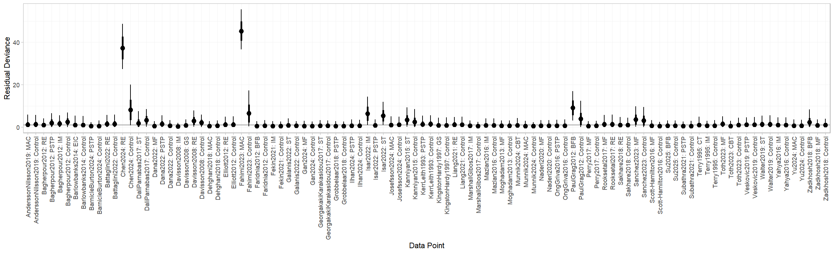

Supplementary Figure 2. Random model of residuals
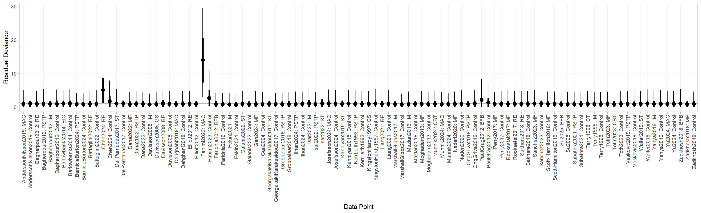

Supplementary Figure 3. Prior and posterior distribution plot of random effects model
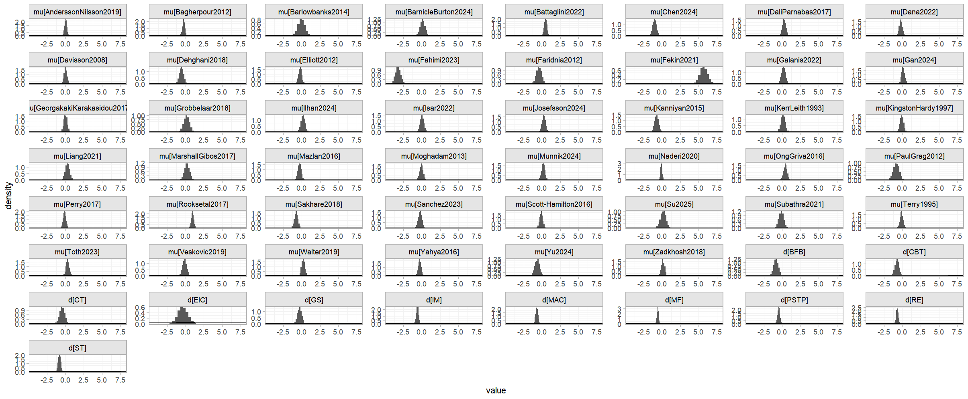

Sensitivity analysis to exclude sparse nodes
Supplementary Figure 4. Prior and posterior distribution plot of random effects models excluding sparse nodes
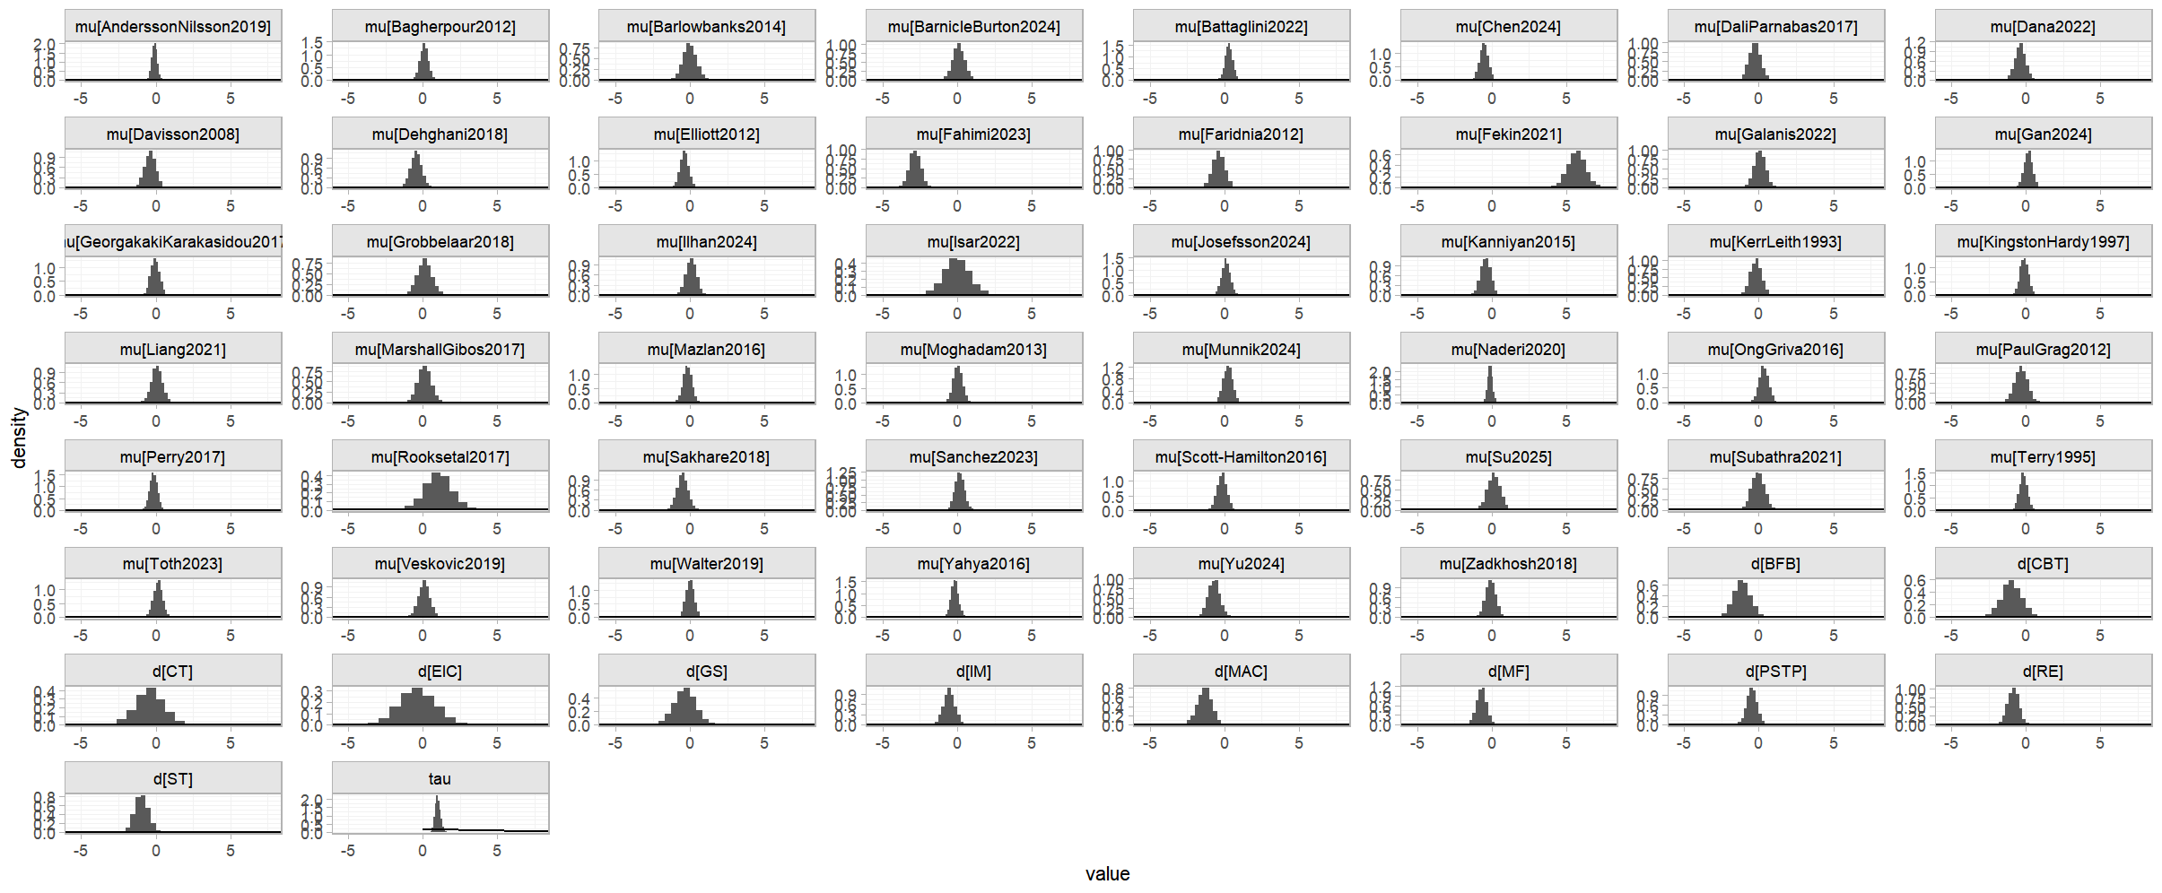

Supplementary Figure 5. Relative effects plot of excluding sparse nodes
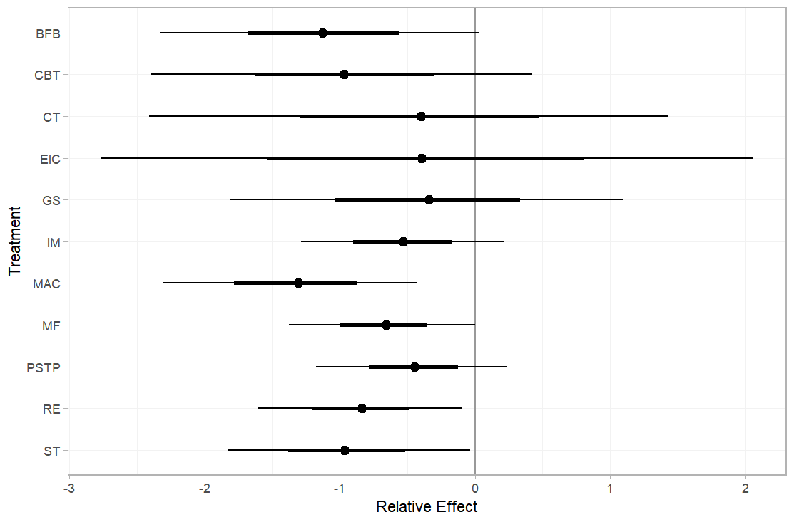
Supplementary Figure 6. SUCRA plot of excluding sparse nodes

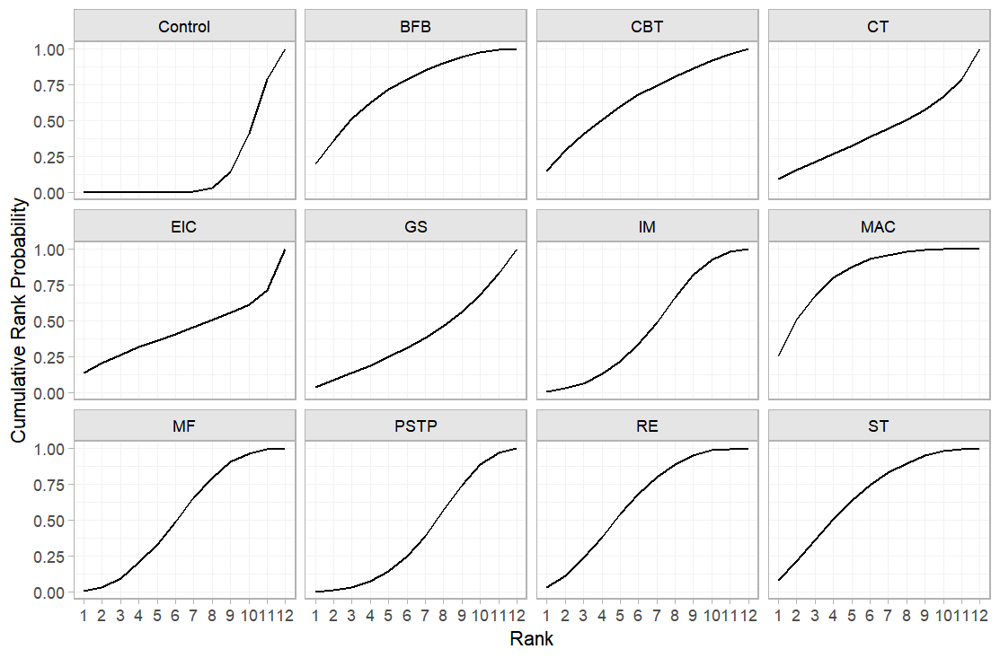

Supplementary Figure 7. Node splitting method
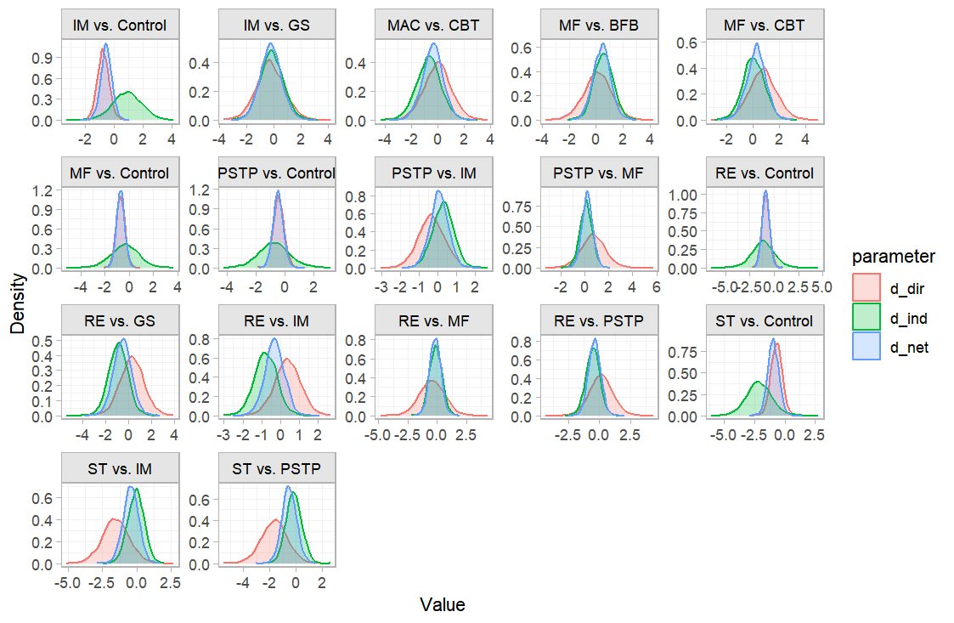
Supplementary Figure 8. Ranking probability plot

Subgroup analysis: cognitive anxiety
Supplementary Figure 9. Random model of prior and posterior distribution plot
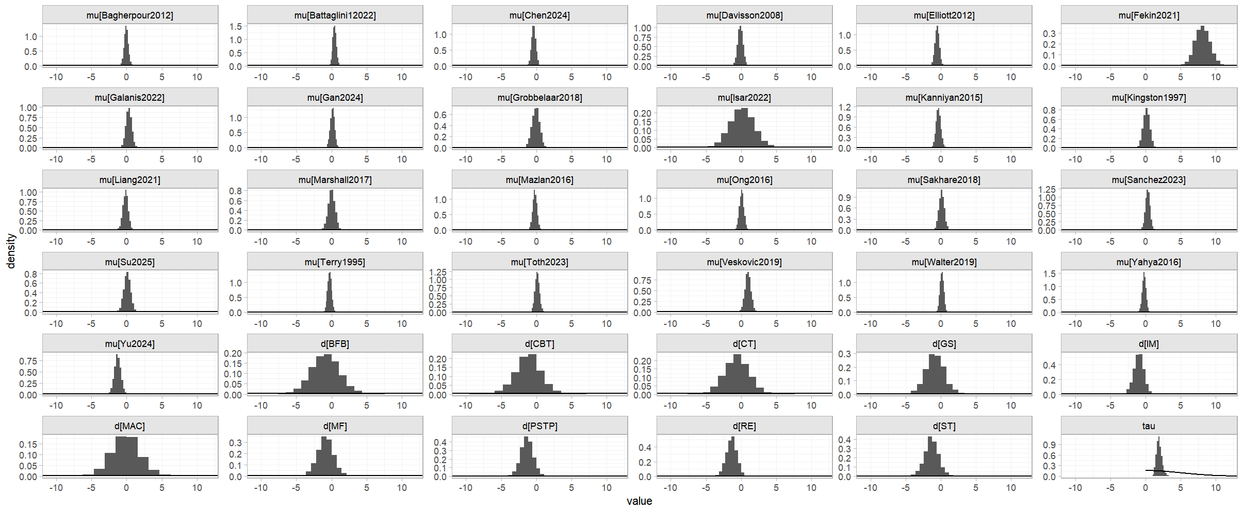

Supplementary Figure 10. Ranking of effectiveness
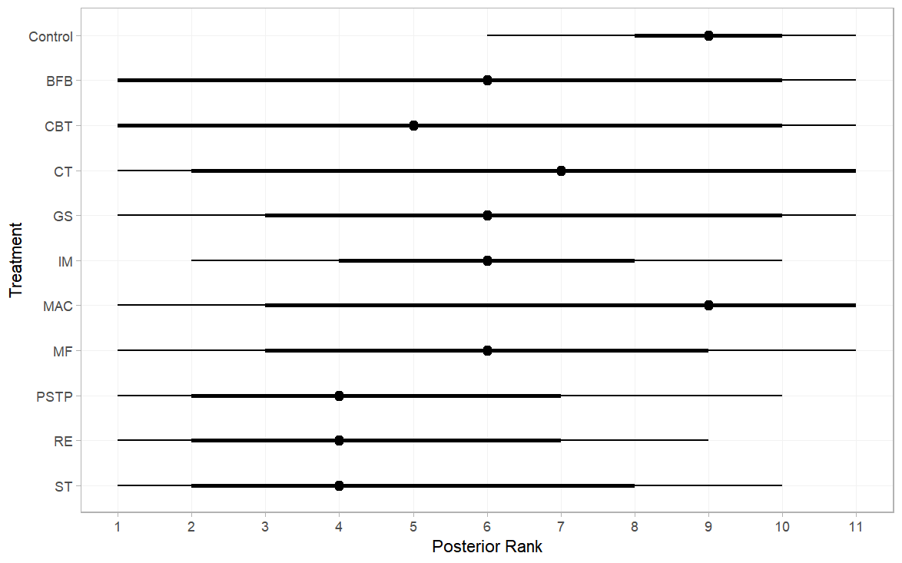
Supplementary Figure 11. SUCRA plot
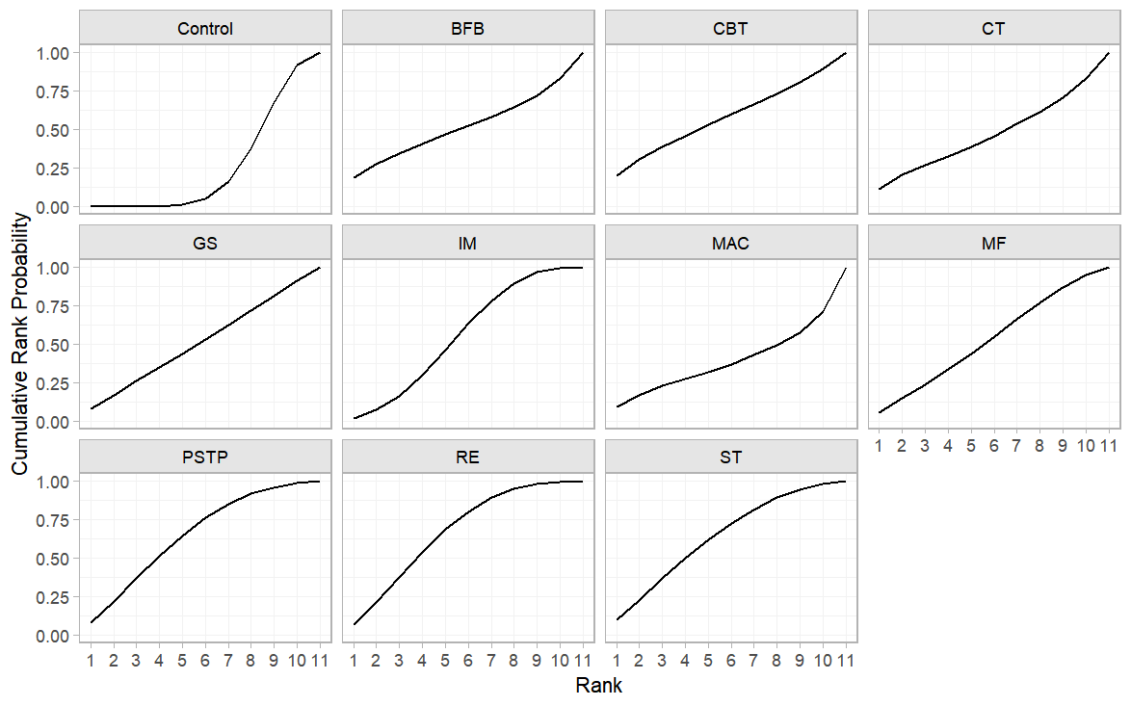

Subgroup Analysis: Somatic Anxiety
Supplementary Figure 12. Random model of prior and posterior distribution plot
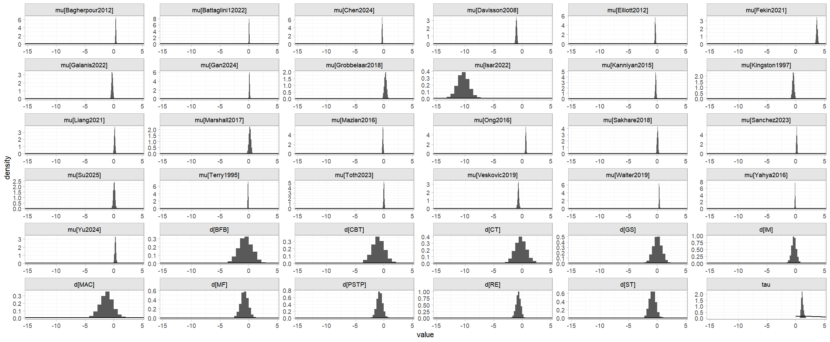

Supplementary Figure 13. Ranking of effectiveness
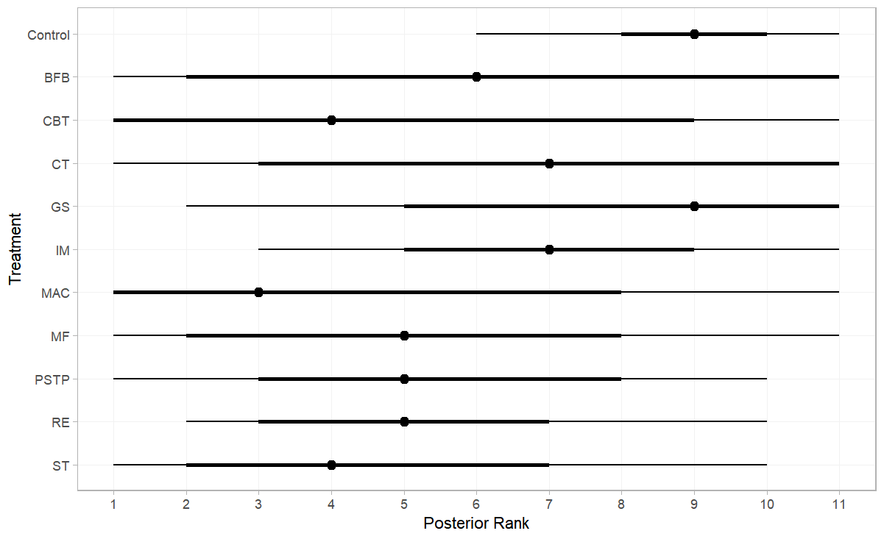
Supplementary Figure 14. SUCRA plot
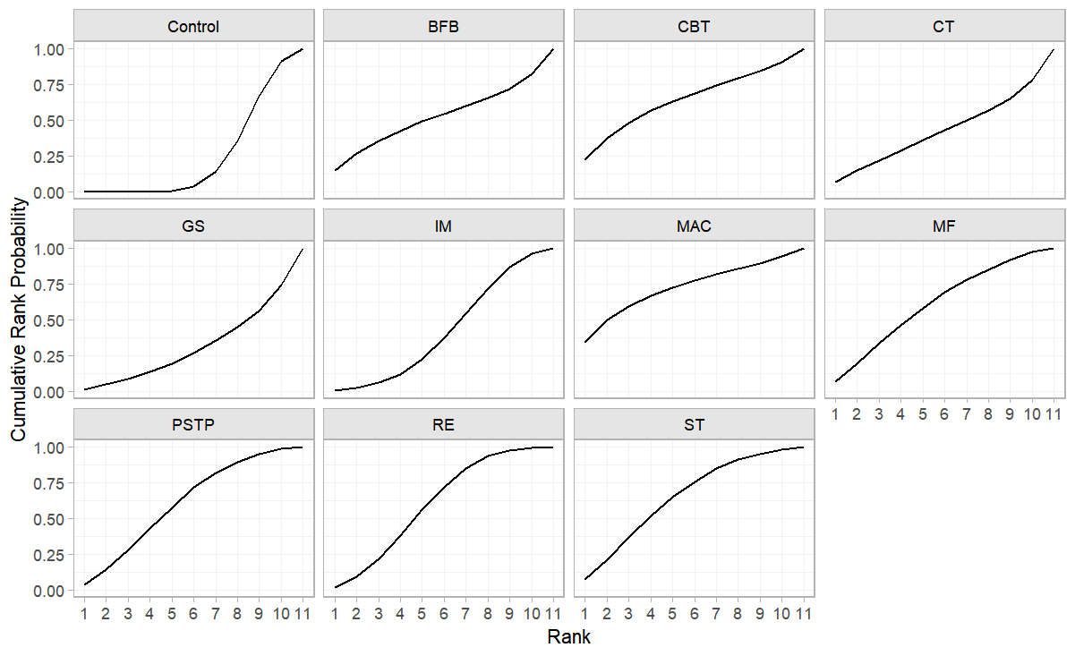

Subgroup analysis: Elite
Supplementary Figure 15. Random model of prior and posterior distribution plot
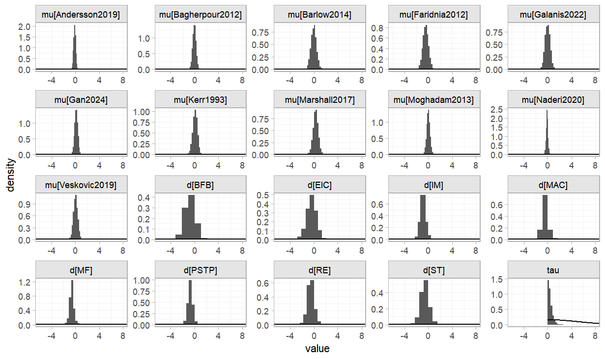
Supplementary Figure 16. Ranking of effectiveness
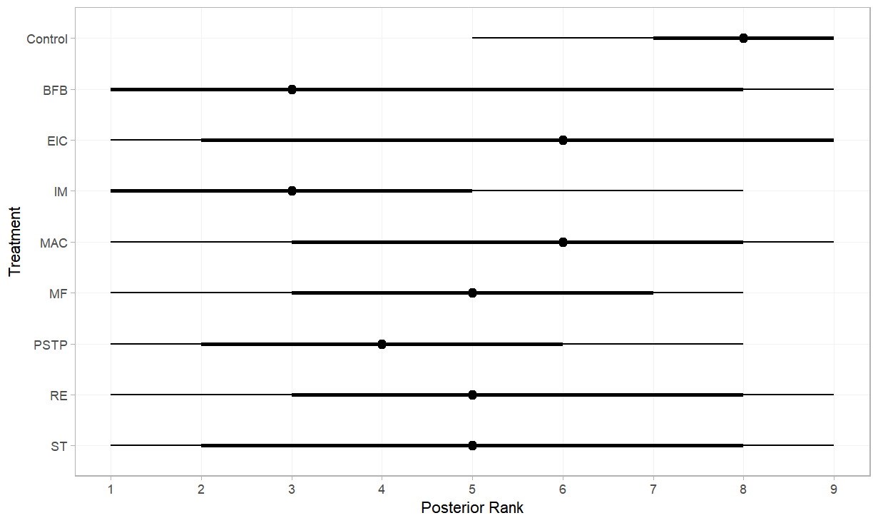

Supplementary Figure 17. SUCRA plot
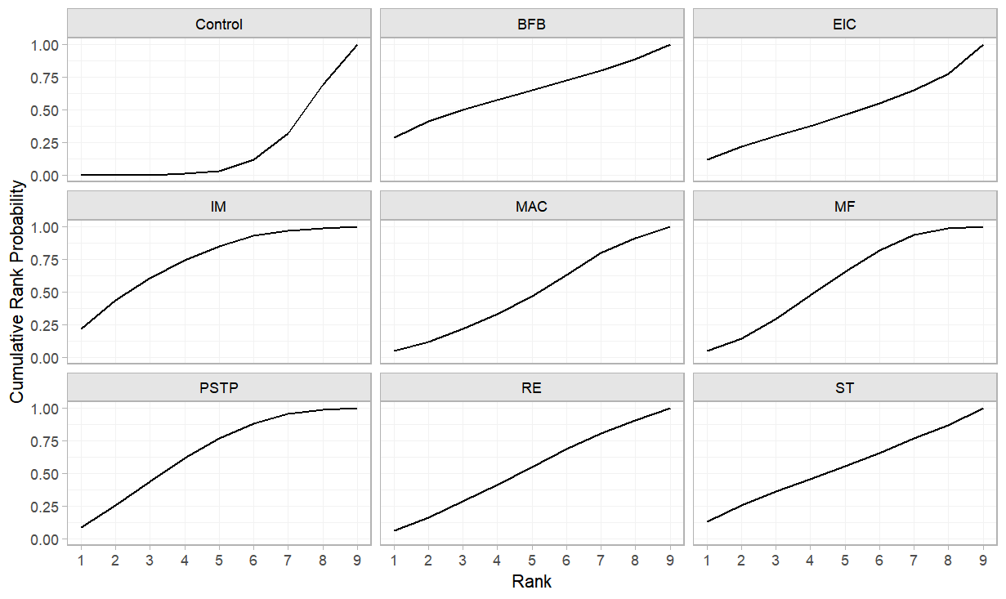
Subgroup analysis: Semi-elite
Supplementary Figure 18. Random model of prior and posterior distribution plot
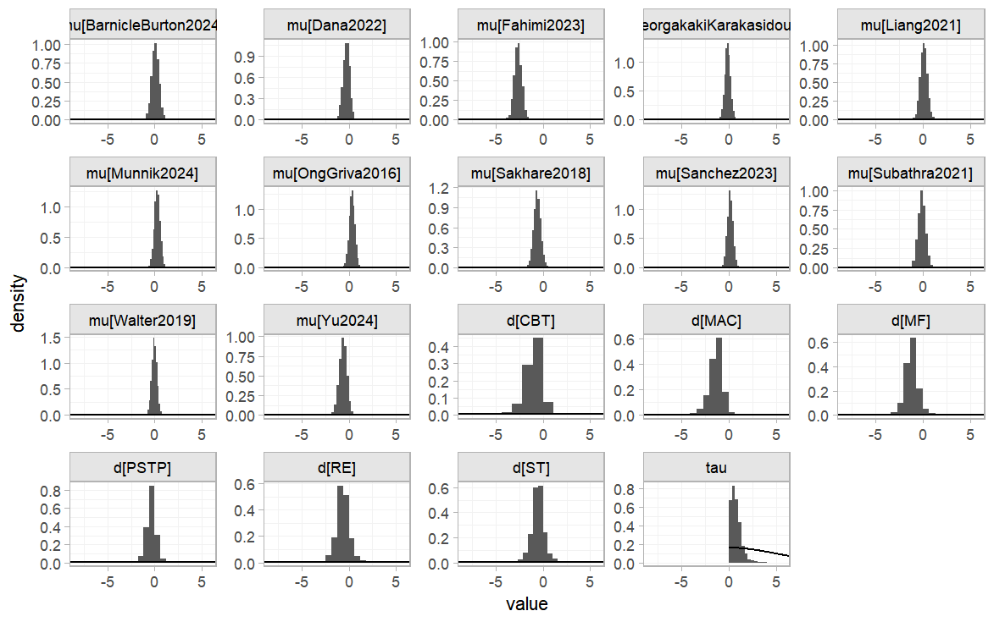

Supplementary Figure 19. Ranking of effectiveness
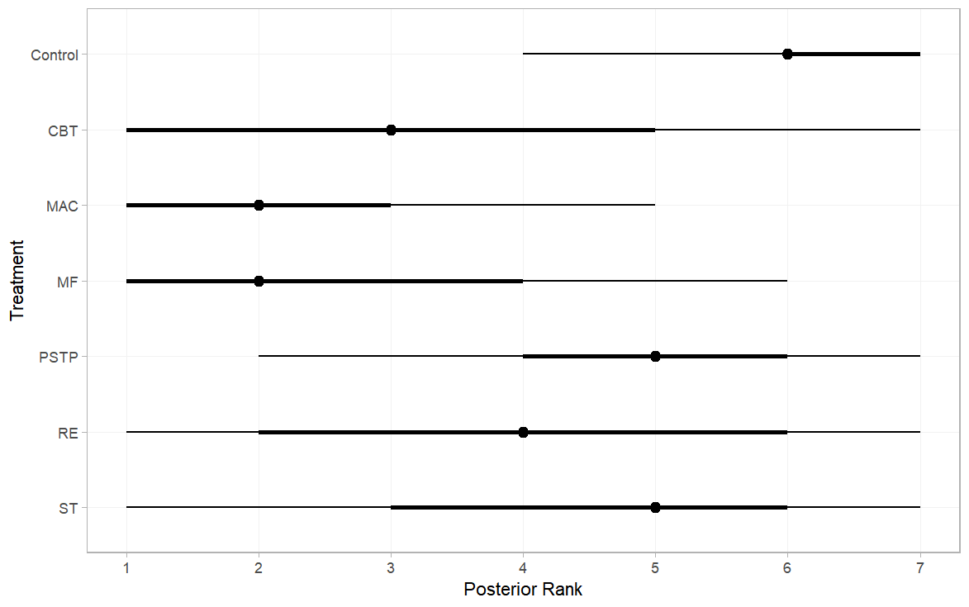
Supplementary Figure 20. SUCRA plot
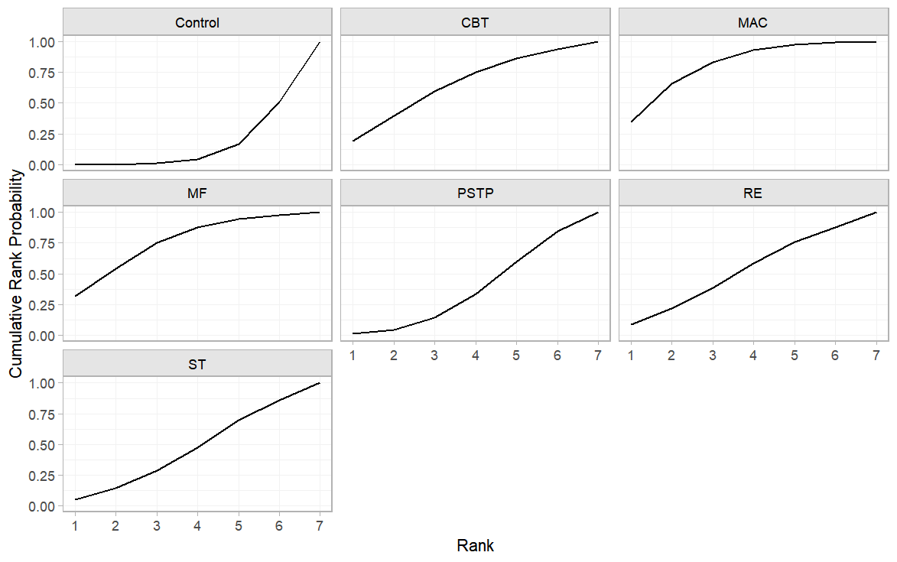

Subgroup analysis: Junior
Supplementary Figure 21. Random model of prior and posterior distribution plot
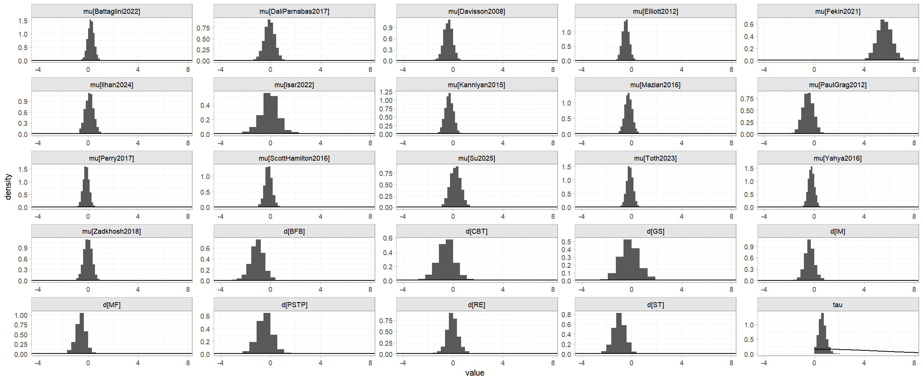

Supplementary Figure 22. Ranking of effectiveness
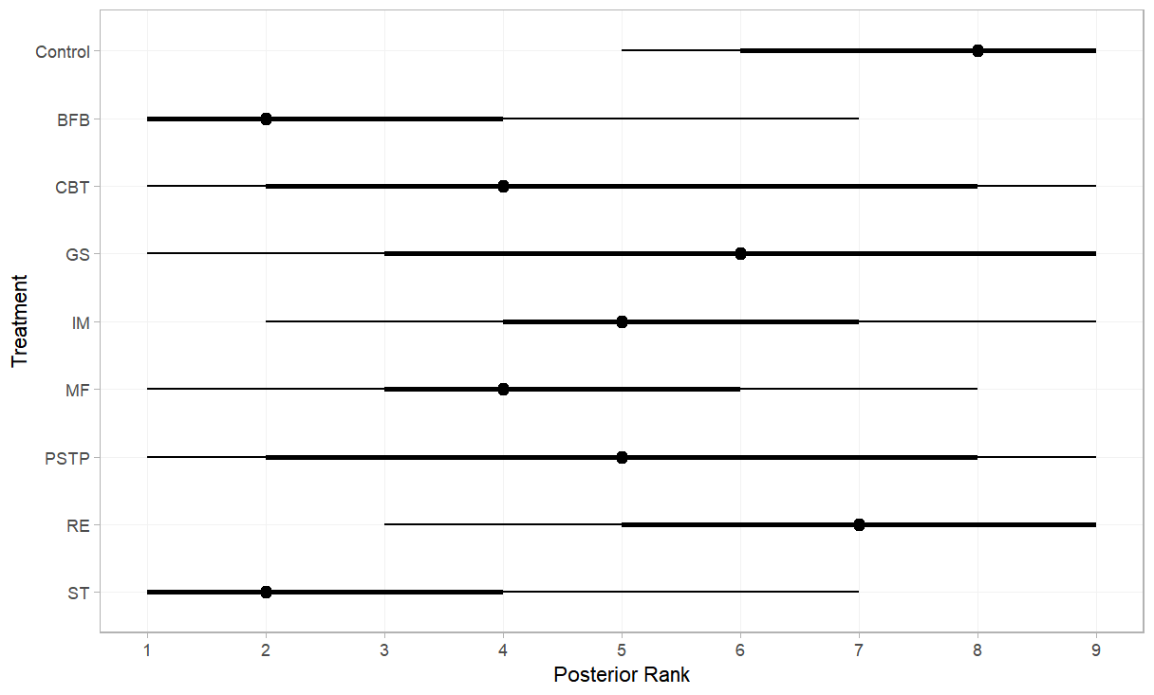
Supplementary Figure 23. SUCRA plot
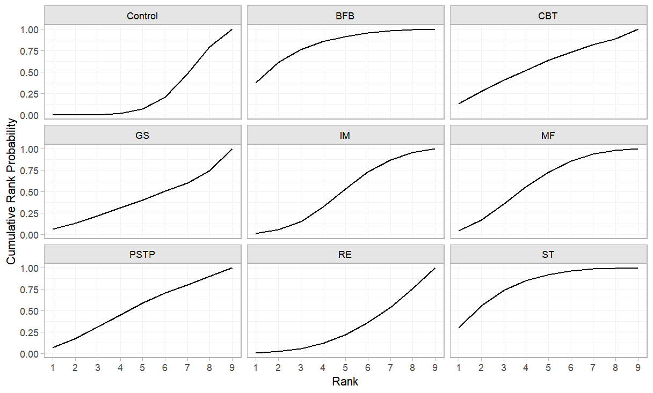

Supplementary Figure 24. ‘Comparison-adjusted’ funnel plot
Exploratory staged meta-regression
Matching rules and outcome classification
Only studies that reported both competitive anxiety and sport performance outcomes within the same participant sample were eligible for inclusion in the staged meta-regression. This same-study requirement ensured that Paths A (psychological intervention → competitive anxiety) and C (psychological intervention → sport performance) were estimated from identical study samples, thereby avoiding the combination of effect sizes derived from different populations. For Path B (competitive anxiety → sport performance), effect sizes were derived exclusively from the subset of studies that contributed data to both anxiety and performance outcomes, maintaining consistency at the study level. In total, 14 studies contributed to Paths A and C; Path B was estimated using these same studies. Although this matching rule enhances internal consistency, the analysis remains based on aggregated study-level data and is therefore subject to ecological bias. Competitive anxiety outcomes were exclusively measured using validated self-report psychological scales (e.g., CSAI-2, SAS, STAI). Sport performance outcomes were classified as subjective if assessed through self-report questionnaires, athlete self-ratings, or coach ratings, and as objective if measured using competition results, official performance statistics, or standardized task-based performance metrics. Because anxiety was entirely self-reported, associations involving subjective performance measures may be influenced by shared method variance. To address this concern, sensitivity analyses were conducted excluding subjective performance outcomes, restricting analyses to objectively assessed performance indicators. Given the exploratory nature of this staged meta-regression and the reliance on study-level summary data, findings should not be interpreted as evidence of causal mediation.
Statistical analysis
Since correlation matrices required for a two-stage meta-analytic structural equation model were not consistently reported across studies, such an approach could not be implemented [1]. As an exploratory alternative, we conducted a staged meta-regression using study-level effect sizes to examine statistical associations among psychological interventions, competitive anxiety, and sport performance. For Path A (psychological intervention → competitive anxiety), the direction of effect sizes was harmonized so that reductions in anxiety were coded as positive values. For Path C (psychological intervention → sport performance), the original direction of effect sizes was retained. Random-effects models estimated using restricted maximum likelihood (REML) were applied separately to obtain pooled estimates for Paths A and C. The association between competitive anxiety and sport performance (Path B) was examined using mixed-effects meta-regression at the study level. Indirect associations were approximated using the product-of-coefficients method [1]. Uncertainty around indirect estimates was evaluated using 5,000 bias-corrected and accelerated (BCa) bootstrap resamples. Indirect effects were interpreted cautiously and considered statistically compatible with an association when the 95% bootstrap confidence interval did not include zero [2]. However, given the reliance on aggregated data and heterogeneous outcome measures, these estimates should not be interpreted as evidence of causal mediation. To explore potential common method bias, sensitivity analyses were conducted excluding subjective sport performance outcomes. All analyses were conducted in R using the packages 'metafor' and 'boot'.
Result
The hypothesized indirect association model is presented in Supplementary Figure 25. At the study level, random-effects meta-analyses indicated that psychological interventions were associated with reductions in competitive anxiety (Path A: Hedges’ g = 0.80, 95% CI [0.42, 1.18]) and improvements in sport performance (Path C: Hedges’ g = 0.98, 95% CI [0.55, 1.41]). Mixed-effects meta-regression examining the association between anxiety-related and performance-related effect sizes at the study level (Path B) yielded a positive regression coefficient (β = 0.72, 95% CI [0.23, 1.57]; Supplementary Figure 26). This suggests that, across studies, larger reductions in competitive anxiety were statistically associated with greater improvements in sport performance. Using a product-of-coefficients approach with 5,000 bias-corrected and accelerated (BCa) bootstrap resamples, the estimated indirect association was 0.70 (95% BCa CI [0.45, 0.96]). Sensitivity analyses excluding subjective performance outcomes produced a comparable estimate (indirect association = 0.78, 95% BCa CI [0.40, 1.06]; Supplementary Figures 27 and 28), although uncertainty increased after restricting to objective outcomes. These findings suggest the presence of a statistical indirect association at the study level. However, given the reliance on aggregated data, heterogeneity in outcome measures, and the exploratory nature of the staged meta-regression framework, the results should not be interpreted as evidence of formal mediation or causal mechanisms.
- Preacher KJ, Hayes AF. Asymptotic and resampling strategies for assessing and comparing indirect effects in multiple mediator models. Behav Res Methods. 2008; https://doi.org/10.3758/BRM.40.3.879
- Hesterberg T. Bootstrap. Wiley Interdiscip Rev Comput Stat. 2011; https://doi.org/10.1002/wics.182
Supplementary Figure 25. Pathway plot
Supplementary Figure 26. Scatter plot

Supplementary Figure 27. Scatter plot excluding subjective performance outcomes
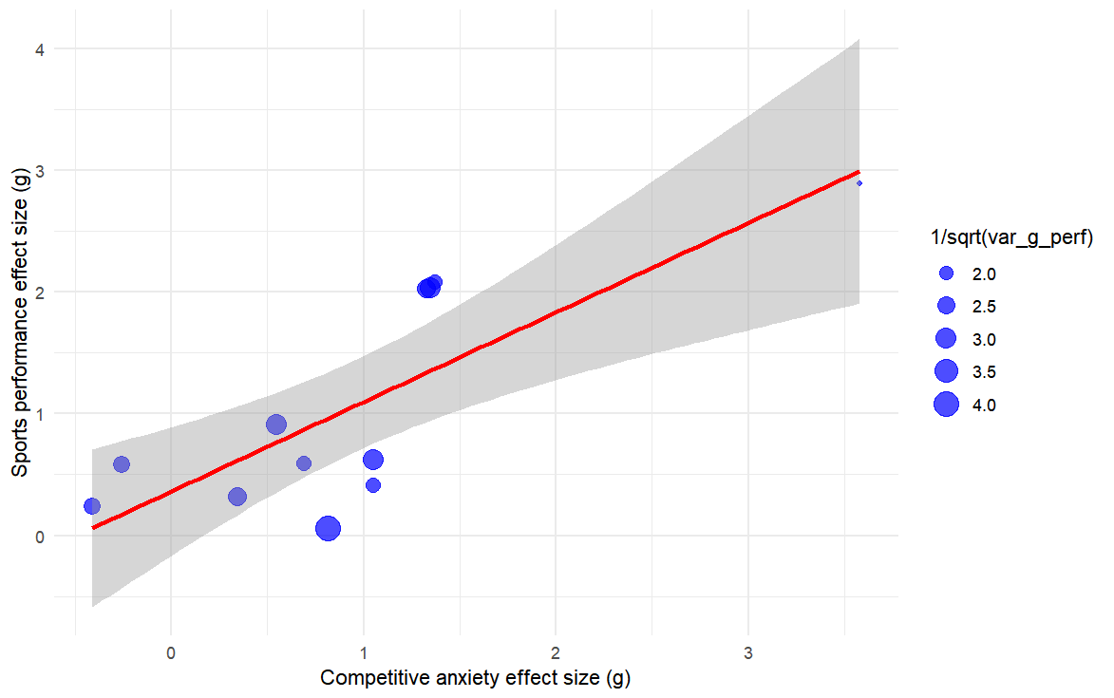

Supplementary Figure 28. Distribution plot excluding subjective performance outcomes
