The Effect of Variable Resistance Training on Post-Activation Performance Enhancement: A Systematic Review and Three-Level Meta-Analysis
Zhijie Yan¹⁺ , Shengfa Lin¹⁺ , Junchen Wu¹⁺, Xiaolan Yi¹ , Jianxiu Liu^{2*}, Ruidong Liu^{1,3 *}
1 Sports Coaching College, Beijing Sport University, Beijing 100084, China;
2 Division of Sports Science and Physical Education, Tsinghua University, Beijing 100084, China
3 Key Laboratory of Sport Training of General Administration of Sport of China, Beijing Sport University, Beijing 100084, China
Submitted for review and possible publication in Sports Medicine - Open
*Corresponding author:
Ruidong Liu
Email:lrd5156@bsu.edu.cn
Jianxiu Liu
Email: liujianxiu@mail.tsinghua.edu.cn
+:These authors contributed equally to this study and share first authorship.

- Supplementary Table 1: Check list (PRISMA 2020)
- Supplementary Table 2: Search Strategy
- Supplementary Table 3: Methodological quality assessment [PEDro]
- Supplementary Fig. 1: Risk of bias for the included studies
- Supplementary Fig. 2: Funnel Plot of Primary Outcome
- Supplementary Fig. 3: Funnel Plot of Subgroup analysis
- Supplementary Fig. 4: A sensitivity analysis based on level-2 leave-one-out
- Supplementary Fig. 5: A sensitivity analysis based on level-3 leave-one-out
- Supplementary Fig.6 Moderator analysis for primary result
- Supplementary Fig.7 Regression analysis of VR load ratio and Percent VR

Supplementary Table 1(Check list)
Section and Topic | Item # | Checklist item | Location where item is reported
TITLE
Title | 1 | Identify the report as a systematic review. | Title Page (Title: The Effect of Variable Resistance Training on Post-Activation Performance Enhancement: A Systematic Review and Three-Level Meta-Analysis)
ABSTRACT
Abstract | 2 | See the PRISMA 2020 for Abstracts checklist. | Abstract section
INTRODUCTION
Rationale | 3 | Describe the rationale for the review in the context of existing knowledge. | Introduction, paragraphs 1-3 (discusses PAPE application, VRT characteristics, limitations of existing research on VRT and PAPE)
Objectives | 4 | Provide an explicit statement of the objective(s) or question(s) the review addresses. | Introduction, final paragraph (aims to systematically evaluate VRT-induced PAPE via three-level meta-analysis and provide evidence-based guidance for athlete warm-up protocols)
METHODS
Eligibility criteria | 5 | Specify the inclusion and exclusion criteria for the review and how studies were grouped for the syntheses. | Methods, 2.1. Eligibility Criteria (details inclusion/exclusion criteria); subgroup analyses in 2.6.3 (grouping by outcome measures, training level, etc.)
Information sources | 6 | Specify all databases, registers, websites, organisations, reference lists and other sources searched or consulted to identify studies. Specify the date when each source was last searched or consulted. | Methods, 2.2. Data Sources and Search (databases: PubMed, Web of Science, EBSCO; additional sources: forward/backward reference tracing; last search date: prior to 1 October 2025)
Search strategy | 7 | Present the full search strategies for all databases, registers and websites, including any filters and limits used. | Methods, 2.2. Data Sources and Search (search terms and combination logic provided; syntax adjusted for each database, no publication year restrictions)
Selection process | 8 | Specify the methods used to decide whether a study met the inclusion criteria of the review, including how many reviewers screened each record and each report retrieved, whether they worked independently, and if applicable, details of automation tools used in the process. | Methods, 2.3. Data Extraction (preliminary deduplication via EndNote; two independent reviewers for title/abstract/full-text screening; discrepancies resolved via discussion or third reviewer; WebPlotDigitizer for graphical data extraction)
Data collection process | 9 | Specify the methods used to collect data from reports, including how many reviewers collected data from each report, whether they worked independently, any processes for obtaining or confirming data from study investigators, and if applicable, details of automation tools used in the process. | Methods, 2.3. Data Extraction (two independent reviewers for data extraction; email contact with corresponding authors for incomplete data; WebPlotDigitizer for graphical data)
Data items | 10a | List and define all outcomes for which data were sought. Specify whether all results that were compatible with each outcome domain in each study were sought (e.g. for all measures, time points, analyses), and if not, the methods used to decide which results to collect. | Methods, 2.3. Data Extraction and 2.6.3 (outcomes: strength/power measures including CMJ, SJ, PP, 1RM, sprint time; data collected for pre-post changes across relevant time points)
Data items | 10b | List and define all other variables for which data were sought (e.g. participant and intervention characteristics, funding sources). Describe any assumptions made about any missing or unclear information. | Methods, 2.3. Data Extraction (variables: study design, sample characteristics, VRT equipment/format/intensity, training sets; assumption of r=0.5 for pre-post correlation coefficients due to scarcity of reported values)
Study risk of bias assessment | 11 | Specify the methods used to assess risk of bias in the included studies, including details of the tool(s) used, how many reviewers assessed each study and whether they worked independently, and if applicable, details of automation tools used in the process. | Methods, 2.4. Quality Assessment (PEDro scale) and 2.5. Risk of Bias Assessment (Cochrane Rob2 tool); two independent reviewers for assessments; discrepancies resolved via discussion
Effect measures | 12 | Specify for each outcome the effect measure(s) (e.g. risk ratio, mean difference) used in the synthesis or presentation of results. | Methods, 2.6.1 (standardized mean difference (SMD) via Hedges’ g; categorized as trivial/small/moderate/large effects)
Synthesis methods | 13a | Describe the processes used to decide which studies were eligible for each synthesis (e.g. tabulating the study intervention characteristics and comparing against the planned groups for each synthesis (item #5)). | Methods, 2.6.3 (subgroup analyses based on pre-specified categorical variables; meta-regression for continuous variables; eligibility based on inclusion criteria and variable grouping)
Synthesis methods | 13b | Describe any methods required to prepare the data for presentation or synthesis, such as handling of missing summary statistics, or data conversions. | Methods, 2.6.1 (calculation of mean change, SD change, pooled SD; Hedges’ g adjustment for small samples; WebPlotDigitizer for graphical data extraction)
Synthesis methods | 13c | Describe any methods used to tabulate or visually display results of individual studies and syntheses. | Methods, 2.6.2 and 2.6.3; Results, Figures 1–3 and Tables 1–2; Supplementary Table 3 and Supplementary Figs. 1–7.
Synthesis methods | 13d | Describe any methods used to synthesize results and provide a rationale for the choice(s). If meta-analysis was performed, describe the model(s), method(s) to identify the presence and extent of statistical heterogeneity, and software package(s) used. | Methods, 2.6.2 (three-level meta-analysis model to address nested data; REML estimation with ML cross-validation; I² for heterogeneity; R software with metafor, meta, ggplot2, orchard packages)
Synthesis methods | 13e | Describe any methods used to explore possible causes of heterogeneity among study results (e.g. subgroup analysis, meta-regression). | Methods, 2.6.3 (subgroup analyses for categorical moderators; meta-regression for continuous variables (recovery time, VR load ratio); linear/non-linear model fitting)
Synthesis methods | 13f | Describe any sensitivity analyses conducted to assess robustness of the synthesized results. | Methods, 2.6.4 (leave-one-out analyses at Level 2/3; re-estimation with alternative correlation coefficients (r=0.2, r=0.8); comparison of REML and ML models)
Reporting bias assessment | 14 | Describe any methods used to assess risk of bias due to missing results in a synthesis (arising from reporting biases). | Methods, 2.6.4 (funnel plot visual inspection, Egger's regression test, fail-safe N method, trim and fill method)
Certainty assessment | 15 | Describe any methods used to assess certainty (or confidence) in the body of evidence for an outcome. | Not reported
RESULTS
Study selection | 16a | Describe the results of the search and selection process, from the number of records identified in the search to the number of studies included in the review, ideally using a flow diagram. | Results, 3.1. Studies selection and Figure 1 (714 records identified, 398 duplicates removed, 316 screened, 35 full-text assessed, 13 studies included)
Study selection | 16b | Cite studies that might appear to meet the inclusion criteria, but which were excluded, and explain why they were excluded. | Results, 3.1. Studies selection and Figure 1 (excluded due to non-acute intervention, ineligible participants, non-original research, incomplete data)
Study characteristics | 17 | Cite each included study and present its characteristics. | Results, 3.2. Characteristics of included studies and Table 1 (13 studies cited; details on design, sample, training, equipment, outcomes)
Risk of bias in studies | 18 | Present assessments of risk of bias for each included study. | Results, 3.5 Risk of bias and quality of methods; Supplementary Table 3 (PEDro scores) and Supplementary Fig. 1 (RoB 2 assessment).
Results of individual studies | 19 | For all outcomes, present, for each study: (a) summary statistics for each group (where appropriate) and (b) an effect estimate and its precision (e.g. confidence/credible interval), ideally using structured tables or plots. | Results, 3.2.2 and 3.3; Table 1 (study-specific outcomes and intensity); Figure 2 (pooled effect sizes with 95% CI/PI)
Results of syntheses | 20a | For each synthesis, briefly summarise the characteristics and risk of bias among contributing studies. | Results, 3.3 Primary Analysis and 3.4 Moderator Analysis (summary of study characteristics, sample size, risk of bias for pooled and subgroup syntheses)
Results of syntheses | 20b | Present results of all statistical syntheses conducted. If meta-analysis was done, present for each the summary estimate and its precision (e.g. confidence/credible interval) and measures of statistical heterogeneity. If comparing groups, describe the direction of the effect. | Results, 3.3 Primary Analysis and 3.4 Moderator Analysis; Figure 2 (main pooled effect); Table 2 (subgroup results); Supplementary Figs. 6–7 (subgroup and meta-regression visualisations).
Results of syntheses | 20c | Present results of all investigations of possible causes of heterogeneity among study results. | Results, 3.3 (variance decomposition) and 3.4 (moderator and meta-regression analyses); Table 2; Supplementary Figs. 6–7.
Results of syntheses | 20d | Present results of all sensitivity analyses conducted to assess the robustness of the synthesized results. | Results, 3.6 Sensitivity Analysis (leave-one-out results, r=0.2/r=0.8 effect, REML vs ML comparison; core conclusion robustness confirmed)
Reporting biases | 21 | Present assessments of risk of bias due to missing results (arising from reporting biases) for each synthesis assessed. | Results, 3.5. Risk of bias and quality of methods (fail-safe N=3007, Egger's test p=0.40, trim and fill no missing studies; low publication bias risk)
Certainty of evidence | 22 | Present assessments of certainty (or confidence) in the body of evidence for each outcome assessed. | Not reported
DISCUSSION
Discussion | 23a | Provide a general interpretation of the results in the context of other evidence. | Discussion, Section 4 (interprets VRT-PAPE effect, moderators, mechanisms; links to prior research on PAPE, VRT, neuromuscular activation)
Discussion | 23b | Discuss any limitations of the evidence included in the review. | Discussion, 4.4 Limitations (methodological heterogeneity, small subgroup effect sizes, unreported r values, grey literature exclusion, sex imbalance).
Discussion | 23c | Discuss any limitations of the review processes used. | Discussion, 4.4 Limitations (lack of allocation concealment/blinding in original studies, potential performance/detection bias, limited female participants)
Discussion | 23d | Discuss implications of the results for practice, policy, and future research. | Discussion, 5. Conclusions and 6 Practical Applications (practical implications for VRT-based warm-up/complex training and suggestions for future research).
OTHER INFORMATION
Registration and protocol | 24a | Provide registration information for the review, including register name and registration number, or state that the review was not registered. | Methods, 2. (OSF registration ID: https://osf.io/nku8r/overview; registered on September 15, 2025)
Registration and protocol | 24b | Indicate where the review protocol can be accessed, or state that a protocol was not prepared. | Methods, 2. (protocol registered on OSF: https://osf.io/nku8r/overview)
Registration and protocol | 24c | Describe and explain any amendments to information provided at registration or in the protocol. | Not reported
Support | 25 | Describe sources of financial or non-financial support for the review, and the role of the funders or sponsors in the review. | Funding section (The Fundamental Research Funds for the Central Universities, grant 2025KYPT04; Beijing Social Science Foundation Project, 24YTC035; National Social Science Fund of China 25CTY033)
Competing interests | 26 | Declare any competing interests of review authors. | Competing interests section (The authors have no relevant financial or non-financial interests to disclose.)
Availability of data, code and other materials | 27 | Report which of the following are publicly available and where they can be found: template data collection forms; data extracted from included studies; data used for all analyses; analytic code; any other materials used in the review. | Availability of data and materials section (all data generated/analysed included in the published article)

Data | Query | Results
PubMed | ("Variable Resistance Training"[All Fields] OR "Resistance Training"[All Fields] OR "Variable Resistance"[All Fields] OR "accommodating resistance"[All Fields] OR "elastic band"[All Fields] OR "elastic tube"[All Fields] OR "rubber band"[All Fields] OR "Thera-band"[All Fields] OR "rubber tube"[All Fields] OR "bands"[All Fields] OR "chains"[All Fields] OR "eccentric overloading"[All Fields]) AND ("Post-activation Potentiation"[All Fields] OR "post-activation performance enhancement"[All Fields] OR "PAPE"[All Fields] OR "PAP"[All Fields]) AND ("strength"[All Fields] OR "repetition maximum"[All Fields] OR "1RM"[All Fields] OR "power"[All Fields] OR "force"[All Fields] OR "jump"[All Fields] OR "speed"[All Fields] OR "performance"[All Fields]) | 171
Web of Science | ("Variable Resistance Training" OR "Resistance Training" OR "Variable Resistance" OR "accommodating resistance" OR "elastic band" OR "elastic tube" OR "rubber band" OR "Thera-band" OR "rubber tube" OR "bands" OR "chains" OR "eccentric overloading") AND ("Post-activationPotentiation"OR" post-activation performance enhancement "OR"PAPE"OR "PAP") AND ("strength" OR" repetition maximum"OR"1RM"OR"power"OR "force" OR" jump" OR "speed" OR"performance") (All Fields) | 294
EBSCO | ("Variable Resistance Training" OR "Resistance Training" OR "Variable Resistance" OR "accommodating resistance" OR "elastic band" OR "elastic tube" OR "rubber band" OR "Thera-band" OR "rubber tube" OR "bands" OR "chains" OR "eccentric overloading") AND ("Post-activation Potentiation" OR" post-activation performance enhancement "OR"PAPE" OR "PAP") AND ("strength" OR" repetition maximum"OR"1RM"OR"power"OR "force" OR" jump" OR "speed" OR"performance") | 249
Supplementary Table 2(Search Strategy)

Supplementary Figure 1
Supplementary Table 3 (Methodological quality assessment [PEDro])
Author/year | D1 | D2 | D3 | D4 | D5 | D6 | D7 | D8 | D9 | D10 | D11 | Total
Ng, 2025 | Y | 1 | 0 | 1 | 0 | 0 | 0 | 1 | 1 | 1 | 1 | 6
Wu, 2025 | Y | 1 | 0 | 1 | 0 | 0 | 0 | 1 | 1 | 1 | 1 | 6
Masel, 2024 | Y | 1 | 0 | 1 | 0 | 0 | 0 | 1 | 1 | 1 | 1 | 6
Masel, 2023 | Y | 1 | 0 | 1 | 0 | 0 | 0 | 1 | 1 | 1 | 1 | 6
Shi, 2023 | Y | 1 | 0 | 1 | 0 | 0 | 0 | 1 | 0 | 1 | 1 | 5
Masel, 2022 | Y | 1 | 0 | 1 | 0 | 0 | 0 | 1 | 1 | 1 | 1 | 6
Krčmár, 2021 | Y | 1 | 0 | 1 | 0 | 0 | 0 | 0 | 0 | 1 | 1 | 4
Marin, 2021 | Y | 1 | 0 | 1 | 0 | 0 | 0 | 1 | 1 | 1 | 1 | 6
Nickerson, 2019 | Y | 1 | 0 | 1 | 0 | 0 | 0 | 1 | 1 | 1 | 1 | 6
Mina, 2019 | Y | 1 | 0 | 1 | 0 | 0 | 0 | 0 | 0 | 1 | 1 | 4
Mina, 2016 | Y | 1 | 0 | 1 | 0 | 0 | 0 | 1 | 1 | 1 | 1 | 6
Wyland, 2015 | Y | 1 | 0 | 1 | 0 | 0 | 0 | 1 | 1 | 1 | 1 | 6
Mina, 2014 | Y | 1 | 0 | 1 | 0 | 0 | 0 | 1 | 1 | 1 | 1 | 6
Note：Studies scoring ≥ 6 are considered high quality, those scoring 4–5 are considered moderate quality, and those scoring ≤ 3 are considered low quality.

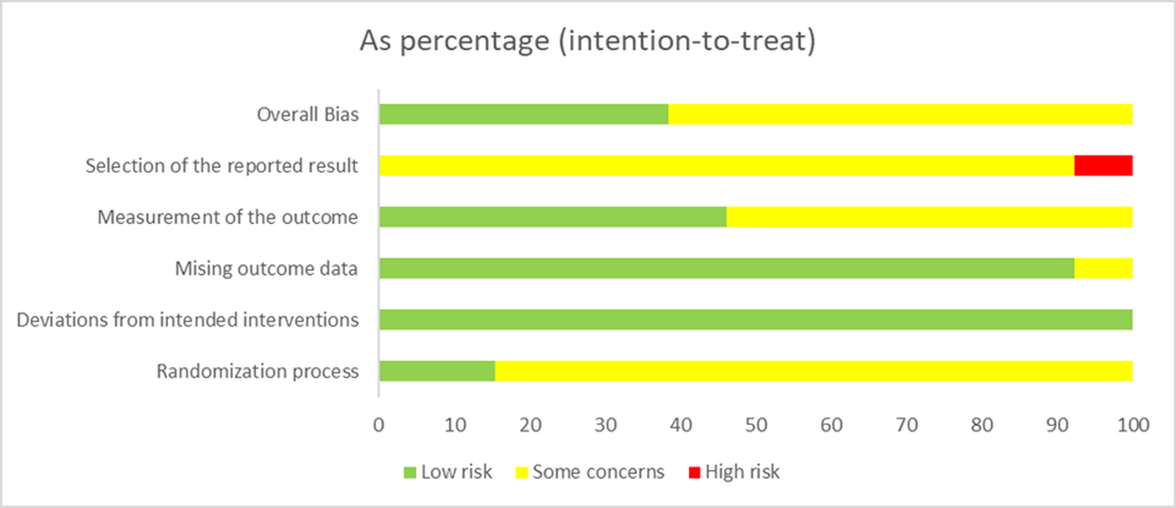
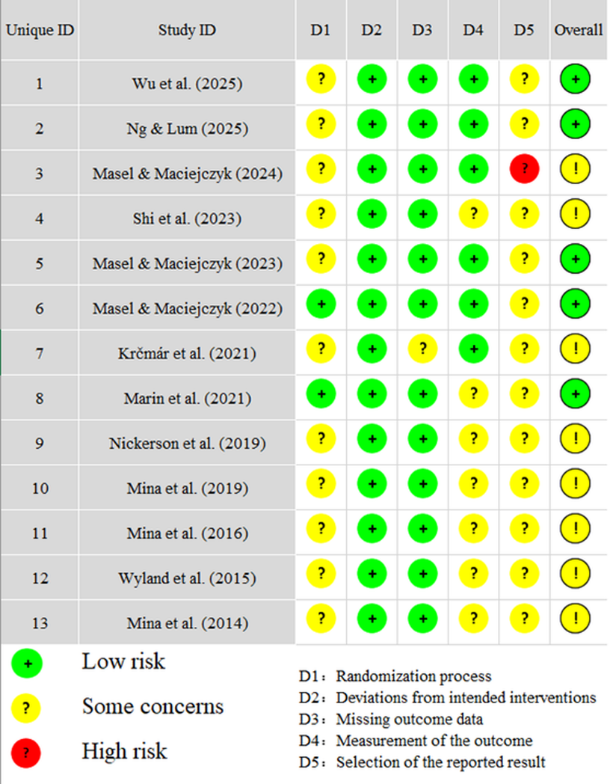
Supplementary Fig. 1 ( Risk of bias for the included studies)
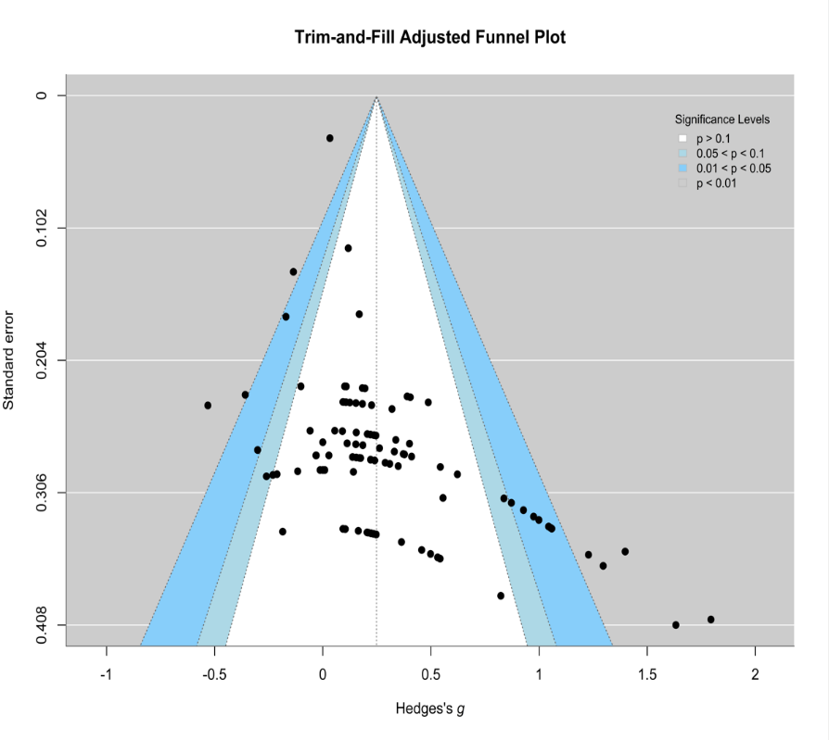
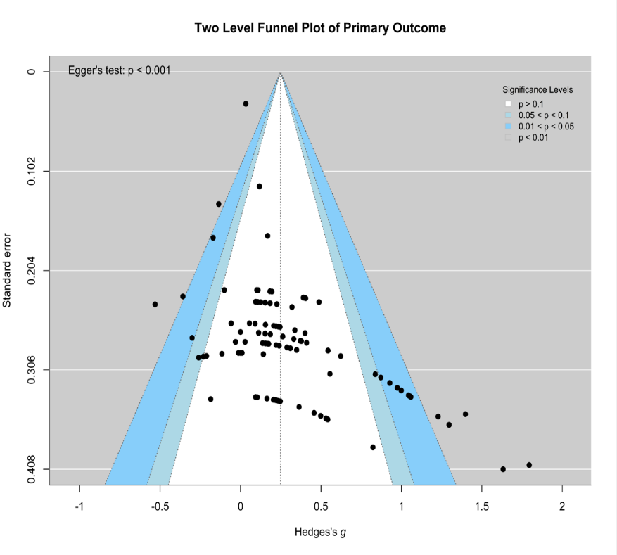
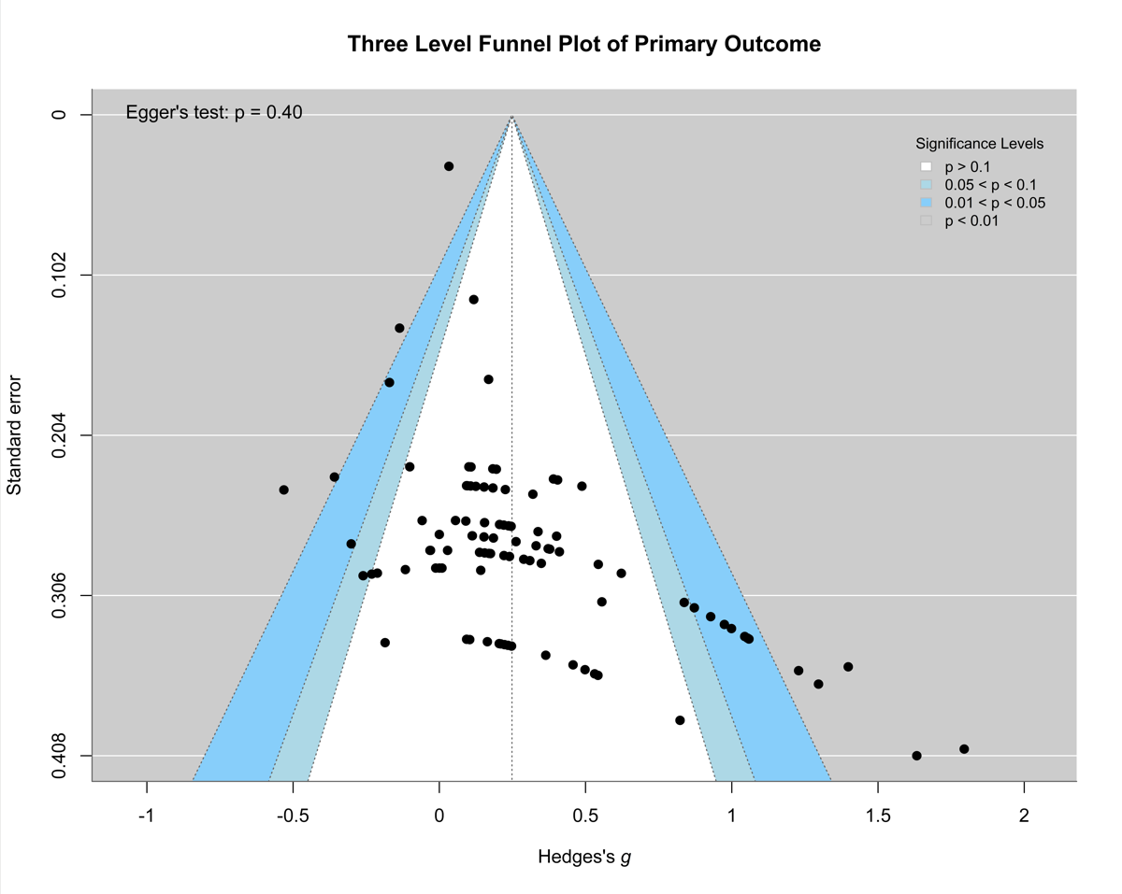
Supplementary Fig. 2 (Funnel Plot of Primary Outcome)

Supplementary Fig. 3 (Funnel Plot of Subgroup analysis)

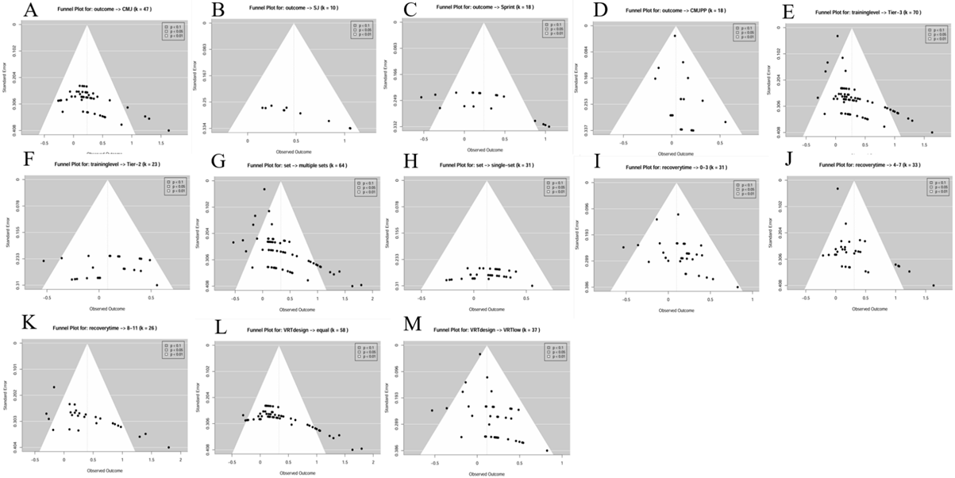
Supplementary Fig.4 (A sensitivity analysis based on level-2 leave-one-out)
Notes: From A to M, they are CMJ, SJ, Sprint, CMJPP, Tier-3, Tier-2, multiple set, single set, recovery time 0-3、4-7、8-11, equal, VRT low.
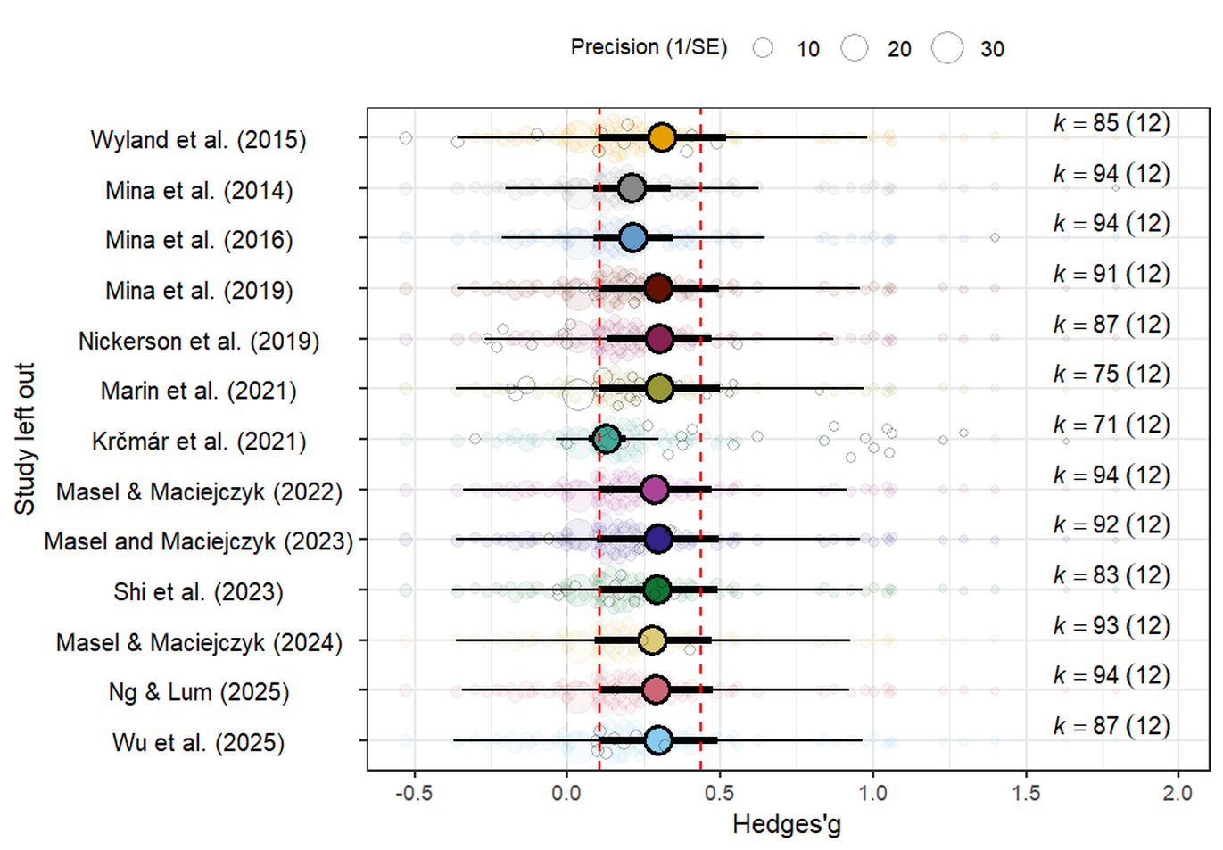
Supplementary Fig.5(A sensitivity analysis based on level-3 leave-one-out)

Supplementary Fig.6 (Moderator analysis for primary result)
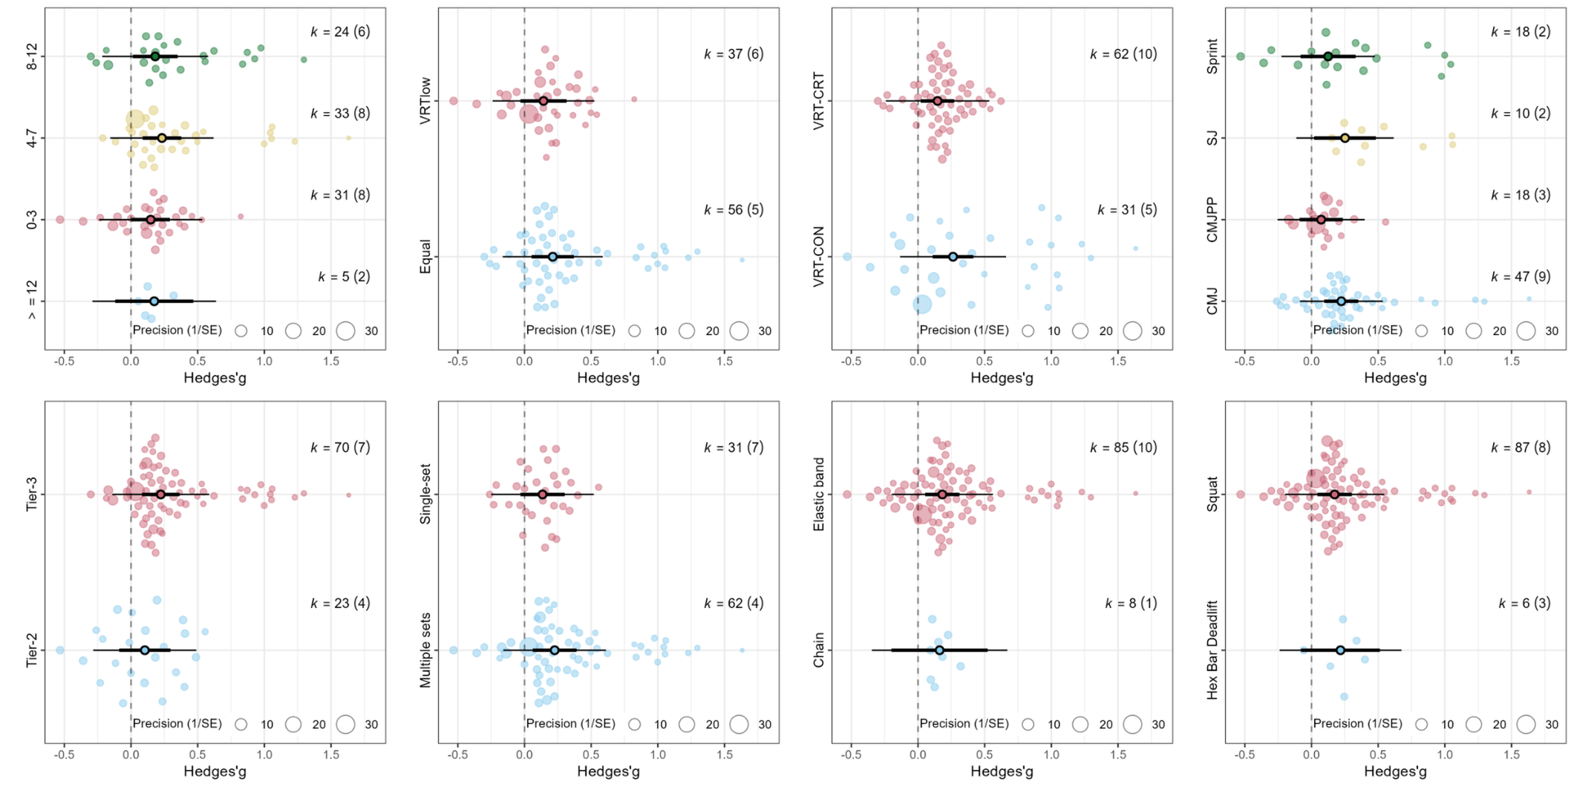
Notes: The primary outcome refers to the effect of VRT on PAPE. k: Number of effect sizes included. g: Hedges' g effect size. CI: Confidence Interval. PI: Prediction Interval. P-within-group: This p-value tests if the overall effect size within a single subgroup is statistically significant (i.e., different from zero). P-between-group: This p-value tests if there are statistically significant differences in the effect sizes between the different subgroups of a moderator. F-level-2: two-level variance. F-Level-3: three-level variance. Level-2 I²:two-level heterogeneity. Level-3 I²:three-level heterogeneity. VRT↓: VRT and CRT share equivalent intensity at the top of the movement.

Supplementary Fig.7 (Regression analysis of VR load ratio and Percent VR)
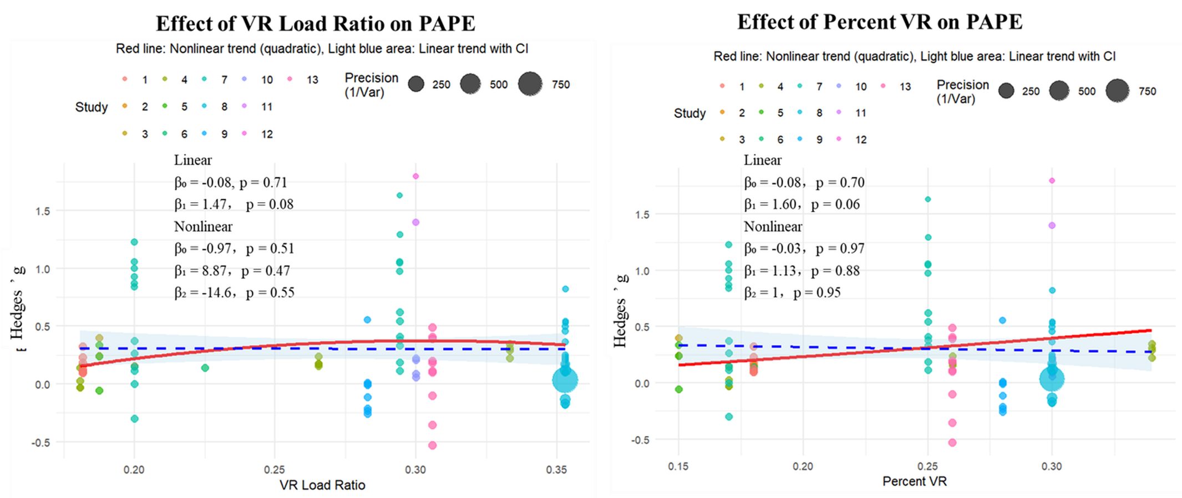
Note: Meta-regression plots showing the associations of variable-resistance load metrics with the PAPE effect size. The left panel presents the association between VR load ratio and Hedges’g for PAPE, and the right panel presents the association between percent VR and Hedges’g for PAPE. Each point represents an individual effect size, with colour indicating the study source and point size reflecting precision (1/variance). The red solid line represents the quadratic trend, the light blue shaded area represents the linear trend with its 95% confidence interval, and the blue dashed horizontal line indicates the overall pooled effect estimate. Abbreviations: PAPE, post-activation performance enhancement; VR, variable resistance; CI, confidence interval; g, Hedges’g; Var, variance.

