Comparative Effectiveness of Exercise Interventions for Hamstring Injury Prevention in Football Players: A Systematic Review and Network Meta-analysis
Sports Medicine - Open
BinJie Hong¹, Xin Hong², Hao Lin³, ZiYi Yang⁴, Jun Feng¹*

Affiliations:
¹ China Football College, Beijing Sport University, Beijing 100084, China
² School of Strength and Conditioning, Beijing Sport University, Beijing 100084, China
³ Physical Education Institute, Inner Mongolia University for Nationalities, Tongliao, Inner Mongolia 028000, China
⁴ College of Education, Beijing Sport University, Beijing 100084, China
Corresponding author information:
Jun Feng
China Football College, Beijing Sport University
Beijing 100084, China
E-mail: fengjun@bsu.edu.cn

Supplementary Tables

Supplementary Table 1. Search Strategy for PUBMED, COCHRANE LIBRARY, WEB OF SCIENCE and EMBASE, January 5th, 2026.

Search Strategy (n=645)
PubMed (Results: 197)
(((((((Soccer [Mesh]) OR (Football [MeSH])) OR (Football European)) OR (European,Football)) OR (Europeans,Football)) OR (European Football)) OR (Football, European))) AND ((((((((((Hamstring Muscles) OR (Hamstring Muscle)) OR (Muscle, Hamstring)) OR (Muscles, Hamstring)) OR (Semitendinosus)) OR (Semimembranosus)) OR (Biceps Femoris)) OR ("Hamstring Muscles"[Mesh])) AND ((((((((((((((((((((((((("Exercise"[Mesh]) OR (Exercises)) OR (Exercise, Physical)) OR (Physical Exercise)) OR (Physical Exercises)) OR (Exercise, Aerobic)) OR (Aerobic Exercise)) OR (Aerobic Exercises)) OR (Exercises, Aerobic)) OR (Exercise, Isometric)) OR (Exercises, Isometric)) OR (Isometric Exercises)) OR (Isometric Exercise)) OR (Acute Exercise)) OR (Acute Exercises)) OR (Exercise, Acute)) OR (Exercises, Acute)) OR (Exercise Training)) OR (Exercise Trainings)) OR (Training, Exercise)) OR (Trainings, Exercise)) OR (Physical Activity)) OR (Activities, Physical)) OR (Activity, Physical)) OR (Physical Activities))) AND ((((((("prevention and control" [Subheading]) OR (prevention and control)) OR (preventive measures[Title/Abstract])) OR (preventive therapy[Title/Abstract])) OR (prophylaxis[Title/Abstract])) OR (control[Title/Abstract])) OR (prevention[Title/Abstract]))
Cochrane Library (Results: 11)
(Hamstring Muscles [MESH] OR Hamstring Muscle OR Muscles, Hamstring OR Muscle, Hamstring OR Semitendinosus OR Semimembranosus OR Biceps Femoris):ti,ab,kw AND (Exercise [MESH] OR Activities OR Physical OR Physical Activities OR Activity, Physical OR Physical Activity OR Exercises, Isometric OR Exercise, Isometric OR Isometric Exercises OR Isometric Exercise OR Exercise Trainings OR Exercise Training OR Trainings, Exercise OR Training, Exercise OR Exercise, Aerobic OR Aerobic Exercise OR Aerobic Exercises OR Exercises, Aerobic OR Acute Exercises OR Acute Exercise OR Exercise, Acute OR Exercises, Acute OR Physical Exercises OR Exercise, Physical OR Exercises, Physical OR Exercises OR Physical Exercise):ti,ab,kw AND (Soccer [MESH] OR Football [MESH] OR European Football OR Europeans, Football OR European, Football OR Football, European OR Football European):ti,ab,kw AND (Primary Prevention [ MESH] OR Secondary Prevention [MESH] OR Disease Prevention, Primary OR Disease Preventions, Primary OR Primary Disease Preventions OR Prevention, Primary OR Primary Disease Prevention OR Primordial Prevention OR Primordial Preventions OR Preventions, Primordial OR Prevention, Primordial):ti,ab,kwOR (Relapse Preventions OR Relapse Prevention OR Preventions, Relapse OR Prevention, Relapse OR Therapies, Early OR Early Therapies OR Therapy, Early OR Early Therapy OR Secondary Disease Prevention OR Secondary Preventions OR Secondary Disease Preventions OR Preventions, Secondary Disease OR Prevention, Secondary OR Disease Prevention, Secondary OR Disease Preventions, Secondary OR Preventions, Secondary OR Prevention, Secondary Disease):ti,ab,kw
Web of Science (Results: 347)
(((((TI;AB;KW=(Soccer OR Football OR Football European OR European,Football OR Europeans,Football OR European Football OR Football, European )) AND TI;AB;KW=(Hamstring Muscles OR Hamstring Muscle OR Muscle, Hamstring OR Muscles, Hamstring OR Semitendinosus OR Semimembranosus OR Biceps Femoris )) AND TI;AB;KW=(Exercises OR Exercise, Physical OR Exercises, Physical OR Physical Exercise OR Physical Exercises OR Exercise, Aerobic OR Aerobic Exercise OR Aerobic Exercises OR Exercises, Aerobic OR Exercise, Isometric OR Exercises, Isometric OR Isometric Exercises OR Isometric Exercise OR Acute Exercise OR Acute Exercises OR Exercise, Acute OR Exercises, Acute OR Exercise Training OR Exercise Trainings OR Training, Exercise OR Trainings, Exercise OR Physical Activity OR Activities, Physical OR Activity, Physical OR Physical Activities)) AND TI;AB;KW=(prevention and control OR preventive measures OR preventive therapy OR prophylaxis OR control OR prevention))))
Embase (Results: 99)
(((((((('hamstring muscle'/exp) OR (hamstring:ti,ab,kw OR 'hamstring muscles':ti,ab,kw OR 'hamstring muscle':ti,ab,kw) AND (('exercise'/exp) OR ('exercise':ti,ab,kw OR 'biometric exercise':ti,ab,kw OR effort:ti,ab,kw OR 'exercise capacity':ti,ab,kw OR 'exercise performance':ti,ab,kw OR 'exercise training':ti,ab,kw OR exertion:ti,ab,kw OR 'fitness training':ti,ab,kw OR 'fitness workout':ti,ab,kw OR 'physical conditioning, human':ti,ab,kw OR 'physical effort':ti,ab,kw OR 'physical exercise':ti,ab,kw OR 'physical exertion':ti,ab,kw OR 'physical work-out':ti,ab,kw OR 'physical workout':ti,ab,kw OR exercise:ti,ab,kw) AND (('football'/exp OR 'soccer'/exp) OR ('football player'/exp) OR ('football players':ti,ab,kw OR footballer:ti,ab,kw OR footballers:ti,ab,kw OR 'football player':ti,ab,kw) OR ('soccer player'/exp) OR ('soccer player':ti,ab,kw) AND (('prevention'/exp) OR ('prevention':ti,ab,kw OR 'precautionary action':ti,ab,kw OR 'preventive action':ti,ab,kw OR 'preventive measure':ti,ab,kw OR prevention:ti,ab,kw))))

Supplementary Table 2. Inclusion criteria adopted by the PICOS framework

Definition | Inclusion criteria applied
Population | Male and female football players of any age and participation level
Intervention | Active exercise or training-based intervention
Control | Usual training routine (UTR)
Outcome | Count of hamstring injuries and exposure hours
Study design | Randomized controlled trials (RCTs)

Supplementary Table 3. Injury definitions used in the included studies

Study | Injury definition as reported | Classification | Included in sensitivity check | Reason
Hasebe et al. (2020) | Pain in posterior thigh regardless of time loss or treatment | Broad symptom-based | No | Not strict time-loss
Al Attar et al. (2023) | Prevented participation in subsequent match/training | Time-loss | Yes | Fuller/time-loss compatible
Soligard et al. (2008) | Unable to fully take part in next match/training | Time-loss | Yes | Fuller/time-loss compatible
Steffen et al. (2008) | Unable to fully take part in next match/training | Time-loss | Yes | Fuller/time-loss compatible
Van de Hoef et al. (2019) | Time-loss hamstring injury | Time-loss | Yes | Time-loss hamstring outcome
Van der Horst et al. (2015) | Any posterior thigh complaint irrespective of medical attention or time loss | Broad physical complaint | No | Not strict time-loss
Engebretsen et al. (2008) | Unable to take full part in future training or match play | Time-loss | Yes | Fuller/time-loss compatible
Van Beijsterveldt et al. (2012) | Consensus-based injury recording; 0-day injuries reported | Broad/unclear Fuller-based | No | Not strict time-loss
Owoeye et al. (2014) | Unable to fully participate in subsequent training or match | Time-loss | Yes | Fuller/time-loss compatible
Silvers-Granelli et al. (2015) | Any physical complaint irrespective of medical attention or time loss | Broad physical complaint | No | Not strict time-loss

Supplementary Table 4. Risk of bias of included studies (RoB2 scale)
Study (Author, Year) | Randomization process | Deviations from intended interventions | Missing outcome data | Measurement of the outcome | Selection of the reported result | Overall risk of bias
Hasebe et al.  (2019) | Some concerns | Some concerns | Low risk | Low risk | Some concerns | Some concerns
Al Attar et al.  (2023) | Low risk | Some concerns | Low risk | Some concerns | Low risk | Some concerns
Soligard et al.  (2008) | Some concerns | Some concerns | Some concerns | Low risk | Some concerns | Some concerns
Steffen et al.  (2008) | Some concerns | Some concerns | Some concerns | Low risk | Some concerns | Some concerns
van de Hoef et al.  (2019) | Some concerns | Some concerns | High risk | Low risk | Low risk | High risk
van der Horst et al.  (2015) | Some concerns | Some concerns | High risk | Some concerns | Low risk | High risk
Engebretsen et al.  (2008) | Some concerns | Some concerns | Some concerns | Low risk | Some concerns | Some concerns
Silvers-Granelli et al.  (2015) | Low risk | Some concerns | Some concerns | Some concerns | Some concerns | Some concerns
Van Beijsterveldt et al.  (2012) | High risk | Some concerns | Low risk | Some concerns | Some concerns | High risk
Owoeye et al.  (2014) | Some concerns | Some concerns | Low risk | Some concerns | Some concerns | Some concerns
Hammes et al.  (2015) | Some concerns | Some concerns | Low risk | Some concerns | Some concerns | Some concerns
Randomization process: Bias arising from the randomization process; Deviations from intended interventions: Bias due to deviations from intended interventions; Missing outcome data: Bias due to missing outcome data; Measurement of the outcome: Bias in measurement of the outcome; Selection of the reported result: Bias in selection of the reported result; Overall risk of bias: Low risk = 5 Low risk; Some concerns ≥ 1 Some concerns; High risk ≥ 1 High risk.
Supplementary Table 5. Certainty-of-evidence assessment for the primary network estimates

Comparison | Studies(n) | IRR (95% CI) | Within-study bias | Reporting bias | Indirectness | Imprecision | Heterogeneity | Incoherence | Overall certainty | Main reasons for reduced certainty
FIFA 11+  vs  usual training | 4 | 0.55 (0.31–0.98) | Some concerns | Some concerns | Some concerns | Some concerns | Major concerns | Not estimable | Low | Moderate-to-high risk of bias across the contributing studies, uncertainty regarding reporting bias, clinical diversity, and substantial between-study heterogeneity
FIFA 11+ Kids  vs  usual training | 1 | 0.43 (0.08–2.32) | Some concerns | Some concerns | Major concerns | Major concerns | Some concerns | Not estimable | Very low | Evidence from a single trial in a very young population, very wide confidence interval, limited applicability to broader football populations, and inability to assess between-study heterogeneity reliably
NHE  vs  usual training | 3 | 0.78 (0.34–1.78) | Major concerns | Some concerns | Some concerns | Major concerns | Major concerns | Not estimable | Very low | Contribution from a study at high risk of bias, wide confidence interval spanning substantial benefit and harm, clinical diversity, and substantial heterogeneity
FIFA 11  vs  usual training | 2 | 0.99 (0.82–1.19) | Major concerns | Some concerns | Some concerns | No concerns | Some concerns | Not estimable | Low | Sparse direct evidence, contribution from a study at high risk of bias, uncertainty regarding reporting bias, and clinical and methodological heterogeneity
BEP  vs  usual training | 1 | 1.18 (0.70–1.99) | Major concerns | Some concerns | Some concerns | Major concerns | Some concerns | Not estimable | Very low | Evidence from a single study at high risk of bias, wide confidence interval spanning possible benefit and harm, and inability to assess comparison-specific heterogeneity reliably
Notes: Certainty was assessed using a GRADE/CINeMA-informed approach across six domains: within-study bias, reporting bias, indirectness, imprecision, heterogeneity, and incoherence. Domain-level judgments were classified as no concerns, some concerns, or major concerns. Overall certainty was classified as high, moderate, low, or very low. Within-study bias judgments were informed by the Cochrane RoB 2 assessment. Reporting bias was judged as having some concerns because the network included only 11 trials and several intervention nodes were supported by one or two studies, although neither visual inspection of the comparison-adjusted funnel plot nor Egger’s regression indicated clear asymmetry. Incoherence could not be estimated because the network contained no closed loops and no direct active–active comparisons. Overall certainty judgments were based on consideration of all domains rather than a purely mechanical downgrading rule.
Abbreviations: BEP, bounding exercise programme; CI, confidence interval; CINeMA, Confidence in Network Meta-Analysis; FIFA, Fédération Internationale de Football Association; IRR, incidence rate ratio; NHE, Nordic hamstring exercise; RoB 2, revised Cochrane risk-of-bias tool for randomized trial
Study | Control condition as reported | Description of usual training / warm-up in control group | Contamination monitoring or comments | Comparator classification
Al Attar et al. (2023) | Usual or standard warm-up | Control teams continued their usual or standard warm-up. The authors defined usual warm-up as “a set of any basic exercises performed before a performance or practice to prepare the athlete for vigorous physical activity.” | Weekly visits were scheduled for randomly selected teams to motivate teams and check consistency; however, detailed control warm-up content was not itemized. | Usual / standard warm-up
Soligard et al. (2008) | Usual warm-up | Control clubs were asked to warm up as usual during the season and were told they would receive the programme in the subsequent season if effective. | Cluster randomization by club was used to reduce contamination; control teams were offered the programme later. | Usual warm-up
Steffen et al. (2008) | Usual warm-up and training | Control teams continued their normal football warm-up and training during the season; the intervention replaced the teams’ usual warm-up routine in the intervention group. | The article focused mainly on low compliance in the intervention group; detailed contamination assessment in controls was limited. | Usual football warm-up / training
van de Hoef et al. (2019) | Usual soccer training / regular training programme | Both groups were instructed to perform their regular training programme, while the intervention group additionally performed the bounding exercise programme; the control group performed usual soccer training. | No detailed description of control training content; BEP monitoring focused on the intervention group. | Regular soccer training
van der Horst et al. (2015) | NHE | Regular soccer training | Both intervention and control groups performed regular soccer training; intervention teams additionally performed NHE. | Control teams did not receive the NHE protocol.
Engebretsen et al. (2008) | Targeted exercise / NHE-related programme | High-risk control / low-risk control; regular team training | The high-risk control group did not receive the prescribed targeted exercises. Intervention exercises were intended to be performed outside regular team training to avoid contamination. | Not purely absent: many teams performed team-based preventive exercises similar to the intervention during the preseason.
Silvers-Granelli et al. (2015) | FIFA 11+ | Typical soccer warm-up | Control teams did not receive FIFA 11+ materials until the end of data collection. Typical soccer warm-ups were described as heterogeneous, usually including running exercises, static and/or dynamic stretching, change-of-direction movements, and short passing, lasting 5–45 minutes; they did not typically emphasize qualitative movement. | No FIFA 11+ in control group during data collection.

Supplementary Table 6. Characteristics of usual-training control conditions across included trials

Note: Comparator descriptions were extracted as reported in the original trial publications. “Not reported in detail” indicates that the original study did not provide an exercise-by-exercise description of the control warm-up or usual-training condition. “Structured prevention programme” refers to a formal injury-prevention programme comparable to the assigned intervention, not to general football conditioning, stretching, warm-up, or ad hoc exercise. This table was used to assess whether heterogeneity in the usual-training node could threaten transitivity and indirect comparisons.

Supplementary Table 6. (continued)

Study | Control condition as reported | Description of usual training / warm-up in control group | Contamination monitoring or comments | Comparator classification
van Beijsterveldt et al. (2012) | FIFA 11 / The11 | Practice sessions as usual | All control participants continued their practice sessions as usual. | The article reported that none of the control teams regularly performed a structured prevention programme comparable to the intervention.
Owoeye et al. (2014) | FIFA 11+ | Usual non-structured warm-up | Control players were instructed to continue their usual non-structured warm-up during training periods with no additional training programme. | No additional structured prevention programme in control group.
Hammes et al. (2015) | FIFA 11+ | Regular training routine | Control teams followed their regular training routine, usually without a structured warm-up programme. The study did not implement FIFA 11+ before matches because of practical match-day constraints. | Usually no structured warm-up programme in control group.
Hasebe et al. (2020) | NHE | Control intervention / normal training without NHE | Control teams did not receive NHE; the intervention group performed NHE after normal training and before cool-down. The detailed content of the control group’s usual training was not reported. | No hamstring-injury prevention training had been received before the study, and control teams did not undertake the NHE programme.

Note: Comparator descriptions were extracted as reported in the original trial publications. “Not reported in detail” indicates that the original study did not provide an exercise-by-exercise description of the control warm-up or usual-training condition. “Structured prevention programme” refers to a formal injury-prevention programme comparable to the assigned intervention, not to general football conditioning, stretching, warm-up, or ad hoc exercise. This table was used to assess whether heterogeneity in the usual-training node could threaten transitivity and indirect comparisons
Supplementary Table 7. Adherence and implementation fidelity across included trials
Study | Intervention | Planned dose / frequency | Reported adherence or compliance | Adherence category | Notes
Hasebe et al. (2020) | NHE | 27-week progressive NHE protocol; mostly 2 sessions/week after week 1 | Recordkeeping compliance 100%; NHE protocol compliance 88% | High | NHE protocol compliance was 88%.
Al Attar et al. (2023) | FIFA 11+ Kids | 15–20 min; at least twice/week; used during training sessions and matches over 6 months | Team compliance was 94% in the experimental group, with 45/48 training sessions completed; control group compliance was 89%, with 43/48 sessions completed. | High | High team-level adherence; no significant between-group difference in compliance.
Soligard et al. (2008) | FIFA 11+ | Complete programme before every training session; running exercises before matches; one season | Compliance described as good; compliance subgroups were reported, but no single directly comparable overall percentage was available | Unclear | Compliance was described and subgrouped, but no single directly comparable overall percentage was available.
Steffen et al. (2008) | FIFA 11 | Programme during football training across the season | Used during approximately 60% of training sessions in the first half of the season; only 14 of 58 teams completed >20 prevention sessions | Moderate | Only 14 of 58 teams completed more than 20 prevention sessions; implementation was considered insufficient.
van de Hoef et al. (2019) | BEP | 12-week build-up plus maintenance; 3–5 min/session | Overall BEP compliance 71% | Moderate | Overall BEP compliance was 71%.
van der Horst et al. (2015) | NHE | 25 NHE sessions over 13 weeks | Compliance 91% | High | NHE compliance was 91%.
Engebretsen et al. (2008) | NHE | Approximately 10-week preseason programme; exercises outside regular team training | Low compliance across programmes, approximately 20%–30% depending on body region | Low | Compliance was approximately 20%–30% across targeted programmes.
Silvers-Granelli et al. (2015) | FIFA 11+ | 20-min programme; suggested 3 times/week over the collegiate season | Compliance was stratified as low (1–19 doses/season), moderate (20–39 doses/season), and high (>40 doses/season). Mean utilization was 30.47±12.16 sessions/team. | Moderate | Dose-response evident: higher FIFA 11+ utilization was associated with lower injury rates.
van Beijsterveldt et al. (2012) | FIFA 11 | 10–15 min; intended at least twice/week during practice sessions | Team compliance 73%; player compliance 71%; average 31 sessions/season | Moderate | Team compliance was 73%; player compliance was 71%.
Owoeye et al. (2014) | FIFA 11+ | At least two training sessions/week throughout the league season | Team compliance 60%; player compliance 74% | Moderate | Team compliance was 60%; player compliance was 74%.
Hammes et al. (2015) | FIFA 11+ | Before each team training session over 9 months | FIFA 11+ performed in 98% of intervention training sessions, but players attended only 47% of team FIFA 11+ sessions; mean 14 ± 8 sessions/player | Low | Team-level implementation was high, but player-level delivered dose was low.

Note: Adherence category was assigned descriptively using reported trial-level information. High adherence was defined as ≥80% compliance or clearly high completion of the prescribed programme; moderate adherence as 50%–79% compliance or moderate programme utilization; low adherence as <50% compliance or clear evidence of poor programme completion; unclear adherence as monitored or discussed without a directly extractable quantitative estimate. For studies reporting categorical utilization rather than a single percentage, the overall category was assigned according to the reported mean or predominant utilization pattern. These categories were used for descriptive interpretation only and were not entered into a formal network meta-regression because adherence metrics differed across trials.
Supplementary Table 8. Availability of closed loops and inconsistency assessment in the IRR network
Comparison | Direct evidence available? | Closed loop available? | Inconsistency method applicable? | Result
NHE vs usual training | Yes | No | No | Not estimable
FIFA 11 vs usual training | Yes | No | No | Not estimable
FIFA 11+ vs usual training | Yes | No | No | Not estimable
FIFA 11+ Kids vs usual training | Yes | No | No | Not estimable
BEP vs usual training | Yes | No | No | Not estimable
NHE vs FIFA 11 | No | No | No | Indirect estimate only; inconsistency not estimable
NHE vs FIFA 11+ | No | No | No | Indirect estimate only; inconsistency not estimable
NHE vs FIFA 11+ Kids | No | No | No | Indirect estimate only; inconsistency not estimable
NHE vs BEP | No | No | No | Indirect estimate only; inconsistency not estimable
FIFA 11 vs FIFA 11+ | No | No | No | Indirect estimate only; inconsistency not estimable
FIFA 11 vs FIFA 11+ Kids | No | No | No | Indirect estimate only; inconsistency not estimable
FIFA 11 vs BEP | No | No | No | Indirect estimate only; inconsistency not estimable
FIFA 11+ vs FIFA 11+ Kids | No | No | No | Indirect estimate only; inconsistency not estimable
FIFA 11+ vs BEP | No | No | No | Indirect estimate only; inconsistency not estimable
FIFA 11+ Kids vs BEP | No | No | No | Indirect estimate only; inconsistency not estimable

Note: Formal inconsistency testing using loop-specific inconsistency factors or node-splitting requires at least one closed loop containing both direct and indirect evidence. The IRR network was star-shaped, with all active interventions connected through usual training and no direct active–active comparisons. Therefore, inconsistency statistics were not estimable for any comparison.
Supplementary Table 9. Statistical data on random effects model

Ránking | Intervention | Incidence Rate Ratio | 95% CI
1º | FIFA 11+ | 0.55 | 0.31, 0.98
2º | FIFA 11+ Kids | 0.43 | 0.08, 2.32
3º | Nordic hamstring exercise | 0.78 | 0.34, 1.78
4º | FIFA 11 | 0.99 | 0.82, 1.19
5º | Bounding Exercise Program | 1.18 | 0.70, 1.99

Supplementary Table 10. League table of pairwise comparisons from the network meta-analysis

Treatment(row vs column) | usual | BEP | FIFA 11 | FIFA 11+ | FIFA 11+ Kids
usual
BEP | 0.92 (0.33–2.56)
FIFA 11 | 0.47 (0.18–1.25) | 0.52 (0.25–1.04)
FIFA 11+ | 0.36 (0.05–2.73) | 0.39 (0.06–2.66) | 0.76 (0.12–5.02)
FIFA 11+ Kids | 0.67 (0.23–1.94) | 0.73 (0.32–1.67) | 1.41 (0.65–3.05) | 1.85 (0.27–12.84)
NHE | 0.85 (0.36–2.01) | 0.92 (0.53–1.60) | 1.79 (1.14–2.80) | 2.35 (0.38–14.70) | 1.27 (0.68–2.38)

Supplementary Table 11. Statistical data on random effects model in males
Ránking | Intervention | Incidence Rate Ratio | 95% CI
1º | Knäkontroll | -0.58 | -1.61, 0.43
2º | CORE training | -0.45 | -2.12, 1.19
3º | FIFA 11+ | -0.43 | -1.99, 1.12
4º | PEP programme | -0.42 | -1.51, 0.77
5º | FIFA 11 | -0.24 | -1.47, 1.00

Supplementary Table 12. Age-stratified subgroup network meta-analyses

Age subgroup | Intervention | IRR vs usual training | 95% CI | P value | Best-rank probability | Interpretation
Youth/adolescent | FIFA 11 | 0.38 | 0.20–0.76 | 0.006 | 0.1% | Statistically significant estimate; interpretation limited by sparse age-specific evidence
Youth/adolescent | FIFA 11+ | 0.34 | 0.06–2.00 | 0.230 | 34.3% | Favourable but highly imprecise
Youth/adolescent | FIFA 11+ Kids | 0.34 | 0.06–2.02 | 0.240 | 51.5% | Favourable but highly imprecise; single child trial
Youth/adolescent | NHE | 0.69 | 0.14–3.34 | 0.650 | 14.1% | Favourable but imprecise
Adult/senior | BEP | 1.18 | 0.28–4.93 | 0.820 | 11.2% | No clear benefit
Adult/senior | FIFA 11 | 0.99 | 0.26–3.81 | 0.990 | 17.1% | No clear benefit
Adult/senior | FIFA 11+ | 0.60 | 0.22–1.64 | 0.320 | 41.8% | Highest best-rank probability but not statistically significant
Adult/senior | NHE | 0.76 | 0.25–2.18 | 0.610 | 28.4% | Favourable but imprecise
Note: Age subgroups were defined using reported mean age or explicit population description. Studies enrolling children, adolescents, youth players, or participants with a mean age <18 years were classified as youth/adolescent studies. Studies enrolling adult or senior competitive players, or participants with a mean age ≥18 years, were classified as adult/senior studies. Engebretsen et al. did not report age but was classified as adult/senior because it enrolled players from the top national divisions. Hammes et al. was included in the adult/senior subgroup but was also examined separately in the population-validity sensitivity analysis because it enrolled veteran players with a mean age in the mid-40s. Both subgroup networks were connected and contained no closed loops; therefore, formal inconsistency testing was not applicable. Youth/adolescent heterogeneity was negligible (τ² ≈ 0.000; I² ≈ 0%; H² ≈ 1.00; Q = 0.129, p > 0.99), whereas adult/senior heterogeneity was substantial (τ² = 0.464; I² = 84.7%; H² = 6.52; Q = 13.03, p = 0.001).

Supplementary Table 13. Sensitivity analysis restricted to time-loss/Fuller-compatible injury definitions

Intervention | No. of studies | IRR vs usual training | 95% CI | P-score | Interpretation
FIFA 11+ Kids | 1 | 0.43 | 0.08–2.32 | 0.83 | Favourable but highly imprecise
FIFA 11+ | 3 | 0.65 | 0.37–1.12 | 0.82 | Directionally favourable, no longer statistically significant
BEP | 1 | 1.18 | 0.70–1.99 | 0.32 | No clear benefit
FIFA 11 | 1 | 1.24 | 0.75–2.03 | 0.28 | No clear benefit
NHE | 1 | 1.32 | 0.71–2.48 | 0.23 | No clear benefit; supported by one study only
Usual training | Reference | 1.00 | Reference | 0.51 | Reference

Supplementary Table 14. Sensitivity analysis excluding Hammes et al.
Intervention | log(IRR) | IRR vs usual training | 95% CI | P value | Interpretation
FIFA 11+ Kids | -0.855 | 0.425 | 0.075–2.402 | 0.333 | Favourable but highly imprecise; single trial
FIFA 11+ | -0.835 | 0.434 | 0.296–0.636 | <0.001 | Clear protective effect
NHE | -0.224 | 0.799 | 0.485–1.318 | 0.380 | Favourable but not statistically significant
FIFA 11 | 0.053 | 1.055 | 0.759–1.465 | 0.751 | No clear benefit
BEP | 0.165 | 1.180 | 0.632–2.201 | 0.603 | No clear benefit

Note: This sensitivity analysis excluded Hammes et al. because the trial enrolled male veteran football players with a mean age in the mid-40s. Veteran players may differ from adolescent and younger adult football players in sprint exposure, recovery capacity, baseline injury risk, training frequency, feasible intervention dose, and injury mechanisms. The analysis was conducted to examine whether inclusion of this clinically distinct population materially influenced the IRR estimates and treatment hierarchy. Residual heterogeneity was low-to-moderate after exclusion of Hammes et al. (τ² = 0.0305; I² = 26.6%; H² = 1.36; Qres = 6.86, p = 0.231). Ranking should be interpreted cautiously because the network remained star-shaped and several nodes were supported by single trials.

Supplementary Figures

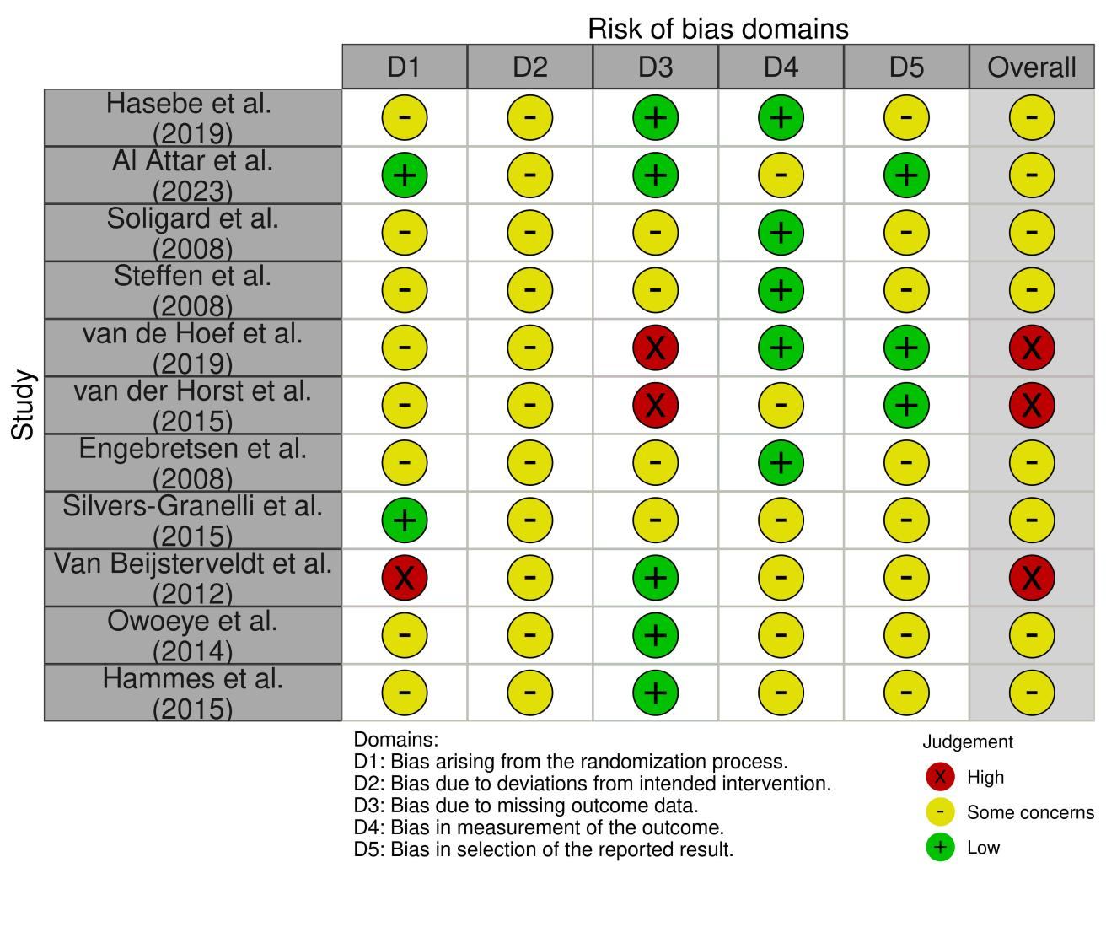
Supplementary Figure 1. Risk of bias assessment of included studies
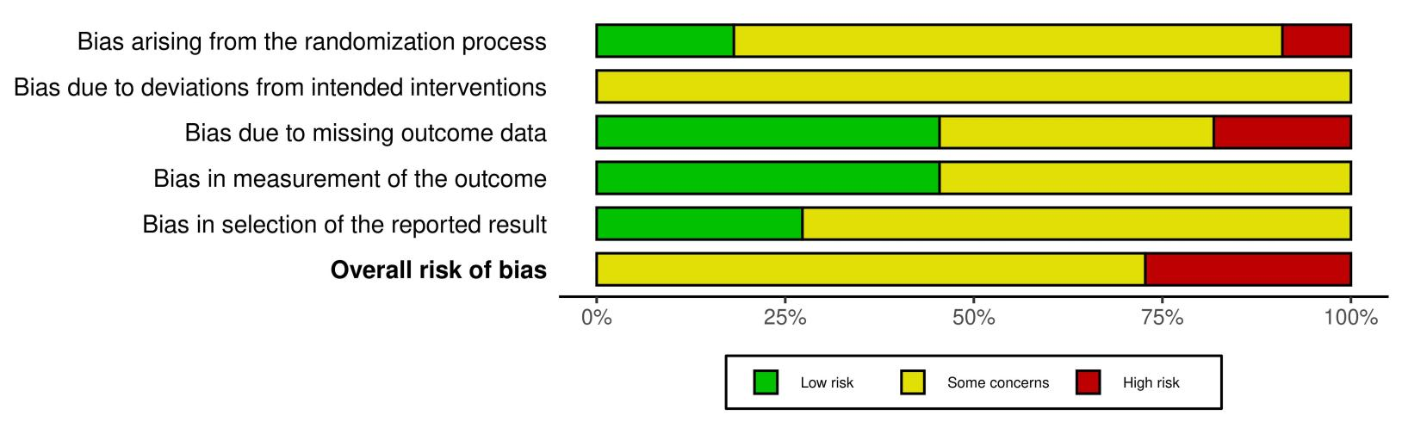

Supplementary Figure 2. Summary of risk of bias judgments across included studies

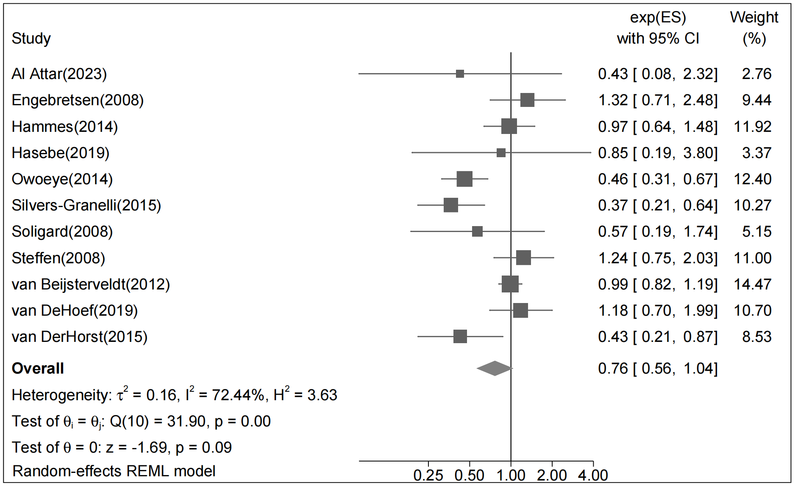
Supplementary Figure 3. Pairwise meta-analysis of hamstring injury incidence

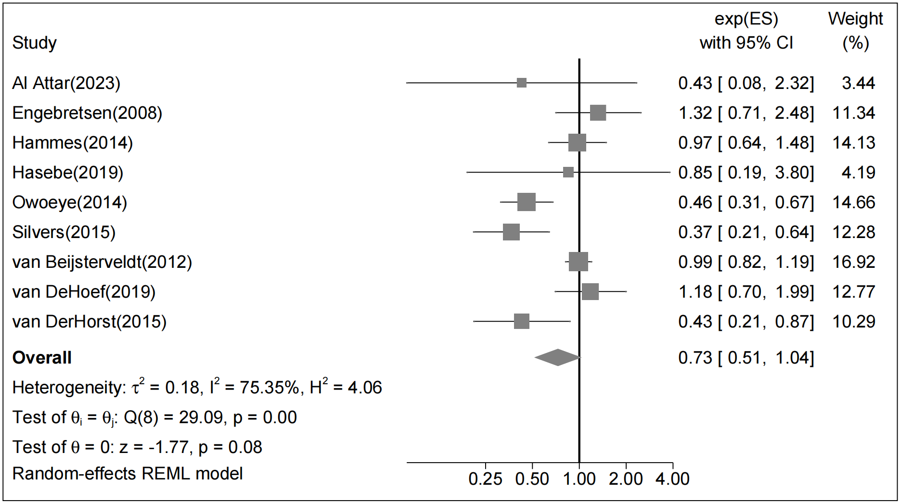

Supplementary Figure 4. Pairwise meta-analysis of hamstring injury incidence in males

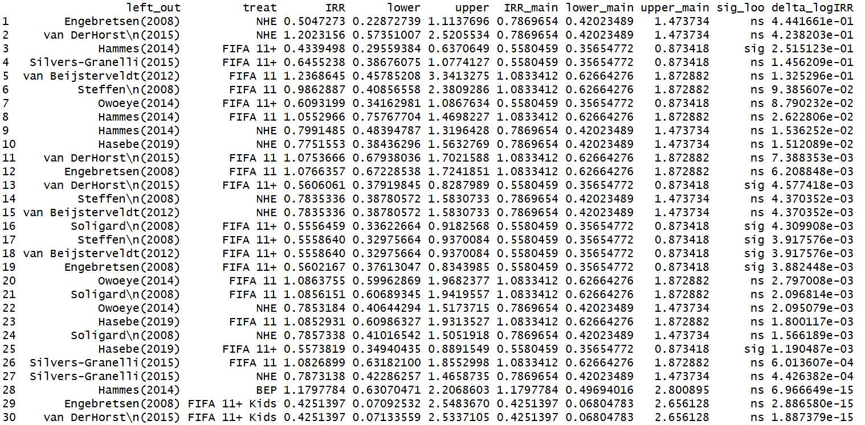

Supplementary Figure 5. Leave-one-out sensitivity analysis for the network meta-analysis

