Supplementary Material
Search strategy：
（1）Embase： Title or Abstract
(“diel rhythm” OR "time of day" OR “exercise timing” OR “morning exercise” OR “morning training” OR “circadian” OR “morning vs afternoon” OR “morning vs evening” OR “timing” OR “time-of-day”) AND (“exercis*” OR “training” OR “sport” OR “physical activity” OR “athletics” OR “workout” OR “fitness” OR “play” OR “movement” OR “walking” OR “strength”)
Filter：Randomized Controlled Trial
Year：From：<1966 To 2026
Total: 2622 results

（2）Pubmed: Title or Abstract
(“diel rhythm” OR "time of day" OR “exercise timing” OR “morning exercise” OR “morning training” OR “circadian” OR “morning vs afternoon” OR “morning vs evening” OR “timing” OR “time-of-day”) AND (“exercis*” OR “training” OR “sport” OR “physical activity” OR “athletics” OR “workout” OR “fitness” OR “play” OR “movement” OR “walking” OR “strength”)
Filter：Randomized Controlled Trial
Year：From：1976 To 2026
Total: 1203 results

（3）WOS: Topic
(“diel rhythm” OR "time of day" OR “exercise timing” OR “morning exercise” OR “morning training” OR “circadian” OR “morning vs afternoon” OR “morning vs evening” OR “timing” OR “time-of-day”) AND (“exercis*” OR “training” OR “sport” OR “physical activity” OR “athletics” OR “workout” OR “fitness” OR “play” OR “movement” OR “walking” OR “strength”)
Document types: Clinical Trial
Total: 3286

（4）Scopus: Title Abstract keywords
(“diel rhythm” OR "time of day" OR “exercise timing” OR “morning exercise” OR “morning training” OR “circadian” OR “morning vs afternoon” OR “morning vs evening” OR “timing” OR “time-of-day”) AND (“exercis*” OR “training” OR “sport” OR “physical activity” OR “athletics” OR “workout” OR “fitness” OR “play” OR “movement” OR “walking” OR “strength”) AND ("Randomized Controlled Trial" OR "randomized controlled trial" OR "randomised controlled trial" OR "RCT")
Total: 3157

（5）SPORTDiscus: Title or Abstract
(“diel rhythm” OR "time of day" OR “exercise timing” OR “morning exercise” OR “morning training” OR “circadian” OR “morning vs afternoon” OR “morning vs evening” OR “timing” OR “time-of-day”) AND (“exercis*” OR “training” OR “sport” OR “physical activity” OR “athletics” OR “workout” OR “fitness” OR “play” OR “movement” OR “walking” OR “strength”) AND ("Randomized Controlled Trial" OR "randomized controlled trial" OR "randomised controlled trial" OR "RCT")
Total: 38

Data Extraction from Figures
In cases where numerical outcome data were presented only graphically in the original publication and could not be obtained from the corresponding authors after two contact attempts, data points were extracted digitally using Origin 2025 software, a validated tool for precise coordinate-based data retrieval.
To minimize extraction error, the following procedure was followed:
(1) The figure was digitized independently by two reviewers.
(2) The final value used in the analysis was the arithmetic mean of the two independently extracted values.
Regarding data extraction from Kim et al. (2022):
For the outcome Fasting Blood Glucose (FBG), we extracted the mean change (Δ) and standard deviation (SD) for both the morning and afternoon exercise groups. The data indicate that:

The morning exercise group showed an average reduction in FBG of 1.33 mmol/L (SD = 0.25, n = 12).
The afternoon exercise group showed a slight increase in FBG of 0.42 mmol/L (SD = 0.24, n = 12).
study | mean1 | sd1 | n1 | mean2 | sd2 | n2
Kim et al. 2022 | -1.33 | 0.25 | 12 | 0.42 | 0.24 | 12

Subgroup analysis
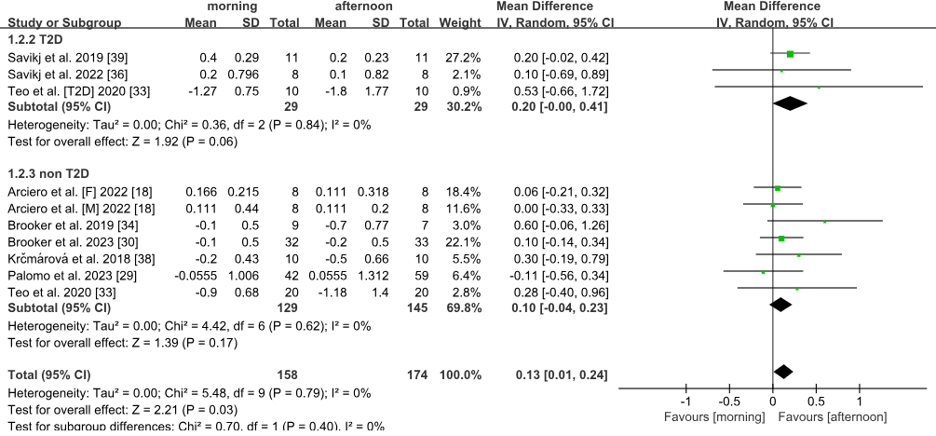
Supplementary Figure S1. Subgroup analysis of fasting glucose stratified by health status (T2D vs. non-T2D).

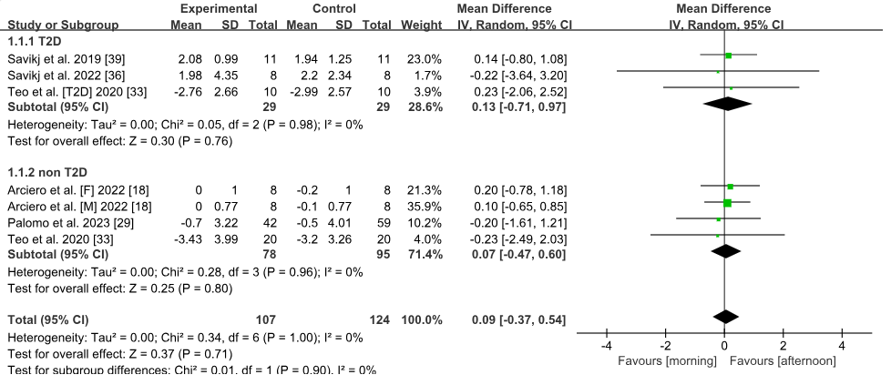
Supplementary Figure S2. Subgroup analysis of insulin stratified by health status (T2D vs. non-T2D).

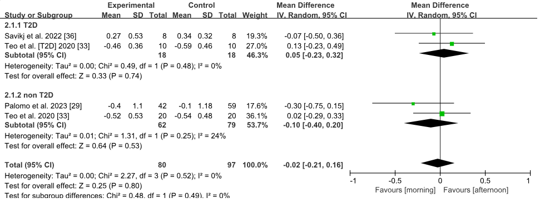
Supplementary Figure S3. Subgroup analysis of HOMA stratified by health status (T2D vs. non-T2D).
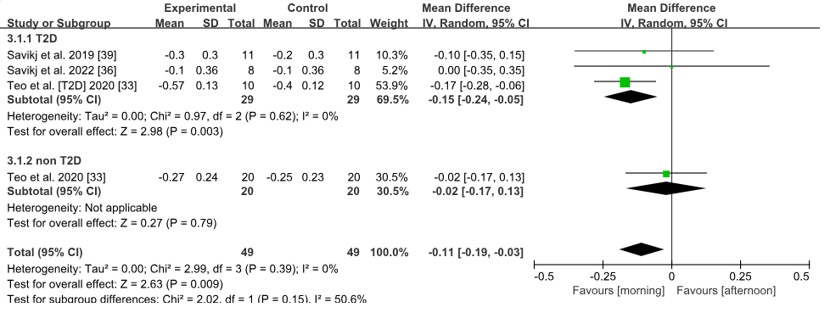
Supplementary Figure S4. Subgroup analysis of HbA1c stratified by health status (T2D vs. non-T2D).

Supplementary Table S1. GRADE summary of findings
Certainty assessment |  |  |  |  |  |  | Number of patients |  | Effect |  | Certainty | Importance
No. of studies | Study design | Risk of bias | Inconsistency | Indirectness | Imprecision | Other considerations | MT | AT | Relative  (95% CI) | Absolute  (95% CI) | Certainty | Importance
BMI
4 | randomised trials | Not Serious | Serious | Not serious | Serious | none | 96 | 109 | - | MD 0.2 lower  (0.59 lower to 0.19 higher) | ⨁⨁◯◯  Llow
Body weight
7 | randomised trials | Not Serious | Not serious | Not serious | Serious | none | 153 | 166 | - | MD 0.38 lower  (0.96 lower to 0.19 higher) | ⨁⨁⨁◯  Moderate
Waist circumference
4 | randomised trials | Not Serious | Not serious | Not serious | Serious | none | 96 | 109 | - | MD 0.21 lower  (1.2 lower to 0.77 higher) | ⨁⨁⨁◯  Moderate
Fat mass
8 | randomised trials | Not Serious | Not serious | Not serious | Serious | none | 147 | 160 | - | SMD 0.09 higher  (0.13 lower to 0.32 higher) | ⨁⨁⨁◯  Moderate
Fat free mass
7 | randomised trials | Not Serious | Not serious | Not serious | Serious | none | 137 | 150 | - | SMD 0.04 higher  (0.19 lower to 0.28 higher) | ⨁⨁⨁◯  Moderate
Body fat
6 | randomised trials | Not Serious | Not serious | Not serious | Very serious | none | 92 | 89 | - | SMD 0.19 lower  (0.64 lower to 0.26 higher) | ⨁⨁◯◯  Low
FBG-long-term studies
10 | randomised trials | Serious | Not serious | Not serious | Serious | none | 158 | 174 | - | MD 0.13 higher  (0.01 higher to 0.24 higher) | ⨁⨁◯◯  Low
Insulin
7 | randomised trials | Serious | Not serious | Not serious | Very serious | none | 107 | 124 | - | MD 0.09 higher  (0.37 lower to 0.54 higher) | ⨁◯◯◯  Very low
HbA1c
4 | randomised trials | Serious | Not serious | Not serious | Serious | none | 49 | 49 | - | MD 0.11 lower  (0.19 lower to 0.03 lower) | ⨁⨁◯◯  Low
HOMA
4 | randomised trials | Serious | Not serious | Not serious | Very serious | none | 80 | 97 | - | MD 0.02 lower  (0.21 lower to 0.16 higher) | ⨁◯◯◯  Very low
FBG-acute studies
3 | randomised trials | Not serious | Very serious | Not serious | Very serious | none | 33 | 34 | - | MD 0.72 lower  (2.12 lower to 0.67 higher) | ⨁◯◯◯  Very low
Glucose before and after exercise-acute
3 | randomised trials | Not serious | Not serious | Not serious | Very serious | none | 36 | 37 | - | MD 0.53 higher  (0.1 higher to 0.96 higher) | ⨁◯◯◯  Very low
TC
8 | randomised trials | Serious | Not serious | Not serious | Serious | none | 207 | 223 | - | MD 0.03 lower  (0.21 lower to 0.15 higher) | ⨁⨁◯◯  Low
TG
9 | randomised trials | Serious | Not serious | Not serious | Serious | none | 217 | 232 | - | MD 0.13 higher  (0.03 lower to 0.29 higher) | ⨁⨁◯◯  Low
HDL
9 | randomised trials | Serious | Not serious | Not serious | Serious | none | 157 | 233 | - | MD 0.03 higher  (0.02 lower to 0.09 higher) | ⨁⨁◯◯  Low
LDL
9 | randomised trials | Serious | Not serious | Not serious | Serious | none | 217 | 233 | - | MD 0.07 lower  (0.19 lower to 0.06 higher) | ⨁⨁◯◯  Low
BMI: Body mass index; FBG:Fasting blood glucose; HbA1c: Hemoglobin A1c; HOMA: Homeostatic Model Assessment for Insulin Resistance; Glucose before and after exercise：post-exercise minus pre-exercise glucose; TC: Total cholesterol; TG: Triglycerides; HDL: High-density lipoproteins; LDL : Low-density lipoproteins

All outcomes were rated below “High” due to one or more serious limitations. The specific downgrading reasons per outcome are listed below. No outcome was downgraded for indirectness (all rated “not serious”) or publication bias (“other considerations” were none in all cases).

BMI– Low (⊕⊕◯◯)
Downgraded for inconsistency(serious unexplained variation across studies), and imprecision(wide confidence interval crossing the null).
Body weight– Moderate (⊕⊕⊕◯)
Downgraded for imprecision(confidence interval includes zero and is relatively wide).
Waist circumference– Moderate (⊕⊕⊕◯)
Downgraded for imprecision(wide confidence interval with limited sample size).
Fat mass– Moderate (⊕⊕⊕◯)
Downgraded for imprecision(confidence interval crosses the null and includes both benefit and harm).
Fat free mass– Moderate (⊕⊕⊕◯)
Same as fat mass – one dominant study; imprecision due to wide CI.
Body fat – Low (⊕⊕◯◯)
Downgraded for very serious imprecision(very wide confidence interval and small sample size, leading to high uncertainty).
Fasting blood glucose (FBG)– Low (⊕⊕◯◯)
Downgraded for risk of bias(methodological limitations across trials) and imprecision(confidence interval is narrow but still crosses no meaningful effect, and total sample size is modest).
Insulin– Very low (⊕◯◯◯)
Downgraded for risk of bias(assay variability and potential lack of blinding) and very serious imprecision(very wide confidence interval and limited number of participants).
HbA1c– Low (⊕⊕◯◯)
Downgraded for risk of bias(few studies and possible selective reporting) and imprecision(confidence interval includes a clinically negligible effect and sample size is small).
HOMA– Very low (⊕◯◯◯)
Downgraded for risk of bias(variations in calculation methods) and very serious imprecision(wide confidence interval spanning from benefit to harm, with few participants).
FBG – acute – Very low (⊕◯◯◯)
Downgraded for risk of bias(limited number of studies),very serious inconsistency(I²=98%, extreme heterogeneity), and very serious imprecision(only 3 studies, extremely wide CI crossing the null).
Glucose before and after exercise – acute– Very low (⊕◯◯◯)
Downgraded for risk of bias(few studies) and very serious imprecision(very wide confidence interval and small total sample size); inconsistency was not judged serious.
Total cholesterol (TC)– Low (⊕⊕◯◯)
Downgraded for risk of bias(moderate heterogeneity and possible lack of blinding) and imprecision(confidence interval includes both directions and is not sufficiently narrow).
Triglycerides (TG)– Low (⊕⊕◯◯)
Downgraded for risk of bias(moderate heterogeneity and uncontrolled confounding) and imprecision(wide CI crossing zero).
HDL cholesterol– Low (⊕⊕◯◯)
Downgraded for risk of bias(measurement variability) and imprecision(confidence interval includes zero and is relatively broad).
LDL cholesterol– Low (⊕⊕◯◯)
Same as HDL – risk of bias and imprecision due to methodological concerns and wide confidence interval.

