Supplementary file 1. Articles excluded from the systematic review and reasons for exclusion.
Studies that did not match the inclusion criteria to be reviewed in full text (n = 13)
Year | Authors | Title | Reason for exclusion
2004 | Andersen et al. | Video analysis of the mechanisms for ankle injuries in football. | It exclusively focused on ankle injury mechanisms.
2011 | Ekstrand et al. | Injury incidence and injury patterns in professional football: the UEFA injury study. | Muscle injuries were not analysed through video analysis.
2018 | Albers et al. | The iliotibial band and anterolateral capsule have a combined attachment to the Segond fracture. | Muscle injuries were not analysed through video analysis.
2020 | Danielsson et al. | The mechanism of hamstring injuries - a systematic review. | Publication type – systematic review.
2022 | Argibay-González et al. | Analysis of Injury Patterns in Men's Football between the English League and the Spanish League. | Muscle injury mechanisms and injury patterns were not clearly described or analysed separately.
2022 | Prieto-Lage et al. | Patterns of Injury in the Spanish Football League Players. | Muscle injury mechanisms and injury patterns were not clearly described or analysed separately.
2022 | Yuce et al. | Systemic video analysis of hamstring injury mechanism for professional athletes: sprint-type injuries occurring during the swing phase of the running cycle | Included multiple sports; not specific to professional football (soccer).
2022 | Yuce et al. | The Injury Mechanism of Knee Extensor Mechanism Rupture in Professional Athletes: A Video Analysis Study. | Included multiple sports; not specific to professional football (soccer).
2023 | Aiello et al. | Injury-Inciting Activities in Male and Female Football Players: A Systematic Review. | Publication type – systematic review.
2023 | Gronwald et al. | Injury patterns of Achilles tendon ruptures: a systematic video analysis of 80 cases in professional male football. | The analysis focused exclusively on tendon injuries.
2023 | Raya-González et al. | Understanding the impact of hamstring injuries on match performance in Spanish professional soccer players: two full seasons follow-up. | Injury mechanisms were not assessed through video analysis.
2023 | Yuce et al. | Injury mechanism of patellar dislocation in professional athletes: a video analysis study. | This study did not analyse muscle injuries in professional football (soccer) players.
2024 | Aiello et al. | Broadening our understanding of injury mechanisms to include at-risk situations: an overview of potential injuries at the FIFA men's World Cup Qatar 2022. | They described potential injury situations.
Studies that did not match the inclusion criteria to be included in the review (n = 6)
Year | Authors | Title | Reason for exclusion
2004 | Andersen et al. | Video analysis of injuries and incidents in Norwegian professional football. | Muscle injury mechanisms were not accurately analysed.
2004 | Arnason et al. | A prospective video-based analysis of injury situations in elite male football: Football incident analysis. | Muscle injury mechanisms were not accurately analysed.
2004 | Fuller et al. | The Influence of Tackle Parameters on the Propensity for Injury in International Football. | They only studied overall tackling injuries.
2007 | Tscholl et al. | Causation of injuries in female football players in top-level tournaments. | Injury mechanisms and injury patterns in muscle injuries were not described.
2022 | Della Villa et al. | Video analysis of Achilles tendon rupture in male professional football (soccer) players: injury mechanisms, patterns and biomechanics. | The analysis focused exclusively on tendon injuries.
2024 | Moreno-Pérez et al. | Hamstring muscle injury is preceded by a short period of higher running demands in professional football players. | Injury mechanism and injury patterns were not analysed throughout video analysis.

Supplemental file 2. Characteristics of injury mechanisms in professional football players based on video analysis studies.

Study |  |  | Injury mechanism |  |  | If contact, contact location: |  |  |  | Kinetic chain |  |  | Horizontal velocity |  | Vertical velocity
Study | Muscle group  (n injuries) | Sex | Direct contact, n | Indirect contact, n | Non-contact, n | Upper body, n | Pelvis, n | Uninjured leg, n | Injured leg, n | Open, n | Close, n | Unsure, n | Zero-Low | Moderate-High | Zero-Low | Moderate-High
Serner et al., 2019 [34] | A (17) | M | 2 | 3 | 12 | - | - | - | - | 7 | 9 | 1 | - | - | - | -
Klein et al., 2020 [19] | H (31); Q (7); A (18) | M | 0 | 21 | 35 | - | - | - | - | - | - | - | - | - | - | -
Gronwald et al., 2022 [18] | H (63) | M | - | 21 | 42 | - | - | - | - | 8 | 18 | 0 | - | - | - | -
Aiello et al., 2023 [32] | H (17); Q (2); A (6); C (4) | M | - | - | 29 | - | - | - | - | - | - | - | - | - | - | -
Della Villa et al., 2023 [10] | H (61); Q (9); A (16); C (17) | M | 0 | 18 | 85 | 10 | 3 | 4 | 1 | 43 | 41 | 19 | 27 | 76 | 99 | 4
Jokela et al., 2023 [16] | Q (20) | M | 0 | 2 | 18 | 2 | 2 | 0 | 0 | 14 | 4 | 2 | 9 | 11 | - | -
Jokela et al., 2023 [17] | H (14) | M | 1 | 6 | 7 | 6 | 0 | 0 | 0 | 7 | 7 |  | 13 | 48 | - | -
Della Villa et al., 2024* [33] | H (29) | F | 0 | 10 | 19 | 10 | 0 | 0 | 0 | 10 | 9 | 10 | 11 | 18 | 29 | 0
Della Villa et al., 2024* [33] | H (61) | M | 0 | 8 | 53 | 4 | 1 | 3 | 0 | 26 | 16 | 19 | 13 | 48 | 58 | 3
Vermeulen et al., 2024 [35] | H (63) | M | 0 | 17 | 45 | - | - | - | - |  |  |  | 2 | 51 | 57 | 3
Jokela et al., 2025 [20] | A (20) | M | 0 | 7 | 13 | - | - | - | - | 3 | 14 | 3 | - | - | - | -
Gandarias-Madariaga et al., 2025 [36] | H (78) | M | 0 | 13 | 65 | - | - | - | - | - | - | - | - | - | - | -
Pellegrini et al., 2025 [37] | H (57) | F | 0 | 15 | 42 | 9 | 0 | 4 | 2 | 15 | 24 | 18 | - | - | - | -
*The male players’ sample was included in the cohort of the previous study by Della Villa et al., 2023, and was excluded from the analyses. The female players’ sample was reported separately.

Supplemental file 3. Actions at the time of muscle injury in professional football players based on video analysis studies.
 |  |  |  | Specific action
Study | Muscle group  (n injuries) | Sex | Running  n | Stretching/reaching  n | Kicking  n | Jumping  n | COD  n | Other, n
Serner et al., 2019 [34] | A (17) | M | 0 | 4 | 5 | 2 | 6 | 0
Klein et al., 2020 [19] | H (31); Q (7); A (18) | M | 18 | 0 | 11 | 0 | 41 | 0
Gronwald et al., 2022 [18] | H (63) | M | 25 | 16 | 8 | 2 | 0 | 1
Aiello et al., 2023 [32] | H (17); Q (2); A (6); C (4) | M | 14 | 5 | 5 | 2 | 3 | 0
Della Villa et al., 2023 [10] | H (61); Q (9); A (16); C (17) | M | 35 | 44 | 16 | 2 | 0 | 6
Jokela et al., 2023 [16] | Q (20) | M | 2 | 0 | 16 | 0 | 2 | 0
Jokela et al., 2023 [17] | H (14) | M | 3 | 1 | 4 | 1 | 4 | 1
Della Villa et al., 2024* [33] | H (29) | F | 18 | 6 | 5 | 0 | 0 | 0
Della Villa et al., 2024* [33] | H (51) | M | 24 | 28 | 6 | 0 | 0 | 3
Vermeulen et al., 2024 [35] | H (63) | M | 6 | 11 | 13 | 7 | 25 | 1
Jokela et al., 2025 [20] | A (20) | M | 1 | 13 | 0 | 3 | 3 | 0
Gandarias-Madariaga et al., 2025 [36] | H (78) | M | 42 | 11 | 0 | 0 | 0 | 25
Pellegrini et al., 2025 [37] | H (57) | F | 29 | 12 | 14 | 2 | 0 | 0
*The male players’ sample was included in the cohort of the previous study by Della Villa et al., 2023, and was excluded from the analyses. The female players’ sample was reported separately.

Supplementary file 4. Pooled category proportions (posterior medians with 95% credible interval [CrI]) from a Bayesian hierarchical multinomial-logit random-effects meta-analysis across studies. The upper panel reports the marginal pooled proportion for each action category. Values are on a 0–1 scale and, within each domain, proportions sum to ≈1; the middle panel gives the between-study standard deviations on the logit scale for the C−1 contrasts with the reference category (baseline = last category in each domain: Uninjured leg; Others; 75–90 min), quantifying heterogeneity. Larger SDs indicate greater between-study variability in the relative frequency of that category compared with the reference.; and the lower panel presents the posterior median correlation matrix of study-level random effects (positive values indicate co-variation across studies, negative values indicate inverse co-variation).
Pooled category proportions (posterior medians, 95% CrI)
 | Category | Median RE | Lower 95%CrI | Upper 95%CrI
Contact Location | Upper body | 0.69 | 0.39 | 0.89
Contact Location | Pelvis | 0.10 | 0.02 | 0.32
Contact Location | Injured leg | 0.12 | 0.02 | 0.36
Contact Location | Uninjured leg | 0.06 | 0.01 | 0.18
Injury pattern | Running | 0.29 | 0.17 | 0.44
Injury pattern | Stretch/Reach | 0.24 | 0.12 | 0.39
Injury pattern | Kicking | 0.22 | 0.09 | 0.38
Injury pattern | Jumping | 0.05 | 0.02 | 0.14
Injury pattern | COD | 0.11 | 0.03 | 0.28
Injury pattern | Others | 0.05 | 0.02 | 0.10
15-min match intervals | 0–14 | 0.16 | 0.11 | 0.24
15-min match intervals | 15–29 | 0.22 | 0.15 | 0.32
15-min match intervals | 30–45 | 0.17 | 0.10 | 0.26
15-min match intervals | 46–59 | 0.14 | 0.08 | 0.20
15-min match intervals | 60–74 | 0.16 | 0.1 | 0.26
15-min match intervals | 75–90 | 0.13 | 0.09 | 0.17
Between-study SDs (logit dimensions, baseline = last category):
 | Dim | SD median
Contact Location | Upper body vs Uninjured leg | 0.84
Contact Location | Pelvis vs Uninjured leg | 0.64
Contact Location | Injured leg vs Uninjured leg | 0.66
Injury pattern | Running vs Others | 1.00
Injury pattern | Stretch/Reach vs Others | 1.32
Injury pattern | Kicking vs Others | 1.80
Injury pattern | Jumping vs Others | 1.43
Injury pattern | COD vs Others | 2.26
15-min match intervals | 0–14 vs 75–90 | 0.27
15-min match intervals | 15–29 vs 75–90 | 0.40
15-min match intervals | 30–45 vs 75–90 | 0.45
15-min match intervals | 46–59 vs 75–90 | 0.28
15-min match intervals | 60–74 vs 75–90 | 0.58
Median correlation matrix between category random effects (C-1 dims):
Contact Location | index | Upper body vs Uninjured leg | Pelvis vs Uninjured leg | Injured leg vs Uninjured leg
Contact Location | Upper body vs Uninjured leg | 1 | -0.06 | -0.05
Contact Location | Pelvis vs Uninjured leg | -0.06 | 1 | 0.06
Contact Location | Injured leg vs Uninjured leg | -0.05 | 0.06 | 1
Injury pattern | index | Running vs Others | Stretch/Reach vs Others | Kicking vs Others | Jumping vs Others | COD vs Others
Injury pattern | Running vs Others | 1 | -0.05 | 0.36 | 0.01 | 0.16
Injury pattern | Stretch/Reach vs Others | -0.05 | 1 | 0.10 | 0.51 | 0.01
Injury pattern | Kicking vs Others | 0.36 | 0.1 | 1 | 0.33 | 0.46
Injury pattern | Jumping vs Others | 0.01 | 0.51 | 0.33 | 1 | 0.46
Injury pattern | COD vs Others | 0.16 | 0.01 | 0.46 | 0.46 | 1
15-min match intervals | index | 0–14 vs 75–90 | 15–29 vs 75–90 | 30–45 vs 75–90 | 46–59 vs 75–90 | 60–74 vs 75–90
15-min match intervals | 0–14 vs 75–90 | 1 | 0.13 | 0.11 | -0.04 | 0.04
15-min match intervals | 15–29 vs 75–90 | 0.13 | 1 | 0.07 | -0.02 | 0.22
15-min match intervals | 30–45 vs 75–90 | 0.11 | 0.07 | 1 | -0.01 | 0.08
15-min match intervals | 46–59 vs 75–90 | -0.04 | -0.02 | -0.01 | 1 | 0.06
15-min match intervals | 60–74 vs 75–90 | 0.04 | 0.22 | 0.08 | 0.06 | 1
Abbreviations: RE = random-effects (marginal) estimate from the hierarchical multinomial-logit model; CrI = credible interval; SD median = posterior median of the between-study standard deviation; Dim = logit dimension (category contrasted with the reference); vs = versus; COD = change of direction. Notes: Pooled proportions are posterior medians and sum to ~1 across categories; between-study SDs are on the logit scale for the C−1 contrasts versus the reference (baseline = last category, Others). The correlation matrix shows posterior median correlations between category random effects: positive values indicate co-variation in the same direction across studies; negative values indicate inverse co-variation.

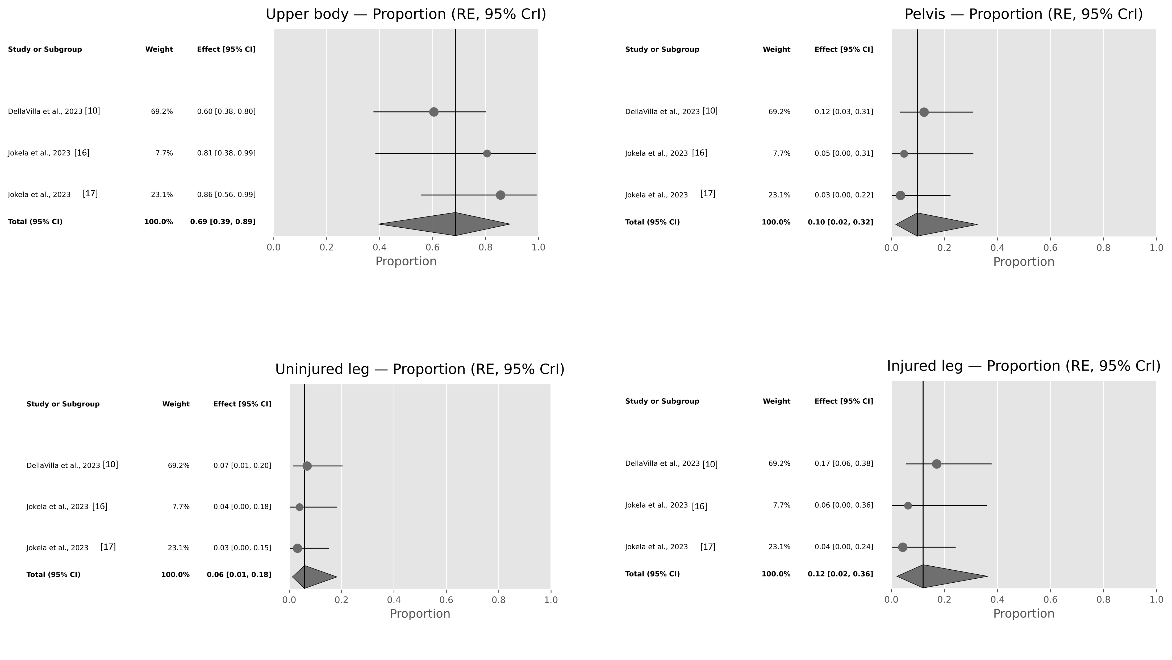
Supplementary file 5. Forest plots of category-specific proportions from the Bayesian hierarchical multinomial-logit random-effects meta-analysis. Each panel (upper body, pelvis, injured leg and uninjured leg) shows study-level posterior medians (points) with 95% credible intervals (horizontal bars) on a 0–1 proportion scale; point size reflects the relative weight (study total). The diamond marks the pooled random-effects marginal estimate with its 95% CrI. The vertical line indicates the pooled median for reference. Abbreviations: CrI, credible interval.
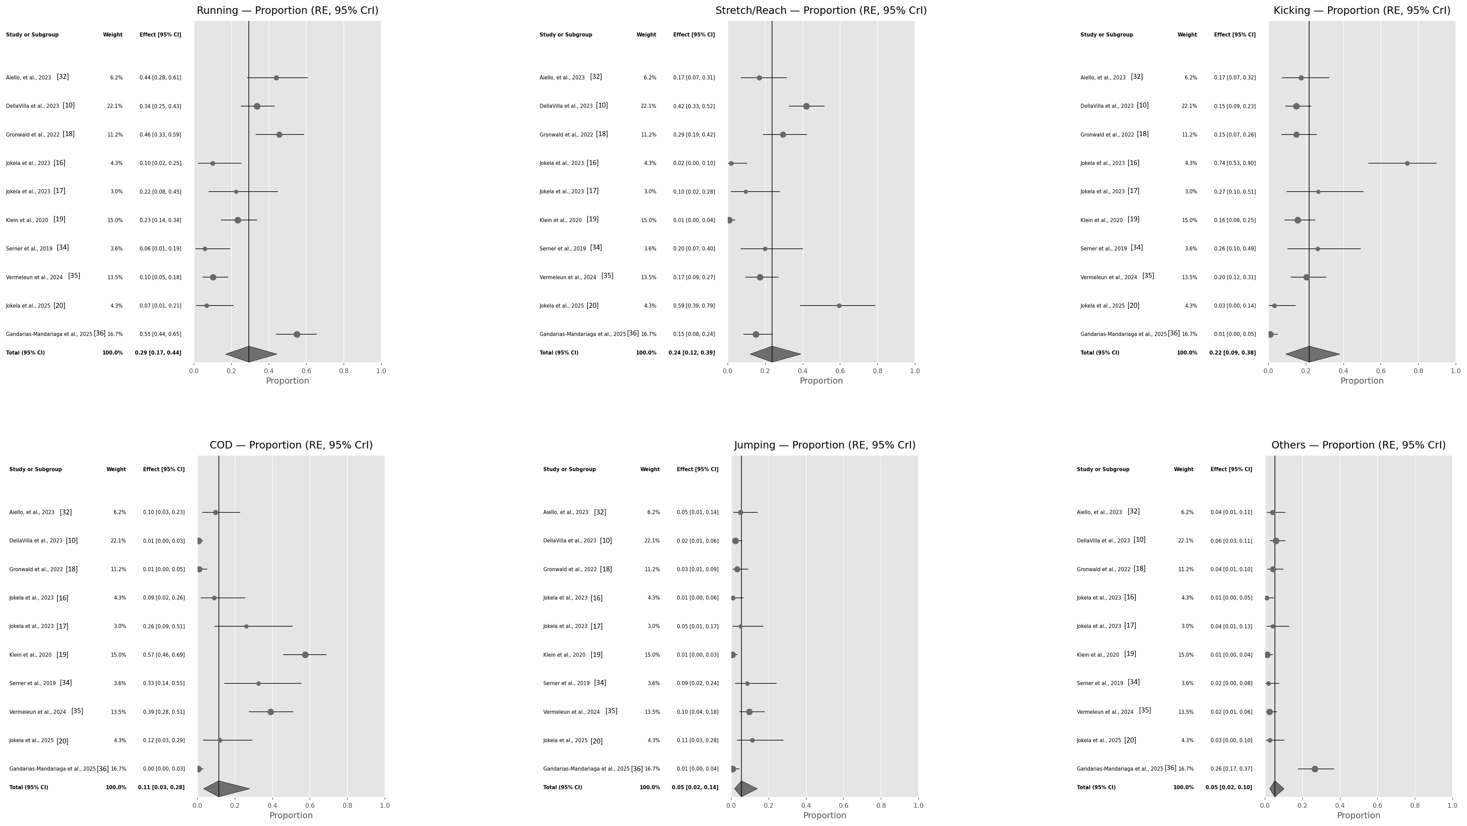
Supplementary file 6. Forest plots of category-specific proportions from the Bayesian hierarchical multinomial-logit random-effects meta-analysis. Each panel (running, stretching/reaching, kicking, jumping, COD and others) shows study-level posterior medians (points) with 95% credible intervals (horizontal bars) on a 0–1 proportion scale; point size reflects the relative weight (study total). The diamond marks the pooled random-effects marginal estimate with its 95% CrI. The vertical line indicates the pooled median for reference. Abbreviations: CrI, credible interval.
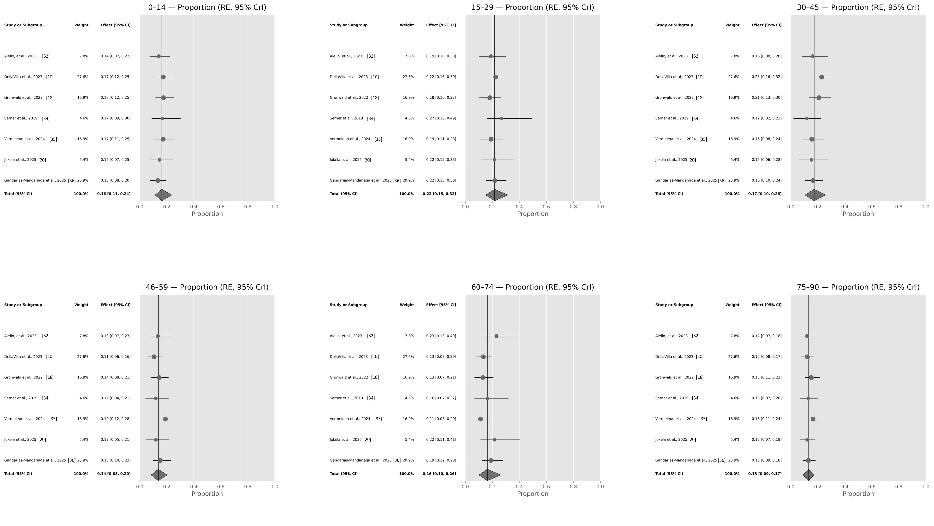
Supplementary file 7. Forest plots of category-specific proportions from the Bayesian hierarchical multinomial-logit random-effects meta-analysis. Each panel (0-14, 15-29; 30-45; 46-59; 60-75; 76-90) shows study-level posterior medians (points) with 95% credible intervals (horizontal bars) on a 0–1 proportion scale; point size reflects the relative weight (study total). The diamond marks the pooled random-effects marginal estimate with its 95% CrI. The vertical line indicates the pooled median for reference. Abbreviations: CrI, credible interval.
Supplemental file 8. Distribution of muscle injuries by match duration and field location in video-analysis studies of professional football players.

Study
Study | n of muscle injuries throughout match minutes |  |  |  |  |  |  |  | Field Location at the injury moment
Study | 0-14 | 15-29 |  | 30-45 |  | 46-59 | 60-75 | 76-90 | Long axis | Short axis
Serner et al., 2019 [34] | 4 | 7 |  | 0 |  | 1 | 3 | 2 | - | Corridor: n = 6  Middle: n = 11
Klein et al., 2020 [19] | - | - |  | - |  | - | - | - | - | -
Gronwald et al., 2022 [18] | 11 | 9 |  | 14 |  | 8 | 7 | 14 | - | -
Aiello et al., 2023 [32] | 4 | 5 |  | 5 |  | 5 | 9 | 1 | - | -
Della Villa et al., 2023 [10] | 21 | 25 |  | 27 |  | 9 | 13 | 8 | Defensive half: n = 43  Mid half: n = 27 Offensive half: n = 33 | Corridor: n = 41  Middle: n = 62
Jokela et al., 2023 [16] | - | - |  | - |  | - | - | - | - | -
Jokela et al., 2023 [17] | - | - |  | - |  | - | - | - | - | -
Della Villa et al., 2024 [33] | - | - |  | - |  | - | - | - | - | -
Vermeulen et al., 2024 [35] | 10 | 10 |  | 8 |  | 14 | 5 | 16 | Defensive half: n = 21  Mid half: n = 26 Offensive half: n = 16 | Corridor: n = 36  Middle: n = 27
Jokela et al., 2025 [20] | 3 | 5 |  | 3 |  | 2 | 6 | 1 | - | -
Gandarias-Madariaga et al., 2025 [36] | 8 | 18 |  | 13 |  | 14 | 16 | 9 | - | -
Pellegrini et al., 2025 [37] | 7 | 16 |  | 8 |  | 8 | 12 | 6 | - | -

Supplementary file 9. Pooled category proportions (posterior medians with 95% credible interval [CrI]) from a Bayesian hierarchical multinomial-logit random-effects meta-analysis across hamstring muscle injury studies. The upper panel reports the marginal pooled proportion for each action category. Values are on a 0–1 scale and, within each domain, proportions sum to ≈1; the middle panel gives the between-study standard deviations on the logit scale for the C−1 contrasts with the reference category (baseline = last category in each domain: Uninjured leg; Others; 75–90 min), quantifying heterogeneity. Larger SDs indicate greater between-study variability in the relative frequency of that category compared with the reference.; and the lower panel presents the posterior median correlation matrix of study-level random effects (positive values indicate co-variation across studies, negative values indicate inverse co-variation).
Pooled category proportions (posterior medians, 95% CrI)
 | Category | Median RE | Lower 95%CrI | Upper 95%CrI
Injury pattern | Running | 0.38 | 0.23 | 0.54
Injury pattern | Stretch/Reach | 0.24 | 0.12 | 0.4
Injury pattern | Kicking | 0.17 | 0.06 | 0.35
Injury pattern | Jumping | 0.05 | 0.01 | 0.15
Injury pattern | COD | 0.04 | 0.01 | 0.17
Injury pattern | Others | 0.09 | 0.04 | 0.16
15-min match intervals | 0–14 | 0.14 | 0.08 | 0.25
15-min match intervals | 15–29 | 0.18 | 0.1 | 0.3
15-min match intervals | 30–45 | 0.17 | 0.09 | 0.28
15-min match intervals | 46–59 | 0.17 | 0.1 | 0.27
15-min match intervals | 60–74 | 0.16 | 0.07 | 0.37
15-min match intervals | 75–90 | 0.16 | 0.09 | 0.22
Between-study SDs (logit dimensions, baseline = last category):
 | Dim | SD median
Injury pattern | Running vs Others | 0.99
Injury pattern | Stretch/Reach vs Others | 1.09
Injury pattern | Kicking vs Others | 1.69
Injury pattern | Jumping vs Others | 1.44
Injury pattern | COD vs Others | 2.07
15-min match intervals | 0–14 vs 75–90 | 0.24
15-min match intervals | 15–29 vs 75–90 | 0.37
15-min match intervals | 30–45 vs 75–90 | 0.3
15-min match intervals | 46–59 vs 75–90 | 0.29
15-min match intervals | 60–74 vs 75–90 | 0.77
Median correlation matrix between category random effects (C-1 dims):
Injury pattern | index | Running vs Others | Stretch/Reach vs Others | Kicking vs Others | Jumping vs Others | COD vs Others
Injury pattern | Running vs Others | 1 | 0.33 | 0 | 0.14 | -0.18
Injury pattern | Stretch/Reach vs Others | 0.33 | 1 | 0.23 | 0.22 | 0.03
Injury pattern | Kicking vs Others | 0 | 0.23 | 1 | 0.34 | 0.38
Injury pattern | Jumping vs Others | 0.14 | 0.22 | 0.34 | 1 | 0.41
Injury pattern | COD vs Others | -0.18 | 0.03 | 0.38 | 0.41 | 1
15-min match intervals | index | 0–14 vs 75–90 | 15–29 vs 75–90 | 30–45 vs 75–90 | 46–59 vs 75–90 | 60–74 vs 75–90
15-min match intervals | 0–14 vs 75–90 | 1 | -0.01 | 0.02 | 0 | 0
15-min match intervals | 15–29 vs 75–90 | -0.01 | 1 | 0.04 | 0.05 | 0.11
15-min match intervals | 30–45 vs 75–90 | 0.02 | 0.04 | 1 | 0.01 | 0.07
15-min match intervals | 46–59 vs 75–90 | 0 | 0.05 | 0.01 | 1 | 0.06
15-min match intervals | 60–74 vs 75–90 | 0 | 0.11 | 0.07 | 0.06 | 1
Abreviations: RE = random-effects (marginal) estimate from the hierarchical multinomial-logit model; CrI = credible interval SD median = posterior median of the between-study standard deviation; Dim = logit dimension (category contrasted with the reference); vs = versus; COD = change of direction. Notes: Pooled proportions are posterior medians and sum to ~1 across categories; between-study SDs are on the logit scale for the C−1 contrasts versus the reference (baseline = last category, Others). The correlation matrix shows posterior median correlations between category random effects: positive values indicate co-variation in the same direction across studies, negative values indicate inverse co-variation.

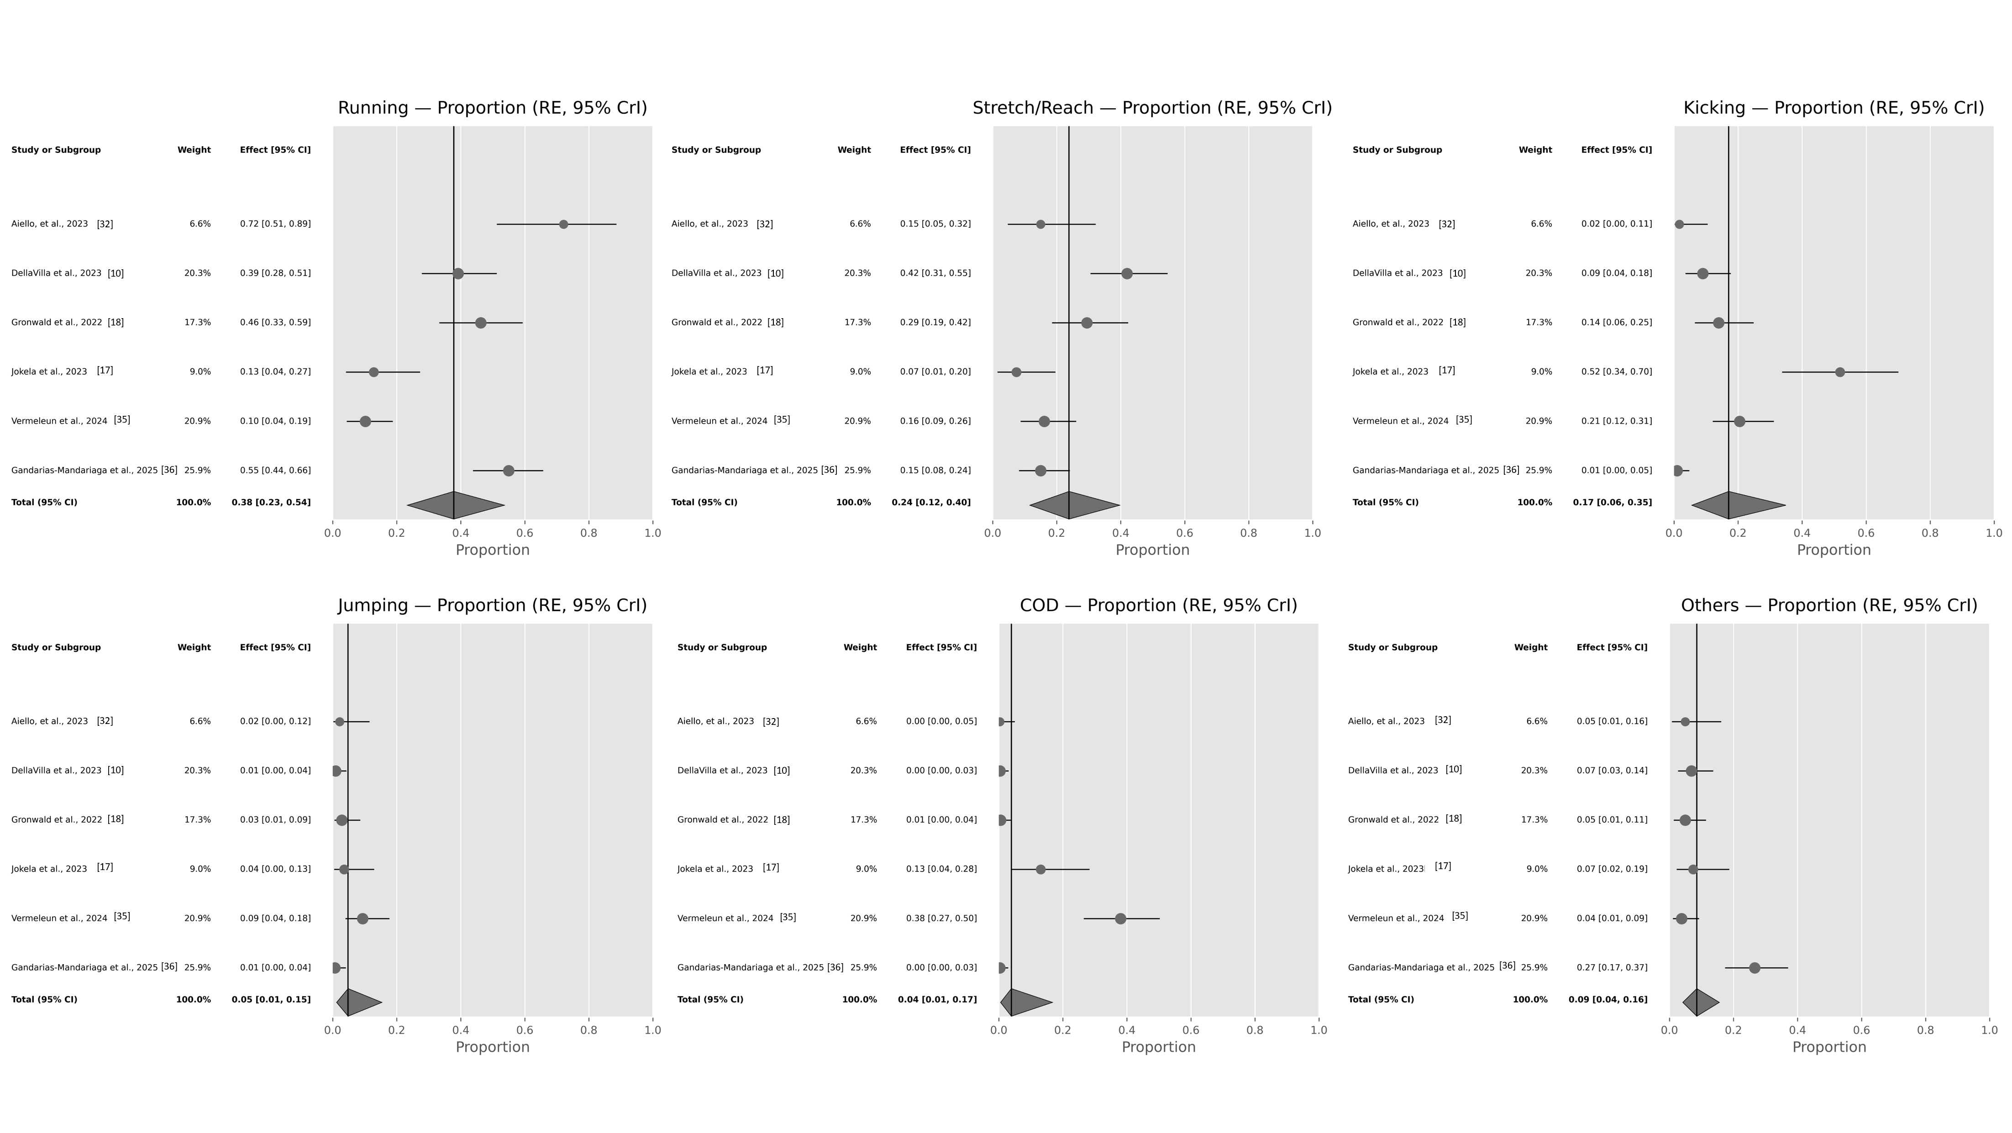
Supplementary file 10. Forest plots of category-specific proportions from the Bayesian hierarchical multinomial-logit random-effects meta-analysis across hamstring muscle injury studies. Each panel (running, stretching/reaching, kicking, jumping, COD and others) shows study-level posterior medians (points) with 95% credible intervals (horizontal bars) on a 0–1 proportion scale; point size reflects the relative weight (study total). The diamond marks the pooled random-effects marginal estimate with its 95% CrI. The vertical line indicates the pooled median for reference. Abbreviations: CrI, credible interval.
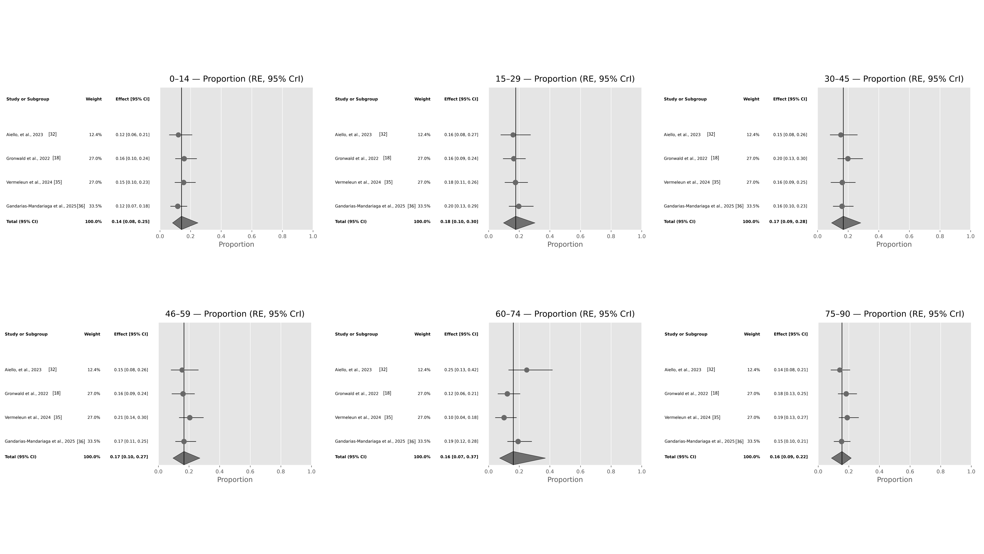
Supplementary file 11. Forest plots of category-specific proportions from the Bayesian hierarchical multinomial-logit random-effects meta-analysis across hamstring muscle injury studies. Each panel (0-14, 15-29; 30-45; 46-59; 60-75; 76-90) shows study-level posterior medians (points) with 95% credible intervals (horizontal bars) on a 0–1 proportion scale; point size reflects the relative weight (study total). The diamond marks the pooled random-effects marginal estimate with its 95% CrI. The vertical line indicates the pooled median for reference. Abbreviations: CrI, credible interval.
Supplementary file 12. Pooled category proportions (posterior medians with 95% credible interval [CrI]) from a Bayesian hierarchical multinomial-logit random-effects meta-analysis across adductor muscle injury studies. The upper panel reports the marginal pooled proportion for each action category. Values are on a 0–1 scale and, within each domain, proportions sum to ≈1; the middle panel gives the between-study standard deviations on the logit scale for the C−1 contrasts with the reference category (baseline = last category in each domain: Uninjured leg; Others; 75–90 min), quantifying heterogeneity. Larger SDs indicate greater between-study variability in the relative frequency of that category compared with the reference.; and the lower panel presents the posterior median correlation matrix of study-level random effects (positive values indicate co-variation across studies, negative values indicate inverse co-variation).
Pooled category proportions (posterior medians, 95% CrI)
 | Category | Median RE | Lower 95%CrI | Upper 95%CrI
Injury pattern | Running | 0.19 | 0.06 | 0.42
Injury pattern | Stretch/Reach | 0.34 | 0.15 | 0.55
Injury pattern | Kicking | 0.17 | 0.06 | 0.4
Injury pattern | Jumping | 0.1 | 0.03 | 0.26
Injury pattern | COD | 0.11 | 0.03 | 0.27
Injury pattern | Others | 0.04 | 0.01 | 0.09
15-min match intervals | 0–14 | 0.19 | 0.08 | 0.39
15-min match intervals | 15–29 | 0.28 | 0.11 | 0.47
15-min match intervals | 30–45 | 0.09 | 0.02 | 0.28
15-min match intervals | 46–59 | 0.09 | 0.02 | 0.25
15-min match intervals | 60–74 | 0.23 | 0.09 | 0.43
15-min match intervals | 75–90 | 0.07 | 0.03 | 0.16
Between-study SDs (logit dimensions, baseline = last category):
 | Dim | SD median
Injury pattern | Running vs Others | 1.3
Injury pattern | Stretch/Reach vs Others | 0.84
Injury pattern | Kicking vs Others | 0.88
Injury pattern | Jumping vs Others | 0.47
Injury pattern | COD vs Others | 0.85
15-min match intervals | 0–14 vs 75–90 | 0.42
15-min match intervals | 15–29 vs 75–90 | 0.46
15-min match intervals | 30–45 vs 75–90 | 0.71
15-min match intervals | 46–59 vs 75–90 | 0.48
15-min match intervals | 60–74 vs 75–90 | 0.43
Median correlation matrix between category random effects (C-1 dims):
Injury pattern | index | Running vs Others | Stretch/Reach vs Others | Kicking vs Others | Jumping vs Others | COD vs Others
Injury pattern | Running vs Others | 1 | -0.17 | 0.08 | -0.06 | 0.17
Injury pattern | Stretch/Reach vs Others | -0.17 | 1 | -0.07 | 0.09 | -0.03
Injury pattern | Kicking vs Others | 0.08 | -0.07 | 1 | -0.02 | -0.06
Injury pattern | Jumping vs Others | -0.06 | 0.09 | -0.02 | 1 | 0.03
Injury pattern | COD vs Others | 0.17 | -0.03 | -0.06 | 0.03 | 1
15-min match intervals | index | 0–14 vs 75–90 | 15–29 vs 75–90 | 30–45 vs 75–90 | 46–59 vs 75–90 | 60–74 vs 75–90
15-min match intervals | 0–14 vs 75–90 | 1 | 0.04 | -0.01 | -0.02 | -0.01
15-min match intervals | 15–29 vs 75–90 | 0.04 | 1 | -0.03 | -0.04 | -0.01
15-min match intervals | 30–45 vs 75–90 | -0.01 | -0.03 | 1 | 0.02 | 0.06
15-min match intervals | 46–59 vs 75–90 | -0.02 | -0.04 | 0.02 | 1 | 0.03
15-min match intervals | 60–74 vs 75–90 | -0.01 | -0.01 | 0.06 | 0.03 | 1
Abreviations: RE = random-effects (marginal) estimate from the hierarchical multinomial-logit model; CrI = credible interval; SD median = posterior median of the between-study standard deviation; Dim = logit dimension (category contrasted with the reference); vs = versus; COD = change of direction. Notes: Pooled proportions are posterior medians and sum to ~1 across categories; between-study SDs are on the logit scale for the C−1 contrasts versus the reference (baseline = last category, Others). The correlation matrix shows posterior median correlations between category random effects: positive values indicate co-variation in the same direction across studies, negative values indicate inverse co-variation.
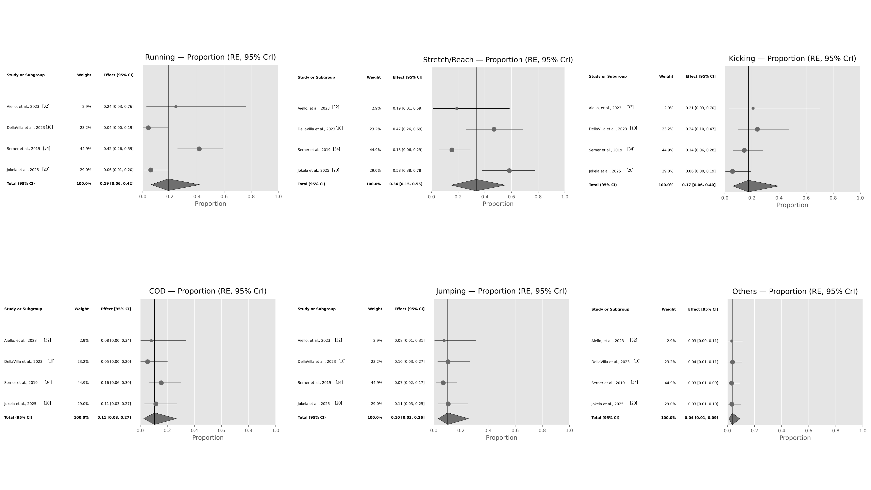
Supplementary file 13. Forest plots of category-specific proportions from the Bayesian hierarchical multinomial-logit random-effects meta-analysis across adductor muscle injury studies. Each panel (running, stretching/reaching, kicking, jumping, COD and others) shows study-level posterior medians (points) with 95% credible intervals (horizontal bars) on a 0–1 proportion scale; point size reflects the relative weight (study total). The diamond marks the pooled random-effects marginal estimate with its 95% CrI. The vertical line indicates the pooled median for reference. Abbreviations: CrI, credible interval.
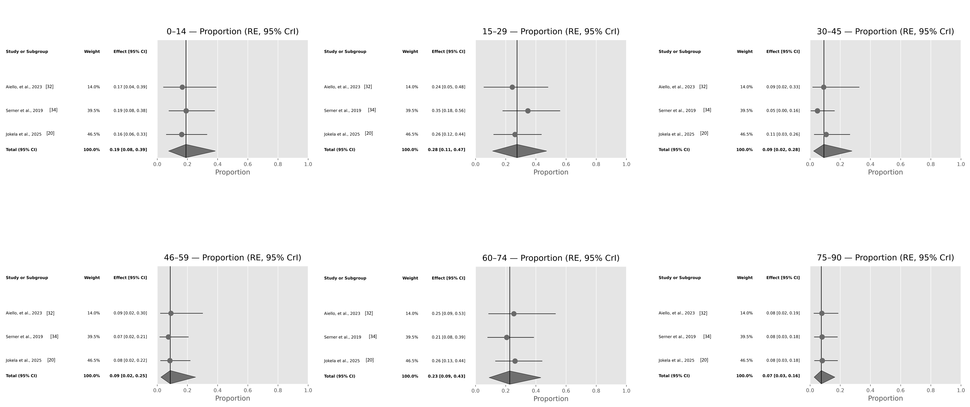
Supplementary file 14. Forest plots of category-specific proportions from the Bayesian hierarchical multinomial-logit random-effects meta-analysis across adductor muscle injury studies. Each panel (0-14, 15-29; 30-45; 46-59; 60-75; 76-90) shows study-level posterior medians (points) with 95% credible intervals (horizontal bars) on a 0–1 proportion scale; point size reflects the relative weight (study total). The diamond marks the pooled random-effects marginal estimate with its 95% CrI. The vertical line indicates the pooled median for reference. Abbreviations: CrI, credible interval.

